WEEK 5
UNIT 1. FAMILY
Lesson 3. Task 7, 8, 9
Period 17
I. OBJECTIVES:
1. Knowledge:
- Review words of family members
- Focus on the pronunciation of the sounds of s and sh.
2. Competences:
- English competences: Students will be able to use the grammar structure and sounds learnt in the lesson to practice saying sentences.
- Common competences: Students will will be friendly and confident in communicating with friends.
3. Qualities:
- Students will respect their family and learn some first steps to take care of family members.
II. EQUIPMENT AND MATERIALS:
- Basic things: Student’s book, printed handouts/ pieces of papers
- Advanced things: PPT, projector/interactive whiteboard/laptop/TV.
III. LESSON PROCEDURE:
Activity 1: Warm up (5 minutes)
Teacher’s activities | Student’s activities
- Greet students.  Movement Game: Sing and dance along  Sing or say, “Head, shoulders, knees and toes,” as follows:  “Head, shoulders, knees and toes, knees and toes.  Head, shoulders, knees and toes, knees and toes.  Eyes and ears, and mouth and nose.  Head, shoulders, knees and toes, knees and toes.”  Have the children touch the body part as it is named. Start off slowly and increase speed as you sing it over and over.  Lead in: Family tree  -Divide class into 2 teams-Boys and Girls  -Let the sts look at the family tree and choose the correct answers to get points. | - Great teacher.  - Enjoy the activity.  - Enjoy the game
Activity 2: Presentation (8 minutes)
Teacher’s activities | Student’s activities
Task 7: Listen and repeat. (Track 1.12)  - -Write s on the board. Ask students to say the name of this letter. Then write seven on the board. Ask students to pronounce the sound for s in the word.  - -Write sh on the board. Ask students to say these letters. Then write short on the board.  - -Ask students to pronounce the sound for sh in the word.  - -Pronounce both sounds again and show students how they are different from each other. Point to each word on the board and ask students to practise the sounds with you.  - -Play the recordings and tell students to repeat the words and the sentences, paying attention to the correct pronunciation of s and sh.  Game: Listen and choose!  Divide the class into 2 teams. Each student from each team come to the board and choose the corret answer.  Play the recording and let the sts tick on the correct one.  This can be played as “slap the board game”: Teacher says a word/sound for sts to slap to the correct one. | - Follow the teacher’s instruction.  -Say the letters.  - Practice saying the letters and words.  Play game: group work.
Activity 3: Practice (10 minutes)
Teacher’s activities | Student’s activities
Task 8: Listen and chant. (Track 1.13)  - -Tell students they are going to learn a chant. Explain to students that the chant uses the sounds they have just learnt.  - -Play the recording and tell students to listen and follow the words with their fingers.  - -Read out the chant one line at a time and ask students to repeat after you.  - -Play the recording again. Encourage students to chant along. Practise several times until students are familiar with the words and sounds.  - -Ask students to practise the chant individually, and then in pairs or in groups. For example, one group chants the first verse, and the other group chants the second verse. Ask some volunteers to chant (optional).  Task 9: Say it!  - -Ask students to look at the sentences. Tell them to pay attention to the sounds s and sh in each word.  - -Read out the words with s and sh and ask students to repeat.  - -Ask students to work in pairs and say the sentences, paying attention to the correct pronunciation of s and sh.  - -Ask volunteers to say the sentences in front of the class.  - Game: Look and guess. Then say!  - Divide the class into four teams. A student from each team come to the front and play the game.  - Teacher shows a picture which is hidden. Sts look and guess what it is. Then say the sentence.  - Who can make it will get points for the team. | - Listen to the teacher.  -Point and repeat.  -Chant along.  -Practice in pairs.  -Listen to the teacher.  -Read out loud.  - Practice saying the sentences.  -Present.  - Play the game.
Activity 4: Production (9 minutes)
Teacher’s activities | Student’s activities
- Divide the class into 4 groups.  -T turns on the music while the sts move around.  -Sts move around the class and ask their friends write more given words of “sh” and ”s” and write in the worksheet.  -Sts have to freeze when the music stops and continue when the music is on.  - Count the words and let the sts read their own’s word.  - Correct pronunciation if any. | -Enjoy te game and practice writing words.  - Count and say the words.
Activity 5: Assessment (3 minutes)
Teacher’s activities | Student’s activities
- Find and circle:  Sts look at the letters then find the words.  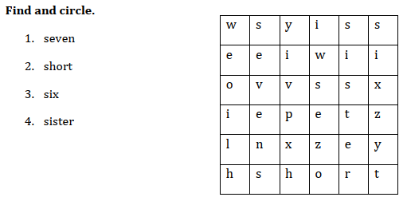  Ask sts to say them out loud. (individual, group, whole class work.  -Say goodbye | - Find and circle.  - Say the words out loud.  - Say goodbye.
_____________________________________
UNIT 1. FAMILY
Funtime and project : Task 1, 2
Period 18
I. OBJECTIVES:
1. Knowledge:
Students will review words related to family and the unit grammar.
2. Competences:
- English competences: Students will be able to write some words about family members, then describe a family member by using a photo or a picture.
- Common competences: Students will develop their cooperation ability in working in groups.
3. Qualities:
- Students will be responsible in doing their tasks, develop the love toward family.
II. EQUIPMENT AND MATERIALS:
- For Teacher: PP, TV, personal boards, flashcards…
- For students: A4 paper, books, pens, crayons, small boards, family pictures bring from home.
III. LESSON PROCEDURE:
Activity 1: Warm up and review (5 minutes)
Teacher’s activities | Students’ activities
- Greet students.  Sing Family song (track 1.11) to warm up and energize the class.  Review:  Game: Choose a star!  Teacher shows 6 stars in a living room. Each star will show a picture of a family member with unscramble letters. Sts choose a star to have a picture then write the words on personal boards.  Teacher checks the answer. Who can write it correctly will get points for the groups.  Example:  Lead in:  Introduce the lesson. | - Great teacher.  - Listen, sing and do actions.  - Some sts come to the board to sing and dance.  - Play the game and review the words of family members.  - Follow the teacher.
Activity 2: Game. Do the crossword (12 minutes)
Teacher’s activities | Students’ activities
- Watch a video clip about the family members.  - Say the family members word from slow to fast.  - Play the song in the video clip. Ask students to repeat after it. Play the recording and ask students to repeat what they hear. Then ask volunteers to read out the words on their own. | - Review through flashcard/ppt.  - Repeat the words/sentences  - Follow the teacher.  - Listen and repeat (whole class, group, individual).
• Tell the students that they are going to fill in letters to complete a crossword.  • Divide students into pairs or groups to do the crossword.  • Ask students to look at the example and then look at the clues and fill in the other words in order to find the word in yellow (Family).  • Praise or award a prize to the quickest pair or group with all correct answers | - Look at the the picturess.  - Follow the teacher.  - Pair work/group work  - Individual work/group work
Activity 3: Project: A family member. (18 minutes)
Teacher’s activities | Student’s activities
- Before the lesson, ask students to prepare and bring a photo of one of their family members to class.  - Tell students they are going to talk about one of their family members.  - Watch a video clip about a boy introducing his family.  - Tell students to look at the picture and the sample sentences. Read the sample sentences out loud and ask students to repeat after teacher.  - Elicit the picture by asking some questions:  - Who is this?  - Tell me about …  - Is he/she tall/short?  - Is he/she cool, great, funny?  - Ask students to take out the photo of a family member that they have prepared (or they can draw their own picture) and describe that family member.  - Put students in pairs or groups of three. Ask students to take turns to introduce and describe their family members to their peers.  - Ask volunteers to describe their family members to the whole class.  - Ask others to give feedback  - Give feedback at the end | - Prepare pictures from home  - Listen to the teacher  - Follow the teacher  - Take out the photo  - Pair/group work  - Individual work  - Individual work  - Listen to the teacher.
- Give comments, praise the sts.  - Say good bye. | - Say good bye.
_______________________________________________
REVIEW 1
Part 1. Task 1, 2, 3
Period 19
I. OBJECTIVES:
1. Knowledge:
- Students will review the words related to the topic numbers:1 – 10, colours: red, blue, black, green, white, orange, greetings: hi, hello, goodbye, bye, and commands: stand up, sit down, look at the board, come in, don’t talk, go out and structures: Hi./ Hello. I’m + name. Nice to meet you. How are you?. – I’m fine. Thank you. Bye./ Goodbye. What colour is it? – It’s + colour. How old are you? - I’m + number
2. Competences:
- English competences: Students will be able to talk about themselves, say and do some classroom commands, use long noun phrases with adjectives of colour and number...
- Common competences: Students will have the opportunity to develop communication among friends.
3. Qualities:
- Students will be responsible and well-behaved in communicating in the classroom with friends and others.
II. EQUIPMENT AND MATERIALS:
- Basic things: Student’s book, flashcards.
- Advanced things: PPT, projector/interactive whiteboard/laptop/TV.
III. LESSON PROCEDURE:
Warm up (5 minutes)
Teacher’s activities | Student’s activities
- Greet students  Game: Guess the colours  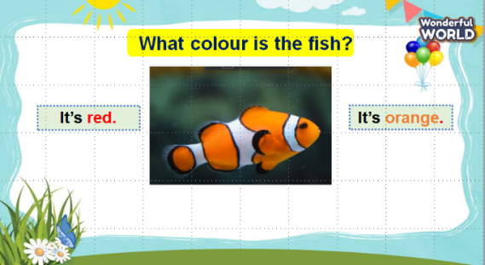  (Teacher shows a black and white picture. Ss have to guess what colour it is.)  - Divide the class into 4 groups  - Set the game rules.  - Ask students to look and guess.  - Award the best groups  1. What colour is this fish? - It’s orange.  2. What colour is this umbrella? - It’s pink.  3. What colour is this pencil case? - It’s blue.  4. What colour is this cat? - It’s grey.  Lead in: Use the pictures about colours lead in the new lesson. | - Greet teacher  - Sit in 4 groups.  - Listen to the game rules carefully  - Play game
Review (20 minutes)
Teacher’s activities | Student’s activities
Task 1: Count, write and say.  - Use the flashcards to review the vocabulary in the task: vans, ducks, ants, eggs, frogs  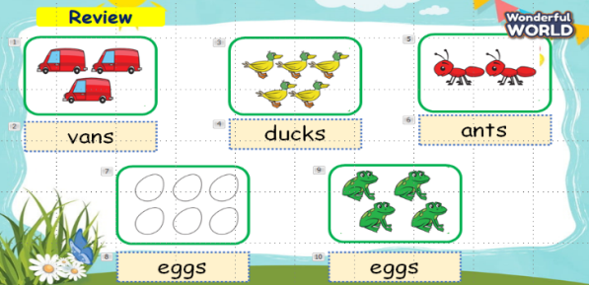  - Point to pictures in the book and say them one by one.  - Ask students to listen and repeat in chorus, and groups.  - Say a word for students to repeat, then point.  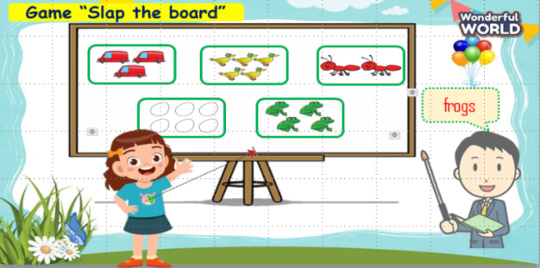  - Vocabulary checking: The teacher asks students to play a small game to check vocabulary. Students have to slap the picture which the teacher calls.  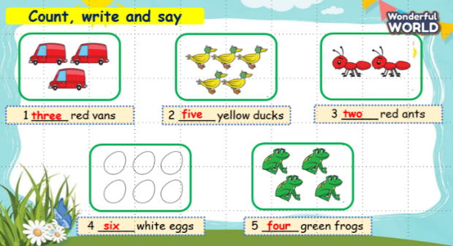  - Ask students to look at the pictures and count, then write numbers.  - Call students to answer.  1. three red vans.  2. five yellow ducks.  3. two red ants.  4. six white eggs.  5. four green frogs.  - Check answers and give feedback.  Task 2: Match and say  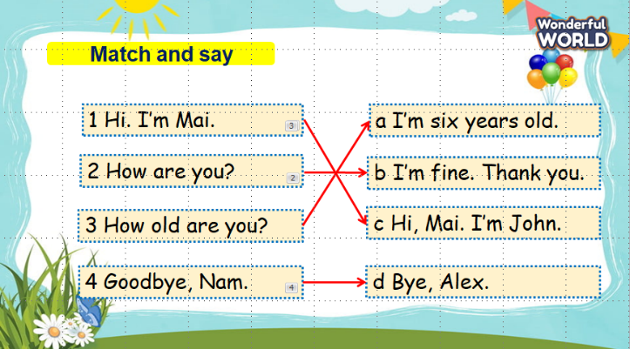  - Ask students to look at the 4 questions and 4 answers. Then T points and say aloud, students listen and repeat in chorus, groups.  - Ask SS to work in pairs and match the questions.  - Call some pairs to match.  1.c 2.b 3.a 4.d  - Check their answers and give them feedback.  Task 3: Write and say 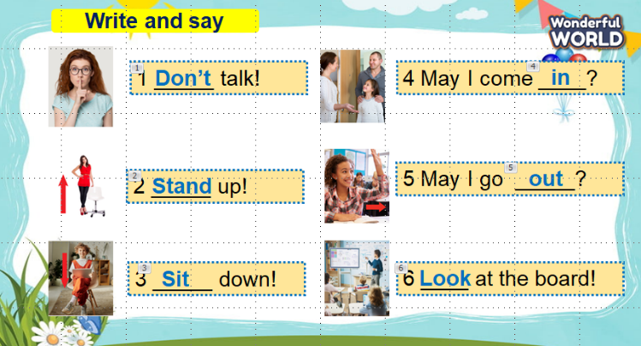  - Ask students to look at 6 pictures and call the names of the commands.  - Call students to fill in the blanks.  1. Don’t talk!  2. Stand up!  3. Sit down!  4. May I come in?  5. May I go out?  6. Look at the board!  - Check answers and give feedback.  Game: “ Doraemon puzzles”  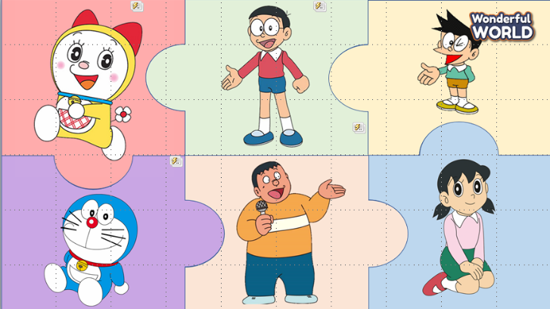  (There are 6 pictures of characters in Doraemon's story. Each picture is a puzzle piece. There is 1 treasure behind the puzzle pieces. Students choose one of the pictures and answer the questions to open the puzzle pieces. Students guess the name of Doraemon’s treasure after opening all the puzzle pieces.)  - Introduce and set game rules.  - Call Ss to choose a character and answer the questions.  1. duck  2. How old are you?  3. Look at the board!  4. insect  5. What colour is it? It’s black.  6. Sit down!  - Check answers and give feedback.  - Guess the name of Doraemon’s treasure. | - Review the words through flashcards.  - Listen  - Repeat the words  - Repeat then point.  - Join the game.  - Count and write.  - Answer T.  - Listen to T.  - Listen and repeat.  - Work in pairs.  - Answer T.  - Listen to T.  - Answer T.  - Answer T.  - Listen to T.  - Listen carefully  - Play games and answer T.  - Listen to T.  It’s a magic door
Extra activity (10 minutes)
Teacher’s activities | Student’s activities
- Introduce yourself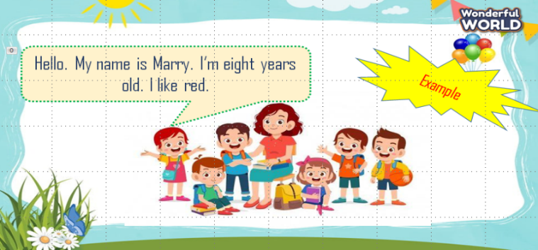  - Work in pairs and introduce themselves to their friends.  - Call some students to present in front of the class.  - Give feedback to them. | - Work in pairs.  - Present.  - Listen to T.
_______________________________________________
REVIEW 1
Part 2. Task 1, 2, 3
Period 20
I. OBJECTIVES:
1. Knowledge:
- Students will review the words related to the topic of family: grandma, grandpa, brother, mum, dad, sister, aunt, cousin, uncle, some adjectives: cool, great, short, tall, old, young, funny and the structure: This is my + noun. He/she is + adjective
2. Competences:
- English competences: Students will be able to introduce and describe their family.
- Common competences: Students will have the opportunity to develop communication among friends.
3. Qualities:
- Students are given opportunities to develop their love toward family.
II. EQUIPMENT AND MATERIALS:
- Basic things: Student’s book, flashcards.
- Advanced things: PPT, projector/interactive whiteboard/laptop/TV.
III. LESSON PROCEDURE:
Warm up (5 minutes)
Teacher’s activities | Student’s activities
- Greet students  Game: Amazing wheel  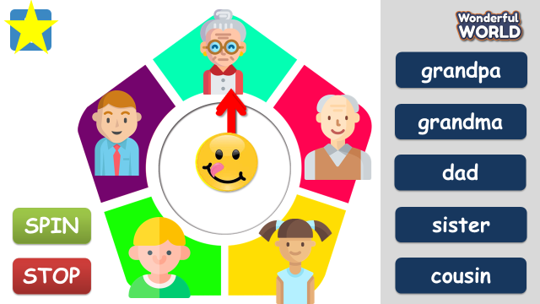  (There are 5 pictures and 5 words of family members. Teacher turns the amazing wheel. When the arrow points to a family member, students have to say it aloud and find the corresponding word.)  - Divide the class into 4 groups, choose a student from each team  - Tell students how to play.  - Ask students to look and say the word.  - Award the best groups | - Greet teacher  - Sit in 4 groups.  - Listen to the teacher carefully  - Play game  Suggested answer:  1 grandma  2 cousin  3 grandpa  4 dad  5 brother  6 me  7 uncle  8 aunt  9 mom
Review (20 minutes)
Teacher’s activities | Student’s activities
Lead in: Use the game to lead in the review lesson.  Task 1: Match  - Use the flashcards to review the vocabulary in the task: me, brother, uncle, sister, aunt and the structure This is my…  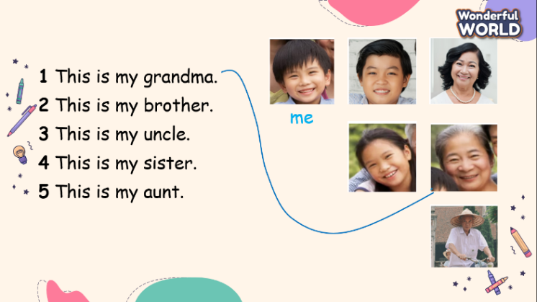  - Show 5 sentences in task 1 and ask students to read.  - Tell them to look at the pictures and to think carefully about the words in the sentences which will help them find the answers.  - Allow them enough time to complete the task alone.  - Check answers. Ask volunteers to point to a picture and read out their answers.  Task 2: Look and write  Game: Who’s faster?  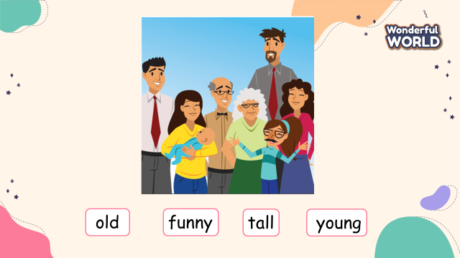  (Prepares 4 adjective cards: old, young, tall, funny. Groups look at the picture in task 2 on screen, discuss and stick the descriptive adjectives into the corresponding members in the picture on the board. Teacher shows the picture again and checks the answer in front of the class. Then awards the group with the most correct answer)  - Divide the class into 6 groups  - Set the game rules  - Hand each group 4 word cards  - Ask students to discuss and stick the descriptive adjectives into the corresponding members in the picture on the board.  - Show the picture again and check in front of the class  - Award the best groups  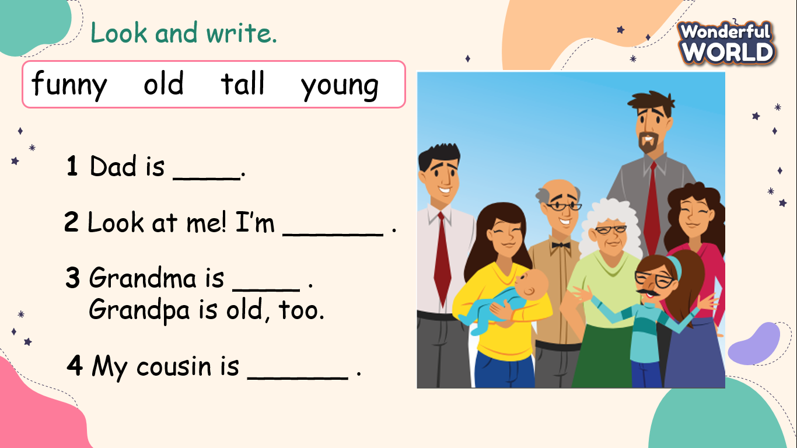  - Tell students to look at the picture and say what they can see.  - Ask students to say the sentences in task 2, using the words in the box  - Ask students to fill the missing words.  - Check answers. Ask volunteers to read out their answers as sentences.  Task 3: Look and say.  Rabbit and turtle game:  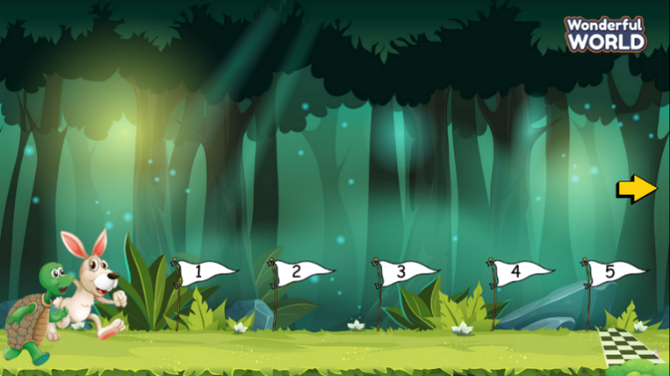  (Divide the class into 2 groups (rabbit and turtle). Set the context: Rabbit and turtle participate in a running competition. There are 5 questions. Students answer the questions. For each correct answer, the student goes forward 1 step. Who student can get to the finish line first will be the winner. )  - Tell students how to play the game  - Do as a model  - Ask students to answer the questions  - Have students look at the pictures, point and say in chorus, group, pairs  Suggested answers:  1 My dad is Jim. He’s cool.  2 My mum is Jane. She’s young.  3 My sister is Amy. She’s funny.  4 My grandma is Laura. She’s nice.  5 My grandpa is Tim. He’s tall. | - Review the words and structure through flashcards.  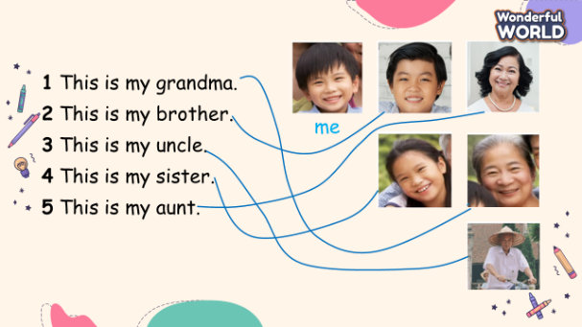  - Listen  - Repeat the words  - Repeat then point.  - Make 6 groups  - Listen to the teacher  - Receive 4 word cards  - Discuss and stick  - Check their answers  - Look and say  - Look and write  - Check their answers  Suggested answers:  1 Dad is tall  2 Look at me! I’m funny  3 Grandma is old  4 My cousin is young  - Listen  - Look carefully  - Join to the activity  - Look and say
Extra activity (10 minutes)
Teacher’s activities | Student’s activities
Look and write  - Ask Ss to look at the picture and write, using the structure: This is my… He/she is…  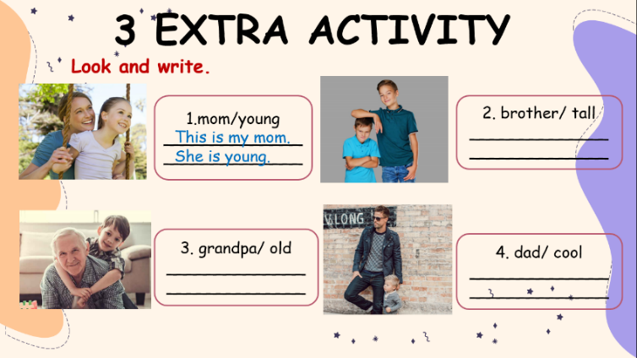  Talk about your family  - Work in pairs and talk about their family to their friends.  - Call some students to present in front of the class.  - Give feedback to them. | - Look and write  Suggested answers:  2 This is my brother. He is tall.  3 This is my grandpa. He is old.  4 This is my dad. He is cool  - Talk about their family to their friends  - Perform in front of the class
_______________________________________________

