WEEK 6
REVIEW 1
Part 3 – video. Task 1, 2, 3
Period 21
I. OBJECTIVES:
1. Knowledge:
- Review the vocabulary related to the topic family:
family, brother, mum, dad, sister, aunt, cousin, grandma, grandpa, uncle.
+ Review grammar:
- This is my …..
- My dad is…..
2. Competences:
English competence
- Students will introduce their family members confidently.
General competence
- Develop communication and collaboration skills through learning activities.
- Demonstrate problem-solving and critical-thinking skills through learning activities.
- Build up self-learning skills through learning activities.
3. Qualities:
- Build up pride in the family.
- Be always respectful and love the members of the family.
II. EQUIPMENT AND MATERIALS:
- For teacher
+ Basic things: Student’s book, teacher’s book,
+ Advanced things: PPT, projector/interactive whiteboard/laptop/TV
- For students: student’s book, workbook, paper.
III. LESSON PROCEDURE:
Warm up (10 minutes)
Teacher’s activities | Student’s activities
Greeting  Option 1:  - “Racing car” Game:  + Divide the class into two or four teams and each team will choose a random letter for the team.  + Ss in that team will say the word whose letters have to begin with the letter of the team  For example letter “B”: bee, brother, boy….  Option 2:  - for advanced facilities in class (internet, projector, TV, …)  - Listen and sing the song “Baby shark”  https://www.youtube.com/watch?v=j8z7UjET1Is | -Sing a song.
Review (15 minutes)
Teacher’s activities |  | Student’s activities
Task1:Tick the name of your family  - Read the instruction to the class.  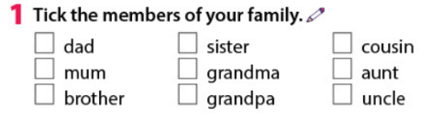  - Tell students to tick the members that they have in their family.  - Ask a volunteer to tell the lists to the class.  Task 2: Who can you see? Tick the people you see in the video.  - Remind Ss that they are going to watch a video about the family.  - Read the task and make sure Ss understand the task.  - Go through the answer or watch the video again if necessary. |  | - Ss will read the list of people in the task1.  - Tell the lists to the class.  - Tick the boxes as they watch through the video.  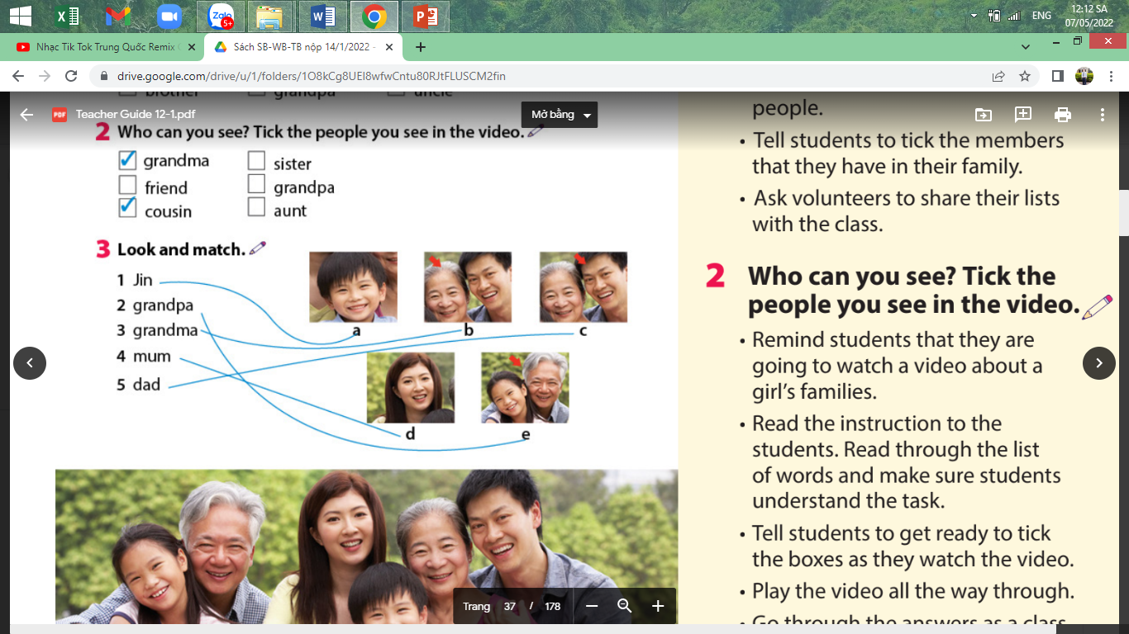
Review
Teacher’s activities |  | Student’s activities
Task 3: Match the picture  - Tell Ss to look at the pictures and the prompt. Explain to the students that they’re going to match the members of Jin’s family with their pictures.  - Read out the word 1 to 5 and ask students to repeat them after the teacher.  - Check the answer as the whole class.  - Game “Crack the brick”  + Each brick is a part of the picture. if the student guesses the answer as soon as possible that student will get many stars in the game |  | - Enjoy the game and receive stars for the team if he/she answers correctly.
Extra activity (10 minutes)
Teacher’s activities |  | Student’s activities
Task 1:Draw a picture.  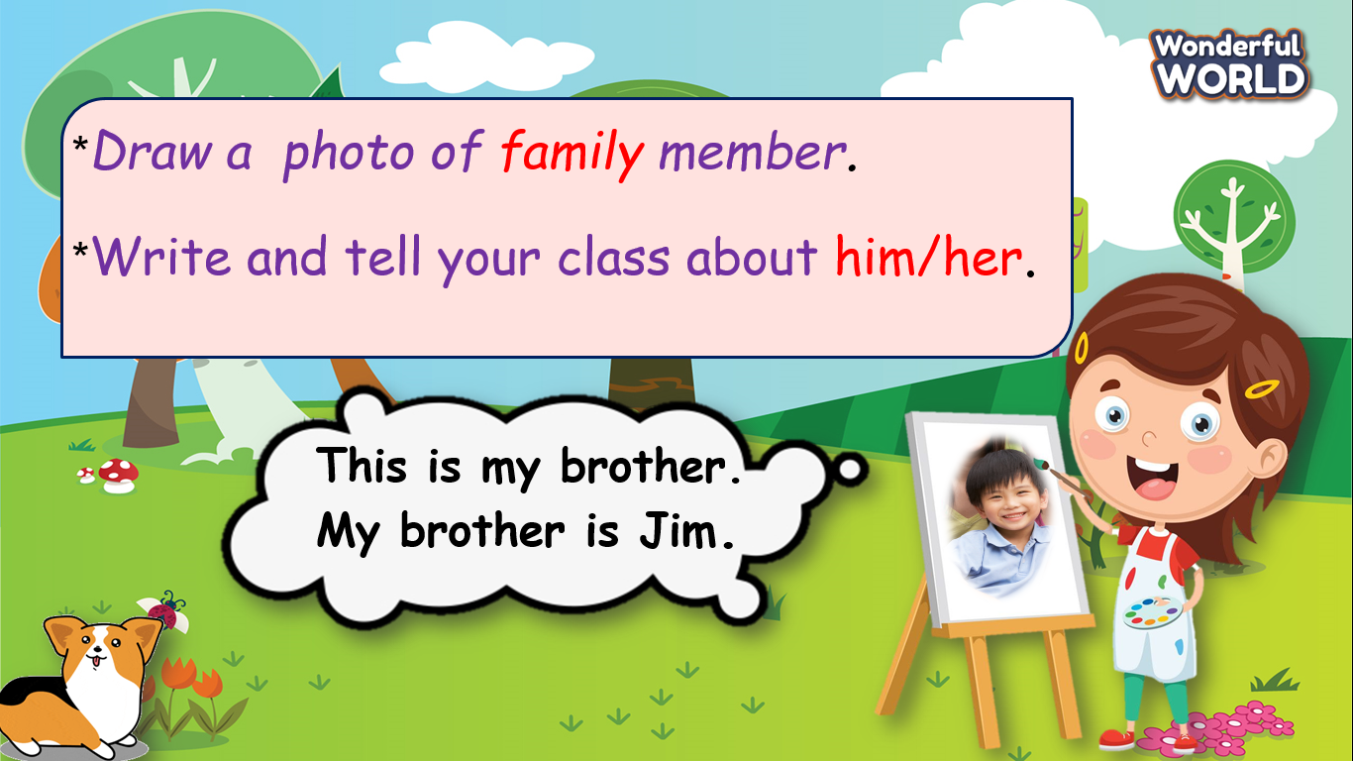  - Ask Ss to stand in front of the class and present the production. |  | - Prepare paper  - be confident and speak smoothly.
Extra activity (10 minutes)
Teacher’s activities |  | Student’s activities
-Task 2: Find and circle word  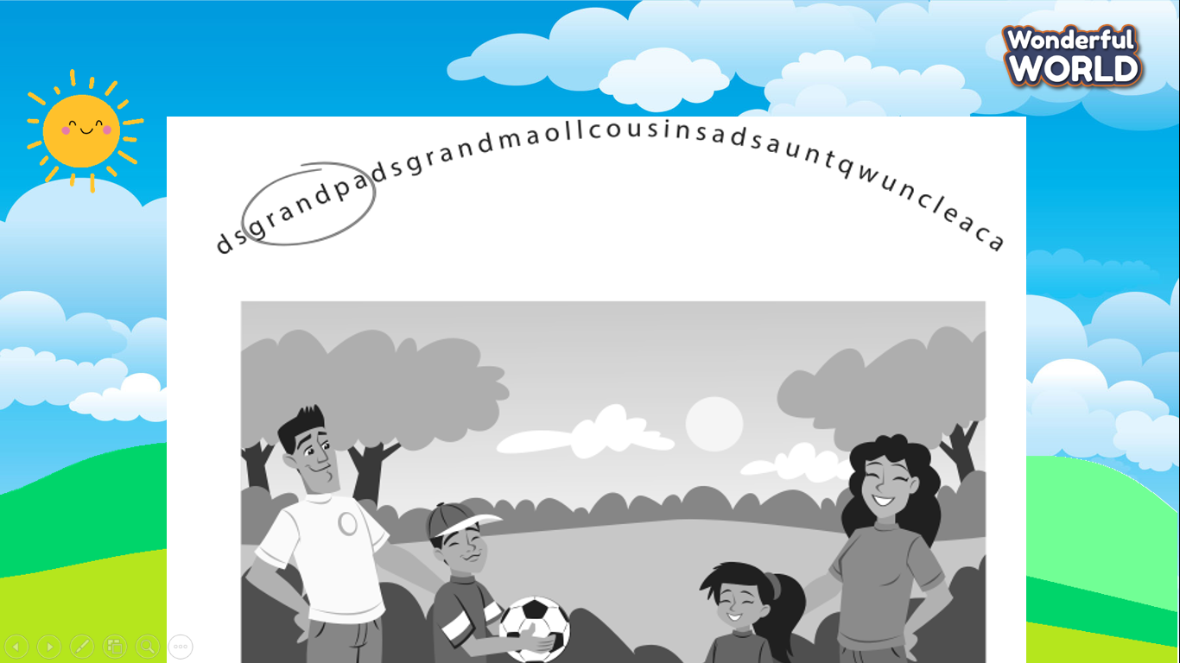  -Say goodbye. |  | *Answer key:  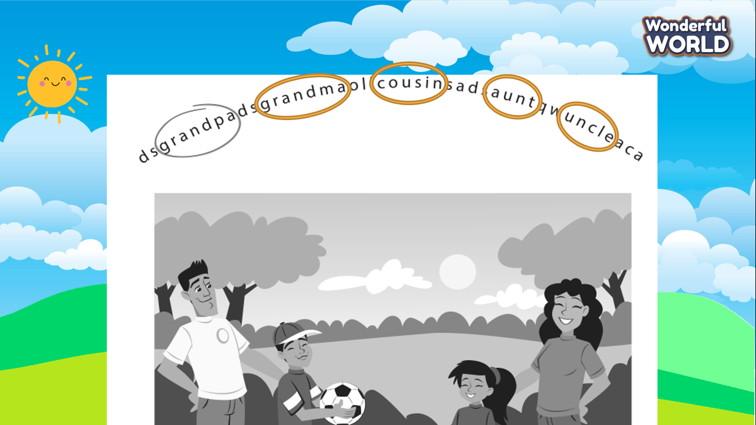  Circle the word.  - Look and read aloud.  -Say goodbye
_______________________________________________
REVIEW 1
Part 4. Task 1, 2, 3
Period 22
I. OBJECTIVES:
1. Knowledge:
- By the end of the lesson, students will be able to:
+ Review vocabularies about family members:
family, brother, mum, dad, sister, aunt, cousin, grandma, grandpa,,uncle f aunt, short, tall, old, young, funny
+Review grammar:
- This is my …..
- My dad is…..
- You’re / We’re / They’re….: short/tall/ old/ young/funny .
2. Competences:
English competence:
Sts can introduce about their family member, name, characteristic and appearance.
General competence:
- Raise motivation and interest in describing the family in English.
- Develop communication through presenting in front of the class.
- Build up self-learning skills through learning activities.
3. Qualities:
+ Build up pride in the family.
+ always respect and love the members of the family.
+ Be responsible for preserving the traditional lifestyle of the family from generation to generation.
II. EQUIPMENT AND MATERIALS:
- For the teacher:
+ Basic things: Student’s book, teacher’s book, Family flashcards.
+ Advanced things: PPT, projector/interactive whiteboard/laptop/TV
- For students: student’s book, workbook.
III. LESSON PROCEDURE:
Warm up (10 minutes)
Teacher’s activities | Student’s activities
- Greeting  Option 1:  - “Pass the ball ” Game:  + While the music is playing Ss will pass the ball around the class. When the music stops, the student with the ball must answer the question from the teacher about family.  Option 2:  Mini-game: Who’s missing?  - Show all the pictures of family members on the screen.  - Ask Ss to read.  - Ask them to close their eyes.  - Choose a student from each team and go to the board.  - Tell the rule and let children do a trial.  - Check children’s understanding. (If children can’t understand well, T can explain the rule in Vietnamese).  - T removes a family member and asks pupils to identify who is missing.  - The winner is who can say the correct member first. | - Pass the ball and answer questions  - Look at the picture of family members on the screen.  - Read the new words.  - Close the eyes.  - Volunteer to go to the board.  - Listen to the rule and do a trial.  - Listen  - Join the activity.
Review (20 minutes)
Teacher’s activities | Student’s activities
. Task1: Brainstorm: Bring a family photo to class. Use one word to describe each person.  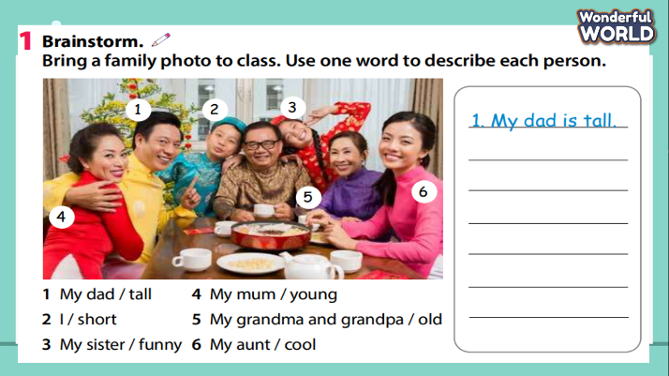  - Read the instruction to the class.  - Ask Ss to use one adjective to describe each person in the family.  - Look at the picture in the book and given words in the task to write a complete sentence.  - Go round to help Ss.  - Check the answer. | - Do the task and receive stars.  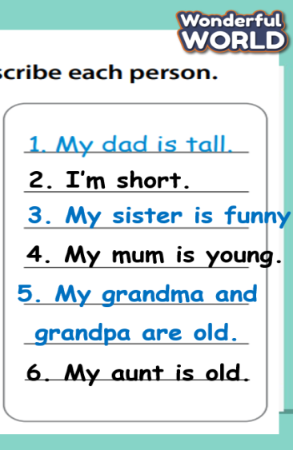
Review
Teacher’s activities | Student’s activities
- Play the game: “ Cross the river”  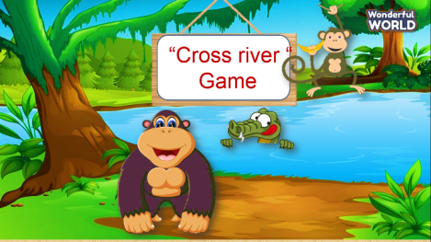  + T prepares 10 question slides to relate to the knowledge from previous lessons and asks students to answer.  + If Ss answer correctly, they will help the monkey cross the river and Ss receive stars for this question. | - Join the game and get stars for the team.
- Task 2: Write and talk about your family.  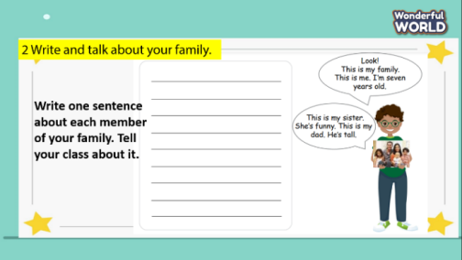  + Ask Ss to write one sentence about each member of your family.  + Invite a few Ss to go to the board to present.  - Assess each presentation of Ss and give them stars. | - Be confident and present smoothly.
Extra activity 5 (minutes)
Teacher’s activities | Student’s activities
-Task 1: Fill in the blank.  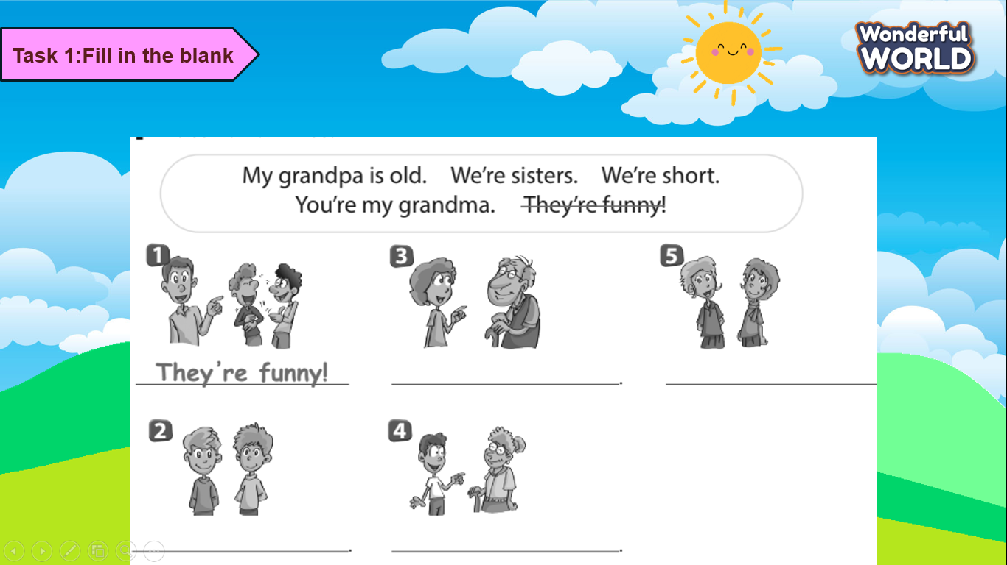  - Say goodbye. | -Do the task  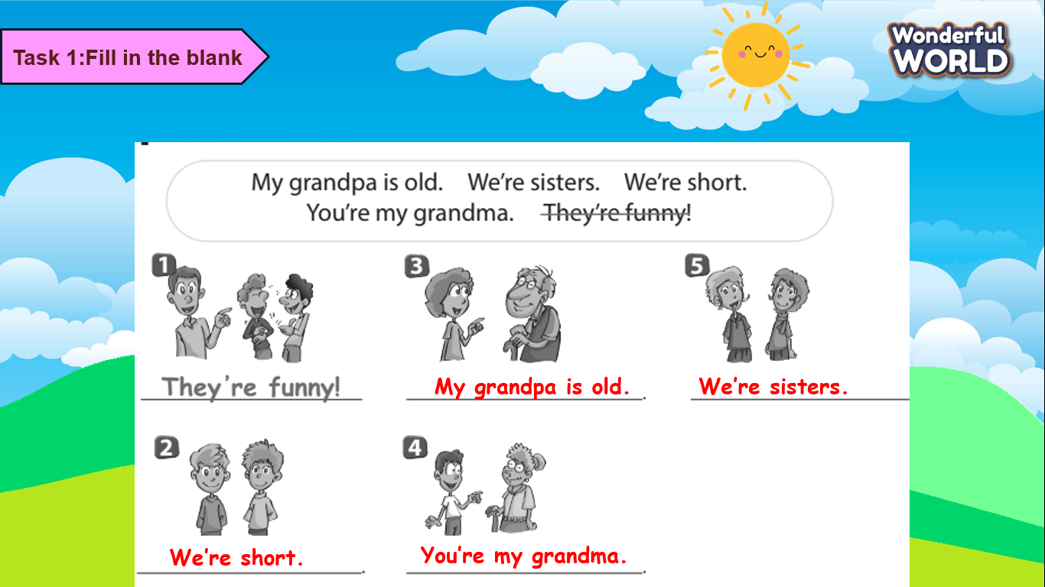  - Check with friends and then with the teacher and the whole class.  - Say goodbye.
_______________________________________________
UNIT 2. MY SCHOOL
Lesson 1. Task 1, 2, 3
Period 23
I. OBJECTIVES:
1. Knowledge:
Students will be able to use the words related to the topic School: classroom, lesson, homework, teacher, student and review the structure This is…
2. Competences:
- English competences: Students will be able to introduce their school
- Common competences: Students will have opportunity to develop the autonomy in doing tasks and communication among friends.
3. Qualities:
- Students will be friendly and confident in communicating with friends.
II. EQUIPMENT AND MATERIALS:
- For Teacher: PP, TV, flashcards, music, audio track 2.1, track 2.2
- For students: pictures, colour tags, personal board, marker, handout
III. LESSON PROCEDURE:
Activity 1: Warm up (5 minutes)
Teacher’s activities | Student’s activities
Game: Best Mind Game  (Prepares some different colour tags. Groups look at the UO picture on screen in 10 seconds, discuss and stick the colours that appear in the picture on the board. Teacher shows the picture again and checks the answer in front of the class. Then awards the group with the most correct answer)  - Divide the class into 6 groups  - Set the game rules  - Hand each group some colour tags  - Give sts 10 seconds look at the UO picture  - Ask sts to discuss and decide what colours there are in the pictures  - Ask groups to stick the colours on the board  - Show the UO picture again and check in front of the class  - Award the best groups | - Sit in 6 circles  - Listen to the game rules carefully  - Receive picture and tags  - Play game  - Read aloud the answer
Activity 2: Presentation (8 minutes)
Teacher’s activities | Student’s activities
Lead-in: Use the game and the Opener picture to lead in the topic: My school  Task 1: Listen and point. Repeat. (Track 2.1)  - Create a story to introduce vocabulary. (A new friend visits your school today. You’re his/ her tour guide to show him/her around the school. You will introduce classroom, lesson, homework, student, and teacher to the friend in turn)  - Play the words one by one  - Play the track 2.1, ask students to listen and repeat in chorus, groups.  - Put the 5 flashcards in 5 different corners around the room.  - Say a word/sentence for sts to repeat then point  - Vocabulary checking:  Ask 5 students to hold the flashcards each  Stand behind and point to one st  Ask class to say the word aloud, the st holding the picture with that word will raise the picture. | - Learn new words and structures through story and pictures  - Repeat the words/ sentences  - Repeat then point.  - Repeat.  - Hold the pictures and stand face to the class  - Say aloud the word  - Raise the picture high
Activity 3: Practice (12 minutes)
Teacher’s activities | Student’s activities
Task 2: Listen and tick (5 minutes)  - Lead-in: Introduce the listening task  - Show the picture in task 2  - Ask sts to look at the picture and answer:  Where are the people in the picture?  How many people are there?  Who is this?  - Ask sts to read and guess the answer before listening:  This is my Mum.  This is my student.  This is my teacher, Mrs Lee  - Play track 2.2 twice for sts to give the answer  - Play the audio again and ask sts to do cross- check  - Show the bubble  - Help sts remember the content in the listening task  - Show the content one by one and ask sts to repeat  - Play role  - Three pairs perform in front of the class  - Give comment after each performance  Task 3: Write. Point and say (7 minutes)  Writing Game  - Introduce and set game rules  - Have sts play in pairs  - Do a demo  - Give sts time to play  (Sts choose a colour. Then write the missing words as fast as possible on their personal board. When they have finished, raise the board and say aloud the word. The first finished pair will get the star)  Point and say  - Show the pictures and the words randomly  - Ask sts to point and say, “This is my ….”  - Divide the class into 6 groups  - Hand each group a set of pictures: students, teacher, classroom, lesson, homework  - Do a demo  - Play Music and give sts time to play | - Listen to the listening instruction carefully  - Look at the picture  - Read and give answers  - Listen to the audio and tick the answer  - Do cross-check  - Read aloud the sentences  - Listen and repeat  - Play role  - Perform the dialogue with a peer  - Listen carefully  - Look at the demo carefully  - Choose a colour  - Look and write the answer  - Raise the board and say the word aloud  - Point and say “This is my …”  - Sit in groups  - Listen to music and pass the pen to a friend  - Pick up a picture and say “This is my…”
Activity 4: Production (7 minutes)
Teacher’s activities | Student’s activities
Stick and say  - Give sts a handout  This is my school  - Ask sts to draw a picture under each sentence  Give sts 2 minutes to move around and say about their school | - Receive handout  - Draw the pictures  - Go around and say
  This is my… | This is my… | This is my… | This is my… | This is my…
Activity 5: Assessment (3 minutes)
Teacher’s activities | Student’s activities
- Ask sts to do the assessment  Look, read and write  - This is my ………   - This is my ………   - This is my ………   - This is my ………   - This is my ………   - Check in pair then whole class.  - Say goodbye | - Do the assessment.  - Check with friends and then with teacher and whole class.  - Say goodbye.
________________________________
UNIT 2. MY SCHOOL
Lesson 1. Task 4, 5, 6
Period 24
I. OBJECTIVES:
1. Knowledge:
Students will learn the sentence pattern: It’s …/ He’s …/ She’s …and review vocabulary classroom, lesson, homework, teacher, student
2. Competences:
- English competences: Students will be able to introduce their school using.
- Common competences: Students will have opportunity to develop the creativeness in making school poster and communication among friends.
3. Qualities:
- Students will be helpful and proud of their school in working with friends.
II. EQUIPMENT AND MATERIALS:
- For Teacher: PP, TV, flashcards, music, audio track 2.3, vocabulary box, pictures, 5 sentences
- For students: Pen, pencils, crayons, A4 paper
III. LESSON PROCEDURE:
Activity 1: Warm up (5 minutes)
Teacher’s Activities | Students’ Activities
Rock-Scissors-Paper Game  (Create 5 pictures and 5 words hidden behind 10 numbers. Sts play in 3 teams, teams take turn to Rock, Scissors, Paper. The winner takes a chance to open a pair of number. If the pair matches the meaning with each other and Team’s members can say the word correctly in chorus, that team gets the point)  - Split sts into three teams  - Have teams vote for a leader each  - Give instructions and set the game rules  - Do a demo in front of the class  - Let teams time to play the game  - Present points for the matching pairs  The team with highest point will be the winner | - Sit in teams  - Choose the team leader  - Listen to the rules carefully  - Watch the demo carefully  - Play “Rock-Scissors-Paper”  - Choose a pair of number  - Say aloud the correct word
Activity 2: Presentation (10 minutes)
Teacher’s Activities | Students’ Activities
Lead-in: Tell the sts they’re going to visit an international school. To get the ticket to the entrance they must listen to a track and match the correct sentence with the picture.  Task 4: Listen and repeat  - Divide the class into groups  - Give instruction: To get the entrance ticket, you must match the sentences that you hear with the correct pictures (Note: There are two pictures left, you just need to match the sentences that you hear)  - Hand each group a set of 5 pictures and 5 sentences  - It’s a classroom.  - It’s a lesson.  - It’s a school.  - She’s a teacher.  - He’s a student.  - Play track 2.3 twice and let sts time to match  - Ask groups to do cross-check  - The correct answers will get the tickets to visit the school  - Ask sts to listen to the audio again and repeat in chorus, in groups  - Ask sts to elicit the meaning of It’s/ He’s/ She’s  - Make sure the meaning by checking | Listen to the teacher carefully  - Sit in groups  - Listen to the instructions carefully  - Place the pictures and the sentences on the table  - Listen to the audio  - Match the sentences to the correct pictures  - Listen and repeat in chorus, in groups  - Say the meaning of It’s/He’s/ She’s
Activity 3: Practice (10 minutes)
Teacher’s Activities | Students’ Activities
Task 5: Point and say  Super-Hero Team  (sts can play in whole class or in groups. Set context that you’re a special member of Super-Hero Team, you help the police to catch the thief that entered your school yesterday. Sts take turn to choose the team’s leader. The game are playing game by answering each question behind the number.  1.It’s a school.  2. He’s a teacher.  3. It’s a classroom.  4. It’s a lesson.  5. He’s a student.  6. She’s teacher.  After solving 6 questions, you win the thief.)  - Set context  - Give game instruction  - Ask sts to choose the team’s leader  - Let time for sts play the game  - Award the winner  Extensional activity: Miming Game  (before the class, teacher prepares flashcard, words or slide. Sts play in groups. One speaker from each group comes to the front and stand face to face to the class. T shows the picture/ word, group members try to mime, the speaker says aloud the sentence. The first player to say correct sentence gets the point.  Change the role of speaker: Before class, cut out a bunch of pieces of paper that have a word on them (make sure they are words the students will know) screw them up and put them in a bag. take it in turns choosing a student from each team and have them pick a vocabulary word from the bag, the student has to then act out the word without making any sounds, the first team to guess the sentences gets the point)  - Split sts into 3 big teams  - Set the game rules  - Do a model  - Give sts time to play the game  - Change the role of speaker to the class after some times  - Award the winner | - Listen carefully to the game instruction  - Choose your favourite team’s leader  - Play game  - Sit in teams  - Listen to the rules carefully  - Look at the model  - Take turn to play the game  - Mime  - Say aloud the answer-
Activity 4: Production (9 minutes)
Teacher’s Activities | Students’ Activities
Draw and say  Sts take time to draw their school  Icebreaker  (Arrange sts to stand in two lines face to face with each other. Tell them the line on the right is the school owner, the opposite line is the visitor. Teacher sets the time 30 seconds for each mini school introduction of school owner. After 30 seconds, the players move one step to the right. The two players standing in each first line move to the opposite line and swap the role. Continue the activity)  - Arrange sts to stand face to face in two lines  - Introduce the activity  - Do a sample  - Let sts time to talk  - Ask sts to move after 30 seconds | - Stand in line  - Listen to the teacher carefully  - Watch the sample  - Talk and listen to the partner  - Move as the instruction
Activity 5: Assessment (3 minutes)
Teacher’s Activities | Students’ Activities
-Ask sts to do the assessment  Look, read and circle the correct answer  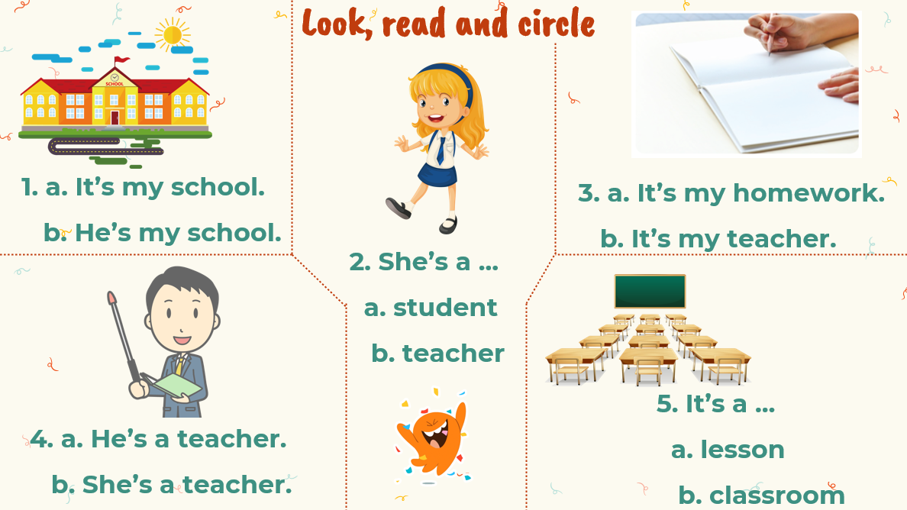  - Ask sts to check in pairs then whole class  - Goodbye | - Do the assessment  - Check in pairs then check with the teacher  Answer:  - A  - A  - A  - A  - B  - Say “Goodbye.”
________________________________

