WEEK 8
UNIT 2. MY SCHOOL
Lesson 3. Task 4, 5, 6
Period 29
I. OBJECTIVES:
1. Knowledge:
Students will learn the structure Are you …?/ Are they…? and review words related to the topic school.
2. Competences:
- English competences: Students will be able to ask and answer about their school
- Common competences: Students will have opportunity to develop communication in working with friends
3. Qualities:
- Students will be benevolent in adapting concept about Alien
II. EQUIPMENT AND MATERIALS:
- For Teacher: PP, track 2.11, Word set, 6 bells, worksheet
- For students: student books, notebooks, pens.
III. LESSON PROCEDURE:
Activity 1: Warm up (5 minutes)
Teacher’s Activities | Students’ Activities
Game: Penguins find the way home  Arrange sts to play in 8 groups. Teacher hands each group a set of vocabulary: pen, pencil, book, rubber, ruler, student, teacher, clock. There are 8 little penguins hanging out far away from home. They play happily on ice with each other. It’s getting dark, however; they can not remember the way home. Please help each penguin find the way home by press on each penguin’s picture, answer the question behind. Sts look at the picture on screen and as fast as possible pick up the equivalent word and group says it aloud. If the answer is correct, you save that penguin.  Set sts as 8 groups  Give game instruction  Hand each group a set of words  Choose a penguin to play as a demo  The first correct team will get a chance to choose the next penguin  Award the winner that has highest score | -Sit in 8 circles  - Listen to the teacher  - Receive the words  - Watch the demo carefully  - Choose a penguin to save  - Pick up the word and say it aloud
Activity 2: Presentation (8 minutes)
Teacher’s Activities | Students’ Activities
Task 4: Listen and repeat  -Set context: Your Alien wants to visit your school on earth. However, he doesn’t know any things about it. He asks you so many questions whenever he meets anyone or anything. Guess what he asks. Then listen and check the question. How you answer.  - Show the picture one by one  - Ask sts to guess the Alien’s question  - Show answer with audio sound  - Sts repeat the questions  - Ask them to answer the Alien  - Show answer to check  - Ask sts to repeat  - Continue until the end of the four pictures  Checking: Play role  - Divide class into 2 big groups  One group will take a role of an Alien and one will be school teachers/ students  - Let sts Tick-tac-toe to choose their favourite role  - Fix the role duty: alien asks, the other answers  - Ask sts to play in 2 big groups several times  - Have pairs ask and answer  - Stick star on the board for each team after a correct asking and answering  - Explain the grammar point:  Are you …?/ Are they ..  I’m not = I am not  aren’t = are not | - Listen to teacher  - Look at the picture and guess the question one by one  - Listen and check  - Give response to Alien’s question  - Listen and check. Then repeat  -Tick-tac-toe  - Play role  - Ask and answer in groups  - Ask and answer in pairs  - Listen and make notes on lesson grammar points
Activity 3: Practice (14 minutes)
Teacher’s Activities | Students’ Activities
Task 5: Point and ask  Ring the Bell Game  -Split sts into 6 teams. Give each team a bell to ring.  Teacher shows the pictures of: 1. teacher, 2. Students, 3. rubbers, 4. chairs, 5. pencils, 6. books, 7. pens, 8. rulers on the board at a time.  - Show the phrases one by one:  1.you/teacher  2. they/ books  3. they/ students  4. they/chairs  5. they/ pencils  6. They/ clocks  7. they/ pens  8. they/ rubbers  - Sts look at the words and the number on each picture  - Ring the bell to take the opportunity to ask the question  - The first ringing bell asks questions. Others answer  - Have sts continue playing  - Give 5 points for each correct questions, 3 points for a correct answer  - Award the winner  Look, ask and answer  Show the picture in task 5 with some changes on it  Ask sts to work in pairs  Hand them a set of words  1.you/teacher  2. they/ books  3. they/ students  4. they/chairs  5. they/ pencils  6. They/ clocks  7. they/ pens  8. they/ rubbers  9. they/rulers  - Ask pairs to play Rock-scissors-paper.  - The winner picks up the words and asks. The other answers.  - Go around to help when needed  - The person gets most words win the game | - Form 6 teams  - Get the bells  - Look at the pictures and numbers carefully  - Look at the words  - Ring the bell to take answer chances  - Look at the picture, numbers on things carefully  - Receive the words  - Play rock-scissors-paper  - Ask-answer-keep those words as private
Activity 4: Production (9 minutes)
Teacher’s Activities | Students’ Activities
Task 6: Let’s talk  Miming Game  -Ask sts to work in pairs  - Have one st act out as school things  - The other guesses by asking question: are they …?  - The actor answers Yes, they are/ No, they aren’t.  -Change the role after 2 minutes  - The one guesses most things correctly in time gets stickers from teacher | - Work in pairs  - Act  - Ask question  - Answer Yes/ No  - Change the role
Activity 5: Assessment (3 minutes)
Teacher’s Activities | Students’ Activities
-Ask sts to do assessment  Look, read and circle  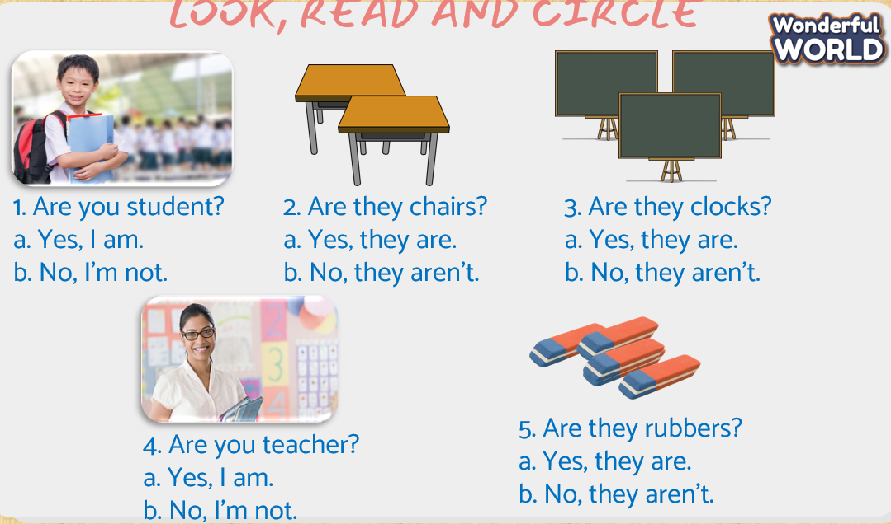  - Check with whole class  - Say goodbye | - Do assessment  - Check with teacher  Answer  1. a  2. b  3. b  4. a  5. a  - Goodbye
________________________________
UNIT 2. MY SCHOOL
Lesson 3. Task 7, 8, 9
Period 30
I. OBJECTIVES:
1. Knowledge:
Students will learn how to pronounce properly the sound /k/ and /u/ separately or in words.
2. Competences:
- English competences: Students will be able to pronounce words with sound /k/ and /u/ in normal saying.
- Common competences: Students will have opportunity to develop language skill in working with friends
3. Qualities:
- Students will be hard-working in their self-study
II. EQUIPMENT AND MATERIALS:
- For Teacher: PP, 6 sentences, magnets, worksheet
- For students: pens, piece of paper
III. LESSON PROCEDURE:
Activity 1: Warm up (5 minutes)
Teacher’s Activities | Students’ Activities
School things song  - Introduce the song  - Ask sts to copy some actions from the dance:  Pick up, write your name, put down, touch  - Play the video  - Sts listen, do action along | - Listen to the introduction  - Do actions  - Look and dance
Activity 2: Presentation (8 minutes)
Teacher’s Activities | Students’ Activities
Task 7: Listen and repeat  -Set context: a Pirate wants to move on land. While moving, he’s got hiccups. So he releases a very strange sound /k/,/k/,/k/ (play video of /k/ sound, three times, let sts repeat the /k/ sound. If he keeps making hiccups, police will recognize him on land. Can you guess how he controls the hiccups (sts guess…) He makes a very cool sound. Play the video of /u/ sound for sts to listen and repeat several times  - Split sts into two big groups.  - Ask one group to pretend the hiccupped pirate and one is controlled pirate  - Guide sts to take turn imitate the /k/ and /u/ sound correctly to save the pirate on land.  The pirate brings lots of things in his suitcase on land. (Let sts guess which things he brings). Open the suitcase and take out: desk, clock, book, toy duck, all of them are black.  - Ask sts to listen to the sound of things ad repeat. Pay attention on /k/ sound. He wants to go to some places on land. (Have sts guess the places)  - Show the picture school, classroom with desks in turn with sound for sts to listen and repeat.  - Ask sts to look at the desks in the classroom  - Ask how the desks are  - Play audio: The desks are cool  - Ask sts to listen and repeat  - Checking:  - Look and match. Then say the sounds and words to friends  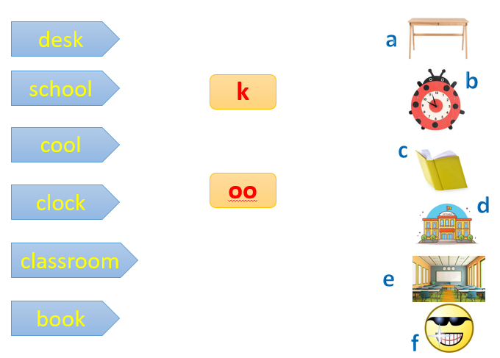 | - Listen to teacher  - Guess the sounds  - Listen and repeat the 2 sounds  - Form 2 groups  - Pretend to be the pirate and imitate the sounds  - Guess the things  - Look, listen and repeat  - Guess the places  - Look, listen and repeat  - Check  Answer:  Desk k a  School oo d  Cool oo f  Clock k b  Classroom oo e  Book k c
Activity 3: Practice (14 minutes)
Teacher’s Activities | Students’ Activities
Task 8: Listen and chant  - Show the picture to set context: the pirate has come to visit a classroom and saw a lot of amazing desks. When looking at the desks he said… (ask sts what he said)  - Show the first part of the chant one by one  K k k!  Desk, desk,desk  They’re desks.  - Ask sts to look at the desks and ask how they are (sts guess: they’re brown, funny,nice, cool.._  - Show the rest part:  Oo, oo, oo  Cool, cool,cool!  They’re cool.  They’re desk. And they’re cool.  - As showing, ask sts to listen, read and repeat  - Play the chant one for sts to listen  - Play again, ask sts to listen and chant along  - Have chant contest in groups, in pairs  Task 9: Look and say  Stick the board game  Teacher prepares some sentences:  1. The clocks are black.  2. My school is cool.  3. The desks are in the classroom.  4. The books are red  5. The boards are cool  6. Look at the clock.  - Ask sts to work in 4 groups  - Give instruction: T shows the pictures on the screen, and you look at the pictures, pick up the right sentence and stick on the board as fast and possible. Read that sentence aloud and you get the point.  - Show pictures one by one  - Ask sts to pick up the equivalent sentence and stick on the board.  - Ask groups to read the sentence out loud  - Give groups points  - Award the team with most point at the end  Name game:  - Hand each group the set of pictures in Stick the board game  - Ask sts to write their name on a piece of paper and put it in a box  - Sts in turn choose a name, pick a picture and say the sentence.  - Provide help when needed | - Look at the picture  - Listen to the teacher  - Guess what he says  - Listen and repeat  - Look at the picture and say how the desks are  - Listen and repeat  - Listen to the chant  - Listen and chant  - Join chant contest  -Form groups  - Listen to teacher  - Look at the pictures  - Pick the equivalent sentence  - Run to the board and stick  - Read the sentence out loud  - Receive pictures  - Write your name  - Choose a name  - Pick a picture  - Say the sentence
Activity 4: Production (9 minutes)
Teacher’s Activities | Students’ Activities
My Phonics Corner  - Ask sts to work in groups  - Ask them to discuss and make their own wordlist  -Groups take turn to say out loud the words content k or oo sound. The group having most words wins the game. | - Sit in groups  - Discuss and write words  - Say words aloud
  k | oo
Activity 5: Assessment (3 minutes)
Teacher’s Activities | Students’ Activities
- Ask sts to do assessment  - Look and circle the correct sound  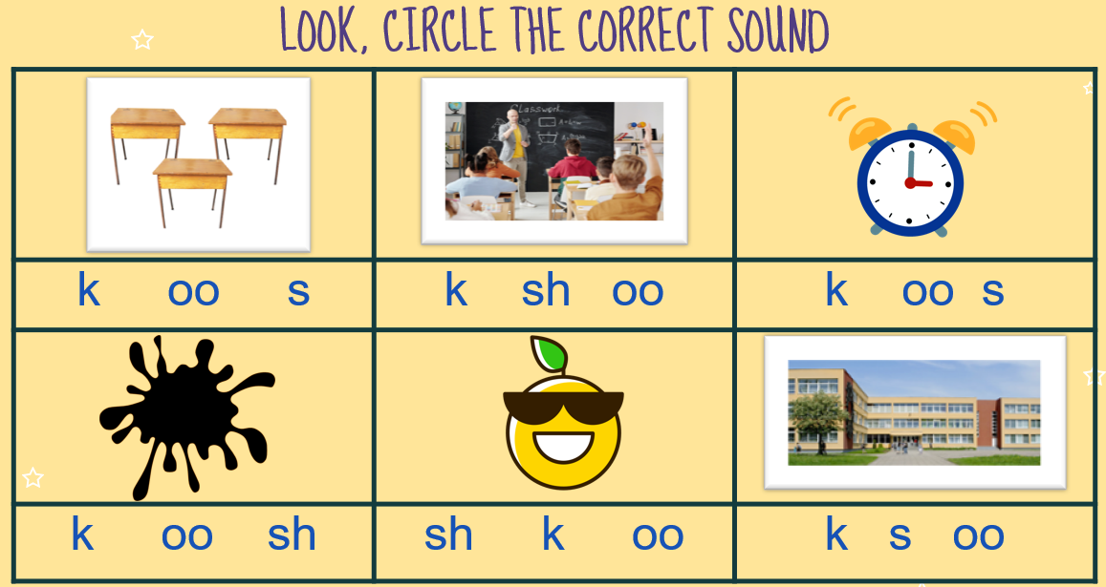  - Check with whole class  - Say goodbye | - Do assessment  - Check with teacher  Answer  1. k  2. oo  3. k  4. k  5. oo  6. oo  - Goodbye
________________________________
UNIT 2. MY SCHOOL
Funtime and project: Task 1, 2
Period 31
I. OBJECTIVES:
1. Knowledge:
Students review all vocabulary and grammars about school
2. Competences:
- English competences: Students will be able to talk about their classroom confidently
- Common competences: Students will have opportunity to develop creativeness skill in drawing picture of their dream classroom
3. Qualities:
Students will have opportunity to think about their classroom therefore increasing sts’ awareness of keeping it nice.
II. EQUIPMENT AND MATERIALS:
- For Teacher: PP, flags, stickers
- For students: pens, crayon, A4 paper,
III. LESSON PROCEDURE:
Activity 1: Warm up (5 minutes)
Teacher’s Activities | Students’ Activities
Lucky Money Game  - Show an animate picture about Tet. Ask sts what do they like about Tet.  - Arrange sts to form 6 groups  - Give instruction: Choose a red envelop, look at the picture and raise flag to have chance make sentence with it. The acceptable answer can have the amount of money behind the picture.  - Hand each group flags  - Choose a red envelop to play as a sample  - Have groups play game  - Write the amount of lucky money for each group on the board | - Listen to teacher  - Share ideas  - Form 6 groups  - Listen to the instruction  - Get the flag  - Choose a red envelop  - Play the game
Activity 2: Practice (10 minutes)
Teacher’s Activities | Students’ Activities
Task 1: Game: Find and circle  - Show the platform of the task  - Set context: You’re going to have Tet festival at school. To get the ticket for the festival, you have to solve the puzzle as fast as possible. Then read the hidden words out loud. The first team that finish wins the ticket.  - Ask sts to work in groups  - Give game instruction: look at the picture, circle the equivalent words  - Give sts time to play the game  - Have sts do cross-check  - Check with whole class by saying words aloud  - Award the fastest team with most correct answer | - Listen to teacher  - Form groups  - Listen to the game instruction  - Look and circle  - Do cross check  - Check with teacher by saying aloud  - Get award ticket
Activity 3: Project (20 minutes)
Teacher’s Activities | Students’ Activities
Introduction: You are going to be the school head teacher. But before taking that very important position, you have to show your talent to the School Council. Your duty is to design your dream classroom.  Vocabulary preparation  - Ask sts to list the things to put in dream classroom  - Share some ideas with whole class using:  It’s a…  He’s a..  She’s a…  They’re ..  - Ask sts put their things in classroom frame  - Draw the dream classroom | - Listen to teacher  - List things to put in dream classroom  - Share with friends  - Decide where to put things in the classroom  - Draw your dream classroom
School’s got talent  -Ask sts to move around to talk about their dream classroom in 3 minutes  - Vote for a School Council  - Choose Sts’ names in random to present their dream classroom to the School Council  - Vote for the best presenter  - Award the new school head teacher | -Talk about your dream classroom  - Talk in front of School Council  - Vote for the best speaker
Goodbye Song  https://youtu.be/Xcws7UWWDEs  - Ask sts to stand up  - Ask them to do some actions as in the song  - Play the song  - Sts sing and do actions | - Stand up  - Look and copy actions  - Listen, sing and do
________________________________
UNIT 3. ANIMALS
Lesson 1. Task 1, 2, 3
Period 32
I. OBJECTIVES:
1. Knowledge:
Students will learn words related to animals: bird, cat, dog, fish, rabbit and review the structure It’s…
2. Competences:
- English competences: Students will be able to introduce some animals as pets properly
- Common competences: Students will have opportunity to develop creativeness in drawing their favourite animals
3. Qualities:
- Students will be benevolent with animals
II. EQUIPMENT AND MATERIALS:
- For Teacher: PP, flashcards, handout, track 3.1, track 3.2
- For students: pens, A4 paper, crayons,
III. LESSON PROCEDURE:
Activity 1: Warm up (5 minutes)
Teacher’s Activities | Students’ Activities
Animals song
https://youtu.be/CT86Dl442jA
Ask sts to watch and copy the actions for fun
What is the song about?
Show tranh Unit Opener
Ask: What animal is it? (Funny burrowing owl)
Ask:
What animals do you like?
What colour is your favourite animal?
Ask sts: look at the UO and tick the colours you see
Check answer with whole class
Activity 2: Presentation (8 minutes)
Teacher’s Activities | Students’ Activities
Task 1. Listen and point. Repeat  Tomas’ Zoo  Set context: Tomas family has opened a mini zoo in the garden named: Tomas’ Zoo. There are a lot of animals in his zoo. They are hiding behind the Magic cage.  Show the big cage  Have sts guess what they are in the big cage.  Show each animal one by one  Ask sts to look, listen and repeat  Make the clue more interesting by animal sounds  Guide sts to listen, repeat and do action  Checking:  Miming Game  Set sts playing game in 3 groups  One actor comes in front  T shows picture is an animal  The actor acts, others say the animal.  The first mouth wins the point  Pass the actor role to another member  Change the role of actor and speaker for fun.  Award the groups with most points | Listen to teacher  Guess the animals  Listen, repeat and mime  Listen to the sound  Guess the animals  Listen, repeat and mime  Join miming game  Look at the picture  Do action  Say the animal  Change role
Activity 3: Practice (14 minutes)
Teacher’s Activities | Students’ Activities
Task 2: Listen and tick  Set context:  Ask sts: Do you want to visit Tomas’ Zoo? Let’s go.  Which animal do you want to see at Tomas’ Zoo first? Guess how it is?  Listen and tick which animal and how it is.  Show the listening task:    Play audio twice  Ask sts to listen and tick  Ask sts to do peer checking  Check with whole class  Role play  Set context: you’re going to meet that cat. Guess its colour, what it likes eating. What it likes playing.  Show the picture of the cats  Check sts guessing  Play audio one by one with the dialogue  Ask sts to listen and repeat  Act out the dialogue as Sophie and Tomas  Vote for the best acting and speaking  Task 3: Look and say  Look and match  Ask sts to work in pairs  Deliver each pair a handout designed with 5 animals in task 3 and 12 words: blue, yellow, red, brown, black, white, green, orange, nice, cool, funny, great  Ask sts to look at the pictures of animals and match with the words (Note: There are more than one option)  Guide sts to do speaking task: one will be listener, one will be speaker  Ask speaker to talk about the handout result to a listener  Change the role of speaker and listener  Go around and offer help when needed | Listen to teacher  Guess the animal  Say how it is  Listen and tick  Do peer checking  Check with teacher  Listen to teacher  Guess the animal, its colour, what it likes eating/playing  Look at the picture  Check your guessing  Listen and repeat  Act out  Vote for the best performance  Work in pairs  Receive handout  Look, read and match  Talk about the information as in the handout  Change the role
Activity 4: Production (9 minutes)
Teacher’s Activities | Students’ Activities
My favourite pet  Ask sts to draw, colour their favourite animal  Make a pet gallery  Do gallery walk | Draw and colour  Make a pet gallery  Join gallery walk
Activity 5: Assessment (3 minutes)
Teacher’s Activities | Students’ Activities
-Ask sts to do assessment  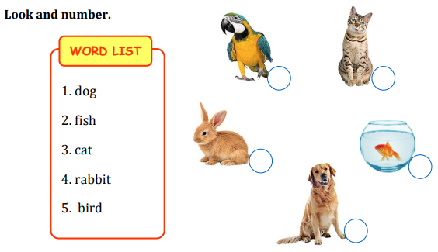  - Check with class  - Say goodbye | -Do the assessment  - Check with teacher  Answer:  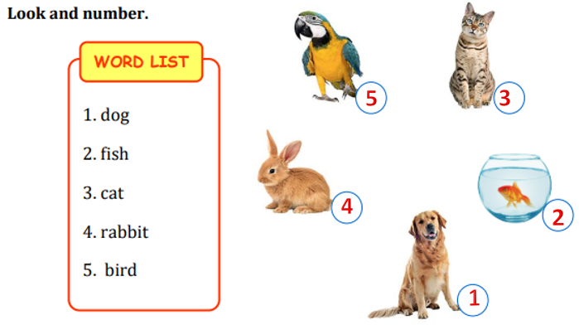  -Goodbye
________________________________

