WEEK 10 (11/11 – 15/11)
UNIT 4. FOOD AND DRINKS
Lesson 3. Task 1, 2, 3
Period 37
I. OBJECTIVES:
1. Knowledge: By the end of the lesson, students will be able to
- review and learn words and phrases related to the topic Food and Drinks: lemonade, yoghurt, nuts, bubble tea, soft drinks
- learn new grammar What’s your favourite food/ drinhks?
- practice the vocabulary and the structures.
2. Competences:
- English competences: Students will be able to talk about some more food and drink items
- Common competences: Students will have the opportunity to develop the creativeness in participating in games and develop communication among friends, improve their listening skill
3. Qualities:
- Students are given opportunities to talk about their favourite food and drinks
II. EQUIPMENT AND MATERIALS:
- For Teacher: PP, flashcards, handout, track 4.9, 4.10
- For students: pens, books, paper.
III. LESSON PROCEDURE:
Teacher’s activities | Teacher’s activities
Activity 1: Warm up (5 minutes)
a.Aims: warm-up activity to introduce lesson, review the words of foods
b. Procedure:  - Greet the students  - Divide class into 4 teams  - Play the video: Food trip around the world.  https://www.youtube.com/watch?v=XINl8YvzxMc  - Ask students to sing along and remember foods in the video.  - Ask students to answer the question: What are foods in the video?  - Check students’answer and give comments.  Korea: Bibimbap, Bulgogi, Kimchi; China: Hot Pot, Mapo Tofu, Dumplings; Japan: Sushi, Natto, Ramen, Onigiri; Vietnam: Banh Mi, Spring Roll and Pho; Thailand: Tom Yum Goong, Pad Thai, Som Tam; India: Curry, Naan, Tandoori Chicken; USA: Hamburger, Donut, Hotdog; Mexico: Burrito, Nacho, Taco; Italy: Pizza, Spaghetti; Spain: Paella, Jamon, Sangria; France: Baguette, Cheese, Crepe; UK: Fish and Chips, Yorkshire pudding  -Play a game: Guess the food  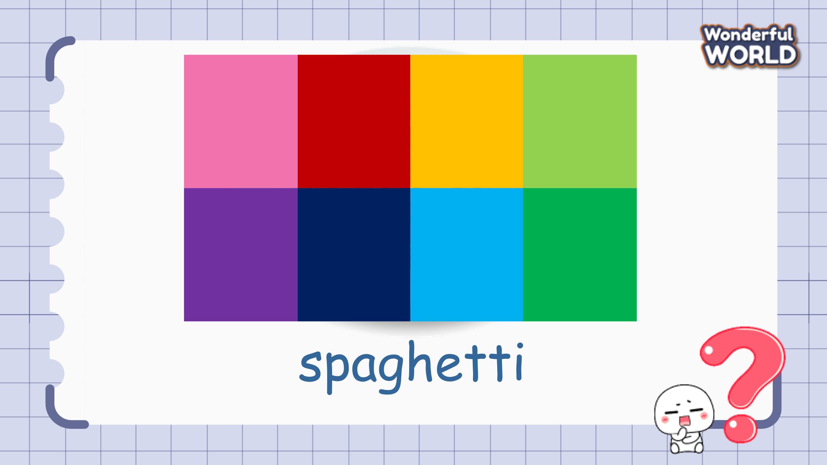  How to play: Teacher shows the picture of food quickly or hide pictures behind puzzle pieces on the screen, students have to look and guess what food it is.  - Set the game rules  - Do a model  - Ask students to listen and guess.  - Award the best groups  Lead-in: Use the picture of the food to lead in the new lesson. | - Greet the teacher  - Choose the team name  - Look, listen, sing and remember the name of foods  - Answer the question of teacher  - Listen to the teacher.  -Join in the game.  Suggested answers:  1.an egg,  2. an orange,  3. sandwich,  4. spaghetti,  5. vegetables
Activity 2: Presentation (8 minutes)
a. Aims: Present new vocabulary of Food and Drink: bubble tea, soft drink, lemonade, nuts, yoghurt
b. Procedure:  Task 1. Listen and point. Repeat.  - Use flashcards to introduce the vocabulary and structure of the lesson.  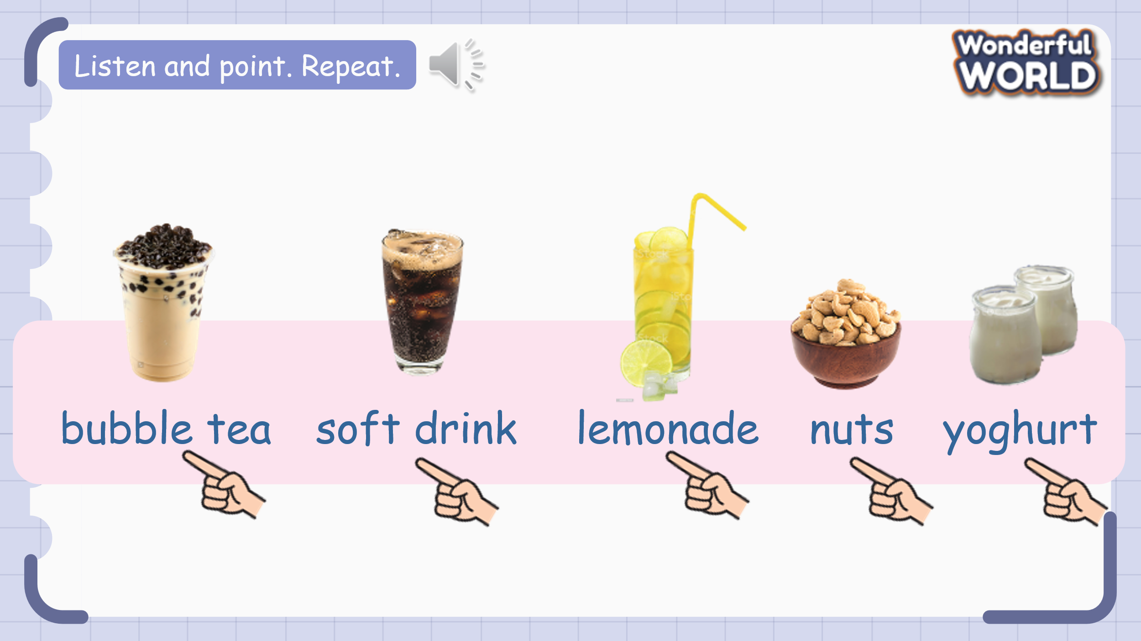  - Say the words/sentences for students to repeat in the chorus.  - Say a word/sentence for students to point then repeat.  - Play track 4.9 for the students to listen to and repeat in chorus, and group.  - Show pictures in random order and ask students to read out the words.  VOCABULARY CHECKING Get the goal game  There are 5 questions. Each question has 4 options (A, B, C, D). Students have to choose A, B, C, D to answer the questions to help the boy and the girl gets the goal.  Questions and suggested answers:  1. Would you like some___?  A. orange juice B. lemonade C. lemon juice D. lemon water  2. Would you like some___?  A. soft drinks B. bubble tea C. lemonade D. coffee  3. Would you like some___?  A. nuts B. bean C. sweets D. chocolate  4. Would you like some___?  A. milk B. bubble tea C. water D. yoghurt  5. Would you like some___?  A. bread B. chicken C. soft drinks D. chocolates | - Learn the new vocabulary.  - Listen and repeat.  - Point
Activity 3: Practice (8 minutes)
a. Aims: Controlled-practice to discuss and practice the vocabulary using: Would you like some...? Yes, please/ No, thanks
b. Procedure:  Task 2: Listen and tick.  -Point to the picture and tell students this is the conversation between Ben and Sandy.  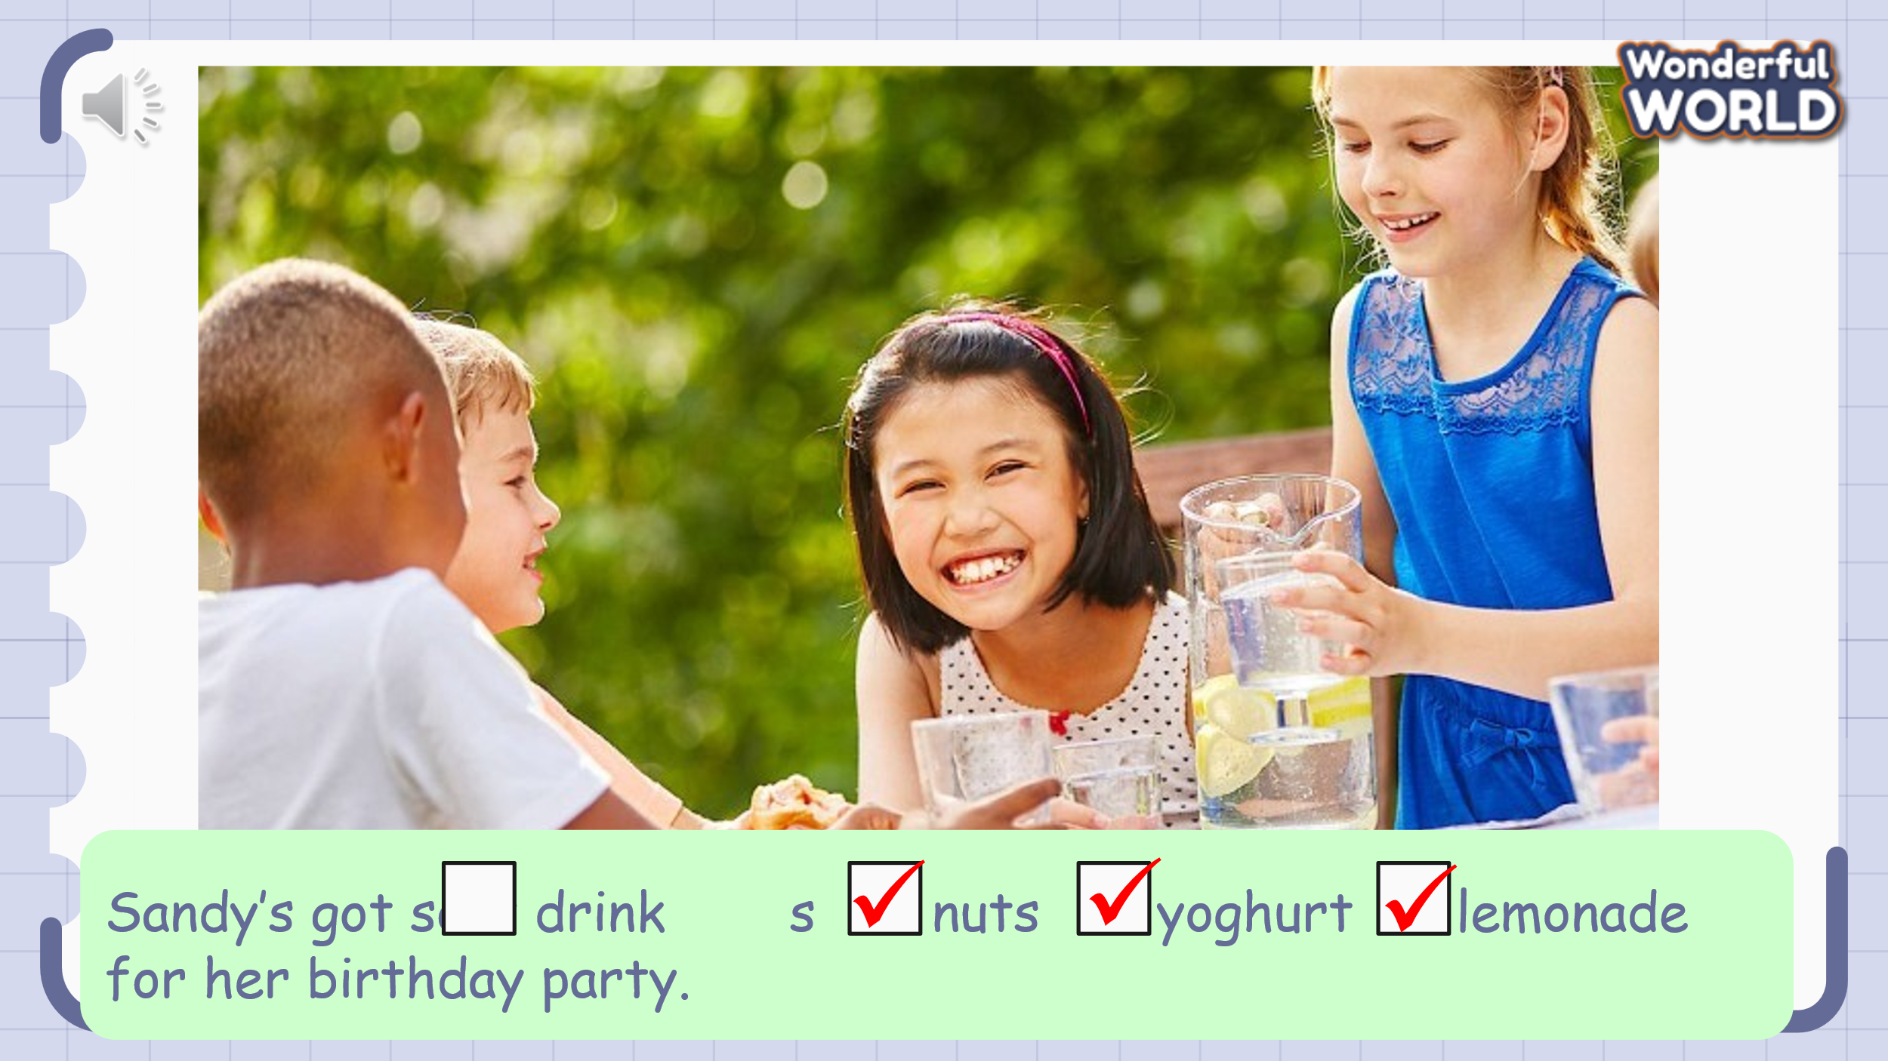  - Ask students to look at the sentence next to the picture. Read the sentence and the options.  - Play track 4.10 twice for students listen and tick.  - Play the audio again and ask students to do cross-check  - Elicit the answer from students and check with the whole class.  - Ask students to act out the dialogue in pairs.  - Ask some volunteers to act it out in front of the whole class  Task 3: Look and say.  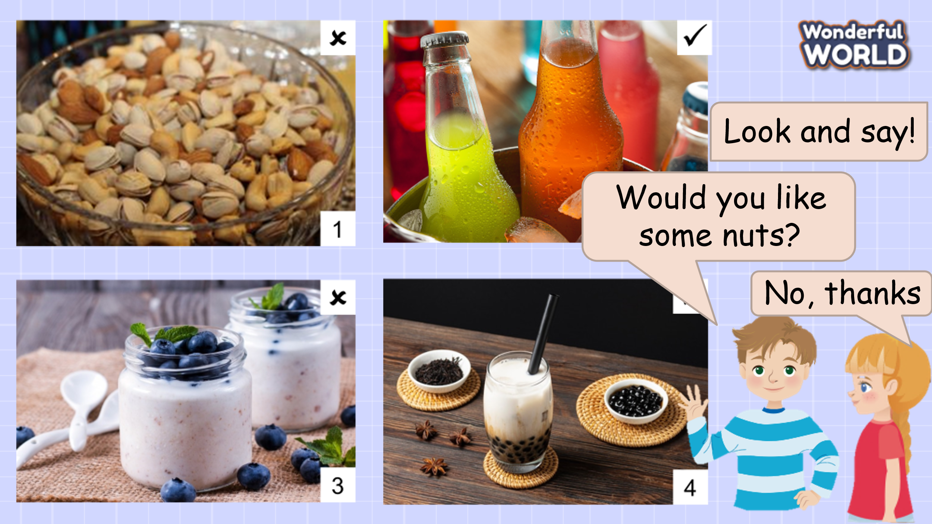  - Ask Ss to look at 4 pictures and identify their names.  - Introduce the structures “Would you like some...?” again. Then ask Ss to look at the example and say.  - Work in pairs and talk about 4 pictures.  - Call some pairs to present in front of the class.  - Give them feedback.  Answers suggested:  1 Would you like some nuts? No, thanks.  2 Would you like some soft drinks? Yes, please.  3 Would you like some yoghurt? No, thanks.  4 Would you like some bubble tea? Yes, please. | - Listen to the listening instruction carefully  - Read and guess  - Listen and tick the answer  - Do cross-check  - Role play  - Practice  - Answer T.  - Remember to use “Would you like some...?”  - Work in pairs.  - Say the sentences.  - Listen to T.
Activity 4: Production (9 minutes)
a. Aims: Apply structure to real world via a funny game.
b. Procedure:
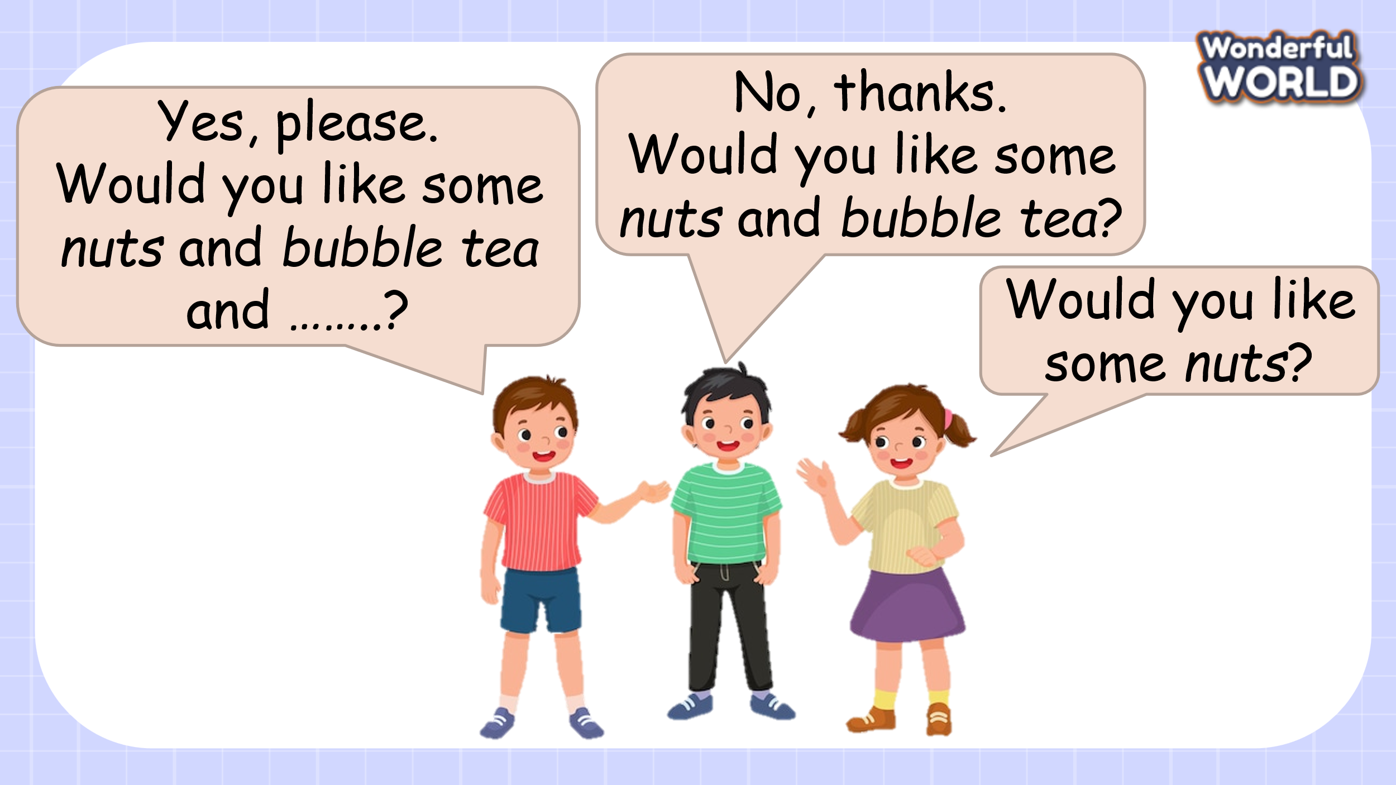
(Teacher calls about 5-6 students for each turn. Students stand in a line. The first student asks the question: “Would you like some...?”. The 2nd student answers: “Yes, please/ No, thanks” and continues to ask the 3rd student, but the question must contain the food that the first student mentioned and add one of his favourite foods. And so on until the last student. The student who can't remember what the previous student said will lose.)
- Introduce and set game rules
- Do a demo
- Play several rounds.
Activity 5: Assessment (3 minutes)
a. Aims: Do a quick exercise to cconsolidate the content of the lesson
b. Procedure:  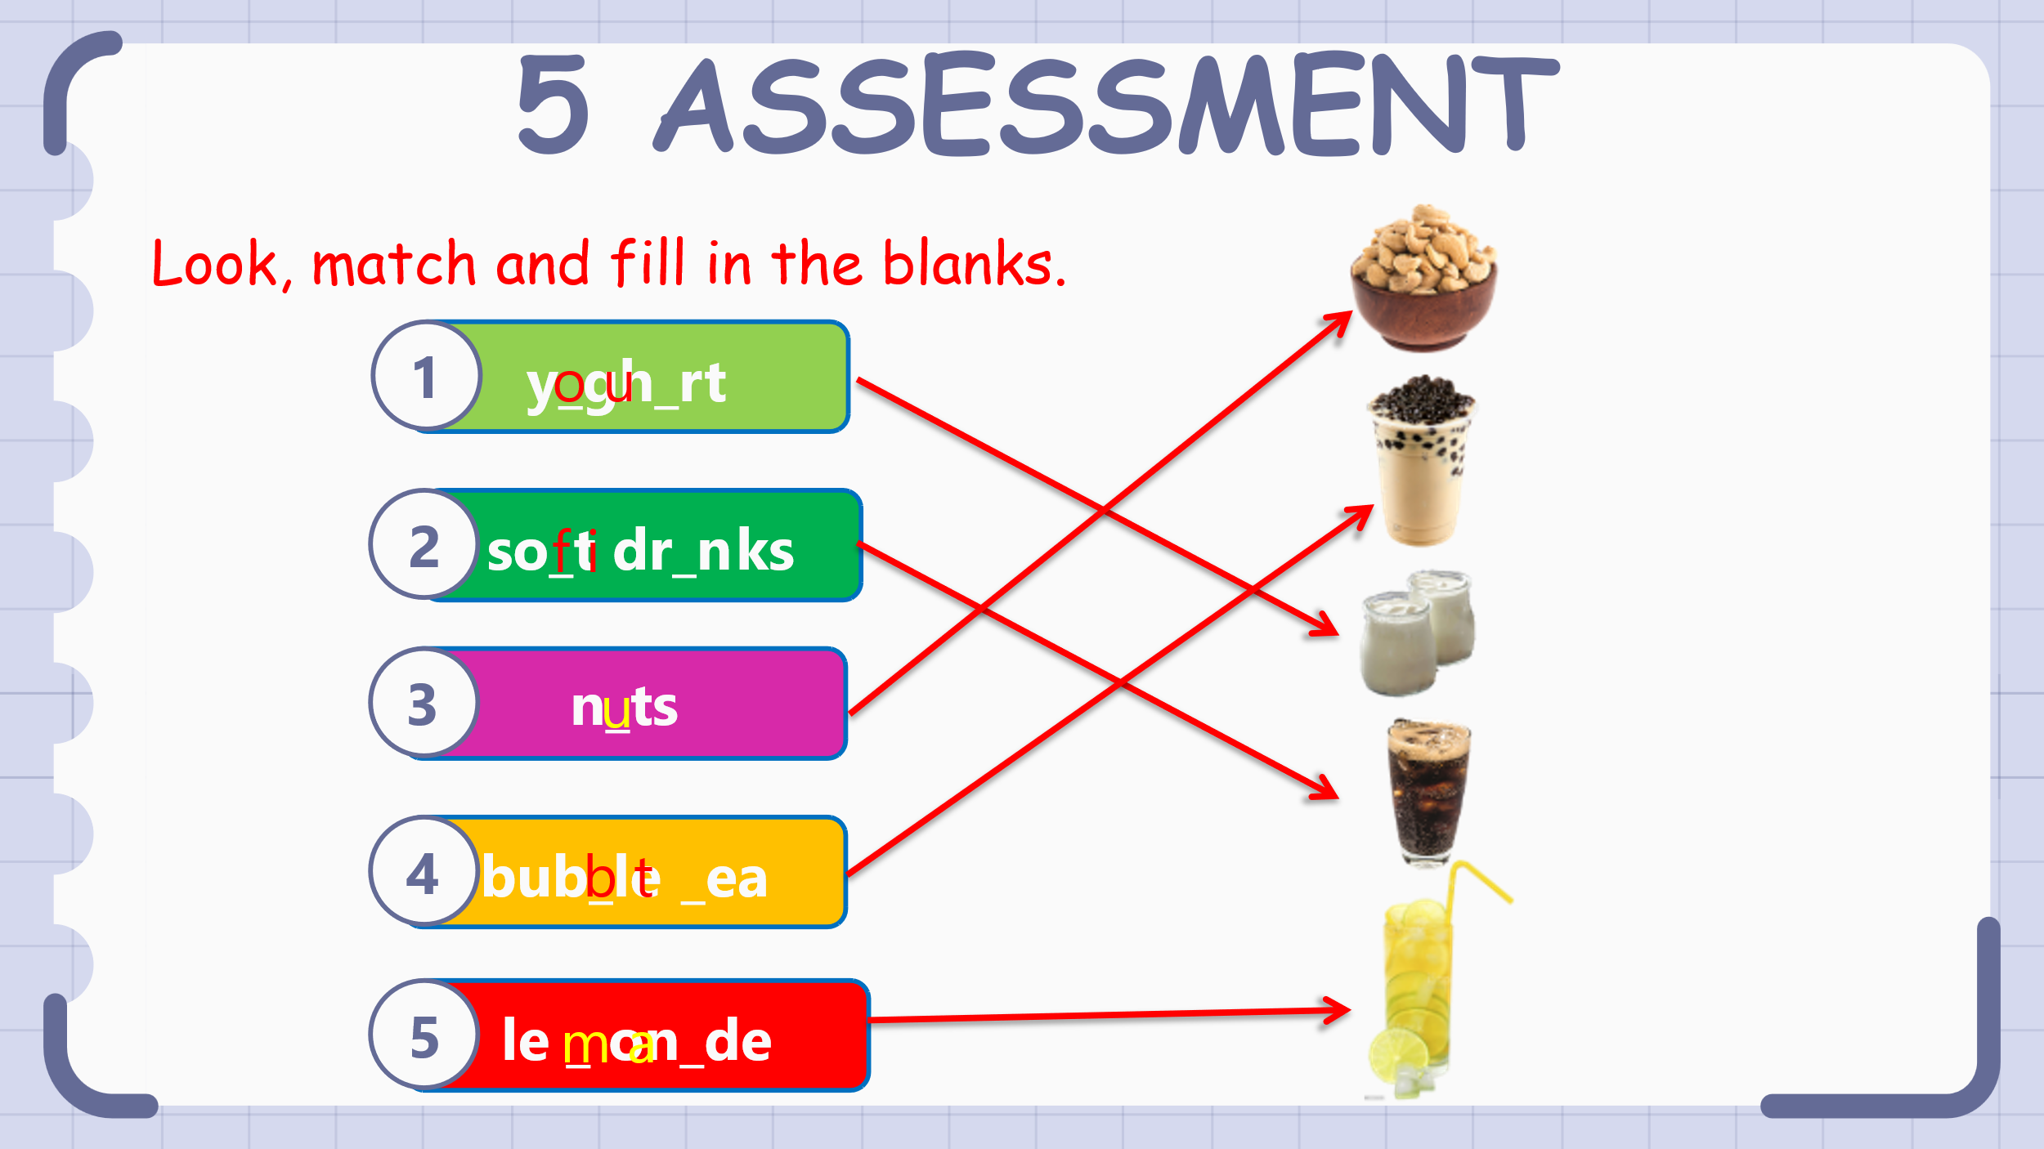  -Αsk students to look at the picture and elicit what foods they can see.  -Tell students they are going to look, fill the blanks and match the pictures with the correct words  - Give an example.  -Allow students enough time to complete the task individually. Go round the class helping students where necessary.  - Check students’answer and give comments  - Play the video, sing, do actions and ask students to sing along then say goodbye. | - Look at the picture and tell the foods in the picture.  - Listen to the teacher  - Complete the task  - Check the answers and listen to the teacher’s comments  - Stand up, sing and dance the say goodbye the teacher.
________________________________________________
UNIT 4. FOOD AND DRINKS
Lesson 3. Task 4, 5, 6
Period 38
I. OBJECTIVES:
1. Knowledge:
Students will learn words and phrases related to the topic Food and Drinks:
What's your favourite food and What’s your favourite drink?
2. Competences:
- English competences: Students will be able to talk about food and drink.
- Common competences: Students will have the opportunity to develop logical thinking and develop communication among friends.
3. Qualities:
- Students develop competency to practice some different leisure activities.
II. EQUIPMENT AND MATERIALS:
- For Teacher: PPT, flashcards, handout, track 4.11
- For students: textbook
III. LESSON PROCEDURE:

Activity 1: Warm-up (5 minutes)
Aim: warm-up activity to introduce the topic
Teacher’s Activities | Students’ Activities
Warm-up:  Play a small game  T calls Ss to answer and check their answers.  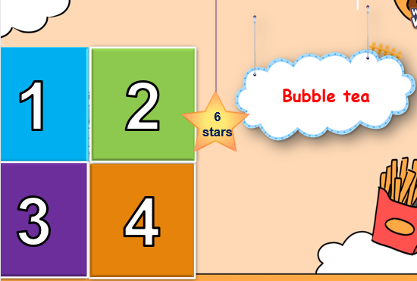  Lead in:  - T introduces that they will learn about “ Food and drinks” | - Play the game  - SS identify different colours and choose a colour to guess the image behind the puzzles.  - Ss answer and check their answers.  - Ss repeat the names of objects in the image.
Activity 2: Presentation (8 minutes)
Aim: - Present the words of the favourite food and drinks
- Encourage sts with the topic and activate knowledge and vocab of related topic.
Teacher’s Activities | Students’ Activities
• Point to the picture. Ask students to notice the two questions: “What's your favourite food and What’s your favourite drink?” Explain to students that we use these 2 questions to ask one what food and/or drink they like most.  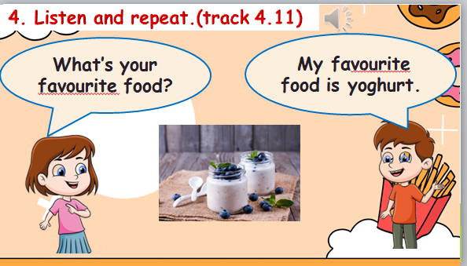 | - Repeat after the teacher.  - Students listen to, point to, and repeat the words.  - Then read out loud the new picture words and phrases in the vocabulary box in random order and students point to the correct pictures.
Activity 3: Practice (14 minutes)
Aim: - Practise the use of What’s your favourite food/ drink? how to answer this question correctly.
- Encourage sts to make a conversation about favourite food or drinks.
Teacher’s Activities | Students’ Activities
5 Look and say.  • Tell students to look at the pictures and the prompts. Read  out loud the prompts and ask students to repeat.  • Tell students to look at the picture for sentence 1 and the example.  Read out the example and ask students to repeat.  • Explain the rest of the task to students. Allow them enough time to practise saying sentences individually and then in pairs. Go round the class helping students where necessary.  • Ask volunteers to read out their answers. Correct any mistakes.  6. Drαw αnd write. Sαy.  • Tell students that they should draw their favourite food  and drink in the box or on a piece of paper. They should  draw some of the food they have learnt in Unit 4 in their  lunch box. Ask them to remind you of all the food and  drink words in Unit 4 and write them on the board to help  with ideas.  • Explain to students that they will write four sentences  about their favourite foods and drinks, two sentences for  foods and the other two for drinks. Read the example  together and tell students to underline the food | - Students look at the pictures and sentences.  - Read them aloud.  - Students practice saying the sentence individually and then in pairs.  - Students are going to learn a chant  - Look at the chant quickly.  - Students repeat after teacher  - Students chant along
Activity 4: Production (9 minutes)
Aim: - Join the game to review the words and structure: How many…. ?
- Encourage sts to work in pairs and make a new conversation about food and drinks.
Teacher’s Activities | Students’ Activities
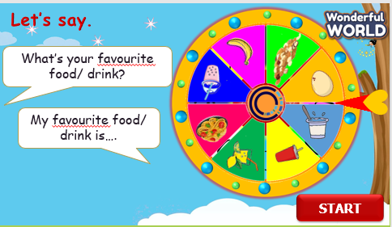  Look and say with the Wheel of fortune  Tell the students to look at the picture for question 1 and read out the example sentences.  • Explain the rest of the task to the students. Allow them enough time to practice saying the sentences individually and in pairs.  • Go round the class helping students where necessary.  • Give students suggestions if they have difficulty thinking of what to say. | - Listen to the rule carefully.  - Join the game.  -Look and read.  - Join the game by look and say.
Activity 5: Assessment (3 minutes)
Aim: Do the exercise to review and remember the words
Teacher’s Activities | Students’ Activities
-Ask sts to do the assessment.  - Check with the class.  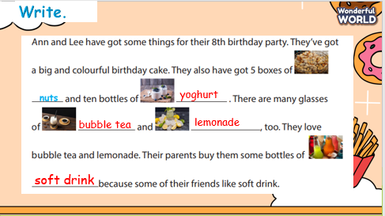 | -Do the assessment.  - Check with the teacher.
____________________________________________
UNIT 4. FOOD AND DRINKS
Lesson 3. Task 7, 8, 9
Period 39
I. OBJECTIVES:
1. Knowledge:
Students will review words and phrases related to the Food and drink:
- Identify and write l, p , ch
2. Competences:
- English competences: Students will be able to talk about their food and drink
- Common competences: Students will have the opportunity to develop the creativeness in drawing the family tree and develop communication among friends.
3. Qualities:
- Students develop love toward family.
II. EQUIPMENT AND MATERIALS:
- For Teacher: PP, TV, music, relating audio track.
- For students: papers, colour pencils or crayons, personal boards and markers.
III. LESSON PROCEDURE:
Activity 1: Warm-up (5 minutes)
Aim: Warm-up activity to revise new words they have learnt from the previous lesson.
Teacher’s Activities | Students’ Activities
Play games: Finding the way home  - Ask students to look the picture  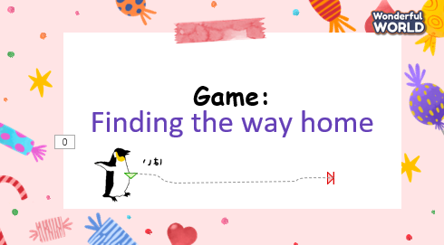 | - Listen to the instruction carefully  - And choose the best answer.
Activity 2: Presentation (8 minutes)
Aim: - Identify and pronounce words with initial sounds via listening task.
Teacher’s Activities | Students’ Activities
Vocabulary:  Task A: Listen and repeat. (track 3.7)  -Write “l” on the board. Ask students to say the  word. Then write “lemonade” on the board.  Ask students to pronounce the sound for “l “in the  word.  -Write “p” on the board. Ask students to say  word. Then write” pizza” on the board.  Ask students to pronounce the sound for “p” in  the word.  -Write “ch” on the board. Ask students to say  word. Then write” sandwich” on the board.  Ask students to pronounce the sound for “ch” in  the word.  - Pronounce both sounds again and show  students how they are different from each other.  Point to each word on the board and ask students to  practise the sounds with you.  - Play the recordings and tell students to repeat  the words and the sentences. | - Join the game.  -Look and read.  -Read  -Identify and read.
Activity 3: Practice (14 minutes)
Aims: Encourage students to chant along.
-Practise saying the sentence individually and then in pairs.
Teacher’s Activities | Students’ Activities
1. Listen and repeat. (Track 4.12)  - Play TR: 4.12, pointing to each photo as students hear  the corresponding word.  - Have students repeat each word.  8. Listen and chant. (4.13)  - Point to the chant and say Listen. Play TR1.13 and have  students just listen and read silently.  - Say Listen and chant. Play TR: 4.13 and have students say  the chant as they read.  9. Say it  - Look at the pictures. Say the whole sentences. | - Learn the words through pictures.  - Listen then circle.  - Repeat the words.  - Repeat then point.  - Say aloud the sentences  - Listen carefully  - Check with friends and then with teacher and whole class
Activity 4: Production (9 minutes)
Aim: Review the vocab and grammar of the previous lesson- using the fun activities in the lesson.
Teacher’s Activities | Students’ Activities
- Let’s play game.  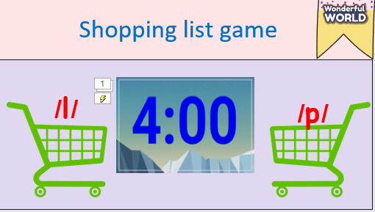  - Game: Shopping list game:  - Teacher writes some words like: lemonade, pizza, spaghetti... on the board.  - Divide class into 2 teams. And then let students say the word.  - Then say the words and sounds. | - Listen to the rule carefully.  -Look and read.  -Read  -Identify and read.  - Check with friends and then with the teacher and the whole class.
Activity 5: Assessment (3 minutes)
Aim: Do the exercise to review and remember the words.
Teacher’s Activities | Students’ Activities
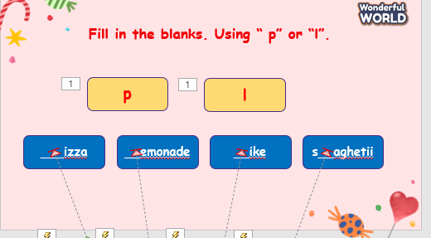  -Ask sts to do the assessment  - Check with the class | - Do the assessment  - Work in pairs.
_______________________________________________
UNIT 4. FOOD AND DRINKS
Lesson 3. Fun time and project
Period 40
I. OBJECTIVES:
1. Knowledge:
Students will learn words and phrases related to the topic Food and Drink:
What’s favourite food and What’s your favourite drink? and use the structures they have learnt to talk in project.
2. Competences:
- English competences: Students will be able to remember the words and structures they have learnt.
- Common competences: Students will have the opportunity to develop logical thinking and develop communication among friends.
3. Qualities:
- Students develop love for different leisure activities and be friendly to their friends in the class.
II. EQUIPMENT AND MATERIALS:
- For Teacher: PPT, flashcards.
- For students: textbook
III. LESSON PROCEDURE:
Activity 1: Warm-up (10 minutes)
Aim: warm-up activity to introduce the lesson.
Teacher’s Activities | Students’ Activities
Warm-up: Play a small game “Climbing trees”  (Divide the class into 2 groups. Set the context: Two teams participate in a tree competition. There are 8 questions. Students answer the questions. For each correct answer, the student climbs up 1 step. The student who can pick the fruit on the tree first will be the winner.)  - Tell students how to play the game  - Do as a model  T asks Ss to repeat after checking.  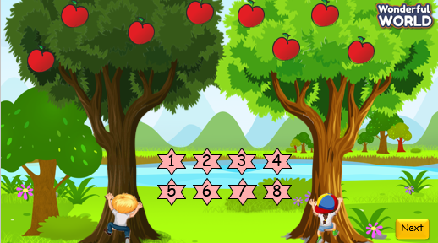  Lead in:  - T introduces that they will review about “Food and Drink”.  - Write on the board “Food and Drink” and introduce the lesson. | - Listen to the rule carefully.  - Join the game.  -Look and read.  -Read  -Identify and read.  - Check with friends and then with the teacher and the whole class.  - Listen to T.
Activity 2: Practice (12 minutes)
Aims: review all target vocabulary and structures of Unit 4 via some fun activities
Teacher’s Activities | Students’ Activities
Task 1: Do the crossword  - Ask SS to look at the picture and identify what activity and food and drink they can see in each picture.  - Ask SS to work in pairs in 2 min.  -Ask SS to play a small “Who’s faster?”  (Game: Who’s faster?”  T divides the class into 2 teams.  • Ask students to look at picture number 1 and elicit answers.  Then ask students to look at the example. Who is faster gets points. Which team has more points will be the winner.)  - Check their answer and give their feedback.  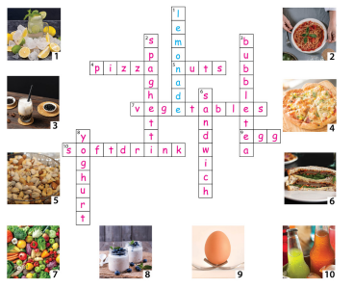 | - Look and answer.  - Work in pairs.  - Play the game.
Activity 3: Project (10 minutes)
Aims: - Guide Ss to make a product about topic “food and drinks” and present to the class
Teacher’s Activities | Students’ Activities
Work in pairs.  - Ask SS to look at the slide and T guides them to draw a picture about Food and drink.  - Ask SS to use 2 structures to make a short dialogue.  - Ask SS to work in pairs and do the project in 5 min.  - Call some pairs to present in front of the class.  - Check and give feedback.  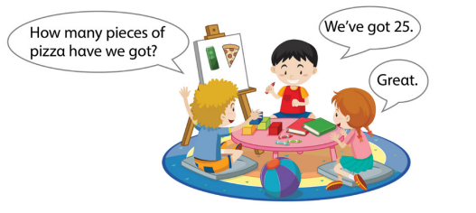 | - Listen and work in pairs.  - Present in front of the class  - Listen.
Activity 5: Assessment (3 minutes)
Aims: Do the exercise to review and remember the words
Consolidate the content of the lesson.

Teacher’s Activities | Students’ Activities
-Ask sts to do the assessment.  - Check with the class.  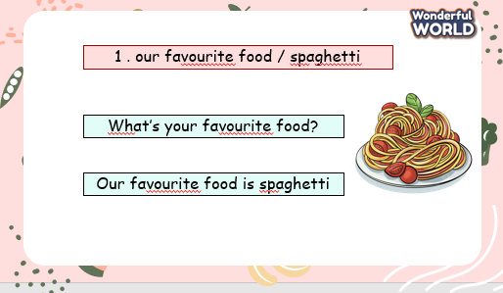 | -Do the assessment.  - Check with the teacher.

