WEEK 9 (04/11 – 08/11)
UNIT 4. FOOD AND DRINKS
Lesson 1. Task 4, 5, 6
Period 33
I. OBJECTIVES:
1. Knowledge:
Students learn the quantifiers some, a

2. Competences:
- English competences: Students will be able to ask and answer about whether someone would like a certain food and express the quantity of fruits using “some”, “a”
- Common competences: Students will have the opportunity to develop the communicative by role play activities.
3. Qualities:
- Students will be friendly and confident in communicating with friends.
II. EQUIPMENT AND MATERIALS:
- Basic things: Student’s book, flashcards, crayons, paper, glue
- Advanced things: PPT, projector/interactive whiteboard/laptop/TV.
III. LESSON PROCEDURE:
Activity 1: Warm-up (5 minutes)
Aims: To make Ss get ready for the topic Food and drink
Teacher’s activities | Student’s activities
- Greet students  Game: Spelling bee game  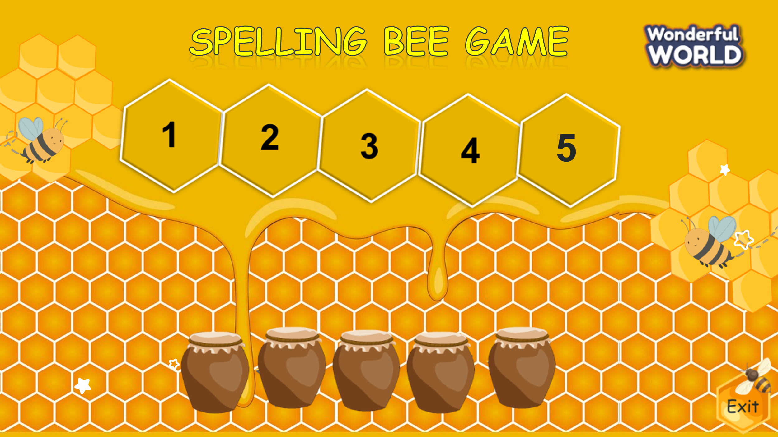  (There are 4 questions. Students have to spell a word of food. Students choose the jar to get the stars with each correct answer.)  - Divide the class into 4 groups  - Set the game rules  - Play as a model.  - Have students play in turns.  - Award the best groups  Lead-in: Use the pictures of the game to lead in the new lesson. | - Greet teacher  - Sit in 4 groups  - Listen to the game rules  - Look  - Join the game  - Listen
Activity 2: Presentation (8 minutes)
Aims: Present new structure: Would you like….? Yes, please/ No, thanks using
vocab of task 1
Teacher’s activities | Student’s activities
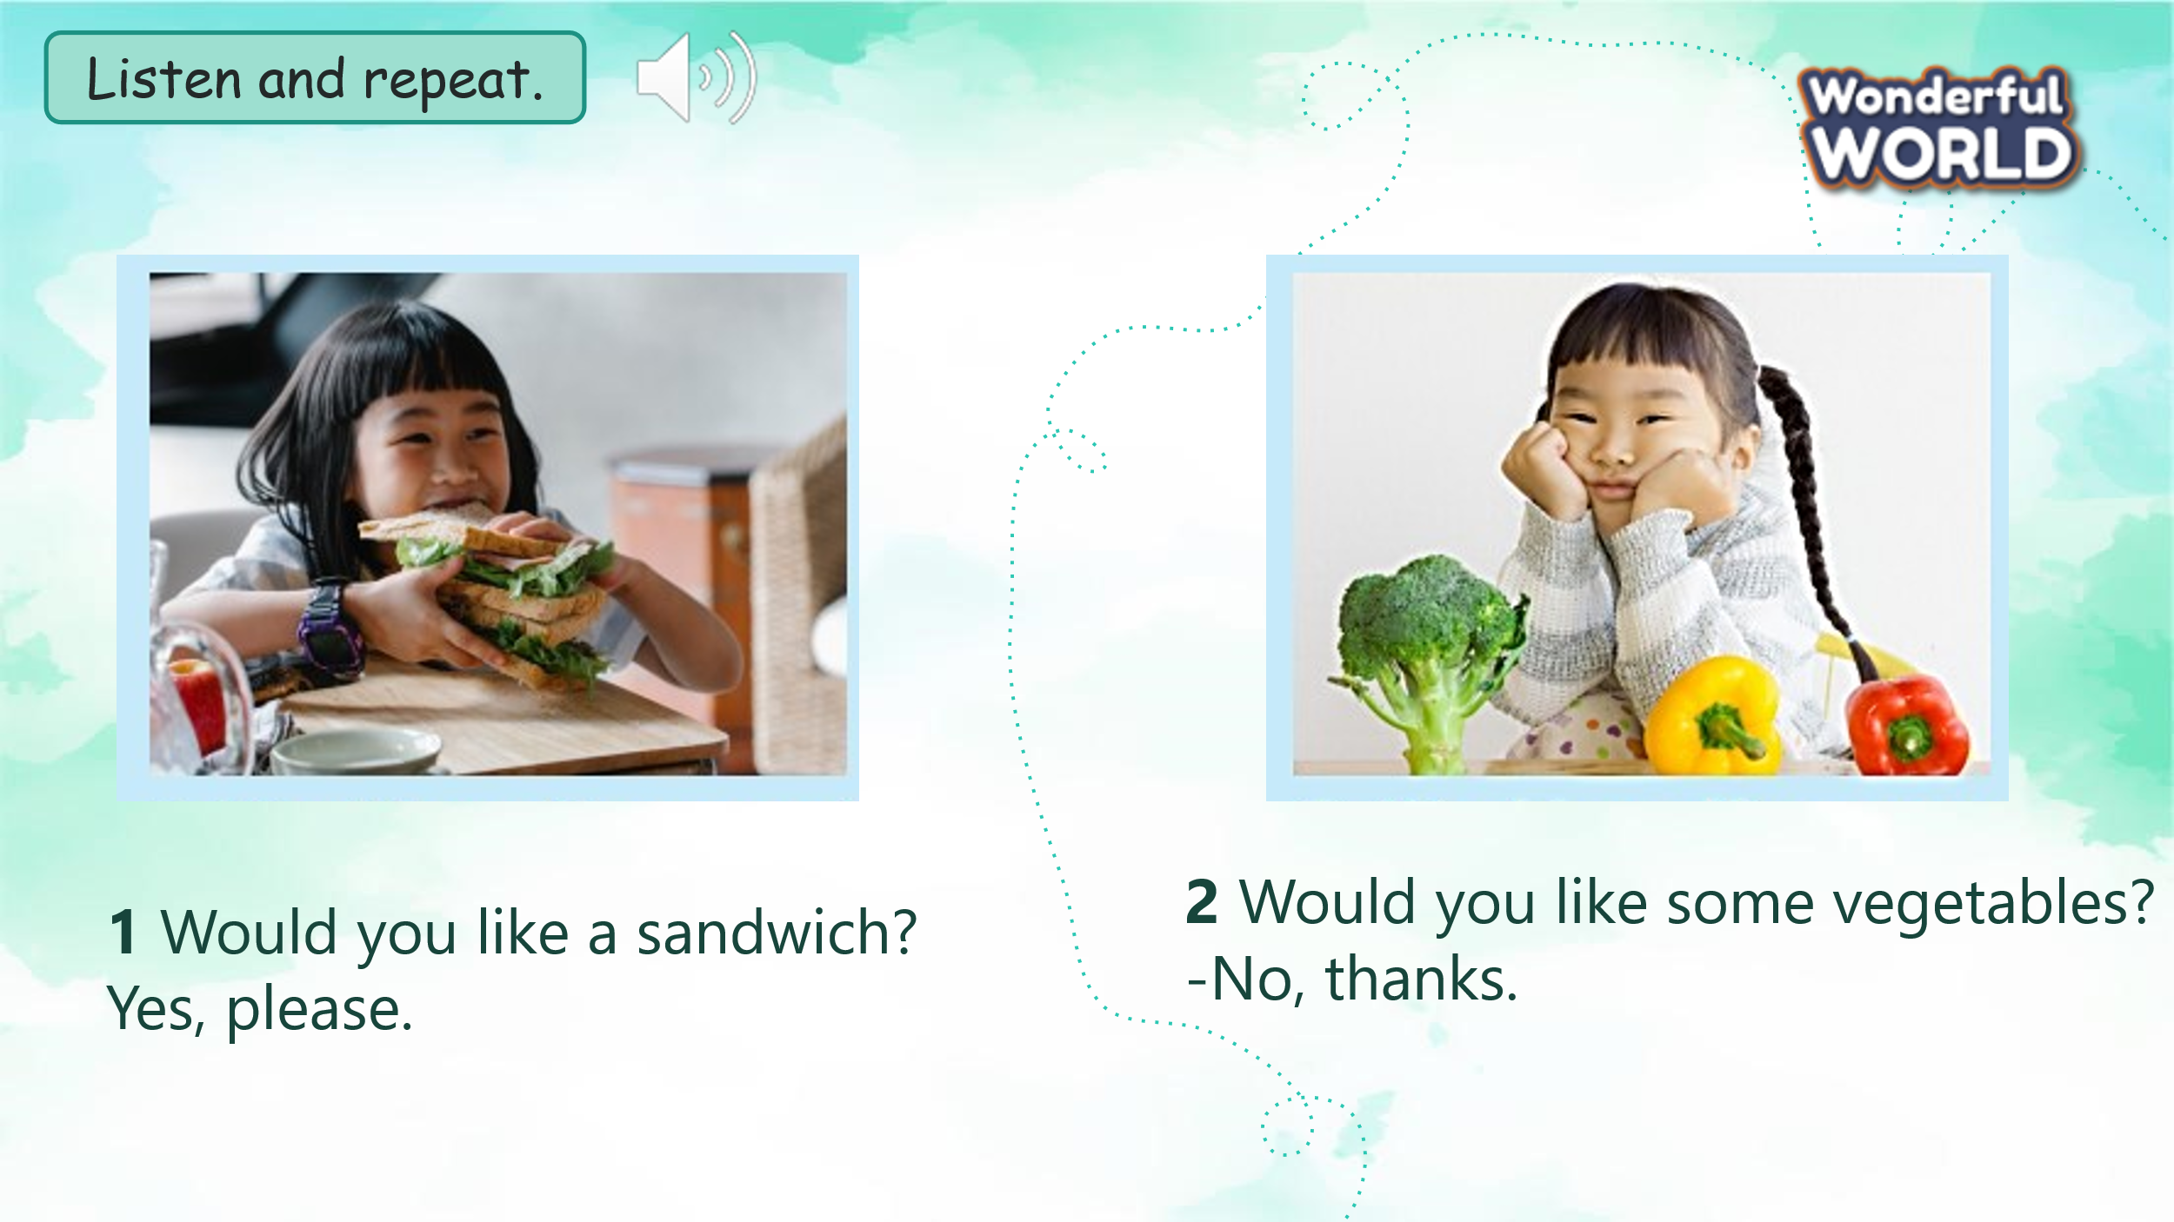  Task 4: Listen and repeat. (Track 4.3)  - Ask students to point and say the name of the food in each picture.  - Use the picture to teach the quantifiers: some, a  - Play the track 4.3.  - Play the track 4.3 again, ask students to listen and repeat in chorus, groups.  - Structure checking:  + Show the question:  Would  like  you  a sandwich?  - Ask Ss If you want it what do they say?  - Show the answer to make sure Ss understand meaning.  - Show the question:  Would  like  you  some vegetables?  - If they don’t want they should say: No, thanks.  -Call some pair practice ask and answer. | - Point and say: sandwich, vegetable  - Learn the grammar  - Listen  - Listen and repeat  - Answer T’s question:  - Ask and answer question:
Activity 3: Practice (12 minutes)
Aims: Controlled- practice to Free practice: to discuss and practice the model structures
Teacher’s activities | Student’s activities
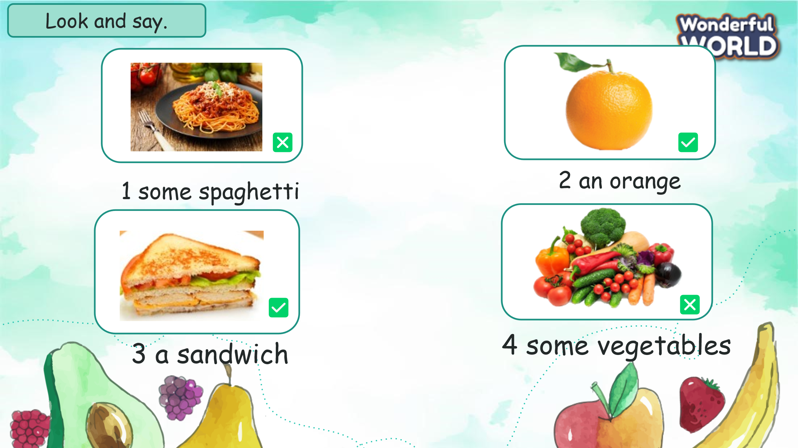  Task 5: Circle and say.  - Show the pictures in task 5  - Ask students to look at the picture and pay attention in the symbol or  ✅  ❎  - Use 2 balls and ask Ss they are going to pass the ball one by one around the class when they hear the music.  - When the music stop, Who has the ball will stand up to ask and aswer the sentences.  - Play music again then do with another pictures. | - Look at the picture  ✅  ❎  - Identify is No, thanks. Is Yes, please.  - Play game.
Activity 4: Production (7 minutes)
Aims: Apply structures to real world, promoting Sts’ activities
Teacher’s activities | Student’s activities
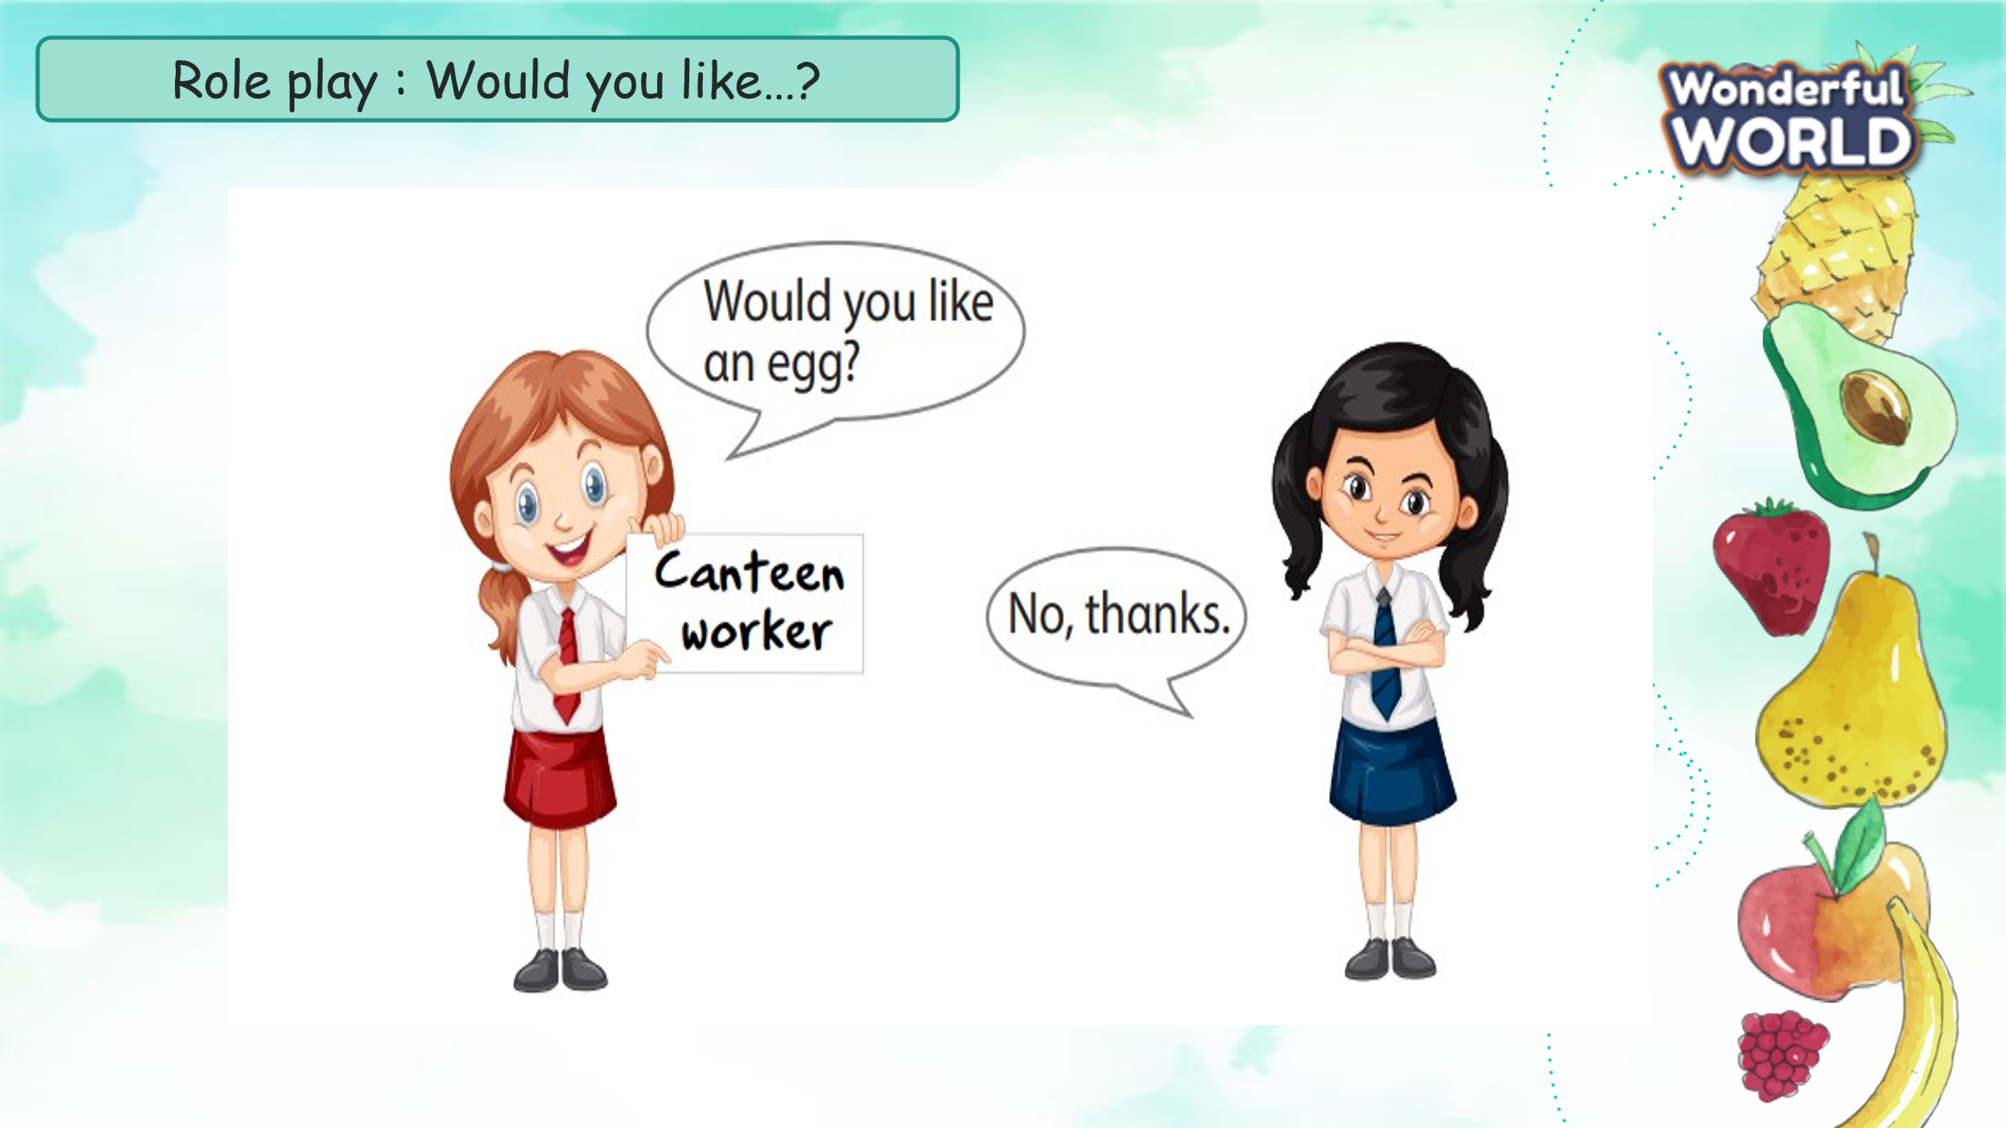  Task 6: Role play  - Ask Ss work in pairs.  - Ask them draw a picture of food. Then ask Their friend if he/she would like to eat this food or not.  - T goes around the class to support Student.  - Call some pairs practice ask and answer .  - Give feedback then give Ss stars. | - Pair work  - Draw a food.  - Ask and answer about  whether someone would like a certain food
Activity 5: Assessment and wrap-up(3 minutes)
Aims: Consolidate the content of the lesson
Teacher’s activities | Student’s activities
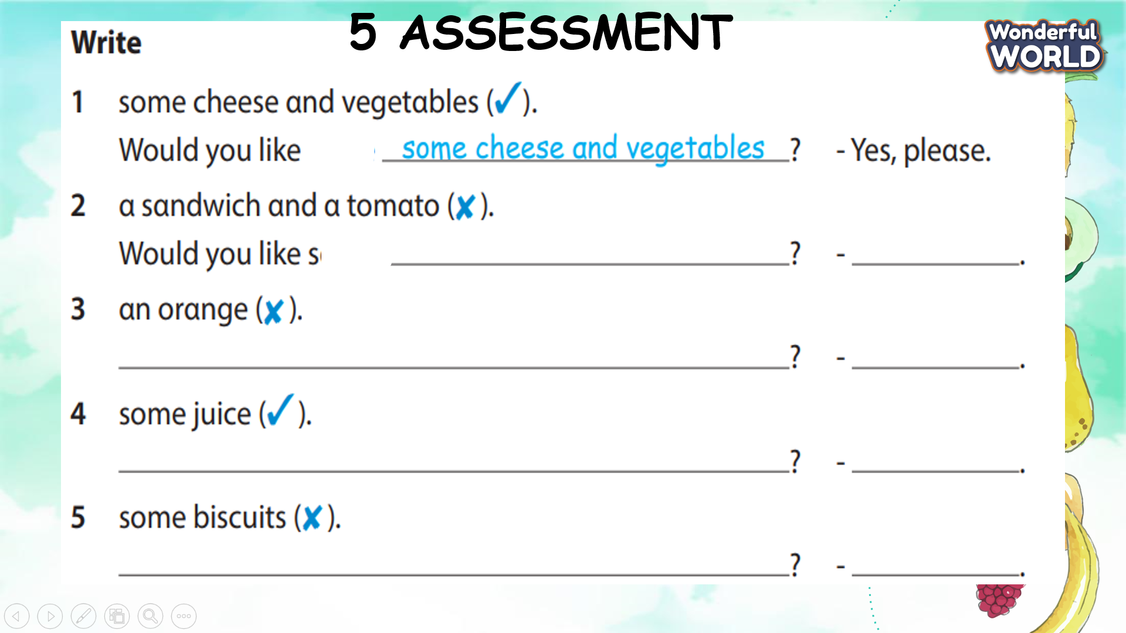  - Ask students to do the assessment.  - Check in pair then whole class.  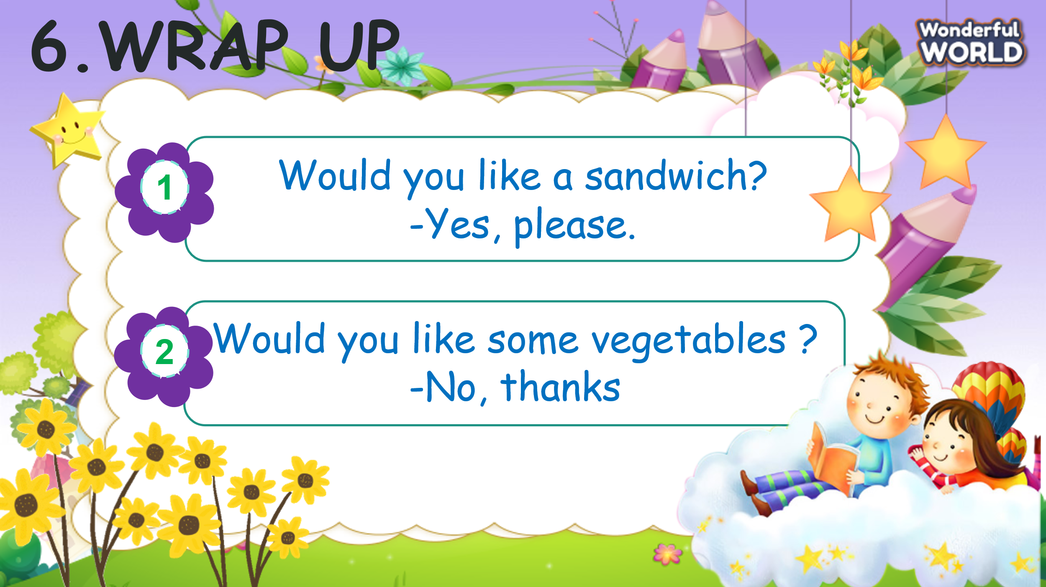  - Say goodbye | - Do the assessment.  - Check with friends and then with the teacher and the whole class.  - Say goodbye.
_____________________________________
UNIT 4. FOOD AND DRINKS
Lesson 2. Task 1, 2, 3
Period 34
I. OBJECTIVES:
1. Knowledge:
Students will learn words and phrases related to the topic Food and Drink: a cookie, a cupcake, pizza, a piece of pizza.
2. Competences:
- English competences: Students will be able to talk about food and drink.
- Common competences: Students will have the opportunity to develop logical thinking and develop communication among friends.
3. Qualities:
- Students develop a love for different leisure activities.
II. EQUIPMENT AND MATERIALS:
- For Teacher: PPT, flashcards, handout, track 4.4, track 4.5
- For students: textbook
III. LESSON PROCEDURE:
Activity 1: Warm up (5 minutes)
Teacher’s Activities | Students’ Activities
Warm up: Play a small game “Puzzle game”  The teacher asks SS to identify different colours and choose a colour to guess the image behind the puzzles.  T calls Ss to answer and check their answers.  T asks Ss to repeat the names of objects in the image.  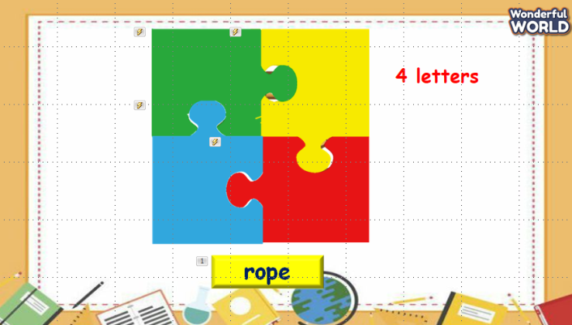  Lead in:  - T introduces that they will learn about “Food and drink” which uses the words in warm up today. | - Listen and answer the questions.  - Listen to T.
Activity 2: Presentation (8 minutes)
Teacher’s Activities | Students’ Activities
- Use flashcards to introduce the vocabulary of the lesson.  - Say the words for students to listen to and repeat in the chorus.  - Say a word for students to repeat then point.  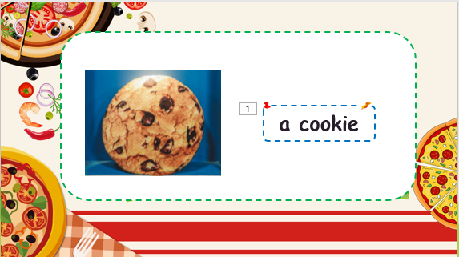 | - Repeat after the teacher.
Activity 3: Practice (10 minutes)
Teacher’s Activities | Students’ Activities
Task 1: Listen and point. Repeat. (Track 4.4)  - Play track 5.4 for the students to listen to, point to, and repeat the words in chorus and groups.  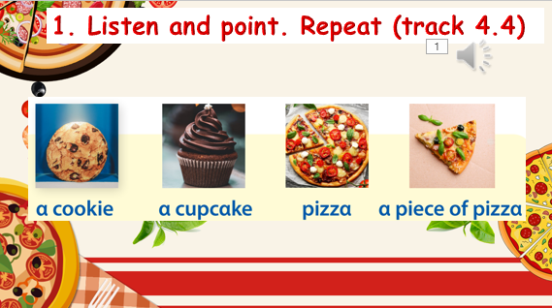  Task 2: Listen and read. Tick. Track 4.5.  - Ask SS to look at the picture and answer some questions about it.  - Call Ss to answer the questions.  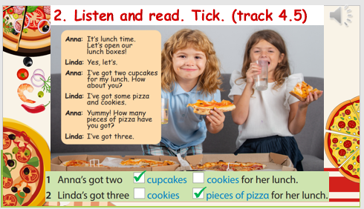  - Ask SS to identify the names of characters in the dialogue.  - Play track 4.5 and let SS listen to the dialogue, then repeat each sentence.  - Ask SS to read again, then write the correct answers.  Task 3: Let’s talk.  • Tell students to look at the pictures and the sample  sentence. Read out loud the sentence and ask students to  repeat it.  • Ask students to look at the prompt pictures and look back  at activity 1 when doing the task.  • Explain to students that they are interviewing their friends  about what their friends want for their lunch. Allow them  enough time to practice saying sentences individually and  then in pairs. Go round the class helping students where  necessary. | - Listen and answer.  - Read and answer.  - Listen and repeat.  - Read and write answers.  - Role play.  - Write the sentences and say.  - Listen to T.  - Work in pairs and present in front of the class.
Activity 4: Production (9 minutes)
Teacher’s Activities | Students’ Activities
Game: The little bee.  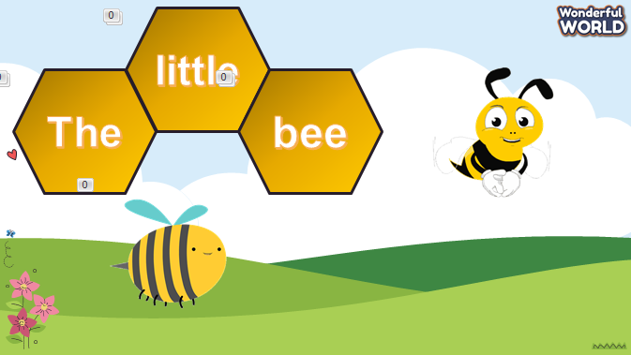  - Let Ss look at the picture. Then choose the best answer. | - Listen to the rule carefully.  - Join the game.  -Look and read.  -Read  -Identify and read.  - Check with friends and then with the teacher and the whole class.
Activity 5: Assessment (3 minutes)
Teacher’s Activities | Students’ Activities
-Ask sts to do the assessment.  - Check with the class.  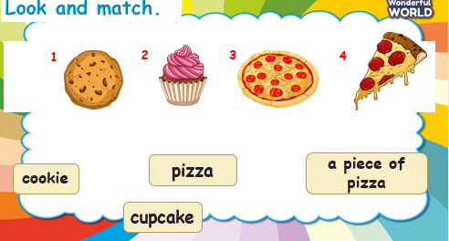 | -Do the assessment.  - Check with the teacher.
_______________________________________________
UNIT 4. FOOD AND DRINKS
Lesson 2. Task 4, 5, 6
Period 35
I. OBJECTIVES:
1. Knowledge:
Students will learn words and phrases related to the topic Food and Drinks: 21,22,23,24,25,26,27,28,29
- How many…..have you got? – I’ve got …..
2. Competences:
- English competences: Students will be able to talk about food and drink.
- Common competences: Students will have the opportunity to develop logical thinking and develop communication among friends.
3. Qualities:
- Students develop a love for different leisure activities.
II. EQUIPMENT AND MATERIALS:
- For Teacher: PPT, flashcards, handout, track 4.6, track 4.7
- For students: textbook
III. LESSON PROCEDURE:
Activity 1: Warm up (5 minutes)
a. Aim: warm-up activity to introduce the topic Food and Drinks
Teacher’s Activities | Students’ Activities
Warm up:  Dance and sing: Do you like broccoli  - Ask students to watch the video  - Dance and sing along to the song.  - Play a small game  - T calls Ss to answer and check their answers. 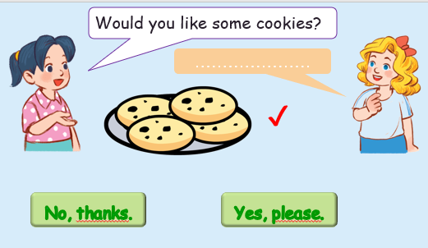  Lead in:  - T introduces that they will learn about “Food and drink” which uses the words in warm up today. | - Listen to the instruction carefully and watch the video.  - Watch the video again and sing along to the song.  Listen and answer the questions.  - Listen to T.
Activity 2: Presentation (8 minutes)
Aim:
- Know how to count the numbers of food or drinks
- Encourage sts with the topic and activate knowledge and vocab of related topic.
Teacher’s Activities | Students’ Activities
Task 4: Listen and repeat.  - Point to the picture. Ask students to notice the meaning of the word his.  - - Explain that we use the question How many  have you got ... for your party? to ask the quantity of food or drink that one’s got for their party.  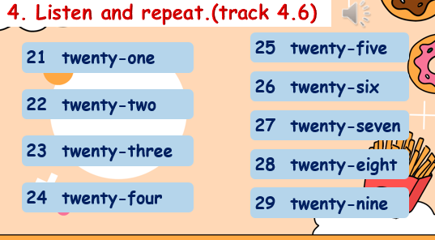 | - Listen and answer.  - Repeat after the teacher.  - Students to repeat the sentences. Let them know that this  activity is linked to the next activity
Activity 3: Practice (10 minutes)
Aim: - Practise the use of How many….? how to answer this question correctly.
- Encourage sts to make a conversation in number of food or drinks.
Teacher’s Activities | Students’ Activities
5 Look and say.  • Tell students to look at the pictures and the prompts. Read out loud the prompts and ask students to repeat them.  • Tell students to look at the picture for sentence 1 and the example.  Read out the example and ask students to repeat it.  • Explain the rest of the task to students. Allow them enough time to practise saying sentences individually and then in pairs. Go round the class helping students where necessary.  • Ask volunteers to read out their answers. Correct any mistakes.  • Suggested answers:  2 How many oranges has your sister got? She’s got 22.  3 How many ice creams have you got? We’ve got 24.  4 How many bananas have your cousins got? They’ve got 28.  6 Listen and chant. TR: 4.7  • Tell students that they are going to learn a chant about pizza.  • Ask students to look at the photo and tell you what it shows (a girl enjoying a piece of pizza). Then tell them to look at the chant quickly.  • Play the chant for students to listen and follow with their fingers.  • Read out the chant alone at a time. Ask students to repeat after you.  • Play the chant again for students to chant along. Practice until students are familiar with the words. | - Students to look at the picture for question 1 and the example.  - Read out the example and repeat  - Students are going to learn a chant about pizza.  - Look at the chant quickly.  - Students repeat after teacher  - Students chant along.
Activity 4: Production (9 minutes)
Aims: - Join the game to review the words and structure: How many…. ?
- Encourage sts to work in pair and make a new conversation about food and drinks.
Teacher’s Activities | Students’ Activities
Game: the Wheel of Fortune  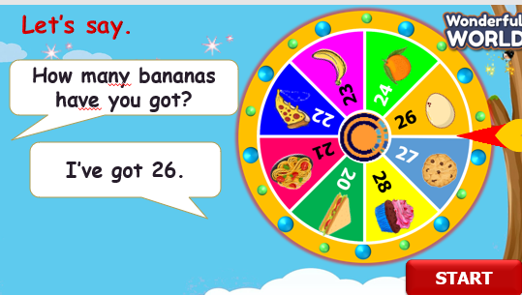  Look and say with the Wheel of Fortune  Tell the students to look at the picture for question 1 and read out the example sentences.  • Explain the rest of the task to the students. Allow them enough time to practice saying the sentences individually and in pair.  • Go around the class helping students where necessary.  • Give students suggestions if they have difficulty thinking of what to say. | - Listen to the rule carefully.  - Join the game.  -Look and read.  - Join the game by looking and saying.
Activity 5: Assessment (3 minutes)
Aim: Do the exercise to remember the words
Teacher’s Activities | Students’ Activities
-Ask sts to do the assessment.  - Check with the class.  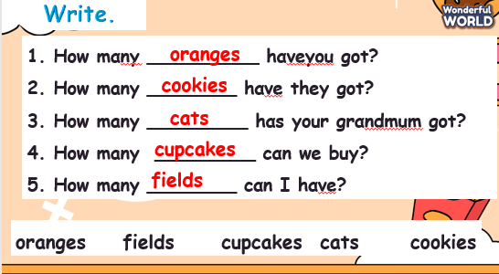 | -Do the assessment.  - Check with the teacher.
______________________________________
UNIT 4. FOOD AND DRINKS
Lesson 2. Task 7, 8, 9
Period 36
I. OBJECTIVES:
1. Knowledge:
Students will review words and phrases related to the topic Food and Drinks: 21,22,23,24,25,26,27,28,29
- How many…..have you got? – I’ve got …..
2. Competences:
- English competences: Students will be able to talk about food and drink.
- Common competences: Students will have the opportunity to develop logical thinking and develop communication among friends.
3. Qualities:
- Students develop a love for different leisure activities.
II. EQUIPMENT AND MATERIALS:
- For Teacher: PPT, flashcards, handout, track 4.6, track 4.7
- For students: textbook
III. LESSON PROCEDURE:
Activity 1: Warm up (5 minutes)
Aim: Warm-up activity to revise new words they have learnt from the previous lesson.
Teacher’s Activities | Students’ Activities
Review:  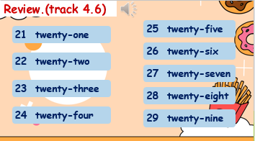  T calls Ss to answer and check their answers. | -Look and read.  -Read  -Identify and read.
Activity 2: Presentation (8 minutes)
Aim: Present the question and the answer about food and drinks.

Teacher’s Activities | Students’ Activities
Task 7: Listen and circle ( track 4.8)  Tell students they are going to listen to five short sentences about the quantity of food that people have got for their party and circle the correct answer for each question.  Play track 4.8  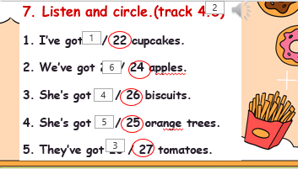 | - Repeat after the teacher.  - Repeat the words.  - Repeat then point.  - Say aloud the sentences
Activity 3: Practice (10 minutes)
Aims: Controlled practice: Help sts to practise the vocab and structure.
Encourage sts to make a full sentence using I’ve got… to say about food and drinks
Teacher’s Activities | Students’ Activities
8. Write and say.  - Ask students to look at the list.  - Point at the first line in the list saying 22 sandwiches.  - Ask students to repeat and make a sentence. “We want a lot of fruit.”  • Then explain the rest of the task to students: they are going to write the food, together with the quantity and amount of the food,  that they need for their family party.  9. Let’s talk. Talk about what you have got for your party.  Tell students they are going to ask and answer the quantity  of food they have got for their party.  • Tell students to look at the picture. Read out the dialogue.  Read it out again, pause after each sentence, and ask  students to repeat it.  • Ask two students to read out the dialogue.  • Ask students to work in pairs of 4-5 to ask and answer  about the quantity of food they need for their class party. | - Listen and answer.  - Read and answer.  - Listen and repeat.  - Read and write answers.  - Students look at the pictures and sentences.  - Read them aloud.  - Students practice saying the sentence individually and then in pairs.
Activity 4: Production (9 minutes)
Aims:
- Join the game to review the words and structure. “How many ….?”
- Encourage sts to work in pair and group.
Teacher’s Activities | Students’ Activities
Game: Gold Rush  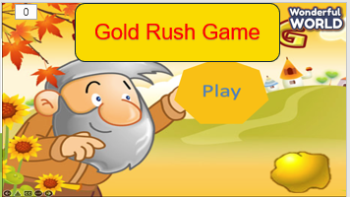  - Lead-in: Introduce the game rule. Click on the score box to open the question.  - Click next to go through the slide to exchange gold for land. Group with higher scores will be prioritized to choose a number. Each number will lead to a question and their mission is to answer it correctly. If the chosen group has an incorrect answer or doesn’t have an answer, other groups can raise their hand, say the answers, and gain points. The teacher will give groups 1 point for each correct answer.  - Play the game.  - Show the questions and check if the answers are correct or not.  - Award the best group. | - Listen to the rule carefully.  - Join the game.  -Look and read.  - Join the game by looking and saying.
Activity 5: Assessment (3 minutes)
Aim: Do the exercise to review and practice the words
Teacher’s Activities | Students’ Activities
-Ask sts to do the assessment.  - Check with the class.  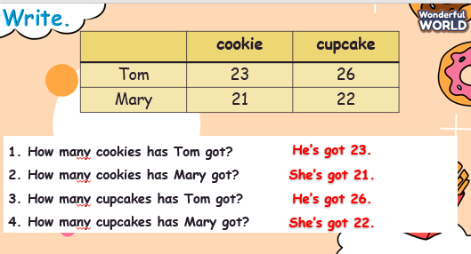 | -Do the assessment.  - Check with the teacher.

