WEEK 9
UNIT 3. ANIMALS
Lesson 1. Task 4, 5, 6
Period 33
I. OBJECTIVES:
1. Knowledge:
Students learn the structure That’s a… and review This is a … with animal vocabulary.
2. Competences:
- English competences: Students will be able to use That’s a …and This is a… talk about animals in term of near and far distance.
- Common competences: Students will have opportunity to develop their creativeness by making animal posters
3. Qualities:
- Students will love animals more through learning activities
II. EQUIPMENT AND MATERIALS:
- For Teacher: PP, TV, flashcards, track 3.3, handout
- For students: A0 paper, pencil, bell
III. LESSON PROCEDURE:
Activity 1: Warm up (5 minutes)
Teacher’s Activities | Students’ Activities
Gold Rush Game  (sts can play in teams or individually. Sts take part in the game by choosing an amount of gold. Answer the question behind. If the answer is correct, they get the gold)  -Set context: Animals are in danger. You need to save them. To save them you need a lot of money to buy them land to live on. How could you fine money? Please, join Gold Rush Team.  Sts choose an amount of gold  - Look at the picture. Say the name of the animal  - Award the player with most gold. | - Listen to teacher  - Play the game  - Choose an amount of gold  - Look and say
Activity 2: Presentation (8 minutes)
Teacher’s Activities | Students’ Activities
Task 4: Listen and repeat  The animals are safe now. Tomas guides you on the tour to the forest to visit them. Guess what animals he let you see first  -Introduce the listening task  Teach the structure That is…  Use the distance of the teacher with flashcard to teach and demonstrate the difference between This/That.  This is (picture: bird) (picture: dog)  That is (picture: cat) (picture: rabbit)  Listen and tick  - Play audio twice  - Ask sts to listen and tick  - Do peer checking  - Check with whole class  Note: This is… / That’s …  - Ask sts to take turn to introduce the animals | - Listen to teacher  - Guess what animal you will see  - Listen and tick  - Check with your peer  - Check with teacher  - Pay attention to the note  - Introduce animals
Activity 3: Practice (14 minutes)
Teacher’s Activities | Students’ Activities
Task 5: Look and say  Build Bridge Game  Teacher prepares 5 pictures and 5 sentences using This is …/ That’s … arrange sts as 4 teams. Count numbers for each member of each team. Place a bell at the middle of the class circle. Sts choose a number, Teacher says a number, sts with that number rob the bell and make a sentence. The fastest correct answer gets the point  - Set context: Animals need to pass the valley. However, there are no bridges for them to go. Please help them build a bridge by looking at the pictures and make equivalent sentences.  - Split sts into 4 teams  - Ask each team to count from numbers for each member  - Give game instruction  - Play as the sample  - Place a brick by clicking on it  - Say a number  Sts rob the bell and team makes a sentence  The fastest correct answer gets the point | - Listen to teacher  - Work in teams  - Count numbers  - Listen to game instruction  - Look at the picture  - Listen to teacher saying a number  - Rob the bell  - Say the sentence
Activity 4: Production (9 minutes)
Teacher’s Activities | Students’ Activities
Task 6: Let’s talk  - Ask sts to be a tour guide at the zoo  - Ask them to make a poster of animals and introduce them to friends using This is…/ That’s ….(remember to have sts stand in different distance when introducing the poster to use This/That meaningfully.) | - Make an animal poster  - Tell friends
  This is … | That’s …
Activity 5: Assessment (3 minutes)
Teacher’s Activities | Students’ Activities
-Ask sts to do assessment  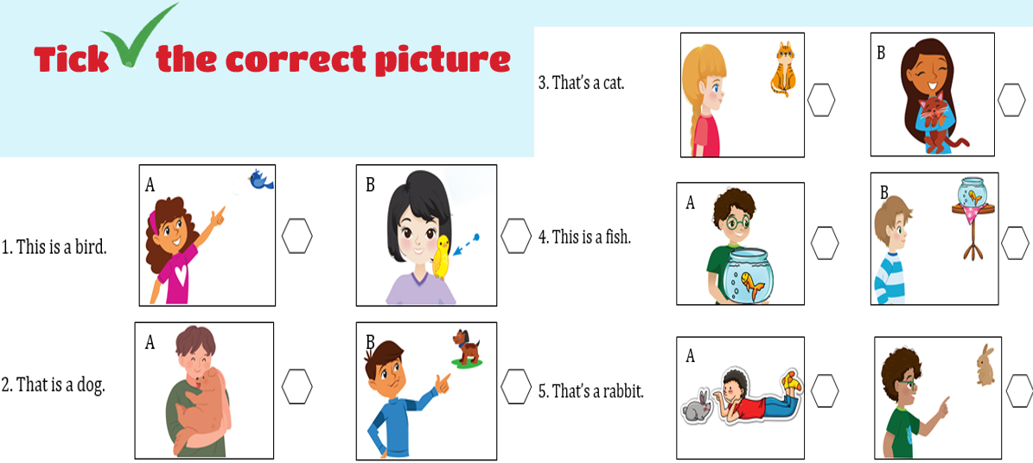  - Check with whole class  - Say goodbye | - Do assessment  - Check with teacher  Answer:  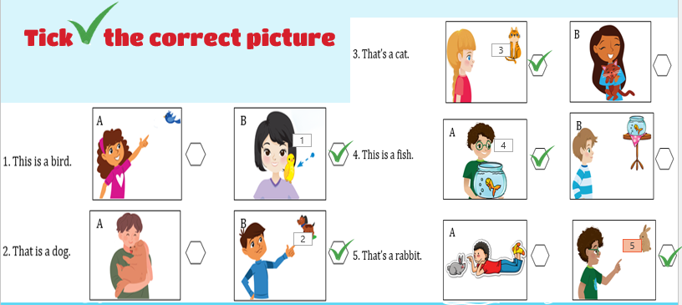  - Check with teacher  - Say goodbye
________

UNIT 3. ANIMALS
Lesson 2. Task 1, 2, 3
Period 34
I. OBJECTIVES:
1. Knowledge:
Students will learn about wild animals: elephant, giraffe, lion and monkey in singular and plural form.
2. Competences:
- English competences: Students will be able to recognize and pronounce names of the four animals correctly, introduce and describe them using They’re…
- Common competences: Students will develop their communication skill through working in groups and making animal fact file.
3. Qualities:
- Students will be benevolent with wild animals.
II. EQUIPMENT AND MATERIALS:
- For Teacher: PP, TV, flashcards, track 3.4, handout
- For students: A0 paper, pen, crayons
III. LESSON PROCEDURE:
Activity 1: Warm up (5 minutes)
Teacher’s Activities | Students’ Activities
Animal songs  https://youtu.be/wCfWmlnJl-A  - Introduce the song  - Mime some animal actions and have sts guess what animals they are  - Have sts do some animal actions like jump, swing, shake, fly, sleep, wake up  - Listen and copy the actions | - Listen to teacher  - Look and guess  - Do actions  - Listen and copy
Activity 2: Presentation (8 minutes)
Teacher’s Activities | Students’ Activities
Task 1: Listen and point. Repeat  - Set context: The children go exploring the forest and meet a new friend Tarzan. Tarzan guides the children going through the forest and see a lot of animals. However, the animals are afraid of strange human. They do not dare to appear until Tarzan calls their names.  - Show the sound and the picture at the same time  - Ask sts to listen, look and repeat  - Check pronunciation when needed  - Checking:  Catch animal smugglers Game  - Set context: on the way visit animals, Tarzan recognizes some animal smugglers. Please help Tarzan save the animals  - Ask sts to work individually  - Stick 4 pictures of animal on 4 corners  - Show 4 smugger bags  - Ask sts to guess what animals is blocked in  - Ask them which animal they want to save first  - Open the bags one by one  - Ask sts to listen to the sound  - Point to the animal and say the word aloud  - The fastest hand and mouth get the point | - Listen to teacher  - Listen, look and repeat  - Listen to teacher  - Work individually  - Guess which animals are blocked  - Tell teacher  - Listen to the sound  - Point and say
Activity 3: Practice (14 minutes)
Teacher’s Activities | Students’ Activities
Task 2: Listen and tick  - Set context: you’re going to visit an animal family. Guess which family is.  - Now. Listen and tick to check your guessing  - Introduce the listening task  - Play the audio twice  - Ask sts to listen and tick  - Ask sts to check with a peer  - Check with whole class  Wildlife Reporter  - Tell sts VTV is recruiting a reporter for Wildlife Channel. All sts are bright candidates.  - Show the picture in task 2  - Show the content of the audio  - Tell sts they are going to rehearse for an animal by reporting about elephant family  - Have sts practice in pairs  - Have elephant family report  - Vote for the best reporter  Task 3: Look and say  Animal fact file  - Teacher prepares picture of animals, colours and adjectives to describe  - Arrange sts to work in groups  - Hand each group a set of animal pictures  - Ask them to make animal fact file  - Guide them how to use these following words in the file:  Black, white, brown, grey, yellow, orange, tall, short, small, big, nice, funny, cool, great  - Give groups time to make  - Do gallery walk | -Listen to teacher  - Guess which family is  - Listen and check  - Listen and tick  - Check with a peer  - Check with teacher  - Listen to teacher  - Look at the picture  - Listen and read  - Practise with a friend  - Report  - Vote for the best reporter  - Work in groups  - Take pictures  - Discuss and make animal fact file  -Do gallery walk
Activity 4: Production (9 minutes)
Teacher’s Activities | Students’ Activities
Animal report  -Set context: you are going to make a report after visiting the zoo. You have to make your real animal fact file to report by complete the table below  - Give sts time to finish  - Ask sts to report with friends  - Award the most effective reporter | - Listen to teacher  - Complete the table  - Report with friends
  Name of animals | Animal information
  elephant | Grey, big, nice
Activity 5: Assessment (3 minutes)
Teacher’s Activities | Students’ Activities
-Ask sts to do assessment  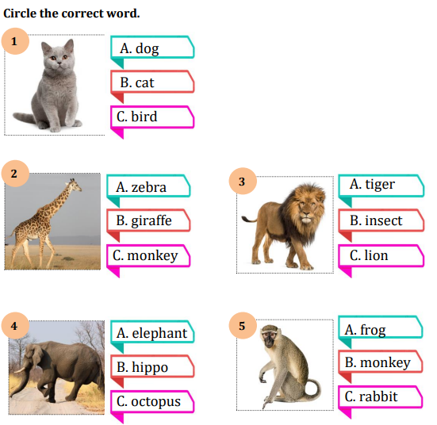  - Check with whole class  - Say goodbye | - Do assessment  - Check with teacher  - Say goodbye

________________________________

UNIT 3. ANIMALS
Lesson 2. Task 4, 5, 6
Period 35
I. OBJECTIVES:
1. Knowledge:
Students will be able to learn the sentence patterns: These are…/ Those are… and review the words related to animals in plural forms.
2. Competences:
- English competences: Students will be able to talk about animals near and far in distance
- Common competences: Students will develop their cooperative skill in composing song and making their own zoo
3. Qualities:
- Students will think about animals and be nice with them
II. EQUIPMENT AND MATERIALS:
- For Teacher: PP, TV, flashcards, track 3.6, track 3.7, handout, set of 6 pictures
- For students: A0 paper, pen, crayons
III. LESSON PROCEDURE:
Activity 1: Warm up (5 minutes)
Teacher’s Activities | Students’ Activities
Butterfly Catching Game  Teacher prepares flashcards or slide to review ten animals: elephant, giraffe, lion, monkey, frog, zebra, hippo, bird, owl, tiger and this is a …/ that is a...  Teacher splits sts into 2 teams. Name each team after their favourite animal. 2 teams are going to play Butterfly Catching with each other. Sts choose a butterfly to catch. The team can rob the flag first and answer correctly the animal behind the chosen butterfly, that team gets the point. Who catches most butterflies will be the game winner.  - Set context: two animals are having a very important contest. The animal that catches most butterflies will become the King of the majesties’ forest.  - Set game rules  - Play as a sample  - Have teams choose a butterfly to catch  - Answer the question hidden behind  - Mark the team that has correct answer  - Award the new king of the forest | - Listen to teacher  - Work in two teams  - Name the teams  - Listen to the game instructions  - Choose a butterfly  - Drop the flag  - Answer the question
Activity 2: Presentation (8 minutes)
Teacher’s Activities | Students’ Activities
Task 4: Listen and repeat  Context: Alex takes us to the zoo today. He’s a good tour guide. He wants us to visit the two nicest animals at the zoo. Guess what they are.  - Show the picture of Alex with two monkeys  - Ask sts to listen and repeat  - Show the picture of giraffes  - Ask sts to listen and repeat  - Ask sts to take turn to practise as a tour  - Perform in front of class  - Note how to use These are and Those are  Check: Lissten, Point and Repeat.  - Use the cards of animal and put in near and far distance.  - Say sentences using These are/Those are...  - Sts listen to T and point to animals in different distance correctly. Sts repeat after pointing. | - Listen to teacher  - Guess what animals are  - Look, listen and repeat  - Practise saying the two sentences  - Perform with friends  Listen, point then repeat.
Activity 3: Practice (14 minutes)
Teacher’s Activities | Students’ Activities
Task 5: Point and say  -Ask sts to work in 8 groups  - Hand them 6 pictures in task 5  - Ask group to draw pointing hands which implicit these/ those  - Set context: Now, you are tour guides at the zoo. Take turn to show your friends the animals at the zoo.  - Sts practice picking up the pictures in turn and say the sentence  - Say BINGO when all group members have at least a chance to say  - Go around to provide help when needed  Task 6: Listen and sing  -Set context: Do you want to be animals’ friends? Do you want to be superman to understand what animals are saying? Let see what animal has the closest relationship with human.  - Have sts guess the animal  - Show the picture of monkeys.  - Ask: what do monkeys say?  - Play the sound ooh, ooh  What animals else do you want to be their friends?  - Show a picture of lions  - Ask: What do lions say?  - Play the sound roar, roar  - Read the song lyric:  - Show the lyric one by one  - Ask sts to listen and repeat  - Model singing:  - Tell sts if they want to understand animals and become their friends, you have to know how to sing and dance with them  - Show sts to pretend to act as monkeys and say monkeys’sound  - Pretend to act as lions and say lions’ sound  - Play the song once for sts to listen to and act along  - Sing the song  - Ask sts to sing and act along several times  - Have monkeys and lions show in groups, in pairs | - Work in 8 groups  - Receive the pictures  - Draw pointing hands  - Listen to teacher  - Pick and say  - Say BINGO  - Answer the teacher’s questions  - Guess names of animals  - Look at the picture  - Say the monkey sound  - Look at the picture  - Say the lion sound  -Repeat the song lyric  - Listen and act along  - Sing and act along  - Join the show
Activity 4: Production (9 minutes)
Teacher’s Activities | Students’ Activities
Animal show  - Ask sts to work in 4 groups  - Ask groups to find more animals and make their sound on posters  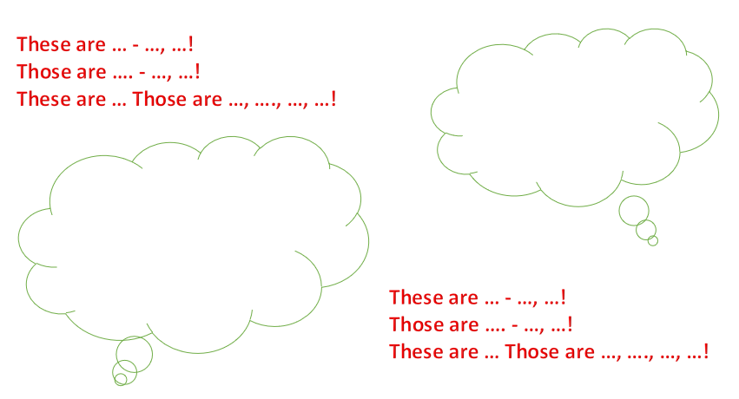  - Give sts time to create their own song version  - Groups perform their song in turns  - Vote for the best performance | - Work in 4 groups  - Create new song versions  - Perform in front of the class  - Vote for the best performance
Activity 5: Assessment (3 minutes)
Teacher’s Activities | Students’ Activities
-Ask sts to do assessment  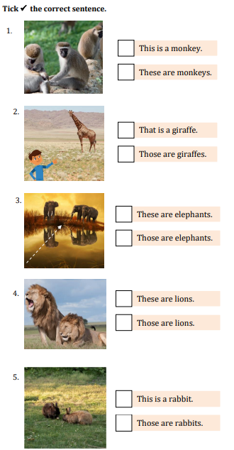  - Check with whole class  - Say goodbye | - Do assessment  - Check with teacher  Answer:  1.These are monkeys.  2. That is a giraffe.  3. Those are elephant.  4. These are lions.  5. Those are rabbits.  - Say goodbye
________________________________
UNIT 3. ANIMALS
Lesson 2. Task 7, 8, 9
Period 36
I. OBJECTIVES:
1. Knowledge:
Students will review grammar and vocabulary about animals
2. Competences:
- English competences: Students will be able to introduce animals properly
- Common competences: Students will develop their self-study ability in joining hard activities during the lesson
3. Qualities:
- Students will pretend to be animals and raise awareness about protecting animals
II. EQUIPMENT AND MATERIALS:
- For Teacher: PP, TV, flashcards, track 3.8, handout, set of 6 pictures
- For students: A0 paper, pen, crayons, personal board
III. LESSON PROCEDURE:
Activity 1: Warm up (7 minutes)
Teacher’s Activities | Students’ Activities
Snow White and Seven Dwarfs Game  Teacher prepares slide to review 7 animals: lions, tigers, hippo, rabbit, giraffe, elephants, monkeys, and grammar: This is a ... / That’s a …/ These are … and Those are …  -Set context: Snow White and Seven Dwarfs are playing hide-and-seek. Please help Snow White find Seven Dwarfs by answering the questions. Sts look at the picture and write the correct letter A, B, C, D on the board. Raise the board and the whole group say aloud the sentence.  - Arrange sts to work in 8 groups  - Hand each group a personal board and marker.  - Set game rules  - Play as a sample  - Give sts time to play the game  - Award the winner | - Listen to teacher  - Form group  - Take boards and markers  - Listen to game instruction  - Watch the demo carefully  - Join the game
Activity 2: Listening (8 minutes)
Teacher’s Activities | Students’ Activities
Task 7: Listen and tick  Pre-listening:  Snow White and Seven Dwarfs invite you to visit their house. There are many animals living in their house, too. Snow White introduces them to you. guess what animals are.  - Show the task  - Ask sts to guess animals living in their house  While listening:  - Ask sts to listen and tick to check  - Ask sts to check with a peer  - Check with whole class  Post listening:  -Ask sts to take turn introducing the animals | - Listen to teacher  - Look at the task  - Give answer  - Listen and tick  - Check with a peer  - Check with teacher  - Introduce animals
Activity 3: Speaking (17 minutes)
Teacher’s Activities | Students’ Activities
Task 8: Let’s play  Preparation:  Sts can play in teams or individually. Teacher prepares golden ears on screen. Sts choose one ear, listen to the sound of animals. Then write and say the name of the animal as fast as possible. The first correct answer will get the point.  Golden Ears Game  - Set context: your school is going celebrate the Golden Ears Contest to find out the Embassy for wild animals. The prize is nearly 1 million dollars. You are going to take part in the contest.  - Set game rules  - Open an ear as a sample  - Let sts choose number of ears and play the game  - Ask sts to listen and say the name of the animals  - Award the winner  Let’s play:  - Ask sts to work in 4 groups  - Each group discuss and take turn to make the sound or act out one animal. The others guess the animal by saying aloud the sentence  - The first correct answer will get the chance to sound or act  - The team with the highest points wins the game  Task 9: Look and say  - Ask sts to work in 8 groups  - Give each group 5 pictures in task 9 and the following background  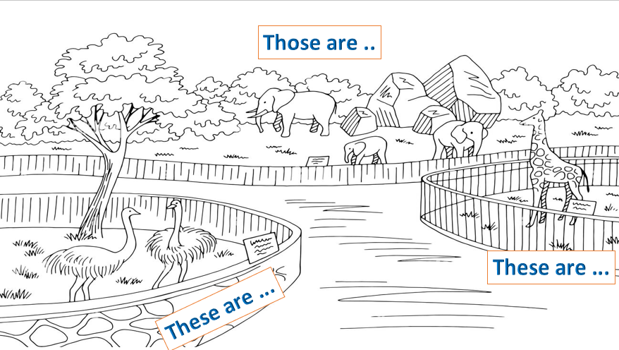  - Ask members of groups to take turn pick up a picture, place it in These are …/ Those are ... column then say the sentence.  - Go around to provide help when needed  Free speaking:  - Ask groups to draw their own These are .../ Those are poster  - Present their posters around the class  - Ask groups to talk by chance | - Listen to teacher  - Get the game rules  - Watch the sample carefully  - Choose an ear  - Listen, write and say  - Form 4 groups  - Discuss then make sound or action  - Say the sentences  - Form 8 groups  - Receive pictures and background  - Practice saying in group  - Draw zoo poster  - Present drawing works  - Talk about the animals at the zoo
  1. | Sound of monkeys | Picture + monkeys
  2. | Sound of cats | Picture + cats
  3. | Sound of lions | Picture + lions
  4. | Sound of elephants | Picture + elephants
  5. | Sound of dogs | Picture + dogs
  6. | Sound of parrots | Picture + Parrots
  7. | Sound of birds | Picture + birds
  8. | Sound of ducks | Picture + ducks
Activity 4: Assessment (3 minutes)
Teacher’s Activities | Students’ Activities
-Ask sts to do assessment  Listen and number  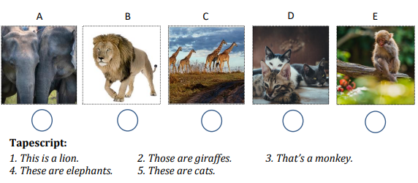  - Check with whole class  - Say goodbye | - Do assessment  - Check with teacher  Answer  1.B  2. C  3. E  4. A  5. D  - Say goodbye
__________________________________

