UBND HUYỆN VĨNH BẢO  TRƯỜNG TH VĨNH AN | ĐỀ KHẢO SÁT CHẤT LƯỢNG GIỮA HỌC KỲ I  MÔN TIẾNG ANH LỚP 4  NĂM HỌC 2025 - 2026  (Thời gian làm bài: 40 phút)
Name: ………………………….. Class: ………………………..
I. LISTENING
Question 1. Listen and number (1pt)
a.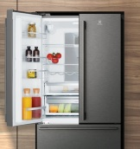 b. 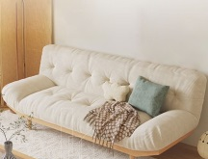 c. 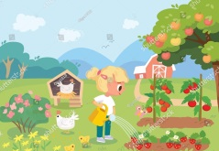 d. 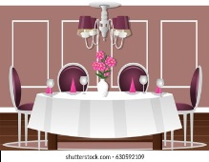

Question 2. Listen and tick ( ) (1pt)
1. A. My father is kind and friendly. B. My father is kind and polite.
2. A. There are five people in my family. B. There are four people in my family.
3. A. My uncle is nice. B. My uncle is hard-working.
4. A. My mother is in the garden. B. My brother in the garden.
Question 3. Listen and complete (1pt)
1. Who is she? – She is my _________ sister.
2. Where is the fridge? – It’s _________ to the chair.
3. What have they got on the farm? – They have got a _______________.
4. Have you got ________________ on the farm? – No, we haven’t.
II. READING
Question 4. Odd the one out (1.25pt)
1. A. pencil B. rubber C. great D. ruler
2. A. tidy B. very C. messy D. funny
3. A. dining room B. living room C. garden D. bookshelf
4. A. front B. sofa C. rug D. fridge
5. A. tall B. sheep C. goat D. horse
Question 5. Read and choose the correct answer (1.25pt)
1. _______________ is she? – She’s my sister.
A. How B. Who C. Whose D. What
2. What is your brother like? - He is ______________.
A. James B. between C. hard-working D. brother
3. The chair is ______________ to the fridge.
A. next B. opposite C. between D. in front
4. The horses haven’t got __________________.
A. legs B. hands C. tails D. fur
5. Have you got plants on the farm?
A. Yes, I do B. Yes, I haven’t C. Yes, I have D. Yes, I don’t
Question 6. Read and tick T (True) or F (False) (1pt)
This is my aunt Mary’s family. She’s got two sons, tom and Ben. Tom and ben are twins. they are 5 years old. They are good and funny. She’s got one daughter, too. Her name is Lucy and she is pretty. |  | T | F
 | 1. Aunt Mary has got two children.
 | 2. Tom and Ben are five years old.
 | 3. Mary’s got a daughter.
 | 4. Lucy is good and funny.

Question 7. Read and circle the correct answer (1pt)
1. Where are the spoons? | A. They’re next to the bowls. | 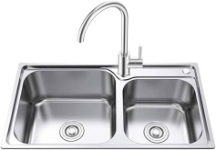
1. Where are the spoons? | B. They’re in the sink.
2. What have you got on the farm? | A. We’ve got some chickens. | 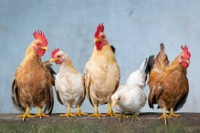
2. What have you got on the farm? | B. We’ve got some sheep.
3. Where is the sofa? | A. It’s in front of the table. | 
3. Where is the sofa? | B. It’s behind the table.
4. What haven’t the horses got? | A. They haven’t got long legs. | 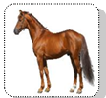
4. What haven’t the horses got? | B. They haven’t got wings.
Question 8. Look and write only one word in each blank (1,25pt)
This is my (1) 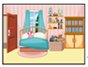_____________________. It’s between the living room and the (1) 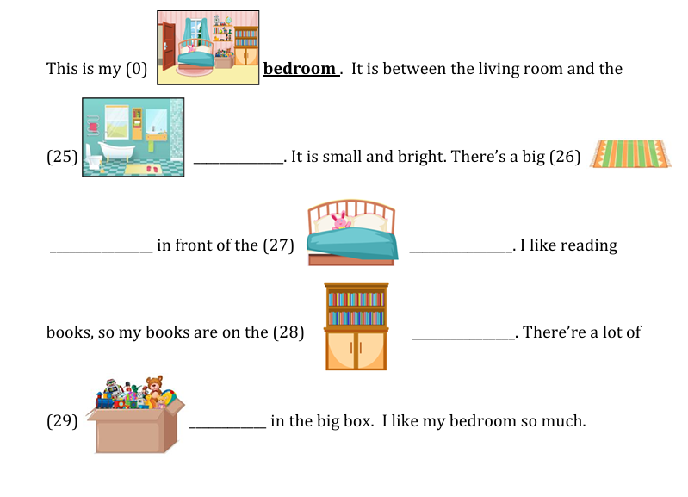________________. It’s small and bright. There’s a big (2) ________________ in front of the (3) _____________________. I like reading books, so my books are on the
(4) _________________. There are a lot of toys in the big box. I like my bedroom so much.
Question 9. Reorder the words to make the correct sentence. (1,25pt)
1. father / tall/ My / and / kind / is / .
_______________________________________________________
2. friends / cute / His / are / friendly / and / .
_______________________________________________________
3. next / It’s / bed / to / the / .
_______________________________________________________
4. The / have / fur / got / sheep / white / .
_______________________________________________________
5. got / have / on / some / fruit trees / you / farm / the / ?
_______________________________________________________

