UBND HUYỆN VĨNH BẢO  TRƯỜNG TH VĨNH AN | ĐỀ KHẢO SÁT CHẤT LƯỢNG GIỮA HỌC KỲ I  MÔN TIẾNG ANH LỚP 4  NĂM HỌC 2025 - 2026  (Thời gian làm bài: 40 phút)
Name: ………………………….. Class: ………………………..
I. LISTENING
Question 1. Listen and number (1pt)
a.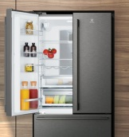 b. 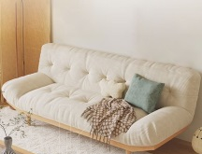 c. 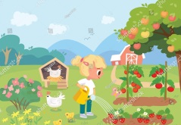 d. 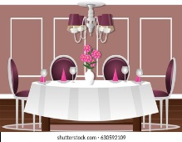

Question 2. Listen and tick ( ) (1pt)
1. A. My father is kind and friendly. B. My father is kind and polite.
2. A. There are five people in my family. B. There are four people in my family.
3. A. My uncle is nice. B. My uncle is hard-working.
4. A. My mother is in the garden. B. My brother in the garden.
Question 3. Listen and complete (1pt)
1. Who is she? – She is my _________ sister.
2. Where is the fridge? – It’s _________ to the chair.
3. What have they got on the farm? – They have got a _______________.
4. Have you got ________________ on the farm? – No, we haven’t.
II. READING/ Question 4. Odd the one out (1.25pt)
1. A. pencil B. rubber C. great D. ruler
2. A. young B. polite C. cousin D. funny
3. A. sister B. son C. brother D. twins
4. A. clever B. friend C. hard-working D. polite
5. A. her B. he C. she D. I
Question 5. Read and choose the correct answer (1.25pt)
1. The TV is ________ the sofa and the table.
A. next to B. between C. near D. behind
2. There are two ________ in the room.
A. bookshelves B. booshelfs C. bookshelvs D. bookshelf
3. Is there a sofa in our living room ?
A. No, there is B. No, it isn’t C. No, they are D. No, there isn’t
4. _______________ is she? – She’s my sister.
A. How B. Who C. Whose D. What
5. Have you got plants on the farm?
A. Yes, I do B. Yes, I haven’t C. Yes, I have D. Yes, I don’t
Question 6. Read and tick T (True) or F (False) (1pt)
Hello. There are five people in my family. This is my father. He’s friendly and kind. That is my mother. She’s hard working and pleasant. These are my twins brother. They are young and clever. And I’m Mary. I’m cheerful and cute. |  | T | F
 | 1. Mary’s family have five member.
 | 2. Her father is friendly hard-working.
 | 3. Mary has a brother.
 | 4. Her brothers are young and clever.
Question 7. Read and circle the correct answer (1pt)
1. Where are the spoons? | A. They’re next to the bowls. | 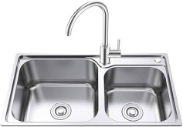
1. Where are the spoons? | B. They’re in the sink.
2. What have you got on the farm? | A. We’ve got some chickens. | 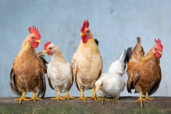
2. What have you got on the farm? | B. We’ve got some sheep.
3. Where is the sofa? | A. It’s in front of the table. | 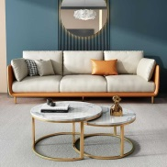
3. Where is the sofa? | B. It’s behind the table.
4. What haven’t the horses got? | A. They haven’t got long legs. | 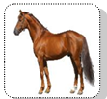
4. What haven’t the horses got? | B. They haven’t got wings.
Question 8. Look and write only one word in each blank (1,25pt)
This is my (0) 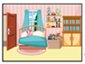 bedroom. It’s between the living room and the (1) 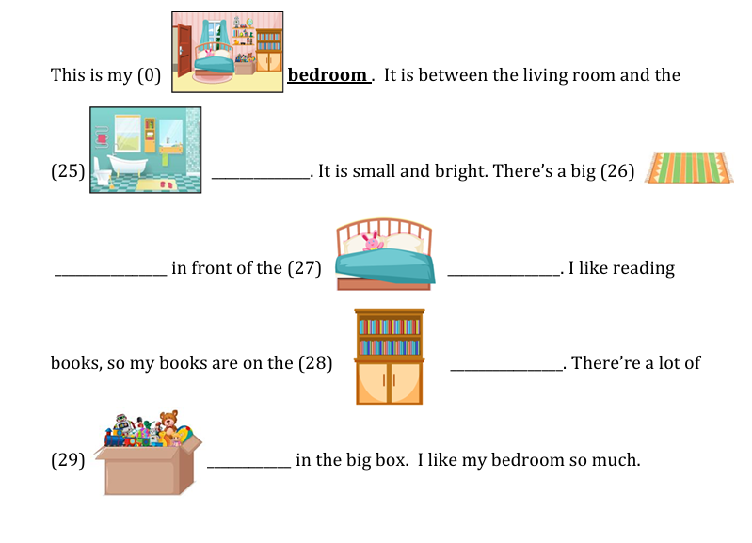________________. It’s small and bright. There’s a big (2) _______________ in front of the (3) _____________________. I like reading books, so my books are on the (4) _________________. There are a lot of toys in the big box. I like my bedroom so much.
Question 9. Reorder the words to make the correct sentence. (1,25pt)
1. father / tall/ My / and / kind / is / .
_______________________________________________________
2. friends / cute / His / are / friendly / and / .
_______________________________________________________
3. next / It’s / bed / to / the / .
_______________________________________________________
4. our / They / plates / are / .
_______________________________________________________
5. got / have / on / some / fruit trees / you / farm / the / ?
_______________________________________________________

