WEEK 14
UNIT 5. LEISURE TIME
Fun time and project. Task 1, 2
Period 53

I. OBJECTIVES:
1. Knowledge: By the end of the lesson, Students will be able to
- Review words related to the topic Leisure activities and weather: jump rope, watch a film, stormy, cloudy, windy, and snowy.
- Review all the grammar in unit 5 through fun activities.
- Use the structures they have learnt to talk about in the project.
2. Competences:
- English competences: Students will be able to remember the words and structures they have learnt.
- Common competences: Students will have the opportunity to develop logical thinking and develop communication among friends.
- Core competences: motivation, communication, creativity, collaboration.
3. Qualities:
Students will:
- Develop a love for different leisure activities and be friendly to their friends in the class.
- Be confident and active in communicating with friends and their teacher.
II. EQUIPMENT AND MATERIALS:
- Student’s book, A4 paper, crayons.
- PowerPoint (PPT) presentation, projector/ laptop, speaker.
III. LESSON PROCEDURE:
Teacher’s Activities | Students’ Activities
Activity 1: Warm-up (10 minutes)
a. Aims: Review the words of leisure activities and the structures.
b. Procedure  Warm-up: Play a small game “Whack-a-mole”  T divides the class into 2 teams.  T introduces the rule of the game:  (Game: Whack-a-mole  - T calls SS from each team to choose a number and answer the question.  If he/she answers correctly, T helps them to write this number to get points.  At the end of the game, which team that has more points will be the winner.)  T asks Ss to repeat after checking.  (1. Where are they playing board games?  2. What is he doing?  3. What can you see? – Play video games  4. Where is he reading comic books? – In the bedroom.  5. The letter “J” makes the sound /dʒ/.  6. What’s the weather like today? - It’s windy.  7. What is the weather like in spring? – It’s warm.  8. What are they doing? – They’re playing on the seesaw.)  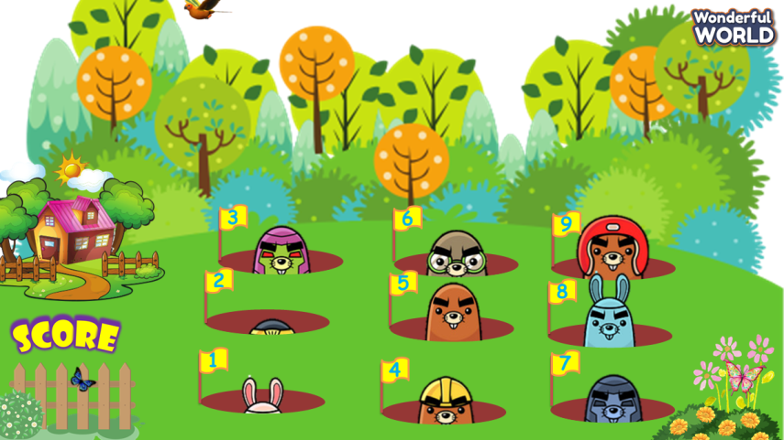  Lead in:  - T introduces that they will review “leisure activities” and present about a wonderful day.  - Write on the board “Leisure time” and introduce the lesson. | - Listen to the game rules.  - Play the game.  - Repeat after the teacher.  - Listen to the teacher.
Activity 2: Practice (12 minutes)
a. Aims: Review the words of leisure activities and weather
b. Procedure  Task 1: Unscramble the letters.  - Ask SS to look at the picture and identify what activity and weather they can see in each picture.  (stormy, jump rope, windy, cloudy, snowy, watch a film)  - Ask SS to work in pairs in 2 minutes.  -Ask SS to play a small “Who’s faster?”  (Game: Who’s faster?”  T divides the class into 2 teams.  2 SS of 2 teams look at the same word which is unscrambled, and SS has to spell the letters, then the full word as soon as possible.  Who is faster gets points. Which team has more points will be the winner.)  - Check their answer and give their feedback.  - T can give the winner stars or stickers.  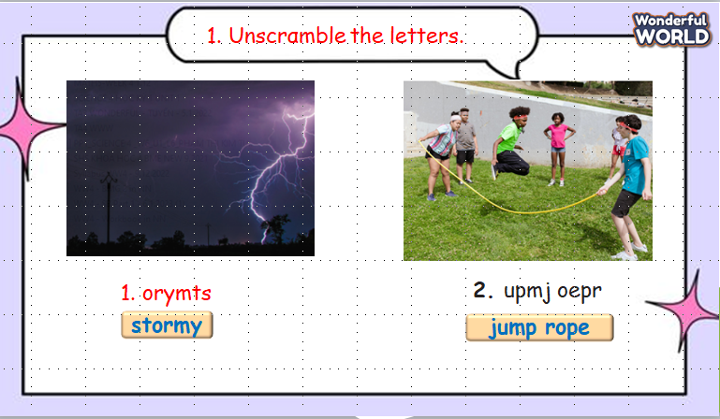 | - Look at the picture and describe it.  - Answer the teacher.  - Work in pairs.  -Listen to the game rules.  - Play the game.
Activity 3: Project (10 minutes)
a. Aims: Draw and make a small conversation in the real world.
b. Procedure  Work in pairs.  - Ask SS to look at the slide and T guides them to draw a picture about leisure activities.  - Ask SS to use 2 structures to make a short dialogue.  (What are you doing?  Where are you ...?)  - Ask SS to work in pairs and do the project in 5 min. T can go around the class and help if necessary.  - Call some pairs to present in front of the class.  - Check and give feedback.  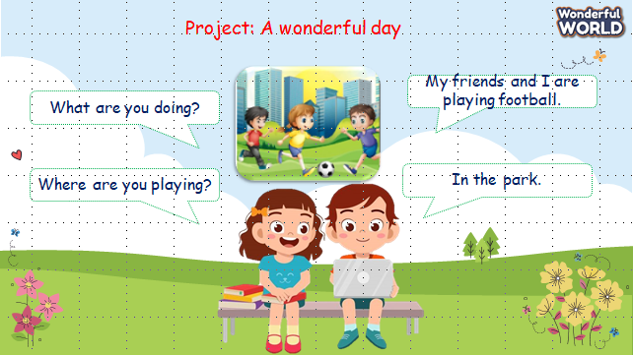 | - Look at the screen.  - Draw a picture of leisure activities.  -Make a short dialogue.  -Listen and work in pairs.  -Some pairs present in front of the class  - Listen to the teacher’s feedback.
Activity 5: Assessment (3 minutes)
Aim: Consolidate the content of the lesson.

b. Procedure  -Ask sts to do the assessment.  - Check with the class.  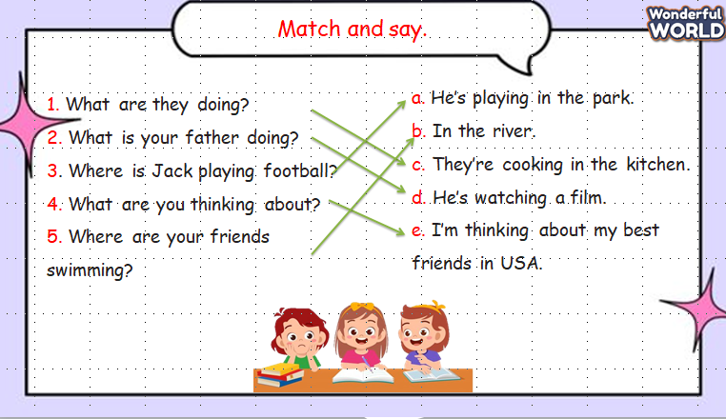 | - Do the assessment.  - Check with the teacher.
___________________________________________

UNIT 6. OUTDOOR ACTIVITIES
Lesson 1. Task 1, 2, 3
Period 54
I. OBJECTIVES:
1. Knowledge:
Students will learn how to talk about what someone is doing and vocabulary related to outdoor activities.

2. Competences:
- English competences: Students will be able to ask and answer about outdoor activities.
- Common competences: Students will have the opportunity to develop communication through role-play activities.
3. Qualities:
- Students will be friendly and confident in communicating with friends.
II. EQUIPMENT AND MATERIALS:
- Basic things: Student’s book, flashcards, crayons, paper, glue
- Advanced things: PPT, projector/interactive whiteboard/laptop/TV.
III. LESSON PROCEDURE:
Activity 1: Warm-up (5 minutes)
a. Aims: Lead in Ss and introduce them the topic and vocab of outdoor activities
Teacher’s activities | Student’s activities
- Greet students  - Students will choose to open a picture then ask and answer with it.  - Lead-in: Use the Unit Opener to lead in Ss to the lesson by answering some questions  + What can you see in the picture?  + What are they doing?  + Where are they? | - Greet teacher  - Listen and answer questions
Activity 2: Presentation (8 minutes)
Aims: Present new vocabularies related to outdoor activities
Teacher’s activities | Student’s activities
* New words:  - Demonstrate flashcards and ask Ss to guess what it is  - Ask them to listen and repeat words individually, whole class  - Check their pronunciation | - Listen and do the task.  - Check the answers.
Activity 3: Practice (12 minutes)
Aims: Do some tasks to apply knowledge and practice English skills
Teacher’s activities | Student’s activities
* Task 1: Listen and point. Repeat.  - Ask Ss to open the book p.64  - Listen to the audio and point and repeat one by one word  - Call some Ss to check  * Extra activity: Matching  - Ask Ss to look at pictures and words/phrases then let them match together  - Optional: T can print out the worksheet and give Ss to complete then swap to their partner to check the answers  * Task 2: Listen and read. Check.  - Open the picture and have them answer these questions – Brainstorming:  + What is he doing?  + Where is he?  + What’s the weather like?  - Open the book page 54 – Listen and read. Tick  - have Ss listen to the passage  - Call some Ss to read one by one sentence  * Practice game: Help the Pooh  - Tell Ss how to play the game  - Call some Ss to choose the correct answer in each question  - Award the student  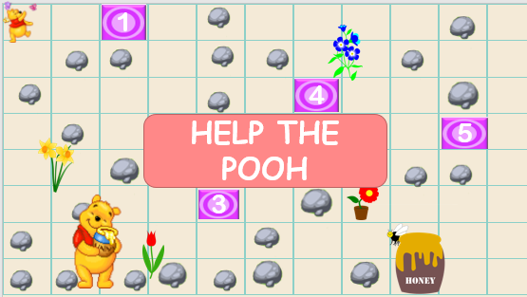 | - Open the book and do the tasks  - Answer the questions  - Stand up and read sentences in the passage  - Listen to the rule.  - Play the game.
Activity 4: Production (5 minutes)
Aims: Apply vocabularies into some specific tasks and develop the 4 skills
Teacher’s activities | Student’s activities
Task 3: Look and say  - Ask Ss open the book page 64  - Have Ss look at 4 pictures and work in pair to practise asking and answering  - T goes around and check their work  - Call some pairs to practise | - Listen the instruction.  - Work in pair.
Activity 5: Assessment and wrap-up (5 minutes)
Aims: Consolidate the content of the lesson, summarize knowledge and evaluate students’ learning competency.
Teacher’s activities | Student’s activities
* Assessment activity: Look at the pictures and write the correct answers  - Ask students to do the assessment.  - Check in pair then the whole class.  - Say goodbye | - Do the assessment.  - Check with friends and then with the teacher and the whole class.  - Listen carefully.  - Say goodbye.
____________________________________

UNIT 6. OUTDOOR ACTIVITIES
Lesson 1. Task 4, 5, 6
Period 55
I. OBJECTIVES:
1. Knowledge:
Students will learn how to talk about where someone can do in specific places and vocabulary related to outdoor activities.
2. Competences:
- English competences: Students will be able to ask and answer about outdoor activities and abilities.
- Common competences: Students will have the opportunity to develop communication through role-play activities.
3. Qualities:
- Students will be friendly and confident in communicating with friends.
II. EQUIPMENT AND MATERIALS:
- Basic things: Student’s book, flashcards, crayons, paper, glue
- Advanced things: PPT, projector/interactive whiteboard/laptop/TV.
III. LESSON PROCEDURE:
Activity 1: Warm-up (5 minutes)
Aim: Review the vocabulary and grammar of the previous lesson and warm up Ss to lead in the next activity
Teacher’s activities | Student’s activities
- Greet students  - Warm up – Game: Charade  + Tell the rules of the game  + Ask Ss to join the game  + Adward points for the best students | - Greet teacher  - Listen and play the game
Activity 2: Presentation (10 minutes)
Aims: Lead in Ss to the lesson, brainstorm and think about activities with the use of possibility questions with Can
Teacher’s activities | Student’s activities
* Review – Gold Miner  - Tell ss how to play this game  - Review the previous lesson and choose any numbers to answer the question  * Brainstorming  - Divide class into 2 big groups and ask them to think about activities on the mountain and in the park in 2mins.  - Demonstrate the answers on the mind map and present  - Adward stars for each team  * Task 4: Listen and repeat (p.65)  - Ask Ss to open page 65 and listen to the audio  - Pay attention intonation and stress  - Have them practice the task in 2 minutes  - Then call some pairs to check | - Listen and do the task.  - Check the answers.  - write the answers in the map  - Demonstrate it in front of the class  - Listen to the audio  - Practise in pairs
Activity 3: Practice (10 minutes)
Aims: Controlled practice: Help Ss to practice the vocab and new grammar with What questions and possibility Can by doing some tasks in SB and a game
Teacher’s activities | Student’s activities
* Task 5: Look and say  - Ask Ss to open the book p.65  - T models with any student to ask and answer questions  - Then have Ss to work in pairs to practice picture 1-4  - T goes around and check  - Call some pairs to check  * Extra activity: Catching butterflies  - Explain the rules of the game  - Have Ss play the game in 2 teams  - Have them choose and answer questions  - Adward stars for the correct answer | - Open the book and do the tasks  - Work in pairs  - Listen to the rules  - Play the game
Activity 4: Production (5 minutes)
Aims: - Apply to make a similar conversation about what someone can do in a specific place
- Encourage Ss to be self-confident when they ask and answer questions
Teacher’s activities | Student’s activities
Task 6: Let’s talk (p.65)  - Ask Ss open the book page 65  - Have Ss pick any card  - Let them ask and answer what you can do in the place.  - Listen and check pronunciation  - Award stars | - Listen the instruction.  - Work in pair.
Activity 5: Assessment and wrap-up (5 minutes)
Aims: Consolidate the content of the lesson
Teacher’s activities | Student’s activities
* Assessment activity: Choose the correct answer  - Ask students to do the assessment.  - Check in pair then the whole class.  - Say goodbye | - Do the assessment.  - Check with friends and then with the teacher and the whole class.  - Listen carefully.  - Say goodbye.
___________________________

UNIT 6. OUTDOOR ACTIVITIES
Lesson 2. Task 1, 2, 3
Period 56
I. OBJECTIVES:
1. Knowledge:
- Students will learn words related to the topic Outdoor activities: go camping, make a campfire, pitch a tent, walk the dog
- Learn and use new grammar: Can statements with But (possibility)
2. Competences:
- English competences: Students will be able to describe the outdoor activities and where they can do those activities.
- Common competences: Students will have the opportunity to develop communication among friends.
3. Qualities:
- Students develop a love of the outdoor activities and physical activities.
- Be confident and active in communicating with friends and teachers.
II. EQUIPMENT AND MATERIALS:
- For Teacher: PPT, flashcards, blank papers, crayons, track 6.4, track 6.5.
- For students: textbook
III. LESSON PROCEDURE:

Activity 1: Warm-up (5 minutes)
Aim: warm-up activity to review the word from the previous lesson and introduce new the topic.
Teacher’s Activities | Students’ Activities
- Greet the Ss  - Ask Ss to join a game  Warm-up: Play a small game “Catch the word”  T divides the class into 4 teams.  T introduces the rule of game:  (Game: Catch the word  - Each team will stand in lines. The first SS will be given a word and they must draw a picture according to that word.  After finishing, the picture will be passed down to the next one to re-draw. The last SS will write down the answer on the paper.  Each turn will last for 1’30s.)  T asks Ss to repeat after checking.  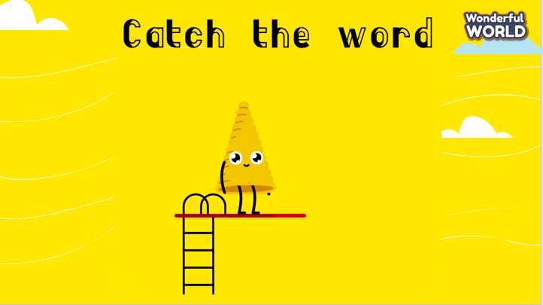  Lead in:  - T introduces that they will learn vocabulary about “Outdoor activities” in English.  - Write on the board “Outdoor activities” and introduce the lesson. | - Greet the teacher  - Choose the team name  - Listen and play games.  - Look at the images and guess the words  - Repeat.  - Listen to T.
Activity 2: Presentation (10 minutes)
Aim:
Controlled practice: Help Ss to know the new words and practice the vocabulary of outdoor activities.
Encourage Ss to make full sentences relating to outdoor activities
Teacher’s Activities | Students’ Activities
Lead-in  - Asks Ss to talk about some outdoor activities they have joined, and introduces the 4 activities in this lesson.  Presentation:  - T explains what outdoor activities are.  - T shows the 4 words in Lesson 1 and asks SS to listen and repeat.  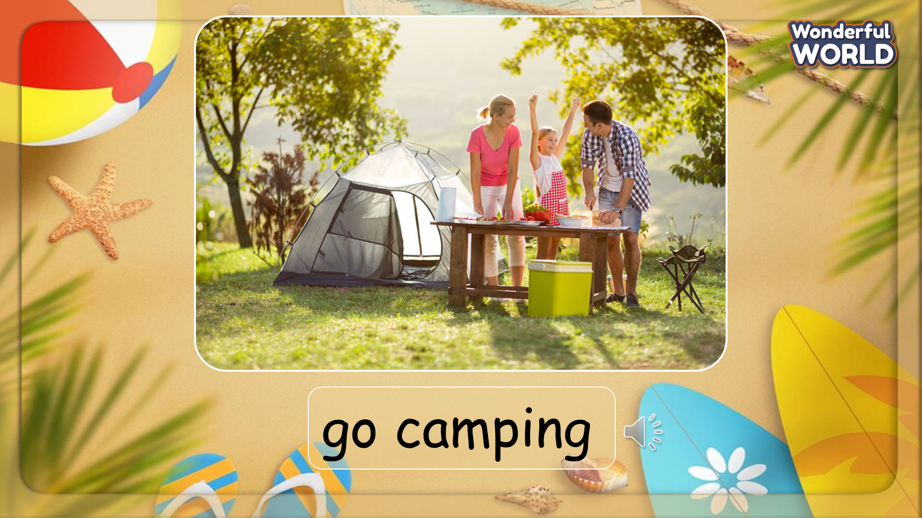 | - Discuss in groups  - Listen and answer.  - Repeat after the teacher.
Activity 3: Practice (12 minutes)
Aim: Practise new words, ask and answer using structure:
- Where can we …?
- We can …
Encourage Ss to use longer sentences while describing their activities.
Teacher’s Activities | Students’ Activities
Based on each task, the teacher will ask Ss to work individually, in pairs, or in groups.  Task 1: Listen and point. Repeat. Track 6.4  - Tell students to look at the vocabulary box on page 66. Ask if they know any of the words.  - Play the recording for students to listen and point. Say the words in a different order for students to listen and point.  - Play the recording again, pausing after each word for students to say the word.  - Invite pairs of SS to read the words aloud.  - Give their feedback.  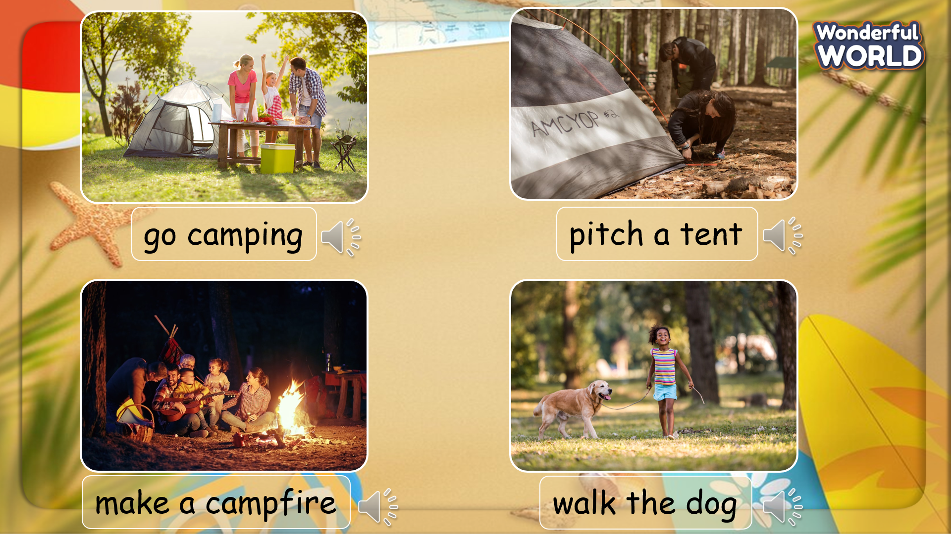  Task 2: Listen and read. Tick.  -Tell students that they are going to listen and read a dialogue about camping. Ask them to find the place mentioned on the map (Baja California, Mexico – see About the photo for more information)  - Ask some pairs to speak in front of the class. Encourage them to speak without looking at the screen.  - Give their feedback.  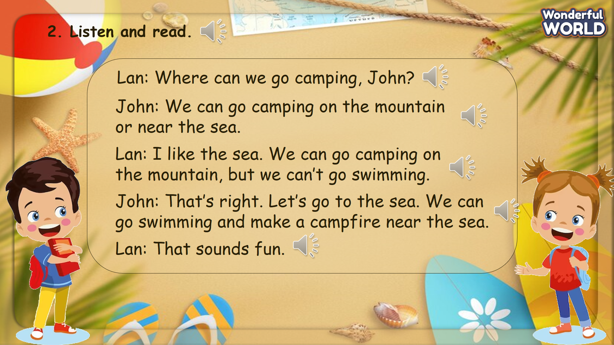  - Ask SS to look at the question and tick. Ask them to work individually.  - Invite some Ss to give out their answers.  - Give them feedback.  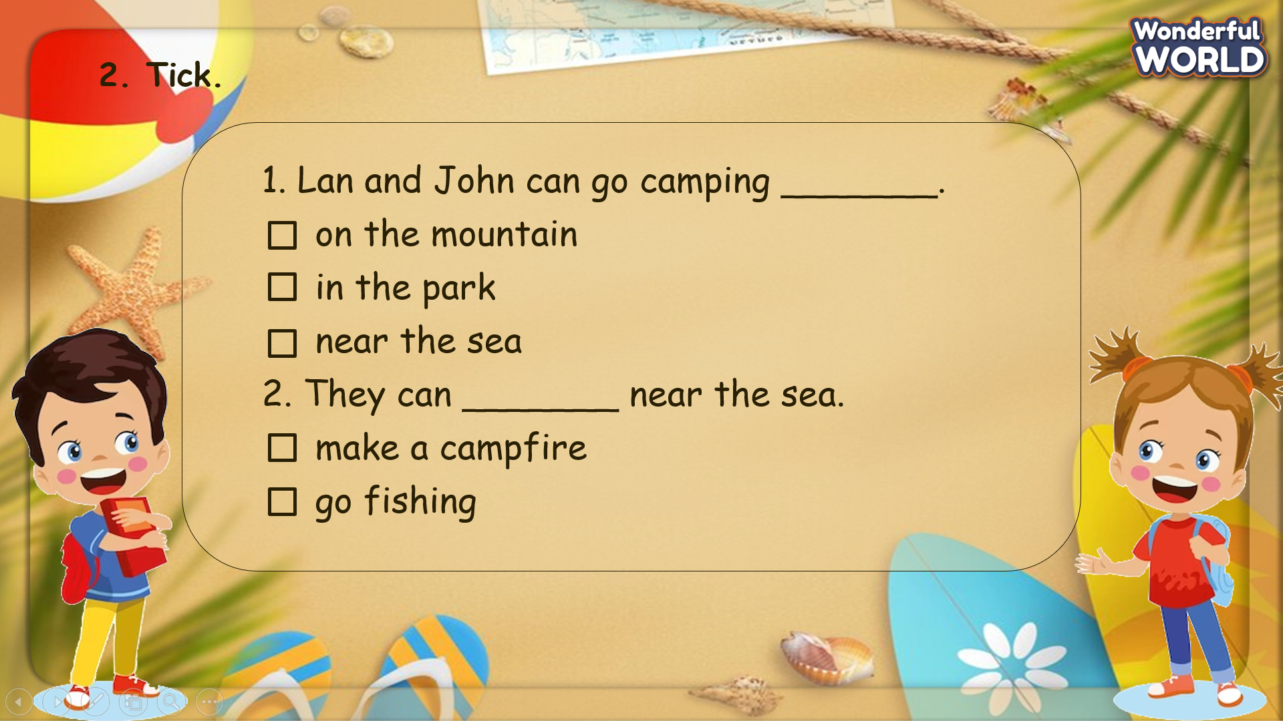  Task 3: Let’s play.  - Tell students to look at the two set of given words and the example sentences. Ask them to read the sentences aloud a few times.  - Ask students to match two sets and think about how to form sentences. Give students suggestions in case they have difficulties.  - Give students time to practice sentences in pairs.  - Ask some volunteers to read their sentences aloud in front of the whole class.  - Answers can vary  - Give them feedback.  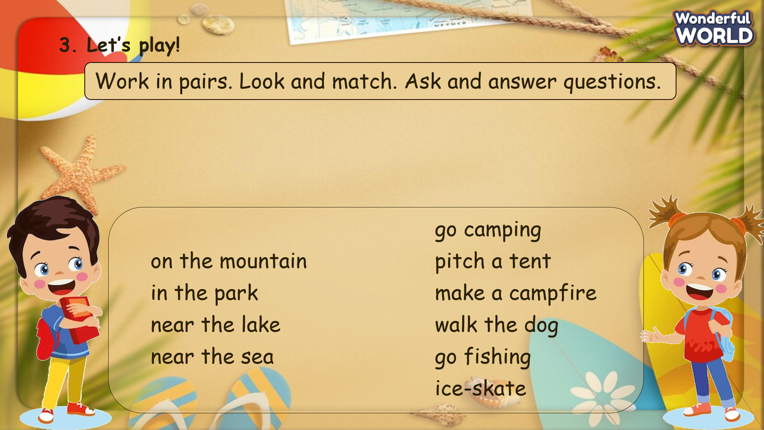 | - Look at the pictures and practice speaking in pairs.  - Work in pairs.  - Speak in front of the class.  - Look at the screen and listen to the whole conversation.  - Listen to each sentence and repeat.  - Practice the conversation in pairs.  - Speak in front of the class.  - Look at the screen. Read the sentences.  - Do the task individually.  - Stand up and read their answer aloud.  - Look at the screen and match the phrases.  - Try to explain how we can do outdoor activities on that place.
Activity 4: Production (9 minutes)
Aim: Join the game to review the words and structure
Teacher’s Activities | Students’ Activities
Let’s talk  - Ask SS to play a game called “Naruto game”.  - Introduce the rules of the game.  T divides the class into 2 groups. Each group will have a bell.  When the question is opened, each group will ring the bell to answer.  T click on the screen to reveal the answer. If the answer is correct, T click the screen again to open the mystery box. S can choose how many times they want to click to open (must <5 times).  If not, T click on the icon on the X right corner to go to the home screen.  When the game finishes, the group with the higher score will win.)   | - Listen to the rule  - Play the game.  Ring the bell to get the chance to answer.  - If the answer is correct, choose the times to open the box.
Activity 5: Assessment (3 minutes)
Aim: Do the exercise to review and remember the words
Consolidate the content of the lesson.
Teacher’s Activities | Students’ Activities
- Ask Ss the words they have learnt without looking at the book.  - Ask S to do the assessment to revive the lesson.  - Check with the class.  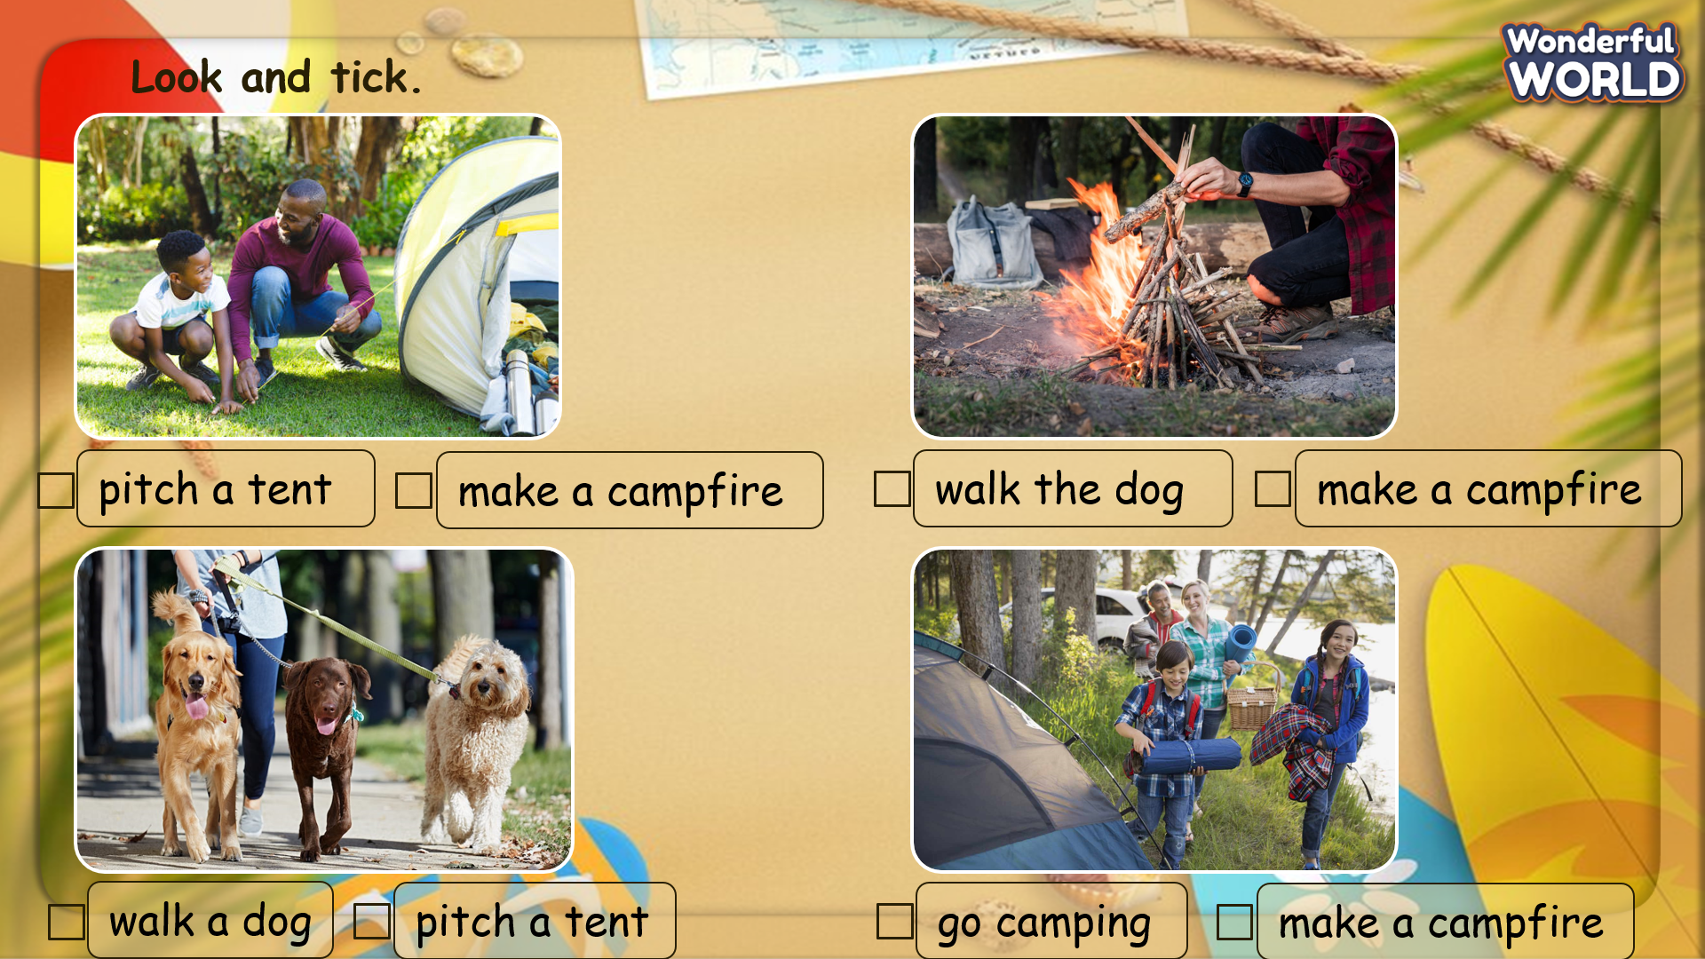 | - Do the assessment individually.  - Check with the teacher.

___________________________________

