WEEK 15
UNIT 6. OUTDOOR ACTIVITIES
Lesson 2. Task 4, 5, 6
Period 57
I. OBJECTIVES:
1. Knowledge:
Students will learn how to use can, can’t …
2. Competences:
- English competences: Students will be able to ask and answer about places.
- Common competences: Students will have the opportunity to develop communication through role-play activities.
3. Qualities:
- Students will be friendly and confident in communicating with friends.
II. EQUIPMENT AND MATERIALS:
- Basic things: Student’s book, flashcards, crayons, paper, glue
- Advanced things: PPT, projector/interactive whiteboard/laptop/TV.
III. LESSON PROCEDURE:
Activity 1: Warm-up (5 minutes)
Aim: Review vocabulary and grammar of the previous lesson
Teacher’s activities | Student’s activities
- Greet students  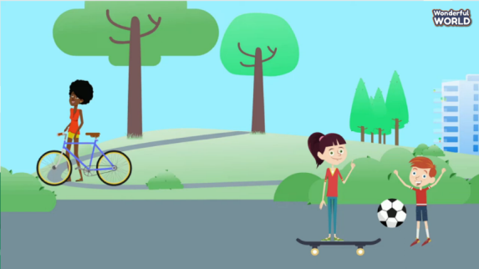  (Students will watch the video and memorize as many words as possible. After watching, students will be asked to write down all the words, groups with the most correct answer will win the game)  - Divide the class into 4 groups  - Set the game rules  - Play as a model.  - Have students play in turns.  - Award the best groups  Lead-in: Use the pictures of the game to lead in the new lesson. | - Greet teacher  - Sit in 4 groups  - Listen to the game rules  - Look  - Join the game  - Listen
Activity 2: Presentation (8 minutes)
Aim: Apply language to sentences; help Ss practice vocab and structures more effectively in pronunciation
Teacher’s activities | Student’s activities
Task1: Listen and repeat  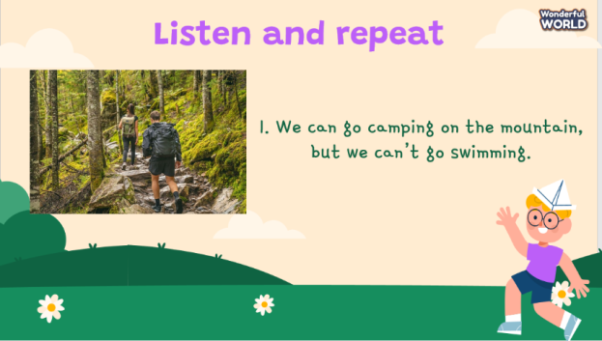  - Play the recording word by word and ask the student to memorize and repeat.  - Pay attention Ss’ pronunciation and intonation in each sentence  - Call some Ss to check and encourage Ss to do the best, award stars  - Optional: T can divide the class into 2 big groups and practice one by one | - Listen and repeat.
Activity 3: Practice (15 minutes)
Aim: To approach and apply model sentences in a sentence and practice how to form sentences; express structure what they can/ can’t do
Teacher’s activities | Student’s activities
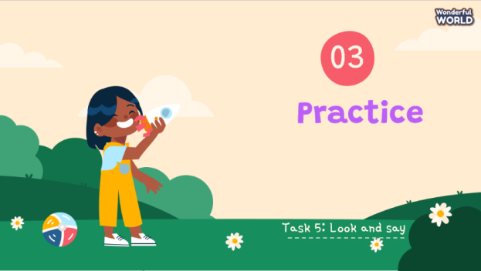  Task 2: Look and say (Track 6.6)  - Ask students to look and say the name of the activities in the pictures.  - Ask the students to read out loud.  - Play track 6.6.  - Play track 6.6 again, and ask students to listen and repeat in chorus, groups.  - Ask the students to do the exercise and check.  - Play track 6.6 one more time and show the answers.  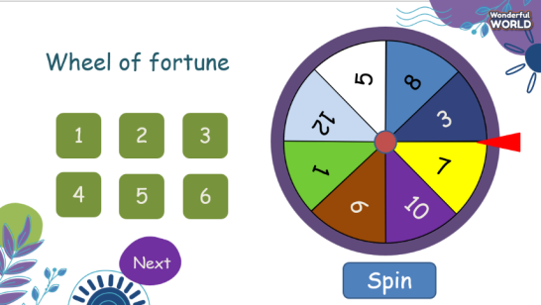  Game: Wheel of fortune  - Divide students into 4 groups. Each group will spin the wheel, choose the question and answer to get points.  - There are points for each correct answer. Group with highest score will be awarded. | - Look and say the activities.  - Learn the grammars.  - Read out loud.  - Listen  - Listen and repeat  - Repeat the conversation.  - Do the exercise and show the result - - Check with answers.  - Sit in groups and listen to the rule.  - Play the game.
Activity 4: Production (5 minutes)
Aims: - To guide sts how to use a chant; reviewing the lesson and knowledge
to check Ss’ understanding and remembering the lesson
Teacher’s activities | Student’s activities
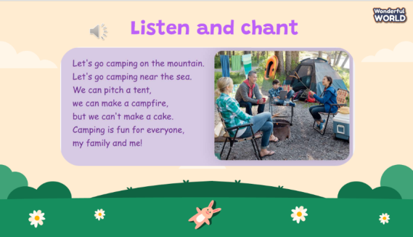  Task 6: Listen and chant  - Ask the students to listen and chant.  - Play track 6.7.  - Play track 6.7 again.  - Ask the students to chant. | - Listen to track 6.7.  - Chant
Activity 5: Assessment and wrap-up (3 minutes)
Aim: To do the exercise to review and summarize the lesson
Teacher’s activities | Student’s activities
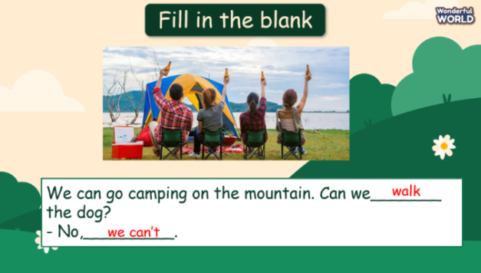  - Ask students to do the assessment.  - Check in pair then the whole class.  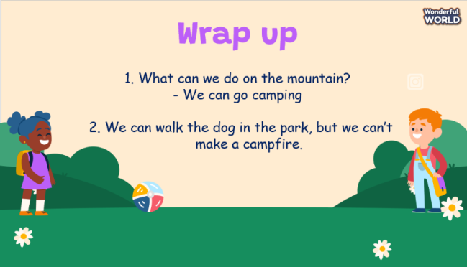  - Say goodbye | - Do the assessment.  - Check with friends and then with the teacher and the whole class.  - Listen carefully.  - Say goodbye.
__________________________________
UNIT 6. OUTDOOR ACTIVITIES
Lesson 2. Task 7, 8, 9
Period 58
I. OBJECTIVES:
1. Knowledge:
Students will learn how to use can, can’t …
2. Competences:
- English competences: Students will be able to ask and answer about places.
- Common competences: Students will have the opportunity to develop communication through role-play activities.
3. Qualities:
- Students will be friendly and confident in communicating with friends.
II. EQUIPMENT AND MATERIALS:
- Basic things: Student’s book, flashcards, crayons, paper, glue
- Advanced things: PPT, projector/interactive whiteboard/laptop/TV.
III. LESSON PROCEDURE:
Activity 1: Warm-up (5 minutes)
Aim: Review the previous period about vocab and structures, leading to the next activity
Teacher’s activities | Student’s activities
- Greet students  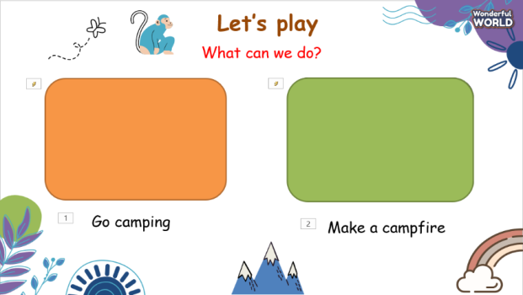  - Students will choose to open a picture then ask and answer with it.  - Lead-in: Use the pictures of the game to lead in the new lesson. | - Greet teacher  - Listen and do the task.
Activity 2: Presentation (8 minutes)
Aim: review the structure “can” do something and how to express ideas in order to take part in some activities
Teacher’s activities | Student’s activities
Task 7: Listen and match  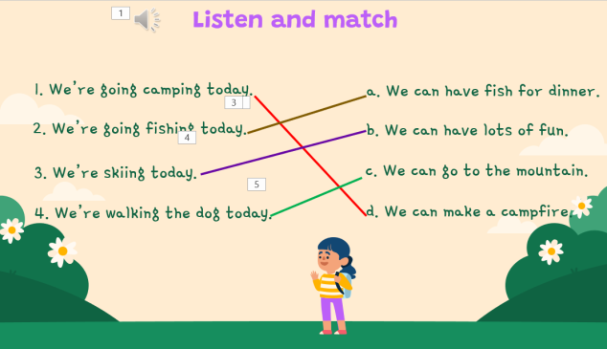  - Teacher asks the students to do read, listen and do the task.  - Play track 6.8.  - Play track 6.8 again.  - Check the students’ answers. | - Listen and do the task.  - Check the answers.
Activity 3: Practice (15 minutes)
Aim: Apply and practice language in words, sentences; help Ss practice through different activities
Teacher’s activities | Student’s activities
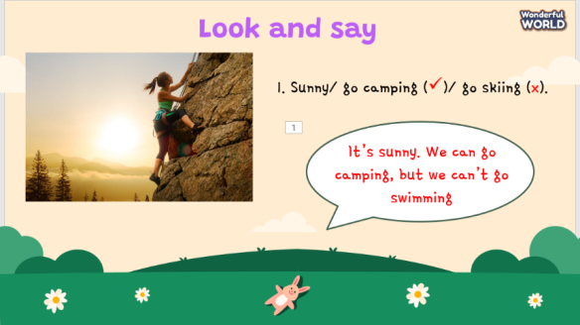  Task 8: Look and say.  - Show the pictures in task 3.  - Ask students to look at the picture and pay attention to the symbol or  ✅.  ❎  - Ask the students to make the sentences with the phrases.  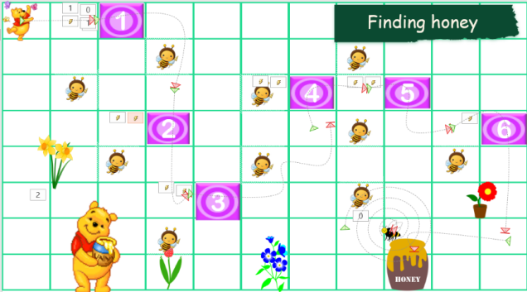  Game: Finding honey.  - Divide students into 4 groups. Each group will answer the questions to help the bear find the way to honey.  - There are points for each correct answer. Group with higher speed will gain higher scores.  - Play the games.  - Award the best groups. | - Look at the picture  ✅  ❎  - Identify is No and is yes  - Do the exercise.  - Sit in groups and listen to the rule.  - Play the game.
Activity 4: Production (5 minutes)
Aims: - Apply to make a similar conversation about what someone can do in the specific place; cannot do in different seasons
- Encourage Ss to be self-confident when they ask and answer questions
Teacher’s activities | Student’s activities
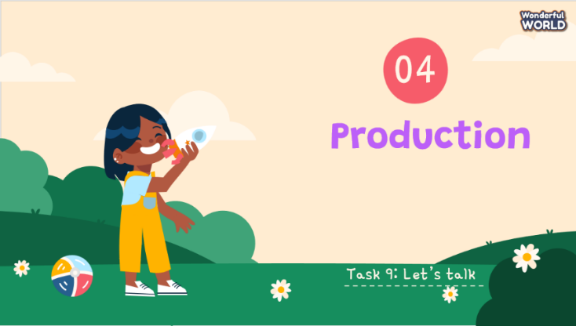  Task 9: Let’s talk  - Ask the students to read the bubble chat and talk about the activities of the pictures in the next slides.  - Students do the task in pair.  - Teacher goes around to check and support.  - Ask some pair to speak in front of the whole class. | - Listen the instruction.  - Work in pair.
Activity 5: Assessment and wrap-up (3 minutes)
Aim: Consolidate and summarize the content of the lesson
Teacher’s activities | Student’s activities
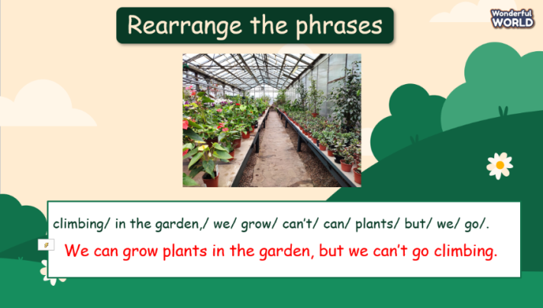  - Ask students to do the assessment.  - Check in pair then the whole class.  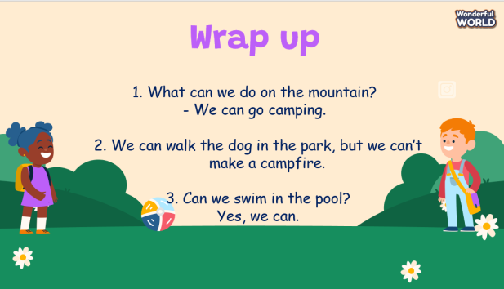  - Say goodbye | - Do the assessment.  - Check with friends and then with the teacher and the whole class.  - Listen carefully.  - Say goodbye.
__________________________________
UNIT 6. OUTDOOR ACTIVITIES
Lesson 3. Task 1, 2, 3
Period 59
I. OBJECTIVES:
1. Knowledge:
Students will learn and use new vocabulary: beach, forest, go hiking, have a picnic and learn and use new grammar: Can statements with Because (possibility)
2. Competences:
- English competences: Students will be able to talk about the natural places and the activities.
- Common competences: Students will have opportunity to say about their activities
3. Qualities:
- Students develop the love toward the natural places where they play and do the activities.
II. EQUIPMENT AND MATERIALS:
- For Teacher: PP, flashcards, handout, track 6.9, track 6.10
- For students: pens, A4 paper, crayons,
III. LESSON PROCEDURE:

Activity 1: Warm up (5 minutes)
- Aims: Review the knowledge of the previous lesson by playing a game
Encourage sts to get the students ready for the lesson by a song.
Teacher’s Activities | Students’ Activities
b. Procedure  Revise the words from Lesson 2 with flashcards. Hold up the flashcards or magazine pictures one at a time and ask volunteers to call out the words. Give the flashcards or magazine pictures to a volunteer and say three words quickly.  Tell the student to choose the correct three cards and put them in order. Invite other students to say words and to put the cards in order.  Elicil the lesson by the song with “ can”  Song : “ What can you do ?”  Link: https://www.youtube.com/watch?v=7MKmbyfhkkE | - Say the words.  - Choose and put them in order.  - Sts sing along and dance.
Activity 2: Presentation (8 minutes)
a. Aim: Present new vocabulary: beach, forest, go hiking, have a picnic
and introduce grammar of possibility “Can”.
Teacher’s Activities | Students’ Activities
b. Procedure  1 Listen and point. Repeat. TR: 6.9  • Tell students to look at the vocabulary box on page 69.  Ask if they know any of the words. Play the recording for students to listen and point to the correct pictures. Say the words in a different order for students to listen and point.  • Play the recording again, pausing after each word for students to say the word. | - Look  - Listen and point.
Activity 3: Practice (14 minutes)
a. Aim: Listen for comprehension and lead sts to speak following a model sentence.
Teacher’s Activities | Students’ Activities
b. Procedure  Set the context:  Tell students to look at the picture and guess which activity Mark and Nora decide to do (ride a bike in the forest)  2 Listen and match. TR: 6.10  New vocabulary: beach, forest, go hiking, have a picnic  • • Ask students to look at the matching task below the picture. Ask them to read the options and guess the answers.  • Play the recording and ask students to listen carefully.  • Ask students to match the activities and places where they are done.  • Ask some volunteers to act out the dialogue in pairs in front of the class.  • Check the answers with the whole class.  • Replay the recording if necessary.  Game “Protect the jungle” through the activity Look and say.  • Tell students to look at the first set of given words and the example sentences. Ask them to read the sentences aloud a few times.  • Ask students to look at other sets of words and think about how to form sentences. Give students suggestions in case they have difficulties.  • Give students time to practice other  sentences in pairs.  • Ask some volunteers to read their sentences aloud in front of the whole class.  Suggested answer:  1. It’s sunny. We can go to the beach.  2 It’s cold. We ride a bike in the forest.  3 It’s cool. We can go hiking on the  mountain.  4 It’s warm. We can have a picnic in  the park. | - Look and guess.  - Look and match  - Act out.  - Read aloud.  - Look.  - Practice.
Activity 4: Production (9 minutes)
a. Aims: Apply the learned knowledge to create a presentation/ own conversation (attached with illustrated craft)
Teacher’s Activities | Students’ Activities
b. Procedure  Let Sts think and draw about their activities what they like to do with their friends and family. Then say.  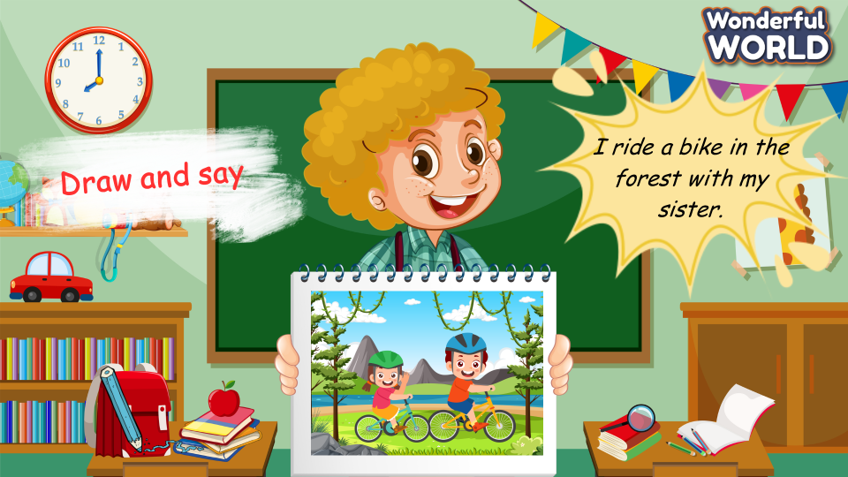 | - Think,  - Draw  - Say
Activity 5: Assessment and Wrap Up(3 minutes)
a. Aims: Consolidate the content of the lesson
Teacher’s Activities | Students’ Activities
b. Procedure  Let Sts read and choose, circle the correct option.  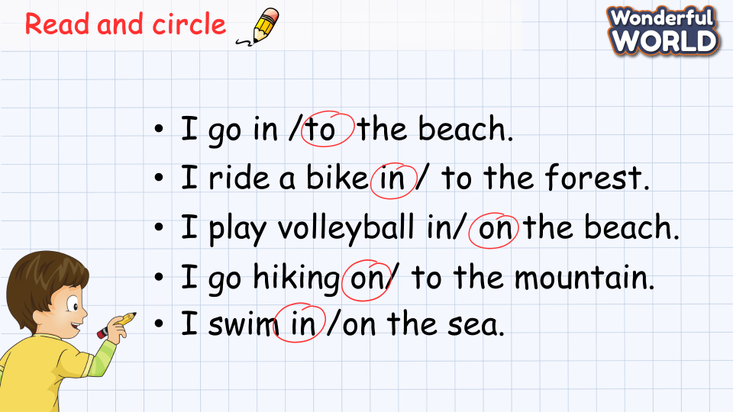  - Drill all words again and check for correct pronunciation  - Count stars and award stamps to winning team.  Say goodbye students | Read and circle.  - Join in with drilling words for their team  Ss stand up to say  - Goodbye Teacher.
_______________________________
UNIT 6. OUTDOOR ACTIVITIES
Lesson 3. Task 4, 5, 6
Period 60
I. OBJECTIVES:
1. Knowledge:
Students will review the vocabulary: beach, forest, go hiking, have a picnic
2. Competences:
- English competences: Students will be able to identify some more outdoor activities and 2 natural places
- Common competences: Students will have opportunity to talk about what someone
can or can’t do because of the weather
3. Qualities:
- Students develop the love forward natural places and raise the awareness of protecting them.
II. EQUIPMENT AND MATERIALS:
- For Teacher: PP, flashcards, handout, track 6.11
- For students: pens, student’s book.
III. LESSON PROCEDURE:

Activity 1: Warm up (5 minutes)
a. Aims: Review the knowledge of the previous lesson by listening the task and get ready for the lesson by the song.
Teacher’s Activities | Students’ Activities
- Greet the students.  - Divide class into 4 teams.  b. Procedure  Let Sts listen the sentences related to the lesson, especially the weather words. Then tick the correct words.  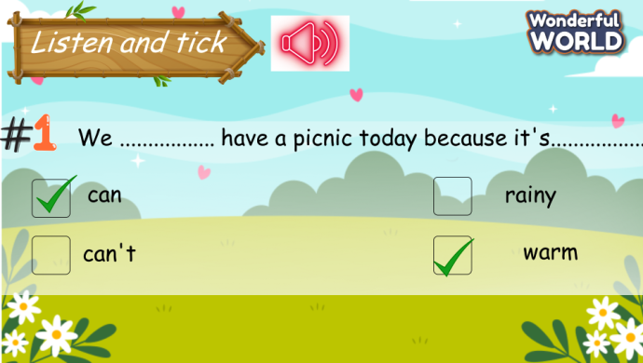  Elicit the lesson with the song:  “How’s the weather?”  https://www.youtube.com/watch?v=XcW9Ct000yY  T can ask the weather’s today to help S think about the weather word such as : sunny ; rainy…. | - Greet the teacher.  - Choose the team’s name.  - Listen and tick.  - Sing along.  .  - Answer the questions.
Activity 2: Practice (14 minutes)
a. Aim: Review the content of the lesson about the vocabulary and the ways to introduces clauses of cause and reason “because”
Teacher’s Activities | Students’ Activities
b. Procedure  4 Listen and repeat. TR: 6.11  • Play the recording. Tell students to look at the sentences and follow them with their fingers.  • Play the recording again. Ask students to repeat.  • Point to the sentences. Ask students to notice the use because in linking two clauses.  • Ask students to repeat sentences and link to the next activity.  Game: Treasure hunter, choose the numbers to look and say the sentence and then get stars.  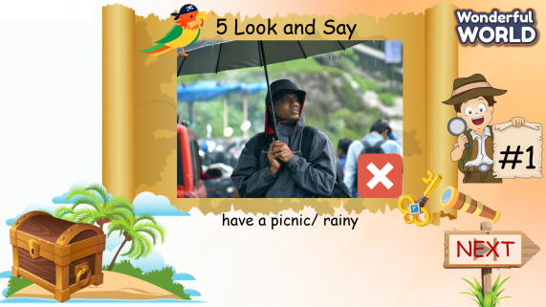  5 Look and say.  • Tell students to look at the pictures and the prompts. Read out loud the prompts and ask students to repeat.  • Tell students to look at the picture for sentence 1 and the example.  Read out the example and ask students to repeat.  • Explain the rest of the task to students. Allow them enough time to practise saying sentences  individually and then in pairs. Go round the class helping students where necessary.  • Ask volunteers to read out their  answers and play with the game. If they do it incorrect, correct any mistakes.  Keys :  1. We can’t have a picnic today because it’s rainy.  2 We can go fishing because it’s cool.  3 We can make a camp fire because it’s dry.  4 We can’t play ice hockey because it’s hot. | - Look and repeat.  - Play the game by look and say.  - Look.  - Read out.
Activity 3: Production (9 minutes)
a. Aims: Apply the learned knowledge to play the game (make the conversation)
Teacher’s Activities | Students’ Activities
b. Procedure  6 Let’s play.  • Tell students to work in pairs and make sentences together.  The first student begins the sentence with We can or We can’t, and the second one continues it with because.  Remind students to make sure of the logical link between two clauses.  • Go around the class helping students if necessary.  • Ask some volunteers to play the game in front of the whole class. Correct mistakes if necessary.  • Praise good combination of clauses.  • Optional activity: Divide the class into two sides. One writes sentences beginning with We can or We can’t, and the other writes sentences beginning with because. Then ask some volunteers to match random sentences and see if  the complex sentences are logical or meaningful. | - Work in pairs  - Play the game.  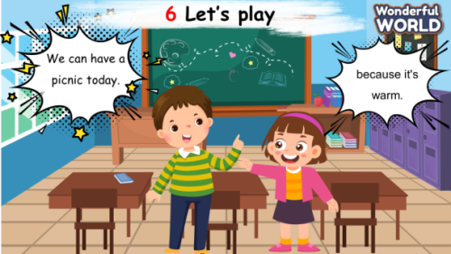
Activity 4: Assessment (3 minutes)
a. Aims: Consolidate the content of the lesson.
Teacher’s Activities | Students’ Activities
b. Procedure  Let Ss do the assessment .  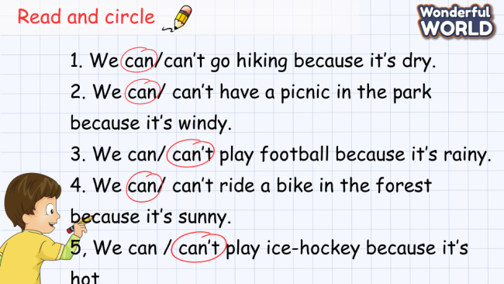  - Drill all words again and check for correct pronunciation  - Count stars and award stamps to winning team  Say goodbye students | Do the assessment.  - Join in with drilling words for their team  Ss stand up to say  - Goodbye Teacher

