WEEK 16
UNIT 6. OUTDOOR ACTIVITIES
Lesson 3. Task 7, 8, 9
Period 61
I. OBJECTIVES:
1. Knowledge:
Students will review words and phrases related to the Outdoor Activities Topic:
- identify and write g, sk
- identify and pronounce words with initial sounds /g/, /sk/.
2. Competences:
- English competences: Students will be able to talk about some outdoor activities.
- Common competences: Students will have the opportunity to develop the creativeness in speaking new phonics and develop communication among friends.
3. Qualities:
- Students get used to new phonics.
II. EQUIPMENT AND MATERIALS:
- For Teacher: PP, TV, music, related audio track.
- For students: Books, papers and pencils.
III. LESSON PROCEDURE:

Activity 1: Warm-up (5 minutes)
Aims: Start some greeting activities, words, and phrases that the students have learnt from the previous lesson.
Teacher’s Activities | Students’ Activities
Dance and sing: If You’re Happy.  - Ask students to watch the video  - Sing along to the song. | - Listen to the instructions carefully and watch the video.  - Watch the video again and sing along to the song.
Activity 2: Presentation (8 minutes)
Aims: Present new phonics: /h/ and /æ/, and teach students how to pronounce correctly
Teacher’s Activities | Students’ Activities
Vocabulary:  Task A: Listen and repeat. (track 9.12)  -Write “g” on the board. Ask students to say the  word. Then write “go” on the board.  -Write f on the board. Ask students to say  the word. Then write “ski” on the board.  Ask students to pronounce the sound for “sk” in  the word.  - Pronounce both sounds again and show  students how they are different from each other.  Point to each word on the board and ask students to  practise the sounds with you.  - Play the recordings and tell students to repeat  the words and the sentences. | - Join the game.  -Look and read.  -Read  -Identify and read.
- Let’s play a game.  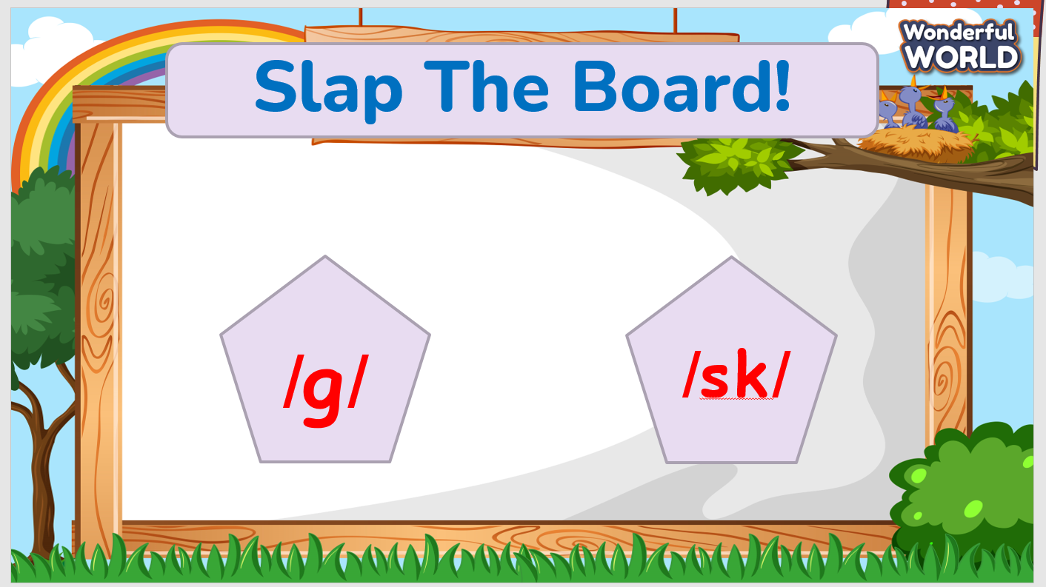  - Game: Slap the board.  - Teacher writes two phonics /g/ and /sk/ on the board.  - Pick 2 students from the class. Have them place against the class. The teacher reads out loud one of the words that contains the phonics, and the students must jump back and slap their hands on the correct phonic. The faster student is the winner.  - Then say the words and sounds. | - Listen to the rules carefully.  -Look and read.  -Read  -Identify and read.  - Check with friends and then with the teacher and the whole class.
Activity 3: Practice (14 minutes)
Aims: Review phonics: /h/ and /æ/ with leisure activities and practice the new phonics with the words. Chant the song correctly according to its lyrics.
Teacher’s Activities | Students’ Activities
1. The Starry night game.  - Practice words by playing a game.  2. Listen and repeat. (Track 6.12)  - Play TR: 6.12, pointing to each photo as students hear  the corresponding word.  - Have students repeat each word.  3. Listen and chant. (6.13)  - Point to the chant and say Listen. Play TR6.13 and have students just listen and read silently.  - Say Listen and chant. Play TR: 6.13 and have students practice the chant. | - Learn the words through pictures.  - Listen then circle.  - Repeat the words.  - Repeat the point.
Activity 4: Production (9 minutes)
Aims: Review words and phrases used in the unit by reading the sentences out loud.
Teacher’s Activities | Students’ Activities
1. Say it (Activity 9)  - Look at the pictures. Say the whole sentences. | - Say aloud the sentences  - Listen carefully  - Check with friends and then with the teacher and the whole class
Activity 5: Assessment (3 minutes)
Aims: Consolidate the content of the lesson.
Teacher’s Activities | Students’ Activities
-Ask sts to do the assessment  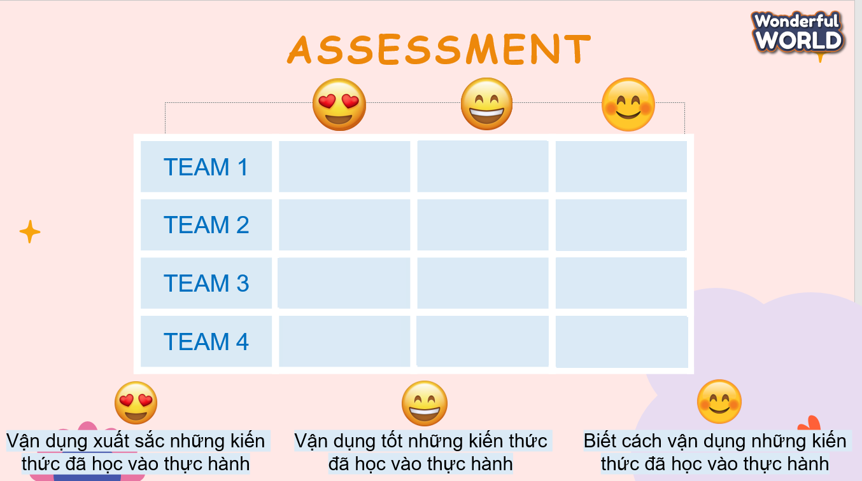  - Check with the class | - Do the assessment  - Work in pairs.
______________________________________________

UNIT 6. OUTDOOR ACTIVITIES
Fun time and project. Task 1, 2
Period 62
I. OBJECTIVES:
1. Knowledge:
- Students will review Outdoor Activities vocabulary and unit grammar.
2. Competences:
- English competences: Students will be able to remember the words and structures they have learnt.
- Common competences: Students will have the opportunity to develop logical thinking and develop communication among friends.
3. Qualities:
- Students develop love for different leisure activities and be friendly to their friends in the class.
II. EQUIPMENT AND MATERIALS:
- For Teacher: PP, TV, boards, markers, sweets.
- For students: A4 paper, books, pens, notebook/paper.
III. LESSON PROCEDURE:

Activity 1: Fun Time (10 minutes)
Aims: Elicit the words from the vocabulary about the outdoor activities.
Teacher’s Activities | Students’ Activities
WARM-UP : (3 MINUTES)  Clothes song  - Introduce the song  - Ask sts to review some vocabulary and do action  - Play the song: Ten Little Indians  Task 1: Unscramble (7 MINUTES)  Before unscrambling: Game  Ask sts to look at the screen and choose the characters they want. Then, answer all the questions and get stars  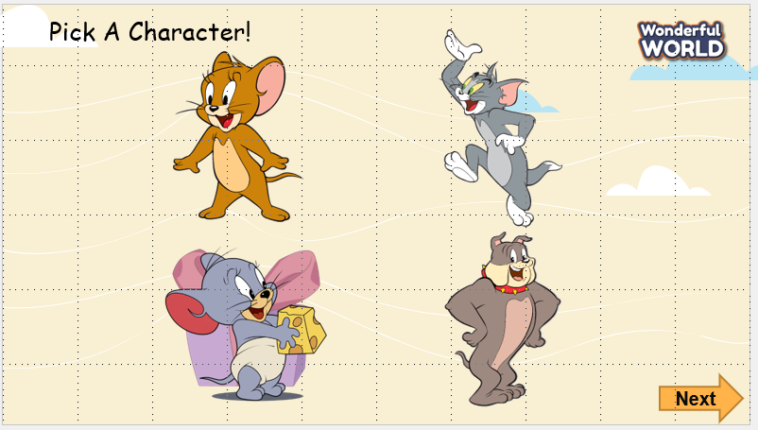  While gaming  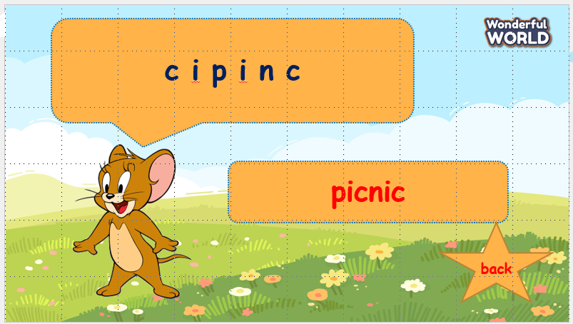  - Ask sts to work in groups  - Hand each group a print of task 1  - The sts will unscramble the words and get stars.  - The team, who gets the highest scores, will be the winner. | -Listen to the teacher  - Repeat and do the action  - Sing along and repeat the song.  Speak out correctly, paying attention to the pronunciation.  Do the game and get stars
Activity 2: Project (20 minutes)
Aims: Review phonics and words learned in the unit via fun activities (drawing) and quiz.
Teacher’s Activities | Students’ Activities
Project: Hobbies  Outdoor activities quiz  - Guides sts to play with the game and match the correct pictures with the correct words  - Anyone who can answer correctly will be given a star.  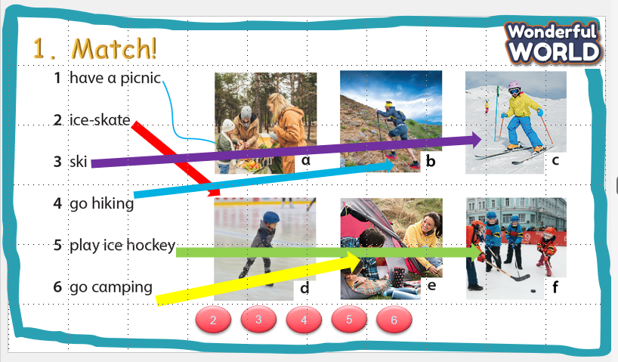  Project: Your Camp  - Tell them to draw a picture of a camp  - Colour the picture  - Ask sts to go to the board – group by group and present.  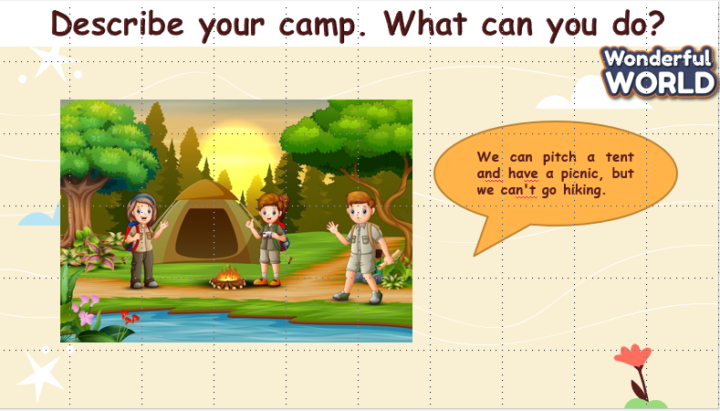 | - Listen to the teacher  - Listen to the game rules  - Look at the picture  - choose the correct answer  - show the board of correct answers.  -Talk to friends about the picture  - Read aloud the answers about objects.  - Write down the answer on their own board/book.
Activity 3: Assessment
Aim: Consolidate the content of the lesson.
Evaluation (2 MINUTES)  Answer the multiple choice and show answers  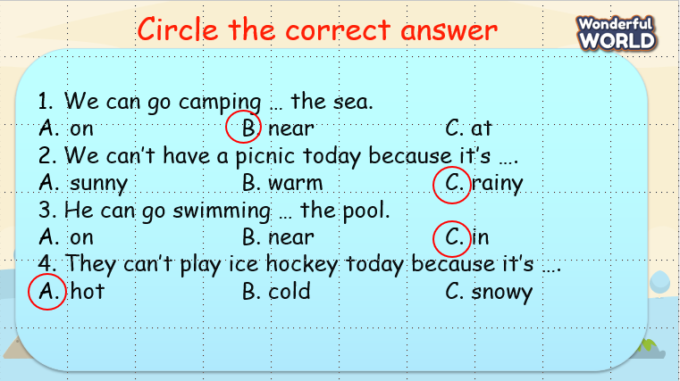  Home work (2 MINUTES) | - Do the assessment
_____________________________________________________________

REVIEW 3
Part 1. Task 1, 2, 3
Period 63
I. OBJECTIVES:
1. Knowledge:
- Students will review the words and structures related to the topic Outdoor Activities:
2. Competences:
- English competences: Students will be able to talk about outdoor activities.
- Common competences: Students will have the opportunity to develop communication among friends.
3. Qualities:
- Students will be responsible and well-behaved in communicating in the classroom with friends and others.
II. EQUIPMENT AND MATERIALS:
- Basic things: Student’s book, flashcards
- Advanced things: PPT, projector/interactive whiteboard/laptop/TV.

III. LESSON PROCEDURE:
Activity 1: Warm up (5 minutes)
Aims: Start greeting activities, phrases and sentences that the students have learnt from the previous lesson
Teacher’s activities | Student’s activities
- Greet students  Task 1: Unscramble (7 MINUTES)  Before unscrambling via a game  Ask sts to look at the screen and choose the characters they want. Then, answer all the questions and get stars  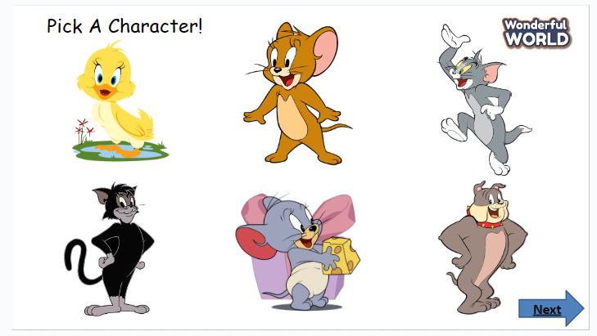  While playing  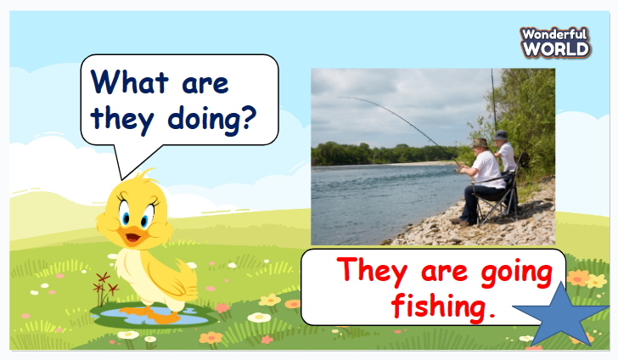  - Ask sts to work in groups  - Hand each group a print of task 1  - The sts will unscramble the words and get stars.  - The team, who gets the highest scores, will be the winner | - Greet teacher  - Sit in 4 groups.  - Listen to the game rules carefully  - Play game
Activity 2: Practice (20 minutes)
Aims: Review phonics and words of Outdoor activities learned in the unit via various activities from the book
Teacher’s activities | Student’s activities
Task 1: Match  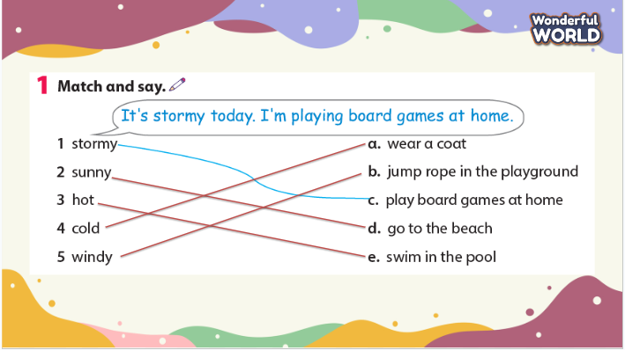  -Ask students to look at the questions 1–5 and their answers a–e. Look at the example as a class.  -Read the sentences aloud and ask students to repeat. Match the first sentence as a class.  -Check students understand the task. Allow enough time to complete it, alone or with a partner.  -Check answers as a class.  Task 2: Match  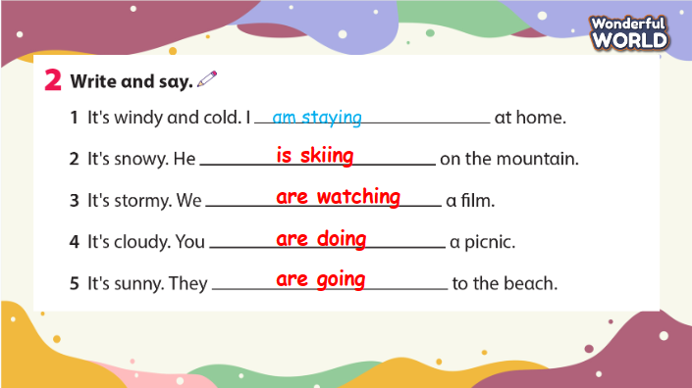  -Ask students to look at the questions 1–5 and look at the example as a class.  -Read the sentences aloud and ask students to repeat.  -Check if students understand the task. Allow enough time to complete it, alone or with a partner.  -Check answers as a class.  Activity: Talk about activities  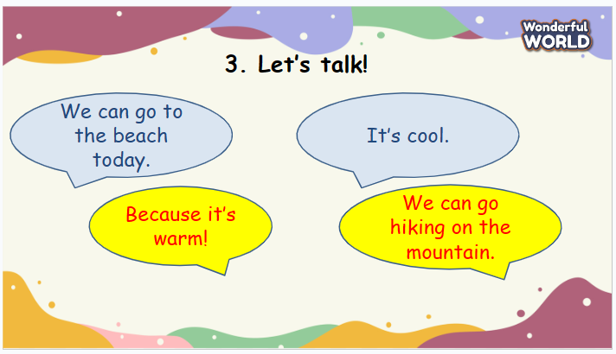 | -Look  -Answer  -Listen  -Do the crossword  -Check answers  -Look and read the example.  -Repeat  -Match  -Check answers with friends  -Listen  -Ask and answer the questions in pairs  -Check and practice in front of class
Activity 3: Assessment (10 minutes)
Aims: Consolidate the content of the lesson.
Teacher’s activities | Student’s activities
- Order and write.  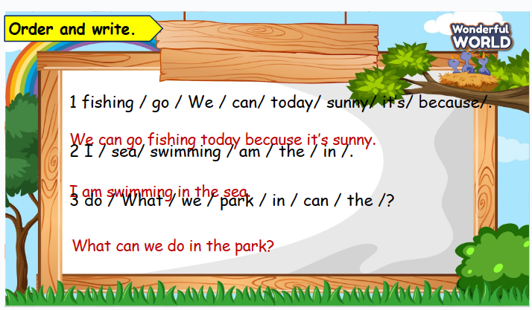  -Read out the question and the example answer.  -Ensure students understand how to complete the task. Allow them enough time to complete it, monitoring and helping as necessary  -Check answers. Ask volunteers to read out their answers.  - Give feedback to them.  -Ask students to sing the goodbye song | - Work in groups  - Present.  - Listen.
_____________________
REVIEW 3
Part 2. Task 1, 2, 3
Period 64
I. OBJECTIVES:
1. Knowledge:
- Students will review the words and structures related to the topic Outdoor Activities:
2. Competences:
- English competences: Students will be able to talk about outdoor activities.
- Common competences: Students will have the opportunity to develop communication among friends.
3. Qualities:
- Students will be responsible and well-behaved in communicating in the classroom with friends and others.
II. EQUIPMENT AND MATERIALS:
- Basic things: Student’s book, flashcards.
- Advanced things: PPT, projector/interactive whiteboard/laptop/TV.
III. LESSON PROCEDURE:
Warm up (5 minutes)
Teacher’s activities | Student’s activities
- Greet students  Task 1: What’s your favourite food?  (7 MINUTES)  Before starting:  Ask sts to look at the screen and choose the fruits they want. Then, answer all the questions and get stars  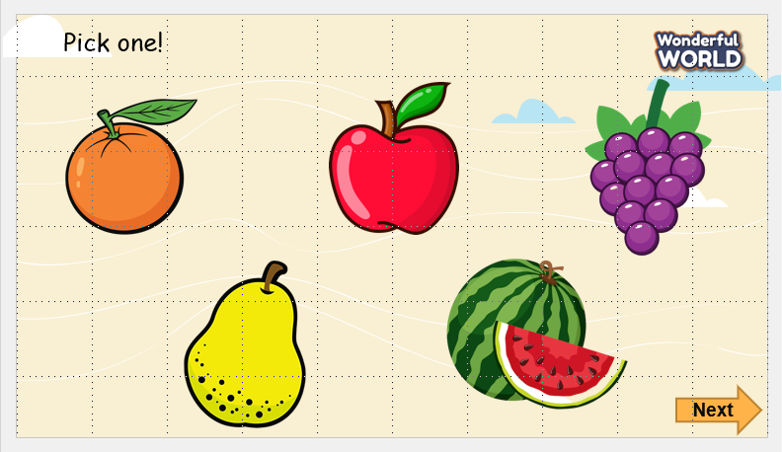  While playing  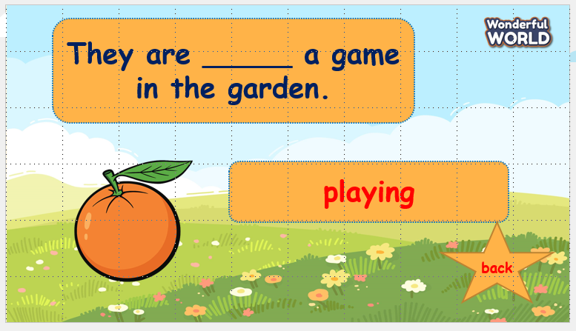  - Ask sts to work in groups  - Hand each group a print of task 1  - The sts will say the words and get stars.  - The team, who gets the highest scores, will be the winner. | - Greet teacher  - Sit in 4 groups.  - Listen to the game rules carefully  - Play game
Review (20 minutes)
Teacher’s activities | Student’s activities
Task 1: Match  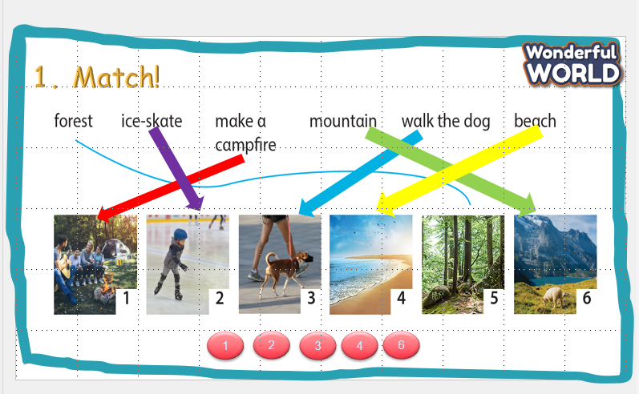  -Ask students to look at the questions 1–5 and their answers a–e. Look at the example as a class.  -Read the sentences aloud and ask students to repeat. Match the first sentence as a class.  -Check students understand the task. Allow enough time to complete it, alone or with a partner.  -Check answers as a class.  Task 2: Write and say  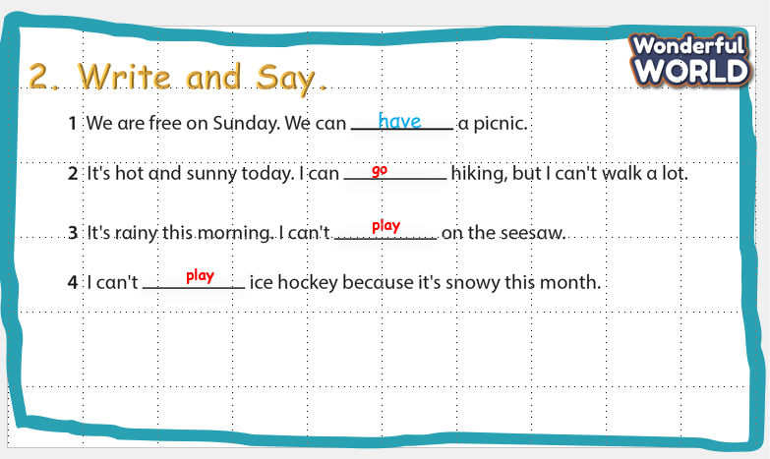  -Ask students to look at the questions 1–4 and look at the example as a class.  -Read the sentences aloud and ask students to repeat.  -Check if students understand the task. Allow enough time to complete it, alone or with a partner.  -Check answers as a class.  Activity 3: Write and say  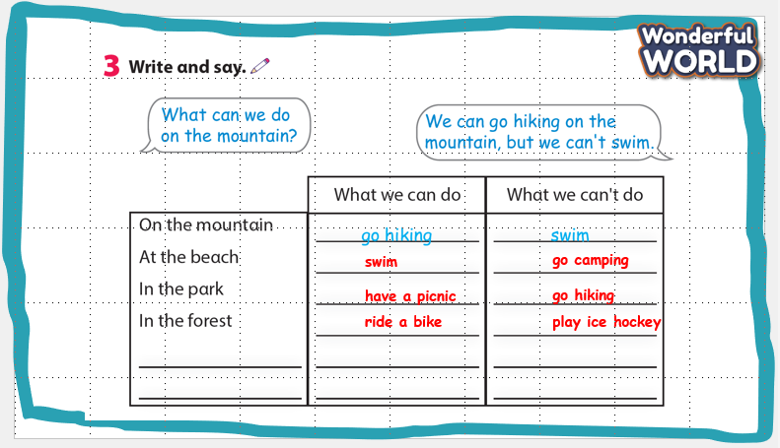 | -Look  -Answer  -Listen  -Do the crossword  -Check answers  -Look and read the example.  -Repeat  -Match  -Check answers with friends  -Listen  -Ask and answer the questions in pairs  -Check and practice in front of class
Extra activity (10 minutes)
Teacher’s activities | Student’s activities
- Write the correct answer.  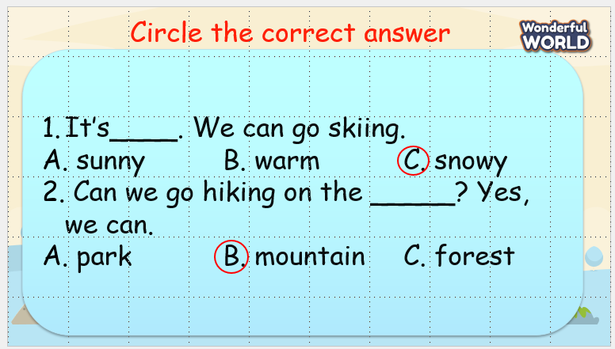  -Read out the question and the example answer.  -Ensure students understand how to complete the task. Allow them enough time to complete it, monitoring and helping as necessary  -Check answers. Ask volunteers to read out their answers.  - Give feedback to them.  -Ask students to sing the goodbye song | - Work in groups  - Present.  - Listen.

