Question 8. Ararange the words to make sentences.
- cold/ It’s / snowy / and / in winter /. /
_____________________________________________________
- weather / What’s / like / this / the / week / ? /
_____________________________________________________
- hot / very / It’s / today /. /
_____________________________________________________
- summer / in / What’s / like / weather / the / ? /
_____________________________________________________
Question 9 Look at the picture and write one word in the blank.
1. My sister is…………… | 
2 . The baby is very …………….. | 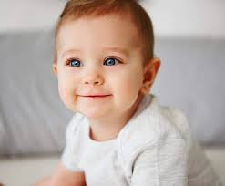
3. My ………………. is funny. | 
4.They are …………….. They are pretty. | 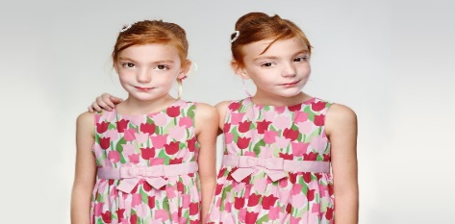

Question 8. Reorder the words to make the correct sentence. (1pt)
1. is / weather/ today / The / sunny / .
_______________________________________________________
2. Are / tree / they / the / climbing / ?
_______________________________________________________
3. are / My grandma / and / reading / grandpa / books / .
_______________________________________________________
4. video / your friends / Where / playing / are / games / ?
_______________________________________________________

Question 9. Look and write (1pt)
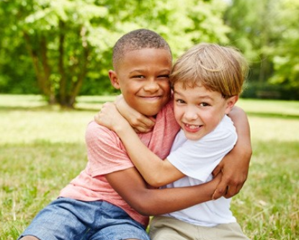
1. ______________ 2. ____________ 3. ____________ 4. _____________
Question 8. Ararange the words to make sentences.
- cold/ It’s / windy / and / today /. /
_____________________________________________________
- weather / What’s / like / Sunday / the / on / ? /
_____________________________________________________
- snowy / very / It’s / week / this /. /
_____________________________________________________
- summer / in / What’s / like / weather / the / ? /
_____________________________________________________
Question 9 Look at the picture and write one word in the blank.
1………………
2 . The baby is very ……………..
3. My ………………. is funny.
4.They are …………….. They are pretty. | 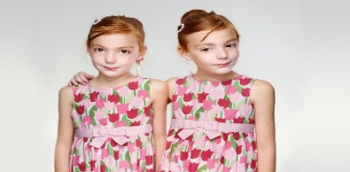

Question 8: Reorder these words to make sentences. (1pt)
1. winter /weather/is/what/like/in/the/?
…………………………………………………………………………………...
2. jumping/ in / rope/ garden/ She/ the/ is
…………………………………………………………………………………..
3. tree/ they/ Are/ climbing/ the/ ?/
…………………………………………………………………………………..
4. sofa/ comic/ They/ on/ books/ are/ reading/ the/
………………………………………………………………………………….

Question 9: Look at the pictures and write one word only to complete sentences. (1pt)
  1.She is my …………………….. | 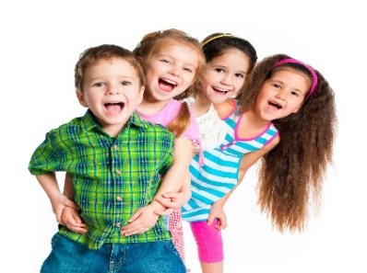  2. My friends are……………….
  3.My brother is………………….... | 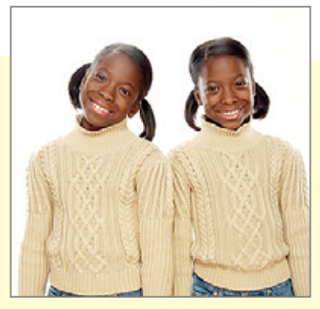  4.They are………………………
Questions 8: Arrange the words to make sentences(1pt)
1. camping/ on/ go/ I/ can/ mountain/ the/.
=>...............................................................................................................................
2. We/ picnic/ can’t/ snowy/ go/on/ today/ because/ a/ is/ it.
=> ..........................................................................................................................
3. in / What’s / like / summer /weather / the / ?
=> ....................................................................................................................
4. is / jumping / she / in / rope/ garden / the
=> ..........................................................................................................................
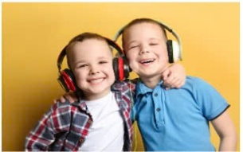
Questions 9: Look at the pictures and write one word in the blank (1pt)
1. They are ________________.

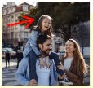
3. They have got a ________________.


2. My sister is ________________.


4. My friends are very ___________________
Question 8: Reorder these words to make sentences;
1, summer/weather/is/what/like/in/the/?
………………………………………………………………………..
2, playing /hide-and-seek/me/with/they/are/.
…………………………………………………………………………..
3, cooking/are/they/kitchen/now/in/the/.
…………………………………………………………………………..
4, where/Peter/Alex/and/playing/games/boards/are/?
…………………………………………………………………………..
Question 9: Look at the pictures and write one word only to complete sentences:
  1.My cousin is …………………….. | 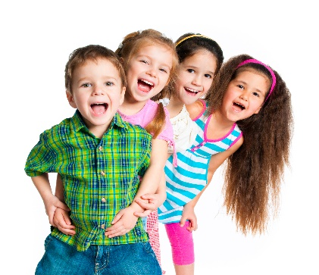  2. My friends are……………….
  3.His father is ………………….. | 4.They are…………………..

Question 8: Reorder these words to make sentences( 1 point );
1, Sunday/weather/is/what/like/on/the/?
………………………………………………………………………..
2, playing /seesaw /me/the/with/he/is/on.
…………………………………………………………………………..
3, doing/is/teacher/what/your/ ?.
…………………………………………………………………………..
4, the/in/playing/children/games/their/boards/are/bedroom/.
…………………………………………………………………………..
Question 9: Look at the pictures and write one word only to complete sentences( 1 point) :
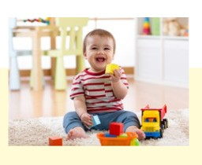  1.My cousin is …………………….. | 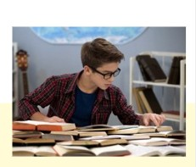  2. My brother is …………………….
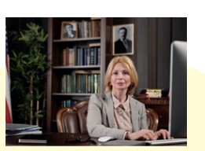  3.His aunt is ………………….. | 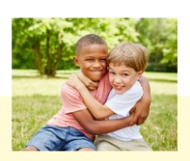  4.His friend is …………………..

Question 8: Arrange the words to make sentences (1,pt)
1. in / the / What / winter / weather / like / is /?/
...............................................................................................................................
2. playing /on / We / the / are / seesaw / ./
................................................................................................................
3. homework / are/ Tom / doing / and / Jack / ./
.................................................................................................................................
4. friends / your / board / Where / games / playing / are / ?/
.................................................................................................................................
Question 9 : Look at the picture and write one word in the blank.(1,pt)
1.She’s my ___________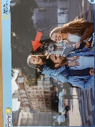 2.My cousin is ___________
3. She’ _______________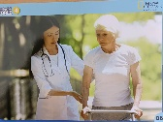 4.My mother is ___________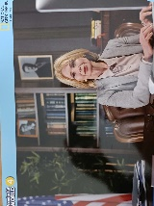
Question 8: Reorder these words to make sentences (1pt)
1. seesaw / your / Where / is / on / the / playing / cousin / ?
__________________________________________________________________
2. in / the / is / like / weather / What / autumn / ?
__________________________________________________________________
3. the / playing / park / seek / in / and / hide / They're / .
__________________________________________________________________
4. a / theatre / play / the / Linda / at / watching / is / .
__________________________________________________________________
Question 9: Look at the pictures and write ONE word to complete sentences (1pt)
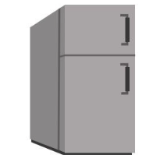  1. There is a _________ in my kitchen. | 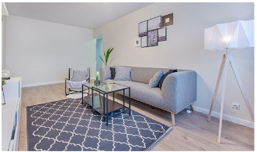  2. The rug is ____________ the sofa.
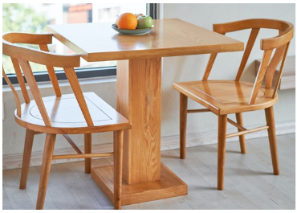  3. The table is ___________ the chairs. | 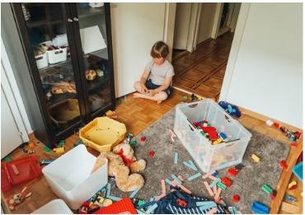  4. His room is very ______________.
Question 8: Reorder these words to make sentences
1.is/ What/ doing/ he?
………………………………………………..
2.reading/ My / is/ in the park/ brother/ a book
…………………………………………………..
3. Mai and Lan/ doing/ are/ homework
…………………………………………………………..
4.today/ is/ the/ weather/ What?/ like .
………………………...........................................................
Question 9: Look at the pictures and write one word only to complete sentences
  Who is he? He is my………….. | 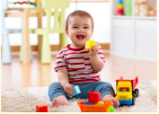  His brother is……………
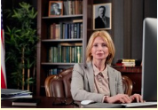  Her aunt is………….. |   My mother is……………..
Question 8: Arrange the words to make sentences. (1pt)
1. is / the / in / like / weather / What / summer/ ?
-> ………………………………………………………………………
2. the / playing / playground / are / in / football / They / .
-> ……………………………………………………………………………
3. pool / going/ the / you / in / swimming /Are / ?
-> …………………………………………………………………………
4. comic / Where / are / books / the / reading / girls / ?
-> ……………………………………………………………………………
Question 9: Look at the picture and write ONE word in the blank. (1pt)
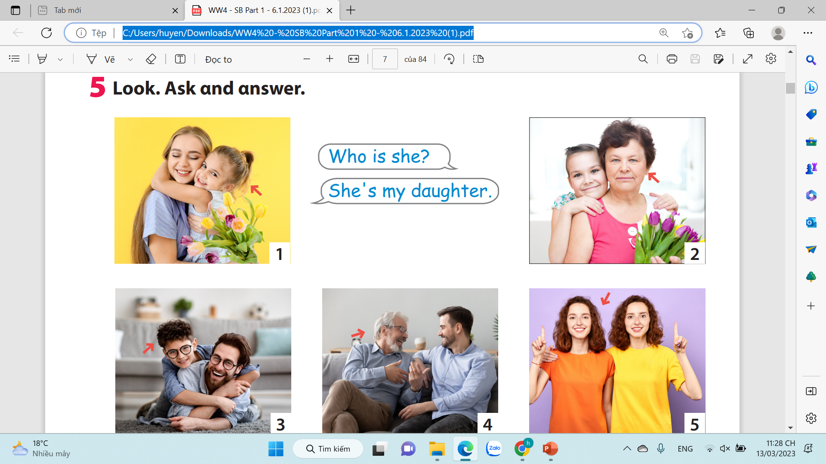  1. She is my ……………………. | 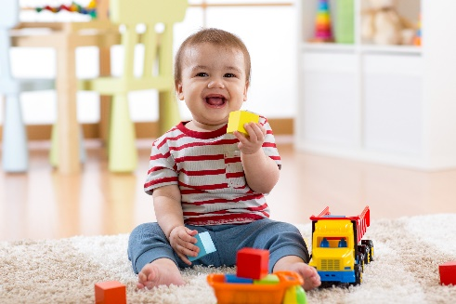  2. My brother is very ……………….
  3. She 's ………………….. |   4. They are clever and ………………..
Question 8: Reorder these words to make sentences;
1. spring /weather/is/what/like/in/the/?
………………………………………………………………………..
2. with/they/me/playing/are/hide-and-seek/
…………………………………………………………………………..
3. under/they/playing/tree/are/the/
…………………………………………………………………………..
4. Jack/Joe/ where/ and/playing/games/video/are/.
…………………………………………………………………………..
Question 9: Look at the pictures and write one word only to complete sentences:
 1.My sister is …………..….

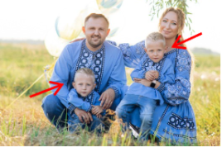2.Their ……………….are pretty and kind

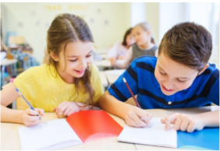 3. My…………………are cool and hard-working
 4. His father is……………………………….
Question 8: Reorder these words to make sentences;
1, winter/weather/is/what/like/in/the/?
………………………………………………………………………..
2,They/playing/on/are/the/seesaw.
…………………………………………………………………………..
3, cooking/are/they/kitchen/now/in/the/.
…………………………………………………………………………..
4, Where/watch/are/Jack/a/and/Alex/film/?.
…………………………………………………………………………..
Question 9: Look at the pictures and write one word only to complete sentences:
1.My cousin is …………………….. | 2. My friends are……………….
3.His father is ………………….. | 4.They are…………………..

Question 8: Reorder these words to make sentences;
1, summer/weather/is/what/like/in/the/?
………………………………………………………………………..
2, playing /hide-and-seek/me/with/they/are/.
…………………………………………………………………………..
3, cooking/are/they/kitchen/now/in/the/.
…………………………………………………………………………..
4, where/peter/Alex/and/playing/games/boards/are/.
…………………………………………………………………………..
Question 9: Look at the pictures and write one word only to complete sentences:
1.My cousin is …………………….. |   2. My friends are……………….
3.His father is ………………….. | 4.They are…………………..
Question 8: Reorder these words to make sentences;
1, Autumn /weather/is/what/like/in/the/?
………………………………………………………………………..
2, playing /seesaw/on /they/are/the/
…………………………………………………………………………..
3, cooking/is/My /mother/ kitchen/now/in/the/
…………………………………………………………………………..
4, where/Mary/Anna /and/playing/games/boards/are/.
…………………………………………………………………………..
Question 9: Look at the pictures and write one word only to complete sentences



1.Her …………..….are good and pretty

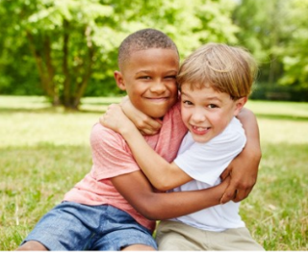
2. My friend is ………………….


3.What is her sister like?
Her sister is………………
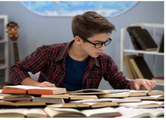

4. What ‘s your brother like ?
My brother is ……………..

Question 8: Reorder these words to make sentences (1pt)
1. summer / weather / What’s / like / in / the/?
………………………………………………………………………….
2. cold / It’s / and / today / windy/.
…………………………………………………………………………..
3. playing / are / They / living room /game /in / board / the /.
…………………………………………………………………………..
4. they / Are / the / climbing / tree /? – are / Yes, / they /.
…………………………………………………………………………..
Question 9: Look at the pictures and write one word only to complete sentences (1pt)
  1.Her daughter is …………………….. | 2. My ………………. is pleasant.
  3.His father is ………………….. | 4.They are…………………..

