WEEK 11
REVIEW 2
Part 1. Task 1, 2, 3
Period 41
I. OBJECTIVES:
1. Knowledge:
Students will learn words and phrases related to the topic the farm
We’ve got α field. They’ve got αlpαcαs on their fαrm and Hαs α chicken got wings? Hαve αlpαcαs got blαck fαces?
2. Competences:
- English competencies: Students will be able to remember the words and structures they have learnt.
- Common competences: Students will have the opportunity to develop logical thinking and develop communication among friends.
3. Qualities:
- Students develop love for different leisure activities and be friendly to their friends in the class.
II. EQUIPMENT AND MATERIALS:
- For Teacher: PPT, flashcards.
- For students: textbook
III. LESSON PROCEDURE:
Activity 1: Warm-up (10 minutes)
Aim: Revise the words and structures learnt in unit 4
Teacher’s Activities | Students’ Activities
Warm-up:  Dance and sing: The ocean jam  - Ask students to watch the video  - Dance and sing along the song.  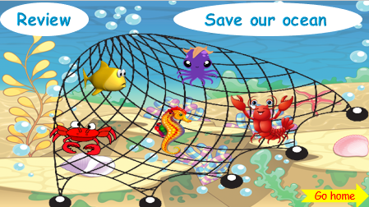  - Tell students how to play the game  Instructions:  1) Divide into Teams  2) Ask a sea animal to a Team (click the sea animal)  3) If correct, click “the house” button to go back  4) Continue until out of sea animals – click the “go home” button to finish.  - Do as a model  - T asks Ss to repeat after checking. | - Listen to the instructions carefully and watch the video.  - Watch the video again and sing along to the song.  - Repeat.  - Listen to T.
Activity 2: Practice (12 minutes)
Aim: - practise words and structure
- Practise speaking in front of the class
Teacher’s Activities | Students’ Activities
Task 1: Match  • Tell students to look at the pictures and then match each picture with the sentence describing it.  • Tell students to look at the example. Read the sentence and ask students to repeat.  • Check if students understand the task. They allow enough time for students to complete the task.  • Check the answers as a class.  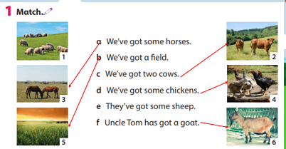 | - Look and answer.  - Work in pairs.  - Play the game.
Teacher’s Activities | Students’ Activities
Task 2: find and circle  • Tell students that they are going to find the given words in the puzzle.  • Divide the students into pairs or groups to do the puzzle.  • Show students how to do the task by circling the first word if necessary.  • Praise or award a prize to the quickest pair or group will all correct answers.  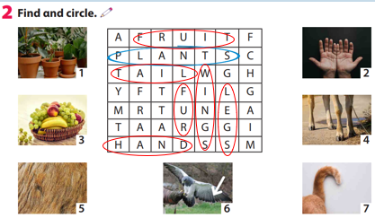 | - Listen and work in pairs.  - Present in front of the class  - Listen.
Task 3: Write  Read the first question and the sample answer. Explain to students and have them read the question and write the answer.  • Check students understand the task. Allow enough time to complete it.  • Check answers as a class.  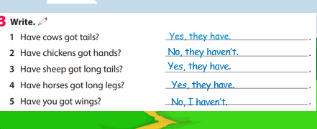 | - Look and answer.  - Work in pairs.
Activity 4: Product (3 minutes)
Aim: Review the vocab and grammar of the previous lesson- using the fun activities in the lesson.
Click on the number to show the question  Click next to go to the next part  Click star to display the crown  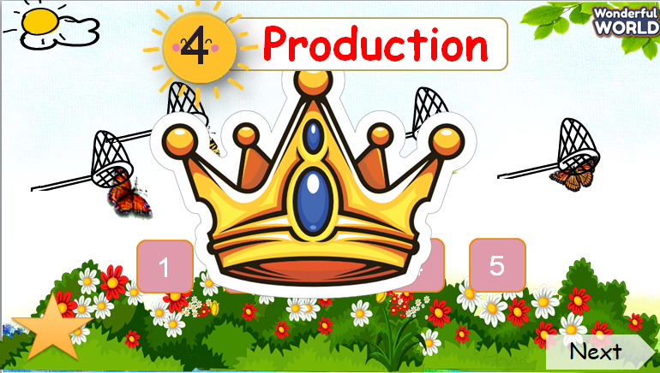 |  | - Look and answer.  - Work in pairs.
Activity 5: Assessment (3 minutes)
Aims: Do the exercise to review and practice the words
Consolidate the content of the lesson.

Teacher’s Activities | Students’ Activities
-Ask sts to do the assessment.  - Check with the class.  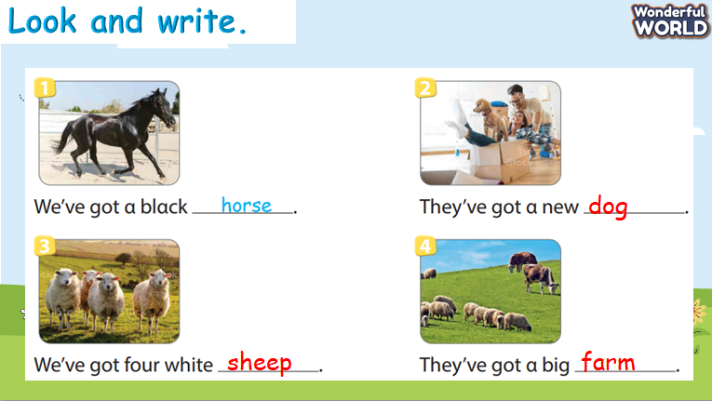 | -Do the assessment.  - Check with the teacher.
___________________________________
REVIEW 2
Part 2. Task 1, 2, 3
Period 42
I. OBJECTIVES:
1. Knowledge:
Students will learn words and phrases related to the topic Food and drinks
2. Competences:
- English competences: Students will be able to remember the words and structures they have learnt.
- Common competences: Students will have the opportunity to develop logical thinking and develop communication among friends.
3. Qualities:
- Students develop love toward different leisure activities and be friendly to their friends in the class.
II. EQUIPMENT AND MATERIALS:
- For Teacher: PPT, flashcards.
- For students: textbook
III. LESSON PROCEDURE:

Activity 1: Warm-up (10 minutes)
Aim: warm-up activity to introduce the lesson, reviewing the words of Food and drinks.
Teacher’s Activities | Students’ Activities
Warm-up:  Review: Play game Horse Race  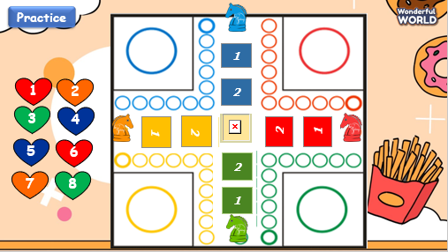  - Tell students how to play the game  - Do as a model, T asks Sts to repeat after checking. | - Listen to the instruction carefully  - Repeat.  - Listen to T.  - Play the game.
Activity 2: Practice (12 minutes)
Aims: Review words of Food and drinks learned in the unit via various activities from the book.
- Encourage sts to look around in class and ask friends about Food and drinks.

Teacher’s Activities | Students’ Activities
Task 1: Write. Circle a or b  • Tell students to look at the pictures and write “would”  • Ask students to look at the first picture, read out the first question and ask  students to repeat  • Check the answers as a class.  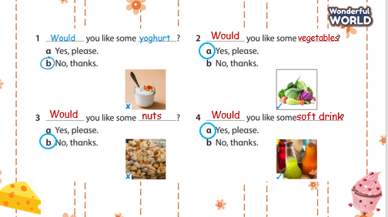 | - Look and answer.  - Work in pairs.  - Notice the cross at the corner of the  picture
Teacher’s Activities | Students’ Activities
Task 2: Look and say  -Tell students to look at the picture for question 1 and the example.  -Read out the example and ask students to repeat.  -Explain the rest of the task to students. Allow them enough time to practise saying the sentences individually and in pairs. Go round the class helping students where necessary.  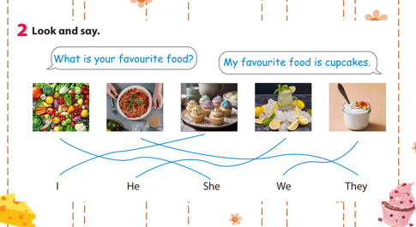 | - Listen and work in pairs.  - Present in front of the class  - Listen.
Task 3: Write  Read out the first question and ask students to look at the  words in the box to fill in the gap.  • Check that students understand the task. Allow enough  time to complete it.  • Check answers as a class  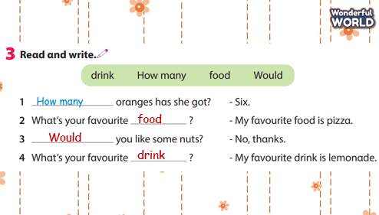 | - Look and answer.  - Work in pairs.
Activity 5: Assessment (3 minutes)
Aims: Do the exercise to review and practice the words
Consolidate the content of the lesson
Teacher’s Activities | Students’ Activities
-Ask sts to do the assessment.  - Check with the class.  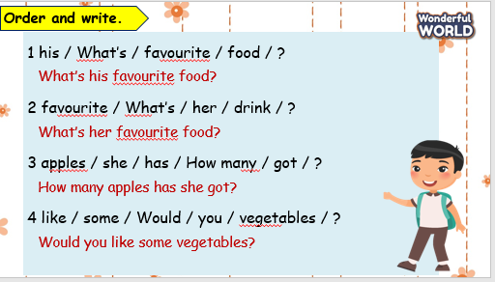 | -Do the assessment.  - Check with the teacher.
_____________________________
REVIEW 2
Part 3 – VIDEO. Task 1, 2, 3
Period 43

I. OBJECTIVES:
1. Knowledge:
Students will review words and phrases related to the topic food and drinks
What we learnt today:
- review words and structures from Unit 3, 4.
2. Competences:
- English competences: Students will be able to talk about their family.
- Common competences: Students will have the opportunity to develop the creativeness in drawing the family tree and develop communication among friends.
3. Qualities:
- Students develop love toward family.
II. EQUIPMENT AND MATERIALS:
- For Teacher: PP, TV, music, relating audio track.
- For students: papers, colour pencils or crayons, personal boards and markers.
III. LESSON PROCEDURE:
Activity 1: Warm-up (5 minutes)
Aims: warm-up activity to introduce the lesson, review the words of food and drinks.
Teacher’s Activities | Students’ Activities
Play the game.  - Divide class into 2 teams  - Explain game’s rule:  + 2 teams choose numbers to answer questions, if they have the right answer, their teams will jump 1 step.  + The team jumps to the last steps with the Turtle will be the winner.  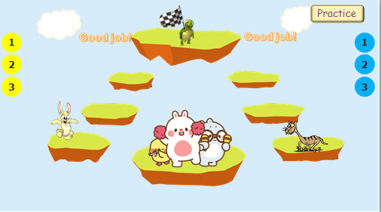 | - Join the game.  -Look and read.  -Read  -Identify and read.  - Check with friends and then with teacher and whole class  - Listen to the instructions carefully.
Activity 2: Presentation (8 minutes)
Aims: Review the words and structures learned in unit 4

Teacher’s Activities | Students’ Activities
1. What do you like to eat?  • Tell students to close their books. Tell them you’re going to review words from Unit 4 before showing the video.  • Brainstorm words with students and write them on the  board. Circle any words that match the list in their books.  • Tell students to open their books and look at Activity 1. Review the words with the students.  • Look at the list of foods on the board. How many foods match the foods in Activity 1?  • Tell students to complete the activity, circling the foods they like.  • Go round the class asking students which food they like and which food they don’t like. | -Look and read.  -Read  -Identify and read.
Activity 3: Practice (14 minutes)
Aims: Watch the video and do activities about the topic food and drinks.

Teacher’s Activities | Students’ Activities
Task 2: What can you see in the video? Circle.  • Read the instructions to the students. Read through the list of words and make sure students understand the task.  • Tell students to get ready to tick the boxes as they watch the video.  • Play the video all the way through.  • Go through the answers as a class, playing the video again if you need to.  Task 3: Read. Tick T for True and F for False  • Read out the first statement to the class. Ask students if they remember seeing anyone eating yoghurt for breakfast in the video. Say People never eat yoghurt  for breakfast. Is that right? Elicit No. Ask students where the tick should go (F). Put a tick in the ‘F’  box.  • If necessary, play the video again and give students time to complete the activity alone.  • Check the answers with the class. | - Learn the grammar through pictures.  - Listen then point.  - Repeat then point.  - Say aloud.  - Do the task carefully  - Check with friends and then with teacher and whole class
Activity 4: Assessment (5 minutes)
Aim: Revive the lesson by doing some exercises - time limitation
Teacher’s Activities | Students’ Activities
-Ask sts to do the assessment  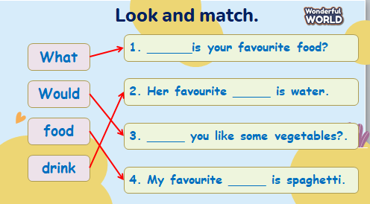  - Check with the class | -Do the assessment  - Check with the teacher
________________________
REVIEW 2
Part 4. Task 1, 2, 3
Period 44
I. OBJECTIVES:
1. Knowledge:
Students will learn words and phrases related to the topic Food and drinks & On the farm
2. Competences:
- English competences: Students will be able to remember the words and structures they have learnt.
- Common competences: Students will have the opportunity to develop logical thinking and develop communication among friends.
3. Qualities:
- Students develop love for different leisure activities and be friendly to their friends in the class.
II. EQUIPMENT AND MATERIALS:
- For Teacher: PPT, flashcards.
- For students: textbook
III. LESSON PROCEDURE:
Activity 1: Warm-up (10 minutes)
Aims: warm-up activity to introduce the lesson, review the words of Food and drinks & on the farm
Teacher’s Activities | Students’ Activities
Warm-up:  Listen and dance: “Fruit Juice | Shake Shake Shake it.” | - Listen and dance along
Activity 2: Review
Aim: Practise words, ask and answer using structure unit 3,4
Review: Play game “The Big Wheel”  - Tell students how to play the game:  Instructions:  1) Divide into Teams  2) Ask a Question to a Team (click the question number button)  3) If correct, click the Spin Wheel Button to choose the number of  points that the team will receive.  4) Continue until out of questions.  - Do as a model  - T asks Ss to repeat after checking.  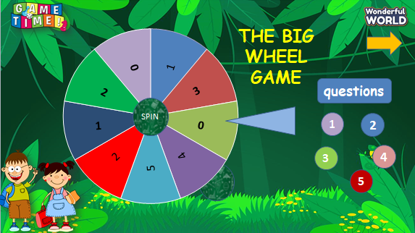 | - Listen to the instruction carefully  - Repeat.  - Listen to T.  - Play the game.
Activity 3: Practice (12 minutes)
Aims: - review words and structures of Food and drinks
- Practise vocab and structures via listening and speaking

Teacher’s Activities |  | Students’ Activities
Task 1: Read and match  • Tell students they are going to read sentences from 1 - 5 and match each sentence with the ones that have similar meaning from a - e.  Read out sentence number 1 and ask students to repeat.  • Check the answers as a class.  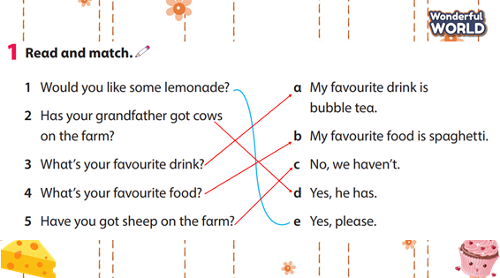 |  | - Look and answer.  - Work in pairs.
Teacher’s Activity |  | Students’ Activities
Task 2: Look and say  • Ask students to look at the sample.  • Tell the students they have to draw a magical animal, as magical as they can imagine. Then ask students to write 15-20 words to describe the animal.  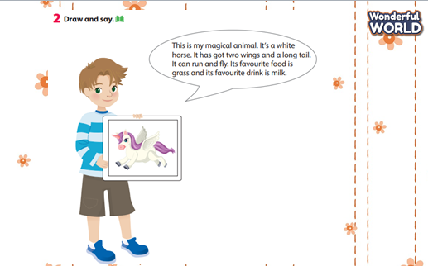 |  | - Listen and work in pairs.  - Present in front of the class  - Listen.
Activity 4: Assessment (3 minutes)
Aims: Do the exercise to review and remember the words
Consolidate the content of the lesson.

Teacher’s Activities |  | Students’ Activities
-Ask sts to do the assessment.  - Check with the class.  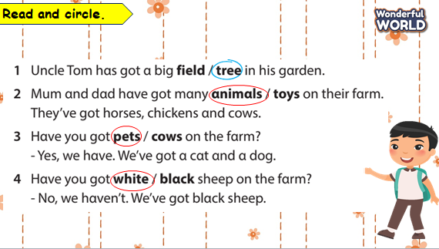 |  | -Do the assessment.  - Check with the teacher.

