WEEK 12
UNIT 5. LEISURE TIME
Lesson 1. Task 1, 2, 3
Period 45
I. OBJECTIVES:
1. Knowledge: By the end of the lesson, Students will be able to
- Identify some weather phenomena: cloudy, windy, snowy, stormy.
- Listen to and read a dialogue about the weather.
2. Competences:
- English competences: Students can talk about different weather and what they are wearing for different kinds of weather
- Common competences: Students will have the opportunity to develop logical thinking and develop communication among friends.
- Core competences: motivation, communication, creativity, collaboration.
3. Qualities:
Students will:
- Develop a love for different weather.
- Be confident and active in communicating with friends and their teachers.
II. EQUIPMENT AND MATERIALS:
- Student’s book, flashcards, track 5.1, track 5.2.
- PowerPoint (PPT) presentation, projector/ laptop, speaker.
III. LESSON PROCEDURE:

Teacher’s Activities | Students’ Activities
Activity 1: Warm-up (5 minutes)
a. Aims: Review some kinds of weather and engage students in the topic “weather” of the lesson.
b. Procedure  Warm-up: Play a small game “Guess weather”  -The teacher asks SS to listen to the sound and guess what weather it is.  -T calls Ss to answer and check their answers.  -T asks Ss to repeat the names of the weather.    Answer keys:  - Rain  - Wind  - Storm  - Sunshine  Lead in: Photo time!  -T shows the picture of a boy throwing snow into the air and gives students some questions: What can you see? What is he wearing? Is it sunny/ rainy/cold/ hot?  - T calls SS to answer and check their answers.  - T introduces that they will learn about “Weather” today.  - Write on the board “Leisure time” and introduce the lesson.  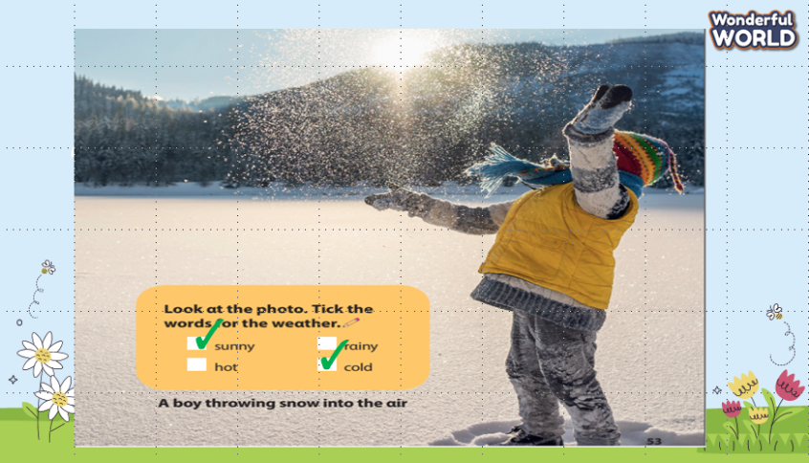 | -Listen to the sound and guess.  -Answer the questions.  - Repeat the name of the weather.  - Listen to the teacher.  - Answer the questions.  - Listen to the teacher.
Activity 2: Presentation (8 minutes)
a. Aims: Present new vocabulary about some weather phenomena.
b. Procedure  Task 1: Listen and point. Repeat. (Track 5.1)  - Use flashcards to introduce the vocabulary and structure of the lesson.  - Say the words for students to repeat in the chorus.  - Say a word for students to repeat then point.  - Play track 5.1 for the students to listen to, point to, and repeat the words in chorus and groups.  - Check their pronunciation and give them feedback.  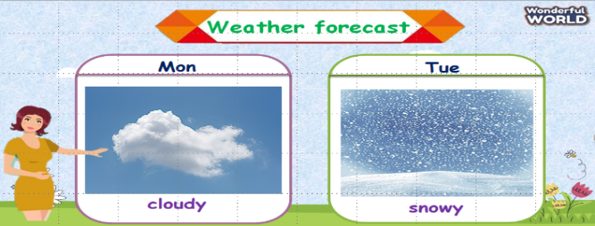  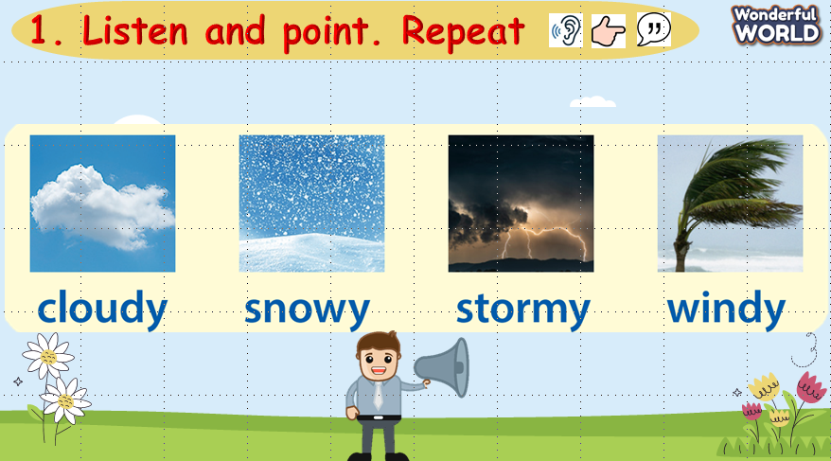  VOCABULARY CHECKING:  - Show pictures in random order and ask students to read aloud the correct words.  - Ask SS to say the words again.  - Check and give them feedback.  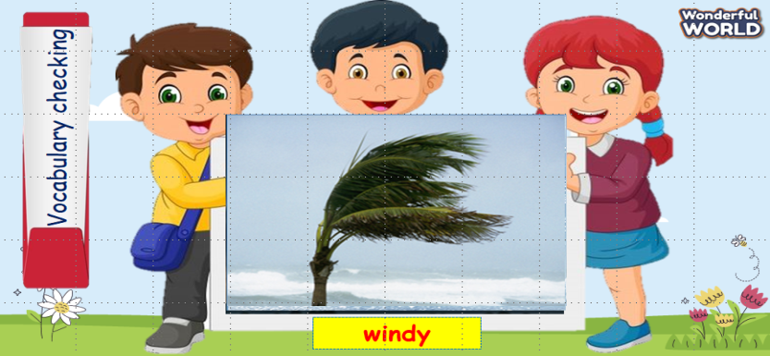 | - Listen to the teacher.  - Repeat after the teacher.  - Listen and repeat then point.  - Listen to track 5.1, point, and repeat the words.  - Look and answer.  - Read aloud the words.  - Listen to the teacher.
Activity 3: Practice (10 minutes)
a. Aims: Controlled practice: to listen to and read a dialogue about the weather, then make sentences to describe the weather.
b. Procedure  Task 2: Listen and read. Tick.  - Ask SS to identify the names of characters in the dialogue.  - Play track 5.2 and let SS listen to the dialogue, then repeat each sentence.  - Ask SS to read again, then tick the correct answers.  - Let Sts read the dialogue by role-playing “Jane and Tom” to practice the words and the sentences.  - Check and give them feedback.  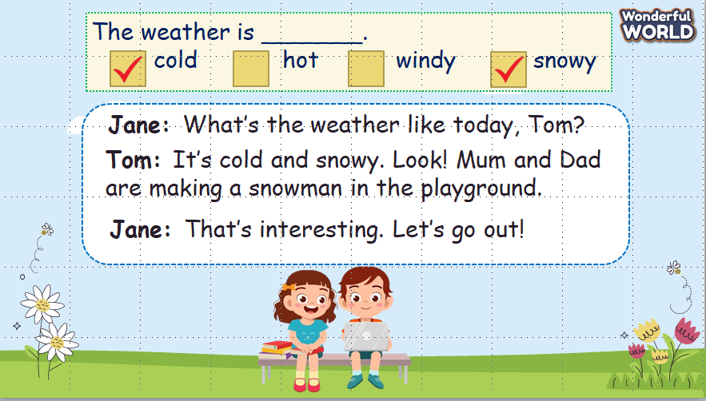  Task 3: Look and say:  - Look at the picture and let SS write the sentences and say these sentences like the example.  - Call SS to say aloud in front of the class.  - Check and give them feedback.  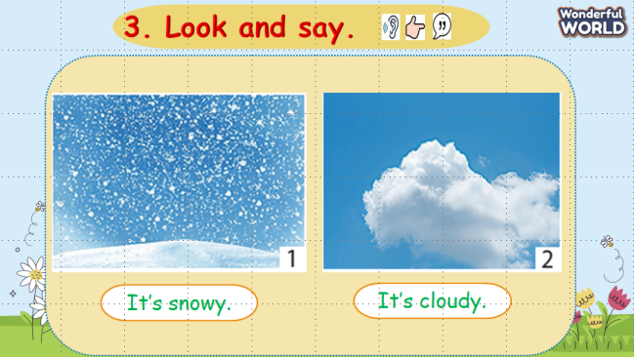 | -Answer the teacher.  -Listen to track 5.2 and repeat each sentence.  -Read and tick the correct answers.  -Role-play 2 characters: Jane and Tom to practice the dialogue.  - Listen to the teacher.  - Write the sentences and say.  - Say aloud in front of the class.
Activity 4: Production (9 minutes)
a. Aims: Apply vocabulary to the real world.
b. Procedure  - Work in pairs.  - Ask SS to look at the board and identify what they can see.  - Guide SS to answer 2 questions on the slides.  - Work in pairs and discuss what they are wearing in different kinds of weather.  - Call pairs to present in front of the class.  - Check and give feedback.  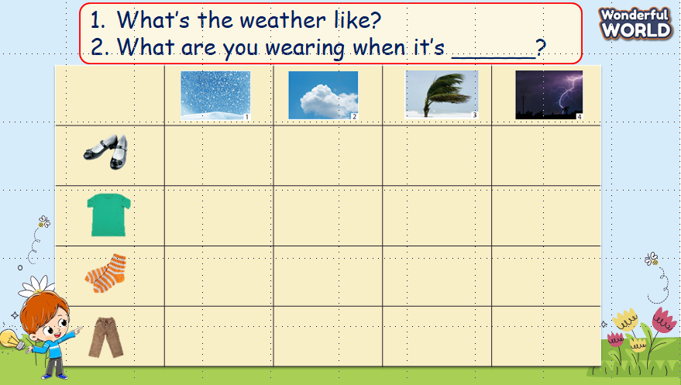 | - Look at the board and answer the questions on the slides.  - Work in pairs and discuss.  - Some pairs present in front of the class.  - Listen to the teacher.
Activity 5: Assessment (3 minutes)
a. Aims: Consolidate the content of the lesson.
b. Procedure  - Ask sts to do the assessment.  - Check with the class.  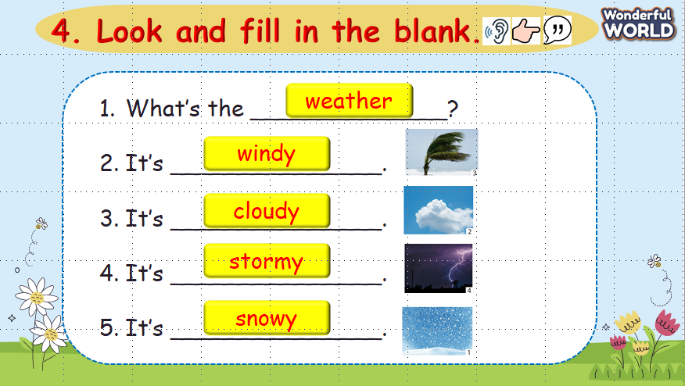 | - Do the assessment.  - Check with the teacher.
___________________________________
UNIT 5. LEISURE TIME
Lesson 1. Task 4, 5, 6
Period 46
I. OBJECTIVES:
1. Knowledge: By the end of the lesson, Students will be able to
- Review some weather phenomena: cloudy, windy, snowy, stormy.
- Learn words and phrases related to the topic: Weather and Season: spring, summer, autumn, winter.
2. Competences:
- English competences: Students can talk about different weather in different seasons.
- Common competences: Students will have the opportunity to develop logical thinking and develop communication among friends.
- Core competences: motivation, communication, creativity, collaboration.
3. Qualities:
Students will:
- Develop a love for different weather in different seasons in a year.
- Be confident and active in communicating with friends and their teachers.
II. EQUIPMENT AND MATERIALS:
- Student’s book, flashcards, track 5.3, a pen, and A4 paper.
- PowerPoint (PPT) presentation, projector/ laptop, speaker.
III. LESSON PROCEDURE:
Teacher’s Activities | Students’ Activities
Activity 1: Warm-up (5 minutes)
a. Aims: Review the vocabulary of the weather which they have learned from the previous lesson.
b. Procedure  Warm-up: Play a small game “Hangman”  -The rule of the game:  -T divides the class into 2 teams.  -The teacher asks SS to say the different letters to guess the names of the weather.  -T calls Ss to answer and check their answers.  Which team has the correct answer will get 1 point. Which team has the most points will be the winner.  T asks Ss to repeat the names of the weather.  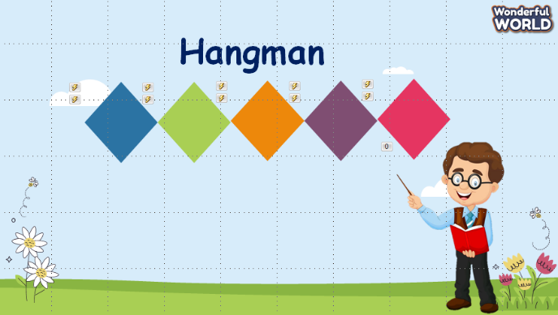  Answer keys:  - windy  - stormy  - snowy  - cloudy  Lead in:  - T introduces that they will learn about “Weather in each season in a year” today.  - Write on the board “Leisure time” and introduce the lesson. | -Listen and answer the questions.  -Guess the name of the weather  - Answer the questions to get points.  -Repeat the name of the weather.  - Listen to the teacher.  - Answer the teacher.
Activity 2: Presentation (8 minutes)
a. Aims: Present the question and the answer about the weather.
b. Procedure  Task 1: Listen and point. Repeat. (Track 5.3)  - Use flashcards to introduce the vocabulary and structure of the lesson.  - Say the words for students to repeat in the chorus.  - Say a word for students to repeat then point.  - Use flashcard “winter” to introduce the structure of the lesson.  - Say the structure for SS to repeat in the chorus.  - Play track 5.3 for the students to listen to, point to, and repeat the words in chorus and groups.  - Call pairs of SS to present in front of the class.  - Check and give them feedback.  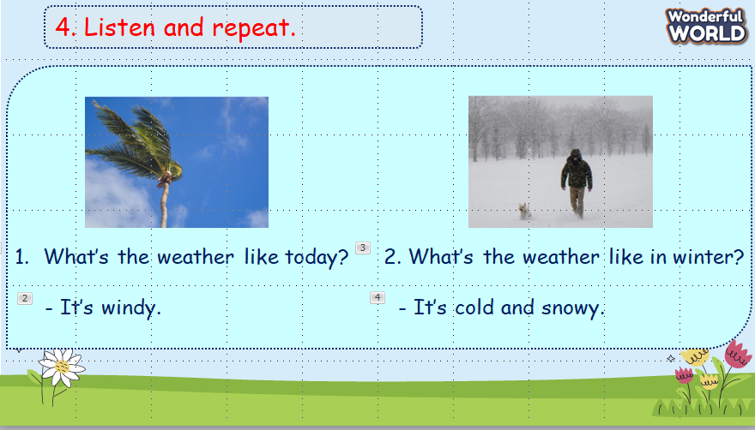  .  VOCABULARY CHECKING:  - Show pictures behind the black circles and ask students to guess the correct words. Then choose the kind of weather for each season.  - Check and give feedback.  - Ask SS to say the words again.  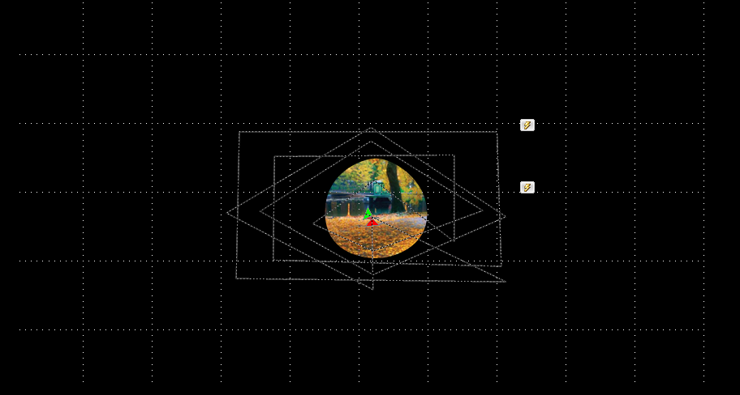 | -Listen to the teacher.  -Repeat after the teacher.  -Listen to the teacher.  -Listen and repeat the structure.  - Listen to track 5.3, point and repeat the words  - Some pairs present in front of the class.  - Listen to the teacher’s feedback.  -Look at the pictures and guess the words.  - Listen to the teacher.  - Read aloud the words.
Activity 3: Practice (10 minutes)
a. Aims: Controlled practice: Make the sentences based on the structure they have learned.
b. Procedure  Task 5: Look and say.  - Ask SS to identify the names of pictures and words under them.  - Ask SS to look at the board and call a student to role-play with T, then ask SS to work in pairs in 3 min.  - Let SS work in pairs and present in front of the class by spinning the circle to choose which picture they say.  - Call SS to present in front of the class and give them comments.  - Call Ss to write the correct answers on the board.  - Give them feedback.  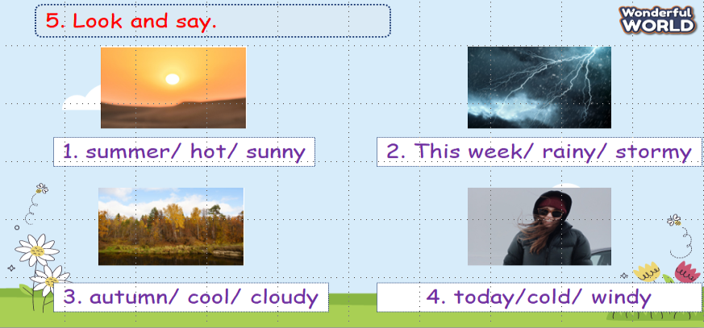  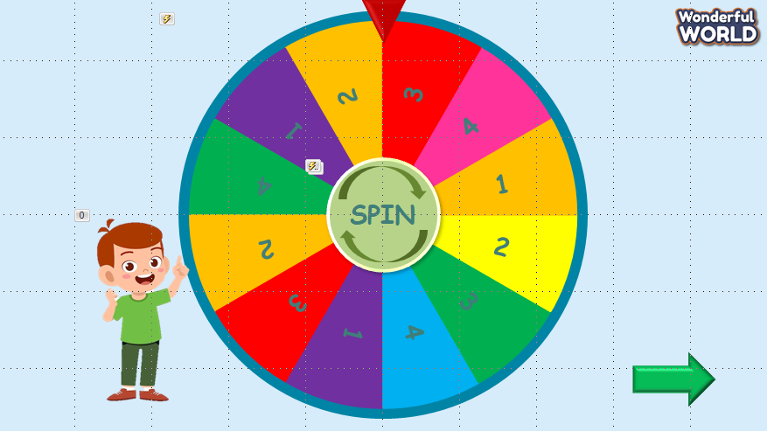 | -Answer the teacher  -Role-play.  -Work in pairs.  - Present in front of the class.  - Listen to teacher’s comments.  - Write the sentences and say.  - Listen to teacher’s feedback.
Activity 4: Production (9 minutes)
a. Aims: Apply vocabulary and structure to make a small conversation about the weather with their classmates.
b. Procedure  6. Let’s play.  - Work in pairs.  - Ask SS to look at the board and call a student to make a conversation.  - Ask SS to prepare a pen and paper to draw the weather in 2 min. Then ask them to work in pairs to ask and answer.  - Call pairs to present in front of the class.  - Check and give feedback.  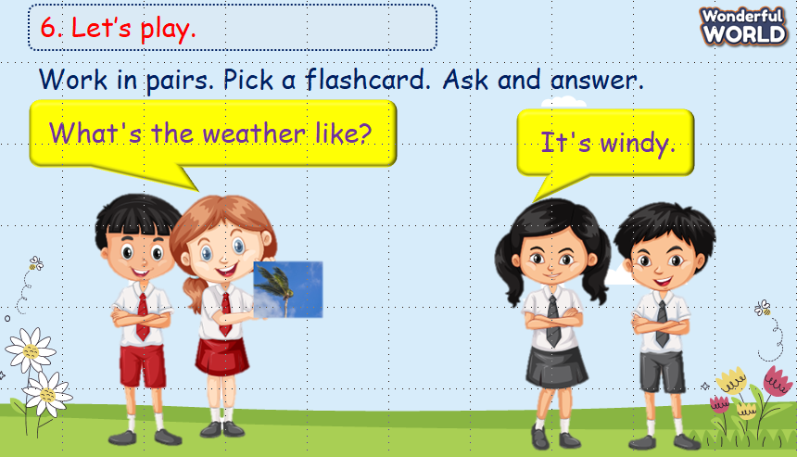 | - Work in pairs and make a conversation.  - Draw the weather.  - Practice asking and answering about what you draw  - Some pairs present in front of the class.  - Listen to the teacher’s feedback.
Activity 5: Assessment (3 minutes)
a. Aims: Consolidate the content of the lesson.
b. Procedure  -Ask sts to do the assessment.  - Check with the class.  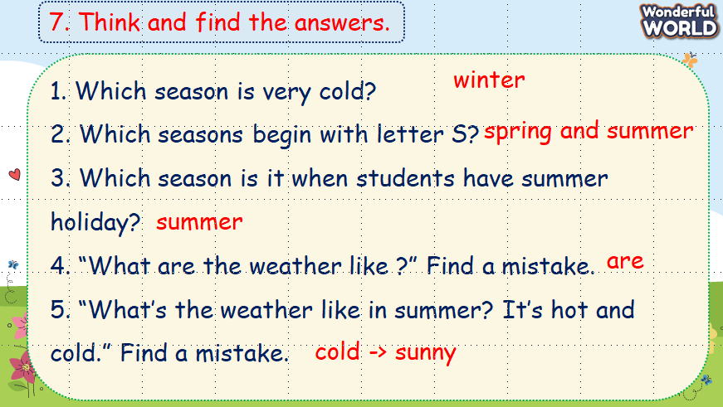 | - Do the assessment.  - Check with the teacher.
___________________________________
UNIT 5. LEISURE TIME
Lesson 2. Task 1, 2, 3
Period 47
I. OBJECTIVES:
1. Knowledge: By the end of the lesson, Students will be able to
- Learn words and phrases related to the topic Leisure activities: jump rope, play hide-and-seek, play on the seesaw, ride a horse.
- Listen to and read a dialogue about leisure activities.
2. Competences:
- English competences: Students have the ability to talk about different leisure activities and answer questions about what they are doing or what he/she is doing.
- Common competences: Students will have the opportunity to develop logical thinking and develop communication among friends.
- Core competences: motivation, communication, creativity, collaboration.
3. Qualities:
Students will:
- Develop a love for different leisure activities.
- Be confident and active in communicating with friends and their teachers.
II. EQUIPMENT AND MATERIALS:
- Student’s book, flashcards, track 5.4, track 5.5.
- PowerPoint (PPT) presentation, projector/ laptop, speaker.
III. LESSON PROCEDURE:

Teacher’s Activities | Students’ Activities
Activity 1: Warm-up (5 minutes)
a. Aims: Elicit some words that are used in vocabulary about leisure activities.
b. Procedure  Warm-up: Play a small game “Puzzle game”  -The teacher asks SS to identify different colours and choose a colour to guess the image behind the puzzles.  -T calls Ss to answer and check their answers.  -T asks Ss to repeat the names of objects in the image.  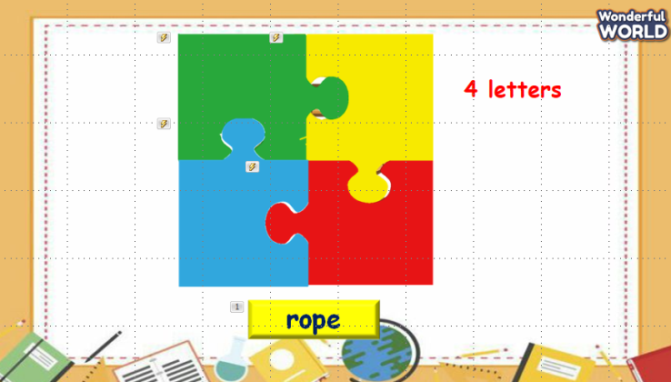  Answer keys:  - rope  - horse  - seesaw  - hide-and-seek  Lead in:  - T introduces that they will learn about “leisure activities” which use the words in warm-up today.  - Write on the board “Leisure time” and introduce the lesson. | -Play the game  -Choose a colour and answer the questions.  -Repeat the names of objects.  - Listen to the teacher.
Activity 2: Presentation (8 minutes)
a. Aims: Identify some leisure activities via the listening task
b. Procedure  Task 1: Listen and point. Repeat. (Track 5.4)  - Use flashcards to introduce the vocabulary of the lesson.  - Say the words for students to listen to and repeat in the chorus.  - Say a word for students to repeat then point.  - Check their pronunciation and give them feedback.    Checking vocabulary: Look and match.  - T asks SS to look at the pictures and words, and then match them together.  - Who can finish first can get stars or stickers.  - T calls SS to match and say the words again.  - Check and give them feedback.  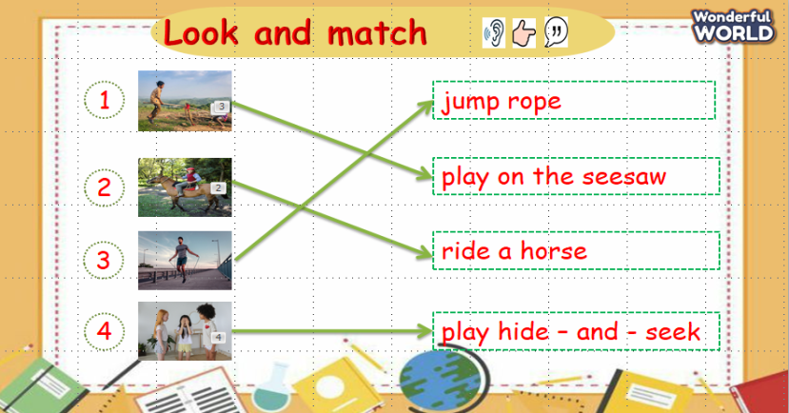  - Play track 5.4 for the students to listen to, point to, and repeat the words in chorus and groups.  - Check and give them feedback.  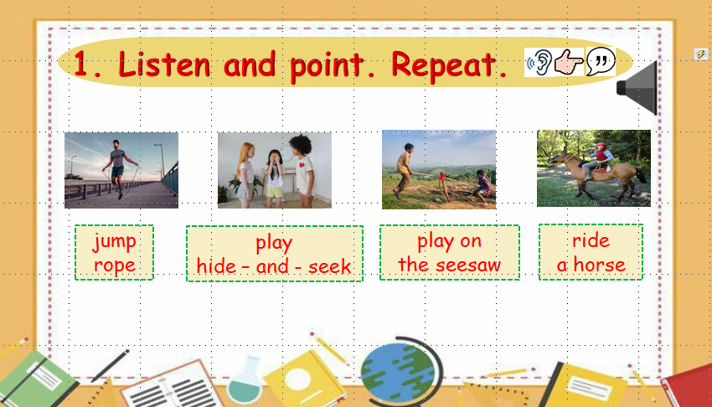 | - Listen to the teacher.  - Repeat after the teacher.  -Listen to the teacher, repeat, and point.  - Listen to the teacher.  - Match the pictures and the words.  - Listen to the teacher.  - Listen to track 5.4, point, and repeat.  - Listen to the teacher’s feedback.
Activity 3: Practice (10 minutes)
  - Aims: - Be able to understand the questions of the listening task related to topic leisure activities.
- Be able to answer the questions and write to complete sentences.
b. Procedure  Task 2: Listen and read. Write. Track 5.5.  - Ask SS to look at the picture and answer some questions about it.  1. How many children can you see?  2. What are they doing?  Answer keys:  - 5 children.  - Playing hide-and-seek.  - Call Ss to answer the questions.  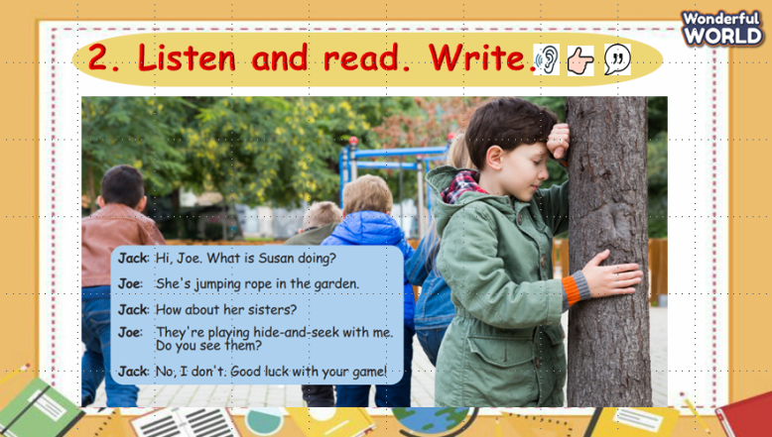  - Ask SS to identify the names of characters in the dialogue.  - Play track 5.5 and let SS listen to the dialogue, then repeat each sentence.  - Ask SS to read again, then write the correct answers.  - Let Sts read the dialogue by role-playing “Jack and Joe” to practice the words and the sentences.  - Check their pronunciation and give feedback.  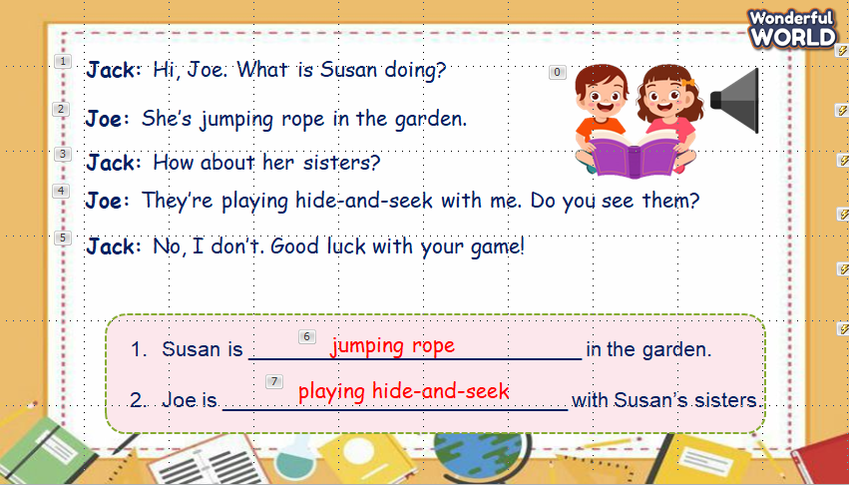  Task 3: Look and say:  - Look at the pictures and identify what they can see in each picture.  - Guide SS to make a sentence with a structure that talks about someone’s actions.  - Look at the picture and let SS write the sentences and say these sentences like the example.  - Call SS to say aloud in front of the class.  - Help Ss identify the questions and answers in general.  - Call SS to work in pairs and use these structures in 2 min, then call them to present in front of the class.  - Check and give them feedback.  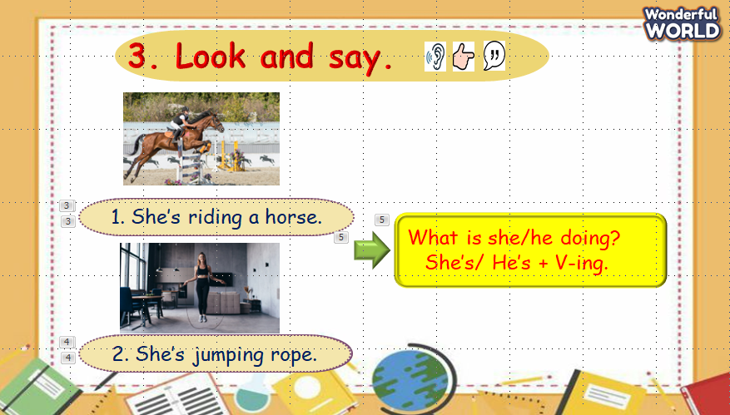 | -Look at the picture and answer the teacher.  - Answer the questions.  - Identify the names of characters.  - Listen to the dialogue and repeat each sentence.  - Read and write answers.  - Role play 2 characters: “Jack and Joe”.  - Listen to the teacher.  - Look and answer.  - Listen to the teacher. Make a sentence.  -Write the sentences and say  - Say aloud.  - Work in pairs, then present in front of the class.  - Listen to the teacher.
Activity 4: Production (9 minutes)
a. Aim: Apply to make a question or an answer (free leisure activities using vocab and structure they have learnt).
b. Procedure  - Work in groups.  - Ask SS to work in groups and look at the board and reorder the words to make a sentence, then answer the questions if it is a question or make a question if it is an answer.  - Call SS to answer then ask and answer in front of the class.  - Check and give feedback.  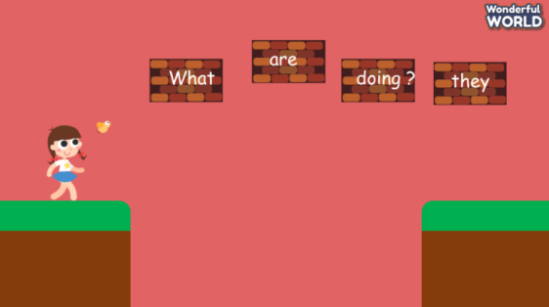  Answer keys:  1. What are they doing?  2. What is Joe doing?  3. She’s riding a horse.  4. We’re playing in the seesaw. | -Work in groups.  -Reorder the words, and make a sentence.  - Work in groups and present.  - Listen to the teacher.
Activity 5: Assessment (3 minutes)
a. Aims: Consolidate the content of the lesson.
b. Procedure  -Ask sts to do the assessment.  - Check with the class.  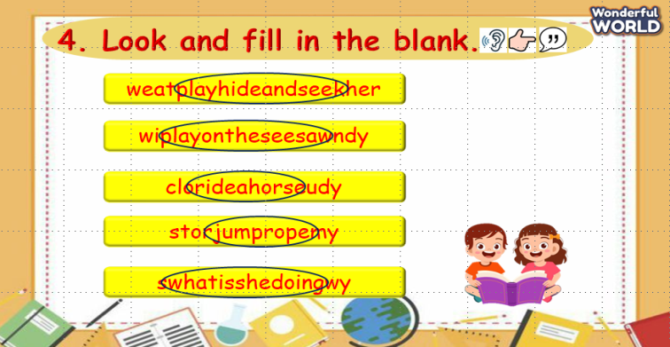 | - Do the assessment.  - Check with the teacher.
____________________________________________
UNIT 5. LEISURE TIME
Lesson 2. Task 4, 5, 6
Period 48
I. OBJECTIVES:
1. Knowledge: By the end of the lesson, Students will be able to
- Review words and phrases related to the topic Leisure activities: jump rope, play hide-and-seek, play on the seesaw, ride a horse.
- Learn new grammar related to what someone is doing:
Eg: - What is she doing?
She’s jumping rope.
- What are they doing?
They’re playing basketball.
- Practice the structures about what someone is doing.
2. Competences:
- English competences: Students have the ability to answer questions about what they are doing or what he/she is doing.
- Common competences: Students will have the opportunity to develop logical thinking and develop communication among friends.
- Core competences: motivation, communication, creativity, collaboration.
3. Qualities:
Students will:
- Develop a love for different leisure activities.
- Be confident and active in communicating with friends and their teachers.
II. EQUIPMENT AND MATERIALS:
- Student’s book, flashcards, track 5.6, track 5.7.
- PowerPoint (PPT) presentation, projector/ laptop, speaker.
III. LESSON PROCEDURE:

Teacher’s Activities | Students’ Activities
Activity 1: Warm-up (5 minutes)
a. Aims: Review some leisure activities they have learnt from the previous lesson.
b. Procedure  Warm-up: Play a small game “Picking flowers”  T divides the class into 2 teams.  T introduces the rule of the game:  (T calls SS to choose a flower and then answer the question on the slide. If he/she can answer correctly, he/she will have a chance to spin the wheel to get flowers. Which team has more flowers will be the winner.)  T asks Ss to repeat after each word that is found.  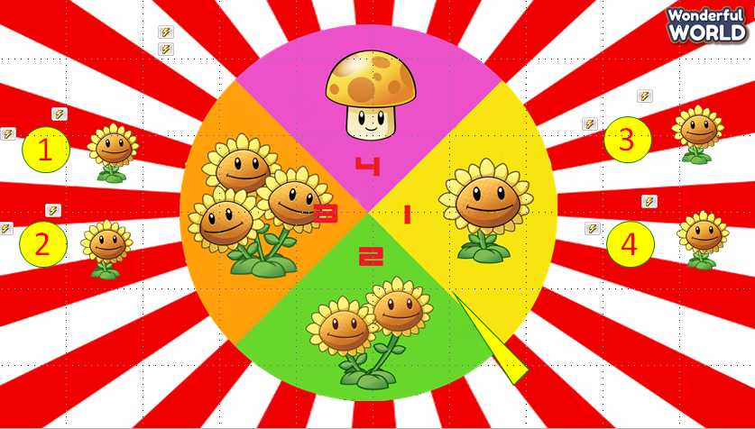  Answer keys:  - Play hide-and-seek  - Play on the seesaw  - Jump rope  - Ride a horse  Lead in:  - T introduces that they will continue to learn about “leisure activities” and the way to make questions with these words.  - Write on the board “Leisure time” and introduce the lesson. | -Listen and play the game.  -Repeat after each word.  - Listen to the teacher.
Activity 2: Presentation (10 minutes)
a. Aims: Present the grammar of present continuous to ask and answer about leisure activities.
b. Procedure  - Use flashcards to identify some information in each picture by asking some questions.  Picture 1: Is it a girl or a boy? (a girl)  How many girls are there? (one)  What activity is it? (jump rope)  - T guides SS to make the question with a person and underline the words “she’s” and “V-ing” for SS to understand this structure.  T continues to picture 2.  Picture 2: How many people are there? (two)  What activity is it? (play basketball)  - T calls SS to read aloud in chorus.  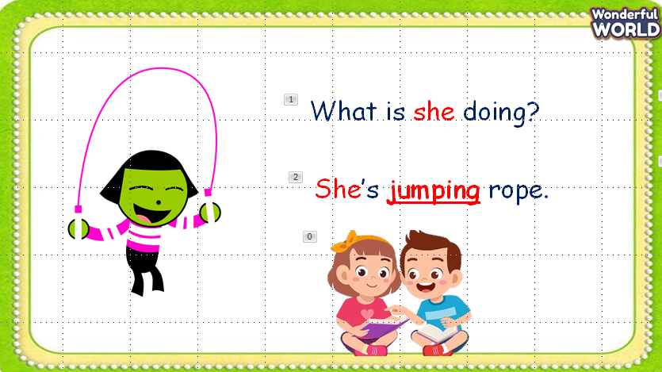  Checking structures: Look and match.  - T asks SS to work in pairs and match pictures with words, then make a question or answer to talk about these pictures.  - T invites SS to present in front of the class.  - Give them feedback.  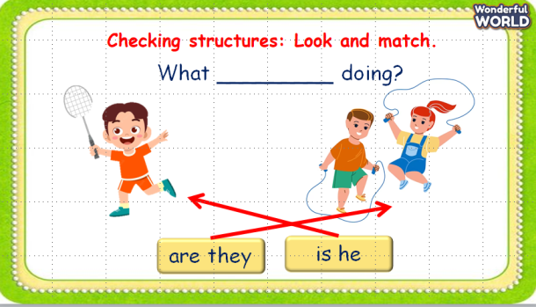  Task 1: Listen and point. Repeat. (Track 5.6)  - Play track 5.6, say the sentences for students to listen to, and repeat in the chorus.  - Say each sentence for students to repeat then point.  - Call SS to role-play in front of the class.  - Check and give them feedback.  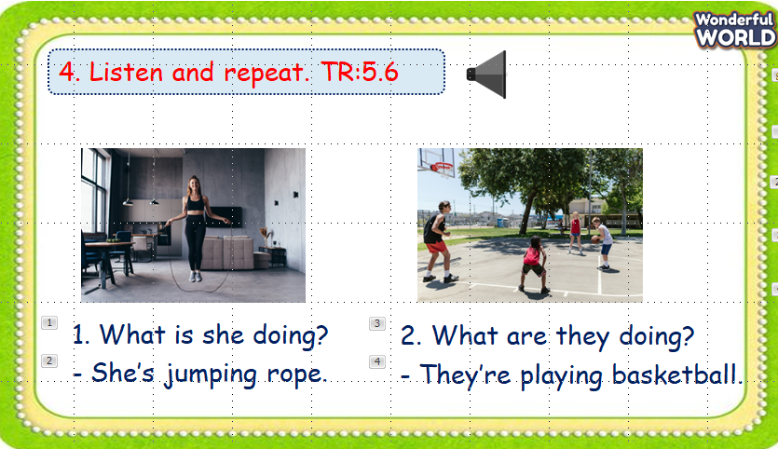 | - Answer the questions.  - Listen to the teacher.  - Answer the teacher.  -Repeat after the teacher.  -Read aloud  - Work in pairs and match pictures with words.  -Practice asking and answering about pictures.  - Present in front of the class  - Listen to the teacher.  - Listen to the track.  - Repeat and point  - Role play.  - Listen to the teacher.
Activity 3: Practice (8 minutes)
a. Aims: Ask and answer about what someone is doing and use the grammar they have learnt.
b. Procedure  Task 5: Look and say.  - Ask SS to look at the picture and identify what they can see in each picture.  - Call a student to role-play with T. T asks the student, then the student answers.  - Ask SS to work in pairs, ask and answer about each picture in 3 min.  - Call Ss to present in front of the class.  - Give them feedback.  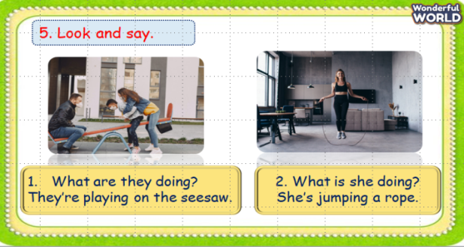 | -Listen and answer the teacher.  -Role-play with the teacher  - Work in pairs. Ask and answer about pictures.  - Present in front of the class.  - Listen to the teacher.
Activity 4: Production (9 minutes)
a. Aims: Chant the song correctly according to its lyrics.
b. Procedure  Task 6: Listen and chant. Track 5.7.  - Ask SS to look at the picture and answer some questions.  1. Who are they? (a family)  2. How many people are there? (three)  3. What season is it? (winter)  4. What’s the weather like? (cold and snowy)  - Play track 5.7 and ask to listen and repeat in chorus.  - Ask SS to work in groups of 4 and chant again in 3 min.  - Call some groups present in front of the class.  - Check and give feedback.  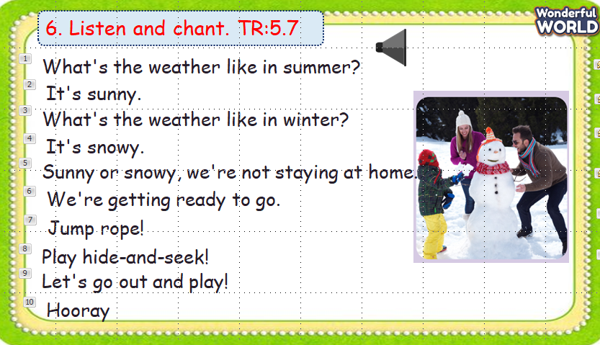 | - Look at pictures and answer the questions.  - Listen to track 5.7 and repeat.  - Work in groups and chant.  - Listen to teacher.
Activity 5: Assessment (3 minutes)
a. Aims: Consolidate the content of the lesson.
b. Procedure  -Ask sts to do the assessment.  - Check with the class.  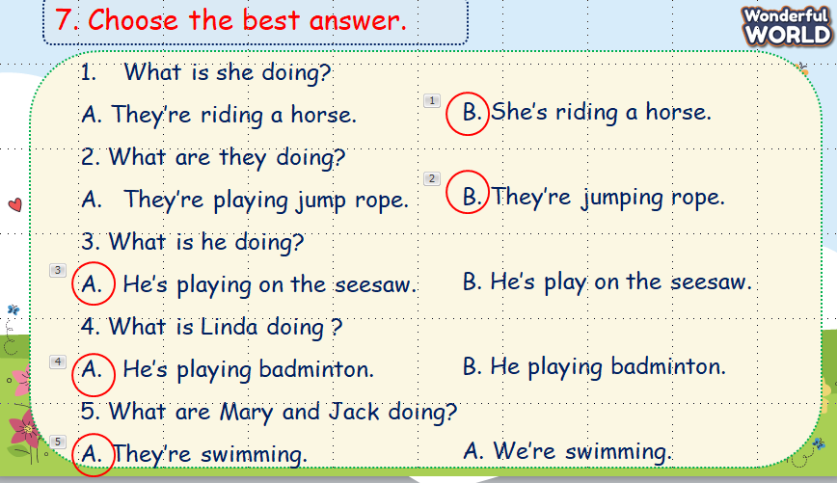 | -Do the assessment.  - Check with the teacher.

