WEEK 13
UNIT 5. LEISURE TIME
Lesson 2. Task 7, 8, 9
Period 49
I. OBJECTIVES:
1. Knowledge: By the end of the lesson, Students will be able to
- Review words and phrases related to the topic Leisure activities: jump rope, play hide-and-seek, play on the seesaw, ride a horse.
- Review the structures related to what someone is doing.
Eg: - What is she doing?
She’s jumping rope.
- What are they doing?
They’re playing basketball.
2. Competences:
- English competences: Students have the ability to answer the questions about what they are doing or what he/she is doing and expand the questions for activities around them.
- Common competences: Students will have the opportunity to develop logical thinking and develop communication among friends.
- Core competences: motivation, communication, creativity, collaboration.
3. Qualities:
Students will:
- Develop a love for different leisure activities.
- Be confident and active in communicating with friends and their teacher.
II. EQUIPMENT AND MATERIALS:
- Student’s book, flashcards, track 5.8.
- PowerPoint (PPT) presentation, projector/ laptop, speaker.
III. LESSON PROCEDURE:

Teacher’s Activities | Students’ Activities
Activity 1: Warm-up (5 minutes)
a. Aims: Review the vocab and grammar of the previous lesson- using the correct tense.
b. Procedure  Warm-up: Play a small game “Slap the board”  T divides the class into 2 teams.  T introduces the rule of the game:  (Game: Slap the board  - T calls 2 Ss to come to the board.  - Ss on the board have a quick look at the activities on the board.  - When the teacher says the sentences, the who get the pictures of those sentences first will get the points for their team. Which team has more points will be the winner)  T asks Ss to repeat after each word that is found.  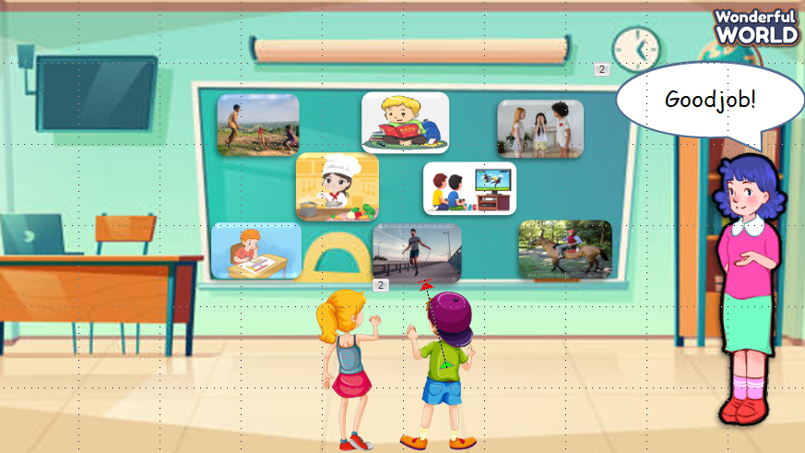  Answer keys:  - I’m playing hide-and-seek.  - They’re playing on the seesaw  - He’s jumping rope.  - I’m riding a horse.  - She’s cooking.  - I’m studying.  - They’re playing a game.  - He’s reading a book.  Lead in:  - T introduces that they will continue to review “leisure activities” and the way to make questions with these words.  - Write on the board “Leisure time” and introduce the lesson. | -Listen to the game rules.  -Play the game.  - Listen to the sentences and slap the correct pictures on the board.  - Repeat after each word.  - Listen to the teacher.
Activity 2: Practice (18 minutes)
Aims:
Controlled practice: Help sts to practise the vocab and new grammar of present continuous by doing matching exercise.
Encourage sts to make a full sentence using Yes/ No questions to ask about leisure activities.
b. Procedure  Task 7: Listen and match. Track 5.8.  - T asks SS to read the information of each question. Then listen and match.  - T calls SS to answer each question.  - Give feedback to SS.  - Ask SS to repeat each question.  - Check and give them feedback.  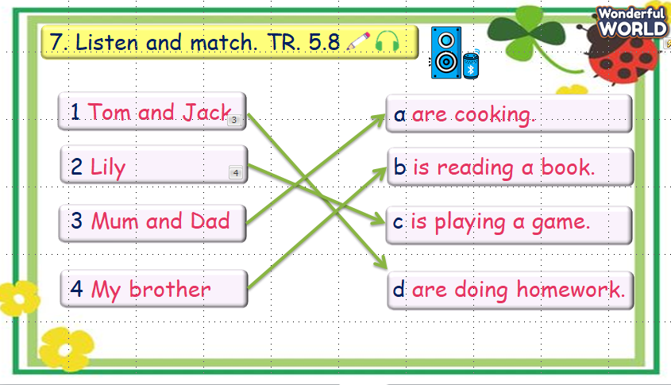  Task 8: Look and say.  - T asks SS to identify each picture that they can see.  - T makes the question and calls SS to answer as an example.  - T asks SS to work in groups of 4 and do task 8 in the textbook.  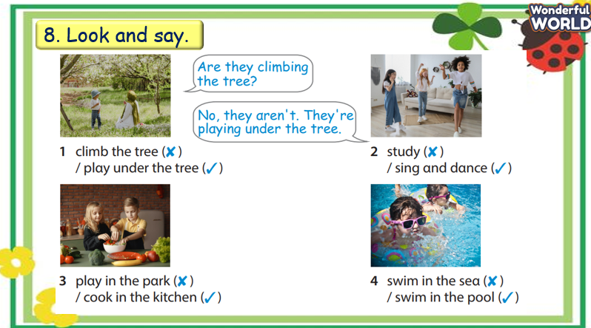  - T asks SS to play the “Lucky Numbers” game and introduces the rules of the game:  (T divides the class into 2 teams.  There are 4 sunflowers and SS chooses a flower to ask and answer the question in each picture as an example. Then choose a number to get points for their team. Which team has the most points will be the winner. Each number can be chosen more than once.)  - T gives feedback.  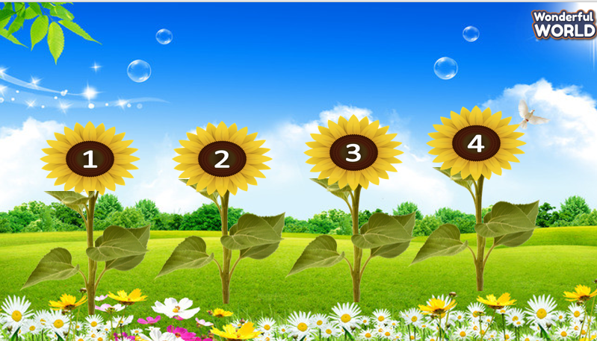  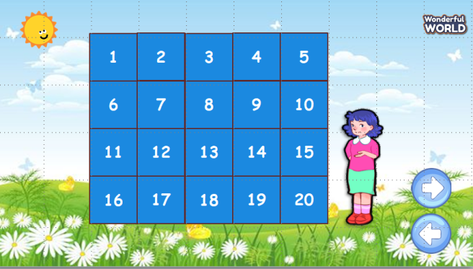 | -Read the question.  -Listen and match.  - Listen to the teacher and answer the questions.  -Repeat after the teacher.  - Listen to the teacher.  -Identify pictures.  -Do the example with teacher.  -Work in groups. Do task 8 in the textbook. (Make questions and answer the questions based on given words and pictures)  -  -Listen to the game rules.  -Play the game.  - Listen to the teacher’s feedback.
Activity 3: Production (9 minutes)
Aims:
        - Apply to make a similar conversation about leisure activities
        - Encourage sts to look around in class and ask friends what people are doing.
b. Procedure  Task 9: Let’s talk.  - Ask SS to look around your classroom and identify some activities in the classroom.  - Ask SS to work in pairs for 3 min and ask their friends about what people are doing in the classroom.  - Call pairs to present in front of the class.  - Check and give feedback.  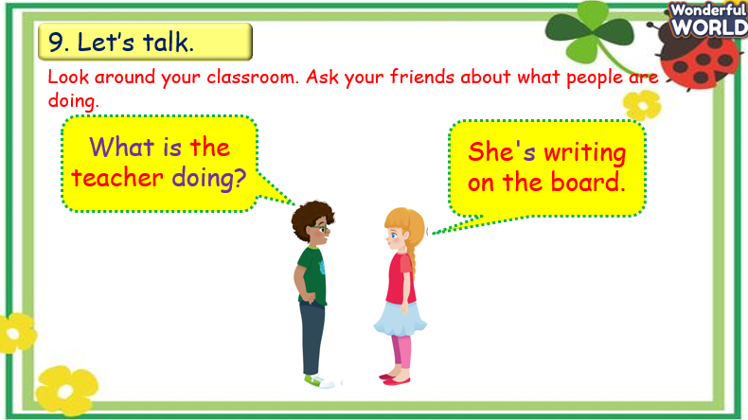 | -Look around the classroom and identify some activities.  -Work in pairs. Practice asking and answering what people are doing.  -Some pairs present in front of the class.  -Listen to the teacher.  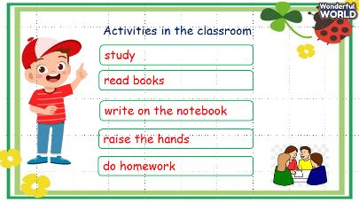
Activity 4: Assessment (3 minutes)
a. Aims: Consolidate the content of the lesson.
b. Procedure  -Ask sts to do the assessment.  - Check with the class.  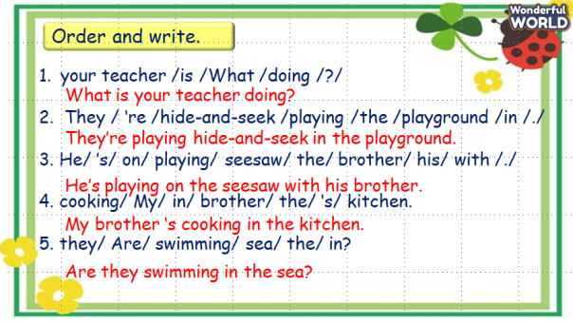 | -Do the assessment.  -Check with the teacher.
____________________________________
UNIT 5. LEISURE TIME
Lesson 3. Task 1, 2, 3
Period 50
I. OBJECTIVES:
1. Knowledge: By the end of the lesson, Students will be able to
- Learn words related to the topic Leisure activities: play board games,play video games, read a comic book, watch a film.
2. Competences:
- English competences: Students will be able to use more words related to leisure activities.
- Common competences: Students will have the opportunity to develop logical thinking and develop communication among friends.
- Core competences: motivation, communication, creativity, collaboration.
3. Qualities:
Students will:
- Develop a love for different leisure activities.
- Be confident and active in communicating with friends and their teacher.
II. EQUIPMENT AND MATERIALS:
- Student’s book, flashcards, track 5.9, track 5.10.
- PowerPoint (PPT) presentation, projector/ laptop, speaker.
III. LESSON PROCEDURE:

Teacher’s Activities | Students’ Activities
Activity 1: Warm-up (5 minutes)
a. Aims: List the names of leisure activities they have known.
b. Procedure  Warm-up: Play a small game “Name leisure activities”  -T divides the class into 2 teams.  -T introduces the rule of the game:  (Game: Name leisure activities  - T calls Ss to make a line of 3-5.  - Ss have to go to the board write the name of one activity and give the chalk to other members in their group in 3 min.  - After the time is out, T checks their answers. Those who get more words related to leisure activities will get points for their team. Which team has more points will be the winner.)  -T asks Ss to repeat after checking.  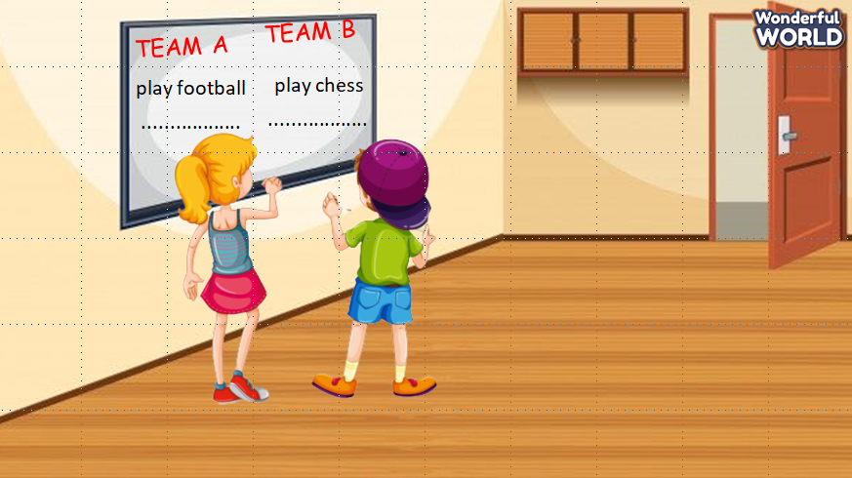  Lead in:  - T introduces that they will continue to learn more about “leisure activities”.  - Write on the board “Leisure time” and introduce the lesson. | -Listen to the game rules.  -Play the game.  - Repeat all the correct words on the board.  - Listen to the teacher.
Activity 2: Presentation (10 minutes)
a. Aims: Present some more vocabulary about leisure activities.
b. Procedure  Task 1: Listen and point. Repeat. Track 5.9.  - T asks SS to look at the picture and guess what activity it is.  - T plays audio and asks SS to listen and check their answers.  - T asks Ss to repeat in the chorus.  - Check their pronunciation and give feedback.  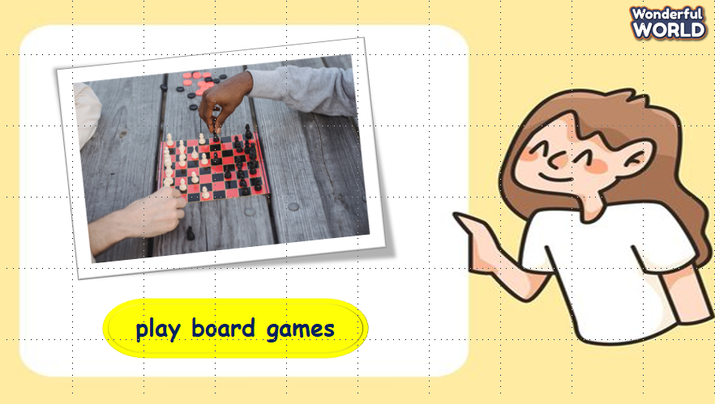  *Checking vocabulary: Circle.  - T asks SS to look at pictures and words, then choose the word that is suitable to each picture.  - Call SS to choose answers.  - Check students’ answers.  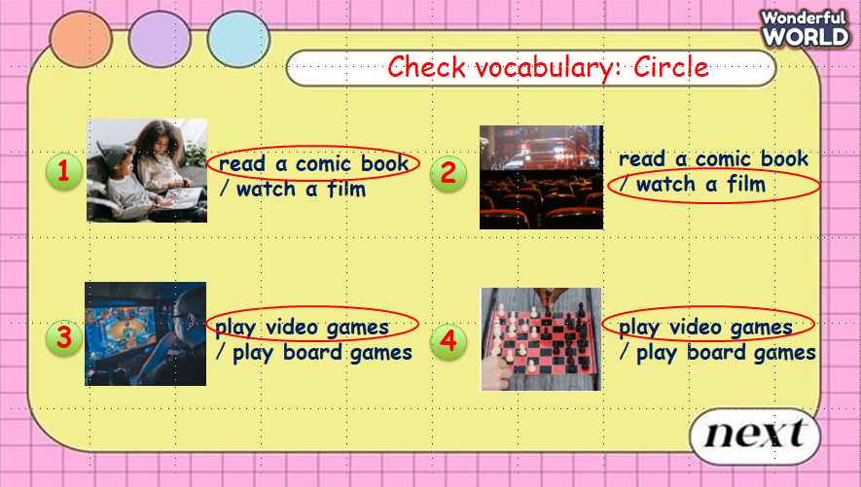  - Play track 5.9, say the words for students to listen to, and repeat in the chorus.  - Say each word for students to repeat then point.  - Call SS to read aloud in front of the class.  - Give them feedback.  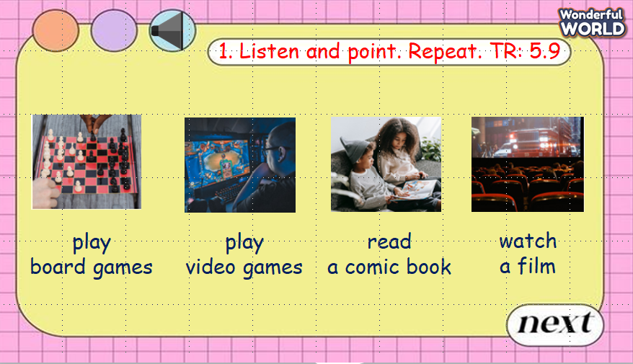 | - Listen and answer.  - Repeat after the teacher.  - Listen to the teacher’s feedback.  - Look and circle the correct answers.  - Listen to the teacher and check.  - Listen and repeat.  - Read aloud the word and point.  - Listen to the teacher.
Activity 3: Practice (8 minutes)
- Aims: Controlled – practice: Listen and tick a conversation using the vocab of task 1.
- Encourage sts to act out the dialogue in pair in front of the class
b. Procedure  Task 2: Listen and tick. TR: 5.10  - Ask SS to look at the picture and identify what they can see in the picture.  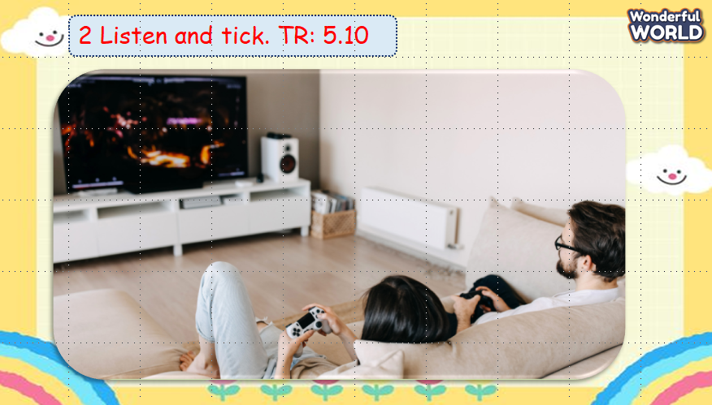  - Ask SS to look at three questions and guess their answers.  - Ask SS to listen and tick a correct answer for each question.  - Check their answers.  - Call SS to read aloud each sentence.  - Give them feedback.  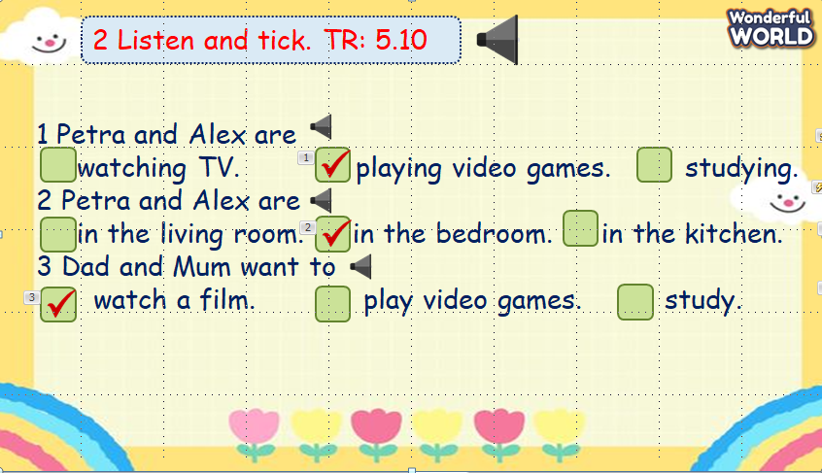  Task 3: Look and say.  - Ask SS to look at the picture and identify what activity they can see in each picture.  -Ask SS to look at the example and work in pairs to make the sentences in 2 min.  - Call SS to present in front of the class.  - Give their feedback.  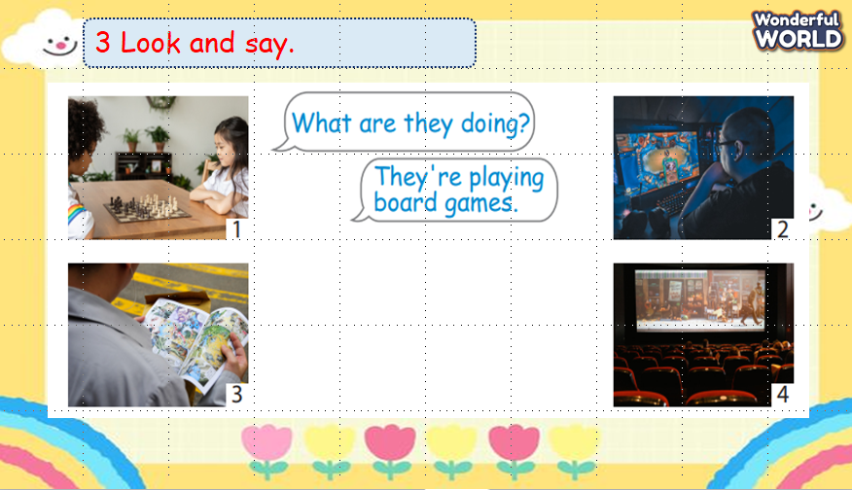 | -Look at the picture and answer.  - Listen and tick the correct answers.  - Answer the teacher.  - Read aloud the sentences.  - Look and answer.  - Work in pairs.  - Present in front of the class.
Activity 4: Production (9 minutes)
a. Aims: Apply to present in front of the class about their classmates’ leisure activities
b. Procedure  Let’s talk  - Ask SS to go around the class and find 4 answers about the leisure activities in 3 min.  - Ask SS to make a mind map and present it in front of the class.  - Check and give feedback.  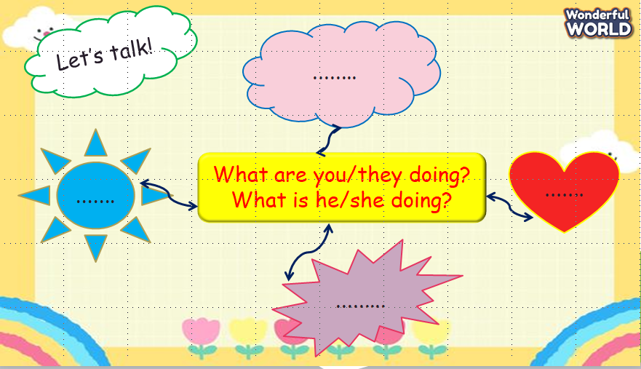 | - Go around the class, ask and find answers.  - Make a mind map and present in front of the class.
Activity 5: Assessment (3 minutes)
a. Aims: Consolidate the content of the lesson.
b. Procedure  - Ask sts to do the assessment.  - Check with the class.  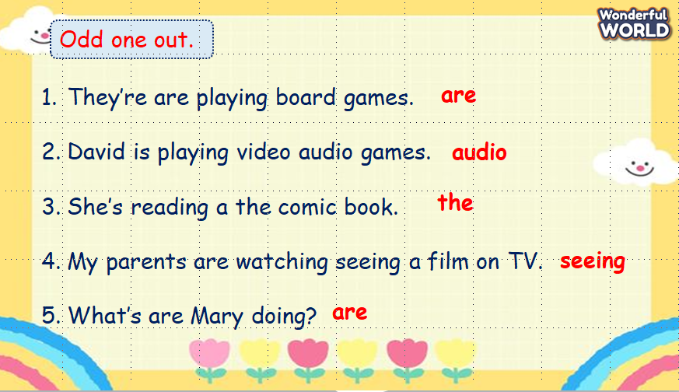 | - Do the assessment.  - Check with the teacher.
___________________________________
UNIT 5. LEISURE TIME
Lesson 3. Task 4, 5, 6
Period 51
I. OBJECTIVES:
1. Knowledge: By the end of the lesson, Students will be able to
- Review words related to the topic Leisure activities: play board games, play video games, read a comic book, watch a film.
- Learn new grammar: where someone is doing a certain thing.
E.g.: Where are they playing video games?
- In the living room.
2. Competences:
- English competences: Students have the ability to use the new structure to ask and answer where someone is doing a certain thing.
- Common competences: Students will have the opportunity to develop logical thinking and develop communication among friends.
- Core competences: motivation, communication, creativity, collaboration.
3. Qualities:
Students will:
- Develop a love for different leisure activities and places where they are playing.
- Be confident and active in communicating with friends and their teachers.
II. EQUIPMENT AND MATERIALS:
- Student’s book, flashcards, track 5.11.
- PowerPoint (PPT) presentation, projector/ laptop, speaker.
III. LESSON PROCEDURE:

Teacher’s Activities | Students’ Activities
Activity 1: Warm-up (5 minutes)
a. Aim: Review the words of leisure activities.
b. Procedure  Warm-up: Play a small game “Matching”  -T divides the class into 2 teams.  -T introduces the rule of the game:  (Game: Matching  - T calls SS to choose 2 numbers to match the word and picture together.  Who gets correct answers gets a point.  Which team has more points will be the winner.)  T asks Ss to repeat after checking.  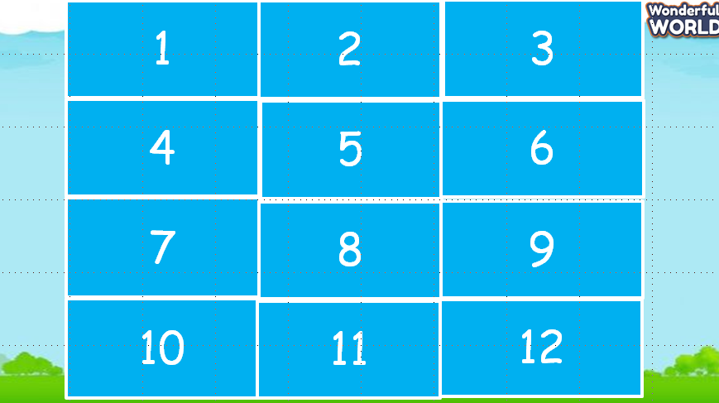  Lead in:  - T introduces that they will review about “leisure activities” and places where someone is doing actions.  - Write on the board “Leisure time” and introduce the lesson. | - Listen to the game rules.  - Play the game.  - Repeat after the teacher.  - Listen to the teacher.
Activity 2: Presentation (10 minutes)
a. Aim: Present the grammar “Where + tobe + S + V-ing?”
b. Procedure  Task 4: Listen and repeat. Track 5.11.  - T asks SS to look at the board and guide SS to use different subject pronouns: “they”- plural subjects use “are” and “she”- singular subjects use “is”.  - T shows a picture and asks SS some questions  How many people are there in the picture?  What are they doing?  Where are they playing video games?  - T reads the question and answer, “Where are they playing video games? – In the living room”, then asks SS to repeat.  - T calls SS to repeat in the chorus.  - Check and give feedback.  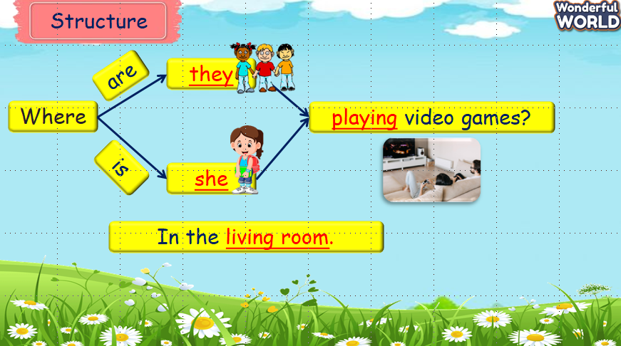  - T plays track 5.11 and asks SS to repeat in the chorus.  Then T guides SS to practise this structure in pairs.  - T calls some pairs to present in front of the class.  - Check their pronunciation and give feedback.  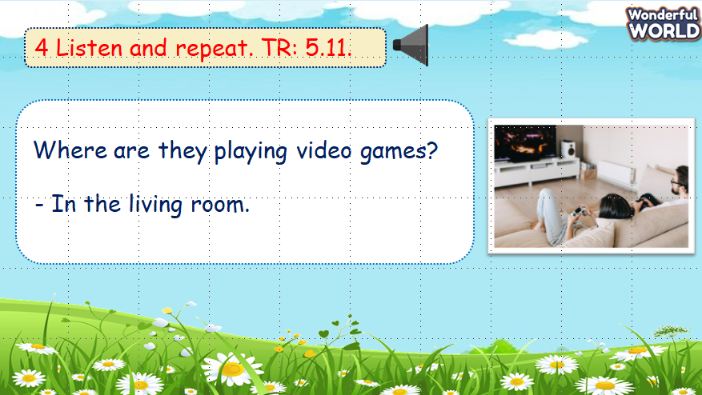 | - Listen and answer.  Two.  They are playing games.  In the living room.  - Repeat after the teacher.  - Listen to the T.  - Listen to track and repeat.  - Work in pairs.  - Some pairs present in front of the class.
Activity 3: Practice (8 minutes)
a. Aim: Use the question “Where + tobe + S + V-ing?” to make sentences.
b. Procedure  Task 5: Look and say.  - Ask SS to look at the picture and identify what activity they can see in each picture and the place where they are.  -Ask SS to look at the example and work in pairs to make the sentences in 3 min.  - T asks SS to play a game: “Tic-tac-toe”.  - T introduces the rule of the game:  (T divides the class into 2 teams. 2 Ss choose a number and make a sentence as the example. If they answer correctly, they can tick X or O for the number that they chose. Which team has 3 X or 3 O in a line will be a winner. A number can exist more than once.)  - Give their feedback.  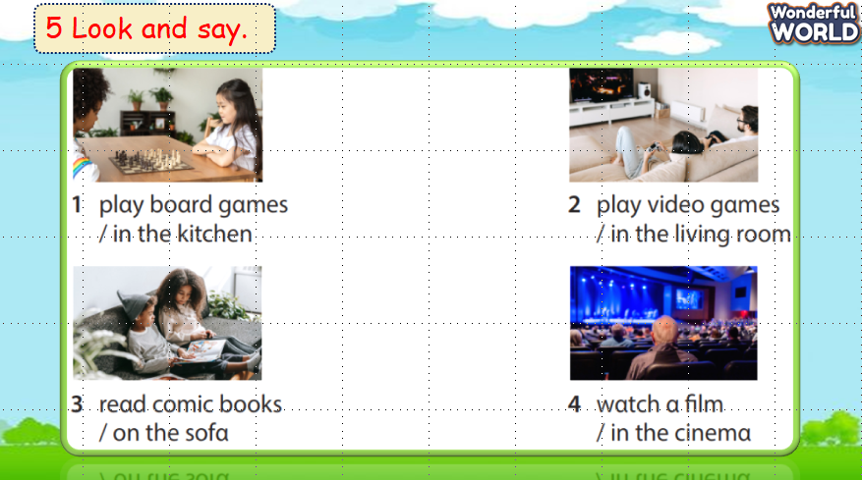  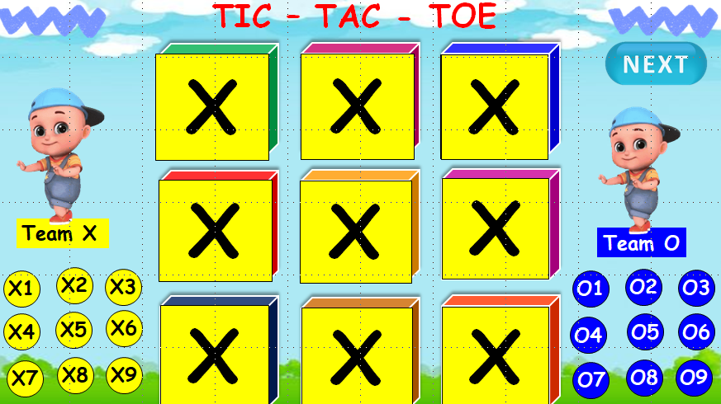 | - Look at the picture and answer.  - Work in pairs. Make the sentences.  -Listen to game rules.  - Play the game.  -Listen to the teacher.
Activity 4: Production (9 minutes)
a. Aims: Draw and apply grammar to make a small conversation.
b. Procedure  Let’s talk  - Ask each SS to draw a small picture that describes an action and a place where someone is in 3 min.  - Ask SS to work in groups of 4 and make the questions as the example on the slide in 2 min.  - Call some groups to present in front of the class.  - Check and give feedback.  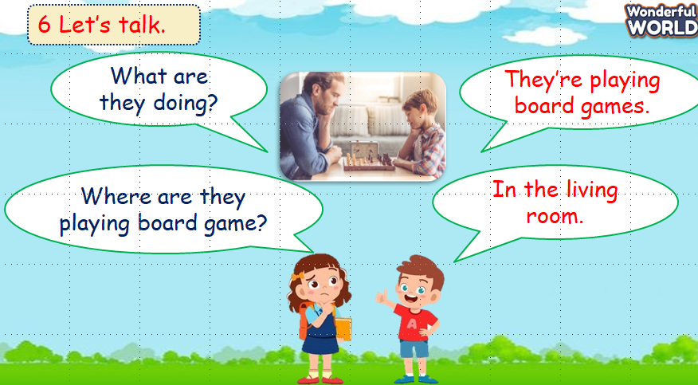 | - Draw a picture to describe an action and a place.  - Work in groups of 4.  - Make the questions.  - Some groups present in front of the class.  - Listen to the teacher.
Activity 5: Assessment (3 minutes)
a. Aim: Consolidate the content of the lesson.
b. Procedure  -Ask sts to do the assessment.  - Check with the class.  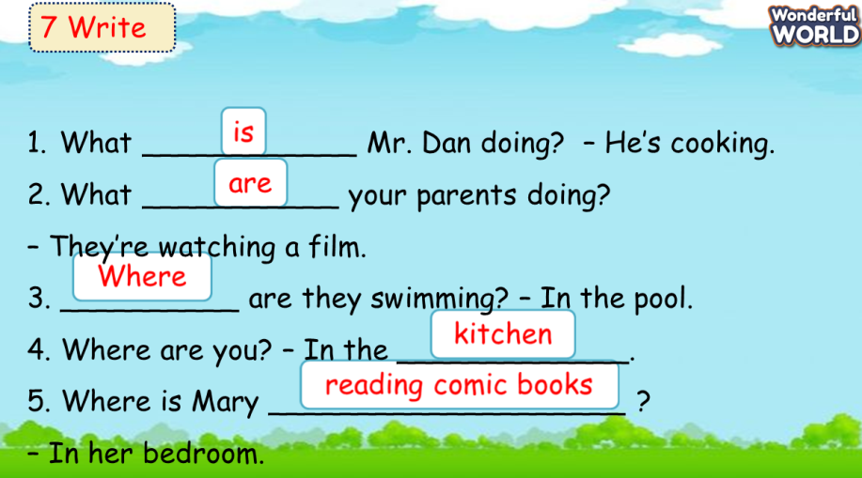 | - Do the assessment.  - Check with the teacher.
________________________________
UNIT 5. LEISURE TIME
Lesson 3. Task 7, 8, 9
Period 52
I. OBJECTIVES:
1. Knowledge: By the end of the lesson, Students will be able to
- Review words related to the topic Leisure activities: play board games, play video games, read a comic book, watch a film.
- Learn to pronounce the sounds /dʒ/ and /θ/ correctly in isolation, in words, and sentences.
2. Competences:
- English competences: Students have the ability to find the words that are pronounced “/dʒ/” and “/θ/”.
- Common competences: Students will have the opportunity to develop logical thinking and develop communication among friends.
- Core competences: motivation, communication, creativity, collaboration.
3. Qualities:
Students will:
- Develop a love for different leisure activities and love the sounds in English.
- Be confident and active in communicating with friends and their teachers.
II. EQUIPMENT AND MATERIALS:
- Student’s book, flashcards, track 5.12, track 5.13.
- PowerPoint (PPT) presentation, projector/ laptop, speaker.
III. LESSON PROCEDURE:

Teacher’s Activities | Students’ Activities
Activity 1: Warm-up (5 minutes)
a. Aim: Review the grammar you’ve learned about describing what someone is doing in the previous lesson
b. Procedure  Warm-up: Play a small game “Sentence puzzle”  T divides the class into 2 teams.  T introduces the rule of the game:  (Game: Sentence puzzle  - T calls SS to choose a number and reorder the words to make a full sentence. Who gets correct answers gets points in the box. At the end of the game, which team that has more points will be the winner.)  T asks Ss to repeat after checking.  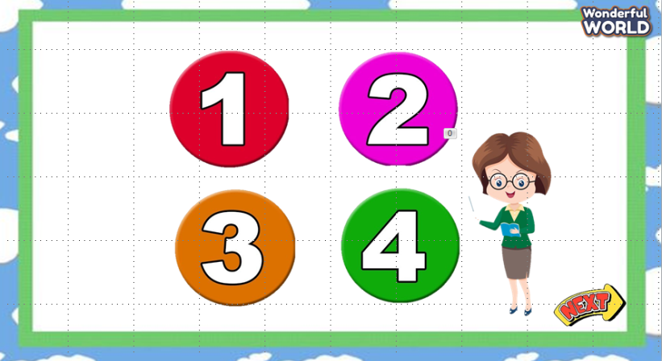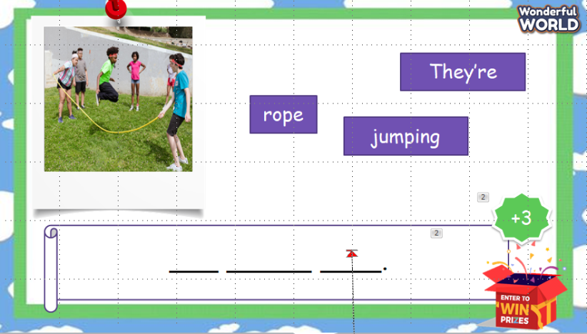  Lead in:  - T introduces that they will review “leisure activities” and learn to pronounce 2 sounds in English.  - Write on the board “Leisure time” and introduce the lesson. | - Listen to the game rules.  -Play the game  - Repeat after the teacher.  - Listen to the teacher.
Activity 2: Presentation (10 minutes)
a. Aims: Present how to pronounce the sounds /dʒ/ and /θ/ correctly.
b. Procedure  Task 7: Listen and repeat. Track 5.12.  - T asks SS to look at the board and introduce 2 sounds in English.  - T guides SS to read these sounds carefully.  - T calls SS to repeat in the chorus.  - Then T calls some SS to stand up and read these sounds, then correct their pronunciation.  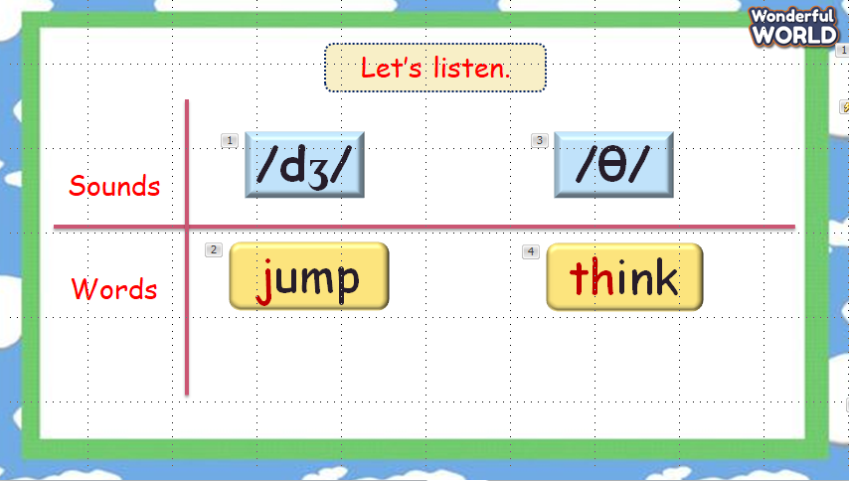  - T asks SS to look at 2 pictures and identify what they can see.  - T plays track 5.12 and asks SS to repeat in the chorus.  - T calls SS to present in front of the class.  - Check and give them feedback.  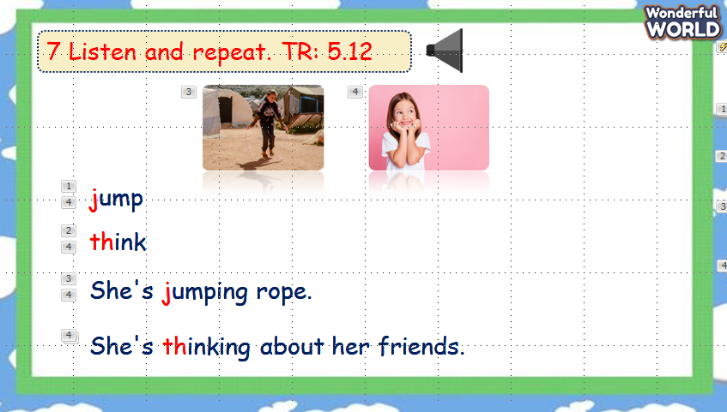 | -Look at the board and listen to the teacher.  -Read the sounds.  - Repeat after the teacher.  -Listen to the teacher.  - Look at the pictures and describe them.  -Listen and repeat.  - Present in front of the class.
Activity 3: Practice (8 minutes)
a. Aims: Practice pronouncing 2 sounds /dʒ/ and /θ/
b. Procedure  Task 8: Listen and chant. Track 5.13  - Ask SS to look at the picture and identify what activity they can see in each picture.  -Ask SS to find the words with each sound they have introduced.  - Call SS to read aloud the words they have found.  - Play track 5.13 and ask Ss to repeat in chorus.  - Teach SS to chant each sentence.  - Ask SS to work in groups of 4 and chant, then present in front of the class.  - Give their feedback.  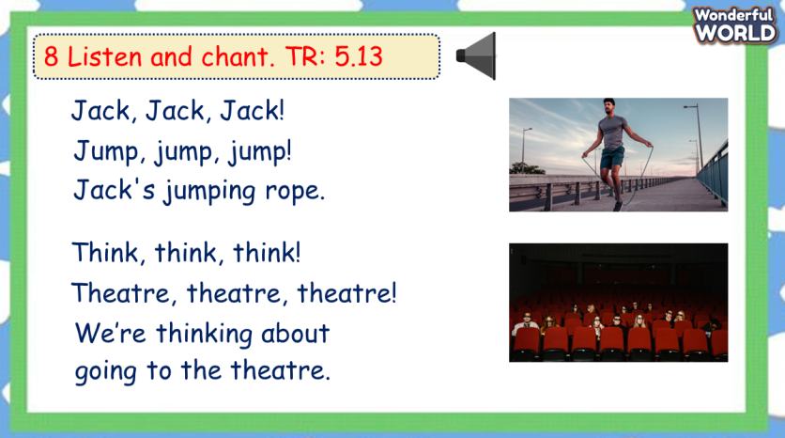  Task 9: Say it!  - Ask SS to identify what they can see in each picture.  - Ask SS to listen and repeat each sentence.  - Ask SS to work in pairs to read again.  - Call some students to present in front of the class.  - Give their feedback.  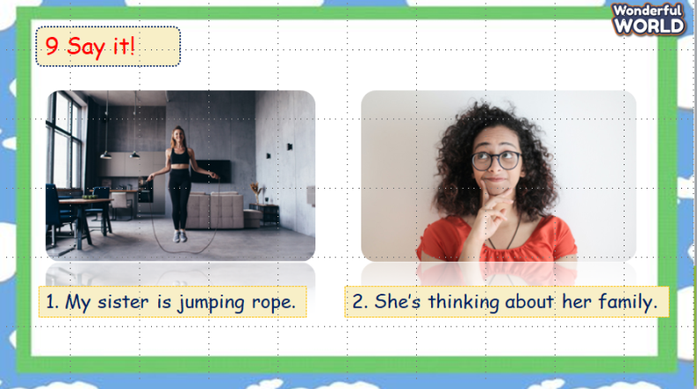 | -Look at the picture and describe it.  - Find the words with sounds  -Read aloud the words.  -Listen and repeat  -Chant the sentences.  - Work in groups.  - Listen to the teacher.  - Answer the teacher.  - Listen and repeat each sentence.  - Work in pairs and read.  - Present in front of the class.  - Listen to the teacher.
Activity 4: Production (9 minutes)
a. Aim: Find more words with 2 sounds they have learnt.
b. Procedure  Let’s talk  - Ask SS to play a game “pass the ball”.  - Introduce the rules of the game.  (The rule of the game: Pass the ball  T plays music and SS has to pass the ball. When the music stops, the student who has the ball will find a word with one of 2 sounds they have learnt. Those who cannot find will become losers and have to ask other students in the class for help.)  - Check and give feedback.  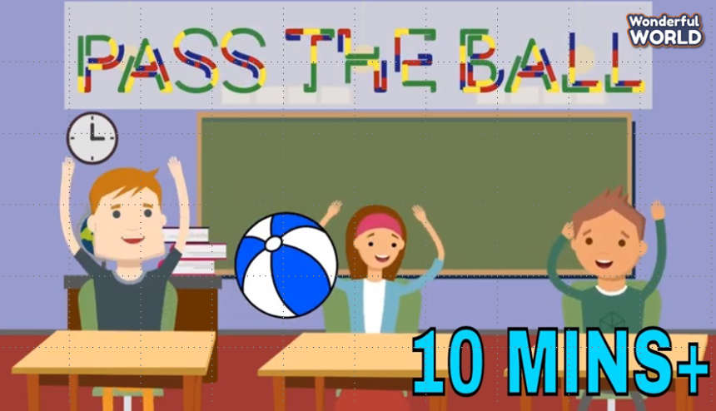 | -Listen to the game rules.  - Play the game.  - Listen to the teacher.
Activity 5: Assessment (3 minutes)
a. Aim: Consolidate the content of the lesson.
b. Procedure  -Ask sts to do the assessment.  - Check with the class.  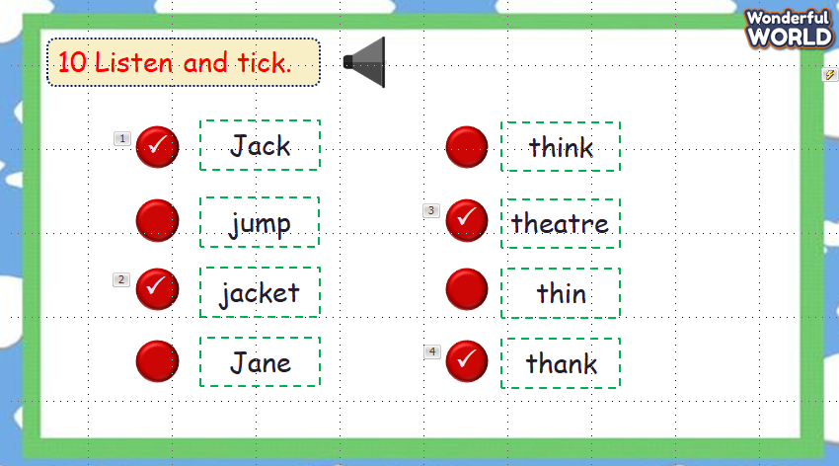 | -Do the assessment.  - Check with the teacher.

