TUẦN 25 Khối 3, 5 (Từ ngày 10/03/2025 đến ngày 14/03/2025)
THỨ | TIẾT | MÔN | TIẾT THỨ | NỘI DUNG BÀI DẠY |  | UDCNTT | ĐỒ DÙNG DẠY HỌC
Hai  10/03 | 1 | 5A | 97 | Unit 9. Holiday and travel | Lesson 3 (1, 2, 3) | Wonderfulworld | Flashcards, TV, books
Hai  10/03 | 2
Hai  10/03 | 3 | 3A | 97 | Unit 8. My town | Lesson 2 (7, 8, 9) | Wonderfulworld | Flashcards, TV, books
Hai  10/03 | 4 | 3A | 98 | Unit 8. My town | Lesson 3 (1, 2, 3) | Wonderfulworld | Flashcards, TV, books
Hai  10/03 | 5 | 5D | 97 | Unit 9. Holiday and travel | Lesson 3 (1, 2, 3) | Wonderfulworld | Flashcards, TV, books
Hai  10/03 | 6 | 3B | 97 | Unit 8. My town | Lesson 2 (7, 8, 9) | Wonderfulworld | Flashcards, TV, books
Hai  10/03 | 7
Ba  11/03 | 1 | 5C | 97 | Unit 9. Holiday and travel | Lesson 3 (1, 2, 3) | Wonderfulworld | Flashcards, TV, books
Ba  11/03 | 2 | 5B | 97 | Unit 9. Holiday and travel | Lesson 3 (1, 2, 3) | Wonderfulworld | Flashcards, TV, books
Ba  11/03 | 3 | 5A | 98 | Unit 9. Holiday and travel | Lesson 3 (4, 5, 6) | Wonderfulworld | Flashcards, TV, books
Ba  11/03 | 4
Ba  11/03 | 5 | 3A | 99 | Unit 8. My town | Lesson 3 (4, 5, 6) | Wonderfulworld | Flashcards, TV, books
Ba  11/03 | 6 | 5D | 98 | Unit 9. Holiday and travel | Lesson 3 (4, 5, 6) | Wonderfulworld | Flashcards, TV, books
Ba  11/03 | 7 | 3B | 98 | Unit 8. My town | Lesson 3 (1, 2, 3) | Wonderfulworld | Flashcards, TV, books
Tư  12/03 | 1 | 5A | 99 | Unit 9. Holiday and travel | Lesson 3 (7, 8, 9, 10) | Wonderfulworld | Flashcards, TV, books
Tư  12/03 | 2
Tư  12/03 | 3
Tư  12/03 | 4
Tư  12/03 | 5 | 5B | 98 | Unit 9. Holiday and travel | Lesson 3 (4, 5, 6) | Wonderfulworld | Flashcards, TV, books
Tư  12/03 | 6 | 5C | 98 | Unit 9. Holiday and travel | Lesson 3 (4, 5, 6) | Wonderfulworld | Flashcards, TV, books
Tư  12/03 | 7
Năm  13/03 | 1 | 5C | 99 | Unit 9. Holiday and travel | Lesson 3 (7, 8, 9, 10) | Wonderfulworld | Flashcards, TV, books
Năm  13/03 | 2 | 5B | 99 | Unit 9. Holiday and travel | Lesson 3 (7, 8, 9, 10) | Wonderfulworld | Flashcards, TV, books
Năm  13/03 | 3 | 5A | 100 | Unit 9. Holiday and travel | Fun time and project (1, 2) | Wonderfulworld | Flashcards, TV, books
Năm  13/03 | 4
Năm  13/03 | 5 | 5D | 99 | Unit 9. Holiday and travel | Lesson 3 (7, 8, 9, 10) | Wonderfulworld | Flashcards, TV, books
Năm  13/03 | 6 | 5C | 100 | Unit 9. Holiday and travel | Fun time and project (1, 2) | Wonderfulworld | Flashcards, TV, books
Năm  13/03 | 7
Sáu  14/03 | 1 | 3B | 99 | Unit 8. My town | Lesson 3 (4, 5, 6) | Wonderfulworld | Flashcards, TV, books
Sáu  14/03 | 2 | 5D | 100 | Unit 9. Holiday and travel | Fun time and project (1, 2) | Wonderfulworld | Flashcards, TV, books
Sáu  14/03 | 3 | 5B | 100 | Unit 9. Holiday and travel | Fun time and project (1, 2) | Wonderfulworld | Flashcards, TV, books
Sáu  14/03 | 4
Sáu  14/03 | 5
Sáu  14/03 | 6 | 3B | 100 | Unit 8. My town | Lesson 3 (7, 8, 9) | Wonderfulworld | Flashcards, TV, books
Sáu  14/03 | 7 | 3A | 100 | Unit 8. My town | Lesson 3 (7, 8, 9) | Wonderfulworld | Flashcards, TV, books

GRADE 3
WEEK 25 (From 10/3 to 14/3)
UNIT 8. MY TOWN
Lesson 2 - Task 7,8,9
Period 97
I. OBJECTIVES:
1. Knowledge:
- Students will review the vocabularies and structure of the lesson
2. Competences:
- English competences:
+ Students will be able to ask and answer, and talk about places and what people are doing there.
+ Develop students’ competences in listening, speaking and writing during the lesson.
- Common competences: Students will have the opportunity to develop cooperation in doing tasks with friends.
3. Qualities:
- Students will be friendly and confident in communicating with their friends.
II. EQUIPMENT AND MATERIALS:
- Basic things: Student’s book, flashcards; audio track
- Advanced things: PPT, projector/interactive whiteboard/laptop/TV.
III. LESSON PROCEDURE
Activity 1: Warm-up (5 minutes)
Teacher’s activities | Student’s activities
- Greet students.  + Game: Jumbled words  - Introduce the game.  + Reorder the letters to make the correct words about places in town or an action:  - mraket  - paly  - oopl  - nur  - pohsyot  - plyagrodnu  - rkpa  -Have Ss check and read out the words. | - Greet teacher.  - Answer key  - market  - play  - pool  - run  - toyshop  - playground  - park  - Read follow the teacher.
Activity 2: Practice listening (8 minutes)
Teacher’s activities | Student’s activities
Task 7: Listen and write  - Ask Ss to look at the picture and introduce them to one town in Greece.  - Ask Ss to describe the town.  - Have Ss read the sentences and guess the answer.  + There is a cool toy shop/ swimming pool.  + There is a big zoo/ pool.  + Her favourite part of town is the playground/ theater.  + Tanias and her friends can swim/ run, jump and play/ sing at the playground.  - Play the recording and tell students to listen and fill in the gap. Play the recording more than once if students cannot catch the answers.  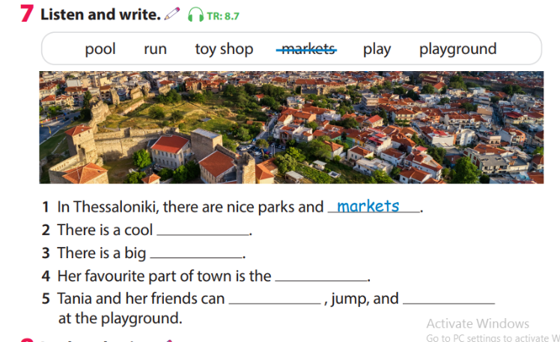  - Ask Ss to read his /her answer and T checks answers.  -Give stars for the correct answer. | - Repeat the words/sentences  - Repeat then point.  - markets  - toy shop  - pool  - playground  - run, play  - Get stars from T.
Activity 3: Practice writing (7 minutes)
Teacher’s activities | Student’s activities
- Task 8: Look and write  - Ask Ss to look at the example. Read out the sentence and ask Ss to repeat it.  - Go through the other sentences and explain the rest of the task to Ss.  - Have Ss find out the answers orally first by reading the sentences.  - Allow them enough time to complete the task individually. Go round the class helping studentsif necessary.  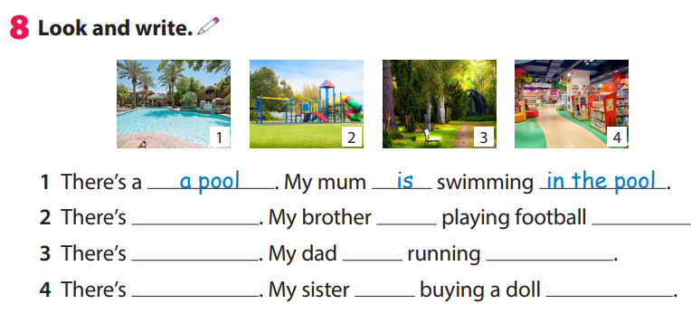  -Ask volunteers to come to the board and write the answers. Correct any mistakes.  - Check the answer.  * Quick check.  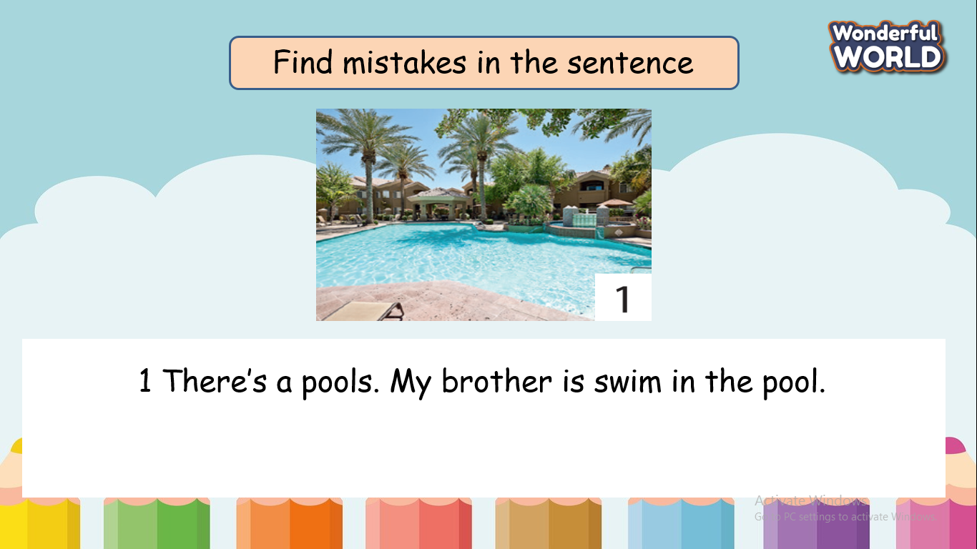 | - Look and read  - Answer key:  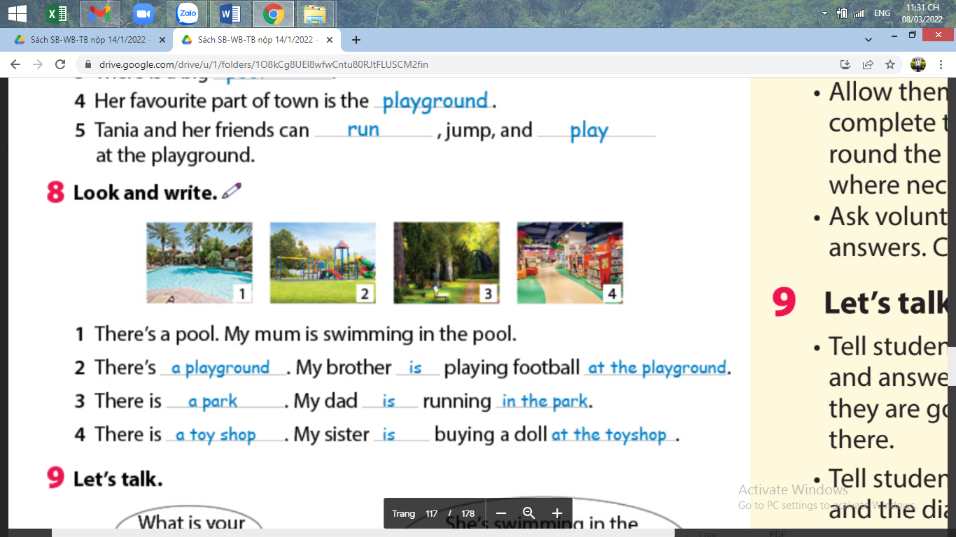  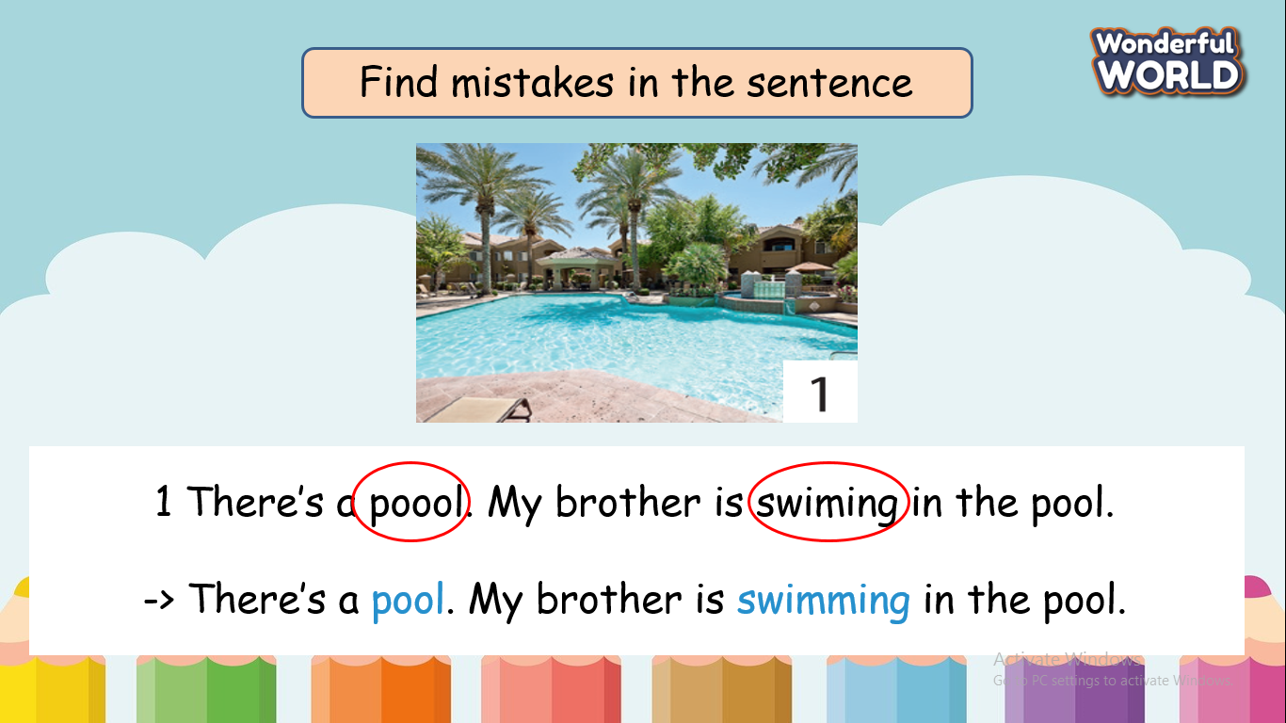
Activity 4: Practice talking (12 minutes)
Teacher’s activities | Student’s activities
Task 6: Let’s talk  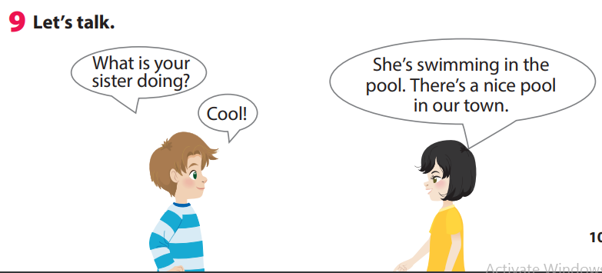  Tell Ss they are going to ask and answer questions about what someone is doing and where  - Tell Ss to look at the picture then practice dialogue.  - Ask Ss to think about family members/friends: where are they now and what are they doing, then complete the table.  - Then Ss work in groups.  S1: I am talking about my mom, dad and brother  S2: What’s your mom doing?  S1: She’s working in the office.  S3: What’s your brother doing?  S1: He’s playing in the playground. There is a playground in his school.  …  Ask some volunteers group to present. | - Read out the example.  -Work in pairs and do a project.
   | The place | What is/she/he doing
  mom
  dad
  brother
  …….
Activity 5: Assessment (3 minutes)
Teacher’s activities | Student’s activities
- Ask Ss to do the assessment  Ex: There’s a park, I am running in the park.  1. There’s a playground,….  2. There’s a market,……  3. There’s a zoo…..  4. There’s are museum…..  5. There’s a theater,….  - Say goodbye | - Do the assessment.  -Each Ss will think his/her idea for each sentence.  - write and read in front of the class  - Say goodbye.
____________________________________
UNIT 8. MY TOWN
Lesson 3 - Task 1,2,3
Period 98
I. OBJECTIVES:
1. Knowledge:
- Students will learn vocabularies about activities drink, eat, have fun, look at, see, take photos and review May as asking for permission.
2. Competences:
- English competences: Students will be able to ask for permission to do something in certain places.
- Common competences: Students will have the opportunity to develop communication among friends.
3. Qualities:
- Students will be aware of the correct behavior in public places.
II. EQUIPMENT AND MATERIALS:
-Basic things: Student’s book, flashcards, A4 paper.
-Advanced things: PPT, projector/interactive whiteboard/laptop/TV.
III. LESSON PROCEDURE:
Activity 1: Warm-up (5 minutes)
Teacher’s activities | Student’s activities
- Greet students  - “word search” Game:  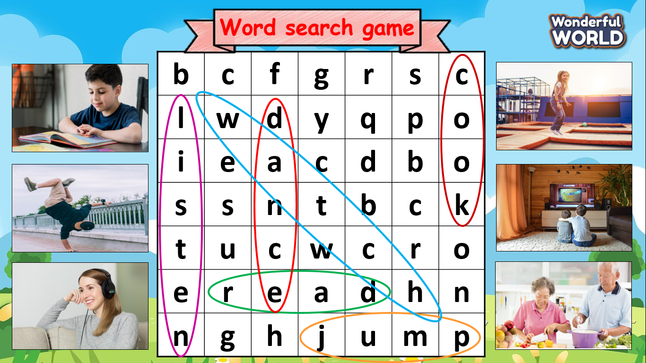  - Prepare a table that contains letters:  - Ask Ss to find words suggested by pictures (watch, cook, dance, listen, jump, read)  - Give stars for each correct answer.  - Ask Ss to read out all the words again one by  one and ask students to repeat after T. | - Greet teacher  - Focus on the table and quick look.  - Raise the hand when finding the word.
Activity 2: Presentation (7 minutes)
Teacher’s activities | Student’s activities
Task 1. Listen, point and repeat. ( P.118)  - Use PowerPoint/ flash cash to teach vocabulary.  drink, eat, have fun, look at, see, take photos.  (Explain the difference between look at  and see, explain it to the students in Vietnamese if necessary)  - Play the recording. Tell Ss to look at the pictures and follow the pictures with their fingers.  - Play the recording again. Ask Ss to repeat.  - Vocabulary checking: “ Cowboy game”  + Invite two Ss to go to the board and back to back  + Those two Ss will choose one picture ( keep secret )  + T counts one, two three they will turn their back and read the opponent’s picture.  - The faster will be the winner. | - Listen and repeat.  - Listen point and repeat.  - Listen to the T’s guide.  - Join the game.  - Quick look and say  - Get stars from T.
Activity 3: Practice (10 minutes)
Teacher’s activities | Student’s activities
- Task 2: Listen and match  * Before listening  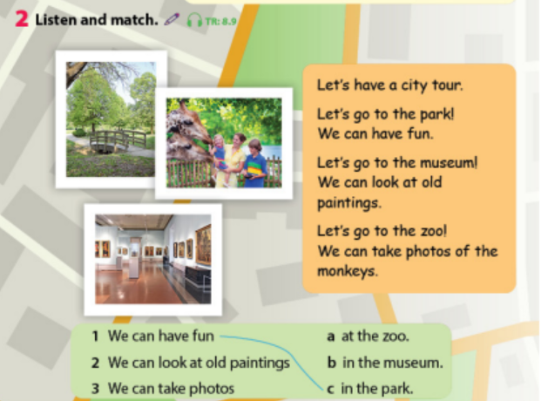  - Ask Ss what the places are and what they can see in the pictures.  - Ask Ss to read through all the text.  * While listening  - Play the recording twice. Tell Ss to look at the picture and follow the dialogue with their fingers.  - Have Ss read 3 questions and check the answers.  1-C,2-B, 3-A  *After listening  • Ask Ss to take turns reading the paragraph  - Task 3: Ask and answer. Then tick or cross.  - Revise the use of may when asking for  permission. Give Ss questions and ask them to give some answers, e.g., May I read in the  library? (Ss) Yes, you can. May I eat in the library? (Ss), No, you can’t.  - Tell Ss they are going to ask and answer what they can or cannot do in public places.  - Tell Ss to look at the sample dialogue. Read out the dialogue  - Ask two Ss to read out the dialogue.  - Ask Ss to work in pairs.  - Ask some volunteers to speak in front of the class. Check answers answer as a class. Then ask volunteers to say the sentences. | - Look and read aloud.  -Work in pairs and practice the dialogue.  - Read out the example  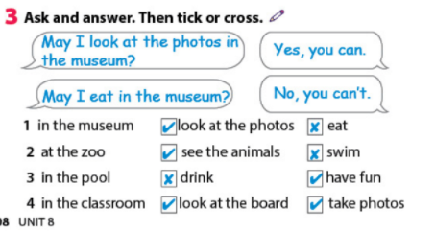
Activity 4: Production (10 minutes )
Teacher’s activities | Student’s activities
-Ask Ss to work in groups and fill the blank( rule in place)  - May I eat in the museum?  No, you can’t.  - Invite a few groups to go to the board to speak out the conversation. | -Work in groups.  - Speak in front of the class.
  Place | Yes | No
  Museum | Take photo | Eat
Activity 5 : Assessement (3 minutes )
Teacher’s activities | Student’s activities
- Ask Ss to do an assessment.  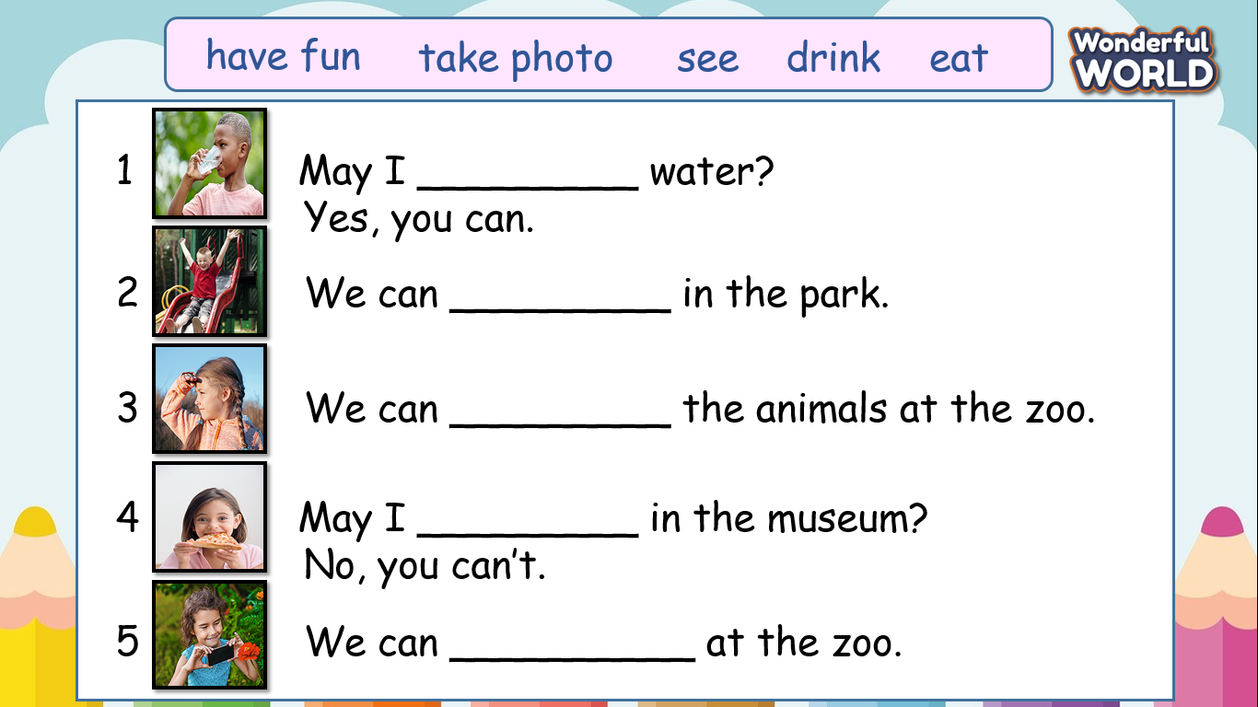  - Check in pair then the whole class.  - Say goodbye | - Do the assessment.  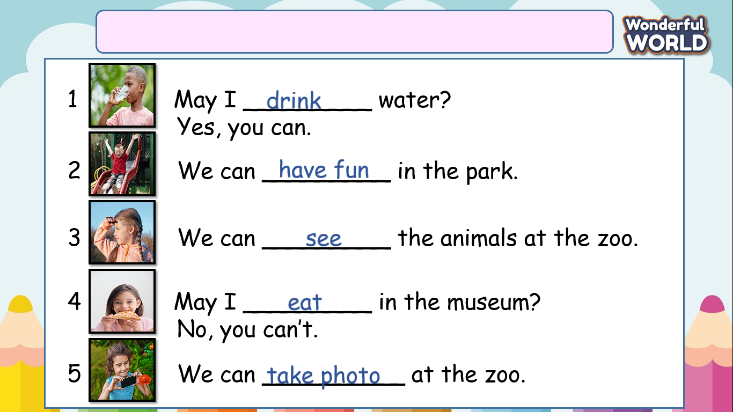  - Check with friends and then with the teacher and the whole class.  -Say goodbye
____________________________________

UNIT 8. MY TOWN
Lesson 3 .Task 4, 5, 6
Period 99
I. OBJECTIVES:
1. Knowledge:
- Students will learn the sentence pattern Let's + V! - Yes, let's. and review the vocabulary of the lesson.
2. Competences:
- English competences: Ss will be able to express suggestions and its response.
- Common competences:
+ Students will have the opportunity to develop communication among friends.
+ Students will have the opportunity to develop autonomy in self-study and creativity in composing songs.
3. Qualities:
- Students will evaluate fun activities with friends.
II. EQUIPMENT AND MATERIALS:
- Basic things: Student’s book, flashcards, A0 paper.
- Advanced things: PPT, projector/interactive whiteboard/laptop/TV.
III. LESSON PROCEDURE:
Activity 1: Warm-up (5 minutes)
Teacher’s activities | Student’s activities
- Greet students  -* Quick look: Before the game, show all the words (have fun, buy toys, take photos, ride a bike, see, watch giraffe, drink, eat, look at, run, play, jump, swim, dance, sing, cook)  - “Bingo” Game:  + Each Bingo card consists of 16 random words and is made up of 4 rows, and 4 columns. When the game starts, each random vocabulary is called, and players are required to cross their words. Once a card has been filled with a winning pattern (a line, row..). the teacher will continue to read until the first students reach 4 words in an arrow, line...  -Ask Ss to read out all the words again one by  one and ask Ss to repeat after T. | - Greet teacher  - Arrange words randomly.  - Tick the word that T reads.  - Get stars for whom reaches 4 words in a row, line...
Activity 2: Presentation (7 minutes)
Teacher’s activities | Student’s activities
Task 4. Listen, point and repeat. ( P.119)  - Tell Ss to look at the picture and ask a few questions:  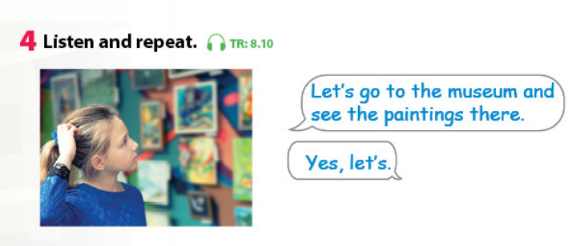  - Where is she?  - Can you see it in the picture?  - Point to the pictures. Tell Ss that we use Let’s suggest doing something.  - Play the recording. Tell Ss to look at the picture and follow the sentences with their fingers.  - Play the recording again. Ask Ss to repeat.  - Ask Ss to repeat the sentences.  - Play game: "pass the ball"  + T opens a song and students will pass the ball.  + When the music stops, which students hold that ball has to say  + Let’s ….and ……./  (Let’s go to the toy shop and buy a truck). | - Look and answer T’s question.  - Listen point and repeat.  - Repeat the sentences.  - Each student has to think of ideas for each blank.  - Listen to the music and pass the ball.  - Stand up and say.
Activity 3: Practice (10 minutes)
Teacher’s activities | Student’s activities
Task 5: Look. Ask and answer  - Tell Ss to look at the pictures and the prompts. Read out the prompts and ask Ss to repeat.  - Tell Ss to look at the picture for question 1 and the example. Read out the example and ask Ss to repeat it.  - Allow them enough time to practice saying the sentences individually and then in pairs. Go round the class helping Ss where necessary.  - Ask volunteers to read out their answers. Correct any mistakes.  Task 6: Listen and sing( p.119)  - Explain that the song is about going to the zoo and ask :  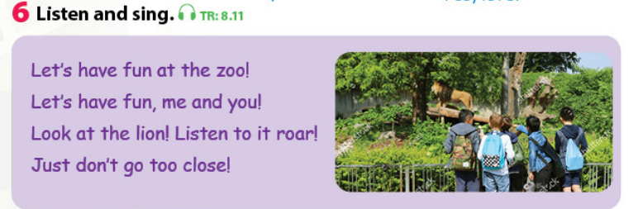  - What animals can they see at the zoo?  - Play the recording and tell Ss to listen and follow the words with their fingers.  - Read out the song one line at a time and ask students to repeat it after you.  - Play the recording again. Encourage Ss to sing along. Practice several times until Ss are familiar with the words. | - Look and read aloud.  -Work in pairs and practice the dialogue.  -Look and answer T’s question.  - Listen to the song  - Listen and repeat  - Join the singing contest
Activity 4: Production (10 minutes )
Teacher’s activities | Student’s activities
Song composer  - Have Ss look at the lyric again.  - Ask sts to form groups.  - Ask groups to fill the words in the blank to create new versions of the song.  - fill the word in the blank t  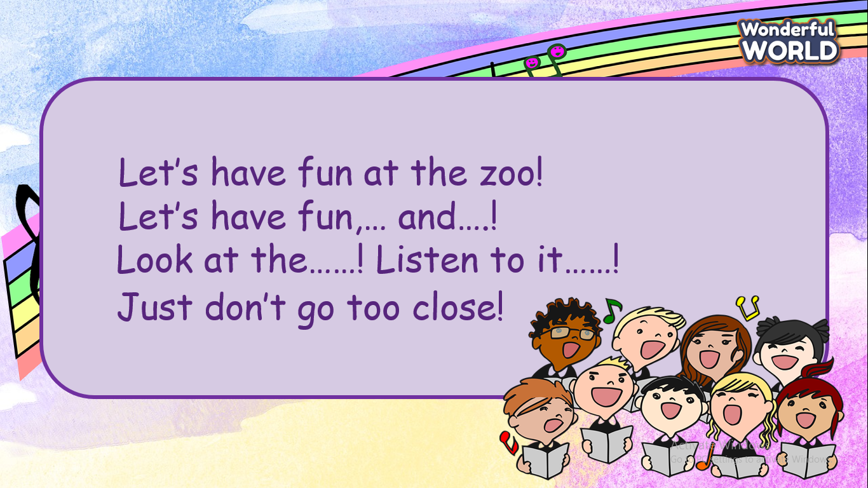  - Vote for the best Song composer. | - Read the lyrics.  - Sit in groups.  - Compose the version for the song.  - Perform in front of the class.
Activity 5 : Assessement (3 minutes )
Teacher’s activities | Student’s activities
- Ask Ss to do a small assessment.  *Write the full sentence.  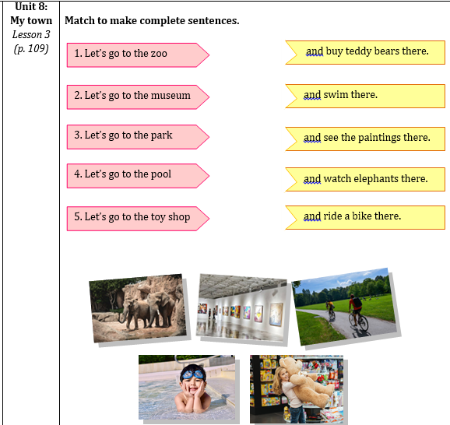  - Check in pair then the whole class.  - Say goodbye. | - Do the assessment.  - Check with friends and then with T and the whole class.  -Say goodbye.
____________________________________

UNIT 8. MY TOWN
Lesson 3 - Task 7,8,9
Period 100
I. OBJECTIVES:
1. Knowledge:
- Students will practice pronouncing /ʊə/ and /ɪə/ sounds separately and in words
2. Competences:
- English competences: To recognize and pronounce /ʊə/ and /ɪə/ sounds correctly.
- Common competences:
+ Students will have an opportunity to develop communication among friends and creativity in composing the chant.
3. Qualities:
- Students will be given the opportunity to think about planning for a tour when visiting something or traveling.
II. EQUIPMENT AND MATERIALS:
- Basic things: Student’s book, CDs player, stereo, papers.
- Advanced things: PPT, projector/interactive whiteboard/laptop/TV.
III. LESSON PROCEDURE:
Activity 1: Warm-up (8 minutes)
Teacher’s activities | Student’s activities
- Greet students.  - Play the game “ magical wheel”  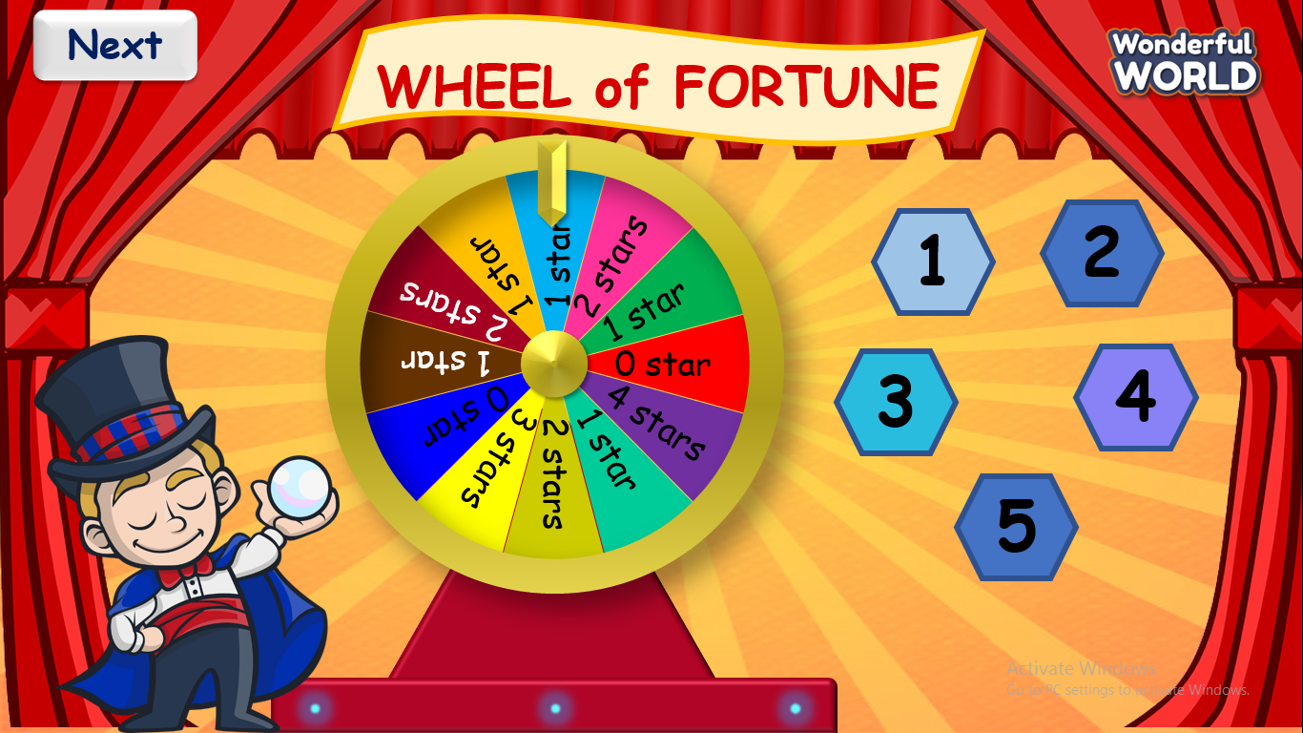  - T prepares 5 questions and Ss have to choose the word whose pronunciation is different from the others.  1.  A. Playground B. Park C. Market  2.  A. Sit B. Library C. Drink  3.  A. Fun B. Museum C. Sun  4.  A. Pool B. Cool C. Look  5.  A Swim B. Sugar C. Sit | - Greet teacher.  - Answer key:  - A (Playground)  - B (Library)  - B (Museum)  - C (Look)  - B (Sugar)  - Spin the wheel to get stars.
Activity 2: Presentation (7 minutes)
Teacher’s activities | Student’s activities
Task 7. Listen and repeat. (P.120)  - Write tour on the board. Write / ʊə / on the board. Then Ask Ss to pronounce the word.  + Turn on the video about how to pronoun the diphthong /ʊə / (https://www.youtube.com/watch?v=nHSqluHrD-U)  + Practice a few of the words that contain that diphthongs (Dour, Journey, Tournament, Tourist)  - Write theater on the board. Write / ʊə / on the board. Then Ask Ss to pronounce the word.  + Turn on the video about how to pronoun the diphthong / ɪə /.  (https://www.youtube.com/watch?v=vC0h4S0YPJc)  + Practice a few words that contain diphthongs (Ear, Tear, Beard, Fear).  - Play the recordings and tell students to repeat the words and the sentence, paying attention to the correct pronunciation of / ʊə / and / ɪə /.  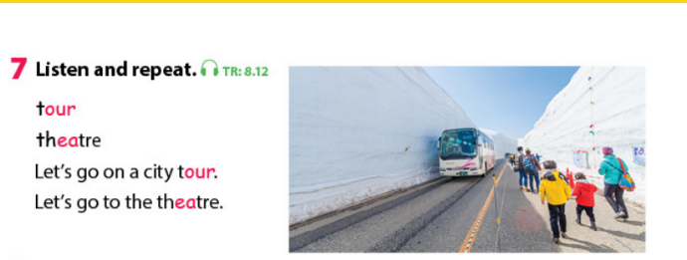 | -Look at the board and read after T.  - Watch a video to practice with a native speaker.  - Look at the board and read after T.  - Watch a video to practice with a native speaker.  - Listen and repeat after the audio.
Activity 3: Practice (12 minutes)
Teacher’s activities | Student’s activities
Task 8: Listen and chant (P.120)  - Tell Ss to learn a chant. Explain that the chant includes the sounds they have just learned.  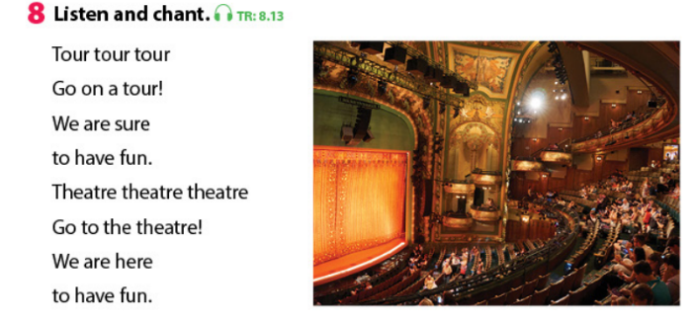  - Play the recording and tell Ss to listen and follow the words with their fingers.  - Read out the chant one line at a time and ask Ss to repeat after T.  - Play the recording again. Encourage Ss to chant along. Practice several times until Ss are familiar with the words and sounds.  - Ask Ss to practice the chant individually, and then in pairs or groups. For example, one group chants the first verse, and the other group chants the second verse.  Task 9: Say it  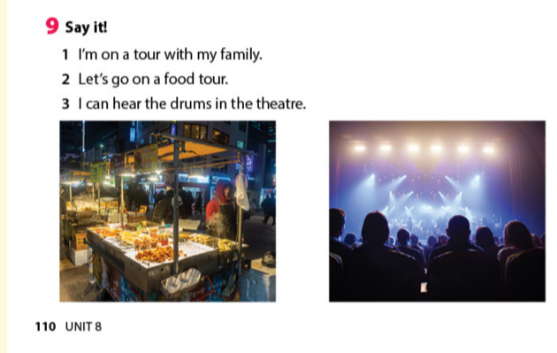  - Ask students to look at the sentences. Tell them to pay attention to the sounds / ʊə / and  / ɪə / in each word.  - Ask students to work in pairs and say the sentences, paying attention to the correct pronunciation of / ɪə / and / ʊə /.  - Ask volunteers to say the sentences in front of the class. | - Listen carefully and repeat.  - Practise the chant individually, and then in pairs or groups.
Activity 4: Production (5 minutes)
Teacher’s activities | Student’s activities
- Decide the class into 2 or 4 teams.  - Ask Ss to go to the board to write the word that contains / ʊə / and /ɪə/  - Record the time for 5 minutes.  - Give stars to the winner. | - Each student think one or more words in their mind.
Activity 5: Assessement (3 minutes)
Teacher’s activities | Student’s activities
-Ask Ss to do the assessment.  * Listen and tick the words you hear.  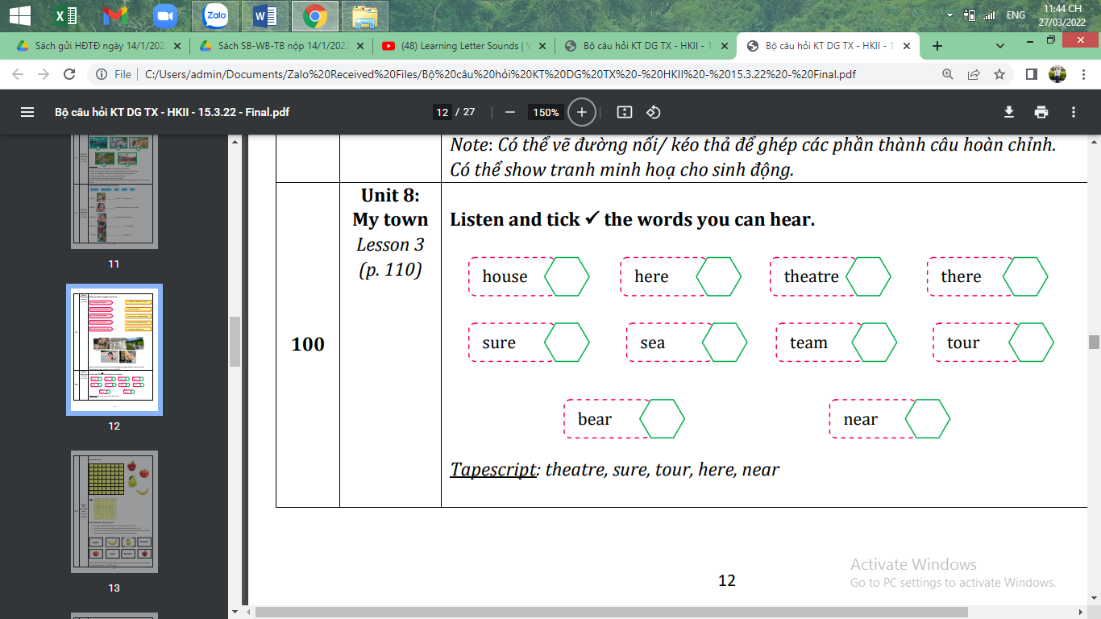  - Check in pair then the whole class.  - Say goodbye. | - Do the assessment.  - Check with friends and then with T and the whole class.  -Say goodbye.

GRADE 5
Week 25 (From 10/3 to 14/3)
UNIT 9: HOLIDAYS AND TRAVEL
Lesson 3 - Part 1,2,3
Period 97
I. OBJECTIVES:
1. Knowledge:
- Students will be able to:
+ Review some regular verbs in past simple.
+ Practise listening and speaking skills about travel and holiday.
2. Competences:
- English competences: Students will be able to use English to talk about their last holiday with their friends.
- Common competences: Students will be able to work in groups effectively to discuss travel and holiday.
3. Qualities:
- Students will
+ Be encouraged to develop mutual bonding through discussion.
+ Develop an appreciation and understanding of what is important to their friends and other people they meet in the community.
II. EQUIPMENT AND MATERIALS:
- Basic things: Student’s Book, Class Audio CD, IWB, DVD.
- Advanced things: PPT, laptop, TV.
III. LESSON PROCEDURE:
Activity 1: Warm-up (5 minutes)
“Let’s do some actions”
Teacher’s Activities | Students’ Activities
Aims: Welcome students. Engage students by doing some actions to help them have a chance to loosen up and relax.
1. Greeting Ss and chatting  2. Introducing the activity.  - Before starting the new lesson, let’s do some actions.  - Play the video and ask Ss to follow the actions. | - Greet Teacher  - Join the activity.
Activity 2: Review(7 minutes)
Teacher’s Activities | Students’ Activities
Aims:
- Review some words relating to the invention of hot-air balloons and regular verbs in past simple.
- Complete task 1
- Ask Ss to look at the slide and shout out all the verbs.  - Give them time to read the sentence in silence and use the Past simple form of the correct verb.  - Ask Ss to raise their hands to say the correct sentence.  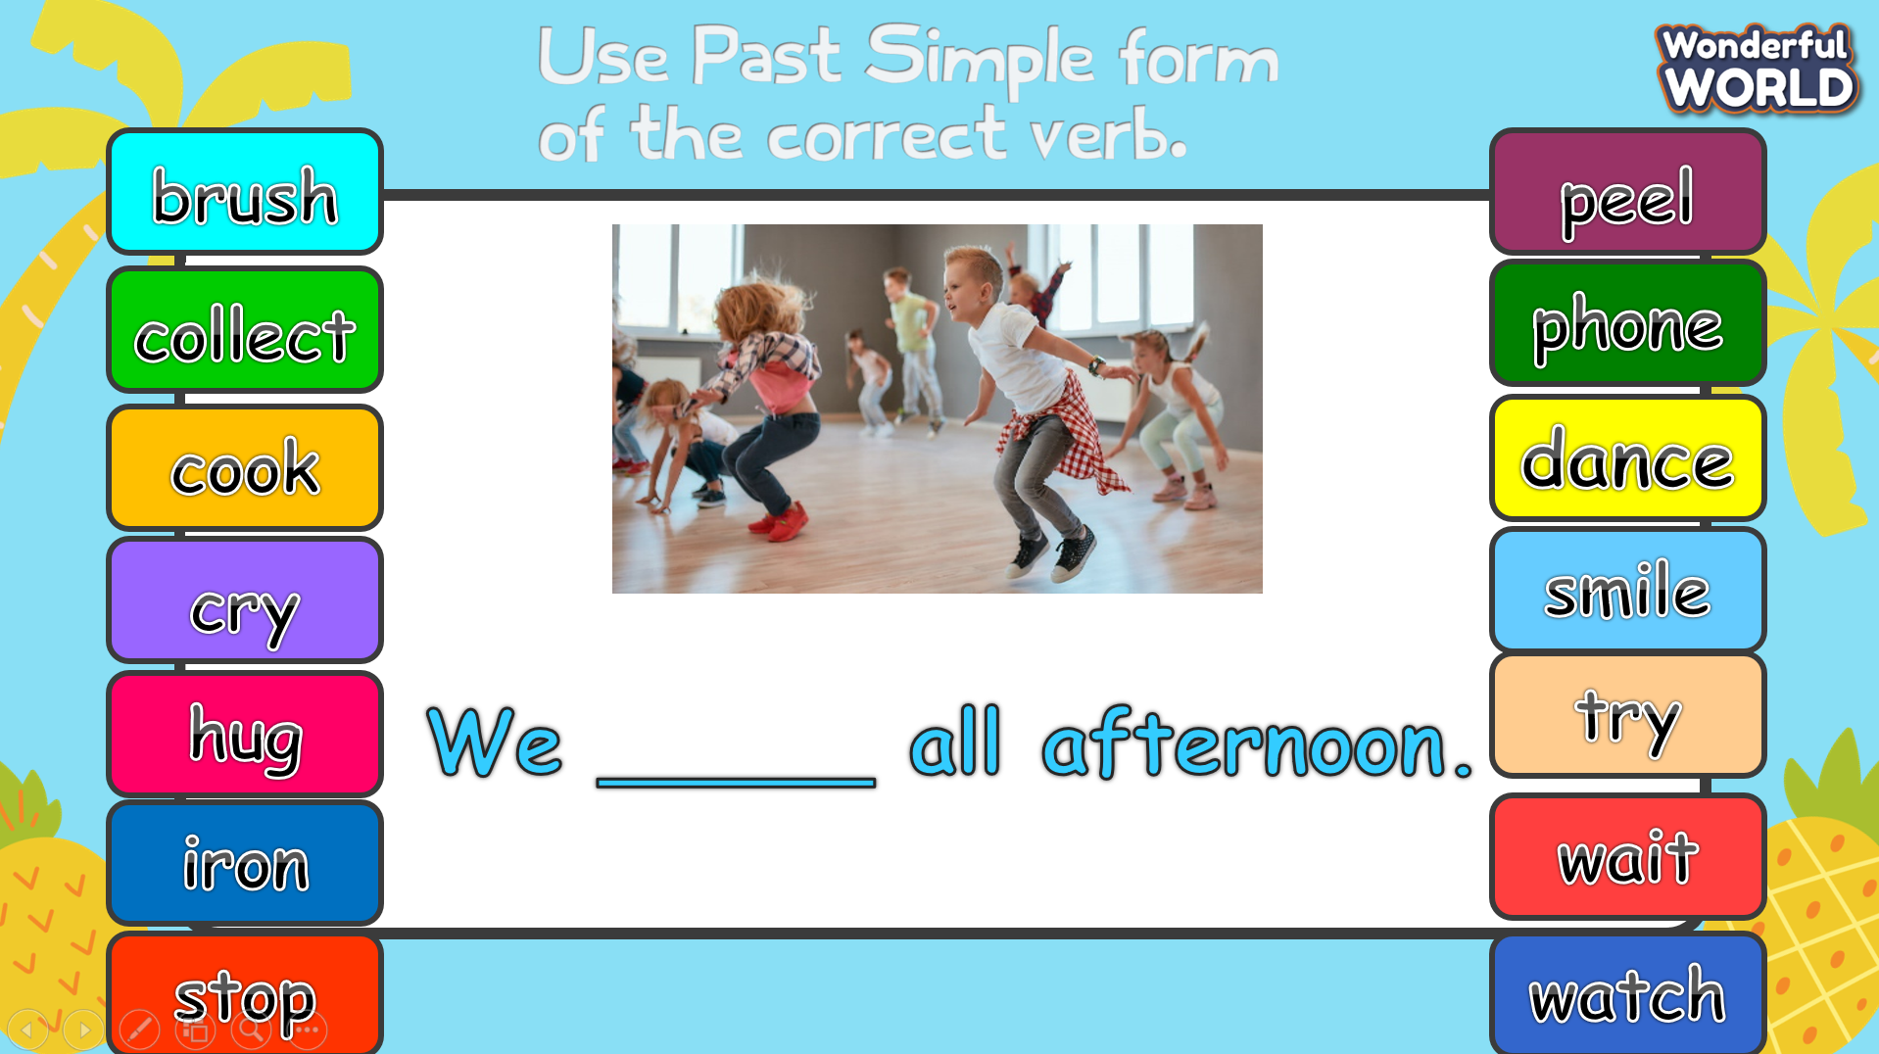 | - Look, listen, and complete the sentence.
Activity 3: Practice – Controlled practice (10 minutes)
Teacher’s Activities | Students’ Activities
Aims:
Ss will be able to:
- observe, analyze, and give their own opinion.
- develop listening skills for specific information.
Task 1: Look at the pictures. Where are these places?  - Show pictures of two places (Mexico and New York) on the screen.  - Ask students to look at the pictures and answer the question: Where are these places?  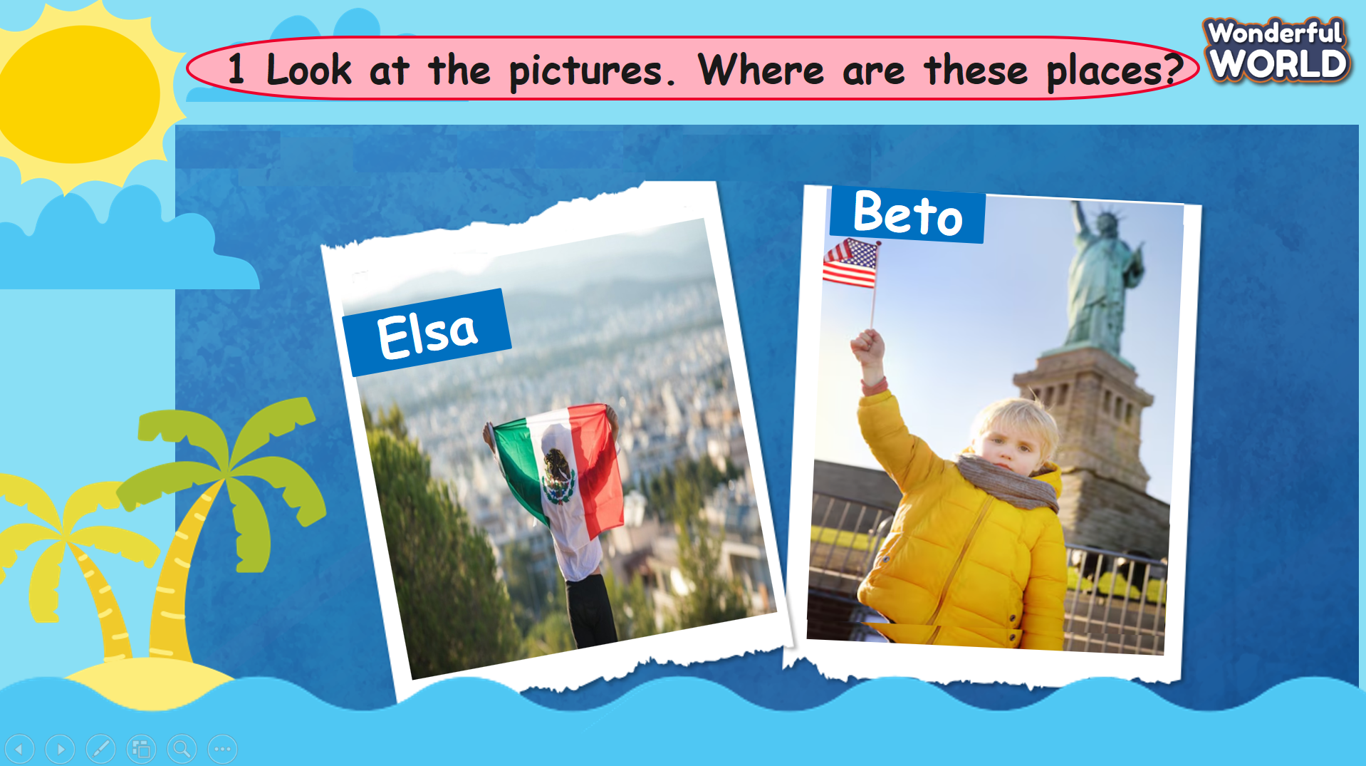  Task 2: Listen and complete the table.  - Tell students that they are going to listen to Elsa and Beto talking about their past holidays.  - Ask students to look at the table and guess the words to complete them.  - Play the recording twice for students to listen and write.  - Call on two students to give their answers.  - Play the recording again for students to listen and check.  - Give feedback if necessary.  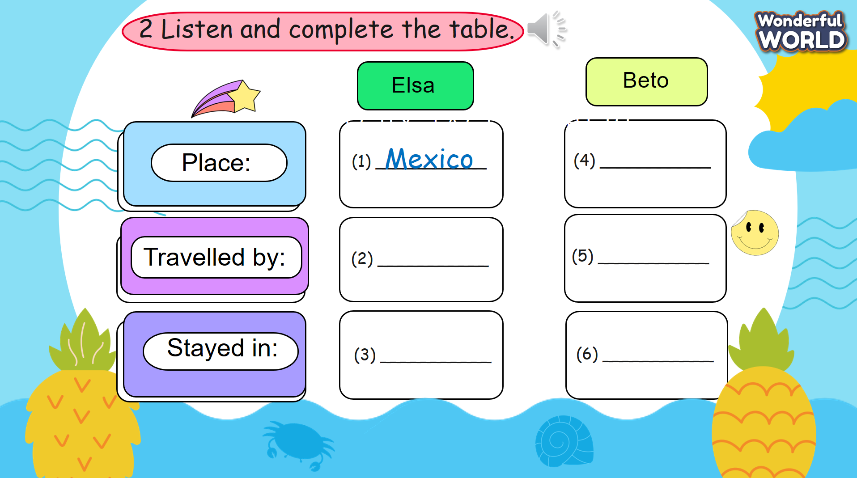 | - Look at the pictures and answer the question.  - Look at the table and guess the words to complete them.  - Listen and write.  - Listen and check.
Activity 4: Production (8 minutes)
Teacher’s Activities | Students’ Activities
Aim:
- Ss will be able to ask and answer about their last holiday.
Task 3: Talk and write.  - Tell students that they are going to practise by asking and answering about their friend’s last holiday, then complete  the table.  - Ask students to use the following questions, then they will write the information in the table.  - Tell students that they have five to eight minutes to practise talking in pairs.  - Call on some pairs to act out the dialogue in front of the class.  - Check pronunciation and give feedback if necessary.  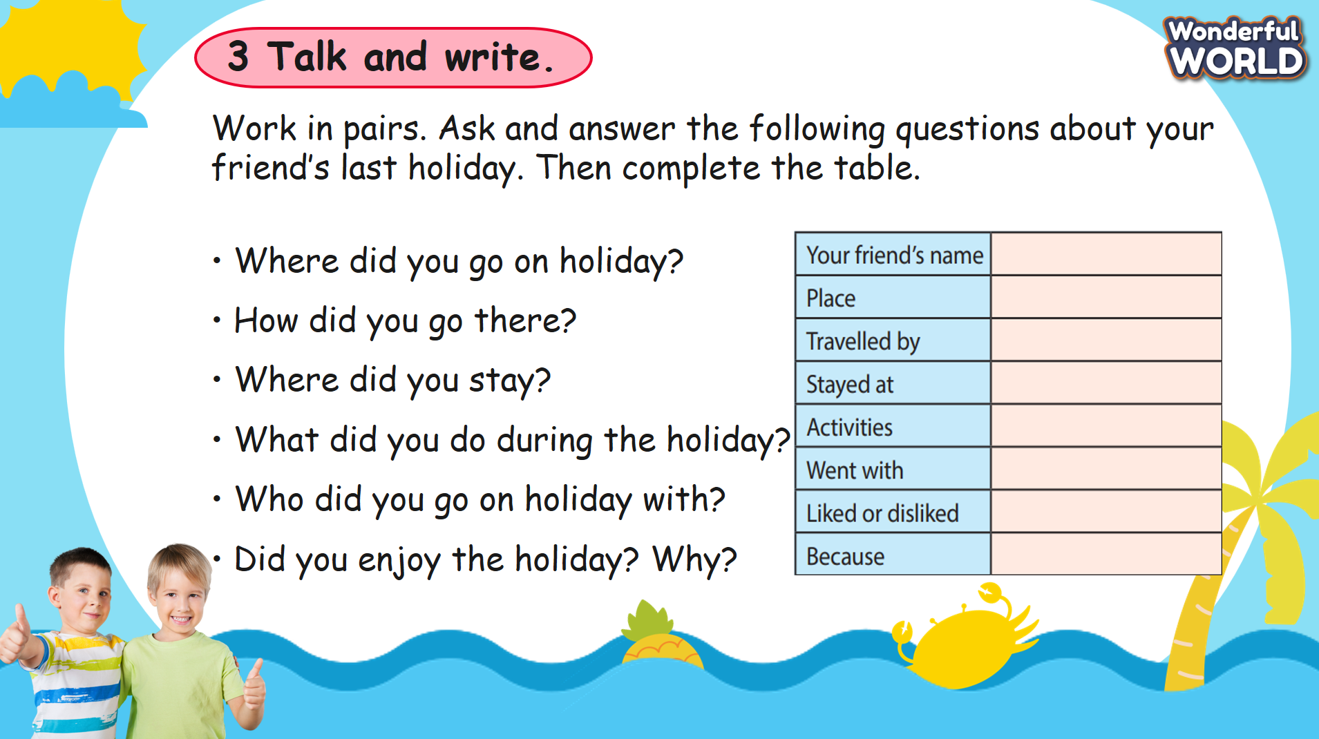 | - Work in pairs.  - Use the following questions to ask and complete the table.  - Share in front of the class.
Activity 5: Wrap up & Assessment (5 minutes)
Teacher’s Activities | Students’ Activities
Aims:
- Assess individuals or groups who have done the best in the lesson.
- Wrap up the activities Ss have done during the lesson.
- Assessment:  Match the vocabulary with the correct definition.  - Ask Ss to read the definitions carefully and match each word with a definition.  - Tell them to check your answers carefully when you finish.  - Check answers as a class.  - Wrap-up: Ask Ss the question: “What have we learnt today?” | - Join the activity.  - Stand up and say goodbye to the teacher.

UNIT 9: HOLIDAYS AND TRAVEL
Lesson 3 - Part 4,5,6
Period 98
I. OBJECTIVES:
1. Knowledge:
- Students will be able to:
+ Review some words relating to travel.
+ Learn more irregular verbs in past simple.
2. Competences:
- English competences: Students will be able to use English to talk about their activities during the last summer holiday.
- Common competences: Students will be able to irregular verbs in the past simple in writing sentences and speaking in English about travel and holiday
3. Qualities:
- Students will
+ Develop public speaking in front of the class.
+ Develop an appreciation and understanding of what is important to their friends and other people they meet in the community.
II. EQUIPMENT AND MATERIALS:
- Basic things: Student’s Book, Class Audio CD, IWB, DVD.
- Advanced things: PPT, laptop, TV.
III. LESSON PROCEDURE:
Activity 1: Warm-up (5 minutes)
“Let’s play a game”
Teacher’s Activities | Students’ Activities
Aims:
- Welcome students.
- Review some words relating to travel by playing a game and then lead in the lesson.
1. Greeting Ss and chatting  2. Introducing and conducting the game.  - Before starting the new lesson, let’s play a game.  - T clicks on the bricks.  - The students have to guess “what is behind the wall?”.  Lead in: So today, we are going to learn more irregular verbs in past simple. | - Greet Teacher.  - Join the activity.
Activity 2: Presentation (7 minutes)
Teacher’s Activities |  | Students’ Activities
Aim:
- Recognize and memorize the irregular forms of common verbs.
Lead in:  An Irregular verb does not take the ending for the Past simple form. They don’t follow the established rules. Each irregular verb has its way of forming a Past Simple.  - Divide irregular verbs into 2 types:  + Most Irregular verbs change completely.  Ex: buy 🡪 bought  I bought a new computer yesterday.  go 🡪 ?  - Ask Ss to try to guess” What is the past tense for go?”.  - Ask Ss to give some examples.  + Some Irregular verbs do not change.  put 🡪 ?  - Ask Ss to try to guess” What is the past tense for put?”.  - Ask Ss to give some examples. |  | - Listen to the teacher.  - went is the past tense of go  - Give some examples.  + Last weekend, we went to the park.  - put is the past tense of go  - Give some examples.  + She put the key in her pocket.
Activity 3: Practice – Controlled practice (10 minutes)
Teacher’s Activities |  | Students’ Activities
Aims:
- Practise irregular verbs by playing the game.
- Complete tasks 4 & 5.
Let's play a” Car racing game”.  - Divide the class into teams and assign a color to each team.  - Set the turns by throwing a dice.  - Click the number in front of the car to show the question. The team has to answer it within the time limit (8 seconds). Click the question mark to show the correct answer.  - Click the arrow to go back to the race.  - If the answer is incorrect, the team loses the turn. If it is correct, click the car to move it forward and repeat the process.  Task 4. Look and match. Then listen and check.  - Tell students that they are going to match the sentences to the correct pictures.  - Divide students into pairs to do the matching tasks.  - Show students how to do the task if necessary by asking them to observe how the first word is matched with the correct picture.  - Give some minutes for students to do the task.  - Tell students that they are going to watch a video to check their answers.  - Give feedback and comments if necessary  Task 5. Use the verbs in Activity 4 to complete the sentences.  - Tell students that the words/phrases in the activity are related  to past simple tense.  - Have students look and match each sentence with its correct picture.  - Model the first one as an example before asking students to match the rest in pairs.  - Check answers as a class. |  | - Join the game.  - Work in pairs.  - Observe how the first word is matched with the correct picture.  - Match the sentences to the correct pictures.  - Watch a video to check the answers.  - Look and match each sentence with its correct picture.
Activity 4: Production (8 minutes)
Teacher’s Activities |  | Students’ Activities
Aims:
- Ss will be able to apply irregular verbs to write about a city/town/village that they visited.
Task 6: Write.  - Tell students that they are going to write about a city/town/village that they visited.  - Give students a few seconds to read the questions in silence and check their understanding.  - Give students 10 minutes to do this task.  - Call some volunteers to read their answers aloud in front of the class.  - Give comments and check pronunciation if necessary. |  | - Write about a city/town/village that Ss visited.  - Some volunteers read their answers aloud in front of the class.
Activity 5: Wrap up & Assessment (5 minutes)
Teacher’s Activities |  | Students’ Activities
Aims:
- Assess individuals or groups who have done the best in the lesson.
- Wrap up the activities Ss have done during the lesson.
- Assessment  - Divide students into four (or more) groups and give each group a paper  - Play the song” The Simple Past” and ask Ss to try to memorize all the irregular verbs they see.  - Give students 2 minutes to list as many irregular verbs as possible on their paper. The team with the most words wins.  - Wrap-up:  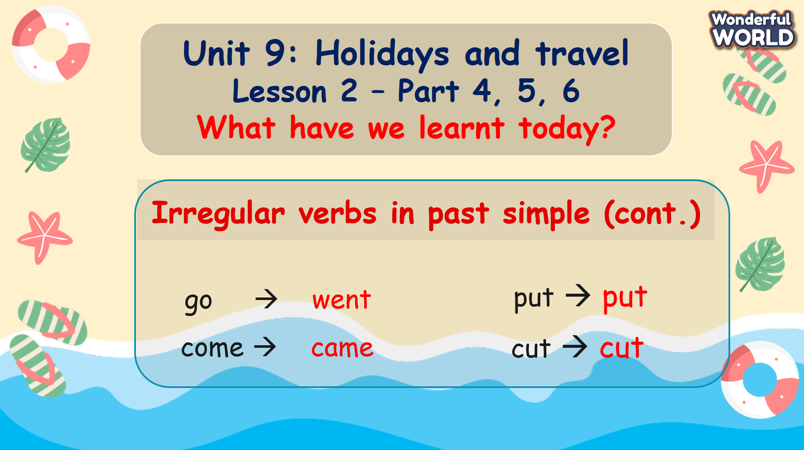 |  | - Let’s sing together and try to memorize all the irregular verbs.  - Work in groups and list as many irregular verbs as possible on the paper.  - Stand up and say goodbye to the teacher.

UNIT 9: HOLIDAYS AND TRAVEL
Lesson 3 - Part 7,8,9,10
Period 99
I. OBJECTIVES:
1. Knowledge:
- Students will be able to:
+ To pronounce verbs ending in /-ed/.
2. Competences:
- English competences: Students will be able to apply in pronouncing other words ending in /-ed/.
- Common competences: Students will be able to build more confidence in speaking English with ending sounds.
3. Qualities:
- Students will
+ Develop a sense of confidence in speaking English.
II. EQUIPMENT AND MATERIALS:
- Basic things: Student’s Book, Class Audio CD, IWB, DVD.
- Advanced things: PPT, laptop, TV.
III. LESSON PROCEDURE:
Activity 1: Warm-up (5 minutes)
“Let’s play a game”
Teacher’s Activities | Students’ Activities
Aims: Welcome students. Engage students by playing games and then lead in the lesson.
1. Greeting Ss and chatting  2. Introducing and conducting the game.  - Before starting the new lesson, let’s play a game.  - T gives the base verb form of the verbs and asks Ss to write the past form of them.  Lead in: So today, we are going to discover how to pronounce verbs ending in /-ed/. | - Greet Teacher.  - Join the activity.
Activity 2: Presentation (7 minutes)
Teacher’s Activities | Students’ Activities
Aim:
- know how to pronounce verbs ending in /-ed/ and recall them.
- Ask Ss some questions:  + How is the -ed part of a verb pronounced?  + Is there more than one way to pronounce it?  The pronunciation of -ed at the end of verbs depends on the last sound in the verb before -ed is added. There are 3 different ways to pronounce “-ed” and they are /t/, /d/, and /ɪd/.  - /t/  - After a voiceless consonant sound (/p, k, θ, f, s, ks, ʃ, tʃ/) our vocal cords do not vibrate, we pronounce the “ed” as /t/.  + Place your fingertips on the front of your neck, and pronounce these sounds.  - Ask Ss: Did you feel the vibration?  - Give Ss examples:  + kissed, watched  (“Kiss” has a/s/ sound before the ED ending so it’s pronounced /kist/).  - Ask Ss: What about “watched”? How do you think that ed is pronounced in this word?  - Check Ss’ understanding by asking them to give some examples.  - /d/  After a vowel or voiced consonant sound (/b, g, ð, v, z, ʒ, dʒ, m, n, ŋ, r, l/) our vocal cords vibrate when we say those sounds, we pronounce the “ed” as /d/.  + phoned  (“phoned” has a/n/ sound before the ED ending so it’s pronounced /fəʊnd/).  - Check Ss’ understanding by asking them to give some examples.  - /id/  After /t/ and /d/ sounds, we pronounce /-id/.  + started  (“started” has a/t/ sound before the ED ending so it’s pronounced /stɑːtid/).  - Check Ss’ understanding by asking them to give some examples. | - Listen and answer the questions.  - Listen to the teacher.  - No vibration.  - “watch” has a/tʃ/ sound before the ED ending so it’s pronounced /wɒtʃt/  - Listen to the teacher.  - Give some examples.  - Listen to the teacher.  - Give some examples.
Activity 3: Practice – Controlled practice (10 minutes)
Teacher’s Activities | Students’ Activities
Aims:
Ss will:
- practice pronouncing verbs ending in /-ed/.
- complete tasks 7 & 8.
Task 7. Listen and repeat.  - T shows the table at task 7 on the screen and tells Ss that they are going to listen to the pronunciation of ed.  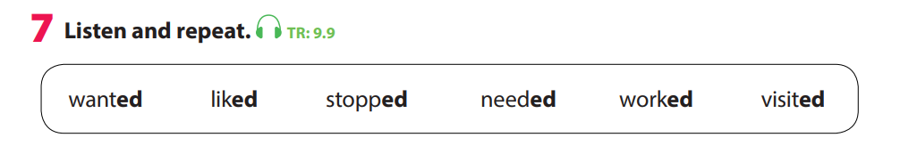  - Ask students to look at six words and try to read them.  - Play the recording, ask Ss to look at their books and listen.  - Ask them to focus on how to pronounce the ending sound of each word.  - Play the recording again and ask students to repeat it a few times.  - Have students say six words aloud as a whole class.  - Check pronunciation if necessary.  - Ask Ss to put the verbs with similar ending sounds together in one group.  - Check answers with class.  Mini-game : Play “Lucky Wheel” to practice the pronunciation of the ending sounds /-ed/.  - The students are split into 4 teams.  - Each team takes turns choosing a number and each number has a different question.  - If a team gives the right answer, they will spin the wheel and receive the points shown by the arrow.  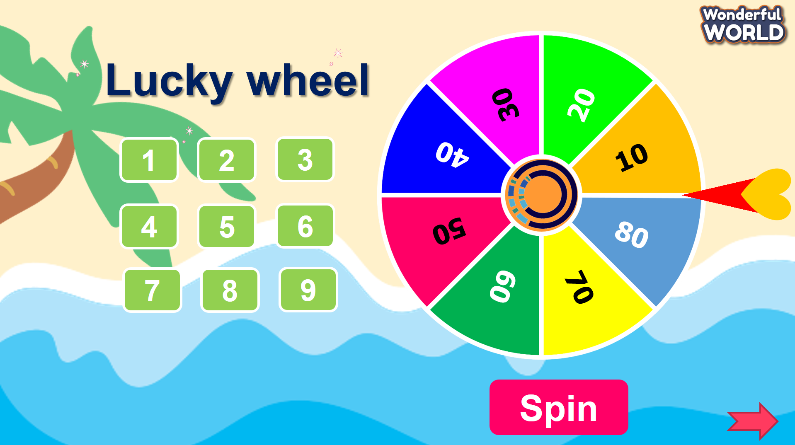  Task 8. Read these verbs aloud. Then write them in the  correct boxes.  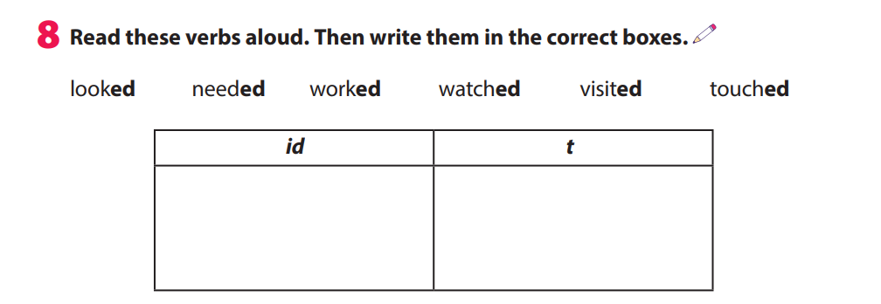  - Have students look at the six words. The teacher points to the words and asks students to read them aloud.  - Tell students they are going to put these words in the correct group.  The teacher gives an example.  - Ask students to work in pairs. After two minutes, call on students to answer each group.  - Check answers and give feedback. | - Join in the activity.  - Join the game.  - Join in the activity.  - Work in pairs.
Activity 4: Production (8 minutes)
Teacher’s Activities | Students’ Activities
Aims:
- Ss will be able to find words ending in /-ed/ in the chant.
- Ss practice listening skills and remember the words ending in /-ed/.
Task 10: Listen and chant  - Tell students they are going to learn a chant. Explain to students  that the chant uses the sounds they have just learnt.  - Play the recording and tell students to listen and follow the words with their fingers.  - Read out the chant one line at a time and ask students to repeat  after you.  - Play the recording again.  - Encourage students to chant along. Practise several times until  students are familiar with the words and sounds.  - Ask students to practise the chant in pairs or groups. For example, one group chants the first verse and the other group chants the second verse. | - Figure out the words ending in /-ed/.  - Read the song for the first time.  - Listen to the audio and point to the books.  - Listen and learn to sing each verse.  - Practice singing the whole paragraph.  - Present in front of the class.
Activity 5: Wrap up & Assessment (5 minutes)
Teacher’s Activities | Students’ Activities
Aims:
- Assess individuals or groups who have done the best in the lesson.
- Wrap up the activities Ss have done during the lesson.
- Assessment:  Task 9. Circle the odd one out  - Circle the one with a different ending sound. Then read aloud.  - Tell students to circle the one with a different ending sound.  - Check whether students understand the task. Elicit number  1 if necessary.  - Check answers as a class.  - Ask them to read each word aloud.  - Let’s sing a song: The sound of “-ed”  - Wrap-up:  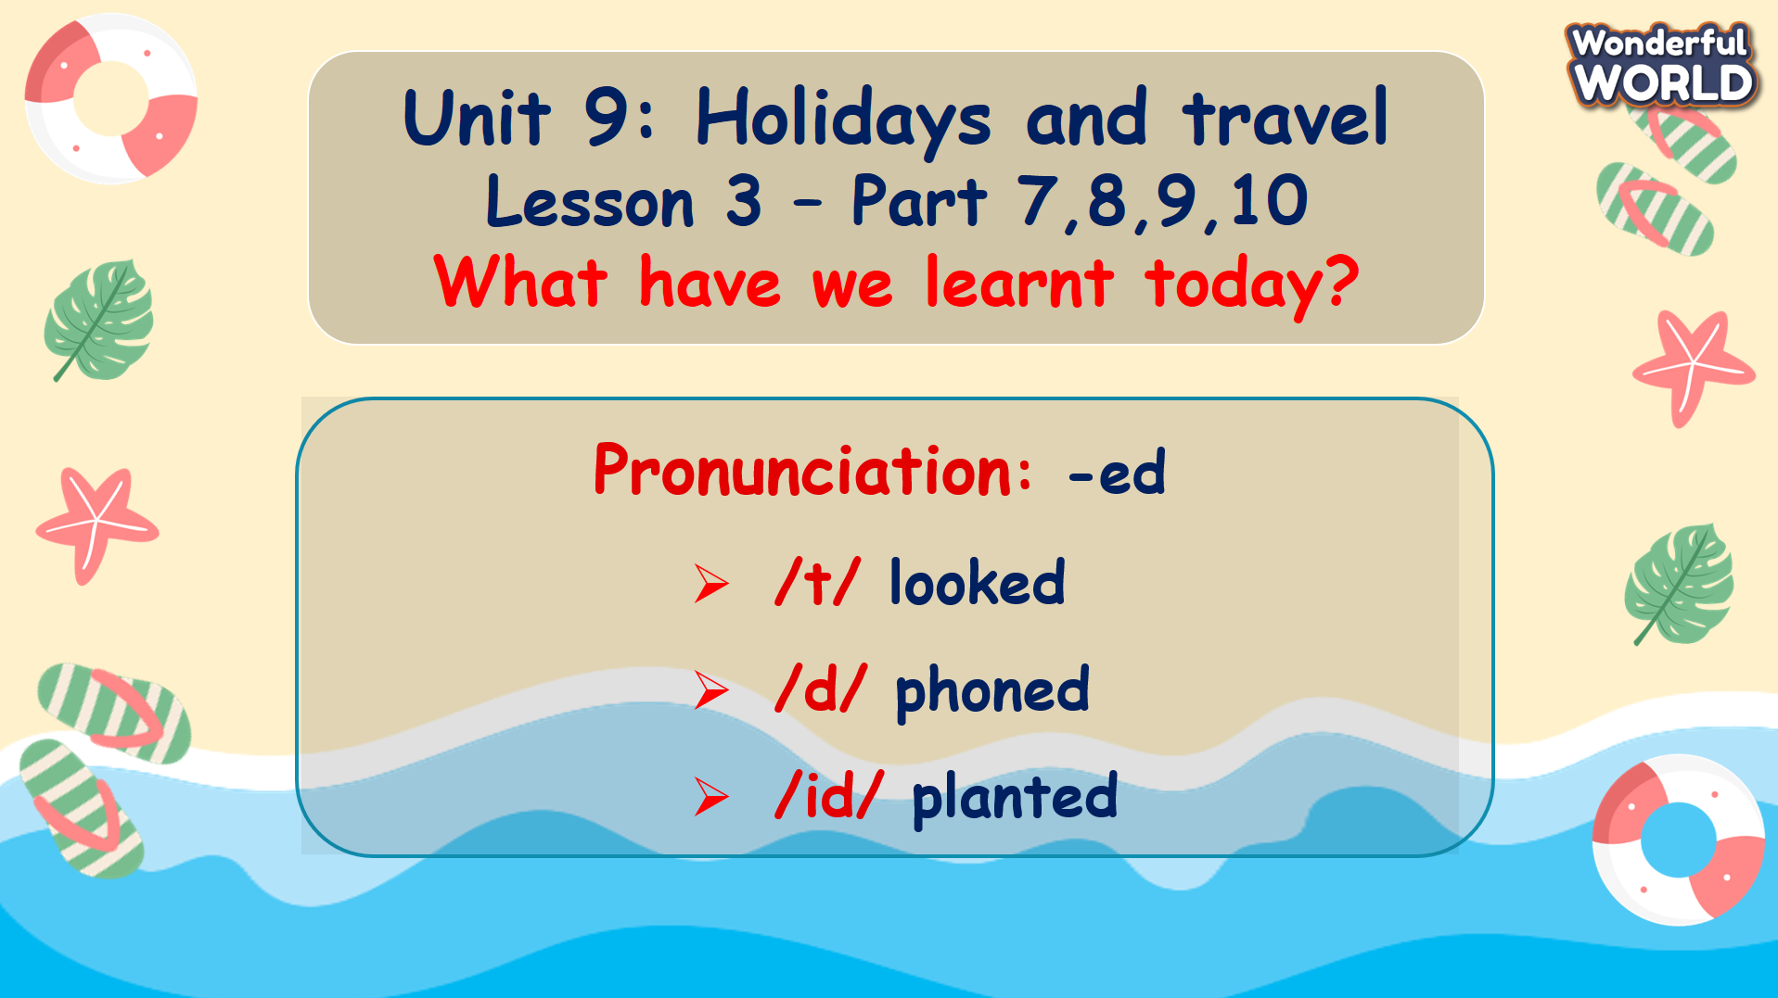 | - Circle the one with a different  ending sound and read aloud.  - Let’s sing together.  - Stand up and say goodbye to the teacher.

UNIT 9: HOLIDAYS AND TRAVEL
Fun time and Project: Part 1-2
Period 100
I. OBJECTIVES:
1. Knowledge:
Students will be able to review all target vocabulary and structures of Unit 9 via some fun activities.
2. Competences:
- English competences: Students will be able to think and talk about topics.
- Common competences: Students will have the opportunity to develop logical thinking and develop communication among friends.
3. Qualities:
- Students develop an appreciation and understanding of what is important to their friends and other people they meet in the community.
- Be confident and active in communicating with friends and teachers.
II. EQUIPMENT AND MATERIALS:
- For Teacher: PPT, flashcards, printed papers, dice.
- For students: textbook
III. LESSON PROCEDURE:
Activity 1: Warm-up (5 minutes)
“Let’s sing a song and do actions”
Teacher’s Activities | Students’ Activities
Aims: Welcome students. Engage the class with a song.
- Greet students. Chatting….. Do you like to sing?  - Play the song “ Hands in the air”.  - Demonstrate the TPR actions that go with the song  - Encourage Ss to do the actions and try to sing along. | - Greet Teacher.  - Let’s sing a song and do the actions.
Activity 2: Review (12 minutes)
Teacher’s Activities |  | Students’ Activities
Aims:
- Review the vocabulary of Unit 9 with the “Hangman” game.
- Review regular verbs and irregular verbs with the “Odd one out” game.
- Review asking questions in the past simply with the “Making question” game.
Play game 1: Hangman in class  - Divide the class into 2 or 4 groups.  - Show the secret word with spaces for the number of letters in a word.  - Ask Ss to guess letters in the word alternating between the groups.  - If a letter in the word is guessed correctly, the T shows it in the correct space.  - If a letter is guessed that is not in the word, the T draws part of the man being hanged.  - The group that can guess the word first receives 3 points.  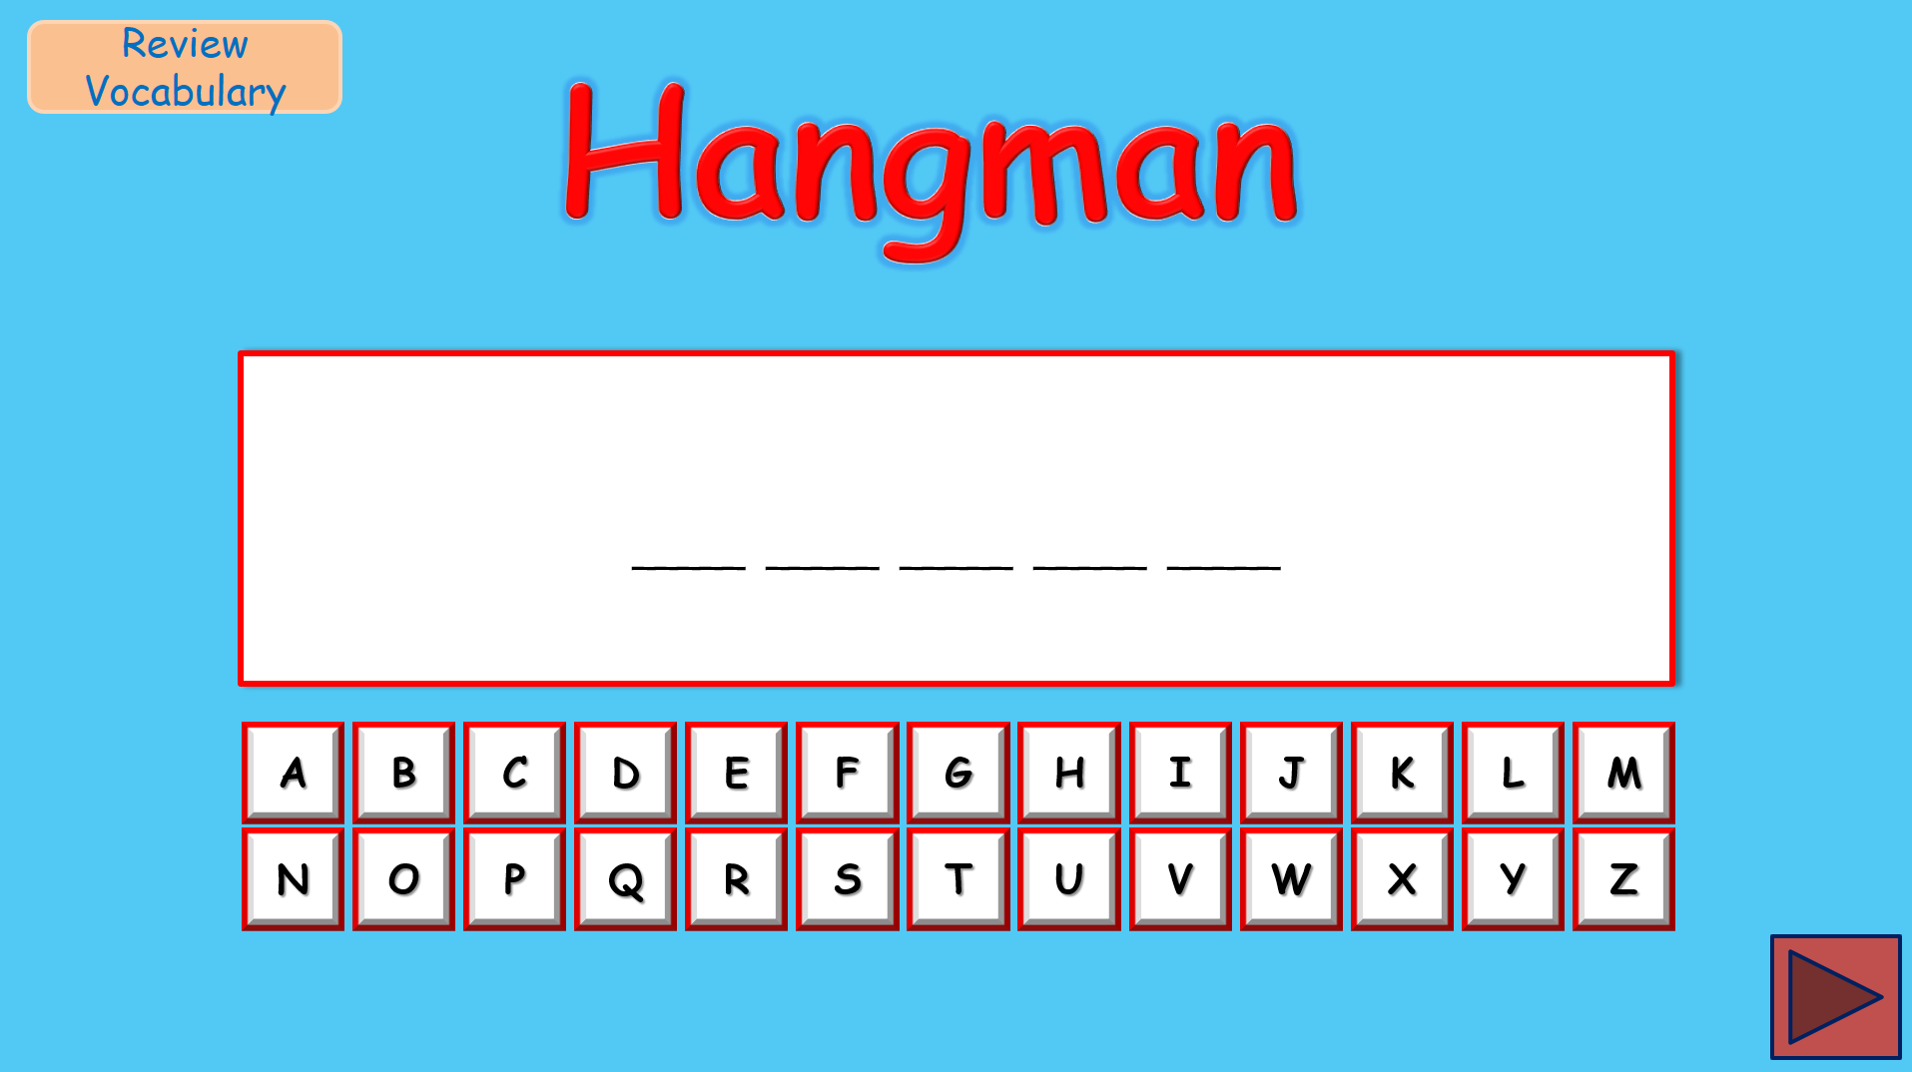  Play game 2: Odd one out  - Divide the class into 2 or 4 groups.  - Ask Ss to choose a word that is different from three words.  - Read all the words carefully and find a connection before you choose the different word.  - After the player has successfully identified the odd one out, they can either guess the explanation or challenge their opponents to guess.  - Choosing the correct item would score two points and figuring out why it didn't belong by guessing the common bond of the other three or a successful challenge is worth three points more, for a total of five points.  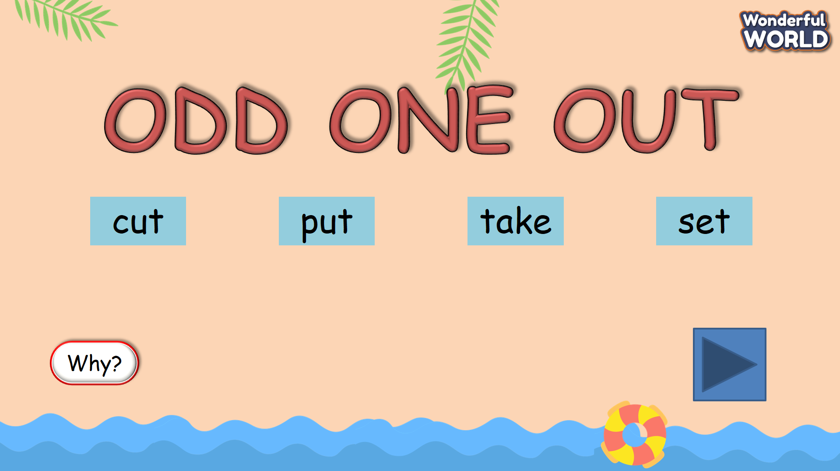  Play game 3: Making question  - Divide the class into 2 groups.  - Ask Ss to choose a color and T opens it.  - Ask Ss to read the sentence carefully and the player has to ask a question in the past simple to suit the answer.  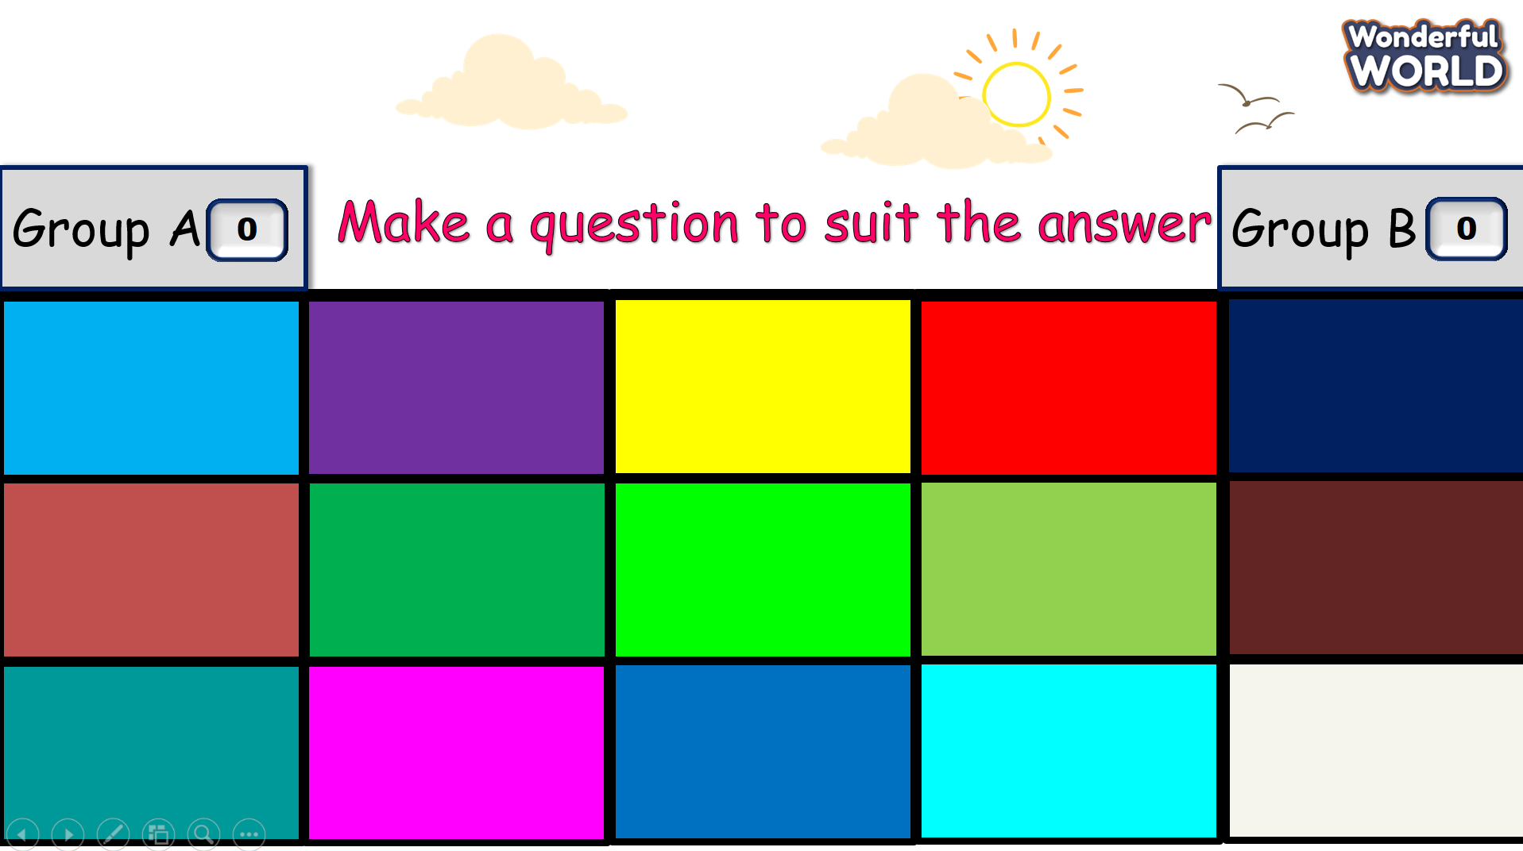 |  | - Look at the secret word and try to guess the correct letters.  - Read all the words carefully and choose the word that is different from the three words.  - Explain why it is different.  \  - Choose a color and ask a question in the past simple to suit the answer.
Activity 3: Practice – Controlled practice (5 minutes)
Teacher’s Activities |  | Students’ Activities
Aim:
Ss will be able to use the words and structures learned in the unit to complete the handout. Then report the results to the class.
Task 1: Find someone who …  - Tell students that they are going to do a Find someone who  activity.  - Show the handout on the screen.  - Make an example conversation with one student:  T: Did you watch a movie last night?  S: Yes, I did.  T: What movie did you watch?  S: I watched one of the Star Wars movies. I liked it very much.  - Tell students that they will ask their friends and then write  their friends’ names on the second column and extra  information on the third column.  - Give each student a handout.  - Tell students that they can go around and talk with  different classmates.  - Give students 10 minutes to do the task.  - After the time limit, ask some students to stand up and  report about what they found. |  | - Listen to the teacher.  - Ask their friends and then write your friends’ names in the second column and extra  information on the third column.  - Go around and talk with  different classmates.  - Stand up and share in front of the class.
Activity 4: Production (8 minutes)
Teacher’s Activities |  | Students’ Activities
Aim:
Ss will be able to develop students' English speaking skills.
Task 2: Let’s talk  - Ask students to look at Activity 1 again and tell them that they are going to practise talking.  - Model one example.  - Give students five to eight minutes to work in pairs.  - Call on some students to go to the board and talk aloud.  - Give feedback and check pronunciation if necessary. |  | - Work in pairs and talk about what Ss found in Activity 1.  - Go to the board and talk aloud.
Activity 5: Wrap up & Assessment (5 minutes)
Teacher’s Activities |  | Students’ Activities
Aims:
- Assess individuals or groups who have done the best in the lesson.
- Wrap up the activities Ss have done during the lesson.
Assessment:  Find and correct the mistakes below.  - Tell Ss that each of the sentences below has at least one mistake.  - Ask Ss to underline the mistakes and rewrite the correct answer.  - Check answers as a class.  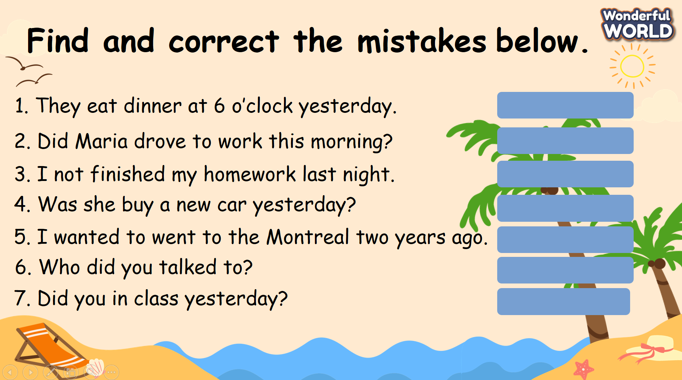  - Wrap-up: Ask Ss the question: “What have we learnt today?”  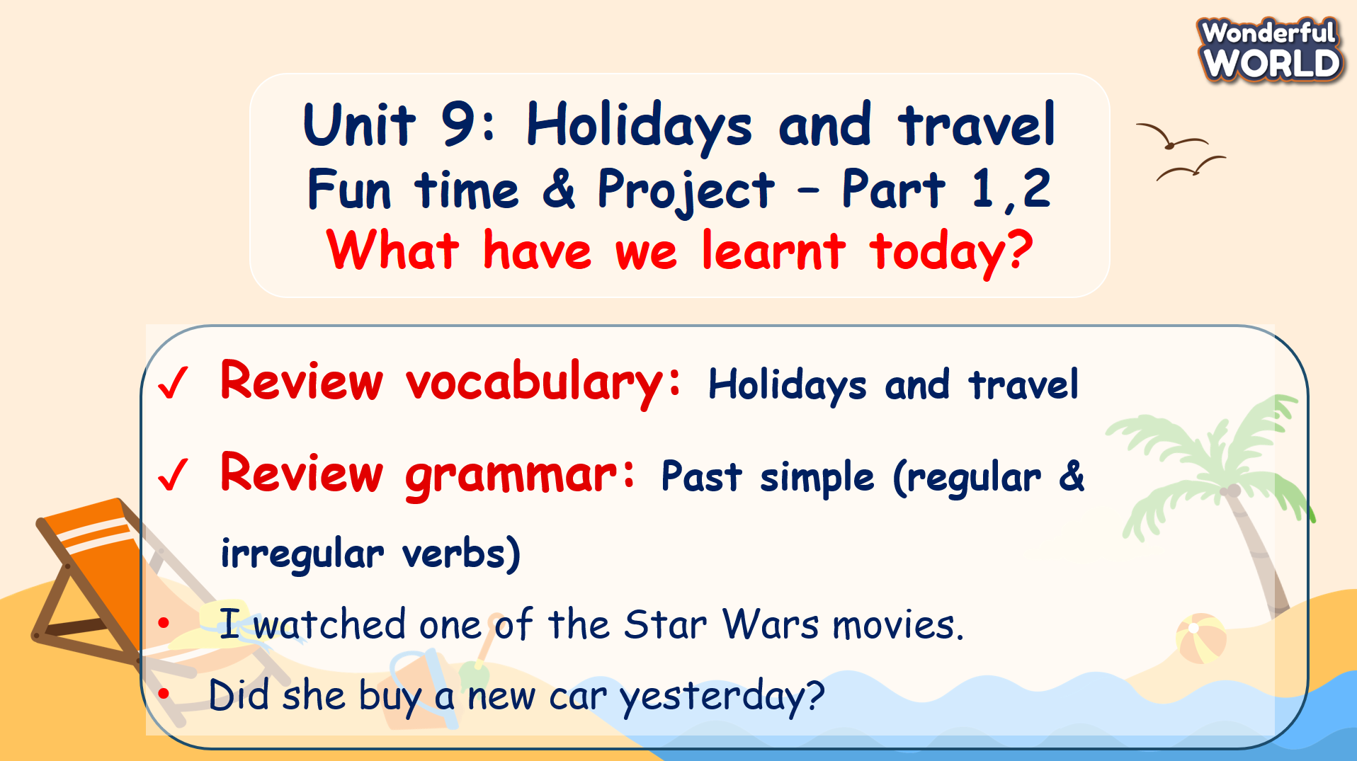 |  | - Join the activity.  - Stand up and say goodbye to the teacher.

