TUẦN 27 Khối 4 (Từ ngày 24/03/2025 đến ngày 28/03/2025)
THỨ | TIẾT | MÔN | TIẾT THỨ | NỘI DUNG BÀI DẠY |  | UDCNTT | ĐỒ DÙNG DẠY HỌC
Hai  24/03 | 1
Hai  24/03 | 2
Hai  24/03 | 3
Hai  24/03 | 4
Hai  24/03 | 5 | 4A | 105 | Unit 10. On holiday | Lesson 2 (4, 5, 6) | Wonderfulworld | Flashcards, TV, books
Hai  24/03 | 6 | 4B | 105 | Unit 10. On holiday | Lesson 2 (4, 5, 6) | Wonderfulworld | Flashcards, TV, books
Hai  24/03 | 7 | 4C | 105 | Unit 10. On holiday | Lesson 2 (4, 5, 6) | Wonderfulworld | Flashcards, TV, books
Ba  25/03 | 1 | 4B | 106 | Unit 10. On holiday | Lesson 2 (7, 8, 9) | Wonderfulworld | Flashcards, TV, books
Ba  25/03 | 2 | 4A | 106 | Unit 10. On holiday | Lesson 2 (7, 8, 9) | Wonderfulworld | Flashcards, TV, books
Ba  25/03 | 3
Ba  25/03 | 4 | 4C | 53 | Tại chỗ lăn bóng qua hai chân |  |  | Còi, sân tập
Ba  25/03 | 5 | 4B | 107 | Unit 10. On holiday | Lesson 3 (1, 2, 3) | Wonderfulworld | Flashcards, TV, books
Ba  25/03 | 6 | 4D | 105 | Unit 10. On holiday | Lesson 2 (4, 5, 6) | Wonderfulworld | Flashcards, TV, books
Ba  25/03 | 7
Tư  26/03 | 1
Tư  26/03 | 2
Tư  26/03 | 3
Tư  26/03 | 4 | 4C | 106 | Unit 10. On holiday | Lesson 2 (7, 8, 9) | Wonderfulworld | Flashcards, TV, books
Tư  26/03 | 5 | 4D | 106 | Unit 10. On holiday | Lesson 2 (7, 8, 9) | Wonderfulworld | Flashcards, TV, books
Tư  26/03 | 6 | 4C | 107 | Unit 10. On holiday | Lesson 3 (1, 2, 3) | Wonderfulworld | Flashcards, TV, books
Tư  26/03 | 7 | 4B | 108 | Unit 10. On holiday | Lesson 3 (4, 5, 6) | Wonderfulworld | Flashcards, TV, books
Năm  27/03 | 1
Năm  27/03 | 2 | 4C | 108 | Unit 10. On holiday | Lesson 3 (4, 5, 6) | Wonderfulworld | Flashcards, TV, books
Năm  27/03 | 3 | 4A | 107 | Unit 10. On holiday | Lesson 3 (1, 2, 3) | Wonderfulworld | Flashcards, TV, books
Năm  27/03 | 4
Năm  27/03 | 5
Năm  27/03 | 6
Năm  27/03 | 7
Sáu  28/03 | 1
Sáu  28/03 | 2 | 4A | 108 | Unit 10. On holiday | Lesson 3 (4, 5, 6) | Wonderfulworld | Flashcards, TV, books
Sáu  28/03 | 3
Sáu  28/03 | 4 | 4D | 107 | Unit 10. On holiday | Lesson 3 (1, 2, 3) | Wonderfulworld | Flashcards, TV, books
Sáu  28/03 | 5 | 4C | 54 | Ôn tập và kiểm tra giữa học kì 2 |  |  | Còi, sân tập
Sáu  28/03 | 6 | 4D | 108 | Unit 10. On holiday | Lesson 3 (4, 5, 6) | Wonderfulworld | Flashcards, TV, books
Sáu  28/03 | 7

GRADE 4
WEEK 27
UNIT 10. OUR HOLIDAY
Lesson 2. Task 4, 5, 6
Period 105
I. OBJECTIVES:
1. Knowledge:
Students will review words and phrases related to the topic on holiday: eat seafood, make a sandcastle, go sightseeing, row a boat.
- English competences: Students will be able to talk about different places
- Common competences: Students will have the opportunity to develop the creativeness in drawing the family tree and develop communication among friends.
3. Qualities:
- Students develop love topic holiday.
II. EQUIPMENT AND MATERIALS:
- For Teacher: PP, flashcards, handout, track 10.6, track 10.7
- For students: pens, A4 paper, crayons,
III. LESSON PROCEDURE:

Activity 1: Warm-up (5 minutes)
Aim: warm-up activity to introduce the topic
Teacher’s Activities | Students’ Activities
- Dance and sing: Samba nana.  - Teacher divides the class into 6 groups.  - Ask students to watch the video  Dance and sing along to the song. | - Sit in 6 circles  - Listen to the instruction carefully and watch the video.  - Watch the video again and sing along to the song.
Activity 2: Presentation (8 minutes)
Aim: Present the new words and practise with structure: What do you like doing on holiday?
Teacher’s Activities | Students’ Activities
4 Listen and repeat. (Track 10.6)  Play the recording. Tell students to look at the sentences  and follow them with their fingers.  • Play the recording again. Ask students to repeat.  • Point to the sentences. Ask students to notice the use  and form of What + going to.  • Ask students to repeat sentences and link to the next  activity | - Repeat after the teacher.
Activity 3: Practice (10 minutes)
Aim: Practise new words, ask and answer using structure

Teacher’s Activities | Students’ Activities
5. Look and say.  Tell students to look at the picture and suggested words for question  1. Then ask them to read out the example sentences.  • Explain the rest of the task to students. Allow them enough time to practise saying sentences  individually and in pairs. Go round the class helping students where necessary.  • Ask volunteers to read out sentences. Correct any mistakes  6 Listen and chant ( track 10.7)  • Ask students to look at the photo and tell you what it shows (a boy making a sandcastle on the beach). Tell students to read the chant quickly.  • Play the chant for students to listen and follow with their fingers.  • Read out the chant a line at a time. Ask students to repeat after you.  • Play the chant again for students to chant along. Practise until students are familiar with the words. | - Students to look at the picture for question 1 and the example.  - Read out the example and repeat - Write the words and say.  - Students are going to learn a chant.  - Look at the chant quickly.  - Students repeat after teacher  - Students chant along.
Activity 4: Production (9 minutes)
Aim: Join the game to review the words and structure
Teacher’s Activities | Students’ Activities
Game Football quiz    - Divide the class into 4 teams.  - Explain the game rule:  + When Ss choose the answer, the players kick the ball  + Team that finishes all the steps first will be the winner. | - Listen to the rule carefully.  - Join the game.  -Look and read.  -Read  -Identify and read.  - Check with friends and then with the teacher and the whole class.
Activity 5: Assessment (3 minutes)
Aim: Do the exercise to review and remember the words
Teacher’s Activities | Students’ Activities
-Ask sts to do the assessment  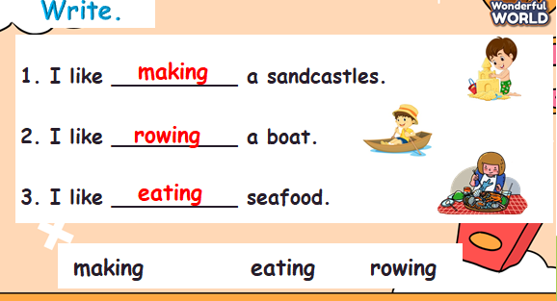  - Check with the class | -Do the assessment  - Check with the teacher
________________________________
UNIT 10. OUR HOLIDAY
Lesson 2. Task 7, 8,9
Period 106
I. OBJECTIVES:
1. Knowledge:
Students will review words and phrases related to the topic on holiday: eat seafood, make a sandcastle, go sightseeing, row a boat.
- English competences: Students will be able to talk about different places
- Common competences: Students will have the opportunity to develop the creativeness in drawing the family tree and develop communication among friends.
3. Qualities:
- Students develop love topic holiday.
II. EQUIPMENT AND MATERIALS:
- For Teacher: PP, flashcards, handout, track 10.8.
- For students: pens, A4 paper, crayons,
III. LESSON PROCEDURE:

Activity 1: Warm-up (5 minutes)
Aim: warm-up activity to introduce the topic of holiday
Teacher’s Activities | Students’ Activities
Play game: Slap the board  In class, divide the students into two teams.  Each team sends one student to the board. These students stand a few steps away from the board.  Call out a vocabulary item pictured on the board. The two students have to slap the appropriate picture as fast as they can.  The student who hits the correct picture first wins a point for their team. | - Listen to the rule carefully.  - Join the game.  -Look and read.  - Join the game by looking and saying.
Activity 2: Presentation (8 minutes)
Aim: Present the new words and practise with the correct structures like: which place would you like to visit on holiday?
Teacher’s Activities | Students’ Activities
7. Listen and match  Tell the students that they are going to listen to some people talking about places they’d like to visit and activities they like doing, then match the three columns.  Ask students to read the columns.  • Play the recording and pause after the first speaker. Ask students what they can hear. Play the rest of the recording and tell students to listen and match three more correct answers. Play the recording more than once if students cannot catch the answers.  • Play the recording again and pause after each sentence to check answers. | - Listen and answer.  - Repeat after the teacher.  - Students to repeat the sentences. Let them know that this activity is linked to the next activity
Activity 3: Practice (10 minutes)
Aim: Practise the song chant using correct places and activities
Teacher’s Activities | Students’ Activities
8 Complete the table.  • Tell students to brainstorm different places in Vietnam and activities to do there.  • Ask them to work individually on their own list to prepare for the next activity.  • Go round the class helping students if necessary.  9. Let’s talk.  • Ask students to look at the example sentences. Read out  the example.  • Tell students to go round the class and ask their friends  about the places they would like to visit and activities they  like doing there before writing down their answers in the  table. Remind students to draw the table in their notebook  or on a piece of paper. | • Students brainstorm different places in Vietnam and activities to do there.  • Students work individually on their own list to prepare for the next activity.  • Students look at the example sentences. Read out  the example.  • Students go round the class and ask their friends about the places they would like to visit and activities they like doing there before writing down their answers in the  table.  - Students draw the table in their notebook or on a piece of paper.
Activity 4: Production (9 minutes)
Aim: Join the game to review the words, structure and get used to which question.
Teacher’s Activities | Students’ Activities
Game :  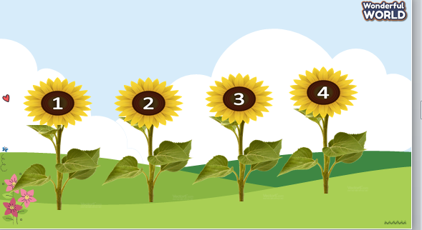  - Divide the class into 4 teams.  - Explain the game rule:  + Ss choose the number and go to the questions. | - Listen to the rule carefully.  - Join the game.  -Look and read.  - Join the game by looking and saying.
Activity 5: Assessment (3 minutes)
Aim: Do the exercise to review and remember the words
Teacher’s Activities | Students’ Activities
-Ask sts to do the assessment  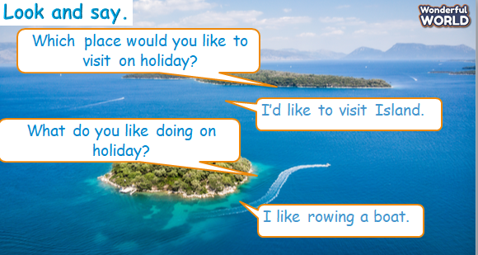  - Check with the class | -Do the assessment  - Check with the teacher
_______________________________
UNIT 10. OUR HOLIDAY
Lesson 3. Task 1, 2, 3
Period 107
I. OBJECTIVES:
1. Knowledge:
- Students will learn words and phrases related to the topic on holiday: buy presents, send a postcard, stay in a hotel, write in a diary.
- Learn and use new grammar: I like ..., but I don’t like ...
- English competences: Students will be able to talk about different holiday activities.
- Common competences: Students will have the opportunity to develop the creativeness in drawing the family tree and develop communication among friends.
3. Qualities:
- Students develop love topic holiday.
II. EQUIPMENT AND MATERIALS:
- For Teacher: PP, flashcards, handout, track 10.9, 10.10.
- For students: pens, A4 paper, crayons,
III. LESSON PROCEDURE:
Activity 1: Warm-up (5 minutes)
Aim: warm-up activity to introduce the topic of holiday using correct verbs and phrases.
Teacher’s Activities | Students’ Activities
- Dance and sing: Sam banana.  - Teacher divides the class into 6 groups.  - Ask students to watch the video  Dance and sing along to the song. | - Sit in 6 circles  - Listen to the instruction carefully and watch the video.  - Watch the video again and sing along to the song.
Activity 2: Presentation (8 minutes)
Aim: Present the new words and practise the phrases related to places and activities
Teacher’s Activities | Students’ Activities
- Use flashcards to introduce the vocabulary and structure of the lesson.  - Say the words/sentences for students to repeat in the chorus.  - Say a word/sentence for students to repeat then point.  - Show pictures in random order and ask students to read out the correct words.  Task 1 Listen and point. Repeat ( Tr. 10.9)  Look at the picture and let sts repeat the words  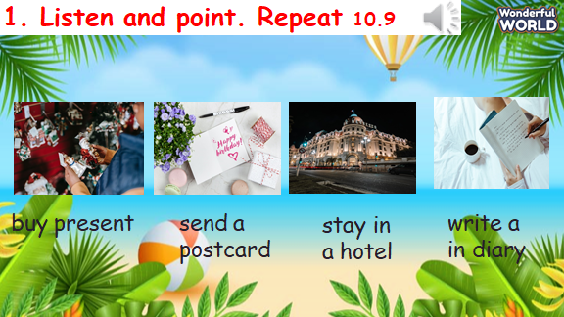 | - Repeat after the teacher.  - Repeat after the teacher.  - Students listen to, point to, and repeat the words.  - Then read out loud the new picture words and phrases in the vocabulary box in random order and students point to the correct pictures
Activity 3: Practice (10 minutes)
Aim: Practise new words, ask and answer using structure with “Wh” question
What do you like doing on holiday?
I like ..., but I don’t like ...
Teacher’s Activities | Students’ Activities
Task 2. Listen and match. Tr 10.10  • Tell students that they are going to learn about these  children’s holidays. Ask them to look at the page and find the children’s names.  • Play the recording and ask students to listen carefully.  • Ask students to match the children with their holiday  activities.  • Check the answer with the whole class. Replay the recording and pause at some parts if necessary  Task 3: Look and say.  • Tell students to look at the first set of given words and the example sentences. Ask them to read the sentences aloud a few times.  • Ask students to look at other sets of words and think about how to form sentences. Give students suggestions in case they have difficulties.  • Give students time to practice other sentences in pairs.  • Ask some volunteers to read their sentences aloud in front of the whole class. | - Students look at the picture and follow the text with their fingers.  • Play the recording. Students repeat.  - Students tick the answer  - Continue with the other sentence.  - Students look at the pictures and the sample sentence.  - Work in pairs and present in front of the class.
Activity 4: Production (9 minutes)
Aim: Join the game to review the words and structure
Teacher’s Activities | Students’ Activities
The bee game  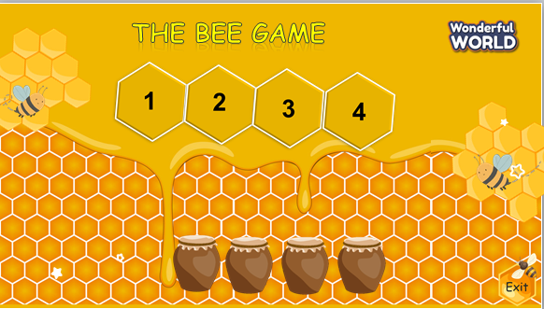  - Click on the number to select the question  - Click on the jar to open the star  - Click Exit to exit the game | - Listen to the rule carefully.  - Play the game.  -Look and read.  -Read  -Identify and read.  - Check with friends and then with teacher and whole class.
Activity 5: Assessment (3 minutes)
Aim: Do the exercise to review and remember the words
Teacher’s Activities | Students’ Activities
-Ask sts to do the assessment  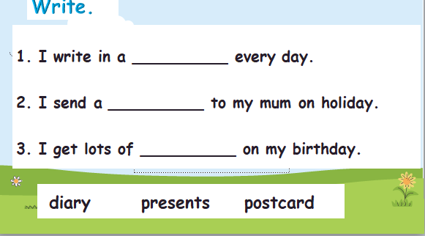  - Check with the class | -Do the assessment  - Check with the teacher
________________________________
UNIT 10. OUR HOLIDAY
Lesson 3. Task 4, 5, 6
Period 108
I. OBJECTIVES:
1. Knowledge:
- Students will review words and phrases related to the topic on holiday: buy presents, send a postcard, stay in a hotel, write in a diary.
- Learn and use new grammar: I like ..., but I don’t like ...
- English competences: Students will be able to talk about different holiday activities.
- Common competences: Students will have the opportunity to develop the creativeness in drawing the family tree and develop communication among friends.
3. Qualities:
- Students develop love topic holiday.
II. EQUIPMENT AND MATERIALS:
- For Teacher: PP, flashcards, handout, track 10.9, 10.10.
- For students: pens, A4 paper, crayons,
III. LESSON PROCEDURE:

Activity 1: Warm-up (5 minutes)
Aim: warm-up activity to introduce the topic of places and activities
Teacher’s Activities | Students’ Activities
Play game: Slap The Board  Call out a vocabulary item pictured on the board. The two students have to slap the appropriate picture with their flyswatter as fast as they can. The student who hits the correct picture first wins a point for their team. | - Listen to the instruction carefully  - play game
Activity 2: Presentation (8 minutes)
Aim: Present the new words and practise the sentences I like and I don’t like + Ving.
Teacher’s Activities | Students’ Activities
Task 1 Listen and repeat ( Tr. 10.11)  • Play the recording. Tell students to  look at the sentences and follow  them with their fingers.  • Play the recording again. Ask  students to repeat.  • Point to the sentences. Ask students to notice the use of but to link two clauses with I like or I don’t  like.  • Ask students to repeat sentences and link to the next activity  Look at the picture and let sts repeat the words | - Repeat after the teacher.  - Students listen to, point to, and repeat the words.  - Then read out loud the new picture words and phrases in the vocabulary box in random order and students point to the correct pictures
Activity 3: Practice (10 minutes)
Aim: Practise new words, ask and answer using structure:
I like ..., but I don’t like ... using the learned vocab and phrases
Teacher’s Activities | Students’ Activities
5 Look and say.  • Tell students to look at the picture and suggested words for question  1. Then ask them to read out the example sentence.  • Explain the rest of the task to students. Allow them enough time to practice saying sentences individually and in pairs. Go round the class helping students where necessary.  • Ask volunteers to read out sentences. Correct any mistakes.  6 Let’s play.  • Tell students that they are going to play a game of making  sentences.  • Ask them to work in pairs. The first student begins the  sentence with I like, and the second one continues it with  but I don’t like. Remind them to notice the logical flow of  the sentence.  • Ask some volunteers to play the game in front of the whole class. Correct mistakes if necessary. | - Students to look at the picture for question 1 and the example.  - Read out the example and repeat  - Students look at the pictures and the sample sentence.  - Work in pairs and present in front of the class.
Activity 4: Production (9 minutes)
Aim: Join the game to review the words and structure using I like and don’t like + Ving.
Teacher’s Activities | Students’ Activities
The bee game  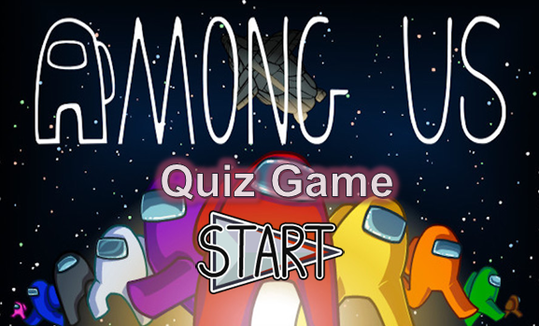  Click start to go to the rules slide.  Explain all the rules. All teams should start with 500 points each.  - The sabotage button- Throughout the presentation, there are random sabotage slides. If a team enables a sabotage, they can steal the respective number of points from a team of their choice. The point intervals are 100, 200, 300, 400, 600, 800, 900. The questions difficulty should be respective to the point value. The point value can be changed to the desired amounts.  Report button: Doesn`t appear again in the presentation. Just remind the students to not shout out the answers.  - Ideally for 4-6 teams. The order is chosen by having the first student in the first group do rock, paper, scissors with the last student in the last team. Whoever wins RPS, determines the order of the game.  Keep track of the teams by writing each team on the board to keep score also write the order. Team one (orange) Write the color below the team order number | - Listen to the rule carefully.  - Join the game.  -Look and read.  - Join the game by looking and saying.
Activity 5: Assessment (3 minutes)
Aim: Do the exercise to review and remember the words
Teacher’s Activities | Students’ Activities
-Ask sts to do the assessment  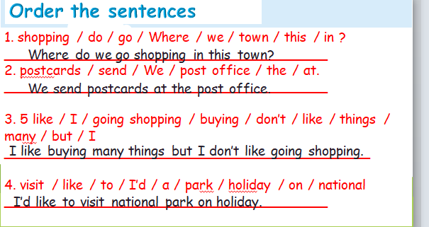  - Check with the class | -Do the assessment  - Check with the teacher
______________________________________

Giáo dục thể chất
TẠI CHỖ LĂN BÓNG QUA HAI CHÂN
I. YÊU CẦU CẦN ĐẠT
1. Yêu cầu cần đạt về kiến thức, kĩ năng
- Biết và thực hiện được động tác các động tác làm tăng khả năng điều khiển bóng
- Có ý thức kĩ luật, đoàn kết tinh thần tập thể, tích cực tham gia hoạt động luyện tập và chơi trò chơi.
2. Yêu cầu cần đạt về năng lưc, phẩm chất
- Đoàn kết, nghiêm túc, tích cực trong tập luyện và hoạt động tập thể.
- Tích cực tham gia các trò chơi vận động, có trách nhiệm trong khi chơi trò chơi và hình thành thói quen tập luyện TDTT.
- Tự chủ và tự học: Tự xem trước cách thực động tác Các động tác làm tăng khả năng điều khiển bóng trong sách giáo khoa.
- Giao tiếp và hợp tác: Biết phân công, hợp tác trong nhóm để thực hiện các động tác và trò chơi.
- NL chăm sóc SK: Biết thực hiện vệ sinh sân tập, thực hiện vệ sinh cá nhân để đảm bảo an toàn trong tập luyện.
- NL vận động cơ bản: Thực hiện được động tác một bước đà bật nhảy về trước, chạy phối hợp bật nhảy về trước, chạy hối hợp bật cao chạm vật.
- Biết quan sát tranh, tự khám phá bài và quan sát động tác làm mẫu của giáo viên để tập luyện.
II. ĐỒ DÙNG DẠY - HỌC:
- Địa điểm: Sân trường
- Phương tiện:
+ Giáo viên chuẩn bị: Tranh ảnh, trang phục thể thao, còi phục vụ trò chơi.
+ Học sinh chuẩn bị: Trang phục thể thao.
III. CÁC HOẠT ĐỘNG DẠY HỌC CHỦ YẾU:
Nội dung | Lượng VĐ |  | Phương pháp, tổ chức và yêu cầu
Nội dung | T. gian | S. lần | Hoạt động GV | Hoạt động HS
I. Hoạt động khởi động:  Nhận lớp  Khởi động  - Xoay các khớp cổ tay, cổ chân, vai, hông, gối,...  - Trò chơi “ Chuyền bóng phải, trái”  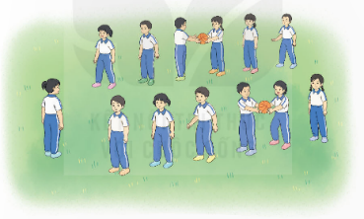  II. Hoạt động luyện tập  - Kiến thức.  -Ôn bài tập: Các động tác làm tăng khả năng điều khiển bóng  -Luyện tập  Tập đồng loạt  Tập theo tổ nhóm  Tập theo cặp đội  Thi đua giữa các tổ  - Trò chơi “Ôm bóng chạy qua vật cản tiếp sức”.  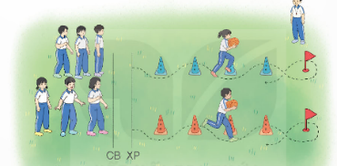  - Bài tập PT thể lực:  - Luyện tập mở rộng:  III.Hoạt động tiếp nối:  - Thả lỏng cơ toàn thân.  - Nhận xét, đánh giá chung của buổi học.  Hướng dẫn HS Tự ôn ở nhà  - Xuống lớp | 5 – 7’  2 - 3’  16-18’  3-5’  4- 5’ | 2x8N  2 lần  2 lần  2 lần  1 lần  1 lần | Gv nhận lớp, thăm hỏi sức khỏe học sinh phổ biến nội dung, yêu cầu giờ học  - GV HD học sinh khởi động.  - GV hướng dẫn chơi  - GV nhắc lại cách thực hiện và phân tích kĩ thuật động tác  - Cho 4 em học sinh lên thực hiện động tác Các động tác làm tăng khả năng điều khiển bóng  - GV cùng HS nhận xét, đánh giá tuyên dương  - GV hô - HS tập theo GV.  - Gv quan sát, sửa sai cho HS.  - Y,c Tổ trưởng cho các bạn luyện tập theo khu vực.  - Tiếp tục quan sát, nhắc nhở và sửa sai cho HS  - GV tổ chức cho HS thi đua giữa các tổ.  - GV và HS nhận xét đánh giá tuyên dương.  - GV nêu tên trò chơi, hướng dẫn lại cách chơi, tổ chức chơi trò chơi cho HS.  - Nhận xét tuyên dương và sử phạt người phạm luật  - Cho HS chạy XP cao 20m  - Yêu cầu HS quan sát tranh trong sách trả lời câu hỏi?  - GV hướng dẫn  - Nhận xét kết quả, ý thức, thái độ học của hs.  - VN ôn lại bài và chuẩn bị bài sau. | - Đội hình nhận lớp  - HS khởi động theo GV.  - HS Chơi trò chơi.  - Đội hình HS quan sát  - HS quan sát GV làm mẫu  - HS tiếp tục quan sát  - Đội hình tập luyện đồng loạt.  ĐH tập luyện theo tổ  GV  - Từng tổ lên thi đua trình diễn  - Chơi theo đội hình hướng dẫn  cb xp  HS chạy kết hợp đi lại hít thở  - HS trả lời  - HS thực hiện thả lỏng  - ĐH kết thúc
IV. Điều chỉnh sau tiết dạy (Nếu có)
…………………………………………………………………………………
________________________________

ÔN TẬP VÀ KIỂM TRA GHK2
_______________________________

Ký duyệt của  Khối trưởng:  Lương Thị Xuyến | Vĩnh An, ngày 20 tháng 03 năm 2025  Người thực hiện:    Nguyễn Thị Kim Chi

