TUẦN 27 Khối 3, 5 (Từ ngày 24/03/2025 đến ngày 28/03/2025)
THỨ | TIẾT | MÔN | TIẾT THỨ | NỘI DUNG BÀI DẠY |  | UDCNTT | ĐỒ DÙNG DẠY HỌC
Hai  24/03 | 1 | 5A | 105 | Unit 10. Performing art | Lesson 2 (4, 5, 6) | Wonderfulworld | Flashcards, TV, books
Hai  24/03 | 2
Hai  24/03 | 3 | 3A | 105 | Unit 9. My favourite food | Lesson 2 (4, 5, 6) | Wonderfulworld | Flashcards, TV, books
Hai  24/03 | 4 | 3A | 106 | Unit 9. My favourite food | Lesson 2 (7, 8, 9) | Wonderfulworld | Flashcards, TV, books
Hai  24/03 | 5 | 5D | 105 | Unit 10. Performing art | Lesson 2 (4, 5, 6) | Wonderfulworld | Flashcards, TV, books
Hai  24/03 | 6 | 3B | 105 | Unit 9. My favourite food | Lesson 2 (4, 5, 6) | Wonderfulworld | Flashcards, TV, books
Hai  24/03 | 7
Ba  25/03 | 1 | 5C | 105 | Unit 10. Performing art | Lesson 2 (4, 5, 6) | Wonderfulworld | Flashcards, TV, books
Ba  25/03 | 2 | 5B | 105 | Unit 10. Performing art | Lesson 2 (4, 5, 6) | Wonderfulworld | Flashcards, TV, books
Ba  25/03 | 3 | 5A | 106 | Unit 10. Performing art | Lesson 3 (1, 2, 3) | Wonderfulworld | Flashcards, TV, books
Ba  25/03 | 4
Ba  25/03 | 5 | 3A | 107 | Unit 9. My favourite food | Lesson 3 (1, 2, 3) | Wonderfulworld | Flashcards, TV, books
Ba  25/03 | 6 | 5D | 106 | Unit 10. Performing art | Lesson 3 (1, 2, 3) | Wonderfulworld | Flashcards, TV, books
Ba  25/03 | 7 | 3B | 106 | Unit 9. My favourite food | Lesson 2 (7, 8, 9) | Wonderfulworld | Flashcards, TV, books
Tư  26/03 | 1 | 5A | 107 | Unit 10. Performing art | Lesson 3 (4, 5, 6) | Wonderfulworld | Flashcards, TV, books
Tư  26/03 | 2
Tư  26/03 | 3
Tư  26/03 | 4
Tư  26/03 | 5 | 5B | 106 | Unit 10. Performing art | Lesson 3 (1, 2, 3) | Wonderfulworld | Flashcards, TV, books
Tư  26/03 | 6 | 5C | 106 | Unit 10. Performing art | Lesson 3 (1, 2, 3) | Wonderfulworld | Flashcards, TV, books
Tư  26/03 | 7
Năm  27/03 | 1 | 5C | 107 | Unit 10. Performing art | Lesson 3 (4, 5, 6) | Wonderfulworld | Flashcards, TV, books
Năm  27/03 | 2 | 5B | 107 | Unit 10. Performing art | Lesson 3 (4, 5, 6) | Wonderfulworld | Flashcards, TV, books
Năm  27/03 | 3 | 5A | 108 | Unit 10. Performing art | Lesson 3 (7, 8, 9) | Wonderfulworld | Flashcards, TV, books
Năm  27/03 | 4
Năm  27/03 | 5 | 5D | 107 | Unit 10. Performing art | Lesson 3 (4, 5, 6) | Wonderfulworld | Flashcards, TV, books
Năm  27/03 | 6 | 5C | 108 | Unit 10. Performing art | Lesson 3 (7, 8, 9) | Wonderfulworld | Flashcards, TV, books
Năm  27/03 | 7
Sáu  28/03 | 1 | 3B | 107 | Unit 9. My favourite food | Lesson 3 (1, 2, 3) | Wonderfulworld | Flashcards, TV, books
Sáu  28/03 | 2 | 5D | 108 | Unit 10. Performing art | Lesson 3 (7, 8, 9) | Wonderfulworld | Flashcards, TV, books
Sáu  28/03 | 3 | 5B | 108 | Unit 10. Performing art | Lesson 3 (7, 8, 9) | Wonderfulworld | Flashcards, TV, books
Sáu  28/03 | 4
Sáu  28/03 | 5
Sáu  28/03 | 6 | 3B | 108 | Unit 9. My favourite food | Lesson 3 (4, 5, 6) | Wonderfulworld | Flashcards, TV, books
Sáu  28/03 | 7 | 3A | 108 | Unit 9. My favourite food | Lesson 3 (4, 5, 6) | Wonderfulworld | Flashcards, TV, books

GRADE 3
WEEK 27 (From 24/3 to 28/3)
UNIT 9. MY FAVOURITE FOOD
Lesson 2 - Task 4,5,6
Period 105
I. OBJECTIVES:
1. Knowledge:
- Students will learn the question: Where’s the ….? and the answer with preposition: It’s in/on/under the…..
2. Competences:
- English competences: Students will be able to practice asking and answering about the location of objects (singular noun)
- Common competences: Students will have the opportunity to develop the solving problem in doing tasks and cooperation among teammates
3. Qualities:
- Students are given opportunities to know more information about food around the world.
II. EQUIPMENT AND MATERIALS:
- Basic things: Student’s book, flashcards, crayons.
- Advanced things: PPT, projector/interactive whiteboard/laptop/TV.
III. LESSON PROCEDURE:
Activity 1: Warm-up (5 minutes)
Teacher’s activities | Student’s activities
- Greet students  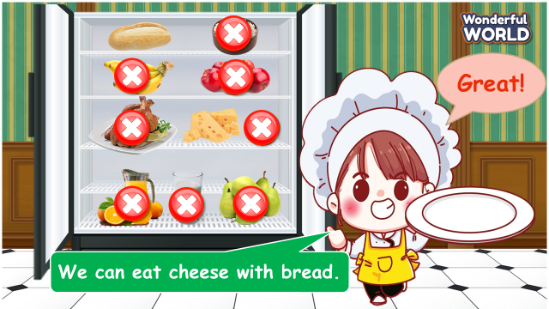  Game: Finding food game  (Set the context: Students help the chef choose the right food. Students read a sentence and choose the correct foods)  - Set the game rules  - Play as a model  - Play game  Sentences:  1. We can eat cheese with bread  2. There are a lot of pears  3. There is a tomato  4. We can eat chicken with rice  5. There are many apples.  6. There are some bananas  7. There is great juice in the jug. | - Greet teacher  - Listen to the game rules carefully  - Look  - Join the game
Activity 2: Presentation (8 minutes)
Teacher’s activities | Student’s activities
Lead-in: Use the game to set the context and lead in task 4  Task 4: Listen and repeat. (Track 9.6)  - Ask students to point and say the food in each picture.  - Use the location of the fruits in the pictures to teach the question: Where’s the ….? and the answer: It’s in/on/under the…..  - Play the track 9.6 and ask students to listen.  - Play the track 9.6 again, ask students to listen and repeat in chorus, groups.  - Vocabulary checking: Monster game?  - Divide the class into 3 groups  - Teacher is a monster  - Ask students to close their eyes and give each group a word card of preposition (on or in or under)  - Give instruction of the game: T shows the picture and asks: Where is the apple? The student who holds the word card of preposition that T mentions will bring it to the teacher and answer: It’s… the box. Then, the student has to back their sit quickly. If the teacher can catch the student, he/she will be the loser.  Take turns to the monitor to guide the teams  - T makes models | - Say the food in each picture  - Learn grammar through flashcards and actions  - Listen  - Repeat then point.  - Join to the activity.
Activity 3: Practice (12 minutes)
Teacher’s activities | Student’s activities
Task 5: Look and say.  - Show the pictures in task 5  - Ask students to look at the picture and identify the food in each picture.  - Ask students to read the words under each picture.  - Have students look at the pictures, point and say in chorus, group, pairs, using the question: Where’s the ….? and the answer: It’s in/on/under the…..  Suggested answers:  1 Where’s the banana? – It’s on the table.  2 Where’s the rice? – It’s in the box  3 Where’s the book? – It’s under the apple.  4 Where’s the milk? – It’s on the table.  5 Where’s the tomato? – It’s in the box.  Quick eyes game  - Call 2 students to the board (or 2 groups stand up) to play in each turn.  - Show a object and the object’s place quickly on the screen.  - Ask a student (a group) to ask a question: Where’s the…? and the other student (group) to answer: It’s in/under/on the… | - Look at the picture  - Identify people and actions: 1 banana, 2 rice, 3 apple, 4 milk, 5 tomato  - Read the words under each picture.  - Look at the pictures, point and say in chorus, group, pairs, using the question: Where’s the ….? and the answer: It’s in/on/under the…..
Activity 4: Production (7 minutes)
Teacher’s activities | Student’s activities
Task 6 Draw and write. Say  - Have sts look at the picture in task 6 and read out the sample.  - Tell students to draw a picture of some food and their places.  - Sts work in group, inturn presenting their pictures to their friends.  - Ask some volunteers to share their pictures and speak in front of the class | - Look and read out the sample  - Draw a picture of some food and their places.  - Work in group, inturn presenting their pictures to their friends.  - Share their pictures and speak in front of the class
Activity 5: Assessment (3 minutes)
Teacher’s activities  - Ask students to do the assessment.  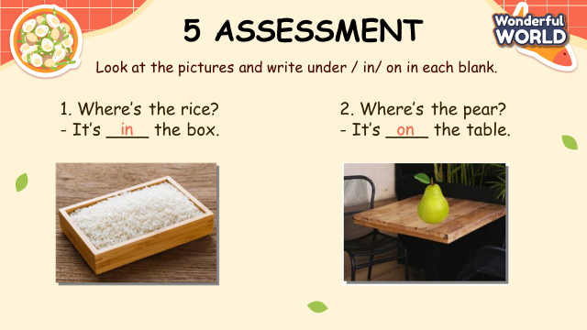 | Student’s activities
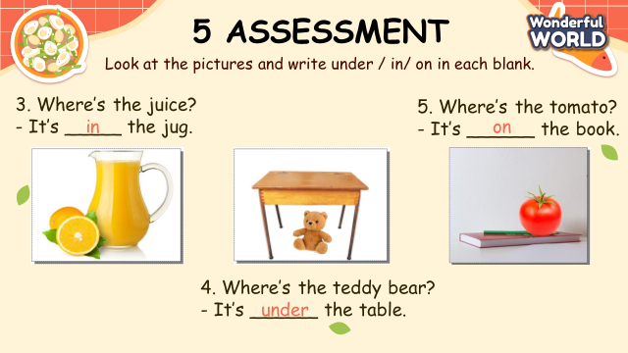  - Check in pair then whole class.  - Say goodbye | - Do the assessment.  - Check with friends and then with the teacher and the whole class.  - Say goodbye.
____________________________________

UNIT 9. MY FAVOURITE FOOD
Lesson 2 -Task 7,8,9
Period 106
I. OBJECTIVES:
1. Knowledge:
- Students will revise the question: Where’s the ….? and the answer: It’s in/on/under the….. and words related to the topic foood
2. Competences:
- English competences: Students will practice skills: listening and speaking about the location of objects.
- Common competences: Students will have the opportunity to develop the solving problem in doing tasks and cooperation among teammates
3. Qualities:
- Students are given opportunities to think about the tidiness in the kitchen
II. EQUIPMENT AND MATERIALS:
- Basic things: Student’s book, flashcards, crayons.
- Advanced things: PPT, projector/interactive whiteboard/laptop/TV.
III. LESSON PROCEDURE:
Activity 1: Warm-up (5 minutes)
Teacher’s activities | Student’s activities
- Greet students  Game: Lucky present  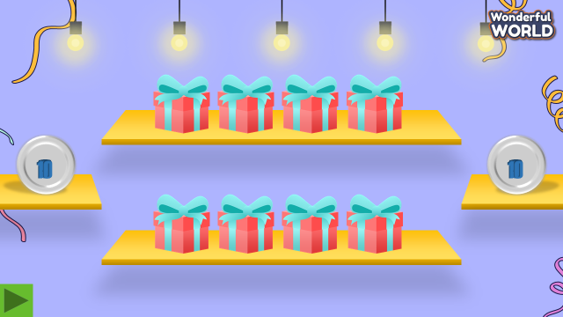  (- Divide the class into 2 big groups. There are 8 presents in the game and 2 of them are lucky presents. If students choose a lucky one, they will get 5 points without answering a question. If not, they must answer the questions and get points if it is right, otherwise other groups will take their turn. The group which has more points will win the game..)  - Set the game rules  - Play as a model  - Play game  Questions:  1. Where’s the juice? – It’s in the jug.  2. Where’s the apple? – It’s under the table.  3. Where’s the tomato? – It’s in the box.  4. Where’s the banana? – It’s on the table.  5. There are … pears. => A  A. many B. some  6. There are … bananas. => B  A. a lot of B. some | - Greet teacher  - Listen to the game rules carefully  - Look  - Join the game
Activity 2: Listening (8 minutes)
Teacher’s activities | Student’s activities
Task 7: Listen and circle. (Track 9.7)  - Ask students to look at the sentence. Explain that they are going to circle the word that they hear from the recording.  - Play the recording and then have students share their answers.  - Play the recording again. Pause after each sentence and explain the correct answer.  - Ask students to read all sentences again | - Look at the sentences.  - Listen and circle  - Check their answer  - Read
Activity 3: Speaking (12 minutes)
Teacher’s activities | Student’s activities
Task 8: Look and say.  - Show the pictures in task 8  - Ask students to look at the picture and identify the food in the picture.  - Ask students to read the words and find them in the picture to identify their places.  - Have sts read the example dialogue.  - Have students work in pairs practicing asking and answering.  - Ask some volunteers to perform in front of the class and correct any mistakes.  Suggested answers:  1 Where’s the banana? – It’s on the table.  2 Where’s the rice? – It’s in the box  3 Where’s the book? – It’s under the apple.  4 Where’s the milk? – It’s on the table.  5 Where’s the tomato? – It’s in the box.  Task 9 Let’s talk  - Show the picture in task 9 and ask some questions:  Where is this?  What’s this/’re these?  Where’s the chicken?  Where’s the bread?  Where’re the apples?  Where’re the tomatoes?  Where’s the juice?  - Show the sample sentence, read out and ask students to repeat after each sentence.  - Ask students to work in pairs to talk about the location of food in the picture.  - Ask some volunteers to speak in front of the class. | - Look at the picture  - Identify food: juice, cheese, chicken, milk, rice, tomato  - Read the words under each picture.  -Listen to the teacher’s instruction  - Listen and repeat  - Practice in pairs  - Look and answer:  In the kitchen.  Chicken, bread, apples, juice, tomatoes…  It’s on the table.  It’s on the table.  They’re in the box/under the table.  It’s on the table.  - Listen and repeat.  - Talk about the location of food in the picture in pairs.  - Perform in front of class.
Activity 4: Production (7 minutes)
Teacher’s activities | Student’s activities
Spot the difference  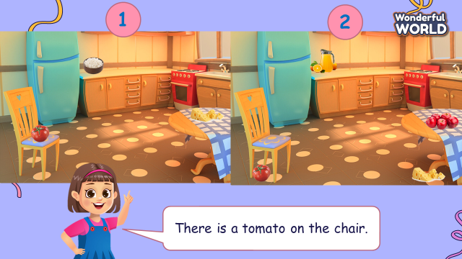  - Ask students to look at 2 pictures and find the differences between them.  Picture 1:  The tomato is on the chair.  The rice is on the table.  The cheese is on the table  Picture 2:  There are some apples on the table  The cheese is under the table  The tomato is under the chair.  The juice is in the jug.  - Ask students to point and talk about the location of foods in the picture, using the structure: There is/are…, It’s on/ in/ under…. | - Look and find the difference
Activity 5: Assessment (3 minutes)
Teacher’s activities | Student’s activities
- Ask students to do the assessment.  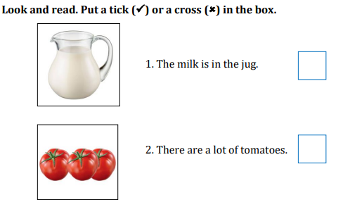  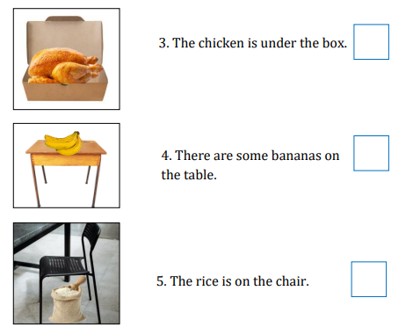  - Check in pair then whole class.  - Say goodbye. | - Do the assessment.  1. V  2. X  3. X  4. V  5. X  - Check with friends and then with the teacher and whole class.  - Say goodbye.
____________________________________

UNIT 9. MY FAVOURITE FOOD
Lesson 3 -Task 1,2,3
Period 107

I. OBJECTIVES:
1. Knowledge:
- Students will learn the words related to the topic of Food: biscuit, sweets, chocolate, ice cream.
2. Competences:
- English competences: Students will be able to describe the some of the sweet food.
- Common competences: Students will have the opportunity to develop communication among friends.
3. Qualities:
- Students are given opportunities to know more about some western food.
II. EQUIPMENT AND MATERIALS:
- Basic things: Student’s book, flashcards.
- Advanced things: PPT, projector/interactive whiteboard/laptop/TV.
III. LESSON PROCEDURE:
Activity 1: Warm-up (5 minutes)
Teacher’s activities | Student’s activities
- Greet students  Game: Guess the food  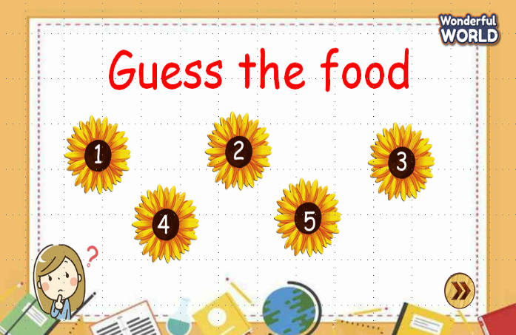  (Teacher shows 5 flowers. Ss have to choose one of them to guess what food it is.)  - Divide the class into 4 groups  - Set the game rules  - Ask students to listen and guess.  - Award the best groups  Lead-in: Use the picture of the food to lead in the new lesson. | - Greet teacher  - Sit in 4 groups.  - Listen to the game rules carefully  - Play game
Activity 2: Presentation (8 minutes)
Teacher’s activities | Student’s activities
Task 1: Listen and point. Repeat. (Track 6.8)  - Use the flashcards to introduce the vocabulary:  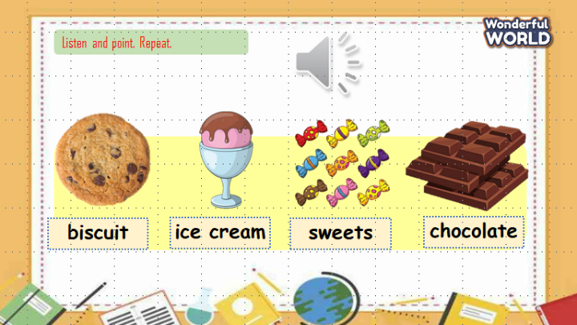  biscuit, sweets, ice cream, chocolate.  - Play the track 9.8 and ask sts to listen and point;  - Play again and ask students to listen and repeat in chorus, groups.  - Vocabulary checking: Get the goal game  There are 5 questions. Each question has 4 options (A, B, C, D). Students have to choose A, B, C, D to answer the questions to help the boy and the girl gets the goal.  Questions:  1. What’s this?  A. sweets B. ice cream C. chocolate D. ice  2. What’s this?  A. pizza B. chocolate C. ice cream D. biscuit  3. What’s this?  A. biscuit B. ice cream C. sweets D. chocolate  4. What’s this?  A. biscuit B. noodle C. ice cream D. sweets  5. Whatn are they?  A. bread B. chicken C. biscuits D. chocolates | - Learn new words through flashcards.  - Listen  - Repeat the words  - Repeat then point.  - Listen, answer the questions.
Activity 3: Practice (12 minutes)
Teacher’s activities | Student’s activities
Task 2: Listen and tick (Track 9.9)  Lead-in: Introduce the listening task  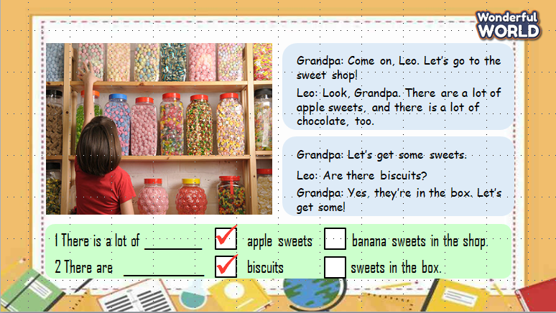  - Show the picture in task 2  - Ask students to look at the picture and answer:  Where is she?  What can you see in the shop?  - Ask students to read 2 sentences and guess the answer before listening:  1 There are a lot of apple sweets/ banana sweets in the shop.  2 There are biscuits/ sweets in the box.  - Play track 9.9 twice for students listen and tick.  - Play the audio again and ask students to do cross-check  - Show the bubbles and have sts look at the dialogue  - Ask students to listen and repeat  - Role play with sts’groups!  - Have sts practice the dialogues in groups, pairs.  Task 3: Look and say  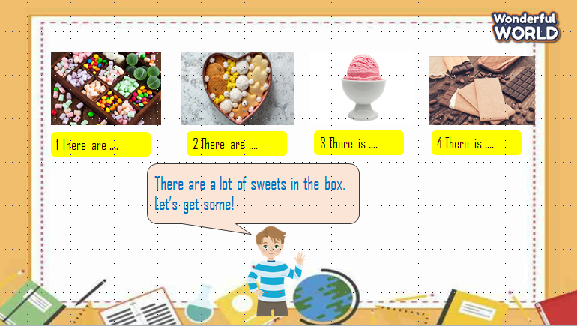  - Ask Ss to look at 4 pictures and identify their names.  - Introduce the structures “ There is/ there are...” again. Then ask Ss to look at the example and say.  - Work in pairs and talk about 4 pictures.  - Call some pairs to present in front of the class.  - Give them feedback.  Answers suggested:  1 There are a lot of sweets in the box. Let’s get some!  2 There are a lot of biscuits in the box. Let’s get some!  3 There is a cup of ice cream. Let’s get some!  4 There is a lot of chocolate. Let’s get some! | - Listen to the listening instruction carefully  - Look at the picture  - Look and give answers:  In the sweets shop  A lot of sweets  - Read and guess  - Listen and tick the answer  - Do cross-check  - Look at the dialogue  - Listen and repeat  - Role play  - Practice  - Answer T.  - Remember to use “ There is/ There are ...”  - Work in pairs.  - Say the sentences.  - Listen to T.
Activity 4: Production (7 minutes)
Teacher’s activities | Student’s activities
Game: What is it?  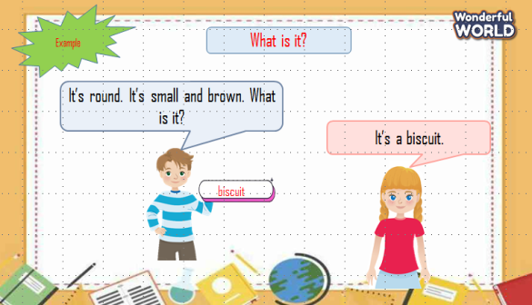  (Teacher calls pairs of SS from the different groups. One of them chooses a piece of paper and describes the word. The other has to guess the word in 20 seconds.)  - Introduce and set game rules  - Do a demo  - Play several rounds.  Words suggested:  Sweets: It’s small and colorfull. It’s yummy but not good for teeth.  Biscuit: It’s round. It’s small and brown.  Chocolate: It’s square and brown.  Ice cream: It’s cold.  Banana: It’s a fruit. It’s long and yellow  Apple: It’s a fruit. It’s round. It’s red or green.  Cheese: It’s yellow. Mice like it. | - Listen carefully  - Look  - Play game
Activity 5: Assessment (3 minutes)
Teacher’s activities | Student’s activities
- Ask students to do the assessment.  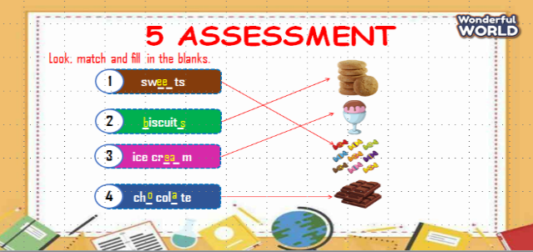  - Check in pair then whole class.  - Say goodbye | - Do the assessment.  - Check with friends and then with the teacher and the whole class.  - Say goodbye.
____________________________________
UNIT 9: MY FAVOURITE FOOD
Lesson 3 -Task 4,5,6
Period 108
I. OBJECTIVES:
1. Knowledge:
Students will learn the structure – How many ….are there? – Number (11 to 20) and revise the words related to the topic My favorite food.
2. Competences:
- English competences: Students will be able to ask and answer about quantity.
- Common competences: Students will have the opportunity to develop the solving problem in doing tasks and the creativeness in composing music.
3. Qualities:
- Students are given opportunities to think about their favorite food.
II. EQUIPMENT AND MATERIALS:
- Basic things: Student’s book, flashcards, crayons.
- Advanced things: PPT, projector/interactive whiteboard/laptop/TV.
III. LESSON PROCEDURE:
Activity 1: Warm-up (5 minutes)
Teacher’s activities | Student’s activities
- Greet students  Movement Game: Challenge: 2 at once  -Have the students do two things at once.  Examples: tap their heads and rub their stomachs, clap their hands and stand on one foot, snap their fingers and nod their heads, do jumping jacks, etc.  - Numbers song https://www.youtube.com/watch?v=0VLxWIHRD4E  - Introduce the song  - Ask students to copy some actions from the dance: jump, spin around, slap the knee  - Play the video  - Students listen, do action along | - Greet teacher
Activity 2: Presentation (8 minutes)
Teacher’s activities | Student’s activities
Lead-in: Use the song to lead in the new lesson.  Task 4: Listen and repeat. (Track 6.10)  - Use the flashcards or ppt to introduce the vocabulary: eleven, twelve, thirteen, fourteen, fifteen, sixteen, seventeen, eighteen, nineteen, and twenty.  - Play the track 9.10 and have sts listen and repeat in chorus, groups then repeat in different speeds.  - Vocabulary checking  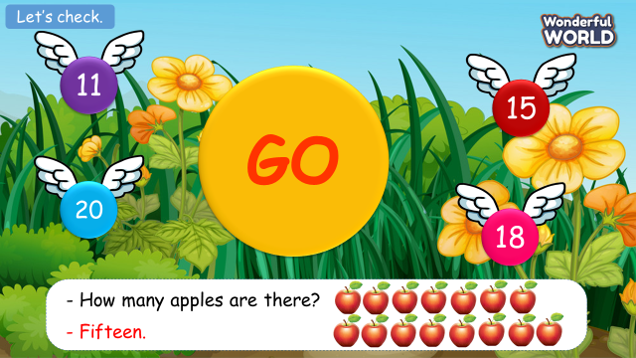  (Show the number of apples and question: How many apples are there?. Ask students to choose the correct number.)  + Divide the class into 4 groups  + Set the game rules  + Play as a model  + Have students play in turns.  + Award the best groups  - Point to the pictures and ask students to read again. | - Learn the new words  - Listen  - Listen and repeat  - Point and repeat  - Join the activity
Activity 3: Practice (12 minutes)
Teacher’s activities | Student’s activities
Task 5: Look and say.  - Show the pictures in task 5 one by one  - Ask students to say the name of foods in each picture.  - Show the word of foods and the number and ask students to read.  - Show the phrases one by one:  1.sweets/15  2. bananas/16  3. biscuits/14  4. tomatoes/13  5. sweets/12  6. pears/11  - Students look at the words and the number on each picture  - Ask students to practice in pairs. (one ask and one answer )  Suggested answers:  1. How many sweets are there? – fifteen  2. How many bananas are there? – sixteen  3. How many biscuits are there? – fourteen  4. How many tomatoes are there? – thirteen  5. How many sweets are there? – twelve  6. How many pears are there? - eleven | - Look  - Say the name of the foods  - Read  - Look and say in pairs
Activity 4: Production (7 minutes)
Teacher’s activities | Student’s activities
Task 6: Listen and chant ( Track 9.11)  - Show the picture in task 6 and ask students to talk about the people and food in the picture.  - Play the audio once for students to check the melody  - Show the lyrics one by one  - Ask students to listen and repeat  - Play the audio again for students to chant along  - Have a chanting contest  Chant composer  - Have students look at the lyric again  - Ask students to form groups  - Make a new version as a model.  - Ask groups to create new versions of the chant (replacing the quantity and the food only)  - Let students perform their chants  - Vote for the best Chant composer | - Talk about the picture in task 6  - Listen  - Look  - Listen and repeat  - Chant along  - Perform the chant  - Look at the lyric  - Make groups  - Listen carefully  - Create a new version of the chant  - Perform the new chant
Activity 5: Assessment (3 minutes)
Teacher’s activities | Student’s activities
- Ask students to do the assessment.  Look and circle the correct answer  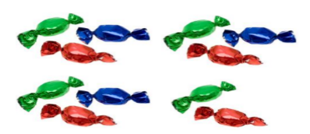  1. How many sweets are there?  A. eleven B. twelve  2. How many biscuits are there?  A. thirteen B. fourteen  3. How many tomatoes are there?  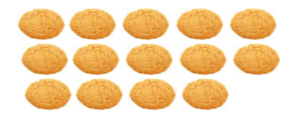  A. fifteen B. seventeen  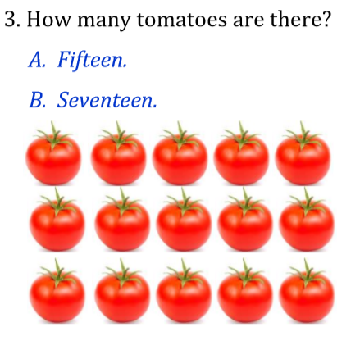  4. How many pears are there?  A. sixteen B. eighteen  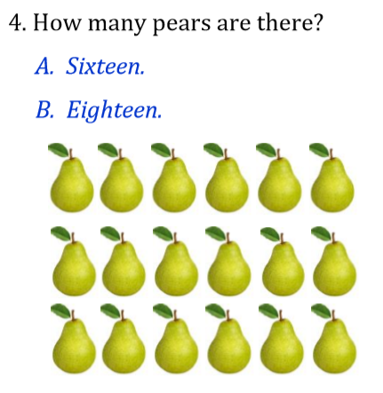  5. How many bananas are there?  A. nineteen B. twenty  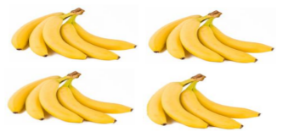  - Check-in pair then whole class.  - Say goodbye. | - Do the assessment.  1. B, 2. B, 3. A, 4. B, 5. A  - Check with friends and then with the teacher and the whole class.  - Say goodbye.

GRADE 5
Week 27 ( From 24/3 to 28/3)
UNIT 10: PERFORMING ARTS
Lesson 2 - Part 4,5,6
Period 105

I. OBJECTIVES:
1. Knowledge:
- Students get to know:
+ Review words: action, animated, award, cartoon, character, company.
+ Ss can use (Wh-questions +answers + time expressions).
2. Competences:
- English competencies: Ss can practice listening and reading skills through the text.
- Common competencies:
+ Understand how to use Wh-questions.
+ Work in pairs or groups to talk about Walt Disney.
3. Qualities:
- Students will have a sense of love towards Performing arts.
II. EQUIPMENT AND MATERIALS:
- Basic things: Student’s book, flashcards, photos.
- Advanced things: PPT, laptop, TV.
III. LESSON PROCEDURE:
Activity 1: Warm-up (5 minutes)
Let’s play a game: “Spin the wheel”
Teacher’s Activities | Students’ Activities
Aim: Welcome Ss. Warm the class up with a "spin the wheel" game using words: action, animated, award, cartoon, character, and company.
1. Greet Ss. Chatting ... Do you like playing a game?  2. Introduce the game:  - Ask Ss to play the "Spin the Wheel" game to revise the vocabulary.  - "Spin a wheel" to obtain random star numbers when Ss ask to stop it.  - Ask Ss to look at the picture and answer what it is. | - Greet T.  - Answer: "Yes"  - Join an activity.
Activity 2: Presentation (14 minutes)
Teacher’s Activities | Students’ Activities
Aims: Practice reading and listening to the text.
Task 4: Read and complete the text about Charlie Chaplin with the given words. Then listen and check.  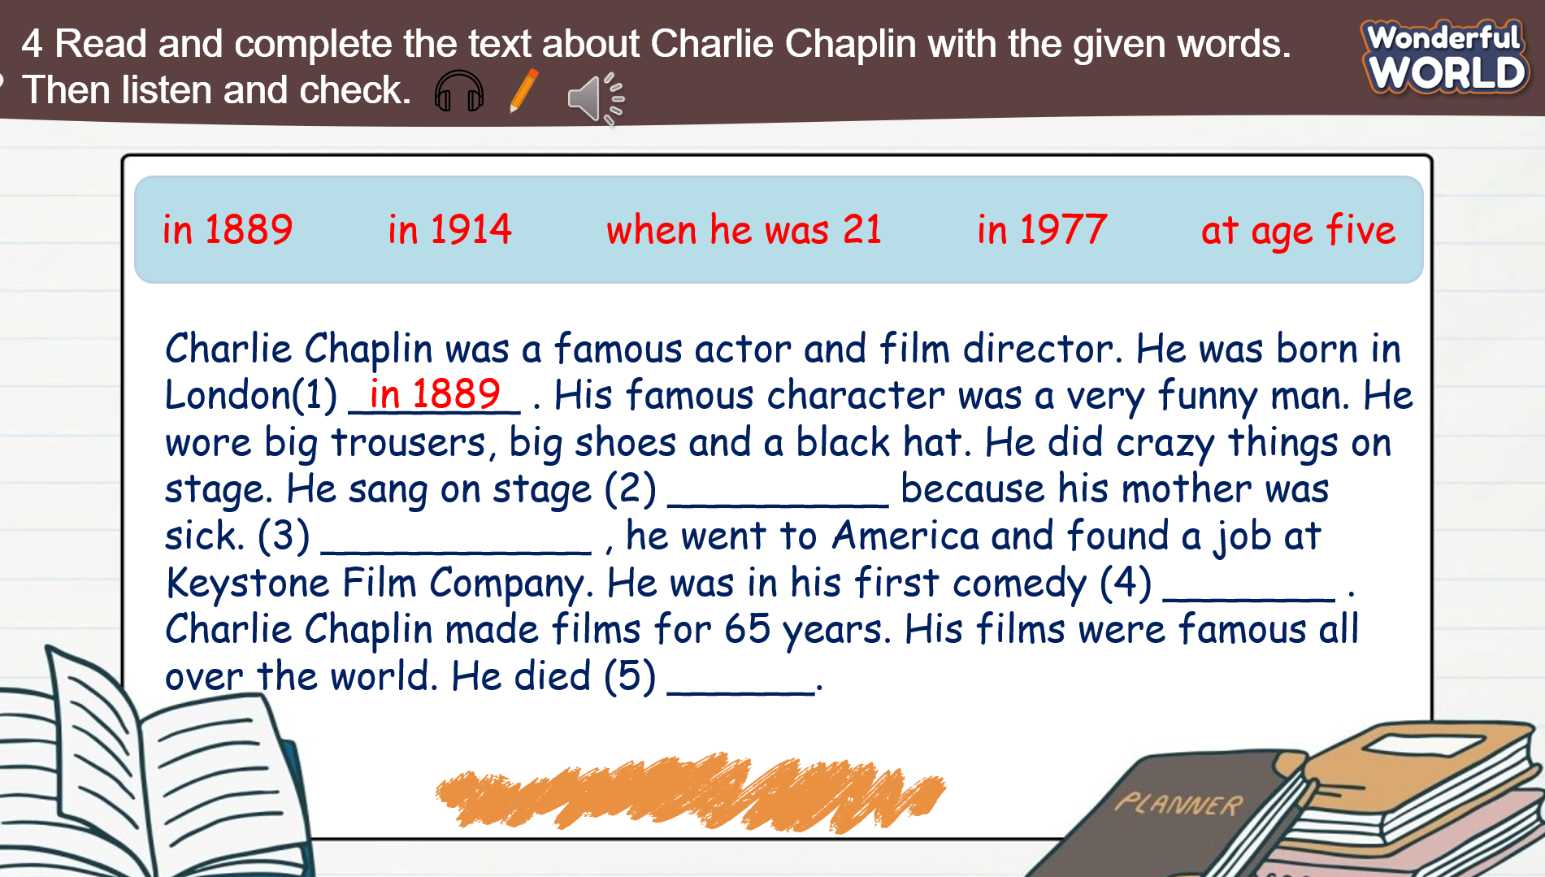  - Ask Ss to look at the text and tell Ss that they are going to fill in the blanks with the given words to complete each sentence.  - Explain the meanings of these phrases if Ss do not know.  - Ask Ss to do the task in pairs.  - Ask Ss to exchange their textbooks and give feedback to each other.  - Play track 10.6 for Ss to listen to.  - Show the text, and play the audio again.  - Ask Ss to check the answers.  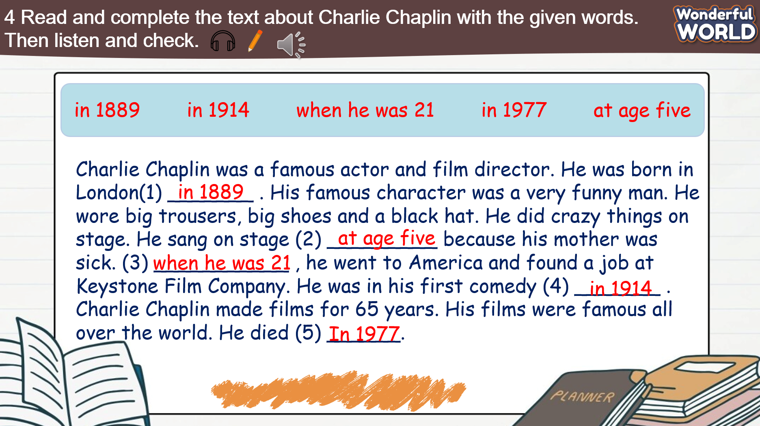  - Ask Ss to listen and read the text individually and as a group.  - Ask some volunteers to read it out in front of the whole class.  Grammar: Wh- questions: what/ who/ where/ why  - Ask Ss to remind them what, who and why are question words.  + What asks about things  + Who asks about a person  + Where asks about the places  + Why asks about the reason 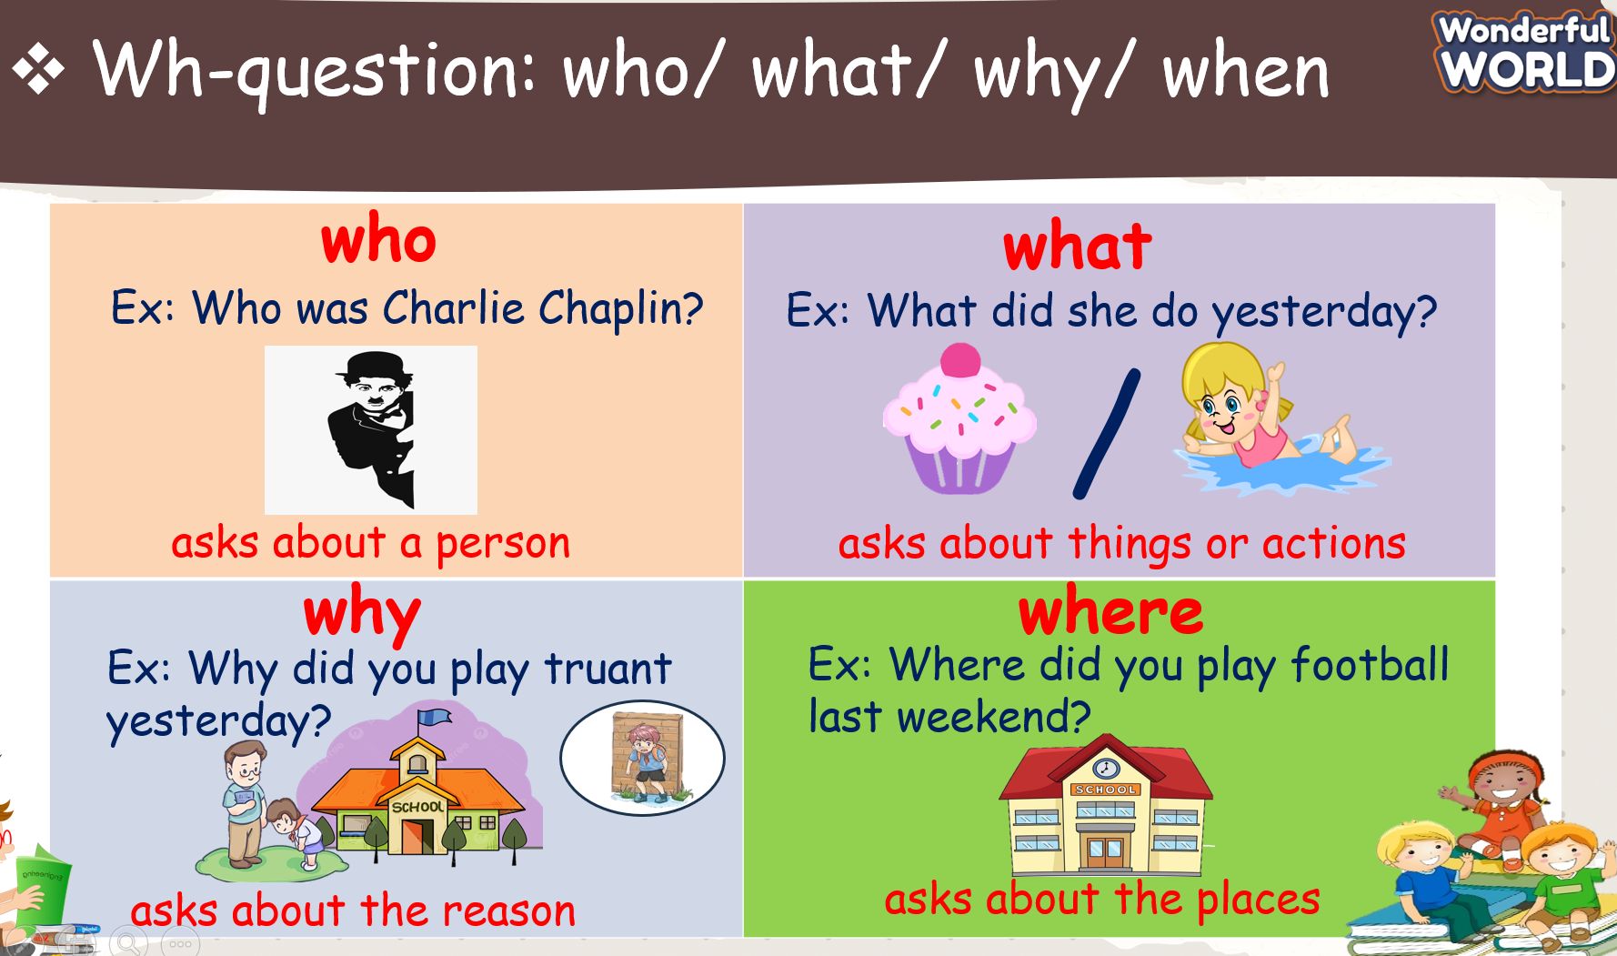  Mini-game: "Lucky Star"  - Explain the rules of the game.  - Ask Ss to choose a star, then fill in the blank.  - Check answers as a class and open the gift box to get stars for their team. | - Look at the text 4 and complete each sentence.  - Listen to the T explain the meanings of these phrases.  - Exchange textbooks with the partner.  - Listen to track 10.6 twice.  - Listen and check answers again.  - Read in front of the class  - Listen to the T.  - Join an activity.
Activity 3: Practice (5 minutes)
Teacher’s Activities | Students’ Activities
Aims: - Controlled practice:
+ Develop answer the questions skills, and observation skills.
+ Get familiar with Wh-questions.
Task 5: Read the text in Activity 4 again. Answer the questions below.  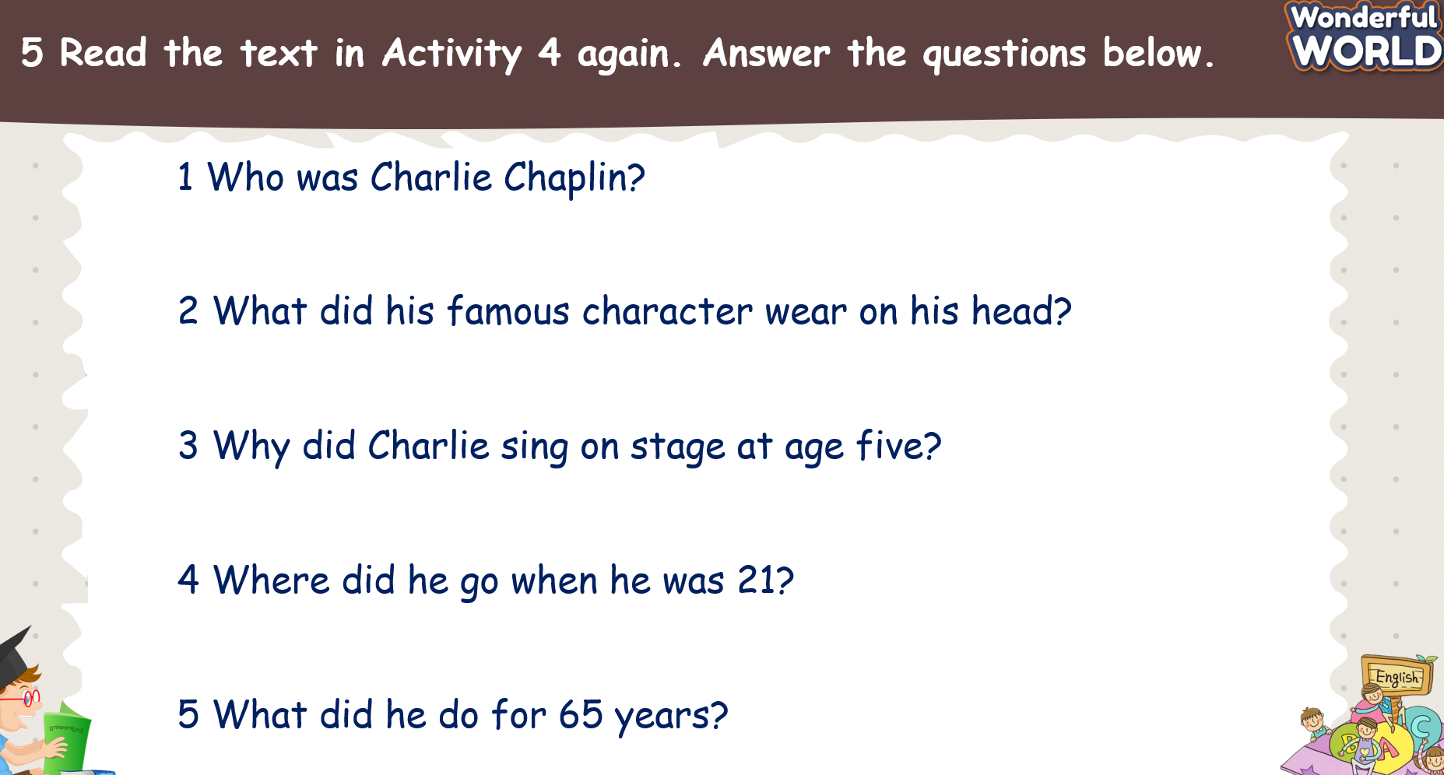  - Ask Ss to read the text in Activity 4 again and answer the questions.  - Read the questions to the class. Ss’ attention to the question form and the use of did as an auxiliary verb in past simple  questions.  - Give Ss five minutes to work in pairs.  - Call on some Ss to go to the board and write the answers.  - Check answers as a whole class.  - Keys:  1 He was a famous actor and film director.  2 He wore a black hat.  3 Because his mother was sick.  4 He went to America.  5 He made films for 65 years. | - Read the passage again and answer the questions.  - Work in pairs to share the answers.  - Write the answers on the board.  -Listen to the T and check them.
Activity 4: Production (6 minutes)
Teacher’s Activities | Students’ Activities
Aims:
+ Complete task 6.
+ Work in pairs and talk about Walt Disney
Task 6: Let’s talk about Walt Disney. Use the prompts and your ideas.  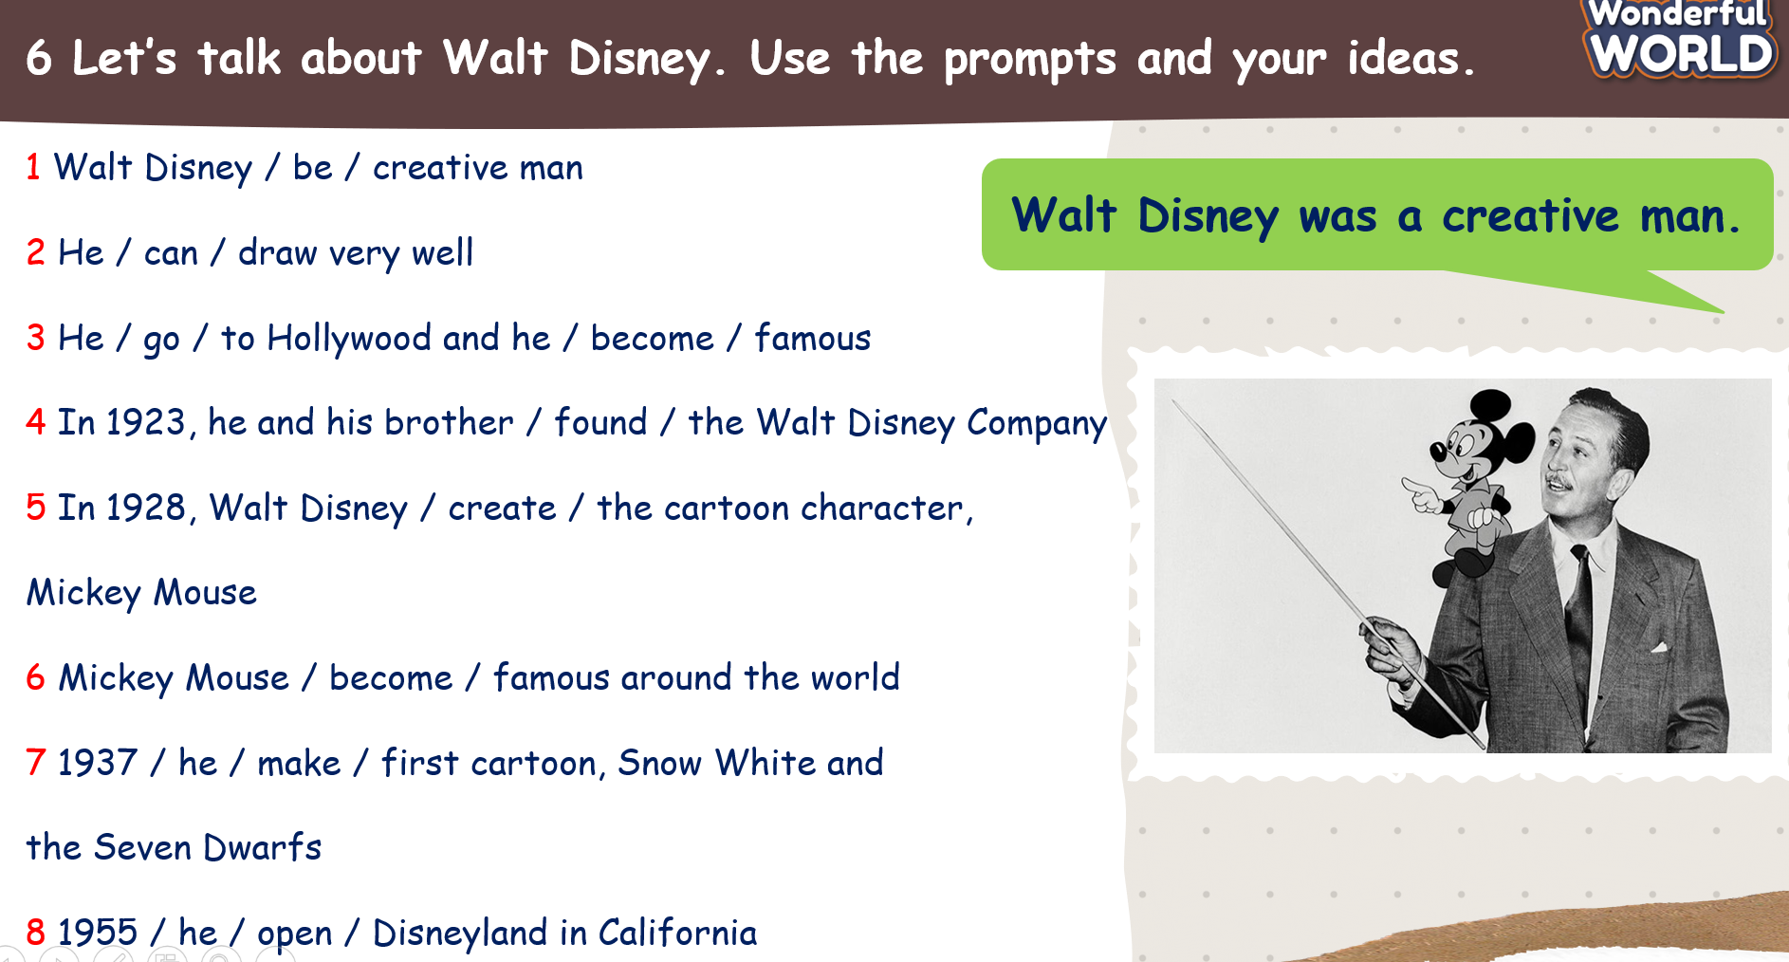  - Tell Ss they are going to talk about Walt Disney.  - Ask Ss if they know anything about him. Elicit the answers.  - Ask Ss to read the prompts.  - Ask Ss to read out the example. Read it out again and ask Ss to repeat.  - Ask Ss to work in pairs. Take turns to talk about him.  - Ask some volunteers to speak in front of the class.  - Check the answers as a whole class.  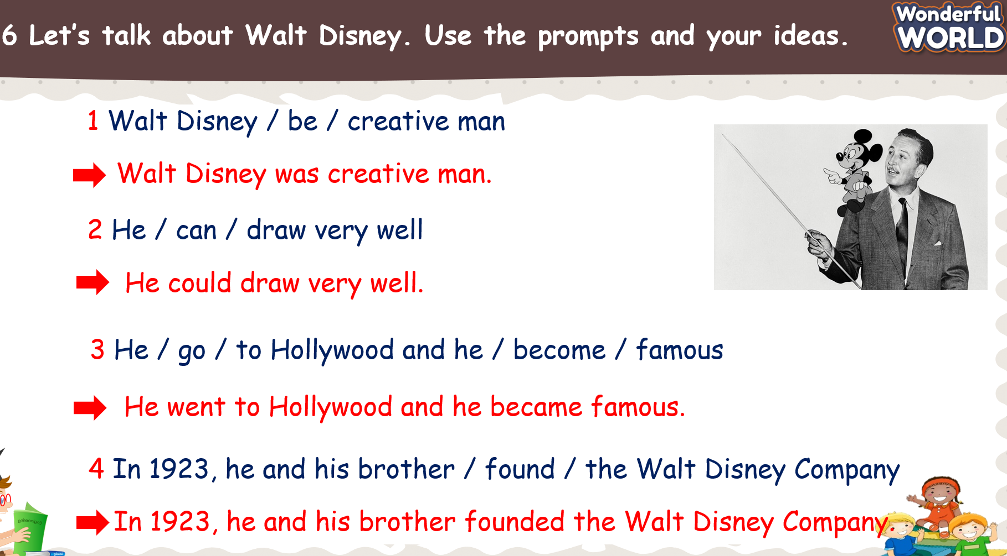  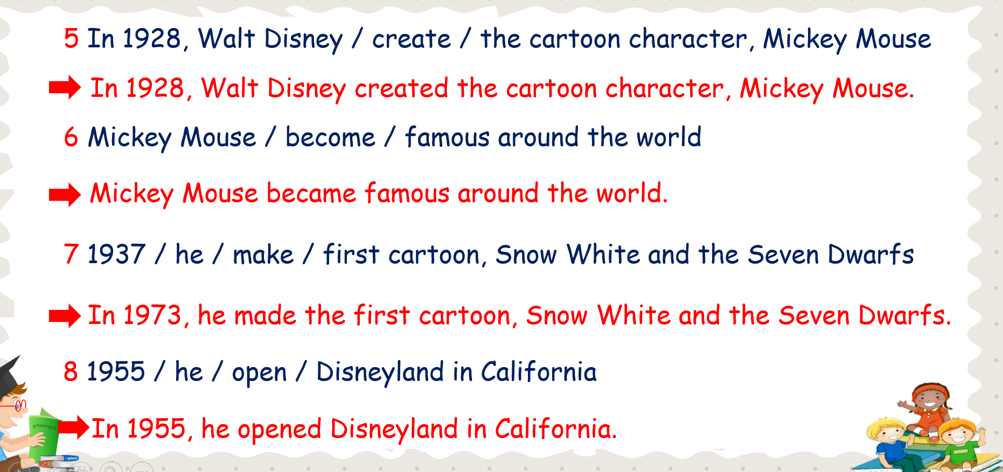 | - Read the prompts and read out the example.  - Work in pairs to complete task 6.  - Some Ss to speak in front of the class.  - Listen to the T and check the answers.
Activity 5: Wrap up & Assessment (5 minutes)
Teacher’s Activities | Students’ Activities
Aims:
- Check Ss’ understanding of what they have learned.
- Ss rehearse what they have learned in the lesson.
- Assessment: Look and complete.  - Ask Ss to look at the screen and fill in the blank using Wh- questions.  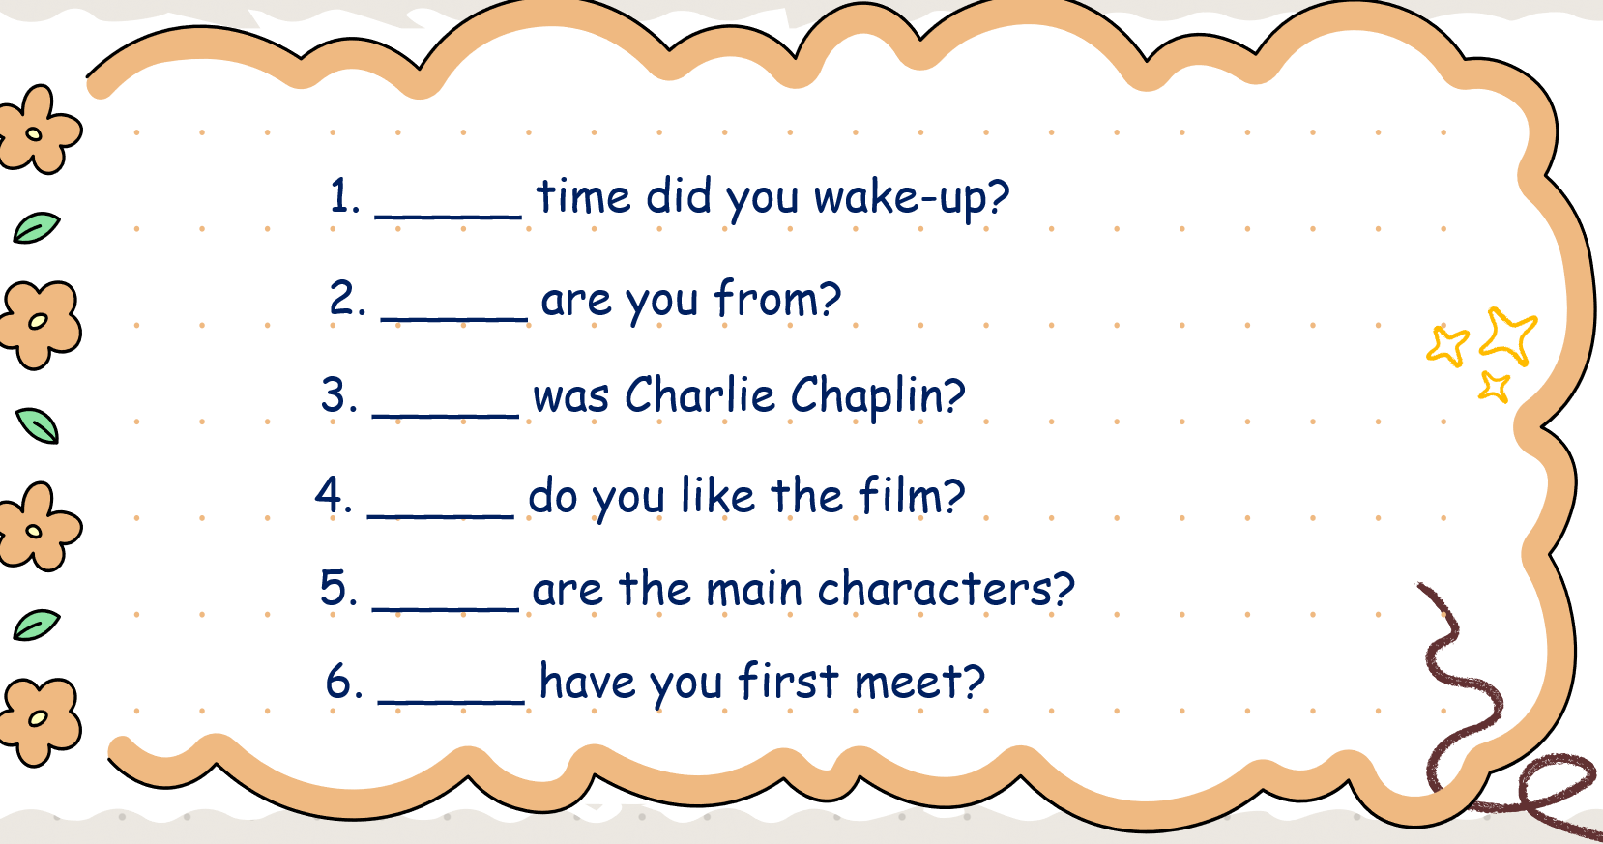  - Check with the class.  - Wrap-up  * Remember  Wh-question:  what/ who/ why/ where  - What asks about things  - Who asks about a person  - Why asks about the reason  - Where asks about the places | - Look at the screen carefully.  - Fill in the blank.  - Check with the teacher.  - Ss read the wrap-up.  - Stand up and say goodbye to the teacher.

Unit 10: Performing Arts
Lesson 3 - Parts 1,2,3
Period 106
I. OBJECTIVES:
1. Knowledge:
- Students will be able to:
+ Review some words related to entertainment
+ Use the words related to entertainment and the past simple tense to talk about favorite films.
2. Competences:
- English competencies: Students can talk about the topic of Performing Arts fluently and coherently
- Common competencies: Students can develop logical thinking and communication among friends.
3. Qualities:
- Students show their love and passion for language.
- Be confident and active in communication with friends and teachers.
II. EQUIPMENT AND MATERIALS:
- For Teacher: PPT, flashcards, printed papers, crayons.
- For students: textbook
III. LESSON PROCEDURE:
Activity 1: Warm-up (5 minutes)
Aims: warm-up activity to greed the class, create an exciting environment, and introduce the new lesson
Teacher’s Activities | Students’ Activities
Greet the Ss  Ask the Ss to read the question aloud:  + How are you?  + What’s the weather like today?  Ask them to watch the video and dance along.  Listen to the song “ Ready Set Dance 2”    After warming up, let students play a mini-game to review vocabulary:  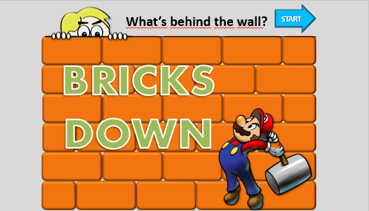  How to play:  - Divide the class into different groups.  - Groups take turns to break down a wall (brick by brick) to reveal the picture.  - When enough bricks are removed, groups can try to guess the action.  - To check students' answers, click the check button, and the whole picture is revealed (the wall simply crumbles). Assign points to groups for any correct answer. | - Greet the T  - Answer the questions aloud  - Watch the video and dance along  - Students can warm up and move their bodies to start the lesson.  - Listen to the game rules carefully  - Play the game in groups
Activity 2: Presentation (7 minutes)
Aim: - Present the words about entertainment and types of films.
Teacher’s Activities | Students’ Activities
- Ask students to look at five pictures and say the words themselves.  - Ask students to read aloud chorally. | - Students read aloud chorally
Activity 3: Practice – Controlled practice (10 minutes)
Teacher’s Activities | Students’ Activities
Aims:
Ss will be able to:
- Practice saying the words in task 1.
- Practice listening to films in the audio of task 2.
Teacher’s Activities | Students’ Activities
1. Look and say. Which type of film is your favorite? Why?  - Ask students to look at five pictures and say the words by themselves.  - Ask students to read aloud chorally.  - Ask students to look at the pictures and answer the question: “Which type of film is your favourite? Why?”  2. Listen to two friends talking about films. Tick the types of films they discuss. Then circle two types of films they choose. TR: 10.7  - Tell students that they are going to listen to two friends talking about films, tick the types of films they discuss, and circle two types of films they choose.  - Explain the meaning of each word if necessary.  - Play the recording twice.  - Check answers as a whole class. | - Students read aloud chorally  - Students look at the pictures and answer the question: “Which type of film is your favourite? Why?”  - Students listen carefully and tick, then circle.  - Check the results
Activity 4: Production (8 minutes)
Teacher’s Activities | Students’ Activities
Aims:
- Ss will be able to talk about their favourite films.
- Use the new words in task 1
- Let students watch a short video  - Discuss with a partner  - Answer questions about the video.  Key:  1. Do you know the film? ( students' answers)  If yes. It is a Harry Potter film.  2. How many characters are there in the video?  3 characters.  Who are they?  Harry Potter, Hermione Granger, and Ron Weasley.  3. Is it an adventure film?  Yes, it is.  4. Did you watch the film? ( students' answers)  5. If yes, when did you watch the film? ( students' answers)  3 Ask and answer about your favourite film.  - Tell students that they are going to ask and answer about  their favourite film.  - Give students two minutes to read the questions in silence  and check their understanding.  - Give students 10 minutes to ask and answer in pairs. | - Students watch a short video  - Discuss with a partner  - Answer questions about the video.  - Answer the questions.
Activity 5: Wrap up & Assessment (5 minutes)
Teacher’s Activities | Students’ Activities
Aims:
- Assess individuals or groups who have done the best in the lesson.
- Wrap up the activities Ss have done during the lesson.
- Asks Ss about the words they have learned in the lesson without looking at the book.  - Asks sts to do the quick assessment.  - Checks with the class. | - Ss answer.  - Stand up and say goodbye to the teacher.

Unit 10: Performing Arts
Lesson 3 - Part 4,5,6
Period 107
I. OBJECTIVES:
1. Knowledge:
- Students will be able to:
+ Review some words related to entertainment
+ Use the words related to entertainment and adjectives (word order) to talk about favourite films.
2. Competences:
- English competencies: Students can talk about the topic of Performing Arts fluently and coherently
- Common competencies: Students can develop logical thinking and communication among friends.
3. Qualities:
- Students show their love and passion for language.
- Be confident and active in communication with friends and teachers.
II. EQUIPMENT AND MATERIALS:
- For Teacher: PPT, flashcards, printed papers, crayons.
- For students: textbook
III. LESSON PROCEDURE:
Activity 1: Warm-up (5 minutes)
Aims: warm-up activity to greed the class, create an exciting environment, and introduce the new lesson
Teacher’s Activities | Students’ Activities
Greet the Ss  Ask the Ss to read the question aloud:  + How are you?  + What’s the weather like today?  Ask them to watch the video and dance along.  Listen to the song “ Ready Set Dance 3”  After warming up, let students play a mini-game to review vocabulary:    How to play:  - Divide the class into different groups.  - The teacher clicks on the time for the students to remember the location of the pictures.  - After 10 seconds, the picture to be found will appear and the groups will take turns guessing.  - The team that guesses correctly will get a point. | - Greet the T  - Answer the questions aloud  - Watch the video and dance along  - Students can warm up and move their bodies to start the lesson.  - Listen to the game rules carefully  - Play the game in groups
Activity 2: Presentation (7 minutes)
Aim: - Use the words related to entertainment and adjectives (word order) to talk about favourite films.
Teacher’s Activities | Students’ Activities
4 Find and correct the mistakes in the following sentences.  - Tell students that they will read each sentence  carefully, and find and correct a mistake in each sentence.  - Give students five minutes to do this task.  Note:  - Adjective Before Noun  We often use more than one adjective before the noun:  - Adjective After Verb  An adjective can come after some verbs, such as: be, become, feel, look… | • Students do the task 1  Do extra exercise.
Activity 3: Practice – Controlled practice (10 minutes)
Teacher’s Activities | Students’ Activities
Aims:
Ss will be able to:
- Use adjective (word order) to complete task 5
Teacher’s Activities | Students’ Activities
5 Complete the film review with these adjectives  - Ask students to look at the passage and tell them that they are going to fill in the blanks with the given words in the box.  - Give students five to seven minutes to do the task in pairs. | - Students stand up and read each sentence
Activity 4: Production (8 minutes)
Teacher’s Activities | Students’ Activities
Aims:
- Use adjective (word order) to complete task 6
- Write about your favourite film
6. Write about your favourite film. Use the questions to  help you  Tell students that they are going to write about their favourite film.  - Tell students to look at the sample writing in Activity 5.  Read out loud the example and ask students to repeat | - Students pair up and share their paragraph and encourage partners to provide feedback to each other
Activity 5: Wrap up & Assessment (5 minutes)
Teacher’s Activities | Students’ Activities
Aims:
- Assess individuals or groups who have done the best in the lesson.
- Wrap up the activities Ss have done during the lesson.
- Asks Ss about the words they have learned in the lesson without looking at the book.  - Asks sts to do the quick assessment.  - Checks with the class. | - Ss answer.  - Stand up and say goodbye to the teacher.

Unit 10: Performing Arts
Lesson 3 - Part 7,8,9
Period 108
I. OBJECTIVES:
1. Knowledge:
- Pronunciation: sentence stress
- English competencies: -To recognize the stressed words in the sentences.
2. Competences:
- To practice pronouncing stressed words
- Common competencies: Students can develop logical thinking and communication among friends.
3. Qualities:
- Students will feel confident in their pronunciation when they speak in the crowd.
II. EQUIPMENT AND MATERIALS:
- For Teacher: PPT, flashcards, printed papers, crayons.
- For students: textbook
III. LESSON PROCEDURE:
Activity 1: Warm-up (5 minutes)
Aims: warm-up activity to greed the class, create an exciting environment, and introduce the new lesson
Teacher’s Activities | Students’ Activities
Greet the Ss  Ask the Ss to read the question aloud:  + How are you?  + What’s the weather like today?  Ask them to watch the video and dance along.  Listen to the song " Ready Set Dance 1" | - Greet the T  - Answer the questions aloud  - Watch the video and dance along  - Students can warm up and move their bodies to start the lesson.
Activity 2: Presentation (7 minutes)
Aim: Introduce the concept of sentence stress, explaining that it involves emphasizing certain words in sentences for clearer pronunciation
Teacher’s Activities | Students’ Activities
- Give examples for students to understand.  - Explain that usually, content words  such as main verbs, nouns, adjectives, adverbs,  and negative auxiliaries (don't, isn't..) are usually stressed.  - Structure words (i.e. words for correct grammar) such as pronouns, prepositions, articles (a, an, the) conjunctions  (and, but, because) or auxiliary verbs (do, have..) usually aren’t stressed.  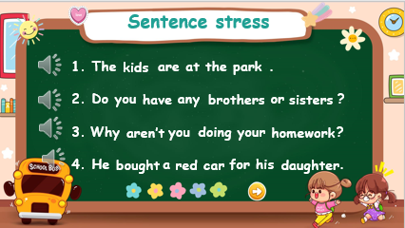 | - Listen and complete the examples.  - Pay attention to the teacher
Activity 3: Practice – Controlled practice (10 minutes)
Teacher’s Activities | Students’ Activities
Aims:
Complete task 7 and task 8
Practice listening and reading stressed sentences.
Teacher’s Activities | Students’ Activities
7 Listen and underline the stressed word. Then repeat.  TR: 10.8  - Play the recording twice.  - Have students do this task in pairs.  - Call on some students to share their answers and check.  - Have students read each sentence chorally and individually.  - Check pronunciation  8 Reorder the words to make a full sentence. Then read it  aloud.  - Tell students that they are going to put the words in the correct order.  - Give students five minutes to do the task individually.  - Call on three students to go to the board and write the answers.  - Check answers as a whole class | - Students do this task in pairs  - Listen and repeat each sentence after listening, -- Paying attention to the stressed words
Activity 4: Production (8 minutes)
Teacher’s Activities | Students’ Activities
Aims:
- Practice stress in sentences
- Complete task 9
9. Listen and chant. TR: 10.9  - Tell students they are going to learn a chant. Explain to students that the chant is about sentence stress.  - T plays the recording and tells students to listen and follow.  - T reads out the chant one line at a time and asks students to repeat after you.  - T plays the recording again. Encourage students to chant along.  - T asks students to practice the chant individually, and then in pairs or groups. For example, one group chants the first verse, and the other group chants the second verse. Ask some volunteers to chant (optional). | - Underline the stressed words in each sentence  - Practise the chant individually, and then in pairs or in groups
Activity 5: Wrap up & Assessment (5 minutes)
Teacher’s Activities | Students’ Activities
Aims:
- Check students’ understanding of what they have learned.
- Students rehearse what they have learned in the lesson.
T asks sts to assess the mini-game  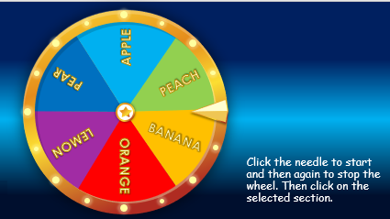  Click the needle to start and then again to stop the wheel. Then click on the selected section. | - Do the assessment.  - Check with the teacher  - Sts read the wrap-up  - Stand up and say goodbye to the teacher.

