TUẦN 28 Khối 3, 5 (Từ ngày 31/03/2025 đến ngày 04/04/2025)
THỨ | TIẾT | MÔN | TIẾT THỨ | NỘI DUNG BÀI DẠY |  | UDCNTT | ĐỒ DÙNG DẠY HỌC
Hai  31/03 | 1 | 5A | 109 | Unit 10. Performing art | Fun time and project (1, 2) | Wonderful world | Flashcards, TV, books
Hai  31/03 | 2
Hai  31/03 | 3 | 3A | 109 | Unit 9. My favourite food | Lesson 3 (7, 8, 9) | Wonderful world | Flashcards, TV, books
Hai  31/03 | 4 | 3A | 110 | Unit 9. My favourite food | Fun time and project (1, 2) | Wonderful world | Flashcards, TV, books
Hai  31/03 | 5 | 5D | 109 | Unit 10. Performing art | Fun time and project (1, 2) | Wonderful world | Flashcards, TV, books
Hai  31/03 | 6 | 3B | 109 | Unit 9. My favourite food | Lesson 3 (7, 8, 9) | Wonderful world | Flashcards, TV, books
Hai  31/03 | 7
Ba  01/04 | 1 | 5C | 109 | Unit 10. Performing art | Fun time and project (1, 2) | Wonderful world | Flashcards, TV, books
Ba  01/04 | 2 | 5B | 109 | Unit 10. Performing art | Fun time and project (1, 2) | Wonderful world | Flashcards, TV, books
Ba  01/04 | 3 | 5A | 110 | Unit 10. Performing art | Fun time and project (3, 4, 5) | Wonderful world | Flashcards, TV, books
Ba  01/04 | 4
Ba  01/04 | 5 | 3A | 111 | Review 5 | Part 1 - Task 1, 2, 3, 4 | Wonderful world | Flashcards, TV, books
Ba  01/04 | 6 | 5D | 110 | Unit 10. Performing art | Fun time and project (3, 4, 5) | Wonderful world | Flashcards, TV, books
Ba  01/04 | 7 | 3B | 110 | Unit 9. My favourite food | Fun time and project (1, 2) | Wonderful world | Flashcards, TV, books
Tư  02/04 | 1 | 5A | 111 | Review 5 | Part 1 - Task 1, 2, 3, 4 | Wonderful world | Flashcards, TV, books
Tư  02/04 | 2
Tư  02/04 | 3
Tư  02/04 | 4
Tư  02/04 | 5 | 5B | 110 | Unit 10. Performing art | Fun time and project (3, 4, 5) | Wonderful world | Flashcards, TV, books
Tư  02/04 | 6 | 5C | 110 | Unit 10. Performing art | Fun time and project (3, 4, 5) | Wonderful world | Flashcards, TV, books
Tư  02/04 | 7
Năm  03/04 | 1 | 5C | 111 | Review 5 | Part 1 - Task 1, 2, 3, 4 | Wonderful world | Flashcards, TV, books
Năm  03/04 | 2 | 5B | 111 | Review 5 | Part 1 - Task 1, 2, 3, 4 | Wonderful world | Flashcards, TV, books
Năm  03/04 | 3 | 5A | 112 | Review 5 | Part 2 - Task 1, 2, 3 | Wonderful world | Flashcards, TV, books
Năm  03/04 | 4
Năm  03/04 | 5 | 5D | 111 | Review 5 | Part 1 - Task 1, 2, 3, 4 | Wonderful world | Flashcards, TV, books
Năm  03/04 | 6 | 5C | 112 | Review 5 | Part 2 - Task 1, 2, 3 | Wonderful world | Flashcards, TV, books
Năm  03/04 | 7
Sáu  04/04 | 1 | 3B | 111 | Review 5 | Part 1 - Task 1, 2, 3, 4 | Wonderful world | Flashcards, TV, books
Sáu  04/04 | 2 | 5D | 112 | Review 5 | Part 2 - Task 1, 2, 3 | Wonderful world | Flashcards, TV, books
Sáu  04/04 | 3 | 5B | 112 | Review 5 | Part 2 - Task 1, 2, 3 | Wonderful world | Flashcards, TV, books
Sáu  04/04 | 4
Sáu  04/04 | 5
Sáu  04/04 | 6 | 3B | 112 | Review 5 | Part 2 - Task 1, 2, 3 | Wonderful world | Flashcards, TV, books
Sáu  04/04 | 7 | 3A | 112 | Review 5 | Part 2 - Task 1, 2, 3 | Wonderful world | Flashcards, TV, books

GRADE 3
WEEK 28 (From 31/3 to 4/4)
UNIT 9: MY FAVOURITE FOOD
Lesson 3 - Task 7,8,9
Period 109
I. OBJECTIVES:
1. Knowledge:
- Students will learn the phonic /dr/ and /br/ in the words and revise the words related to the topic Food.
2. Competences:
- English competences: Students will be able to listen and pronounce the sound separately and in words correctly
- Common competences: Students will have an opportunity to develop the solving problem skill in doing the tasks and the creativeness in chant.
3. Qualities:
- Students are given opportunities to think about good and favourite food
II. EQUIPMENT AND MATERIALS:
- Basic things: Student’s books, flashcards, crayons.
- Advanced things: PPT, projector/interactive whiteboard/laptop/TV.
III. LESSON PROCEDURE:
Activity 1: Warm-up (5 minutes)
Teacher’s activities | Student’s activities
- Greet students  Game: Finding the way home.  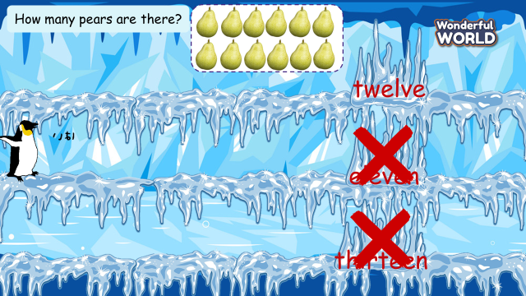  (Set the context: A penguin lost his way. There are 8 questions, each question has 3 answers  Students choose the correct answer to help the penguin find the right way home)  - Tell students how to play the game  - Do as a model  - Ask students to choose the missing letters.  1 How many pears are there?  A. twelve B. eleven C thirteen  2 What can you do?  A. cook B. swim C draw  3 How many tomatoes are there?  A. fifteen B. twenty C thirteen  4. Who’s this?  A. teacher B. brother C grandpa  5. What’s this?  A. dress B. shorts C t-shirt  6. What can you do?  A. dance B. eat C. drink  7. What’s this?  A. pizza B. bread C cheese | - Greet teacher  -Listen  -Look and play with the teacher  - Look and choose the missing letter  1. A. twelve  2. C. draw  3. B twenty  4.B. brother  5. A. dress  6. C. drink  7. B. bread
Activity 2: Presentation (8 minutes)
Teacher’s activities | Student’s activities
Lead-in: Use some words (brother, drink, dress, draw, bread..) in the previous game to lead in the sound /dr/, /br/  Task 7: Listen and repeat. (Track 9.12)  - Play the recording and tell students how to pronounce the sound /dr/, / br/, pronounce the sound /dr/ in the word drink, / br / in the word bread and in the sentence I’m drinking juice and eating bread.  - Play the recording again. Tell students to repeat the words and sounds (whole class, in groups and individually).  - Ask some volunteers to perform in front of the whole class.  - Checking: “Let’s dance” game  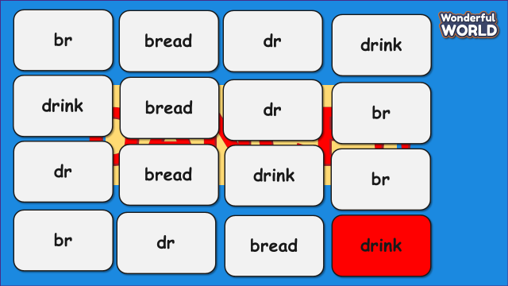  + Students must take turns reading the words (bread, drink) or sound /dr/ /br/ in order.  + Each time a student can choose to say in 1 square or 2 squares  + The student who says the last word must dance. | - Learn to pronounce the sound /dr/, /br /  - Listen and repeat  - Perform in front of the whole class.  - Join in the game
Activity 3: Practice (12 minutes)
Teacher’s activities | Student’s activities
Task 8: Listen and chant. (Track 9.13)    - Play the recording and tell students to listen and follow the words with their fingers.  - Read out the chant one line at a time and ask students to repeat it after the teacher.  - Play the recording again. Encourage students to chant along. Practice several times until students are familiar with the words and sounds.  - Ask one team to make the beat by clapping hands, the team has to follow the beat to chant.  - Ask some volunteers to chant in front of the class.  Task 9: Say it!  - Show three pictures and ask some questions:  1 What is she doing?  2 What can he do?  3 What is he doing?  - Ask students to look at the sentences. Tell them to pay attention to the sounds /dr/ and /br/ in each word.  - Read out the words with /dr/ and /br/ and ask students to repeat them.  - Ask students to work in pairs and say the sentences, paying attention to the correct pronunciation of /dr/ and /br/  - Ask volunteers to say the sentences in front of the class. | - Listen and follow the words with their fingers.  - Listen and repeat after the teacher  - Listen and practice the chants  - One team makes the beat by clap hands and another team have to follow the beat to chant.  - Look and answer:  1 She is drawing a picture  2 He can play the drums  3 He is drinking juice  - Look  - Listen and repeat  - Say the sentences in pairs  - Perform in front of the class.
Activity 4: Production (7 minutes)
Teacher’s activities | Student’s activities
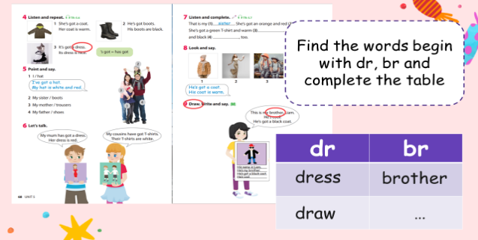  - Divide the class into 8 groups.  - Ask students to open the book and find all the words that begin with the sound /dr/, /br/ in the book.  - Ask students to complete the table and show their work in front of the class. | - Sit in 8 groups.  - Make a survey.  - Perform in front of the class.
  dr | br
Activity 5: Assessment (3 minutes)
Teacher’s activities | Student’s activities
- Ask students to do the assessment.  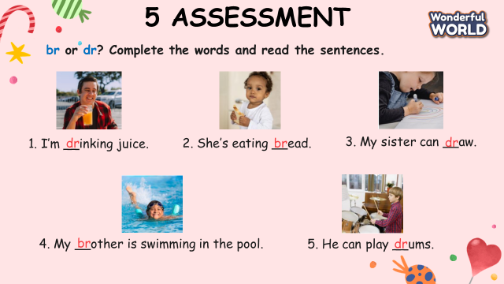  - Check in pair then whole class.  - Say goodbye. | - Do the assessment.  - Check with friends and then with the teacher and the whole class.  - Say goodbye.
____________________________________

UNIT 9. MY FAVOURITE FOOD
Fun time and project -Task 1,2
Period 110
I. OBJECTIVES:
1. Knowledge:
- Students will review words related to the topic My favourite food and the unit grammar.
2. Competences:
- English competences: Students will be able to describe the food and talk about their favourite foods
- Common competences: Students will develop creativeness skills in drawing pictures of food
3. Qualities:
- Students are given opportunities to think about good foods
II. EQUIPMENT AND MATERIALS:
- Basic things: Student’s book, flashcards, crayons, green and red papers.
- Advanced things: PPT, projector/interactive whiteboard/laptop/TV.
III. LESSON PROCEDURE:
Activity 1: Warm-up (5 minutes)
Teacher’s activities | Student’s activities
- Greet students  Game: Climbing tree.  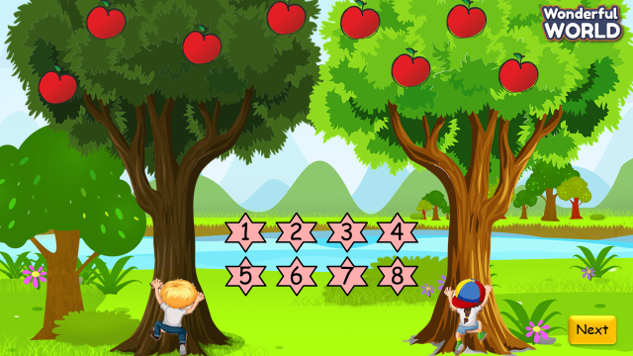  (Divide the class into 2 groups. Set the context: Two teams participate in a tree competition. There are 8 questions. Students answer the questions. For each correct answer, the student climbs up 1 step. The student who can pick the fruit on the tree first will be the winner. )  - Tell students how to play the game  - Do as a model  - Ask students to choose the questions and answer them.  1. How many pears are there?  2. How many tomatoes are there?  3. Where is the chicken?  4. Fill the blank: There __ a lot of chocolate.  There __ some apples  5. Look and choose: There are a lot of/many/ some loaves of bread.  6. What is it? (picture of juice)  7. What is it? (picture of cheese)  8. What is it? (picture of rice)  PP k thấy trèo cây sau mỗi lần trả lời đúng? | - Greet teacher  - Listen  - Look and play with the teacher  - Choose the questions and answer  - Twelve  - Fifteen  - It’s on the table.  - There is a lot of chocolate.  There are some apples  - a lot of  - It’s juice  - It’s cheese  - It’s rice
Activity 2: Review (10 minutes)
Teacher’s activities | Student’s activities
Task 1: Read and match  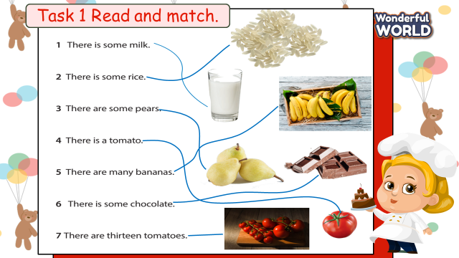  - Show the platform of the task  - Set the context: The chef has to create a list of food in her kitchen but unfortunately the pictures of food are messed up. Help the chef match the names of the foods with the correct picture.  - Ask students to work in groups  - Give game instruction: read and match the sentences with the correct pictures.  - Give students time to play the game  - Have students do cross-check  - Check with the whole class by saying words aloud  - Award the fastest team with the most correct answer | - Look at the platform of the task  - Listen to the context  - Work in groups  - Read and match  - Do cross-check  - Say words aloud
Activity 3: Project (15 minutes)
Teacher’s activities | Student’s activities
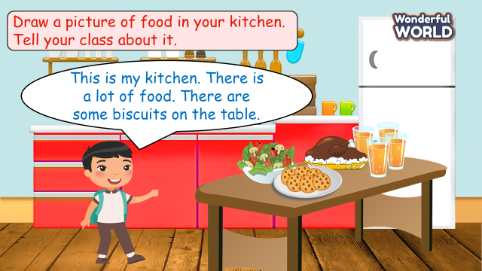  Planning stage  - Show a picture of the kitchen and ask students to guess where this is.  - Ask students to draw their kitchen and their favorite foods in the kitchen.  Implementing stage  - Ask students to share some ideas with friends next to them, using: There is/ are.. a lot of/ many/ some…in/on/ under….  Displaying and Reflecting stage  - Ask students to display their works in front of the class  - Ask others to give feedback  - Give feedback at the end | - Look and guess: Kitchen  - Draw their kitchen and their favorite foods in the kitchen  - Talk with friends next to them  This is my kitchen. There is a lot of food. There are some biscuits on the table….  - Display their works in front of the class
Activity 4: Assessment (5 minutes)
Teacher’s activities | Student’s activities
- Ask students to do the assessment.  Look and circle  1. How many bananas are there?    A. Nineteen  B. Sixteen  C. Twenty    2. Where’s the pear?  A. It’s on the table.  B. It’s under the table.  C. It’s in the table.  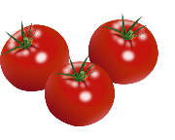  3. There are __ tomatoes.  A. many  B. some    C. a lot of  4. There is some ___.  A. milk  B. chocolate    C. rice  5. There are ___sweets.  A. sixteen  B. some  C. a lot of  - Check in pair then whole class.  - Say goodbye. | - Do the assessment.  1 C twenty  2 A It’s on the table  3 B some  4 B chocolate  5 C a lot of  - Check with friends and then with the teacher and the whole class.  - Say goodbye.

REVIEW 5
Part 1 - Task 1,2,3
Period 111
I. OBJECTIVES:
1. Knowledge:
By the end of the lesson, students will be able to:
- Review vocabulary about places in town: in the library, in the museum, at the theatre, at the zoo, at the market, in the park, at the playground, in the pool, at the toy shop
- Review vocabulary about activities people do when visiting a town/city: drink, eat, have fun, look at, see, take photos
- Review vocabulary about foods: apple, banana, pear, tomato, bread, cheese,
chicken, juice, milk, rice, biscuit, chocolate, ice cream, sweets
- Review grammar: There are some/a lot of/many…
- Review grammar: (May) Imperative
+ May I sit down? Yes, you can.
+ May I talk? No, you can't. Listen, please.
2. Competences:
English competence
- Using vocabularies and structure of Unit 8 and Unit 9 confidently.
General competence
- Raise motivation and interests in reviewing vocabulary
- Build up self-learning skill through learning activities.
3. Qualities:
+ Build up pride about town.
+ Don’t waste food.
II. EQUIPMENT AND MATERIALS:
- For teacher:
+ Basic things: Student’s book , teacher’s book, flashcards.
+ Advanced things: PPT, projector/interactive whiteboard/laptop/TV
- For students: student’s book, work book.
III. LESSON PROCEDURE:
Warm up (10 minutes)
Teacher’s activities | Student’s activities
- Greeting  - “Air racing ” Game:  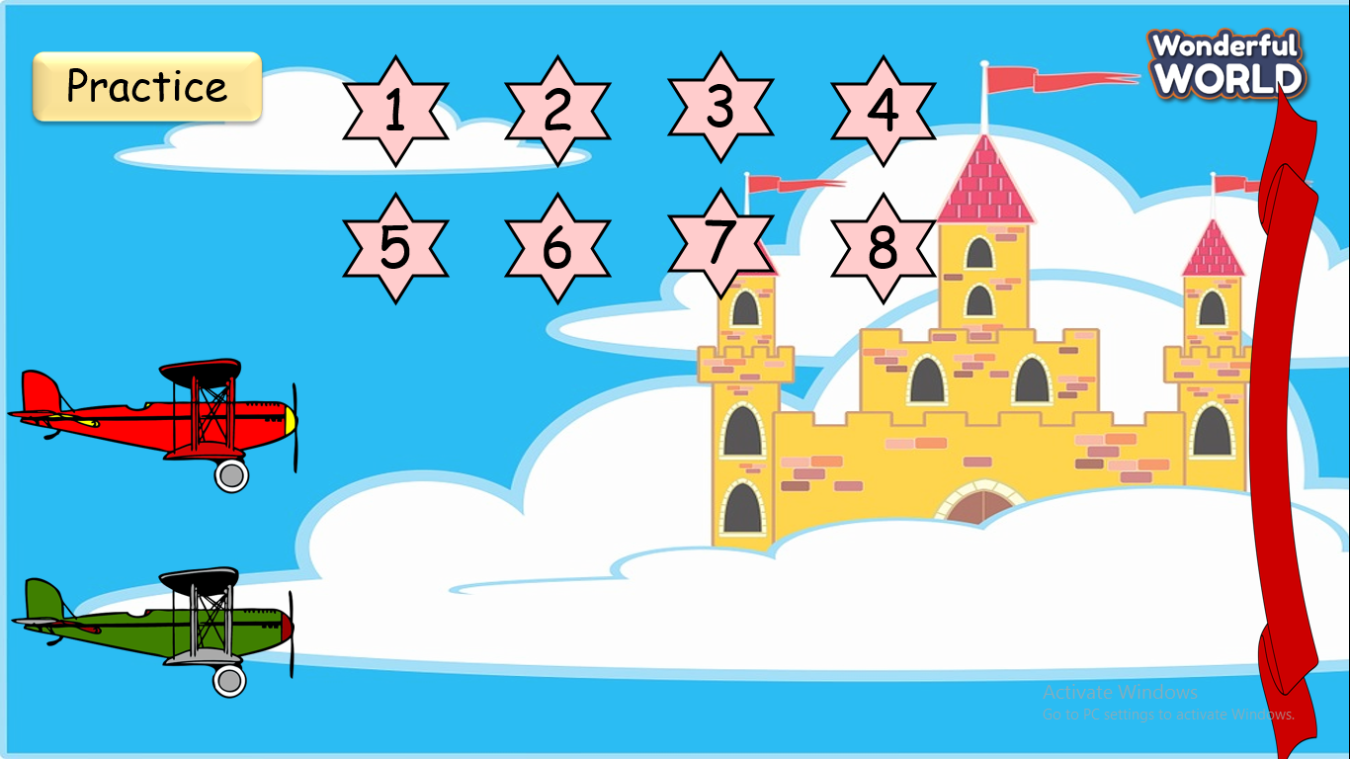  - Two teams will be 4 questions :  Which team answers correctly and quickly will be the winner. | - Pass the ball and answer questions  - Enjoy the game.
Review (15 minutes)
Teacher’s activities | Student’s activities
Task1  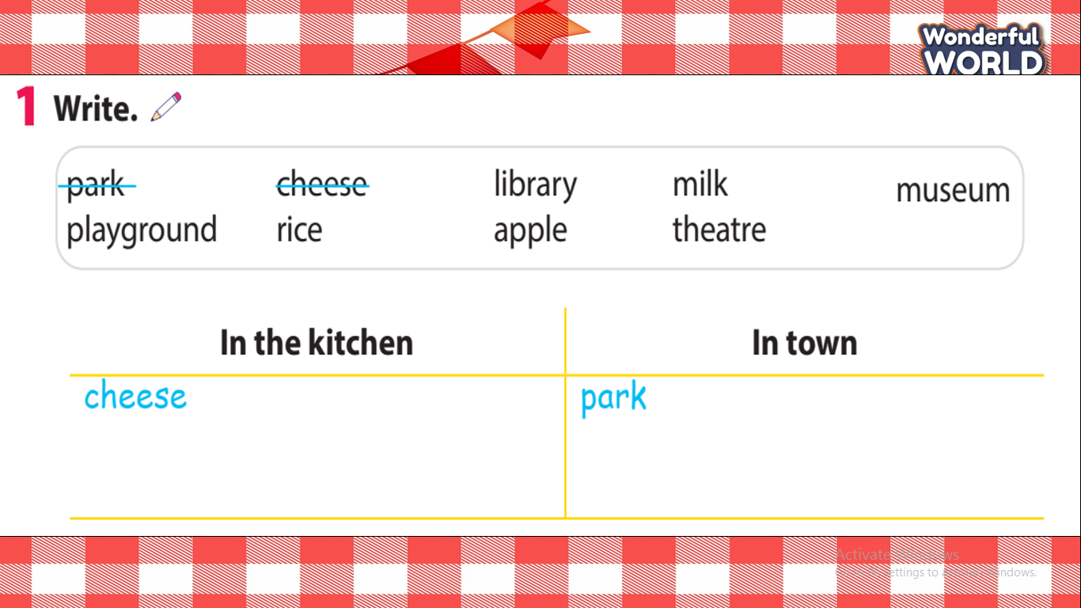  - Tell students to look at the words in the box and the two headings. Explain the headings if necessary.  - Ask volunteers to read out the words in the box.  - Tell students to write the words in the box in the correct columns. Tell them to cross out the word in the box when they have used it. Go round the class helping students where necessary.  • Check answers.  Task 2: Write  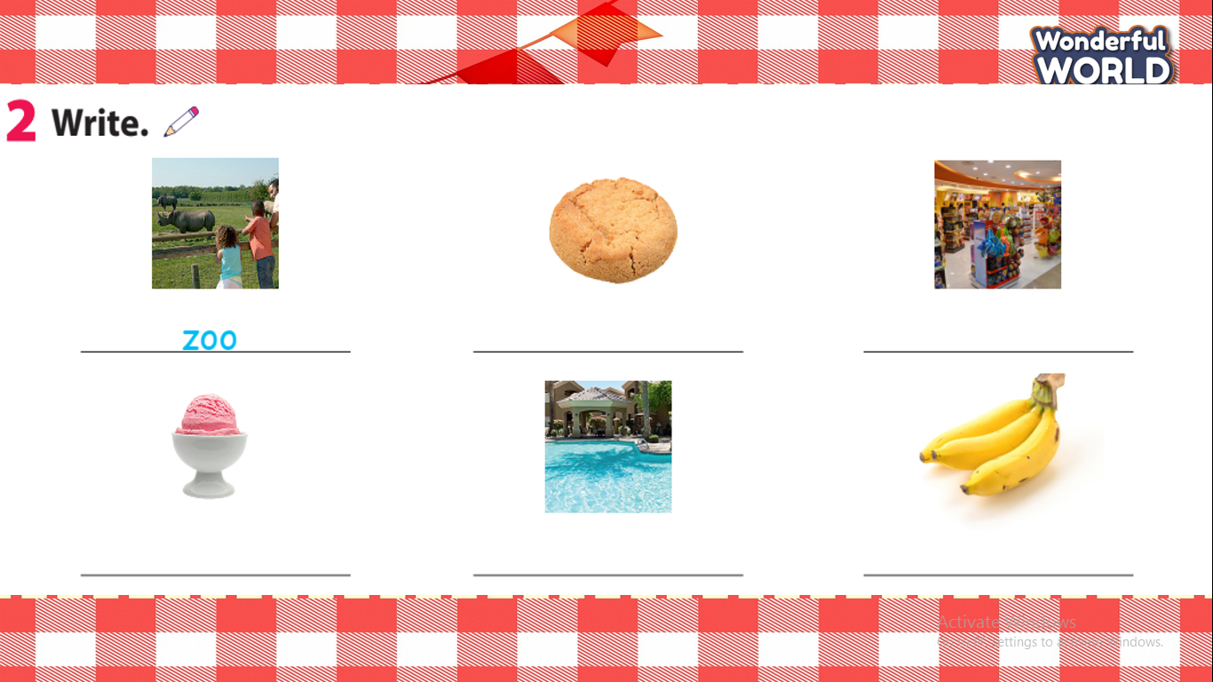  - Tell students to look at the first picture. Ask volunteers to tell you the word for the picture written on the line. Tell students to do the same for the other pictures. Allow them enough time to complete the task alone. Go round the class helping students where necessary.  - Check answers.  Task 3: Unscramble . Then match.  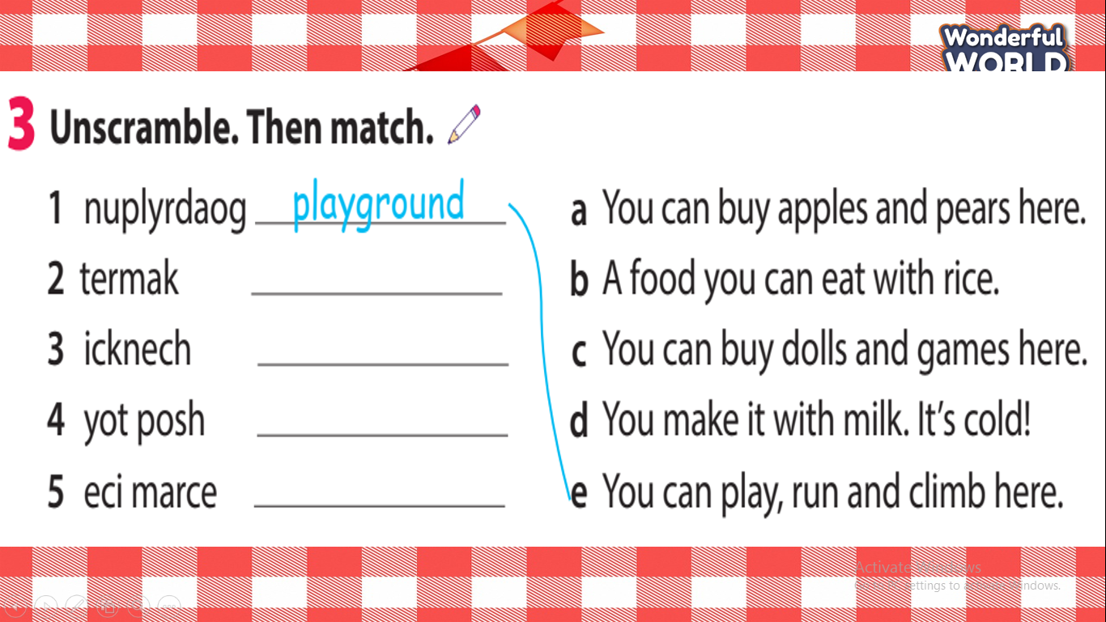  -Tell students to look at sentences 1 – 5 to get an idea of what each sentence is about. Then ask them to look at the first question. Tell them  the letters are in the wrong order.  Task 4: Circle  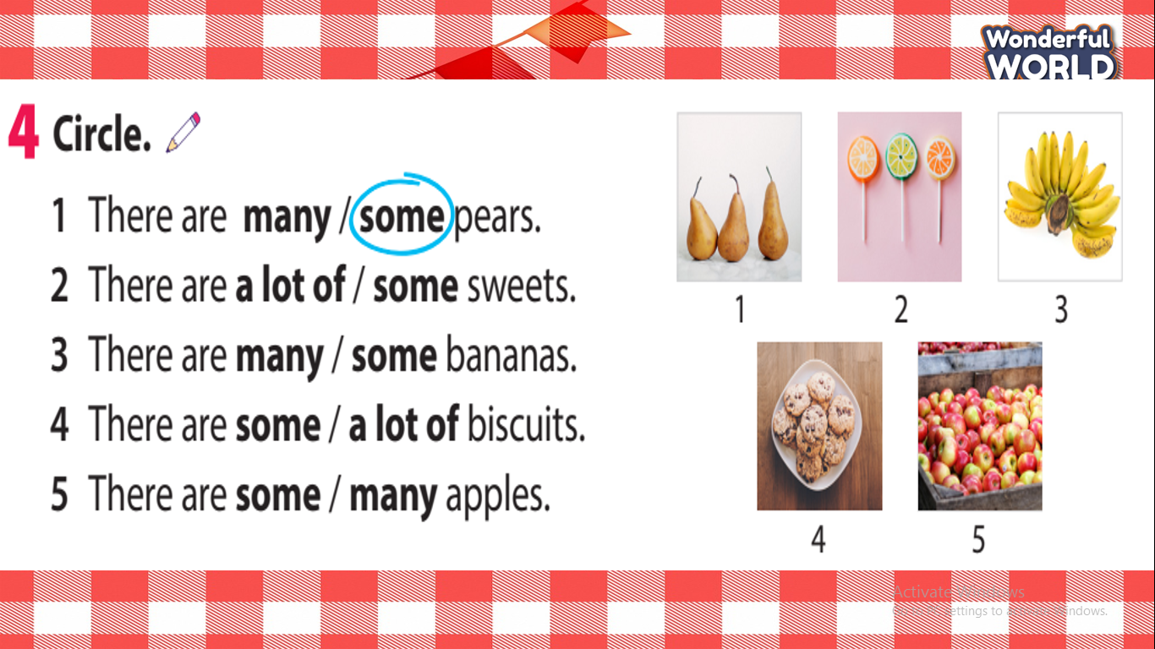  Read out the first sentence with both options and ask students to say the correct option. Ask why many is the correct answer. Read out the three different answer options and make sure that students remember the meanings of all the words.  - Explain the rest of the task to students.  - Check answers. Ask volunteers to read out their answers as sentences. | - Do the task and receive stars.  - Answer key:  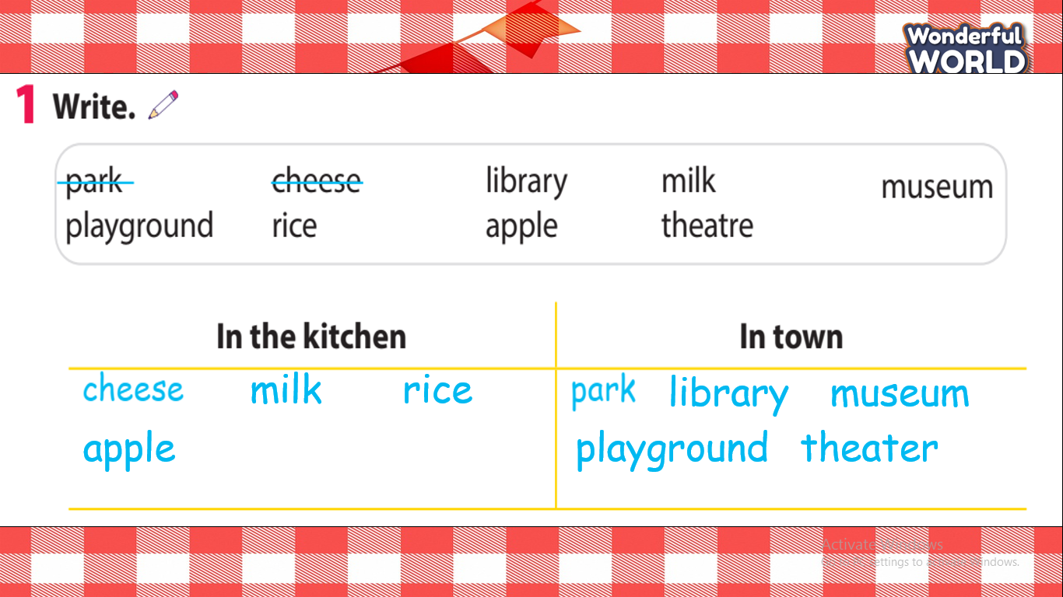  - Answer key:  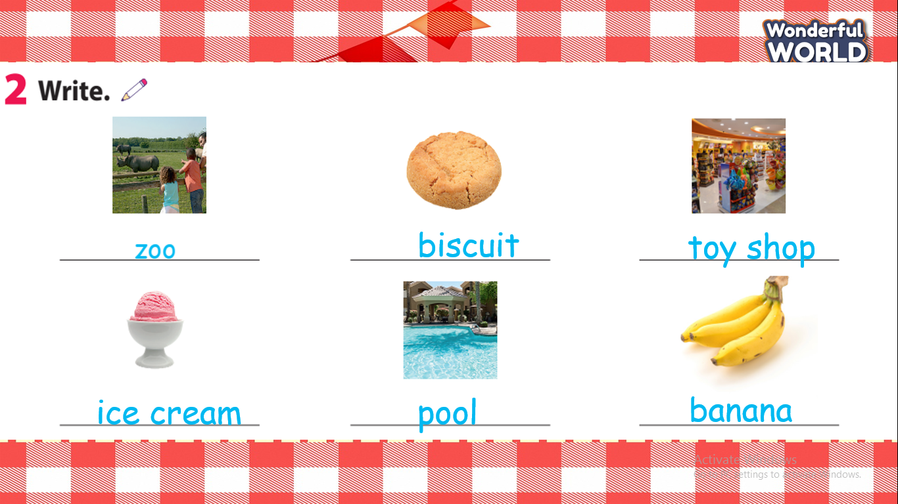  - Answer key:  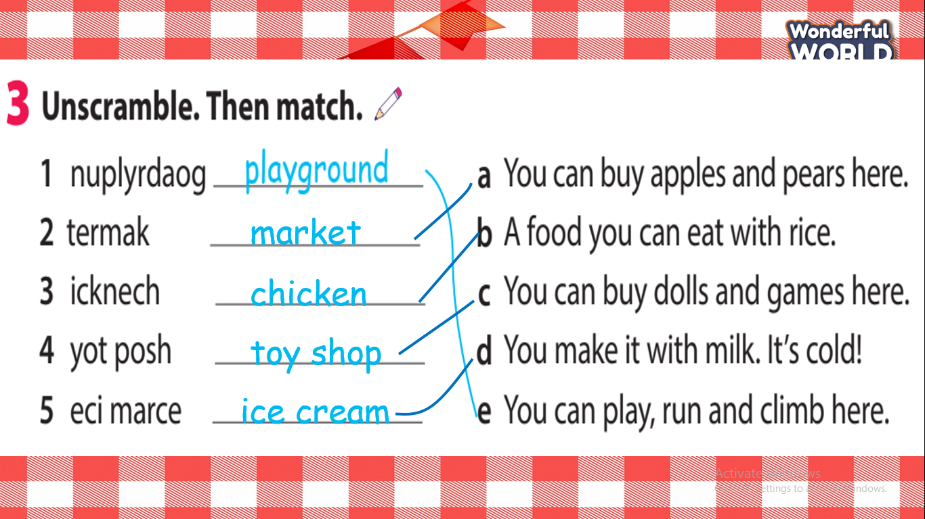  - Answer key:  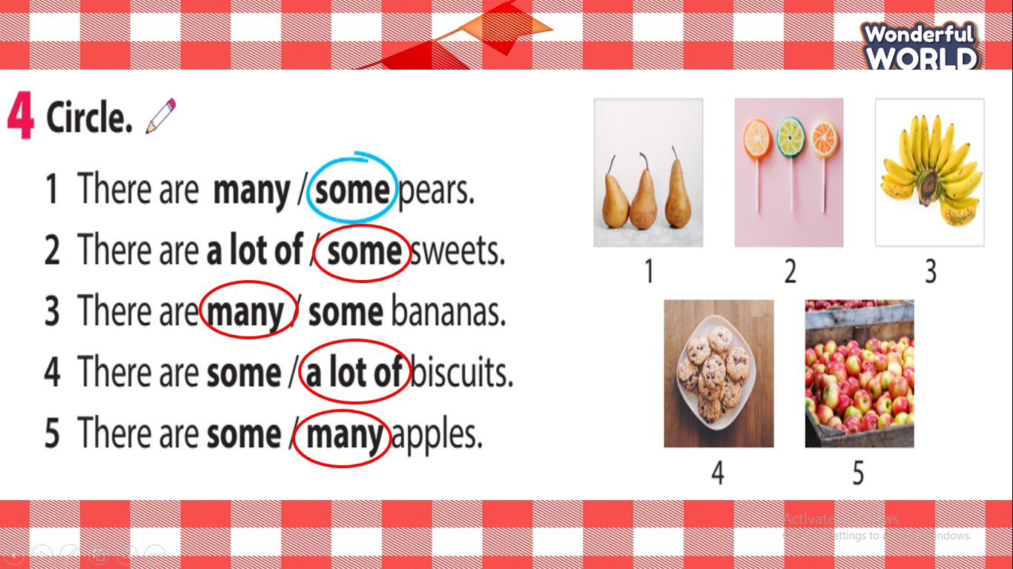
Extra activity (10 minutes )
Teacher’s activities | Student’s activities
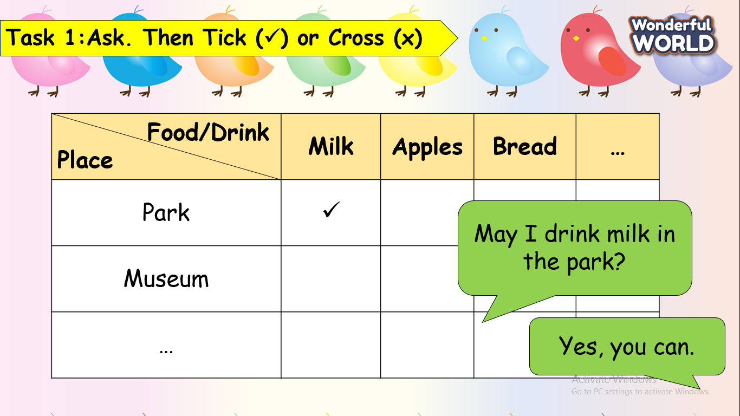  - Have Ss ask their friends about what they can drink or eat in some places, then tick or cross in their tables.  - Invite a few of pairs go to the board to present.  - Assess each presentation of Ss and give them stars.  - Say goodbye. | - Be confident and present smoothly.  - Say goodbye.
____________________________________
REVIEW 5
Part 2 - Task 1,2,3
Period 112
I. OBJECTIVES:
1. Knowledge:
By the end of the lesson, students will be able to:
- Review vocabulary about numbers: 11-20
- Review grammar: (May) Imperative
+ May I sit down? Yes, you can.
+ May I talk? No, you can't. Listen, please
- Review grammar: Present continuous (question)
+ What am I doing?
+ What’s he/she doing?
- Review grammar:
Let's + V!
Yes, let's.
- Review grammar:
Where is the…?
It’s on/in/under ….
- Review grammar:
How many apples are there?
There are sixteen apples.
2. Competences:
English competence
-Using vocabularies and structures of Unit 8 and Unit 9 smoothly.
General competence
- Raise motivation and interests in reviewing structures.
- Build up self-learning skill through learning activities.
3. Qualities:
+ Build up pride about town.
+ Don’t waste food.
II. EQUIPMENT AND MATERIALS:
- For teacher:
+ Basic things: Student’s book , teacher’s book, flashcards.
+ Advanced things: PPT, projector/interactive whiteboard/laptop/TV
- For students: student’s book, work book.
III. LESSON PROCEDURE:
Warm up (10 minutes)
Teacher’s activities | Student’s activities
- Greeting  - “Horserace” Game:  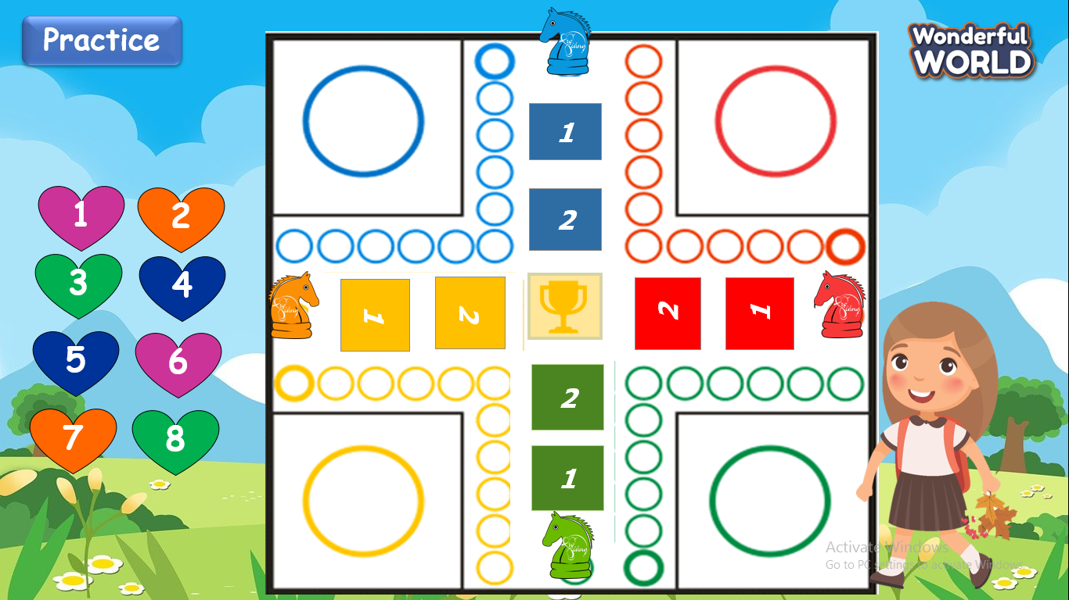  - Students answer correctly to move forward one step.  - The team is the fastest will be the winner and and get the trophy. | - Pass the ball and answer questions.  - Enjoy the game.
Review (15 minutes)
Teacher’s activities | Student’s activities
Task 1: Match.  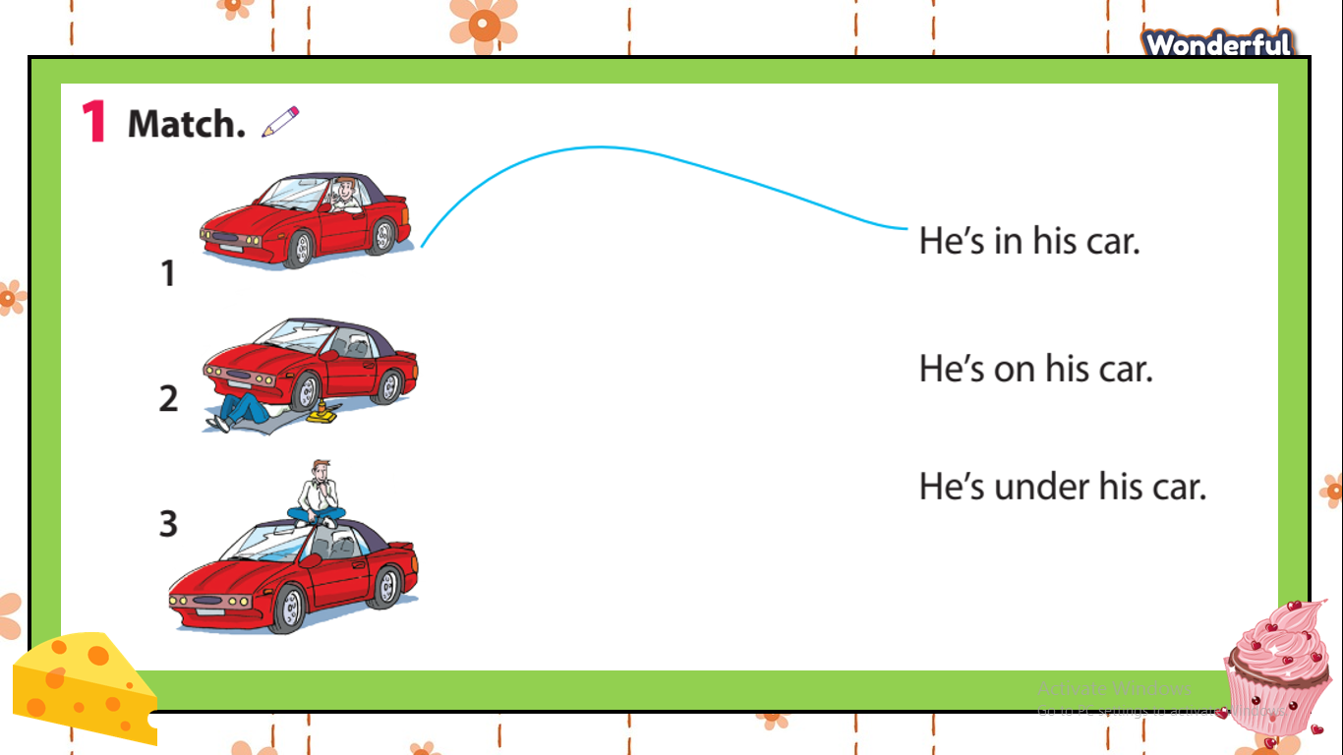  - Tell students to look at the pictures of the man and his car. Explain that they have to look at where he is and match the pictures to the correct sentences. Read out the sentences and ask students to repeat. Make sure they  remember the meanings.  - Allow students enough time to complete the task alone.Go round the class helping students where necessary.  - Check answers. Ask volunteers to read out their answers.  Task 2: Write and say.  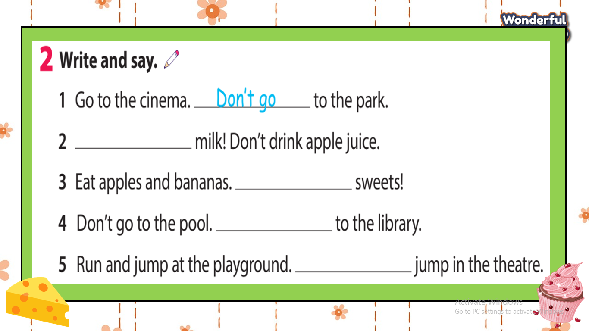  - Read out the first sentence in question 1. Ask students what come before to the park. Elicit Don’t go.  - Tell students they should look carefully at the words tohelp them work out the missing imperatives. Read out the given parts of the sentences and make sure that students  remember the meanings of all the words.  - Allow students enough time to complete the task alone.  - Go round the class helping students where necessary.  - Check answers. Ask volunteers  to read out their answers in full sentences.  Task 3: Say( your friend is in town.Talk about 5 activities to do)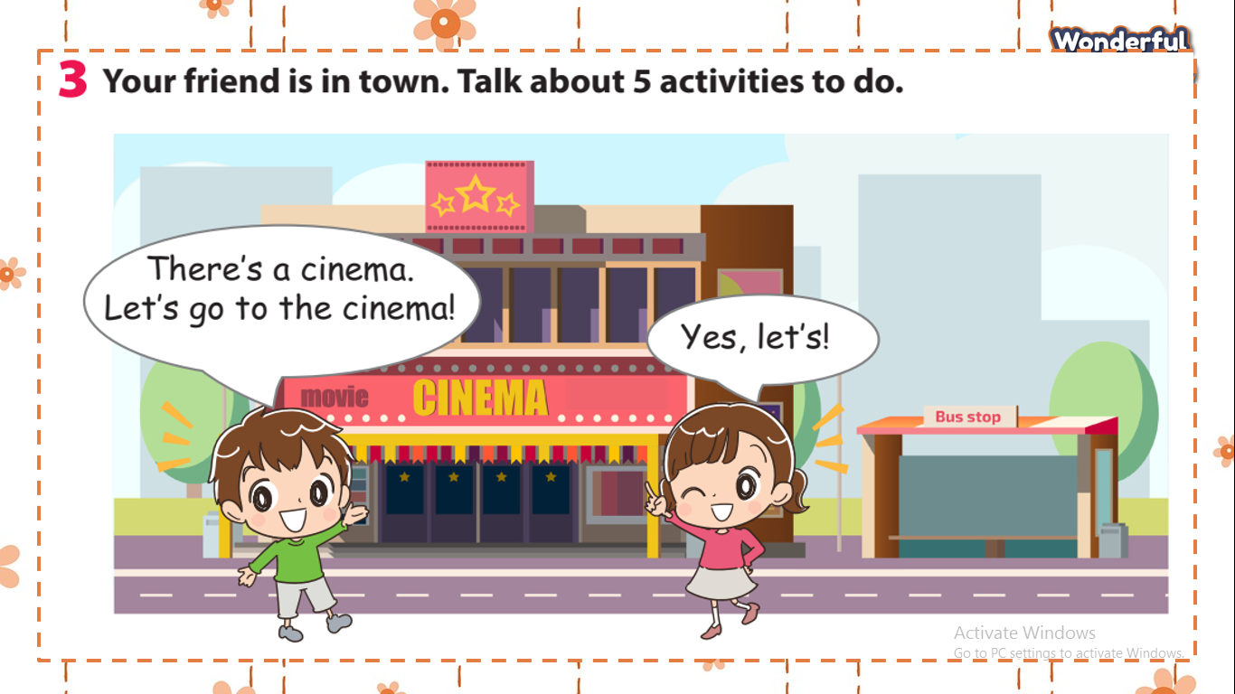  - Tell students they are going to to talk about the 5 activities to do in their town or city.  - Ask two students to read out the  dialogue.  - Ask students to work in pairs and use Let’s + a verb and  and respond to suggestions.  - Allow students enough to practise  speaking. Go round the class helping students where necessary.  - Ask some volunteers to speak in front of the class. | - Do the task and receive stars.  -Answer key:  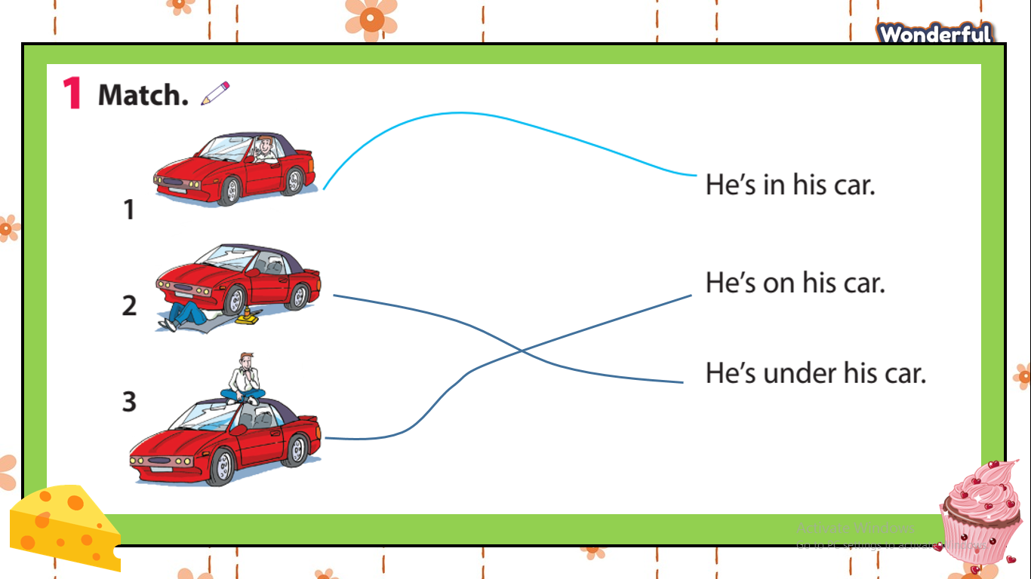  - Answer key:  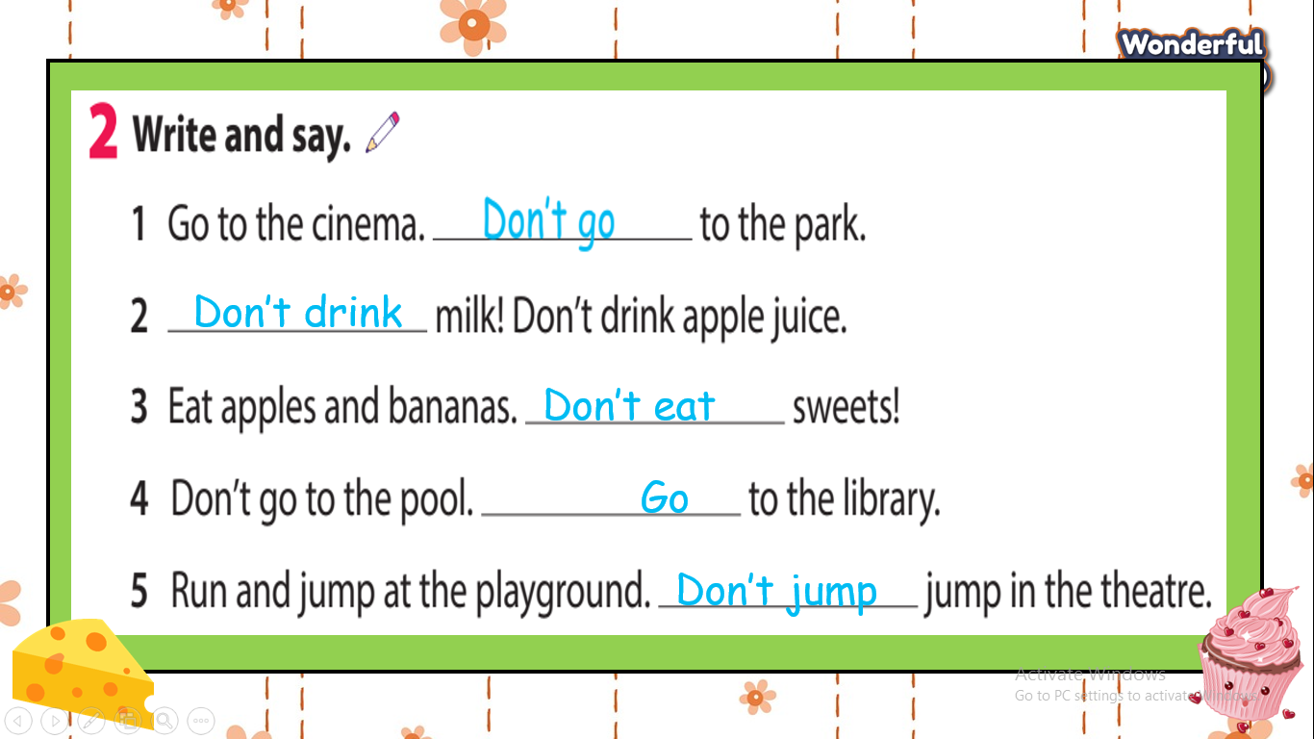  to look at the picture and the dialogue.  - Be confident and present smoothly.
Extra activity(5 minutes )
Teacher’s activities | Student’s activities
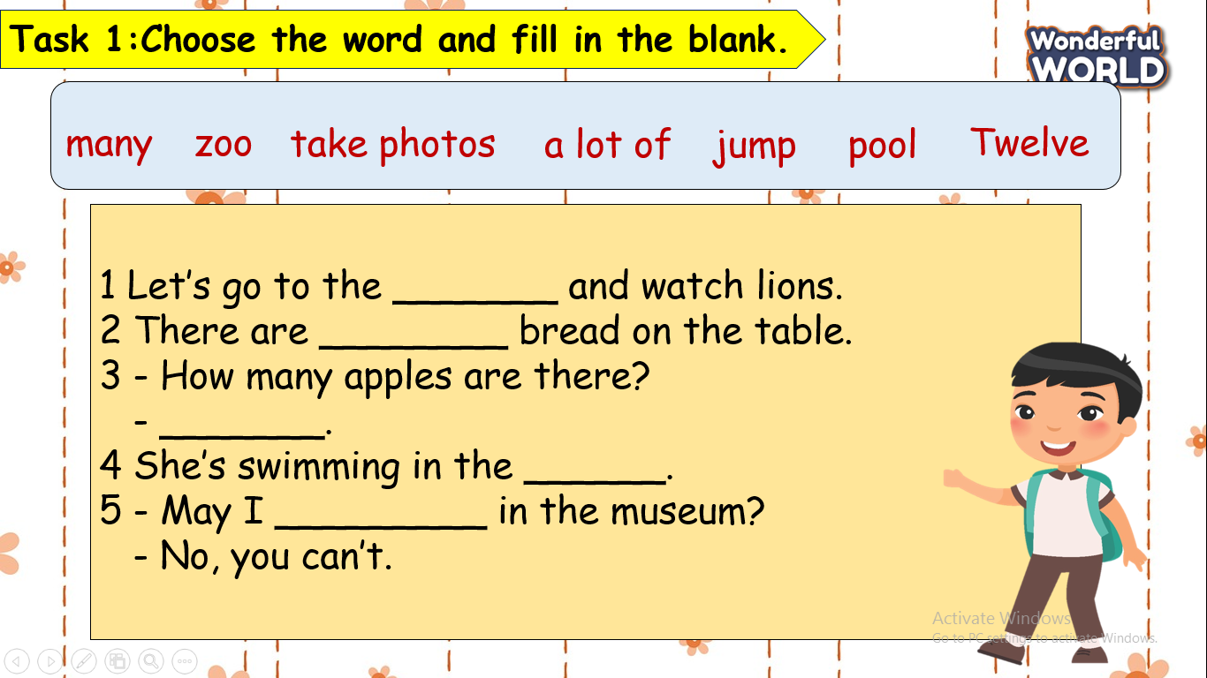  - Call a volunteer to read the word in the box. Guide students to do the task if necessary.  - Have students fill the blanks with the correct words from the box.  - Check answers.  - Say goodbye . | - Do the task  Key answer:  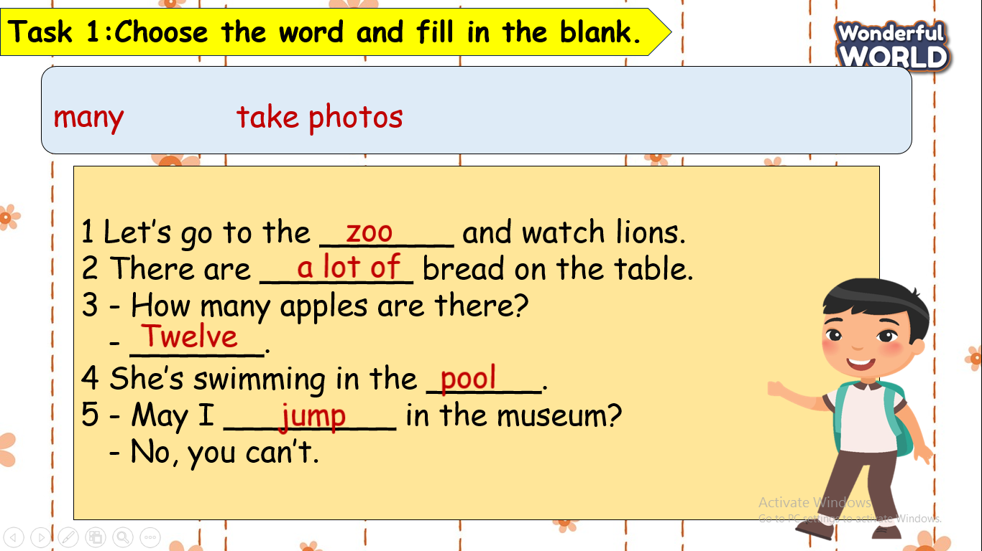  - Check with friends and then with teacher and whole class.  - Say goodbye.

GRADE 5
Week 28
UNIT 10: Performing Arts
Fun time and Project: Period 1
Period 109
I. OBJECTIVES:
1. Knowledge:
Students will review and practice all get vocabulary and structures of Unit 10 via some fun activities with words and structures related to the topic of Performing Arts.
2. Competences:
- English competencies: Students will be able to think and talk about topics.
- Common competencies: Students will have the opportunity to develop logical thinking and develop communication among friends.
3. Qualities:
- Students develop imagination and show their favourite things.
- Be confident and active in communicating with friends and teachers.
II. EQUIPMENT AND MATERIALS:
- For Teacher: PPT, flashcards, printed papers, dice.
- For students: textbook
III. LESSON PROCEDURE:
 | Activity 1: Warm-up (5 minutes)
 | Teacher’s Activities | Students’ Activities
 | Aims: Welcome students. Engage the class with a game and review the vocabulary of Unit 2.
 | Greet the Ss  Ask the Ss to read the question aloud:  + How are you?  + What’s the weather like today?  Ask them to watch the video and dance along.  Listen to the song “ Chicken Dance”  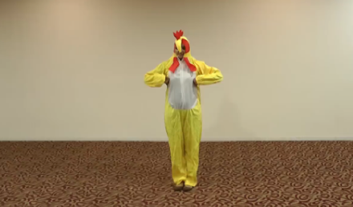  After warming up, let students play a mini-game to review vocabulary:  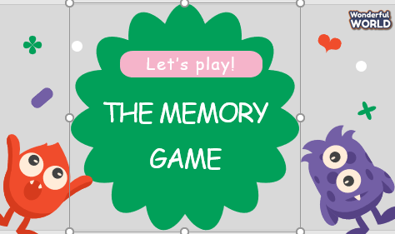  - Show the game on the side, and give instructions on how to play the game.  - Ask Ss to look at the cards carefully and remember as fast as they can. Ss will choose two cards that have the corresponding picture. Each team will only answer once each turn. | - Greet Teacher  - Watch the video and dance along  - Students can warm up and move their bodies to start the lesson.  - Listen to the rules of the game.  - Join the activity.
Activity 2: Review & Practice (17 minutes)
Teacher’s Activities |  | Students’ Activities
Aims:
- Review the words about entertainment and types of films.
- Complete the task 1
1 Unscramble the words.  - Tell students that they are going to look at the picture and  unscramble the words.  - Demonstrate number 1 as an example.  - Have students work in pairs and check answers with their  partners.  - Call on one student to write answers on the board and  check answers as a whole class. |  | - Do the task 1
Activity 3: Production (8 minutes)
Teacher’s Activities |  | Students’ Activities
Aims: - Controlled practice: develop Speaking skills.
2 Board game  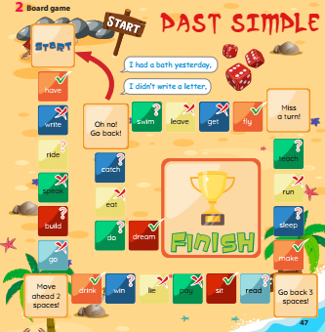  - Tell students to look at this activity and work in pairs.  - Explain the rules of the game.  - Go around the classroom and offer help if necessary.  Rule of the game:  - Play this game in pairs.  - Put the marker on Start.  - Take turns to throw the dice.  - Count the dots.  - Move the maker and make the sentence with the verb.  - The student who reaches the Finish first is the winner |  | - Listen to the rules of the game.  - Join the activity.
Activity 4: Wrap up & Assessment (5 minutes)
Teacher’s Activities |  | Students’ Activities
Aims:
- Do a quick exercise via a mini-game to review the words and grammar used in Unit 10
Play the game "Secret Gift Box Game”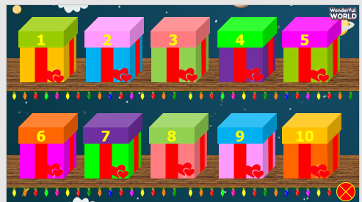  - Ask Ss to take turns choosing a box and choosing a correct answer. After choosing a correct answer, Ss open the secret box. Inside the box can be good points. |  | - Join in the activity.  - Check with the teacher.

UNIT 10: Performing Arts
Fun time and Project: Period 2
Period 110
I. OBJECTIVES:
1. Knowledge:
Students will review and practice all get vocabulary and structures of Unit 10 via some fun activities with words and structures related to the topic of Performing Arts.
2. Competences:
- English competencies: Students will be able to think and talk about topics.
- Common competencies: Students will have the opportunity to develop logical thinking and develop communication among friends.
3. Qualities:
- Students develop imagination and show their favourite things.
- Be confident and active in communicating with friends and teachers.
II. EQUIPMENT AND MATERIALS:
- For Teacher: PPT, flashcards, printed papers, dice.
- For students: textbook
III. LESSON PROCEDURE:
 | Activity 1: Warm-up (5 minutes)
 | Teacher’s Activities | Students’ Activities
 | Aims: Welcome students. Engage the class with a game and review the vocabulary of Unit 2.
 | Greet the Ss  Ask the Ss to read the question aloud:  + How are you?  + What’s the weather like today?  Ask them to watch the video and dance along.  Listen to the song “ Ready Set Dance 1”    After warming up, let students review vocabulary:   | - Greet Teacher  - Watch the video and dance along  - Students can warm up and move their bodies to start the lesson.  - Join the activity.
Activity 2: Review & Practice (17 minutes)
Teacher’s Activities |  | Students’ Activities
Aims:
- Review the words about entertainment and types of films.
- Complete the task 3
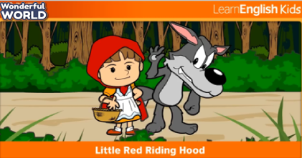  Watch the video:  - Let students watch the story " Little Red Riding Hood "  - Let them discuss, and ask and answer questions about the video.  Role play:  - The teacher divides the class into groups of 5 members.  - The members of the group take turns playing the roles of "the wolf", "little red riding hood", "the hunter" and "the grandmother", the narrator.  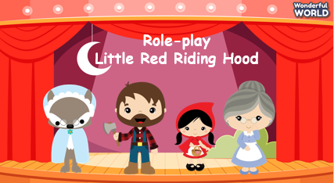  - Let the students read and memorize the character lines.  - Call the groups to act out and retell the story "Little Red Riding Hood"  - The group that performs well will win.  Similarly, the students will do task 3: Project: You are going to perform in English. Follow these steps.  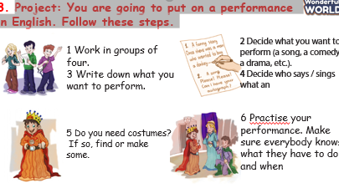  4. Do your performance for the rest of the class and watch the other groups. Which group do you think was best and why?  - Have each group do their performance in front of the class.  - Give students five minutes to observe and choose one they like  best then explain the reason.  - The most voted group will receive a gift. |  | - Students watch the story " Little Red Riding Hood "  - Discuss ask and answer questions about the video.  - Follow the teacher's instructions
Activity 3: Production (8 minutes)
Teacher’s Activities |  | Students’ Activities
Aims: - Controlled practice: develop Speaking skills.
5. Be a director. Tell each group one thing they did so well  and one thing they could do better.  - Have each group discuss and give comments on the performance of other groups.  - Have students tell one thing they did so well and one thing they  could do better.  - Listen and give feedback. |  | - Discuss and give comments on the performance of other groups.
Activity 4: Wrap up & Assessment (5 minutes)
Teacher’s Activities |  | Students’ Activities
Aims:
- Do a quick exercise via a mini-game to review the words and grammar used in Unit 10
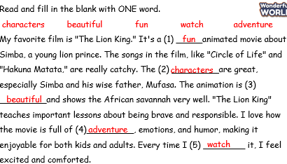  - Asks Ss about the words they have learned in the lesson without looking at the book.  - Asks sts to do the quick assessment.  - Checks with the class. |  | - Ss answer.  - Stand up and say goodbye to the teacher.

REVIEW 5
Lesson 1 –Task 1,2,3
Period 111
I. OBJECTIVES:
1. Knowledge:
Students will be able to review all target vocabulary and structures of Unit 9 via some fun activities.
2. Competences:
- English competences: Students will be able to write a postcard to a friend.
- Common competences: Students will have the opportunity to develop logical thinking and develop communication among friends.
3. Qualities:
- Students develop an appreciation and understanding of what is important to their friends and other people they meet in the community.
- Be confident and active in communicating with friends and teachers.
II. EQUIPMENT AND MATERIALS:
- For Teacher: PPT, flashcards, printed papers, dice.
- For students: textbook
III. LESSON PROCEDURE:
Activity 1: Warm-up (5 minutes)
“Let’s play game: Rhythm song clap back”
 | Teacher’s Activities | Students’ Activities
 | Aims: Welcome students. Engage the class with a song.
 | - Greet students. Chatting….. Do you like to play a game?  - Introduce the game:  + Option 1: Play the video and ask Ss to listen to the rhythms and clap them back when it's "Your Turn!".  + Option 2: T can make her/his own rhythm. I'm gonna clap a rhythm for you and then you're gonna get a chance to clap it back. Listen! Listen! Clap! | - Greet Teacher.  - Join the game.
Activity 2: Review (10 minutes)
Teacher’s Activities |  | Students’ Activities
Aims:
- Review vocabulary and structures of Unit 9
Review vocabulary  Play game: Back to the board  - Get students into two groups.  - Take two chairs and place them so the backs are against the board. When someone is sitting in the chair they are facing the class and their back is towards the board.  - Show or write a word or phrase on the board.  - The students are then given 30 seconds to try and explain the target word on the board to their group members. They must not say the target word or any other word in the phrase, they can use body language to help.  - The first person sitting in the chairs to guess the word or phrase wins a point for their group.  Review structure  - Ask Ss some questions:  + When do we use the past simple tense?  + What are time expressions for the past tense?  + Can you give me some examples of irregular verbs and regular verbs? |  | - Try to explain the target word on the board to your group member by using body language.  - Answer the questions:  + We use past simple tense when we want to talk about actions that happened in the past.  + last year, last month, last weekend, last night, yesterday, two days ago, some months ago...
Activity 3: Practice – Controlled practice (7 minutes)
Teacher’s Activities |  | Students’ Activities
Aim:
Ss will be able to practise reading for specific information.
Task 1: Read and choose the best answer.  - Read out the example sentence with the correct option  and ask Ss why the answer “a” is correct.  - Read out all the sentences and make sure that Ss  know the meaning of all the answers.  - Explain the rest of the task to Ss.  - Give Ss five minutes to do this task individually. Go  around the class and offer help if necessary.  - Call some Ss to share the answer, discuss the correct  answers, and ask Ss to explain their choices.  Task 2: Fill each gap with a word from the box.  - Ask Ss to look at the text and tell Ss that  they are going to fill in the blanks with the given words to  complete each sentence.  - Have Ss do the task in pairs.  - Go around the class and offer assistance if needed.  - Check answers. Ask volunteers to read out their answers. |  | - Read out all the sentences and choose the best answer.  - Stand up, share the answer, and explain the choices.  - Work in pairs.  - Look at the text and fill in the blanks with the given words to  complete each sentence.
Activity 4: Production (8 minutes)
Teacher’s Activities |  | Students’ Activities
Aim:
Ss will be able to develop students' English writing skills.
Task 3: Write a postcard to a friend from a city you know. Use the plan below. Remember to use adjectives to describe nouns.  - Tell Ss that they are going to write a postcard.  - Give Ss about one minute to read the plan below and check their understanding.  - Ask Ss to use adjectives to describe.  - Give Ss 10–15 minutes to do this task.  - Call on two Ss to share their answers on the board.  - Ask students to listen and remember the information in their friends' postcards.  - Give comments and check. |  | - Write a postcard to a friend from a city you know using adjectives to describe.  - Stand up and share their own postcard.  - Listen carefully.
Activity 5: Wrap up & Assessment (5 minutes)
Teacher’s Activities |  | Students’ Activities
Aims:
- Assess individuals or groups who have done the best in the lesson.
- Wrap up the activities Ss have done during the lesson.
Assessment:  Play the game: Who's Faster?  - Ask Ss some questions about the postcards that they've shared in front of the class.  1. Whom did he/she write this letter to?  2. How did he/she go?  3. Who did he/she go with?  4. What did they see/do in………?  5. Where did he/she go on holiday this summer?  6. How was the food?  - Wrap-up: Ask Ss the question: “What have we learnt today?”  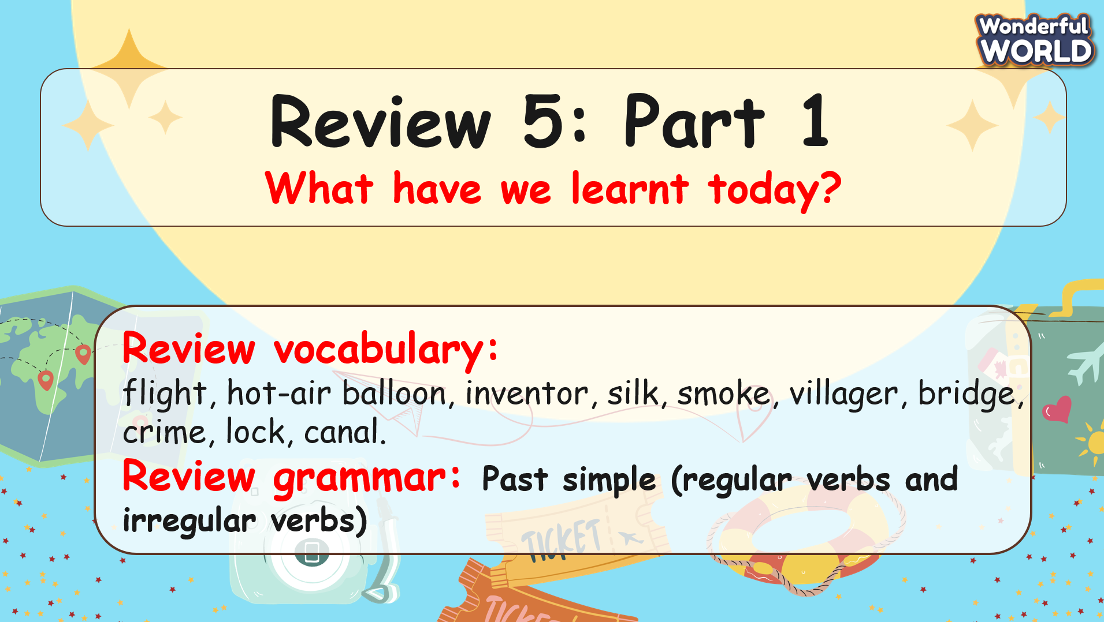 |  | - Answer the questions.  - Stand up and say goodbye to the teacher.

REVIEW 5
Lesson 2 – Task 4,5,6
Period 112
I. OBJECTIVES:
1. Knowledge:
Students will be able to review all vocabulary and structures of Unit 10 via some fun activities.
2. Competences:
- English competences: Students will be able to talk about some activities that they did with someone.
- Common competences: Students will have the opportunity to develop logical thinking and develop communication among friends.
3. Qualities:
- Students develop an appreciation and understanding of what is important to their friends and other people they meet in the community.
- Be confident and active in communicating with friends and teachers.
II. EQUIPMENT AND MATERIALS:
- For Teacher: PPT, flashcards, printed papers, dice.
- For students: textbook
III. LESSON PROCEDURE:

Activity 1: Warm-up (5 minutes)
“Let’s play a game: Put a finger down”
 | Teacher’s Activities | Students’ Activities
 | Aims: Welcome students. Engage the class with a song.
 | - Greet students. Chatting….. Do you like to play a game?  - Introduce the game:  + Hold up 5 fingers. These are your 'lives'.  + Read each of the 'put a finger down if you ......' statements and if they apply to you, put a finger down.  + The last student to lose all their lives is the winner. | - Greet Teacher.  - Join the game.
Activity 2: Review (6 minutes)
Teacher’s Activities |  | Students’ Activities
Aims:
- Review vocabulary and structures of Unit 10
Review vocabulary  - Show the words on the screen.  - Ask students to look at the screen and say the word.  - Show the text and audio.  - Ask Ss to listen again and repeat after the audio.  - Can play twice or three times so that Ss can practice the words.  - Ask some students to read the words or phrases individually.  Review structure  - Ask Ss some questions:  + Ask Ss to remember the positive form and give an example.  Positive form: S + V (past form of the verb) +….  - How do you make negatives and questions in the past simple?  + In the past simple tense, negative statements are formed by adding “did not” (or the contraction “didn’t”) between the subject and the infinitive form of the verb.  Negative form: S + didn’t + V (base form) + ….  + To create a wh-question, start with the wh-word, then add did (or didn't for a negative question), then the subject (a person or thing that does the action), followed by the base form of the verb, and only then add the rest of the sentence.  WH-Question form: Wh- +did + S + V (base form) +…? |  | - Look at the screen and say the words.  - Check the words and listen to the audio.  - Listen and repeat.  - Answer the question and give an example.  + We went to the zoo last weekend.” (irregular).  + He didn’t play soccer last weekend.  + What did you do yesterday?
Activity 3: Practice – Controlled practice (12 minutes)
Teacher’s Activities |  | Students’ Activities
Aims: Ss will be able to:
- practice asking and answering Wh-questions in the Past simple.
- practise listening for specific information.
Let’s play the game: Rock-paper-scissors  - Tell students to look at the board game on page 50 of the book.  - Explain the purpose of the game.  - Explain how they will use hand gestures for rock-scissors paper: rock (a fist), scissors (a fist with the index and middle fingers extended), and paper (an open hand).  - Model the game with a student. Use hand gestures for rock-paper-scissors, the winner will have a move and can choose one square to make the sentence with words/ phrases in the box. Cross out the square they have finished.  - The one who can finish making sentences with all the squares is the winner.  - Have students play the game in pairs.  - Walk around to provide assistance and ensure correct pronunciation and spelling.  - Congratulate the winning pairs who reach the End space first.  - Discuss any challenging words and review correct spelling and pronunciation.  Task 1: What did Jack do last week? Listen and draw a line from the day to the correct picture.  - Tell students that they are going to listen to the recording and draw lines to match each day to the correct picture.  - Ask students to look at the pictures to identify the activities.  - Play the recording twice for students to listen and draw lines to  match.  - Ask students to give answers.  - Play the recording again for students to listen and check.  - Check answers as a whole class. |  | - Look at the board game on page 50 of the book and listen to the rules of the game.  - Play the game in pairs.  - Look at the pictures to identify the activities.  - Listen to the recording and draw lines to match each day to the correct picture.  - Listen again and check.
Activity 4: Production (7 minutes)
Teacher’s Activities |  | Students’ Activities
Aim:
Ss will be able to develop students' English reading and writing skills.
Task 2: Read Peter’s diary. Then write ONE word in each blank.  - Tell students to look at the first picture and say what they can see.  - Read out the example and ask students why beach is the correct  answer.  - Explain the rest of the task to students.  - Tell them to look at the pictures carefully and write the correct  answers. Go round the class and offer help if necessary.  - Check answers. Ask volunteers to read out their answers. |  | - Look at the first picture and answer the question.  - Look at the pictures carefully and write the correct answers.
Activity 5: Wrap up & Assessment (5 minutes)
Teacher’s Activities |  | Students’ Activities
Aims:
- Assess individuals or groups who have done the best in the lesson.
- Wrap up the activities Ss have done during the lesson.
Assessment:  Write the correct form of the verb in the past simple.  - Ask Ss to look at the sentence carefully and write the correct form of the verb in the past simple.  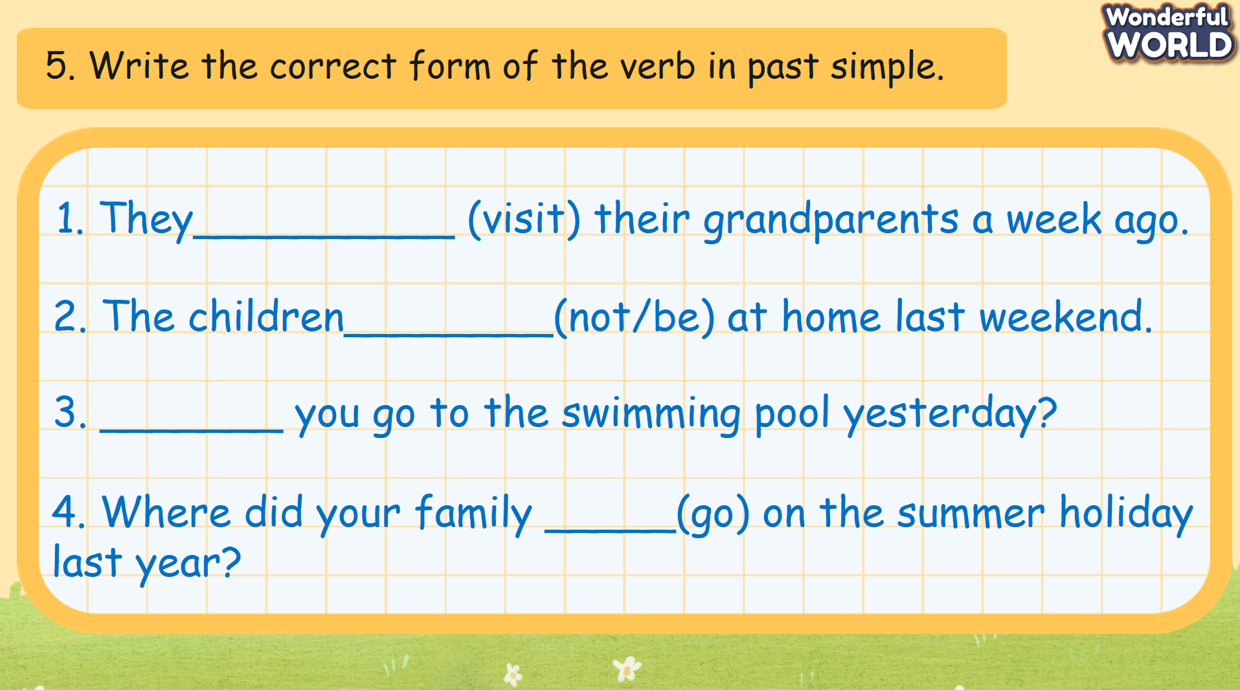  - Wrap-up: Ask Ss the question: “What have we learnt today?”  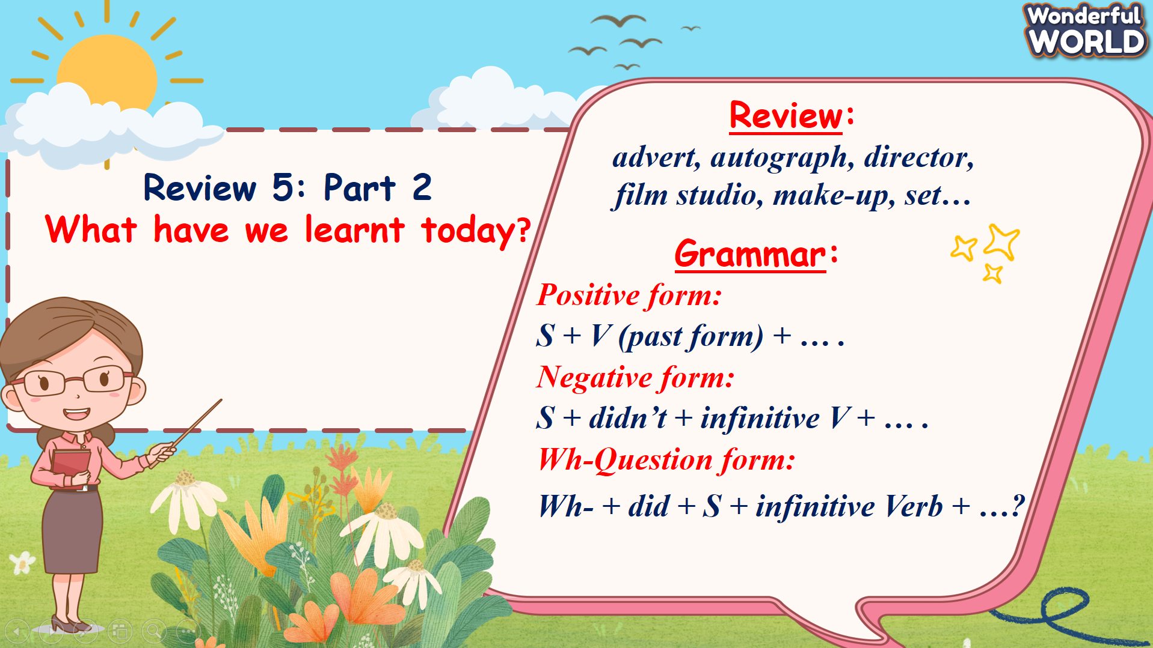 |  | - Write the correct answers.  - Stand up and say goodbye to the teacher.

