TUẦN 30 Khối 3, 5 (Từ ngày 14/04/2025 đến ngày 18/04/2025)
THỨ | TIẾT | MÔN | TIẾT THỨ | NỘI DUNG BÀI DẠY |  | UDCNTT | ĐỒ DÙNG DẠY HỌC
Hai  14/04 | 1 | 5A | 117 | Unit 11. Animals | Lesson 2 (1, 2, 3) | Wonderful world | Flashcards, TV, books
Hai  14/04 | 2
Hai  14/04 | 3 | 3A | 117 | Unit 10. Our world | Lesson 2 (1, 2, 3) | Wonderful world | Flashcards, TV, books
Hai  14/04 | 4 | 3A | 118 | Unit 10. Our world | Lesson 2 (4, 5, 6) | Wonderful world | Flashcards, TV, books
Hai  14/04 | 5 | 5D | 117 | Unit 11. Animals | Lesson 2 (1, 2, 3) | Wonderful world | Flashcards, TV, books
Hai  14/04 | 6 | 3B | 117 | Unit 10. Our world | Lesson 2 (1, 2, 3) | Wonderful world | Flashcards, TV, books
Hai  14/04 | 7
Ba  15/04 | 1 | 5C | 117 | Unit 11. Animals | Lesson 2 (1, 2, 3) | Wonderful world | Flashcards, TV, books
Ba  15/04 | 2 | 5B | 117 | Unit 11. Animals | Lesson 2 (1, 2, 3) | Wonderful world | Flashcards, TV, books
Ba  15/04 | 3 | 5A | 118 | Unit 11. Animals | Lesson 2 (4, 5, 6) | Wonderful world | Flashcards, TV, books
Ba  15/04 | 4
Ba  15/04 | 5 | 3A | 119 | Unit 10. Our world | Lesson 2 (7, 8, 9) | Wonderful world | Flashcards, TV, books
Ba  15/04 | 6 | 5D | 118 | Unit 11. Animals | Lesson 2 (4, 5, 6) | Wonderful world | Flashcards, TV, books
Ba  15/04 | 7 | 3B | 118 | Unit 10. Our world | Lesson 2 (4, 5, 6) | Wonderful world | Flashcards, TV, books
Tư  16/04 | 1 | 5A | 119 | Unit 11. Animals | Lesson 3 (1, 2, 3) | Wonderful world | Flashcards, TV, books
Tư  16/04 | 2
Tư  16/04 | 3
Tư  16/04 | 4
Tư  16/04 | 5 | 5B | 118 | Unit 11. Animals | Lesson 2 (4, 5, 6) | Wonderful world | Flashcards, TV, books
Tư  16/04 | 6 | 5C | 118 | Unit 11. Animals | Lesson 2 (4, 5, 6) | Wonderful world | Flashcards, TV, books
Tư  16/04 | 7
Năm  17/04 | 1 | 5C | 119 | Unit 11. Animals | Lesson 3 (1, 2, 3) | Wonderful world | Flashcards, TV, books
Năm  17/04 | 2 | 5B | 119 | Unit 11. Animals | Lesson 3 (1, 2, 3) | Wonderful world | Flashcards, TV, books
Năm  17/04 | 3 | 5A | 120 | Unit 11. Animals | Lesson 3 (4, 5, 6) | Wonderful world | Flashcards, TV, books
Năm  17/04 | 4
Năm  17/04 | 5 | 5D | 119 | Unit 11. Animals | Lesson 3 (1, 2, 3) | Wonderful world | Flashcards, TV, books
Năm  17/04 | 6 | 5C | 120 | Unit 11. Animals | Lesson 3 (4, 5, 6) | Wonderful world | Flashcards, TV, books
Năm  17/04 | 7
Sáu  18/04 | 1 | 3B | 119 | Unit 10. Our world | Lesson 2 (7, 8, 9) | Wonderful world | Flashcards, TV, books
Sáu  18/04 | 2 | 5D | 120 | Unit 11. Animals | Lesson 3 (4, 5, 6) | Wonderful world | Flashcards, TV, books
Sáu  18/04 | 3 | 5B | 120 | Unit 11. Animals | Lesson 3 (4, 5, 6) | Wonderful world | Flashcards, TV, books
Sáu  18/04 | 4
Sáu  18/04 | 5
Sáu  18/04 | 6 | 3B | 120 | Unit 10. Our world | Lesspn 3 (1, 2, 3) | Wonderfulworld | Flashcards, TV, books
Sáu  18/04 | 7 | 3A | 120 | Unit 10. Our world | Lesspn 3 (1, 2, 3) | Wonderfulworld | Flashcards, TV, books

GRADE 3
WEEK 30
UNIT 10. OUR WORLD
Lesson 2 - Task 4,5,6
Period 117
I. OBJECTIVES:
1. Knowledge:
Students will be able to :
+ To learn some vocabulary about weather and the activities related to this weather.
+ To practice listening to and reading simple sentences about seasons/ weather and the activities related to this weather.
2. Competences:
- English competences: To talk about the nature, by using words
+Students will have the opportunity to develop the communication among friends
3. Qualities:
- Students will be friendly and confident in communicating with friends about the knowledge of seasons and weather, and creativeness in making crafts.
II. EQUIPMENT AND MATERIALS:
- For Teacher: PP, TV, flashcards, music, audio track
- For students: pictures, handout
III. LESSON PROCEDURE:
Activity 1: Warm-up (5 minutes)
Teacher’s activities | Student’s activities
“The sun comes up” song  https://www.youtube.com/watch?v=XcW9Ct000yY  - Ask sts to stand up and stand around the class  - Read the content of the song one by one and do action at the same time  - Play the song once for sts to listen and do the action  - Play the song the second time for sts to sing and do | - Listen to the teacher  - Look and imitate the action  - Listen and do the action  - Sing and do
Activity 2: Presentation (8 minutes)
Teacher’s activities | Student’s activities
Task 1: Listen,point and repeat  - Ask sts “How is the weather in the song?”  - Let time for sts to recall the song content and answer  - Ask sts to give the answer  - Leading: You’ve just sung a weather song. Let’s continue exploring about the weather in the lesson today. Can you guess what the weather is today?  - Set time for sts discuss and say the guessing  - Show the picture one by one  - Ask sts to listen and repeat the words  - Mime for sts to follow as reading the word  GUESSING GAME – CHECKING VOCABULARY  - Use the gestures to have Sts guess the correct weather words  - Ask sts to say the words. The one who says the word first will get the star  - Change the role  - Who gets the most stars will be the winner | - List the weather in the song  - Listen to the teacher  - Look, listen and repeat  - Act out as teacher does  - Join the game with friends.  - Act and say
Activity 3: Practice (12 minutes)
Teacher’s activities | Student’s activities
Listen and fill in the blanks  Context: You are watching a TV program.  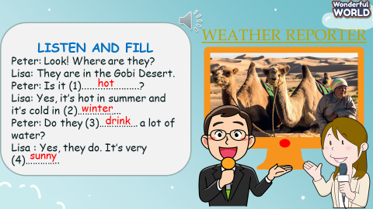  - Show the picture and exploit it with sts  - Ask sts to guess the missing words.  - Play audio once for sts to listen and write  - Ask sts to give the answer  - Play again and check  Task 2: Listen and tick.  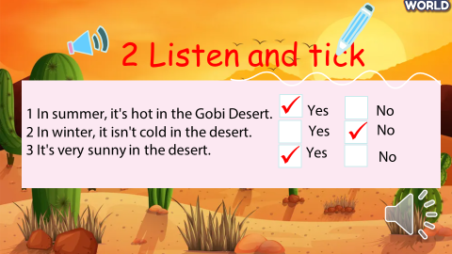  - Ask sts to read the statements  - Ask them to guess the answer Yes/ No  - Play audio again for sts to check their guess  - Do peer checking  Listing Game:  - Ask sts to form 6 groups  - Vote for the team’s leader  - Ask the team to take A0 paper and markers to write  - Show the 6 words on the screen: sunny, rainy, cold, hot, winter, and summer  - Ask sts to list out the activities people can do in this weather/ season | - Listen to the teacher  - Exploit the piture  - Guess the answer  - Listen and check  - Do peer checking  - Read the statements  - Guess the answer Yes/ No  - Listen and check the guessing  - Do peer checking  - Form the group  - Vote for the team’s leader  - List the activities
Activity 4: Production (7 minutes )
Teacher’s activities | Student’s activities
Project  - Guide the sts to do the craft https://www.youtube.com/watch?v=EshTkzJ8avQ  - Ask groups to spin and talk  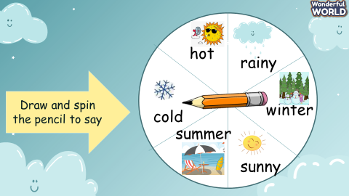 | - Do the crafts.  Spin and talk
Activity 5: Assessment (3 minutes )
Teacher’s activities | Student’s activities
- Ask students to do the assessment.  - Look at the pictures and circle a or b  - Check-in pair then whole class.  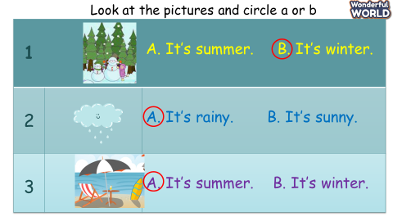  - Say goodbye. | - Do the assessment.  - Check with friends and then with the teacher and the whole class.  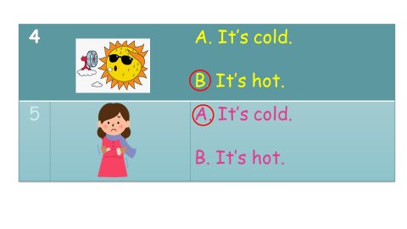  - Say goodbye.

UNIT 10. OUR WORLD
Lesson 2 - Task 4,5,6
Period 118

I. OBJECTIVES:
1. Knowledge:
By the end of the lesson, students will be able to:
+ To practice asking about the activities that they do in seasons.
2. Competences:
- English competences: Students will be able to ask and answer about the activities.
- Common competences: Students will have the opportunity to develop creativeness, carefulness in drawing and develop communication among friends.
3. Qualities:
- Students will be confident in talking about a favourite season and draw the
activities they do in this season.
II. EQUIPMENT AND MATERIALS:
- Basic things: Student’s book, flashcards, pieces of paper to draw.
- Advanced things: PPT, projector/interactive whiteboard/laptop/TV.
III. LESSON PROCEDURE:
Activity 1: Warm-up (10 minutes)
Teacher’s activities | Student’s activities
SONG: “What can you do ?”  - Ask sts to stand around the class  - Do the action and ask the sts to follow the action  - Play the song once for sts to listen and imitate the action  - Play again and ask sts to do  https://www.youtube.com/watch?v=7MKmbyfhkkE  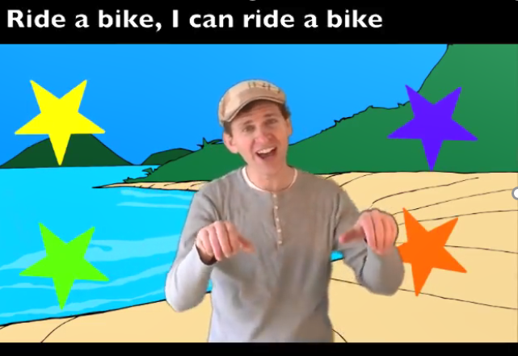 | - Greet teacher.  - Listen and do the action with the.  - Sing along with the song.
Activity 2: Presentation (5 minutes)
Teacher’s activities | Student’s activities
Listing game:  - Ask sts to form 6 groups  - Show 4 seasons of the year on the screen  - Ask group members, in turn, to list activities they do in each season  - Cross-checking  - The group with the most words wins the stars  Task 4: Listen and repeat  - Guide sts to use the technique “Keep the question going on”  - Ask sts to make questions with some activities.  - Check and lead in the question of the lesson.  - Show the pictures one by one  - Ask the sts to guess the question and the answer  - Let sts listen and repeat  - Play role  - Ask some pairs to perform in front of the class | - Form the group  - Use mindmap to list activities  - Choose the words and make questions  - Listen to the teacher  - Listen and repeat  - Play role
Activity 3: Practice (10 minutes)
Teacher’s activities | Student’s activities
Fastest pen Game  (Teacher designs a slide that contains 4 pictures and words in task 5. Sts tick tac toe to choose a number to open. T shows the picture and the given word in task 5 in turn. Sts look at the picture and the word then as fas as possible write the question. The correct question gets the point from 6-1. The group with the most points wins the game)  - Ask sts to work in the same groups  - Ask the leader to take personal board and maker  - Introduce the game  - Set the game rules  - Sts tick tac toe to choose the number  - Encourage sts to write the question as fast as possible  - Check the question in front of the class  - Ask sts to read out loud their writing.  - Give points to groups  - Let sts keep playing the game  Task 5 . Look and Say.  - Hand groups a set of tasks 5 pictures  - Guide the group to work under the leader’s control  - Group members take turns picking up the picture. Other members ask the question, that st answers Yes/ No  - Ask the leader to make sure everyone in the group has the chance to ask and answer  - 3 pairs perform in front of the class. | - Listen to the teacher  - Sit in groups  - Take the materials  - Tick tac toe  - Write the questions  - Check with teacher  - Read aloud  - Pick up the picture and show it to group members  - Ask and answer  - Perform in front of the class
Activity 4: Production (9 minutes)
Teacher’s activities | Student’s activities
Task 6. Draw and write :  - Tell students to look at the picture and the sample sentences. Read out the sentences and ask students to repeat  - Tell students to choose a favourite season and draw the activities they do in this season.  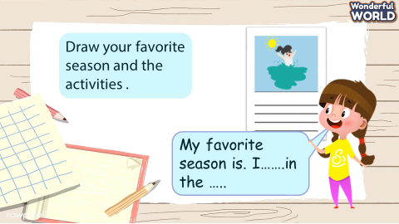  - Explain that they should write about the activities underneath the picture.  - Tell students to complete the task. Help students with spelling where necessary.  - Ask students to work in pairs to show their pictures and practice speaking  - Ask volunteers to share their pictures and act out their dialogue in front of the class. | - Draw the picture  - Write the information  - Work in pairs  - Listen to friends and give speech
Activity 5: Assessment (3 minutes)
Teacher’s activities | Student’s activities
- Ask sts to do the assessment: match  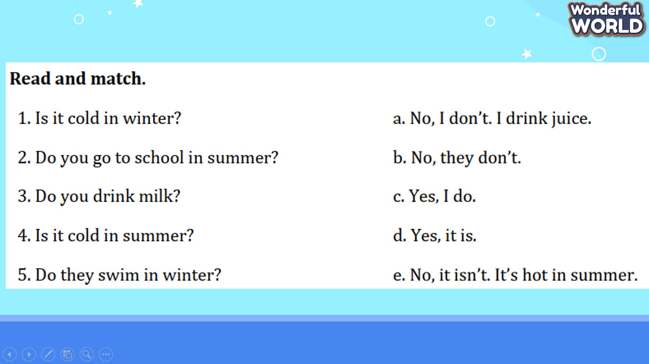  Check in pair then whole class.  - Say goodbye | - Do the assessment.  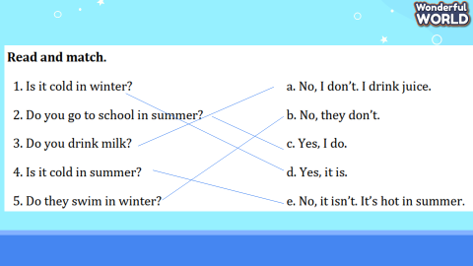  Check with friends and then with the teacher and the whole class.  - Say goodbye.
____________________________________
UNIT 10. OUR WORLD
Lesson 2 - Task 7,8,9
Period 119
I. OBJECTIVES:
1. Knowledge:
By the end of the lesson, students will be able to:
+ To practice asking about the weather and their activities.
2. Competences:
- English competences: Students will be able to ask and answer about the activities.
- Common competences: Students will have the opportunity to develop creativeness, carefulness in drawing and develop communication among friends.
3. Qualities:
- Students will be confident in talking about a favourite season and draw the
activities they do in this season.
II. EQUIPMENT AND MATERIALS:
- Basic things: Student’s book, flashcards, pieces of paper to draw.
- Advanced things: PPT, projector/interactive whiteboard/laptop/TV.
III. LESSON PROCEDURE:
Activity 1: Warm-up (5 minutes)

Teacher’s activities | Student’s activities
Rainbow Game  - Divide the class into 6 groups  - Hand each group a bell  - Introduce the game  - Set the game rules  - Open the number in turn  - Ask sts to ring the bell and give the answer  - The first correct answer gets the point  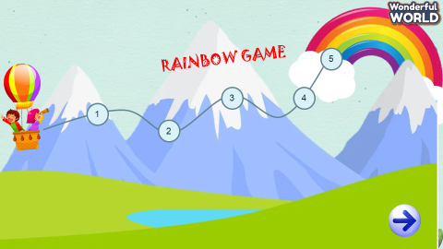  Keys :  1. Sunny  2.   3. winter  4. cold  5. rainy | - Form the groups  - Take the bell  - Listen to the game rules  - Ring the bell ans answer the question
Activity 2: Listening (12 minutes)
Teacher’s Activities | Teacher’s Activities
Task 7: Listen and tick  Pre-listening  -Set context: (Alex and his friend want to play outside. But they don’t know what activities they can do in this weather? Let’s help them find the answer by solving the listening task. The task as below)  Show the task  - Read and guess answers with students  - Give the guessing answer on the board  - Ask sts to listen and check whether their guesses are correct  While listening  - Ask sts to listen and tick  - Play audio twice  - Ask sts to give their answer as they heard  - Ask sts to check with a peer. Then check with the teacher  - Note: explain the key grammar point: It’s …. I …  - Show the answer  - Award the correct guessing  Post listening:  Fastest Pen Game  - Ask sts to work in 4 groups  - Ask each group to create 4 new information as in task 7  - Check with other groups  - Share your information with friends | Listen and tick  Listen and check  Work in groups
Activity 3: Writing (15 minutes)

Teacher’s activities | Student’s activities
Task 8: Write and say  Pre-writing: Reoder the words  - It’s/ summer./hot/ the/ in  - winter./ It’s/ in/ the/ cold/  - I/ hot/ go/ weather./ in/ swimming/  - My/ winter./ play/ the/ chess/ friends/ in/  - My/ shopping/ summer./ family/ go/ and/ I/ in hot/  Answer keys:  - It’s hot in the summer.  - It’s cold in the winter  - I go swimming in hot weather.  - My friends play chess in the winter  - My family and I go shopping in hot summer.  While writing:  - Ask sts to work in pairs  - Ask pairs to look at the sample sentences in the game and write their own answer.  - Give pairs time to practice writing  - Go around to support when needed  Post Writing  - Ask sts to share their writing with friends  - Do Window shopping talk: | - Listen to the teacher carefully  - Reorder the sentences in turn  - Do cross checking  - Pick a sentence and say aloud  - Work in pairs  - Write answer  - Do Window shopping talk
Activity 4: Production (9 minutes)

Teacher’s activities | Student’s activities
Season talking:  - Ask sts to draw a picture of 4 seasons and ask them to note the weather and the activities they do in those seasons.  - Give sts time to draw and note  - Share the picture with friends | - Draw the picture and say.
Activity 5: Assessment (3 minutes)
Teacher’s activities | Student’s activities
- Ask sts to do the assessment :  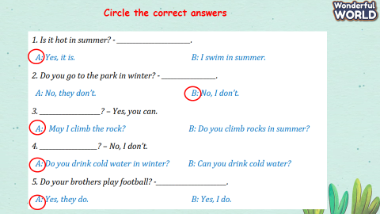  Check in pair then whole class.  - Say goodbye | - Do the assessment.  - Check with friends and then with the teacher and the whole class.  - Say goodbye.
____________________________________
UNIT 10. OUR WORLD
Lesson 3 - Task 1,2,3
Period 120
I. OBJECTIVES:
1. Knowledge:
Students will be able to :
+ To learn some vocabulary about seasons/ weather and the activities related to this weather.
+ To practice listening to and reading simple sentences about seasons/ weather and the activities related to this weather.
2. Competences:
- English competences: To talk about the nature, by using words
+Students will have the opportunity to develop the communication among friends
3. Qualities:
- Students will be friendly and confident in communicating with friends about the knowledge of seasons and weather, and creativeness in making crafts.
II. EQUIPMENT AND MATERIALS:
- For Teacher: PP, TV, flashcards, music, audio track
- For students: pictures, handout
III. LESSON PROCEDURE:
Activity 1: Warm-up (5 minutes)
Teacher’s activities | Student’s activities
Matching game:  (Teacher makes a PP slide that involves 6 words and 6 equivallent pictures about weather.  - Snowy  - Hot  - Cold  - Sunny  - Summer  - Winter  - Divide the sts into 6 groups  - Introduce the game  - Set the game rules  - Teams roll the dice to take turn to open a pair of number  - Give points to the matching pairs  - The team that gets most pairs will be the winner | - Listen to the teacher  - Form teams  - Roll the dice to take turn opening the numbers
Activity 2: Presentation (8 minutes)
Teacher’s activities | Student’s activities
Task 1: Listen, point and repeat.  Context: ask sts “How many seasons are there in a year? What are they? What’s the weather like in each season?) Leading new lesson  - Use the flashcards to give the new words.  - Ask Sts to look, listen to the words.  - Mime the words  - Ask sts to listen again and repeat, and do the action at the same time  - Ask sts to practise reading the word in pairs  Listen and match game  - Ask sts to work in groups  - Give each group a set of the four pictures  - Ask sts to listen and pick up the picture. Then say the words aloud  - The first correct answer gets the point  Audio:  - Autum  - Dry  - Spring  - wet | - Listen to teachet  - Listen and repeat  - Listen, mime and repeat  - Practise with friends  - From groups  - Get the set of pictures  - Listen and pick up the right piture  - Read the word aloud
Activity 3: Practice (12 minutes)
Teacher’s activities | Student’s activities
Season festival  - Show 4 seasons of the year on screen  - Ask sts in groups to add at least 1 adjective and 2 favourite activities for each season.  - Ask the group to do a gallery walk  Task 2: Listen and match  Context: Ana’s family often does many different activities in different seasons. Listen and match what they do.  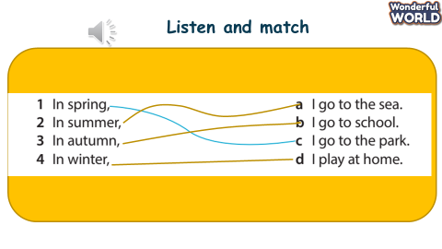  - Introduce the task  - Ask sts to guess the answer  - Play the audio twice for sts to listen and match  - Ask sts to give the answer  - Play the audio again and check  - Sts do peer checking  Read and match  - Form sts into 8 groups  - Show the pictures of task 2 one by one  - Ask sts to exploit the pictures  - Show the reading  - Ask groups to read and match  - Check the answer in front of the class  - Ask sts to read out loud the reading  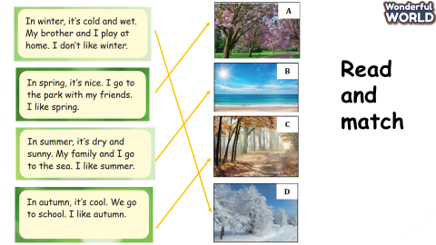 | - Add ADJ and activities for each season  - Do gallery walk  - Listen to teacher  - Guess the answer  - Listen and match  - Do peer checking  - Sit in groups  - Look at the pictures and exploit them  - Read and match  - Read the text aloud
Activity 4: Production (7 minutes )
Teacher’s activities | Student’s activities
Speaking contest  - Ask sts to use the product in season festival to speak  - Ask sts to work in pairs  - One st says the weather/ season – the latter says the activity  - Change the role | - Work in pairs  - Produce the speaking  - Change the role
Activity 5: Assessment (3 minutes )
Teacher’s activities | Student’s activities
Ask students to do the assessment.  - Fill in the blanks  - Check in pair then whole class.  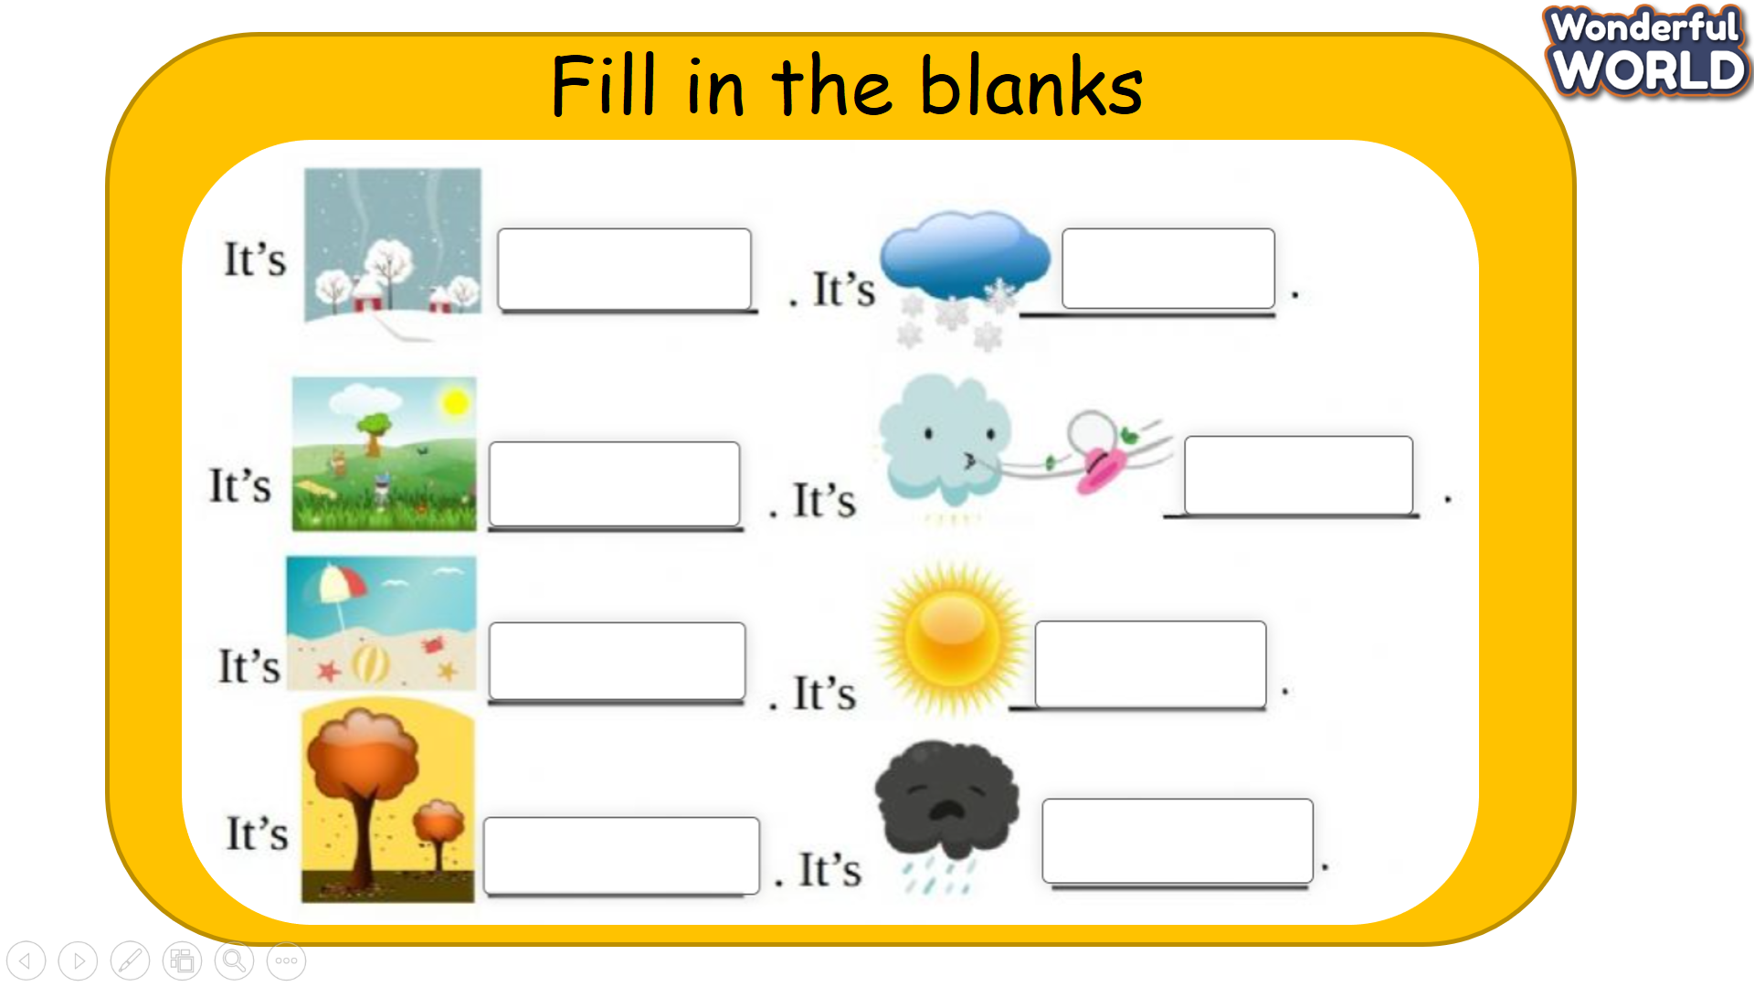  - Say goodbye. | Do the assessment.  - Check with friends and then with the teacher and the whole class.  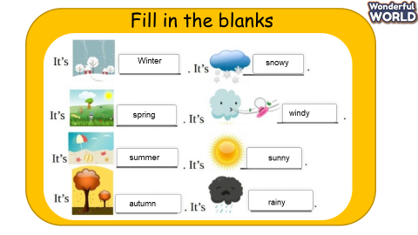  - Say goodbye.

GRADE 5
Week 30
Unit 11. ANIMALS
Lesson 2 - Part 1,2,3
Period 117
I. OBJECTIVES:
1. Knowledge:
Vocabulary:
be together, care for, cheetah, cub, friendship, unusual
2. Competences:
- English competences: Students will identify words relating to animals and listen to and read a passage about the friendship between two animals
- Common competences: Students can imagine and write about the friendship between two animals
3. Qualities:
- Students will
+ Understand more about the animals.
+ Experience and Imagine the real life of the animals
II. EQUIPMENT AND MATERIALS:
- Basic things: Student’s book, flashcards, photos, papers
- Advanced things: PPT, laptop, TV.
III. LESSON PROCEDURE:
Activity 1: Warm-up (5 minutes)
Game: TOP 5 QUIZ ANIMAS
Aims: Welcome students. Warm the class up with a game to check their knowledge and widen their understanding about the planet and lead in the
Teacher’s Activities | Students’ Activities
Read the question and write ONE answer.  If your answer is in the“ TOP 5” answer, then you get points.  1: Name one of the biggest animals in the world.  2 Name one of the smartest animals in the world.  3. Name an animal that lives in Australia.  4. Name a Big Cat  5. Name one of the fastest animals in the world.  This activity helps Ss widen their knowledge about animals and lead in the animal in the passage “ A CHEETAH” by asking them some questions :  Suggested questions :  What’s your favourite animal?  Have you seen these animals in real life?  Have you seen a cheetah | - Greet Teacher  - Join the activity.
Activity 2: Presentation – Controlled practice (8 minutes)
a. Aims: Ss can practice listening and writing skills about the topic: life on the International Space Station
Teacher’s Activities | Students’ Activities
-T says: Let’s read a story of a cheetah.  -Listen and read to learn about unusual animal friendships. Which animal is the cheetah’s good friend? TR: 11.4  -Tell students that they are going to read about unusual animal friendships. Ask them to read quickly and find out the names of the sets of friends (Pancake and Dayo, Kasi and Mtani).  -Play the recording twice.  -Have students listen and read the texts chorally and individually.  -Call on three students to read the texts out loud and check pronunciation if necessary.  -Have students read the texts again and answer the questions.  -Call on two students to share answers and give feedback.  Expected answers: Dogs are cheetah’s good friends. / The dog is the cheetah’s good friend  Then circle these new words to elicit :  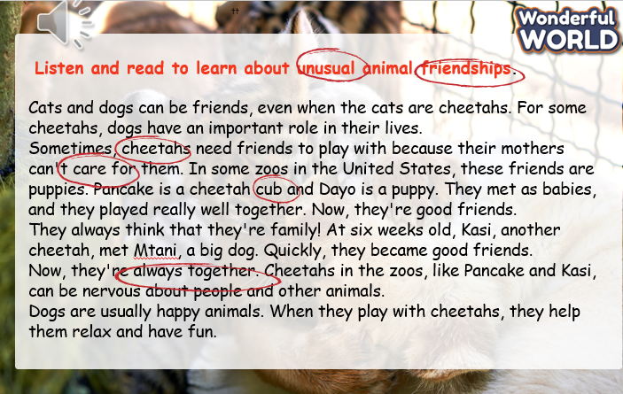  2 Listen, point, and repeat  - Ask students to look at five pictures, explain what they see, and guess the meaning of each word/phrase.  - Check their understanding if necessary.  - Play the recording.  - Have students listen and point to each picture in the textbook along with the recording.  - Play the recording again and ask students to listen, point to each picture, and repeat.  - Call on some students to read each word/phrase out loud. | - Read  - Listen  - Read  - Listen. Point and repeat.
Activity 3: Practice – Controlled practice (8 minutes)
GAME: TRUE or FALSE
a. Aims: Ss can remember the new words.
Teacher’s Activities | Students’ Activities
Read the passage again and choose “ TRUE” or “: FALSE”  1. It’s unusual for cats and dogs to be friends.  TRUE  2. The dogs are important to the cheetahs in the zoos. TRUE  3. The cheetahs’ mothers care for them and the dogs. FALSE  4. Mtani and Dayo are good friends. FALSE  5. People put dogs with cheetahs to help them relax. TRUE | - Answer the questions.
Activity 4: Production – Free practice (6 minutes)
a. Aims:
Apply their understanding in writing the friendship between the animals.
Teacher’s Activities | Students’ Activities
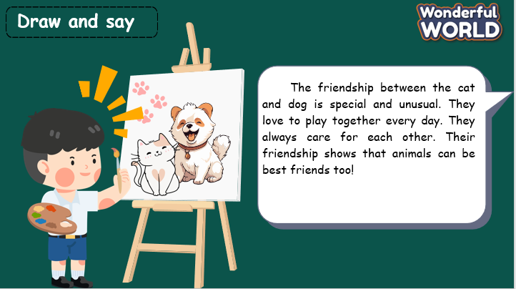 | - Follow the teacher.  - Write  - Introduce
Activity 5: Wrap up & Assessment (4 minutes)
Teacher’s Activities | Students’ Activities
Aims:
- Check students’s understanding of what they have learnt.
-Ask sts to do the assessment.  -T gives the assessment to the class and some Ss.  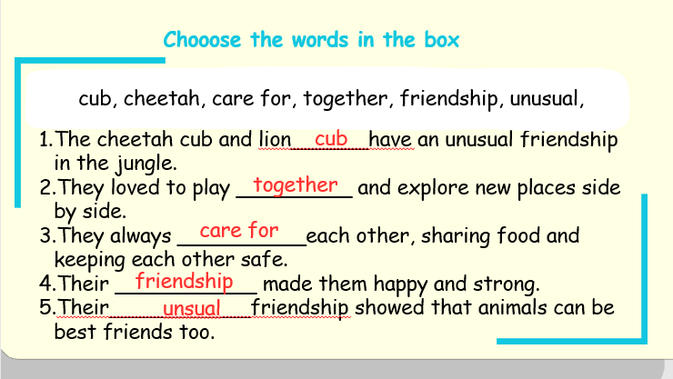  - Check with the class.  - Wrap-up  * Remember  Vocabulary:  be together, care for, cheetah, cub, friendship, unusual | - Do the assessment.  - Check with the teacher  - Sts read the wrap-up  - Stand up and say goodbye to the teacher.

UNIT 11. ANIMALS
Lesson 2 – Part 4,5,6
Period 118

I. OBJECTIVES:
1. Knowledge:
Students review words relating to animals and learn and use “to” to express purposes
2. Competences:
- English competences: Students can use English to talk about the animals,
- Common competences: Students can learn and use “ to” to express purpose.
3. Qualities:
- Students will
+ show their love towards animals.
II. EQUIPMENT AND MATERIALS:
- Basic things: Student’s book, flashcards, photos, papers
- Advanced things: PPT, laptop, TV.
III. LESSON PROCEDURE:
Activity 1: Warm-up (5 minutes)
ANIMAL QUIZ
 | Aims: Welcome students. Warm the class up with a game to recall the animals.
 | Teacher’s Activities | Students’ Activities
 | Greet Students  T: Do you want to play games? Now, Let’s play the quiz game.  - Guess the animal by its skin.  Cheetah  - Guess the animal by its eyes  Macaw  - What is the only animal that can not jump?  Elephant  - What land animal has the biggest mouth?  Hippopotamus  - In some zoos, people put dogs with cheetahs to help them fight.  FALSE | Greet teacher  Join the activity.
Activity 3: Presentation – Controlled practice (8 minutes)
a. Aims: Ss can learn and use “to” to express purposes
Teacher’s Activities |  | Students’ Activities
 | Explain: We use “ to + infinitive” to talk about our goal or purpose.  4 Listen and read. Then match.  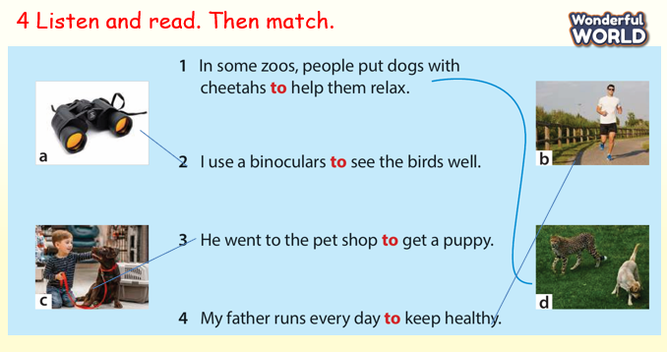  - Ask students to look at five pictures and elicit the pictures.  - Play the recording.  - Have students listen and repeat the sentences chorally and individually.  - Tell the students that they are going to match the sentences to the correct pictures. Explain that we can use “to + infinitive ” to talk about our goal or purpose.  - Divide the students into pairs to do the matching task. • Show students how to do the task if necessary by asking them to observe how the first word is matched with the correct picture. • Check the answers as a class.  Keys: 2 a 3 c 4 b | - Join the activity.
Activity 3: Practice – Controlled practice (8 minutes)
a. Aims: Ss can learn to use “to” to express purposes
Teacher’s Activities |  | Students’ Activities
GAME: Put the words in the correct order to make sentences.  How to play :  Divide into 2 teams: red team and blue team.  Gameplay:  Each team takes turns answering questions.  If a team answers correctly, they roll a dice to determine how many steps they move forward on the board.  The team then clicks on their circle to advance.  Objective:  The goal is for a team to reach the destination first.  Winning:  The first team to reach the destination is the winner.  Answer keys:  - They often go to the beach to swim.  - We went to the zoo to see animals.  - She plays the piano after school to relax.  - Cheetah cubs need friends to play with.  - He bought some eggs to make a cake.  - My mother uses a torch to light the house. |  | - Join the game  - Answer the questions.
Activity 4: Production – Free practice (6 minutes)
a. Aims:
Apply their understanding in giving the ideas.
Teacher’s Activities |  | Students’ Activities
6 Complete these sentences with your ideas. Then share with your friends.  - Ask students to look at Activity 6.  - Tell students that they are going to read each sentence carefully and complete the sentence with their ideas.  - Give students 10 minutes to complete this task, then share it with their partner.  - Call on some students to share answers and give feedback.  Suggested answers:  1. I went to the supermarket to buy some food.  2. My mother uses a torch to light the house.  3. I need a computer to write my letter.  4. We should eat a lot of vegetables and fruits to have good health.  5. The father penguin keeps the eggs on his feet to keep them warm  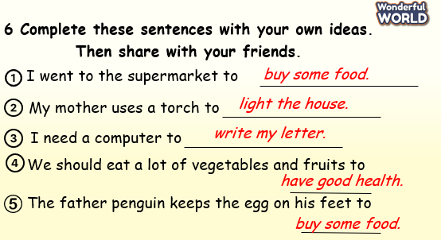 |  | - Complete these sentences with your ideas.  - Share with your friends.
Activity 5: Wrap up & Assessment (4 minutes)
Teacher’s Activities |  | Students’ Activities
Aims:
- Check students’s understanding of what they have learned.
- Students rehearse what they have learned in the lesson.
Asks sts to do the assessment.  T gives the assessment to the class and some Ss  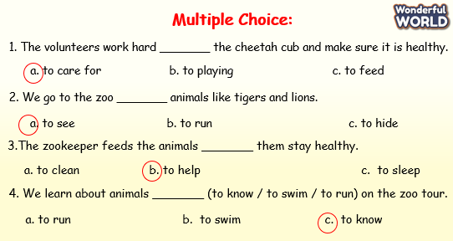  - Check with the class.  - Wrap-up  * Remember  Review Vocabulary:  be together, care for, cheetah, friendship, cub, unusual  Grammar: To + Verb (purpose) |  | - Do the assessment.  - Check with the teacher  - Sts read the wrap-up  - Stand up and say goodbye to the teacher.

UNIT 11: ANIMALS
Lesson 3 - Part 1,2,3
Period 119

I. OBJECTIVES:
1. Knowledge:
- Review new vocabulary and structure of the previous lesson.
- Extra vocabulary related to animals in the reading text.
2. Competences:
By the end of the lesson, students will be able to talk about their favourite animals.
3. Qualities:
- Students develop listening and reading skills.
- Students use vocab and structures to describe animals accurately.
II. EQUIPMENT AND MATERIALS:
- Basic things: Student’s book, flashcards, photos.
- Advanced things: PPT, laptop, TV.
III. LESSON PROCEDURE:
Activity 1: Warm-up (6 minutes)
A guessing game “ Unscramble the words ”
Aims: - Warm up the class with an “Unscramble the words” game to review some vocabulary on the topic of animals such as puppy, monkey, rabbit.
- Check Ss’ spelling of vocabulary in the topic animals.
- Lead in the topic
 | Teacher’s Activities | Students’ Activities
 | Procedure
 | 1. Greet Ss. Chatting…  “Do you like playing games?”  2. Introduce the game:  - Ask Ss to play the “Unscramble the words” game to revise vocabulary.  - T shows the task and some letters are given.  - Ask Ss to reorder the letters to make correct words.  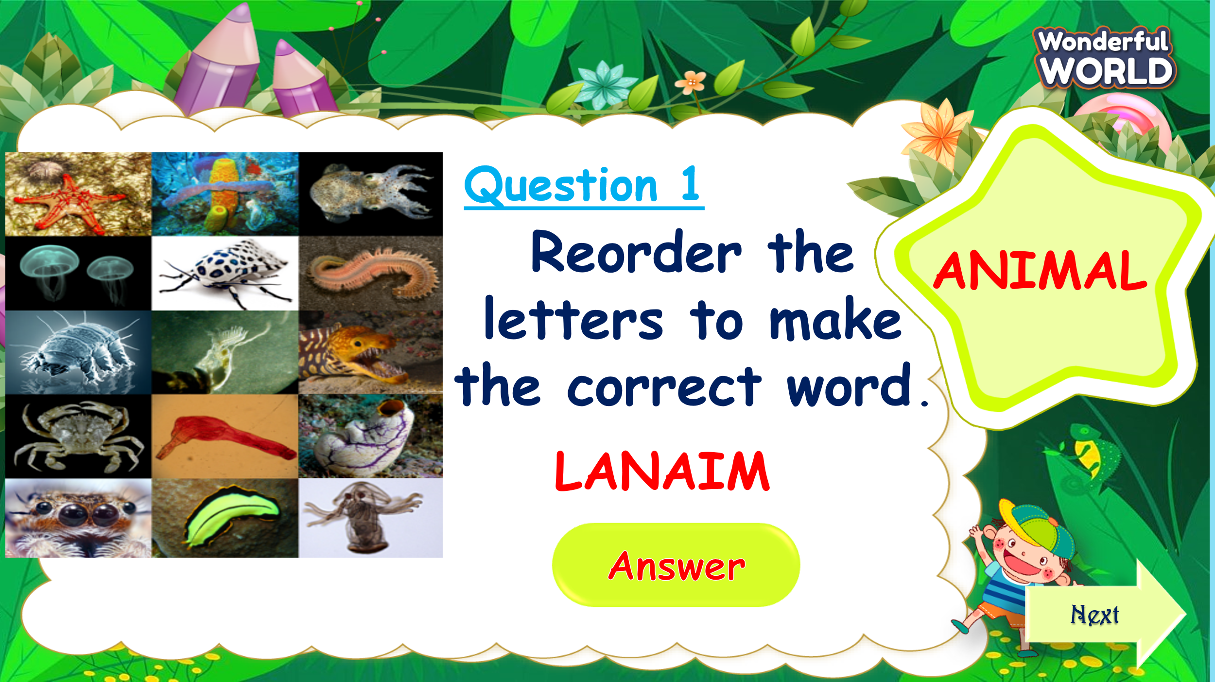  “Teacher will show some letters, you will reorder them to make the correct words. If you have the correct answer, you can roll the dice to gain stars for your team.”  - Let Ss join the game and lead in the topic and write it down on the board.  3. Play the game:  - 4 turns to play using 4 words/flashcards: animal, puppy, rabbit, monkey.  4. Lead in the new lesson:  Unit 11 – Lesson 3 Parts 1,2,3 | - Greet Teacher  - Listen to T’s instructions for the game.  - Join the activity.  - Look at the question and reorder the words.  - Say the answers out loud.  - Roll the dice to get stars if they have correct answers.  -Write down the new topic in their notebooks and say the topic aloud.
Activity 2: Presentation (10 minutes)
Aims:- Ss understand the meaning and say some text correctly about three clever animals.
- Finish part 1 – listen and read, then answer the question about their favourite animals and the reason for it.
Teacher’s Activities |  | Students’ Activities
Lead in: Let's look at the picture and answer the question.  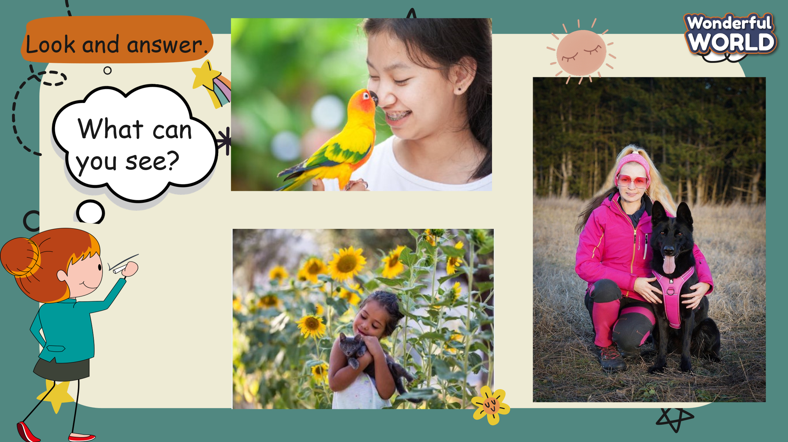  - T shows Ss some pictures and asks them about what they can see.  “What can you see in this picture? Which animals are there?  Part 1. Listen and read.  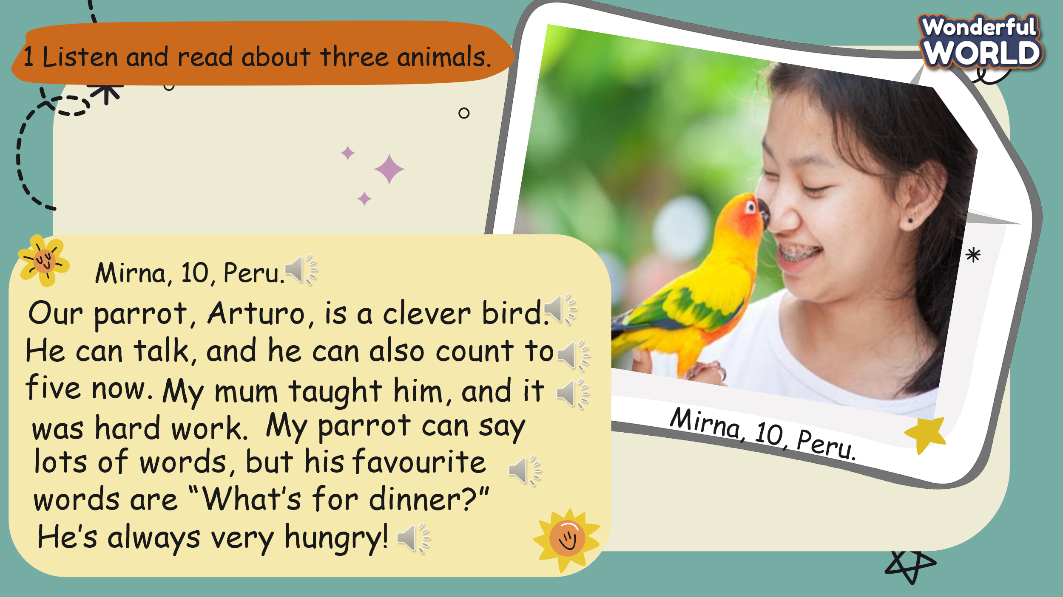  - Show the pictures and sentences on the screen.  - Play the recording 11.7. Pause after each sentence for Ss to repeat.  - Play the recording 11.7 again. Then ask Ss to read out the texts chorally and individually.  - Call three Ss to read three texts out loud and check their pronunciation.  - Have Ss look at the text again and take part in the Choosing game.  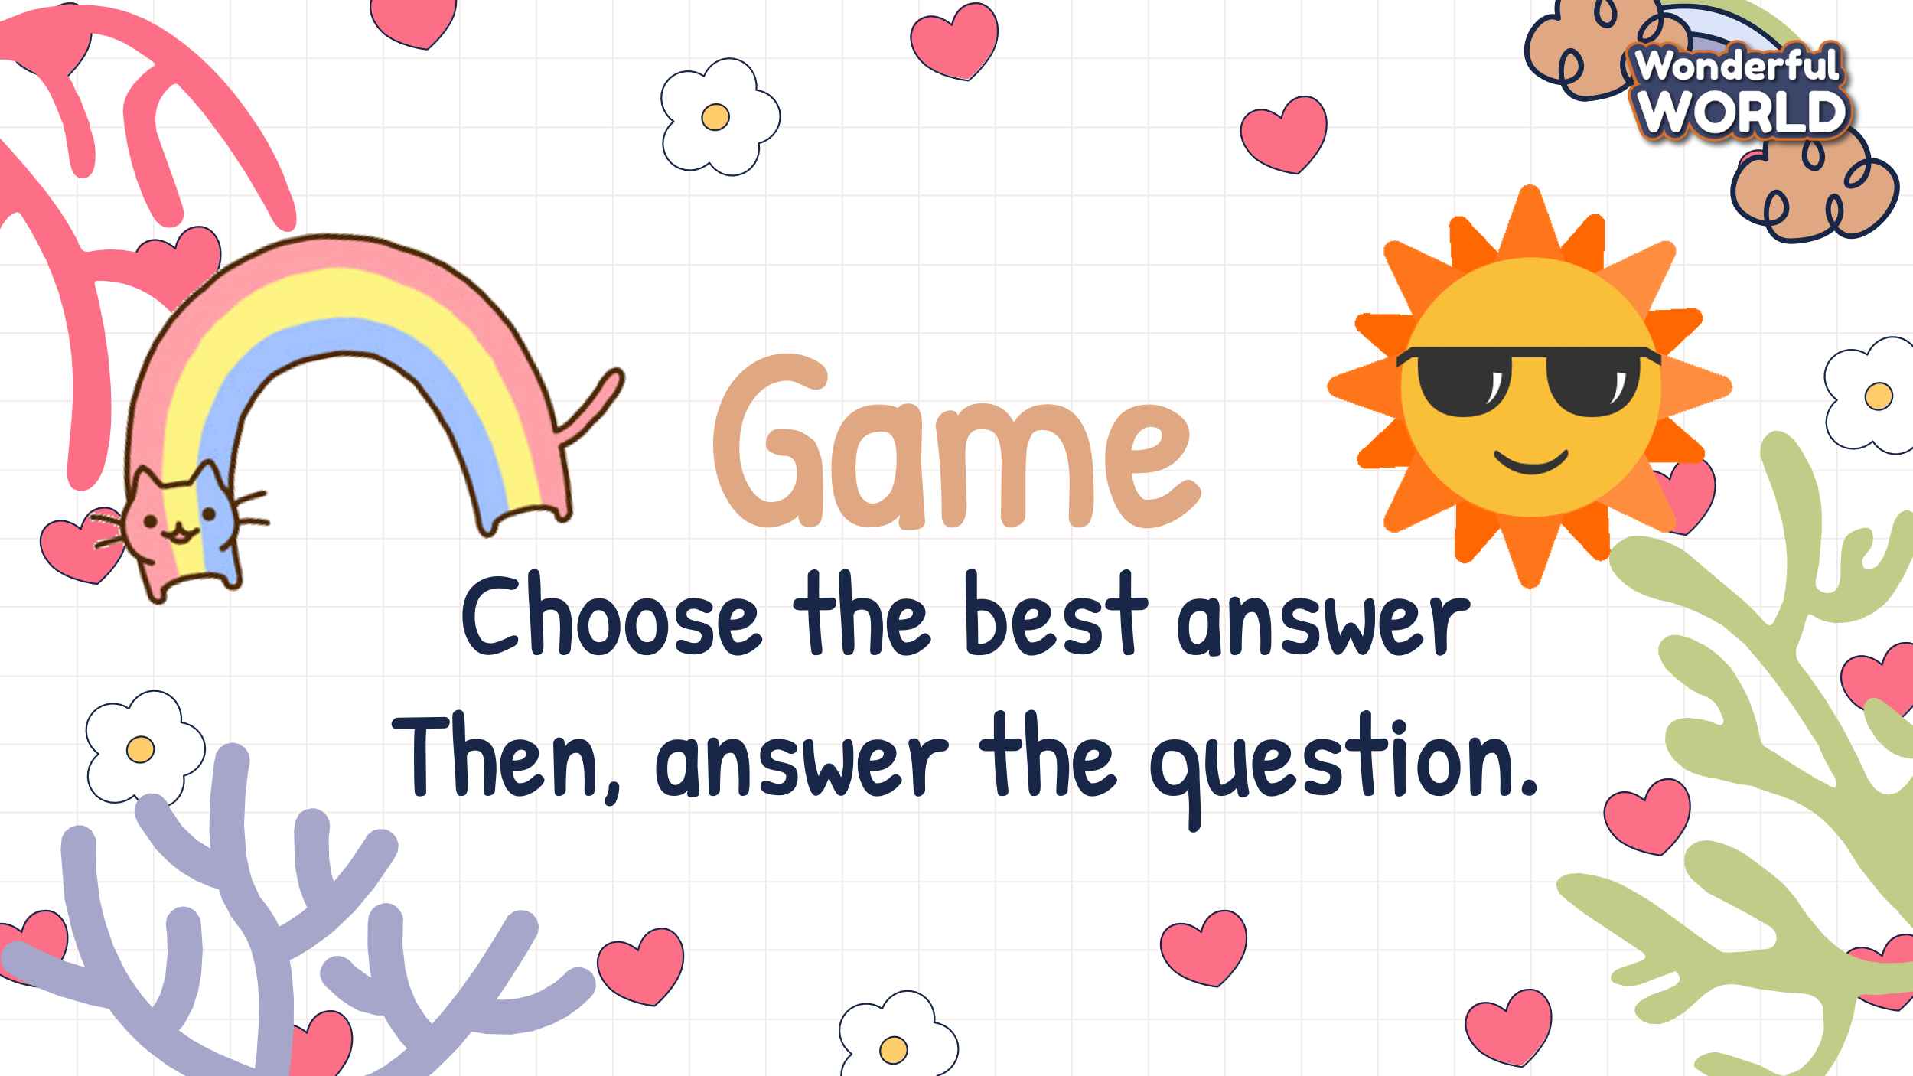  - Have four Ss answer the questions and share the reason why they love those animals. Then give the feedback.  - T shows questions, answers, and three pictures. Ss can look at the pictures, read the whole Q&A, then choose the correct pictures.  - After that, they answer the question about the reason why they like that animal.  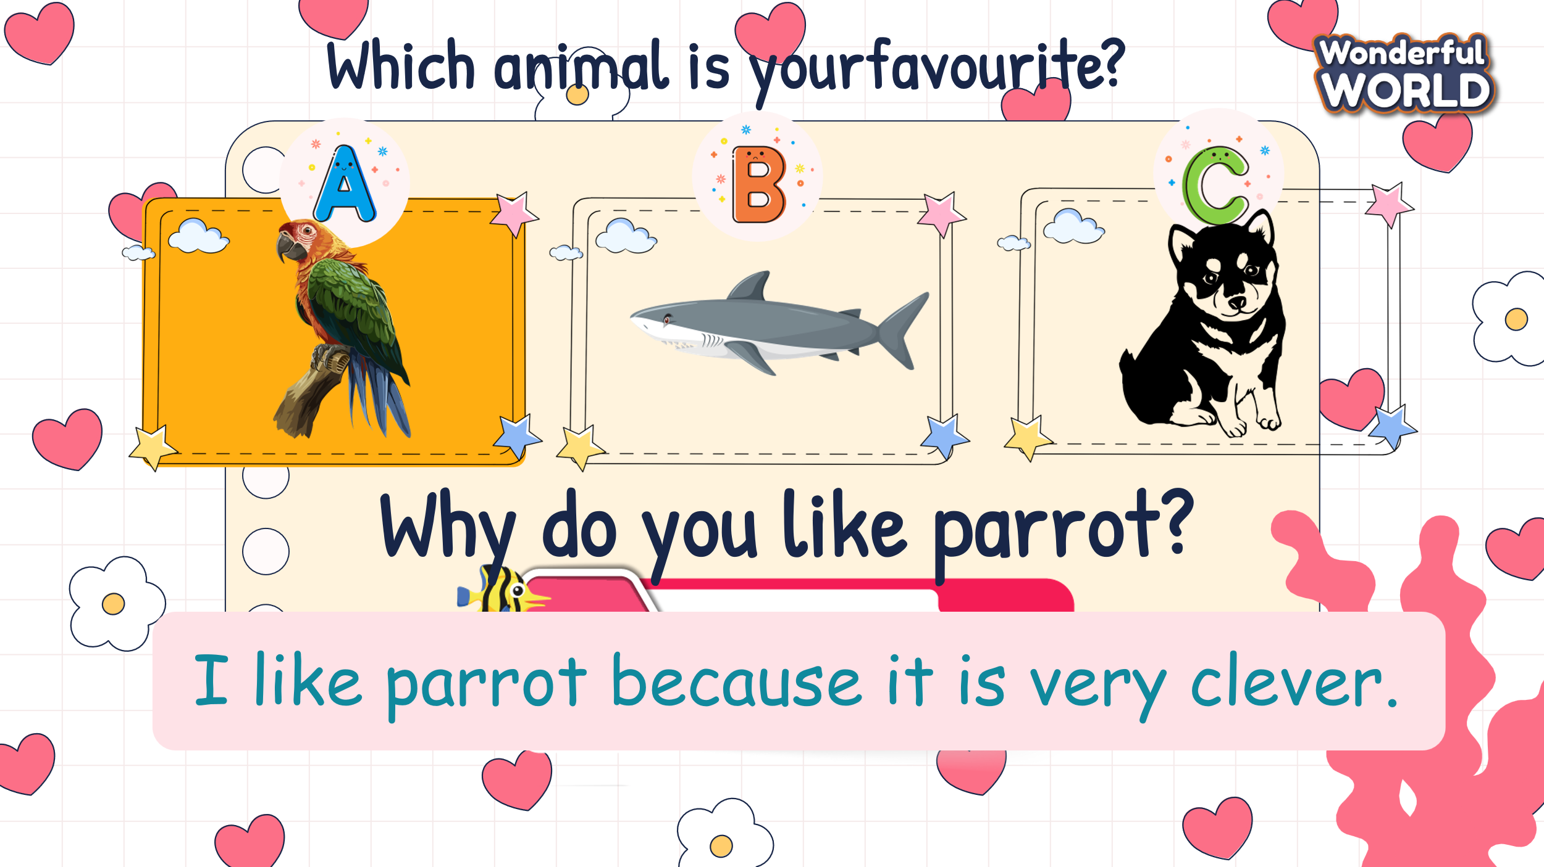  - If they have correct answers, they can roll the dice to get stars. |  | - Ss can look at the picture and answer about what they can see such as:  I see a girl with her parrot.  I see a dog and a cat.  - Ss listen to the recording and repeat sentences after each pausing.  - Ss read out a sentence from the text again.  - 3 Ss read aloud three texts and others check their pronunciation.  - Ss read some texts again.  - Take part in the game.  - They look at the questions, answers, and three pictures.  - Choose the correct pictures.  - Answer the question about the reason why they like that animal.  - Ss can roll the dice if they have the correct answer.
Activity 3: Practice – Controlled practice (6 minutes)
Aims: - Ss can practice new words through reading and writing skills.
- Finish task 2 – Read and complete the table.

Teacher’s Activities |  | Students’ Activities
- Let's listen and read the text again.  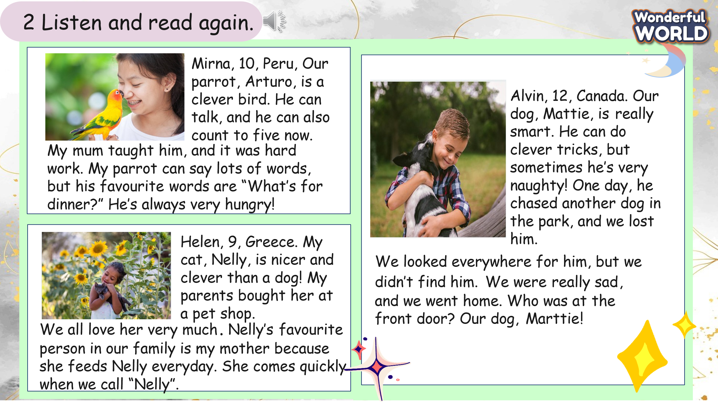  - Call some Ss to read the text aloud, and look at the table.  - Find some keywords of names, kinds of animals, and the things they can do.  - Elicit what gaps need 3 heads.  - Tell Ss to complete the table, and remind them to re-read the text to find out the correct answers.  - Check Ss understand the task and do one example for them.  - Give Ss 5 minutes to complete the task.  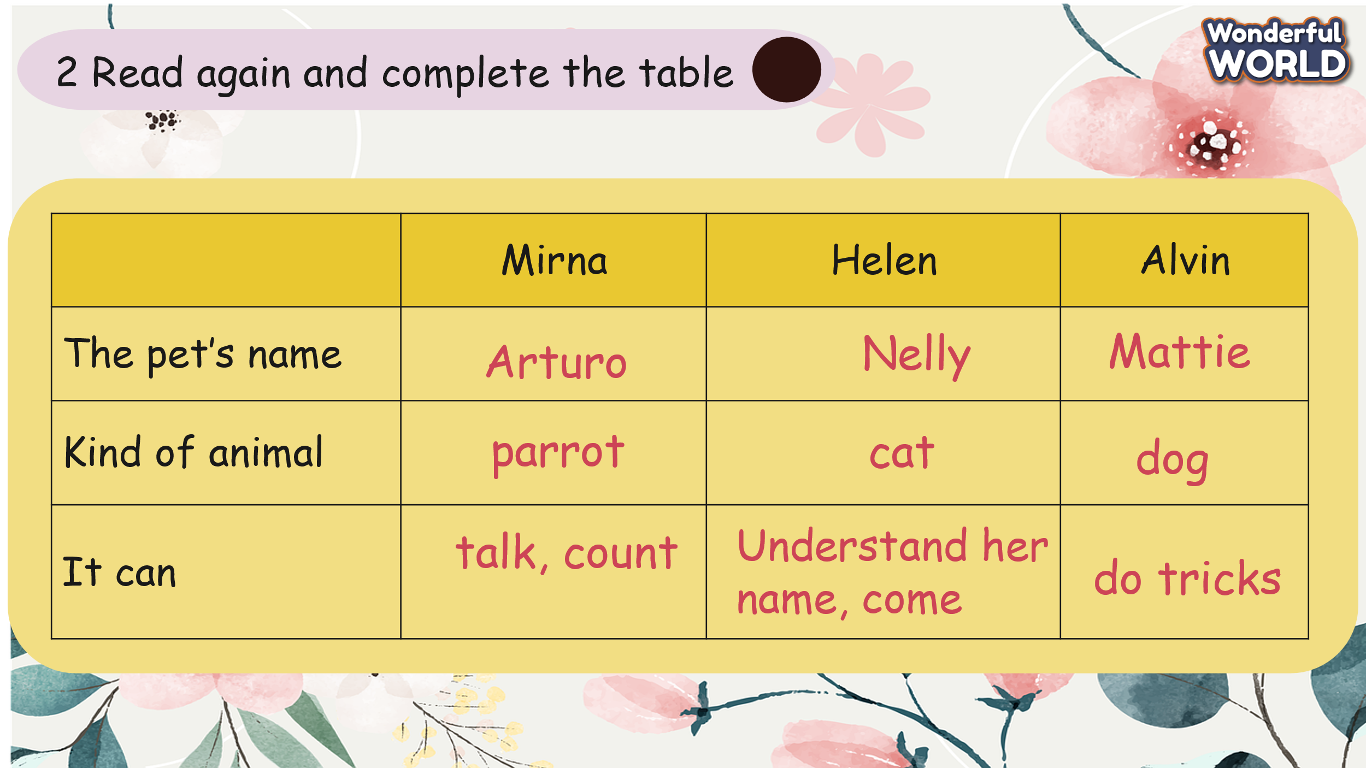  - Have Ss work in pairs to check the results of partners.  - Check the answers as a whole class. |  | - Ss listen to the audio again.  - Some Ss read the text  - They look at the table.  - Find some keywords of three heads in texts.  - Ss do the task individually.  - Check their friend’s books.  - Check the final answers for the whole class.
Activity 4: Production – Free practice (9 minutes)
Aims: - Apply the new words to talk about their favourite animal.
- Encourage sts to answer and make full sentences through the dialogue.

Teacher’s Activities |  | Students’ Activities
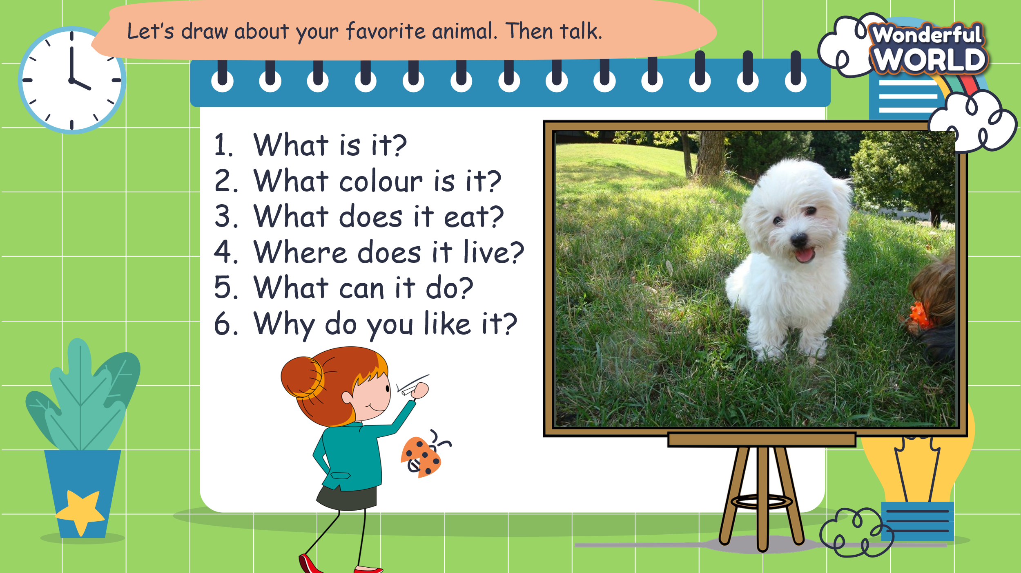  - T shows Ss a picture and some questions.  - Ask them to guess the answers individually.  - Then let Ss do the example. Some Ss can ask, and some others answer the questions.  -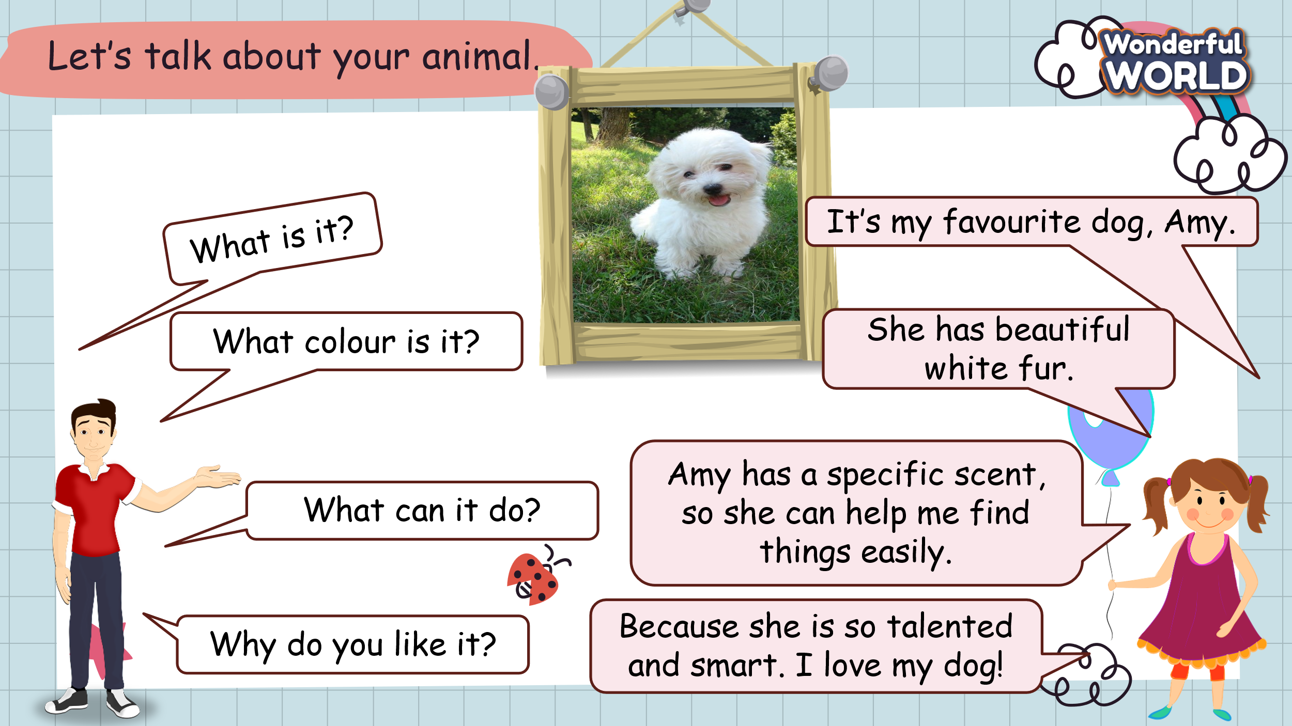  - Give them 5 minutes to make a dialogue of their favourite animal using the given questions and model dialogue.  - Ss work in pairs, one Ss asks, and the other answers about favourite animal using model sentences.  - Then, Ss can swap the role to make a dialogue.  - Ask some pairs to come to the board and make a dialogue to talk about their favourite animal. |  | - Ss look at the picture and guess the answers.  - Some Ss read the questions, and some others read the answers.  - Ss make their dialogue, using the given question and model dialogue.  - Ss can bring a picture or draw their favourite animal.  - They work in pairs and swap roles to make a dialogue.  - Some pairs come to the board and read aloud.
Activity 5: Wrap up & Assessment (4 minutes)
Teacher’s Activities |  | Students’ Activities
Aims:
- Check student's understanding of what they have learned.
- Students rehearse what they have learned in the lesson.
Asks sts to do the assessment.  -T gives the assessment to the class and some Ss can answer them.  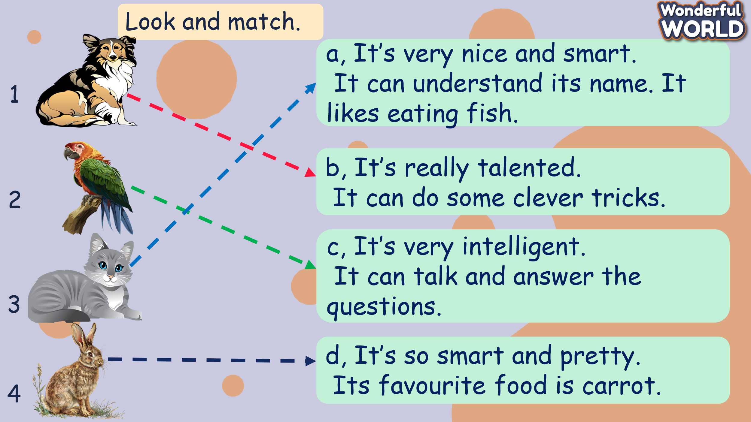  - Check with the class.  - Wrap-up  * Remember  VOCABULARY  dog, cat, parrot, animal, clever, smart  STRUCTURE  1. Which animal is your favourite? – My favourite animal is…  2. Why do you like it?- I like it because it is … . |  | - Do the assessment.  - Check with the teacher  - Sts read the wrap-up  - Stand up and say goodbye to the teacher.

UNIT 11: ANIMALS
Lesson 3 - Part 4,5,6
Period 120

I. OBJECTIVES:
1. Knowledge:
- Grammar: the adverb “ really”, the position of “really” in sentences.
2. Competences:
By the end of the lesson, students will be able to:
- use the adverb: “really” in the sentences
- talk about their favourite animals using the adverb “really”.
3. Qualities:
- Students use the adverb “really” accurately.
- Students know the correct position of ‘really” in sentences.
II. EQUIPMENT AND MATERIALS:
- Basic things: Student’s book, flashcards, photos.
- Advanced things: PPT, laptop, TV.
III. LESSON PROCEDURE:

Activity 1: Warm-up (5 minutes)
A guessing game “ At the laundry ?”
 | Aims: Warm up the class with an “At the laundry” game using some vocabulary such as butterfly, lizard, flamingo, peacock and lead in the new lesson.
 | Teacher’s Activities | Students’ Activities
 | Procedure
 | 1. Greet students. Chatting…  “Do you like playing games?”  2. Introduce the game:  - Ask Ss to play the “At the laundry” game to revise the vocabulary.  - T shows the questions and pictures.  - Let Ss guess what animal it is and answer the question on time.  - If they have the correct answer, they can roll the dice to get stars.  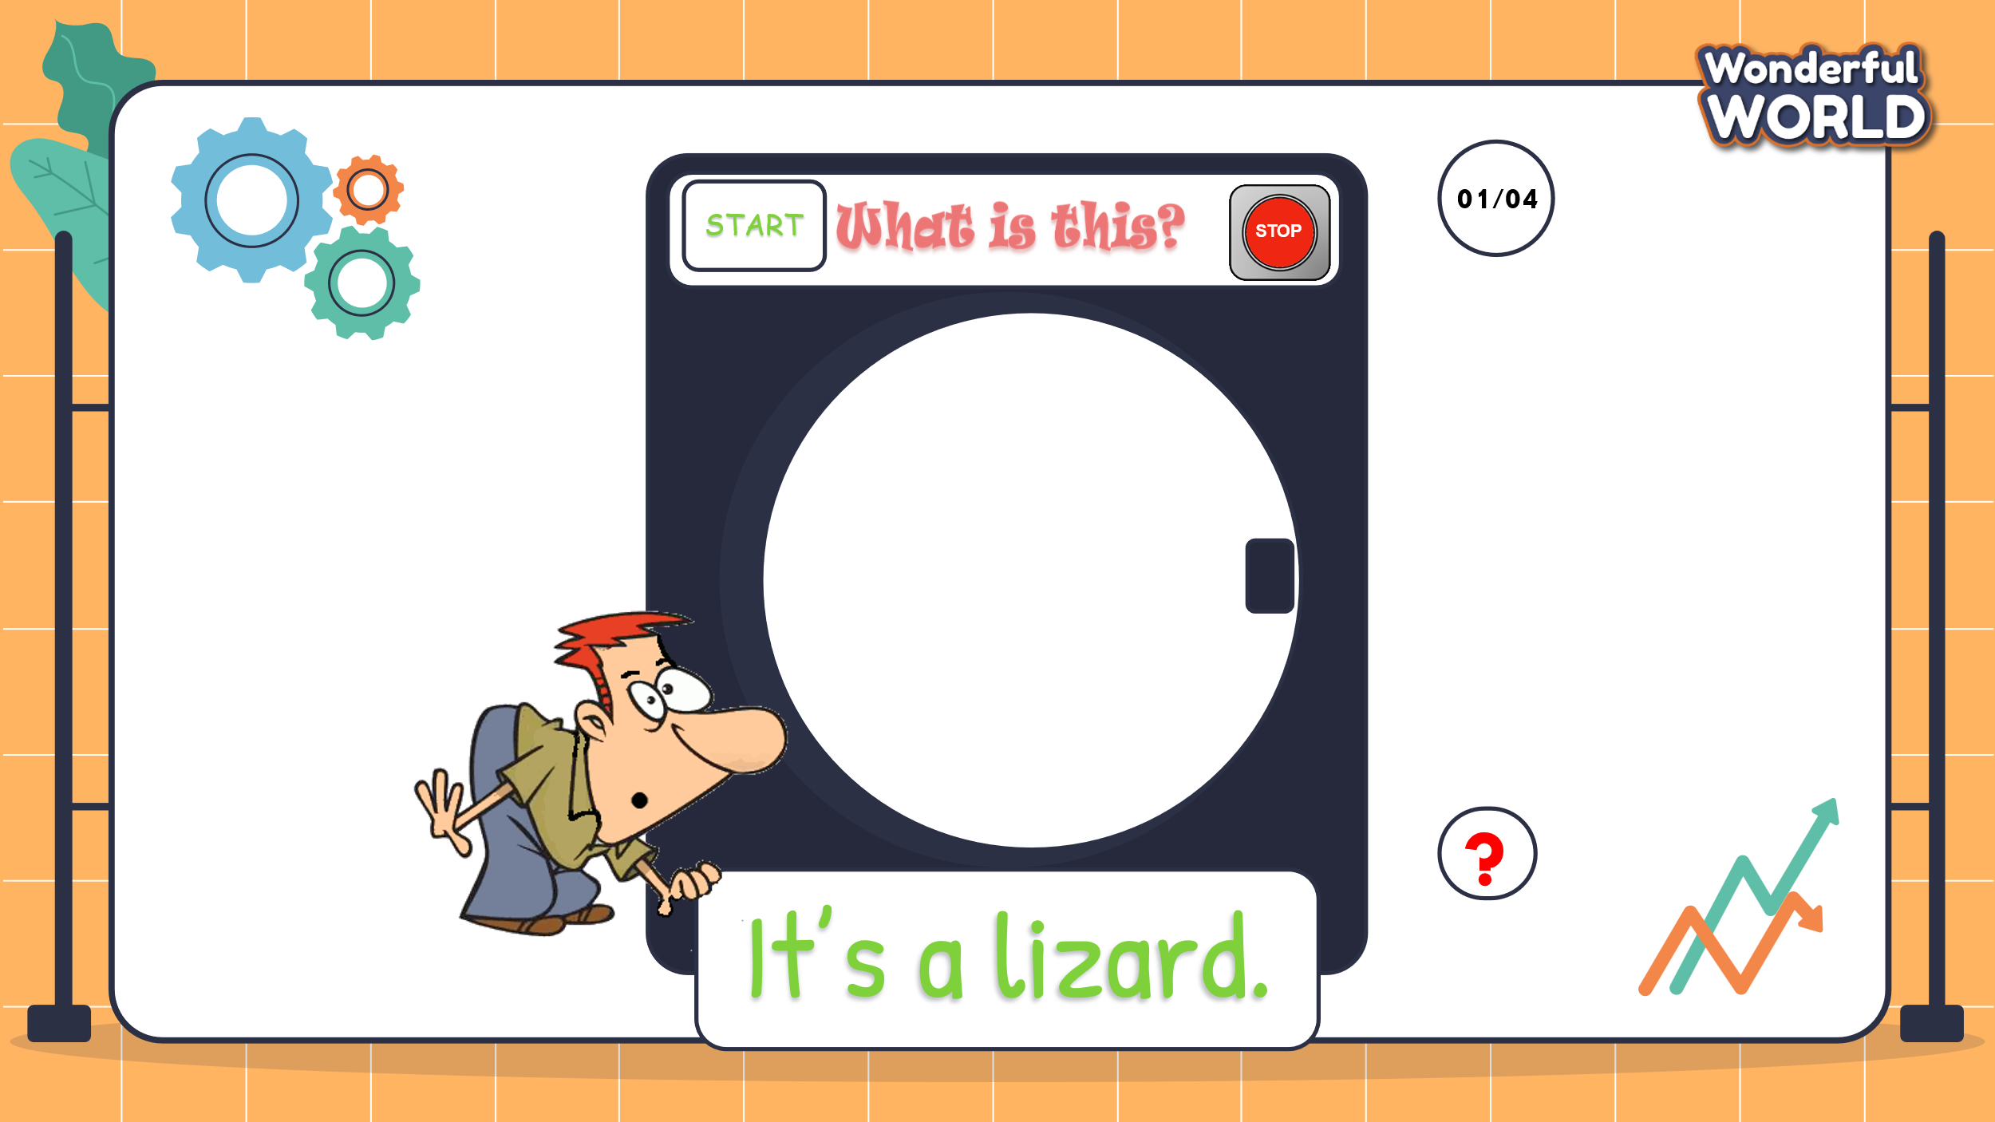  -“The teacher will show some questions and pictures. You can guess what animal it is. If you have the correct answer, you can roll the dice to get stars.”  - Let students join the game and lead in the topic and write it down on the board.  3. Play the game:  - 4 turns to play using 4 words/flashcards: lizard, flamingo, butterfly, peacock.  4. Lead in the new lesson:  Unit 11 – Lesson 3 parts 4,5,6 | - Greet Teacher  - Ss answers: “Yes”  - Join the activity.  - Look at the question and guess about the animal.  - Give the correct answers.  - Ss roll the dice to get stars if they have correct answers.
Activity 2: Presentation (10 minutes)
a. Aims:- Ss understand the meaning and pronounce correctly new structures using really.
- Finish part 4 – listen and read
Teacher’s Activities |  | Students’ Activities
Lead in: Let Ss join the “Good Delivery” game to learn about the new structure. (4’)  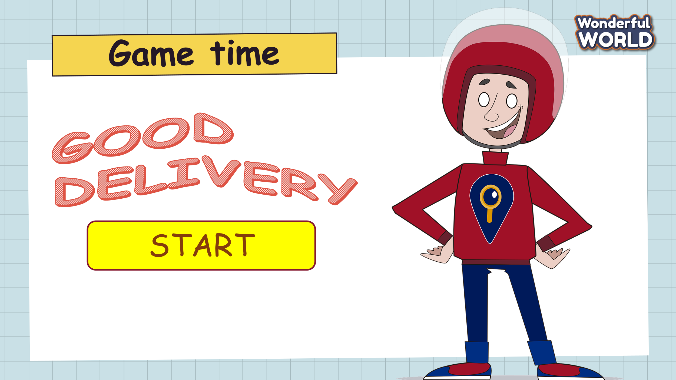  - T shows Ss a picture with some letters given.  - Ask them to look at the pictures and reorder the given letters to make the correct words.  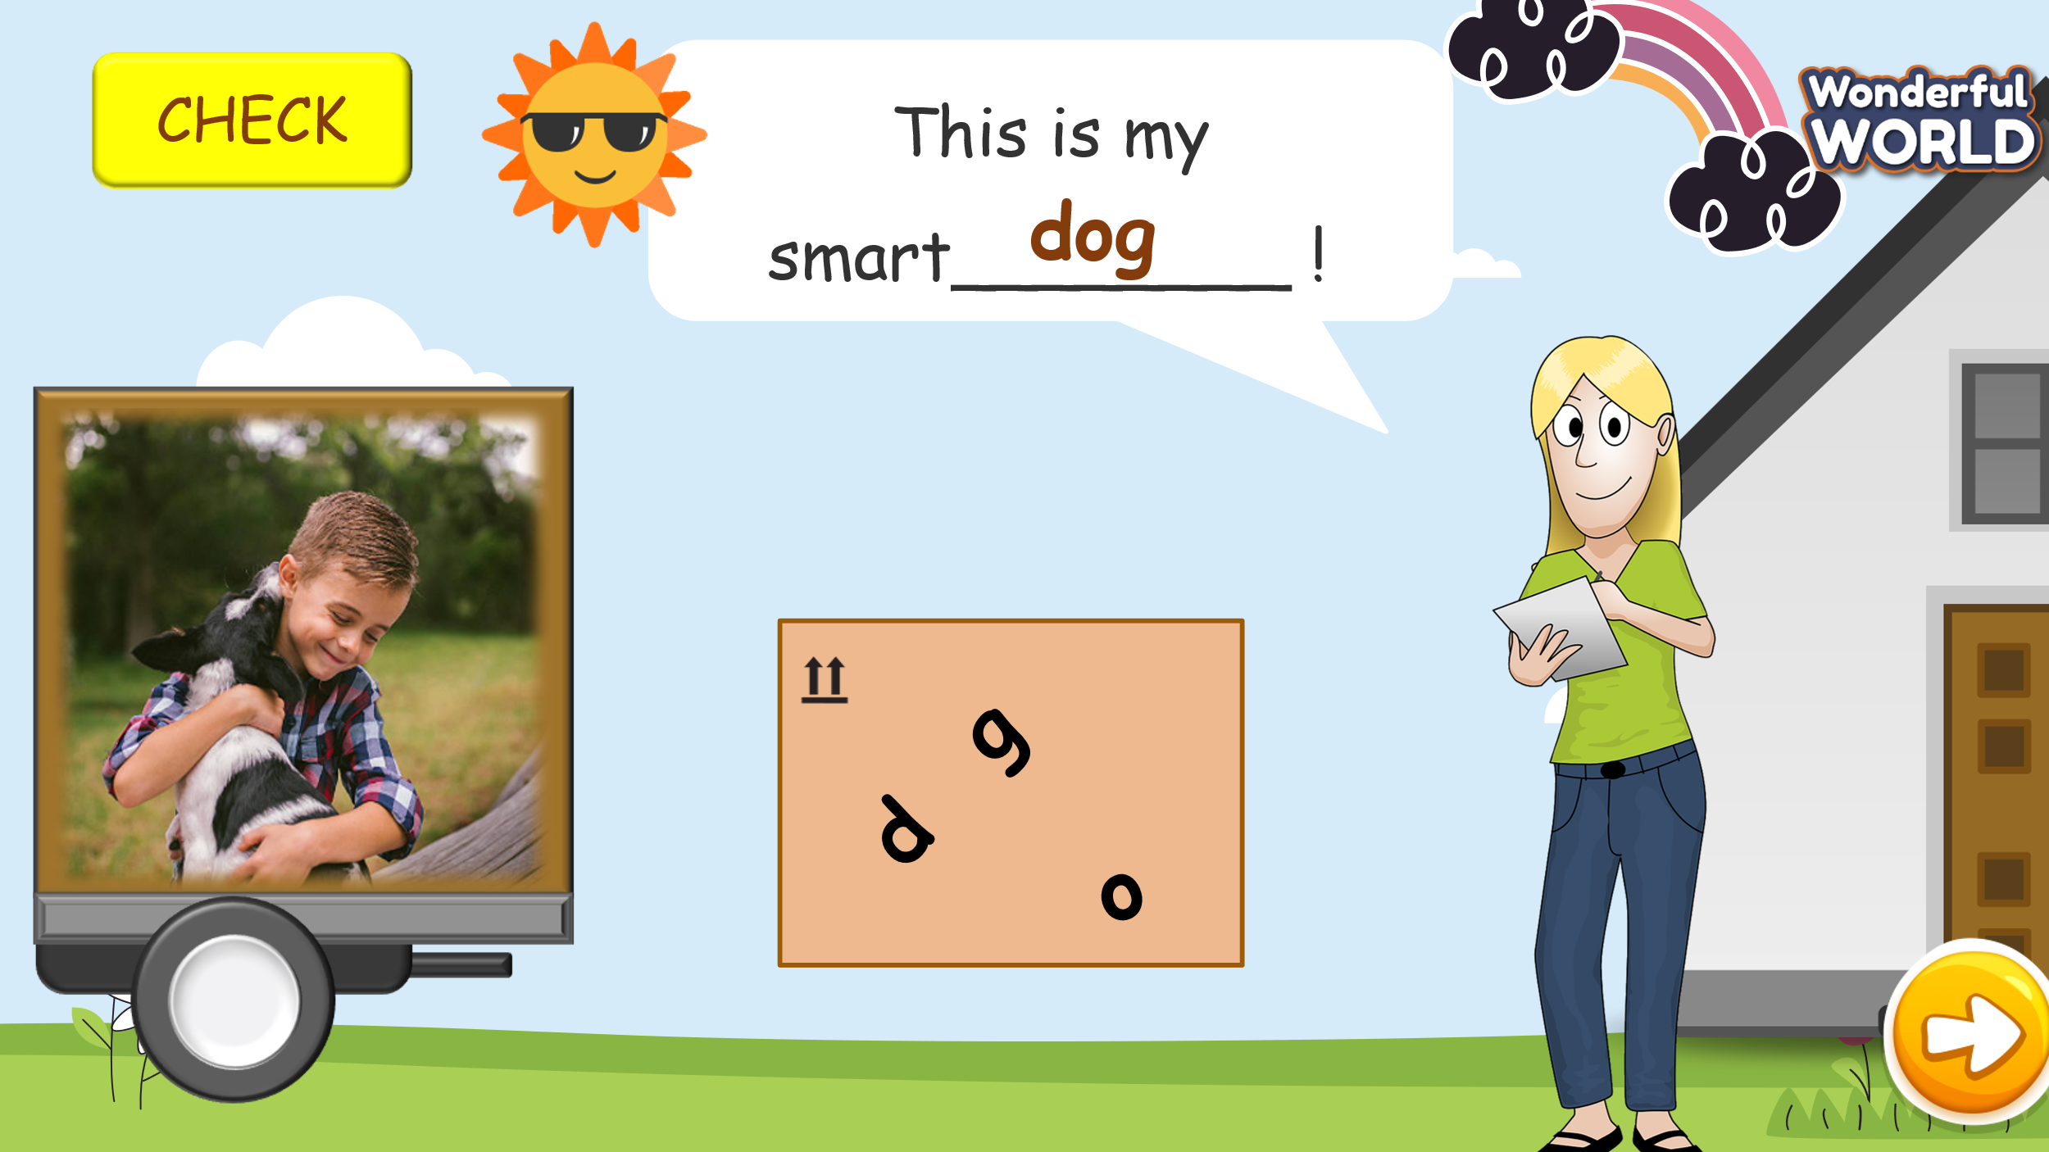  “Look at the pictures and reorder the given letters to make correct words to fill in the blank.”  “If you have correct answers, you can through the dart to get stars.”  - After participating in the game, Ss can guess what grammar they have learnt.  - Show Ss the structures and let them write them down in their notebooks.  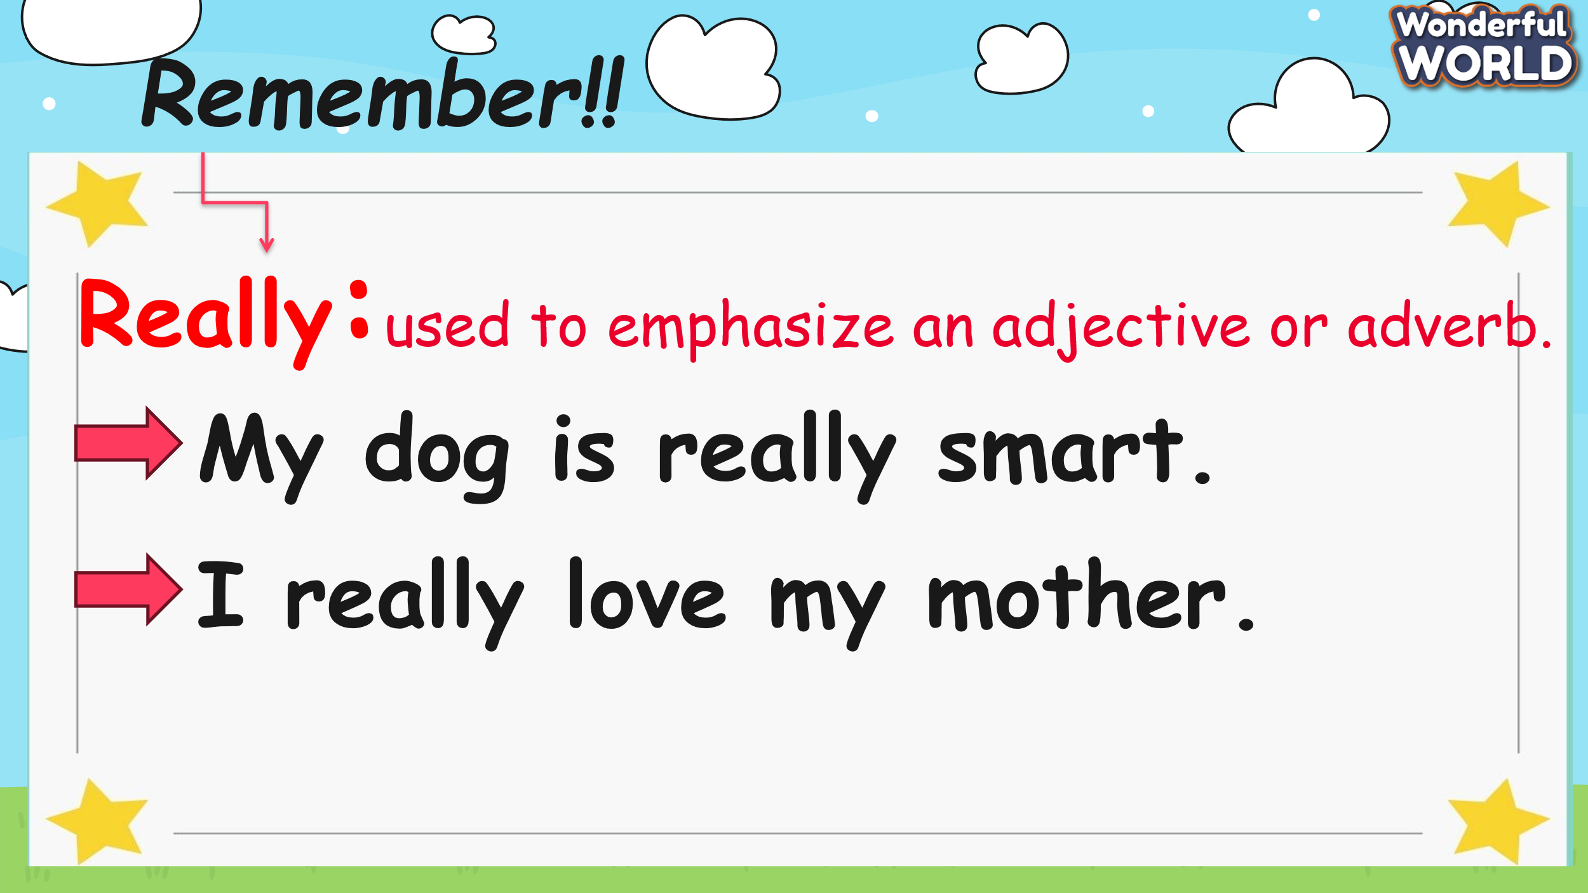  Part 4. Listen and circle(6’)  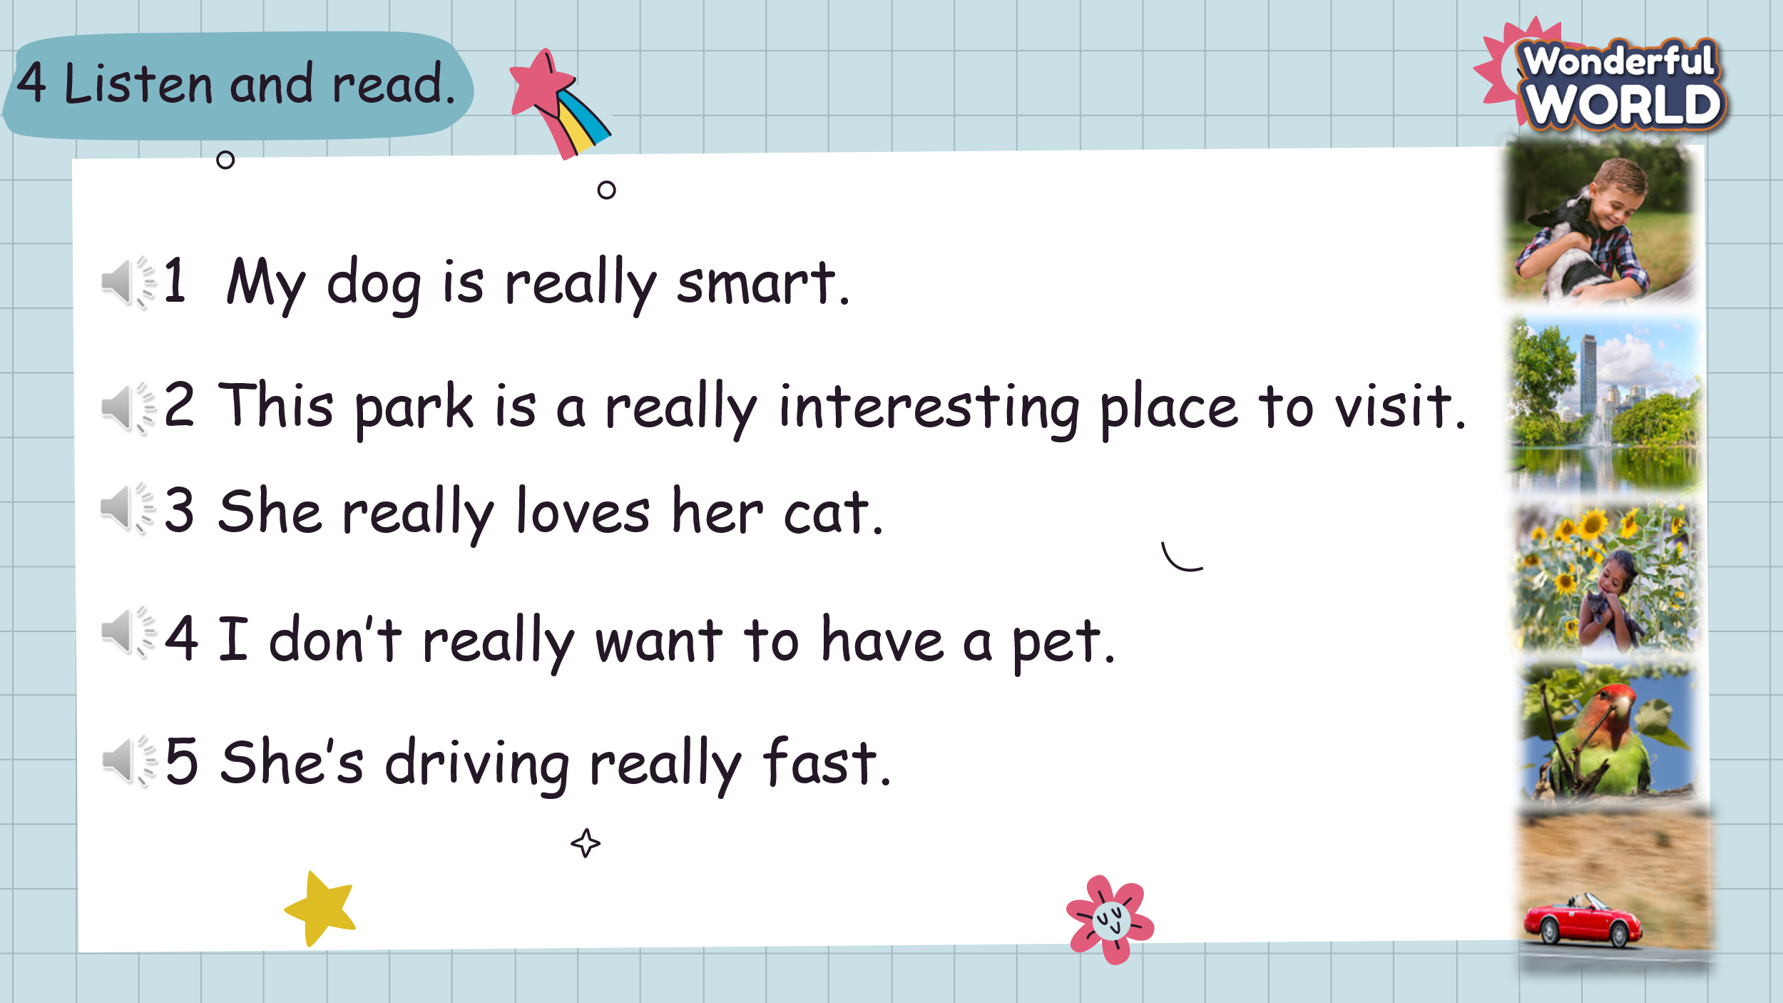  - Show the pictures and sentences on the screen.  - Tell students to look at the photo and say what they can see.  What can you see?  - Ask students to look at the first sentence. Read the sentence.  - Listen to the recording and repeat.  - Have Ss work in pairs and take turns to practice reading each sentence.  -Call some Ss to read each sentence out aloud and check their pronunciation. |  | - Ss participate in the game.  - Raise your hand and reorder the letters.  - Answer the questions and through the dart to get stars.  - Guess what structure that we learn.  - Read the structures a loud.  - Write the new structures on their notebooks.  - Look at the picture and answer the question:  I can a dog, a park, and a girl holding a cat, ….  - Look at the first sentence, listen, and read aloud  - Ss listen and read individually and in pairs.  - Then, some Ss come to the board and read out aloud.  - Others can check their pronunciation.
Activity 3: Practice – Controlled practice (10 minutes)
Aims: - Ss can practice using really through writing skills.
- Finish task 5 – Find and correct a mistake in each sentence.
Teacher’s Activities |  | Students’ Activities
- Let’s Ss participate in the “Catch a butterfly” game to learn about how to use really.  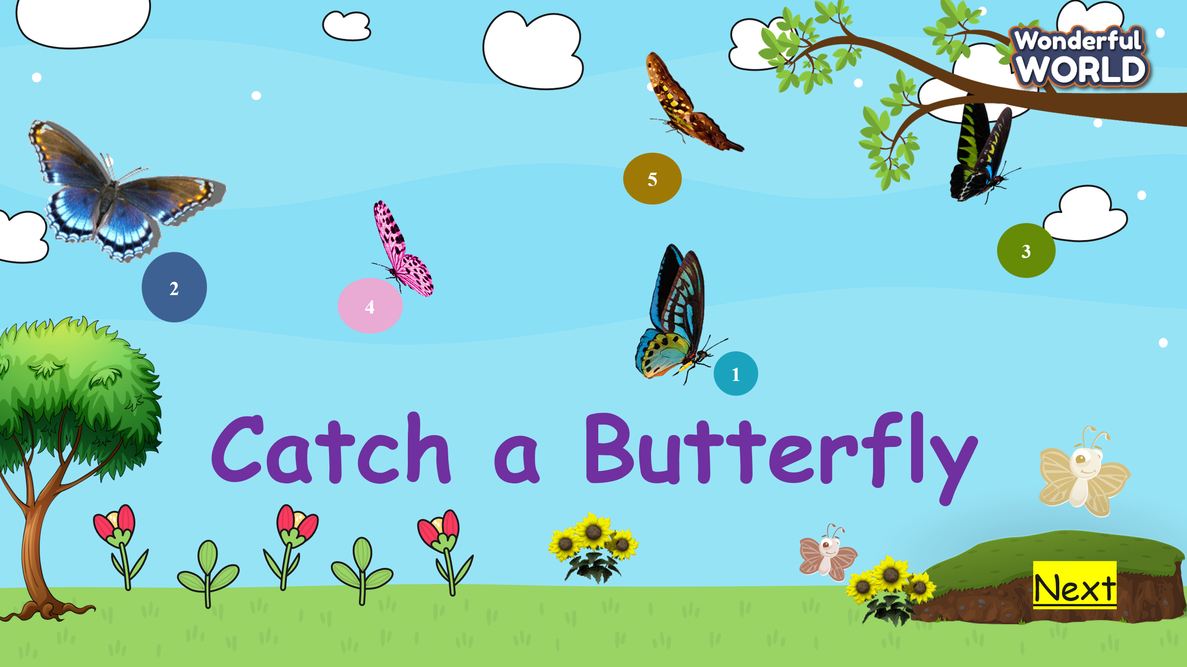  - T asks Ss to look at pictures and numbers. They can choose the numbers, and answer the questions.  - If they have the correct answer, they can get some different stars.  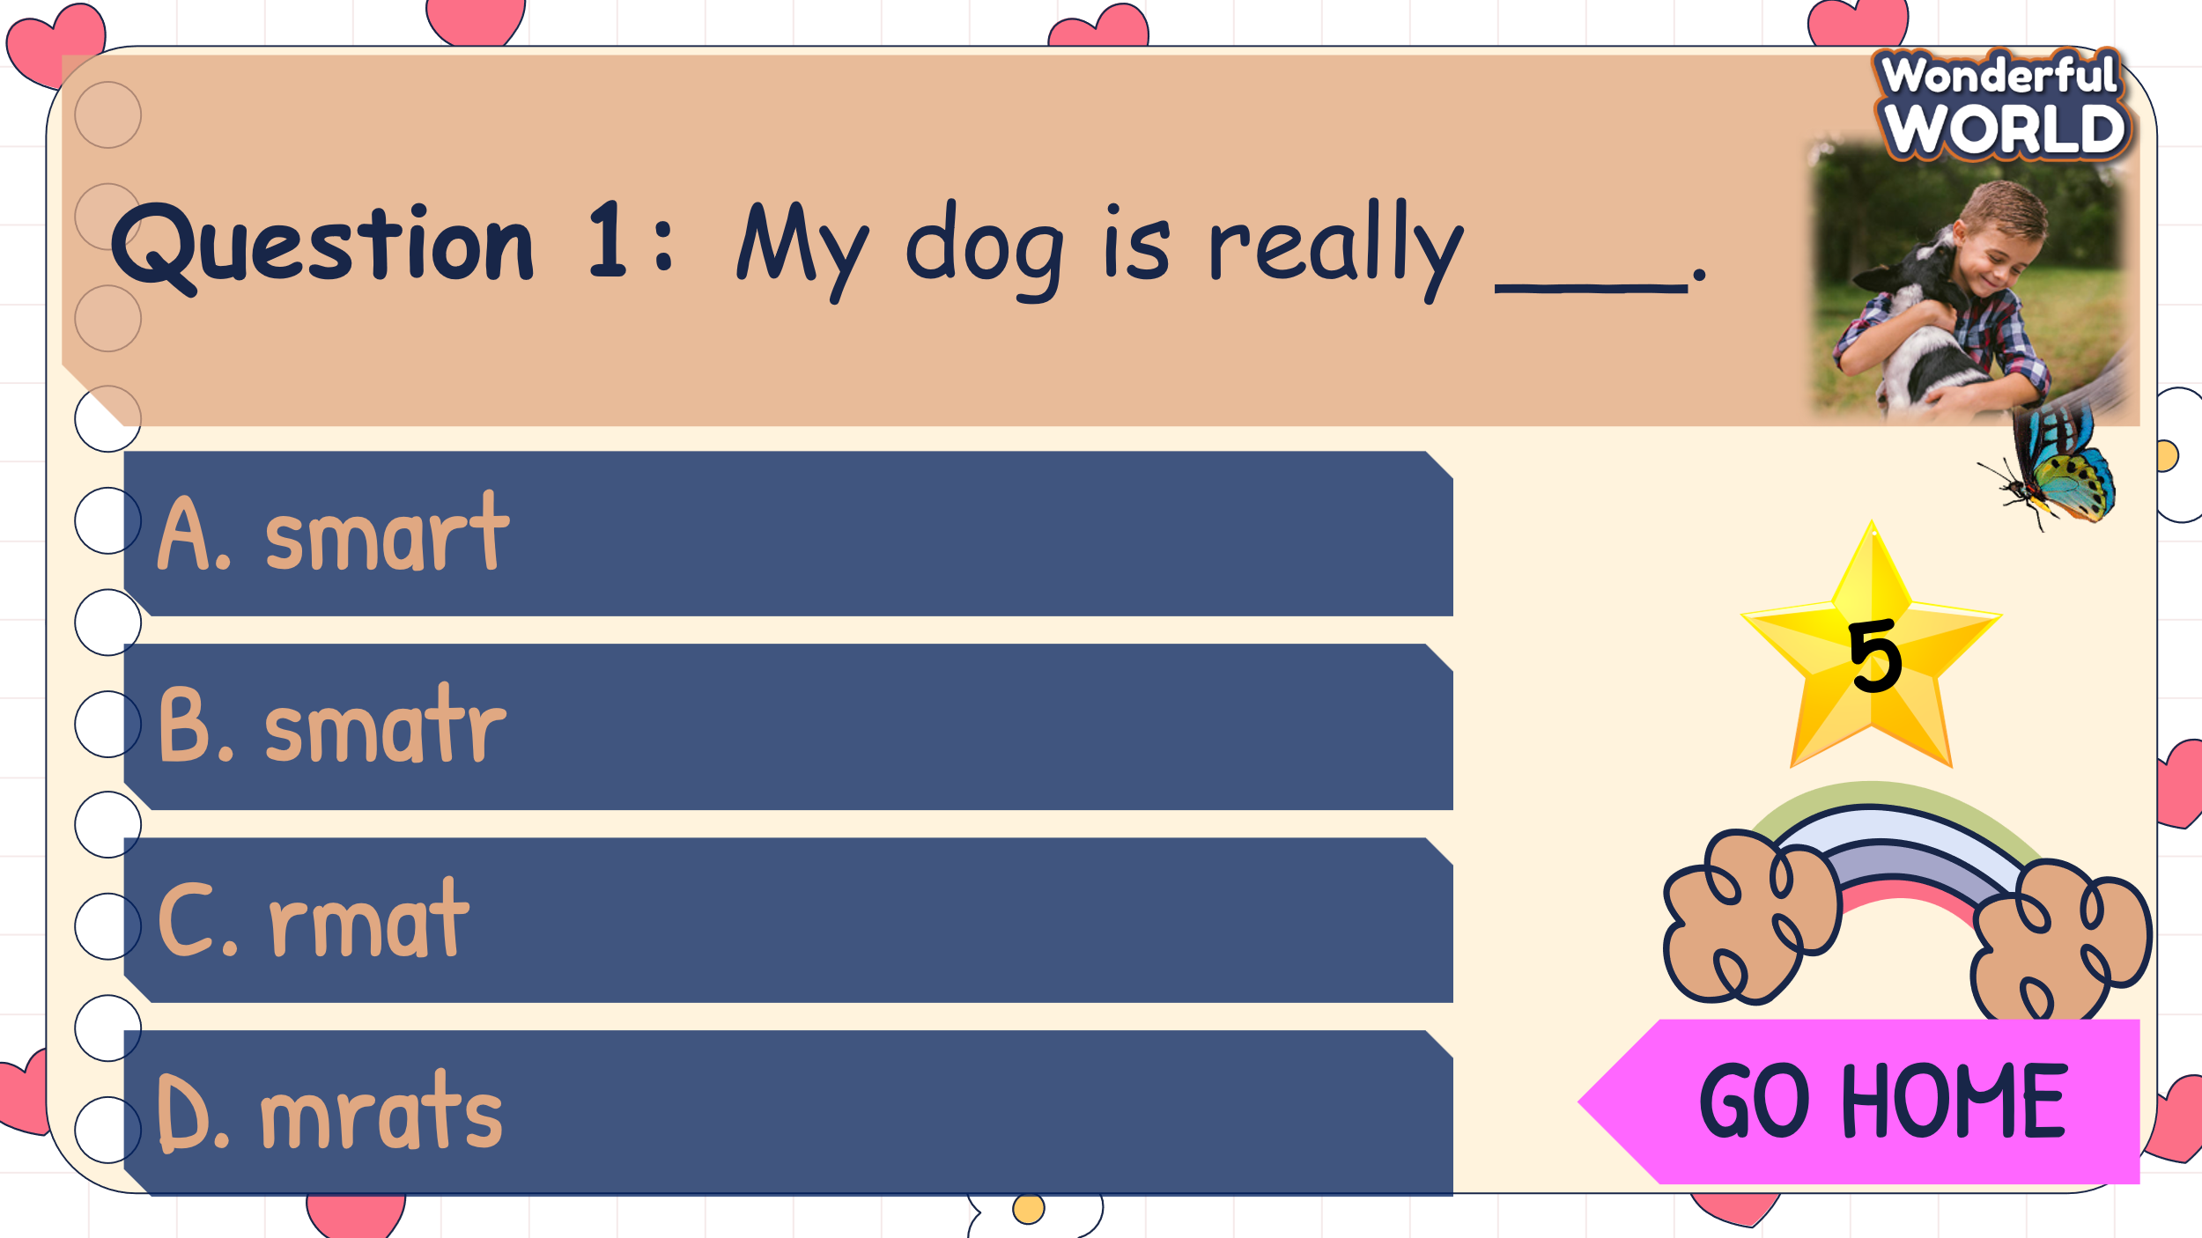  Answers: 1. A 2.D 3. B 4.A 5. C  Part 5. Find and correct a mistake  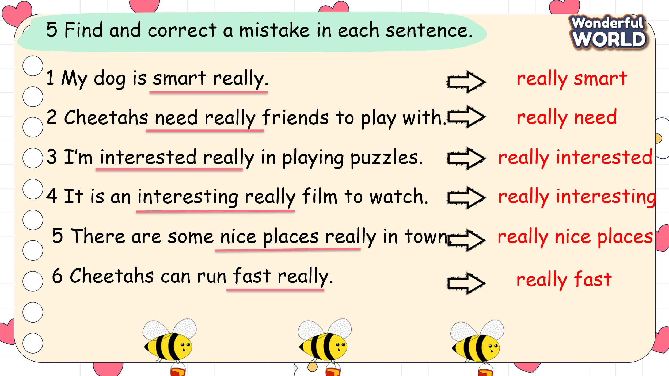  - Ask Ss to look at sentence 1 and read it carefully.  - Tell Ss that they are going to find out a mistake in each sentence.  - Give them 1 minute to underline a mistake and correct it.  - Demonstrate sentence 1 as an example.  - Give Ss 5 minutes to do the rest of the task.  - Call 5 Ss to share the answers and check them with the whole class.  - Have Ss say aloud each sentence individually and in groups. |  | - Ss join the game.  - Some Ss raise their hands and answer the questions.  - Ss having correct answers will have different stars.  Answers: 1. A 2.D 3. B 4.A 5. C  - Look at sentence 1 and read it carefully.  - Find out the mistake and correct it.  - Check the result.  - Do the rest of the task in 5 minutes  - Some Ss read their answers.  - Ss read sentences individually and in groups.
Activity 4: Production – Free practice (6 minutes)
Aims: Apply the grammar to present in front of the class to discuss and make sentences using new structure: Let’s do smt!
Encourage sts to answer and make full sentences using the new structure.

Teacher’s Activities |  | Students’ Activities
Task 6: Point and say  - T shows the pictures and asks Ss what can they see in each picture.  What animal can you see in these pictures?  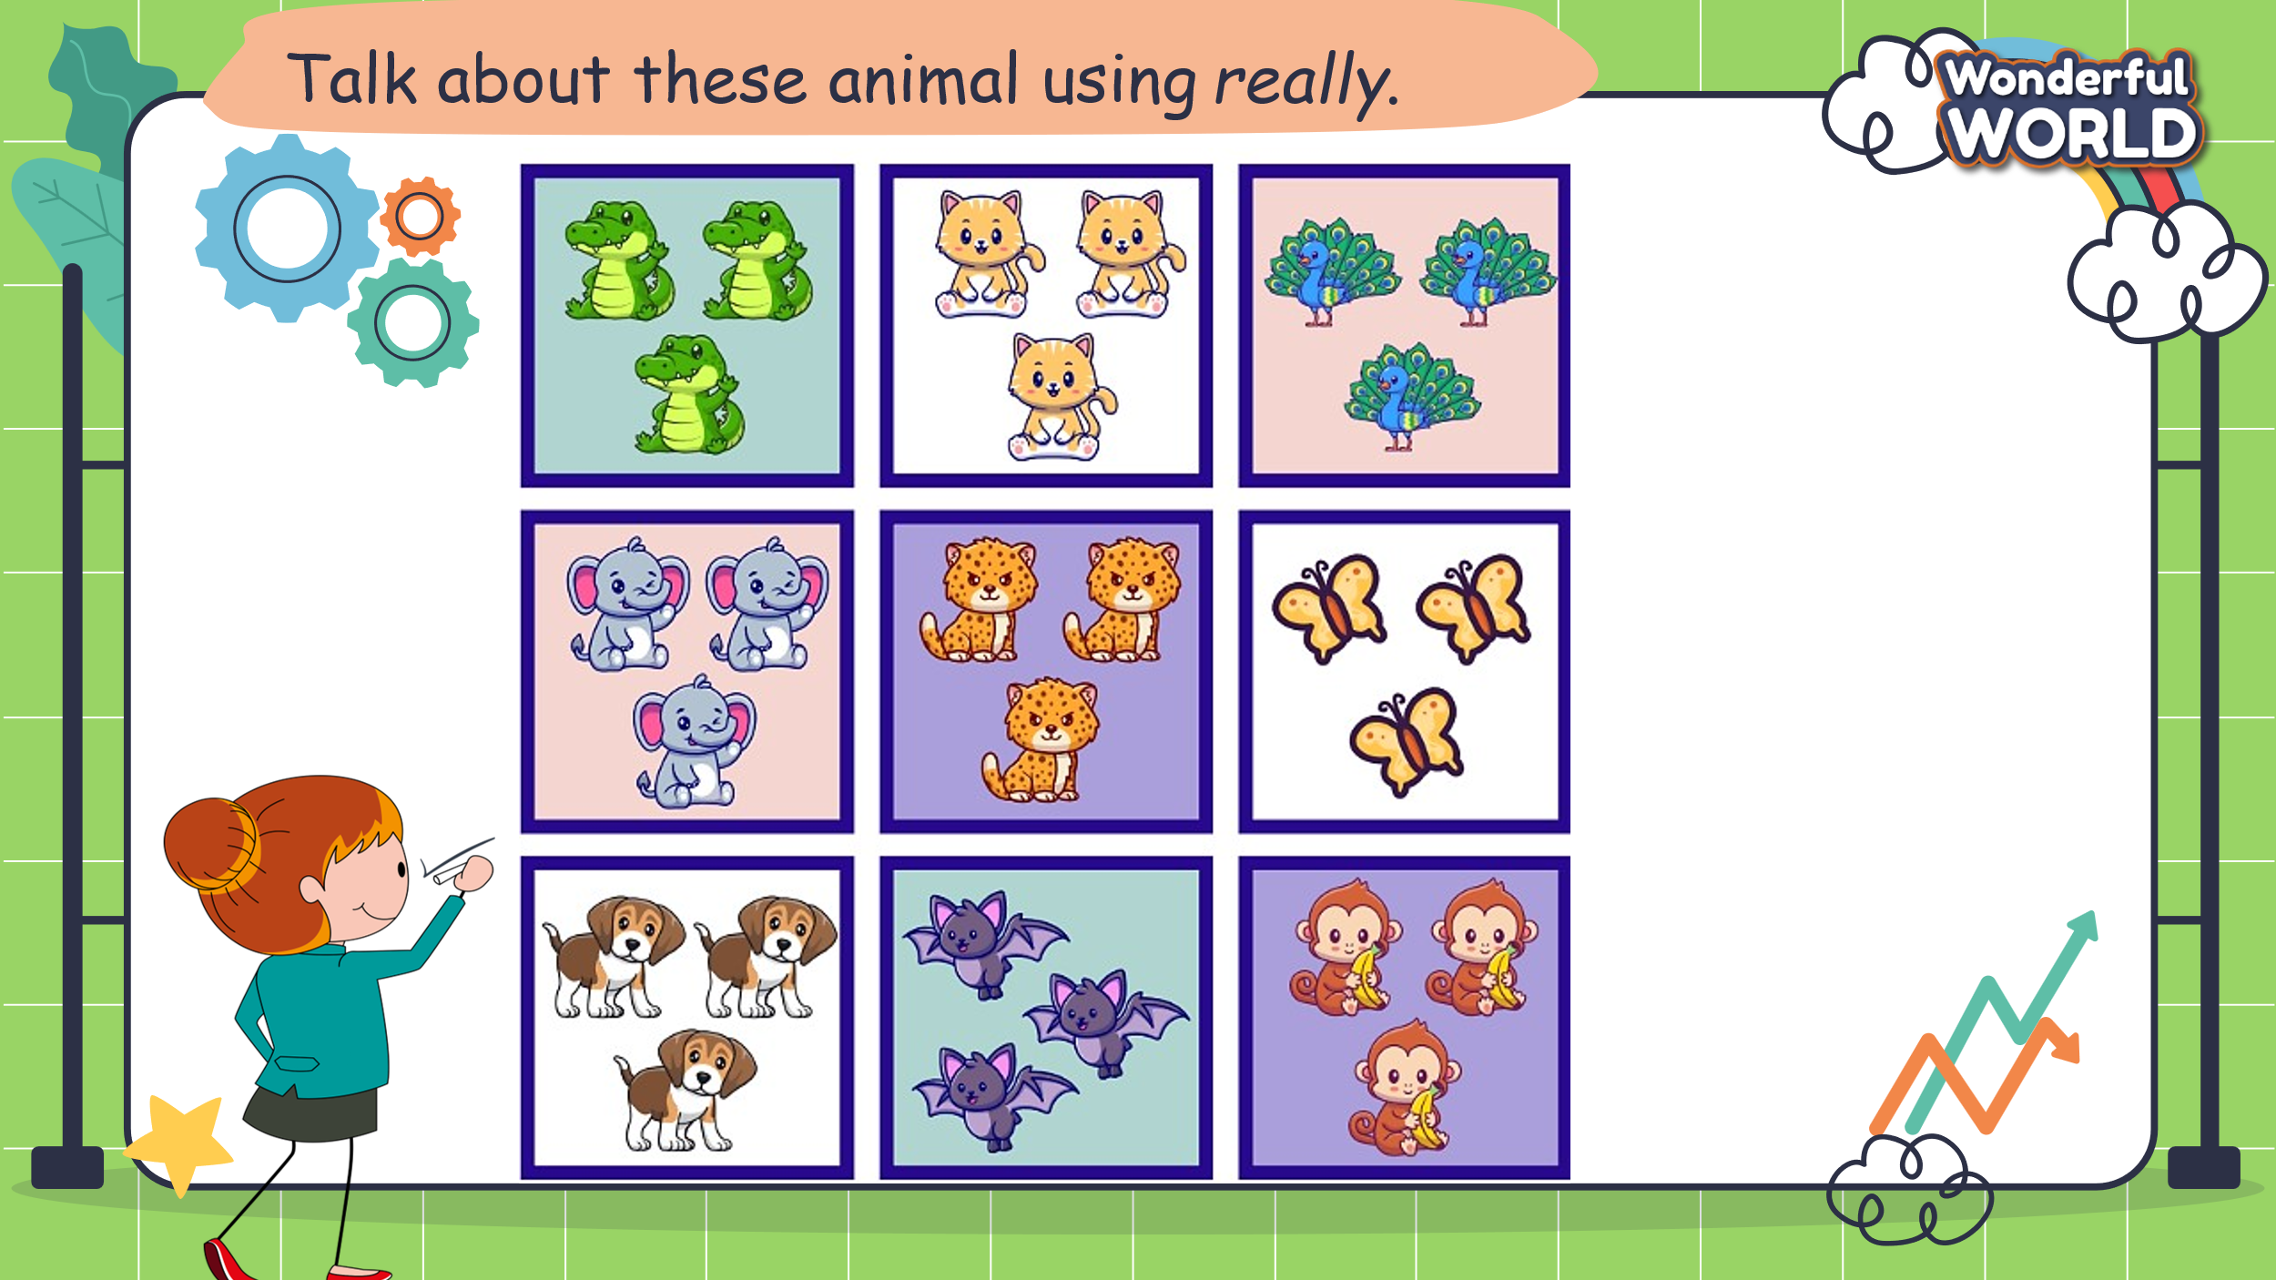  - Tell Ss to look at the picture and make the sentences using really.  - Explain how they will use hand gestures for rock-paper-scissors.  The winner will have a move and can choose one square to make the sentence with “I like … because they are really…”  - Cross out the square when they have finished the sentences.  - The one who can finish making all the sentences with all the squares is the winner.  - Have Ss play the game in pairs.  - Call some pairs to the board and read about their sentences.  - Check their pronunciation. Discuss any challenging words and reinforce correct spelling and pronunciation. |  | - Sts look at the picture and answer the questions about what they can see.  I can see some peacocks, cats, dogs, elephants, butterflies, monkeys….  - Watch the examples, and read the sentences.  - Make their sentences using the structure with really.  - Work in pairs to find out the winners.  - Some pairs come to the board and say aloud their sentences.  - Check their friend’s pronunciation.
Activity 5: Wrap up & Assessment (4 minutes)
Teacher’s Activities |  | Students’ Activities
Aims:
- Check students’s understanding of what they have learned.
- Students rehearse what they have learned in the lesson.
Asks sts to do the assessment.  - T gives the assessment to the class and some Ss can answer them.  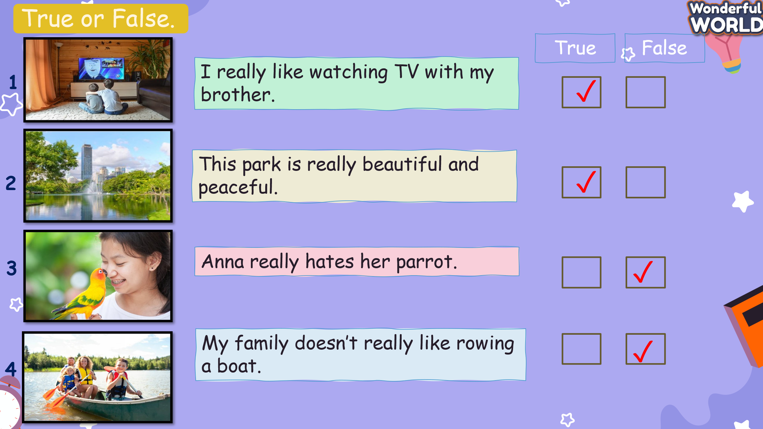  - Check with the class.  - Wrap-up  * Remember  VOCABULARY  really, interest, peacocks, dogs  STRUCTURE  - I like …. because I really …. |  | - Do the assessment.  - Check with the teacher  - Sts read the wrap-up  - Stand up and say goodbye to the teacher.

