TUẦN 32 Khối 3, 5 (Từ ngày 28/04/2025 đến ngày 02/05/2025)
THỨ | TIẾT | MÔN | TIẾT THỨ | NỘI DUNG BÀI DẠY |  | UDCNTT | ĐỒ DÙNG DẠY HỌC
Hai  28/04 | 1 | 5C | 125 | Unit 12. Weather and nature | Lesson 1 (4, 5, 6) | Wonderfulworld | Flashcards, TV, books
Hai  28/04 | 2 | 5B | 125 | Unit 12. Weather and nature | Lesson 1 (4, 5, 6) | Wonderfulworld | Flashcards, TV, books
Hai  28/04 | 3 | 5A | 126 | Unit 12. Weather and nature | Lesson 2 (1, 2, 3) | Wonderfulworld | Flashcards, TV, books
Hai  28/04 | 4
Hai  28/04 | 5 | 3A | 127 | Unit 11. My day | Lesson 2 (4, 5, 6) | Wonderfulworld | Flashcards, TV, books
Hai  28/04 | 6 | 5D | 126 | Unit 12. Weather and nature | Lesson 2 (1, 2, 3) | Wonderfulworld | Flashcards, TV, books
Hai  28/04 | 7 | 3B | 126 | Unit 11. My day | Lesson 2 (1, 2, 3) | Wonderfulworld | Flashcards, TV, books
Ba  29/04 | 1 | 3B | 127 | Unit 11. My day | Lesson 2 (4, 5, 6) | Wonderfulworld | Flashcards, TV, books
Ba  29/04 | 2 | 5D | 128 | Unit 12. Weather and nature | Lesson 3 (1, 2, 3) | Wonderfulworld | Flashcards, TV, books
Ba  29/04 | 3 | 5B | 128 | Unit 12. Weather and nature | Lesson 3 (1, 2, 3) | Wonderfulworld | Flashcards, TV, books
Ba  29/04 | 4
Ba  29/04 | 5
Ba  29/04 | 6 | 3B | 128 | Unit 11. My day | Lesson 2 (7, 8, 9) | Wonderfulworld | Flashcards, TV, books
Ba  29/04 | 7 | 3A | 128 | Unit 11. My day | Lesson 2 (7, 8, 9) | Wonderfulworld | Flashcards, TV, books
Tư  30/04 | 1
Tư  30/04 | 2
Tư  30/04 | 3
Tư  30/04 | 4 |  |  | NGHỈ LỄ 30/4 - 01/5
Tư  30/04 | 5
Tư  30/04 | 6
Tư  30/04 | 7
Năm  01/05 | 1
Năm  01/05 | 2
Năm  01/05 | 3
Năm  01/05 | 4 |  |  | NGHỈ LỄ 30/4 - 01/5
Năm  01/05 | 5
Năm  01/05 | 6
Năm  01/05 | 7
Sáu  02/05 | 1
Sáu  02/05 | 2
Sáu  02/05 | 3
Sáu  02/05 | 4 |  |  | NGHỈ BÙ
Sáu  02/05 | 5
Sáu  02/05 | 6
Sáu  02/05 | 7

GRADE 3
WEEK 32
UNIT 11. MY DAY
Lesson 2 - Task 4,5,6
Period 127
I. OBJECTIVES:
1. Knowledge:
- Students will learn the question Who do you... with? and the answer I…with…
2. Competences:
- English competences: Students will be able to ask and answer about who they do something with.
- Common competences: Students will have the opportunity to develop self-study and cooperation among teammates.
3. Qualities:
- Students will be friendly and confident in communicating with their friends.
II. EQUIPMENT AND MATERIALS:
- Basic things: Student’s book, flashcards; audio track, paper.
- Advanced things: PPT, projector/interactive whiteboard/laptop/TV.
III. LESSON PROCEDURE
Activity 1: Warm-up (5 minutes)
Teacher’s activities | Student’s activities
- Greet students.  - Warm-up: “The wheels on the bus” song  https://www.youtube.com/watch?v=QUFauUR6qa0 | - Greet teacher.  - Watch the video
Activity 2: Presentation (8 minutes)
Teacher’s activities | Student’s activities
Task 1: Listen and repeat (P.140)  - Let Ss look at three pictures and ask Ss a few questions?  + Where are they?  + How many people are there?  + What are they doing?  - Teach the ss how to make the question and the answer  Who do you... with? – I …with… to ask and answer about the person/people who you do the activity with.  - Play the recording. Tell Ss to look at the pictures and follow the pictures with their fingers.  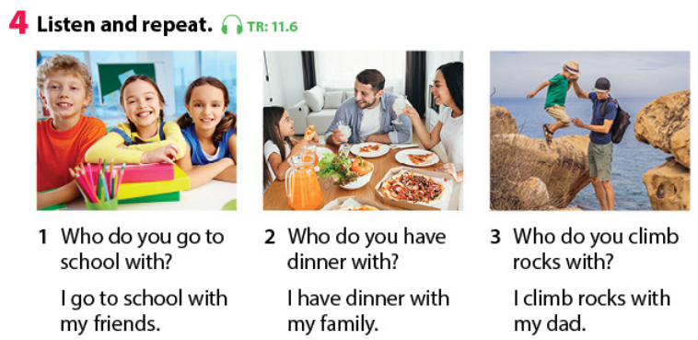  - Play the recording again. Ask Ss to repeat.  - Have sts repeat the questions and answers in pairs.  - Structure checking: “ look and choose the answer”  - Who do you go to the seashore with?    I go to the seashore with my family/my friends.  - Who do you cook with?    I cook with my mum/ my dad.  - Who do you play the piano with?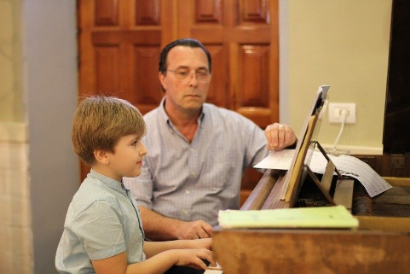  I play the piano with my grandpa/ my grandma.  - Who do you run with?  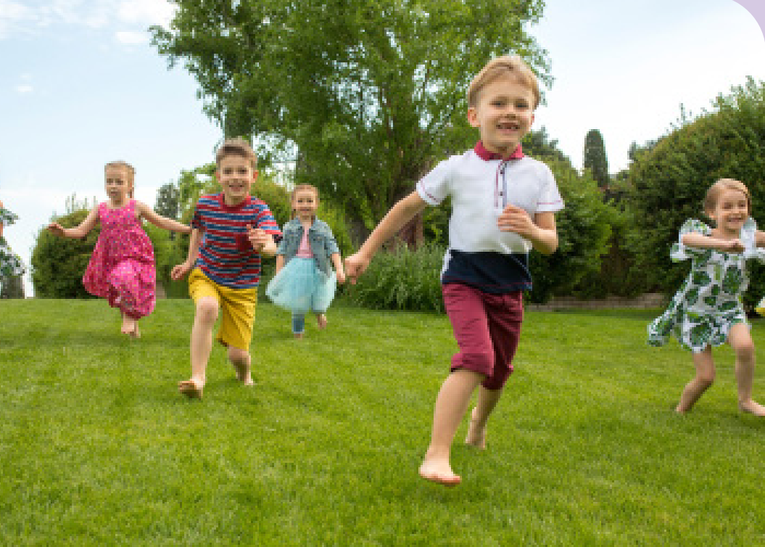  I run with my teachers/ my friends.  5 . Who do you watch TV with?  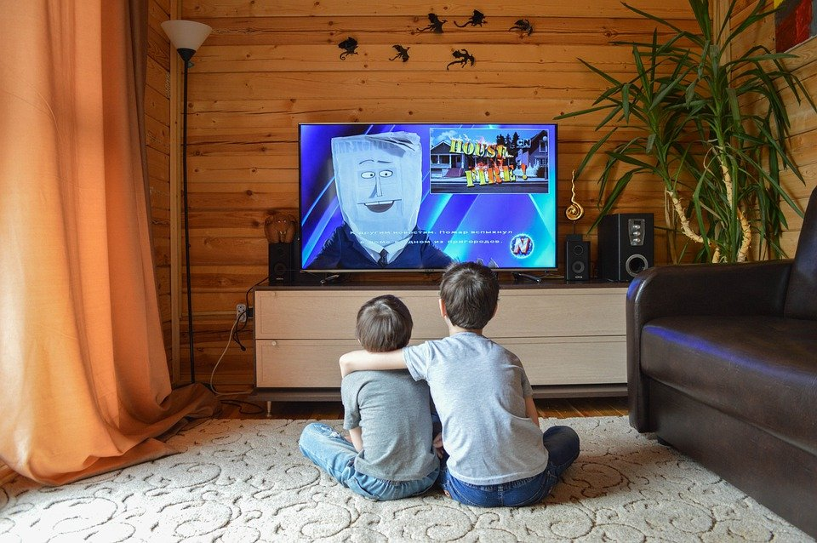  I watch TV with my sister/ my brother. | - Repeat the words/sentences  - Repeat then point.  - Join the activity.  Answer key:  1. I go to the seashore with my family.  2. I cook with my dad  3. I play the piano with my grandpa.  4. I run with my friends.  5. I watch TV with my brother.  - Get stars from T.
Activity 3: Practice (9 minutes)
Teacher’s activities | Student’s activities
Task 5: Look. Ask and answer (P.140)  -Tell students to look at the picture for question 1 and ask them what they can see. Ask them about the person in the picture. Read out the example.  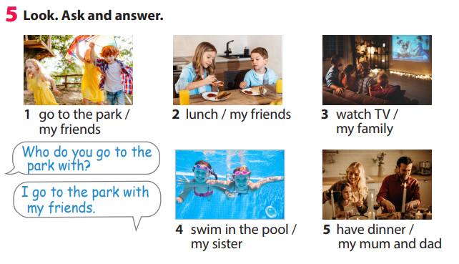  - Explain the rest of the task to Ss. Allow them enough time to practice in pairs. Go round the class helping students where necessary.  - Ask volunteers to read out their answers. Correct any mistakes.  Task 6: Listen and sing. ( P.140)  -Tell Ss they are going to learn a song. Ask Ss to look at the picture and to describe what they can see.  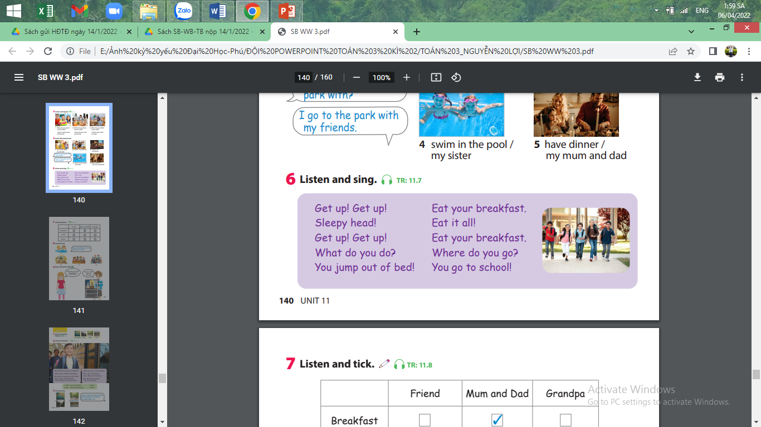  - Play the recording and tell Ss to listen and follow the words with their fingers. Explain the meaning of sleepy, head, using Vietnamese, if necessary.  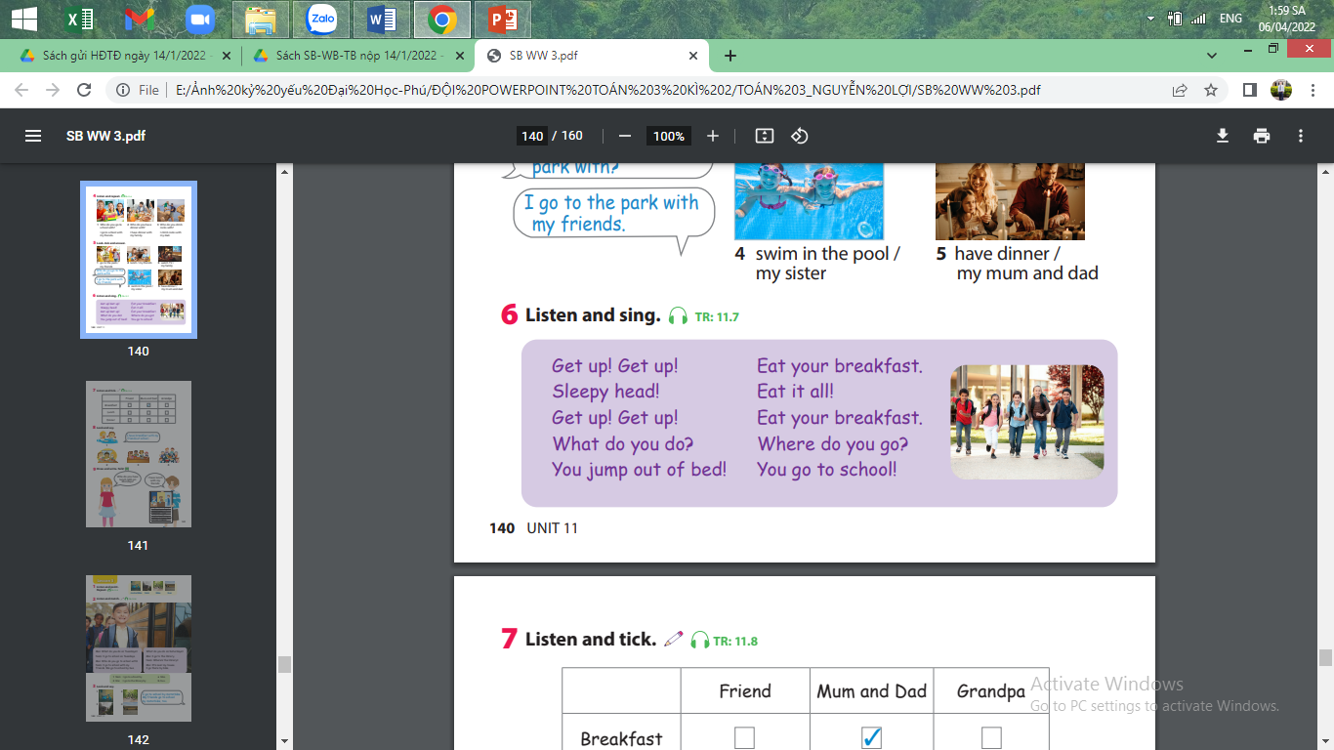  - Read out the song one line at a time and ask students to repeat it after you.  - Play the recording again. Encourage Ss to sing along. Practice several times until Ss are familiar with the words. Ss can mime the actions as they sing. | - practice saying the sentences individually, and then in pairs.  - Answer key:  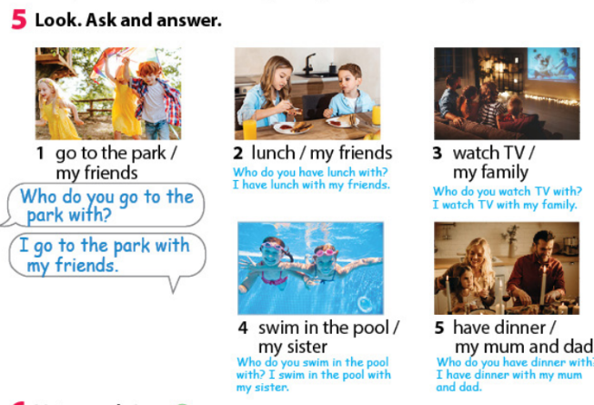  - listen and follow the words with their fingers.  - Encourage Ss to sing along.  - Ss can mime the actions as they sing.
Activity 4: Production (10 minutes)
Teacher’s activities | Student’s activities
What do you do on Mondays?  I play football on Mondays.  Who do you play football with?  I play football with my friends  -Ask Ss to create a table and do interviews around the class to fill in the table.  - Allow them enough time to make their own and practice the dialogue with their friends.  - Ask some volunteers to go to the board to make a speech. | - Prepare paper.  - Create a table and interview around the class.  - Work in pairs ask and tick write the result into the table.
Activity 5: Assessment (3 minutes)
Teacher’s activities | Student’s activities
- Ask sts to do the assessment  * Look and match  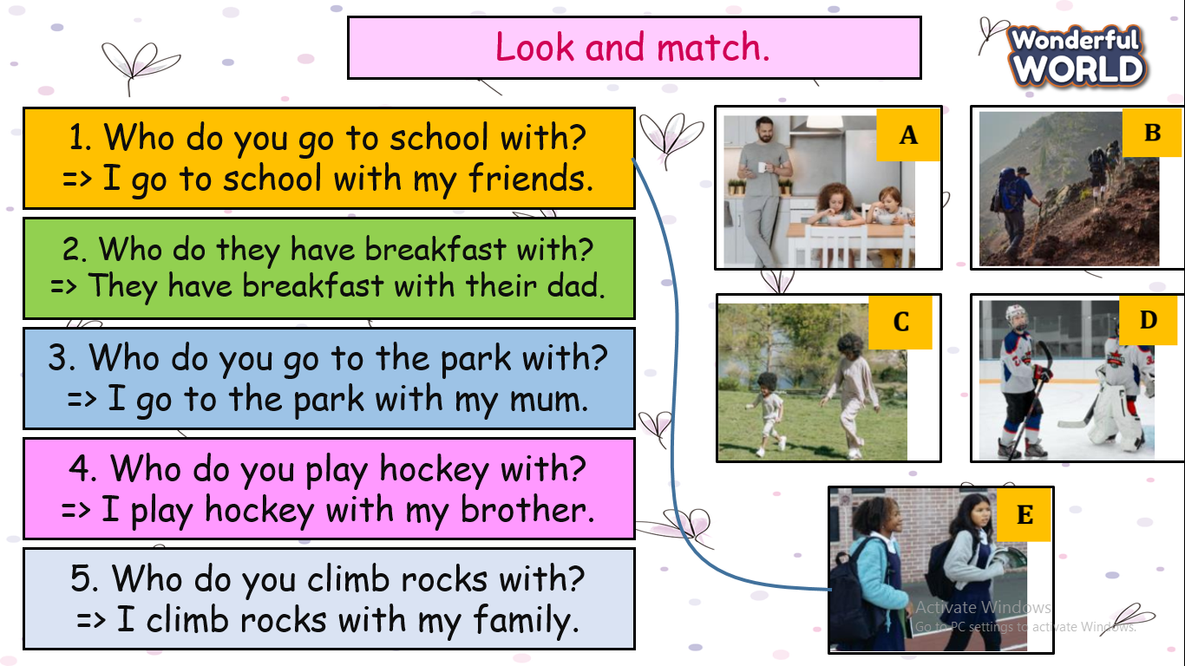  - Say goodbye | - Do the assessment.  - Check with friends and then with T and the whole class.  2. A  3. C  4. D  5. B  - Check in pair then whole class.  - Say goodbye.

UNIT 11. MY DAY
Lesson 2 - Task 7,8,9
Period 128
I. OBJECTIVES:
1. Knowledge:
- Students will review three skills through practising tasks.
2. Competences:
- English competences
+ Develop students’ competences in listening, speaking, and writing during the lesson.
- Common competences: Students will have the opportunity to develop cooperation in doing tasks with friends.
3. Qualities:
- Students will be friendly and confident in communicating with their friends.
II. EQUIPMENT AND MATERIALS:
- Basic things: Student’s book, flashcards; audio track
- Advanced things: PPT, projector/interactive whiteboard/laptop/TV.
III. LESSON PROCEDURE
Activity 1: Warm-up (5 minutes)
Teacher’s activities | Student’s activities
- Greet students.  + Game: Jumbled words  - Introduce the game.  + Reorder the letters to make the correct words about places in town or an action:  - Heva dinern  - Clibm the rcok  - Heva breafastk  - Go ot scoohl  - Heva luchn  - Go ot deb  -Have Ss check and read out the words. | - Greet teacher.  -Answer key  - have dinner  - climb the rock  - have breakfast  - climsdb the rock  - have lunch  - Go to school  - Read follow teacher.
Activity 2: Practice(8 minutes) Listening
Teacher’s activities | Student’s activities
Task 7: Listen and tick( P.141)  -Tell the students that they are going to listen to a talk to tick the correct answer options.  - Have sts read all the information in the board.  -Play the recording and tell students to listen and tick the correct options. Play the recording more than once if students cannot catch the answers.  - Play the recording again and pause after each sentence.  - Ask Ss to read his /her answer and T checks answers.  -Give stars for the correct answer. | - Repeat the words/sentences  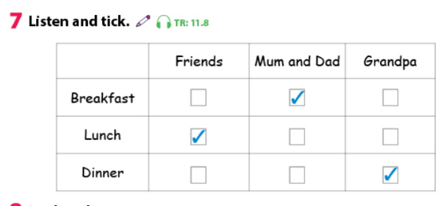  - Get stars from T.
Activity 3: Practice (7 minutes) Speaking
Teacher’s activities | Student’s activities
-Task 8: Look and say( P.141)  - Ask Ss to look at the example. Read out the sentence and ask Ss to repeat it.  - Go through the other sentences and explain the rest of the task to Ss.  -Allow them enough time to complete the task individually. Go round the class helping students  if necessary.  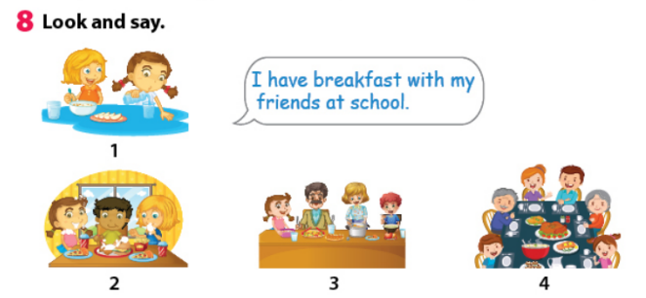  - Ask volunteers to read out their answers.  * Quick check: Find the mistake in the sentences:  1. Which do you play badminton with?  I play badminton with my dad.  2. Who do she have lunch with?  She has lunch with my friends at school.  3. Who do you plays games with on Sundays?  I play games with my brother.  4. Who you run with in the park?  I run with my friends.  5. Who do you have dinner?  I have dinner with my family. | - Look and read  -Answer key:  -Look at the picture and write the sentence in their own.  - Which who  2 . do does  (Who do you plays games with on sundays?)  3. plays play  4. Who they run with in the park? Who do they run with in the park?  5 . Who do you have dinner?  Who do you have dinner with?
Activity 4: Practice (12 minutes) writing
Teacher’s activities | Student’s activities
Task 6: Let’s talk( P.141)  - pre: + Ss look through the example and remember vocabularies and structures in unit 11 to write own sentences.  + work in pair ( one asks another answers.)  - While: draw and write all activities into A4 paper.  - Post: Go to the board and present the task.  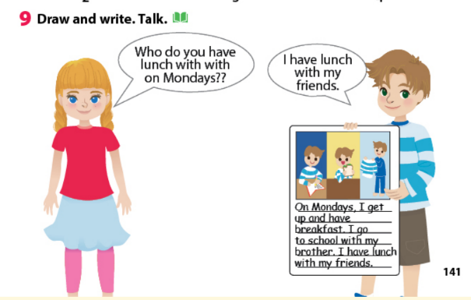 | - Read out the example.  Work in pairs and do the project.
Activity 5: Assessment (3 minutes)
Teacher’s activities | Student’s activities
- Ask Ss to do the assessment  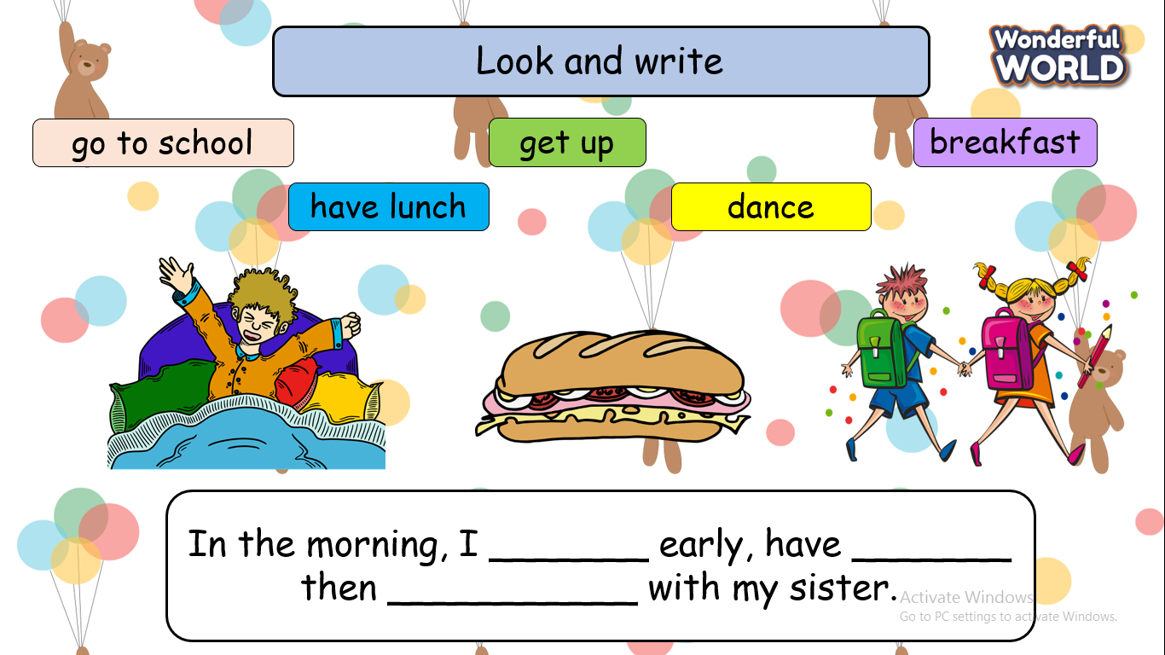  - Say goodbye | - Do the assessment.  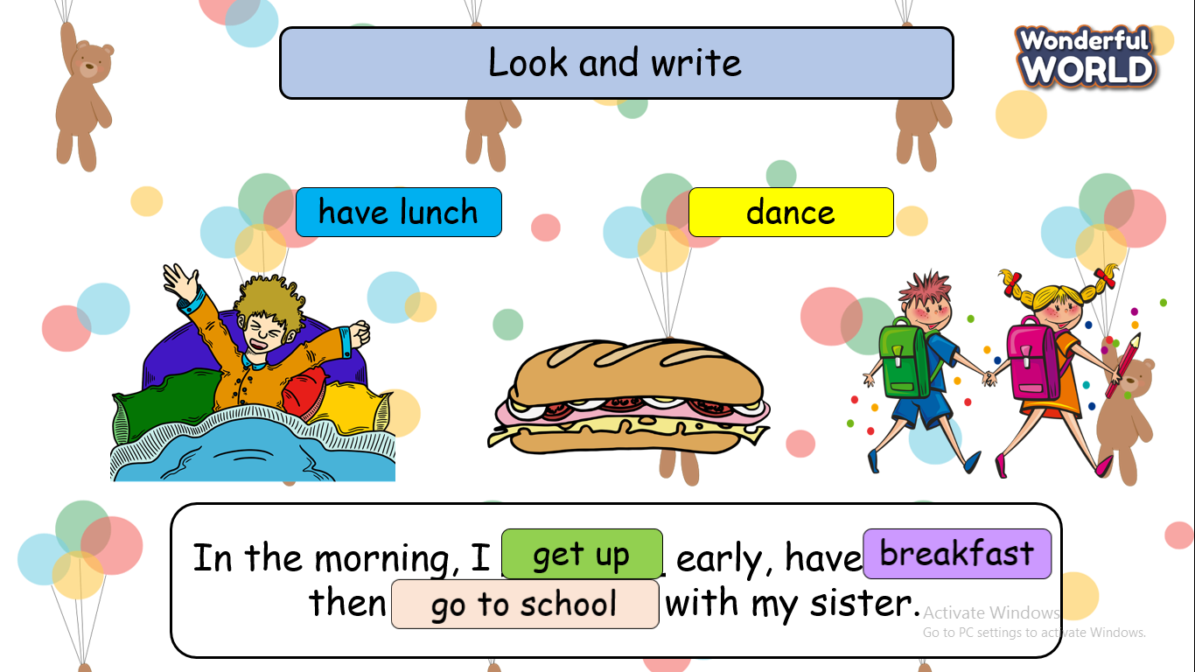  - write and read in front of the class  - Say goodbye.

Week 32 (From 28/4 to 02/5)
UNIT 12: WEATHER AND NATURE
Lesson 1 - Task 4,5,6
Period 125
I. OBJECTIVES:
1. Knowledge:
- Students will be able to:
+ Recall words that they have learnt in the previous lesson: boiling, geothermal energy, environment, rainforest, underground.
+ Get to know and use the new grammar about future simple (will + decision and future decision).
2. Competences:
- English competences: Students will be able to use English to say what they will do in particular situations.
- Common competences: Students will be able to develop collaborative skills through teamwork.
3. Qualities:
- Students will
+ have a strong sense of respect in pairwork.
+ raise their confidence by presenting in front of the class.
II. EQUIPMENT AND MATERIALS:
- Basic things: Student’s Book, Class Audio, IWB.
- Advanced things: PPT, laptop, TV.
III. LESSON PROCEDURE:
Activity 1: Warm-up (5 minutes)
A card game “Crossword game”
Teacher’s Activities | Students’ Activities
Aims: Welcome students. Engage the class with a game to review words that Ss have learnt: boiling, geothermal energy, environment, rainforest, underground.
1. Greeting Ss and chatting: Before starting the new lesson, do you want to play a game?  2. Introducing and playing the game:  - Show the pictures of those words and let Ss say & spell the correct answers.  - If they just say the word but cannot spell the whole word, they will have fewer points than others who can say and spell the words.  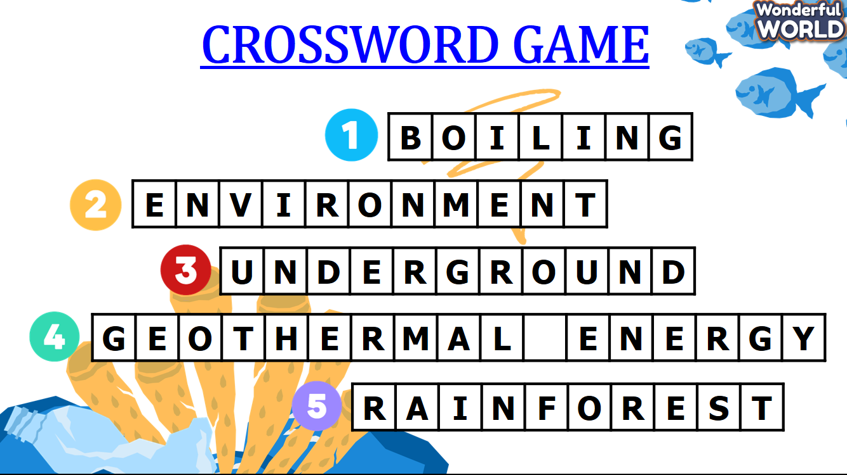 | - Greet Teacher.  - Join the activity.
Activity 2: Presentation (10 minutes)
Teacher’s Activities | Students’ Activities
Aims:
- Present the new grammar: future simple with future decisions.
- Instruct Ss to finish task 4 in individual and pairs.
- Show Task 4 on the screen to elicit Future Simple.  + Ask them what tense is being used in the task.  + Ask them what purpose this tense is being used.  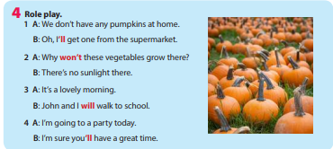  Elicit new grammar: Future simple with future decisions  - Present Ss that Future Simple is used to give on-spot decisions.  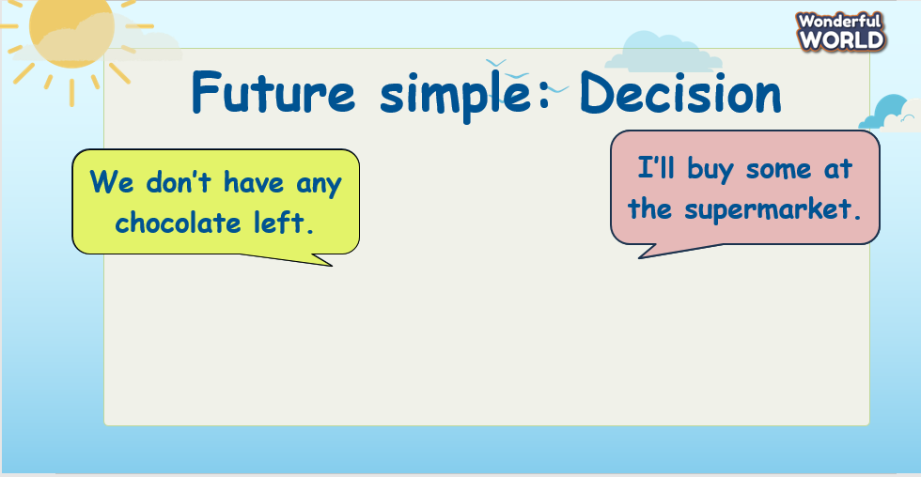  - Elicit the shortened and negative forms of Future simple tense (Ss can guess from Task 4).  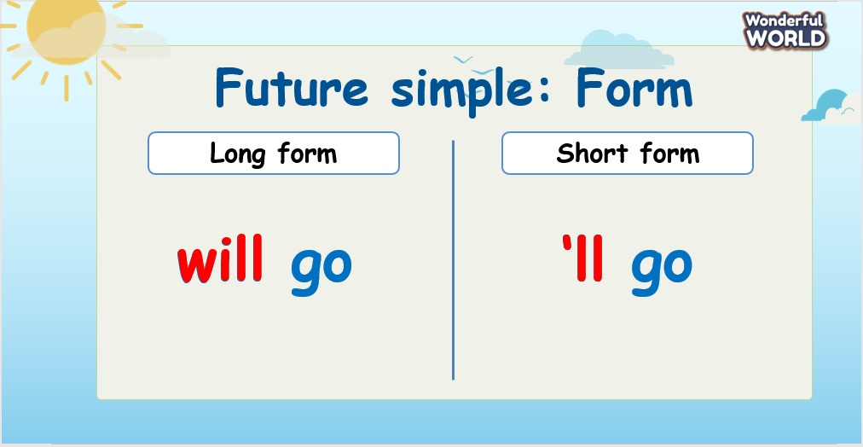  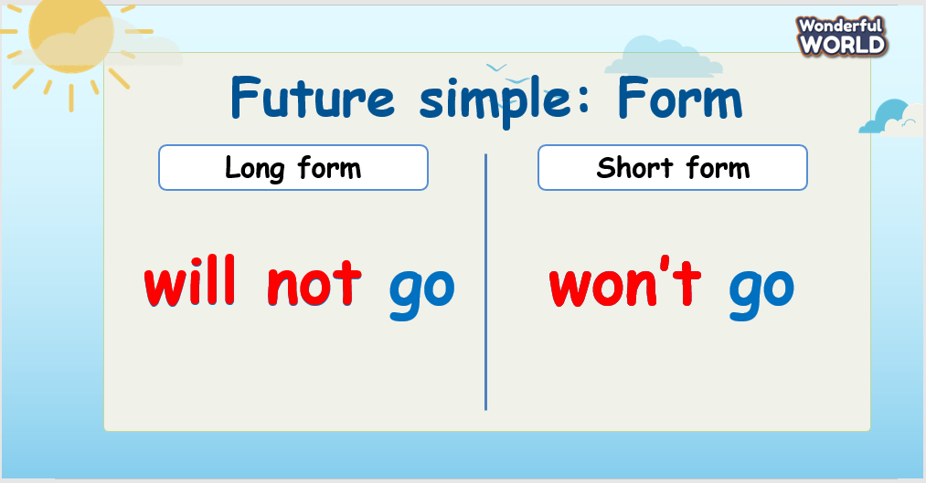  Task 4: Role play.  - Ask students to listen to the teacher’s reading and have them pay attention to the full form and contracted form of WILL.  - Ask students to practice saying individually.  - Ask students to work in pairs and read four dialogues  - Check spelling if necessary. (Focus on and will). | - Look and answer.  - Listen and answer.  - Say individually.  - Role play and work in pairs.
Activity 3: Practice – Controlled practice (10 minutes)
Teacher’s Activities | Students’ Activities
Aims:
- Practice using Future Simple with future decisions through exercise 5.
Task 5: Read and match.  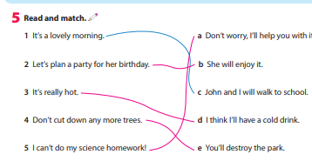  - Tell students that they are going to match the statements to the  relevant responses.  - Read out the first example and discuss with students why C is the  correct answer.  - Divide students into pairs to do the matching task.  - Check answers as a class.  Activity “What will happen?”  - Ss are asked to finish the sentences in Future Simple from the clues on the screen to know what decisions will be made in those situations.  *Note: When Ss pick the wrong clues, they cannot keep answering to get points.  - Example:  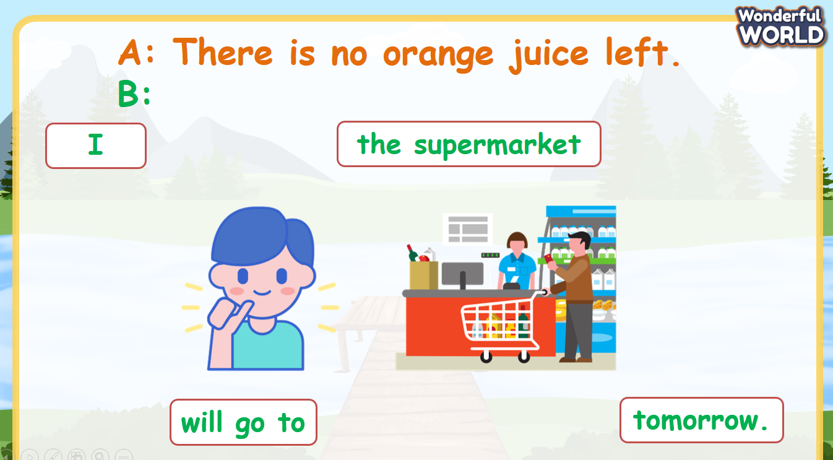 | - Complete the task.  - Join the activity.
Activity 4: Production (5 minutes)
Teacher’s Activities | Students’ Activities
Aims:
- Ss apply the grammar to say what they will do in particular situations in Task 6.
Task 6: What will you say in these situations?  - Tell students to think about what they will say in each situation.  - Take Sentence 1 as an example.  - Read out the example and ask students to repeat.  - Ask students to work in groups of three or four. One will read out the situation and the others will answer.  - Ask some volunteers to speak in front of the class.  - Give corrections and feedback.  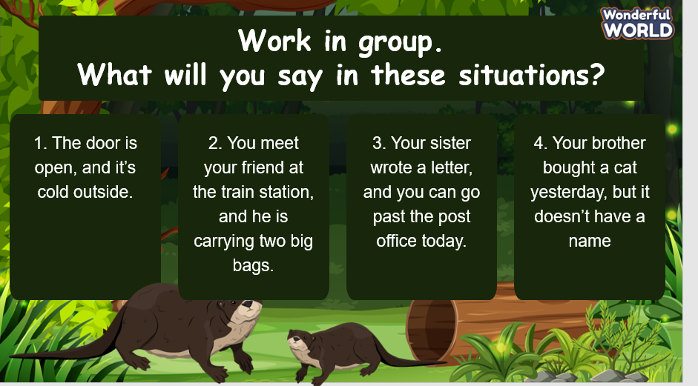  *Suggested answers:  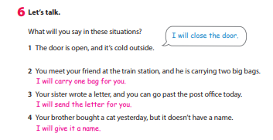 | - Work in groups.
Activity 5: Wrap up & Assessment (5 minutes)
Teacher’s Activities | Students’ Activities
a, Aims:
- Check students’ understanding of what they have learned.
- Students rehearse what they have learned in the lesson.
- Assessment: Give compliments to the group/ team that has completed the activities the best and encourage the other groups/teams to keep doing them during the next lessons.  - Wrap-up: Do the activity “Fill in the blanks with the correct forms of verbs.”.  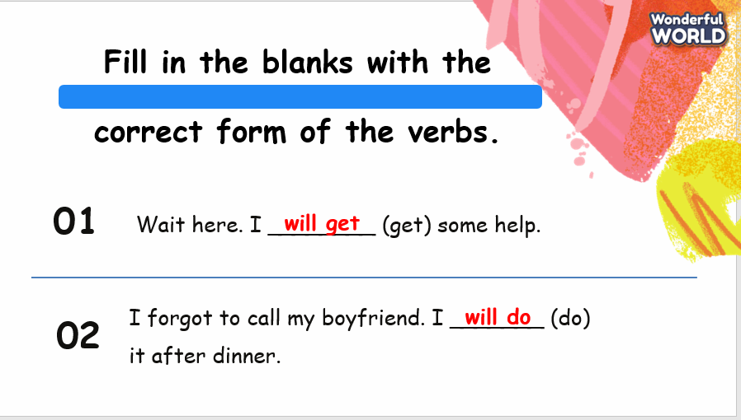  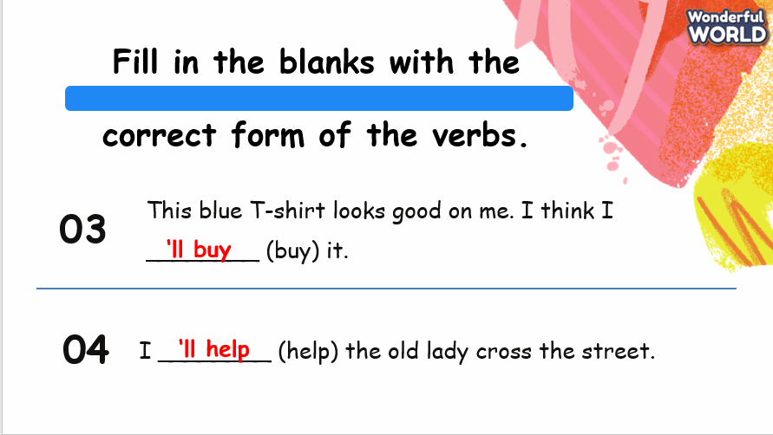  * Remember  - Review vocabulary: boiling, geothermal energy, environment, rainforest, underground.  - Grammar: Future simple with future decisions.   | - Check with the teacher.  - Do the activity.  - Stand up and say goodbye to the teacher.

UNIT 12: WEATHER AND NATURE
Lesson 2 - Task 1,2,3
Perio 126
I. OBJECTIVES:
1. Knowledge:
- Students get to know:
+ Some words: app, geocaching, GPS, treasure.
+Students will be able to draw out new words through listening and reading the text.
2. Competences:
- English competences: Students will be able to use English to describe an app.
- Common competences: Students will be able to write and talk about an app.
3. Qualities:
- Students will
+ Have a strong sense of respect in pairwork.
+ Raise their confidence by presenting in front of the class.
II. EQUIPMENT AND MATERIALS:
- Basic things: Student’s Book, Class Audio, IWB.
- Advanced things: PPT, laptop, TV.
III. LESSON PROCEDURE:

Activity 1: Warm-up (5 minutes)
Watch a video
Teacher’s Activities | Students’ Activities
Aims: Welcome students. Warm the class up with a video to lead in the new lesson.
1. Greeting Ss and chatting:  Let's start our new lesson with a video. Please pay attention and then I’ll ask you some related questions!  2. Watch a video:  - Play the video and ask students to pay attention.  https://youtu.be/sD2f-pXplk4  - Ask Ss to answer the following questions:  1. Where was the boy? (SUGGESTED ANSWER: IN THE WOOD)  2. What was he doing? (SUGGESTED ANSWER: FINDING A TREASURE)  3. What did he bring?  4. What did he find? (SUGGESTED ANSWER: HE FOUND A COIN)  3. Leading in the lesson:  Unit 12 – Lesson 2 Task 1, 2, 3  - Lead in Today, we are going to read about geocaching! | - Greet Teacher.  - Watch and answer.
Activity 2: Presentation (10 minutes)
Teacher’s Activities | Students’ Activities
Aims:
- Present some new words app, geocaching, GPS, treasure.
- Encourage Ss with the topic and vocabulary related to the topic.
New words:  - Use flashcards and PowerPoint to introduce the lesson's vocabulary (app, geocaching, GPS, treasure).  + Show the pictures-> show the words -> play audio twice for Ss to listen then ask them to repeat in chorus, groups, and individually.  - Correct student’s pronunciation if necessary.  Task 2: Listen, point, and repeat (Track 12.5)  - Check their understanding if necessary.  - Ask students to listen, point, and repeat after the speaker.  - Call some students to read it out aloud and correct spelling  if necessary.  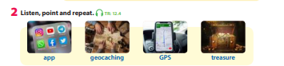  Task 1: Listen and read (Track 12.4)  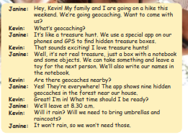  - Ask students to watch the video on the screen and then listen again.  - Have students listen and read it individually and pair  - Call two students to read it out aloud and check pronunciation if  necessary.  - Check the answer to the pre-reading question.  Suggested answers: It’s like a treasure hunt. People use a special app to find hidden treasure boxes. | - Look and answer.  - Listen, point, and repeat.  - Listen and read.  - Pair practice.  - Answer the question.
Activity 3: Practice – Controlled practice (8 minutes)
Teacher’s Activities | Students’ Activities
Aims:
- Practice new words through exercise 3.
Task 3: Complete the sentences with words from Activity 2.  - Tell students to read the sentences carefully and decide which word in Activity 2 can be used to complete each of the sentences.  - Share answers as a class. Have students call out the word they have used in each sentence first.  - Tell students the correct answers. Ask students to explain the meaning of each word using Vietnamese / English definitions.  - Ask some students to read the complete sentences. 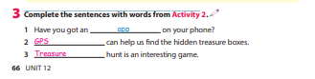  Activity “Zoom it in”  - Guess what the item is, zoomed in.  - Be the first team to guess the zoomed-in picture. | - Complete the task.  - Join the activity.
Activity 4: Production (7 minutes)
Teacher’s Activities | Students’ Activities
Aims:
- Ss apply the new words to talk about an app.
- Divide the class into different pairs.  - Work in pairs to talk about an app.  - Call some students to share in front of the class.  - Suggested questions:  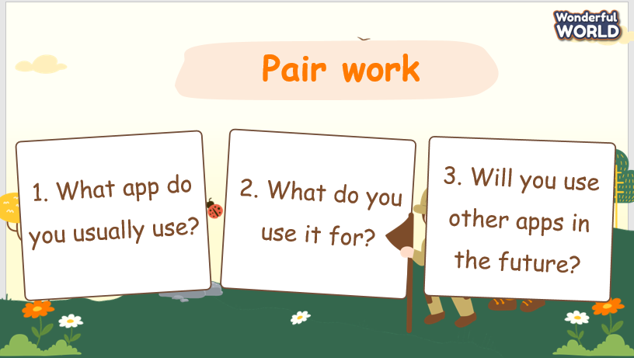 | - Work in pairs.
Activity 5: Wrap up & Assessment (5 minutes)
Teacher’s Activities | Students’ Activities
Aims:
- Check students’ understanding of what they have learned.
- Students rehearse what they have learned in the lesson.
- Assessment: Give compliments to the group/ team that has completed the activities the best and encourage the other groups/teams to keep doing them during the next lessons.  - Wrap-up: Do the activity “Rearrange sentences.”.  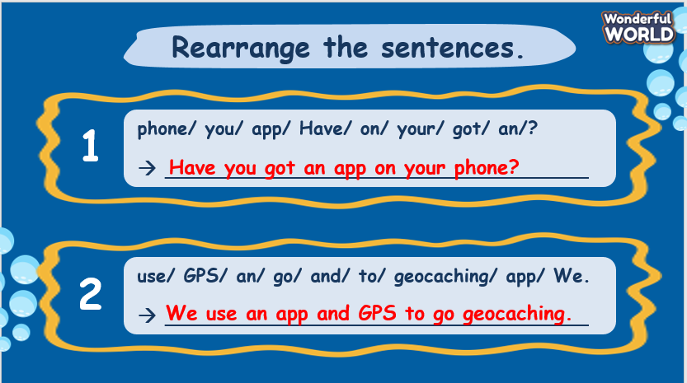  * Remember  - Vocabulary: app, geocaching, GPS, treasure. | - Check with the teacher.  - Do the activity.  - Stand up and say goodbye to the teacher.

UNIT 12: WEATHER AND NATURE
Lesson 2 – Task 4,5,6
Period 127
I. OBJECTIVES:
1. Knowledge:
- Students will be able to:
+ Recall some words that they have learned in the previous lesson.
+ Learn and use new grammar: Will (negative and interrogative, time expressions for future).
2. Competences:
- English competences: Students will be able to use English to describe activities that they will do today and tomorrow.
- Common competences: Students will be able to write and talk about activities that they will do today and tomorrow.
3. Qualities:
- Students will
+ Have a strong sense of respect in pairwork.
+ Raise their confidence by presenting in front of the class.
II. EQUIPMENT AND MATERIALS:
- Basic things: Student’s Book, Class Audio, IWB.
- Advanced things: PPT, laptop, TV.
III. LESSON PROCEDURE:
Activity 1: Warm-up (5 minutes)
“Multiple choice”
Teacher’s Activities | Students’ Activities
Aims: Welcome students. Warm the class up with a “multiple choice” activity to review the words they have learned in the previous lesson “app, geocaching, GPS, treasure”.
1. Greeting Ss and chatting:  Let's start our new lesson with an activity. Raise your hands to answer the questions shown on the screen!  2. “Multiple choice” activity:  - Divide the class into different teams. Which team has the first person to raise his/her hand can answer the question?  - Ask Ss to say the correct answers again as practice.  3. Leading in the lesson:  Unit 12 – Lesson 2 task 4, 5, 6  - Lead in: Today, we continue to learn about Future simple! | - Greet Teacher.  - Join the activity.
Activity 2: Presentation (8 minutes)
Teacher’s Activities | Students’ Activities
Aim:
- Present the Future Simple by recalling Ss’ previous knowledge.
Grammar: Will (negative and interrogative, time expressions for future)  - Ask Ss some questions related to Future Simple to check their understanding.  + Give one sentence in affirmative form.  + Ask Ss to change that sentence into negative and interrogative forms.  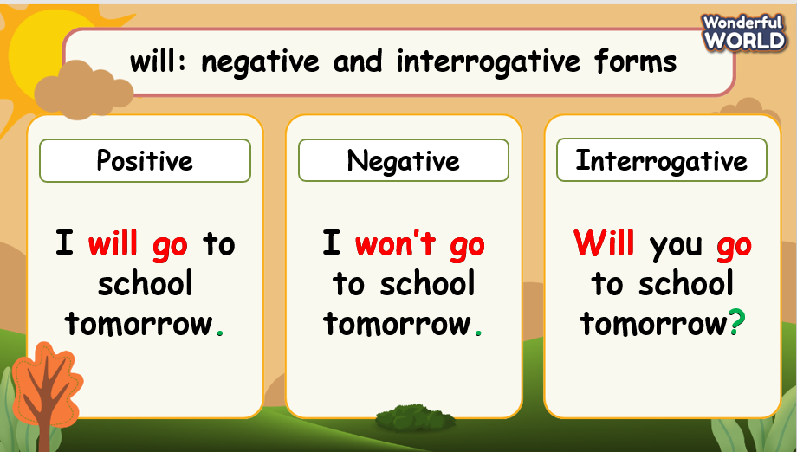  - Elicit Ss to give time expressions of Future simple.  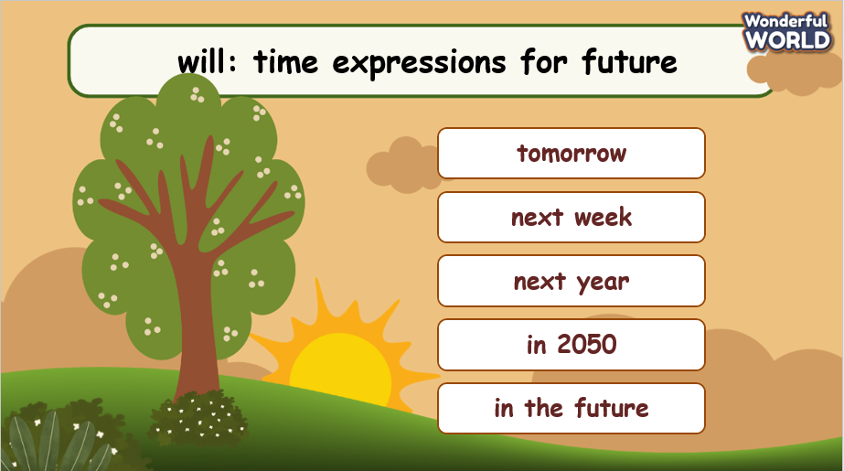  - Correct Ss’ knowledge if necessary. | - Listen and answer.
Activity 3: Practice – Controlled practice (10 minutes)
Teacher’s Activities | Students’ Activities
Aims:
- Practice Future Simple through exercises 4 and 5.
Task 4: Complete the sentences with will / won’t + verb.  - Ask students to review the use and structure of the simple future tense.  - Demonstrate sentences 1 and 2 with the whole class.  - Ask Ss to look at the screen and raise their hands when they know the correct answers.  Example:  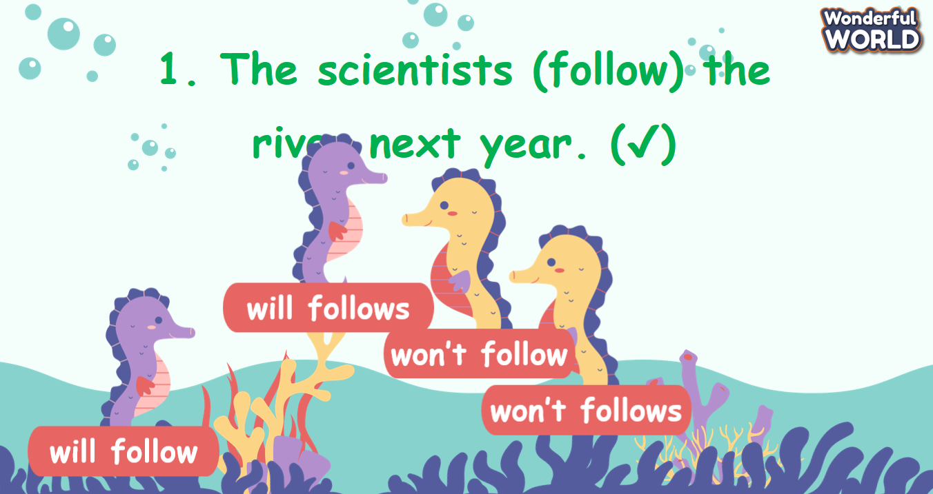  - Ask students to say the correct answers chorally and then write the correct sentence with the correct form of verbs in their Student books.  Answer:  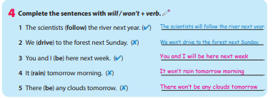  Task 5: Complete the sentences.  - Ask students to review the use and structure of the simple future tense with yes / no Question Type.  - Demonstrate sentence 1 with the whole class.  - Ask students to do the task and then compare the answer with their  partner.  - Ask students to work in pairs and check their answers.  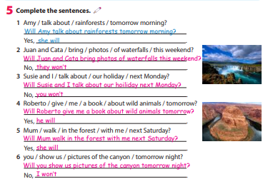 | - Complete the task.  - Join the activity.  - Complete the task.  - Work in pairs.
Activity 4: Production (7 minutes)
Teacher’s Activities | Students’ Activities
Aim:
- Ss apply Future Simple to share about the activities that they will do today and tomorrow.
Task 6: Let’s talk.  - Tell students that they are going to work in pairs to talk about what  they will do today and tomorrow.  - Tell students to look at the given questions and the dialogue.  - Read out the dialogue. Read it out again, pause after each sentence, and ask students to repeat.  - Ask two students to read out the dialogue.  - Ask students to work in pairs and allow students enough time to  practise speaking. Go round the class helping students where  necessary.  - Ask some volunteers to speak in front of the class. | - Work in pairs.
Activity 5: Wrap up & Assessment (5 minutes)
Teacher’s Activities | Students’ Activities
Aims:
- Check students’ understanding of what they have learned.
- Students rehearse what they have learned in the lesson.
- Assessment: Give compliments to the group/ team that has completed the activities the best and encourage the other groups/teams to keep doing them during the next lessons.  - Wrap-up: Do the activity “Say aloud these sentences in positive, negative, and interrogative forms”.  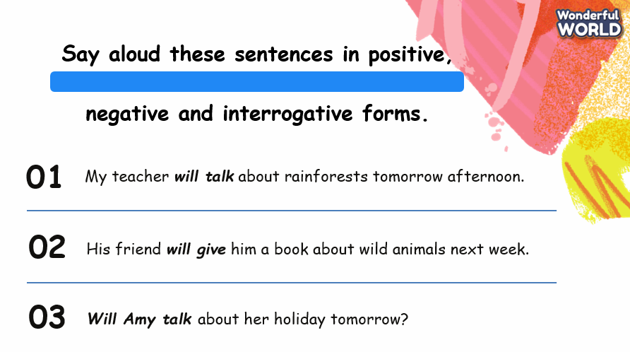  * Remember  - Review vocabulary: app, geocaching, GPS, treasure.  - Grammar: Will (negative and interrogative, time expressions for future).  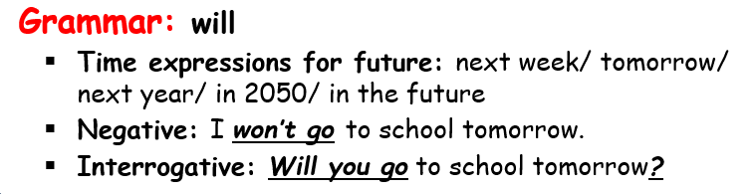 | - Check with the teacher.  - Do the activity.  - Stand up and say goodbye to the teacher.

UNIT 12: WEATHER AND NATURE
Lesson 3 – Task 1,2,3
Period 128

I. OBJECTIVES:
1. Knowledge:
- Students will be able to:
+ Learn some new words: tornado, storm.
+ Practice speaking and listening skills.
2. Competences:
- English competences: Students will be able to use English to talk about their holiday plans.
- Common competences: Students will be able to develop their confidence in speaking about their holiday plan.
3. Qualities:
- Students will
+ Have a strong sense of respect in pair work.
+ Raise their confidence by presenting in front of the class.
II. EQUIPMENT AND MATERIALS:
- Basic things: Student’s Book, Class Audio CD, Posters, IWB, DVD.
- Advanced things: PPT, laptop, TV.
III. LESSON PROCEDURE:
Activity 1: Warm-up (5 minutes)
Let’s play a game: “Guess the word”
Teacher’s Activities | Students’ Activities
Aims: Welcome students. Engage the class with a guess the word game.
1. Greeting Ss and chatting:  - Ask Ss: “Do you like playing games?”  2. Introducing and playing the game: GUESS THE WORD  - Explain the rules of the game.  - Show a picture on the slide and ask Ss to guess: What is the word?  - Give stars for the correct answer. | - Greet Teacher  - Join the activity.
Activity 2: Presentation (12 minutes)
Teacher’s Activities | Students’ Activities
Aims:
- Present some words learned in the lesson: storm, tornado, sun, rain to prepare for the next listening part.
- Complete tasks 1 & 2.
- T presents some new words in the lesson: storm, tornado, sun, rain.  - Show each picture and ask Ss what they see and guess the meaning of each word.  - Stick pictures and show the words.  - Ask Ss to listen and repeat in chorus.  - Correct student’s pronunciation if necessary.  Check vocabulary: mini-game: “Stopping picture”  - Explain a rule of the game.  Task 1. Look at the picture.  - Show a picture of a tornado on screen.  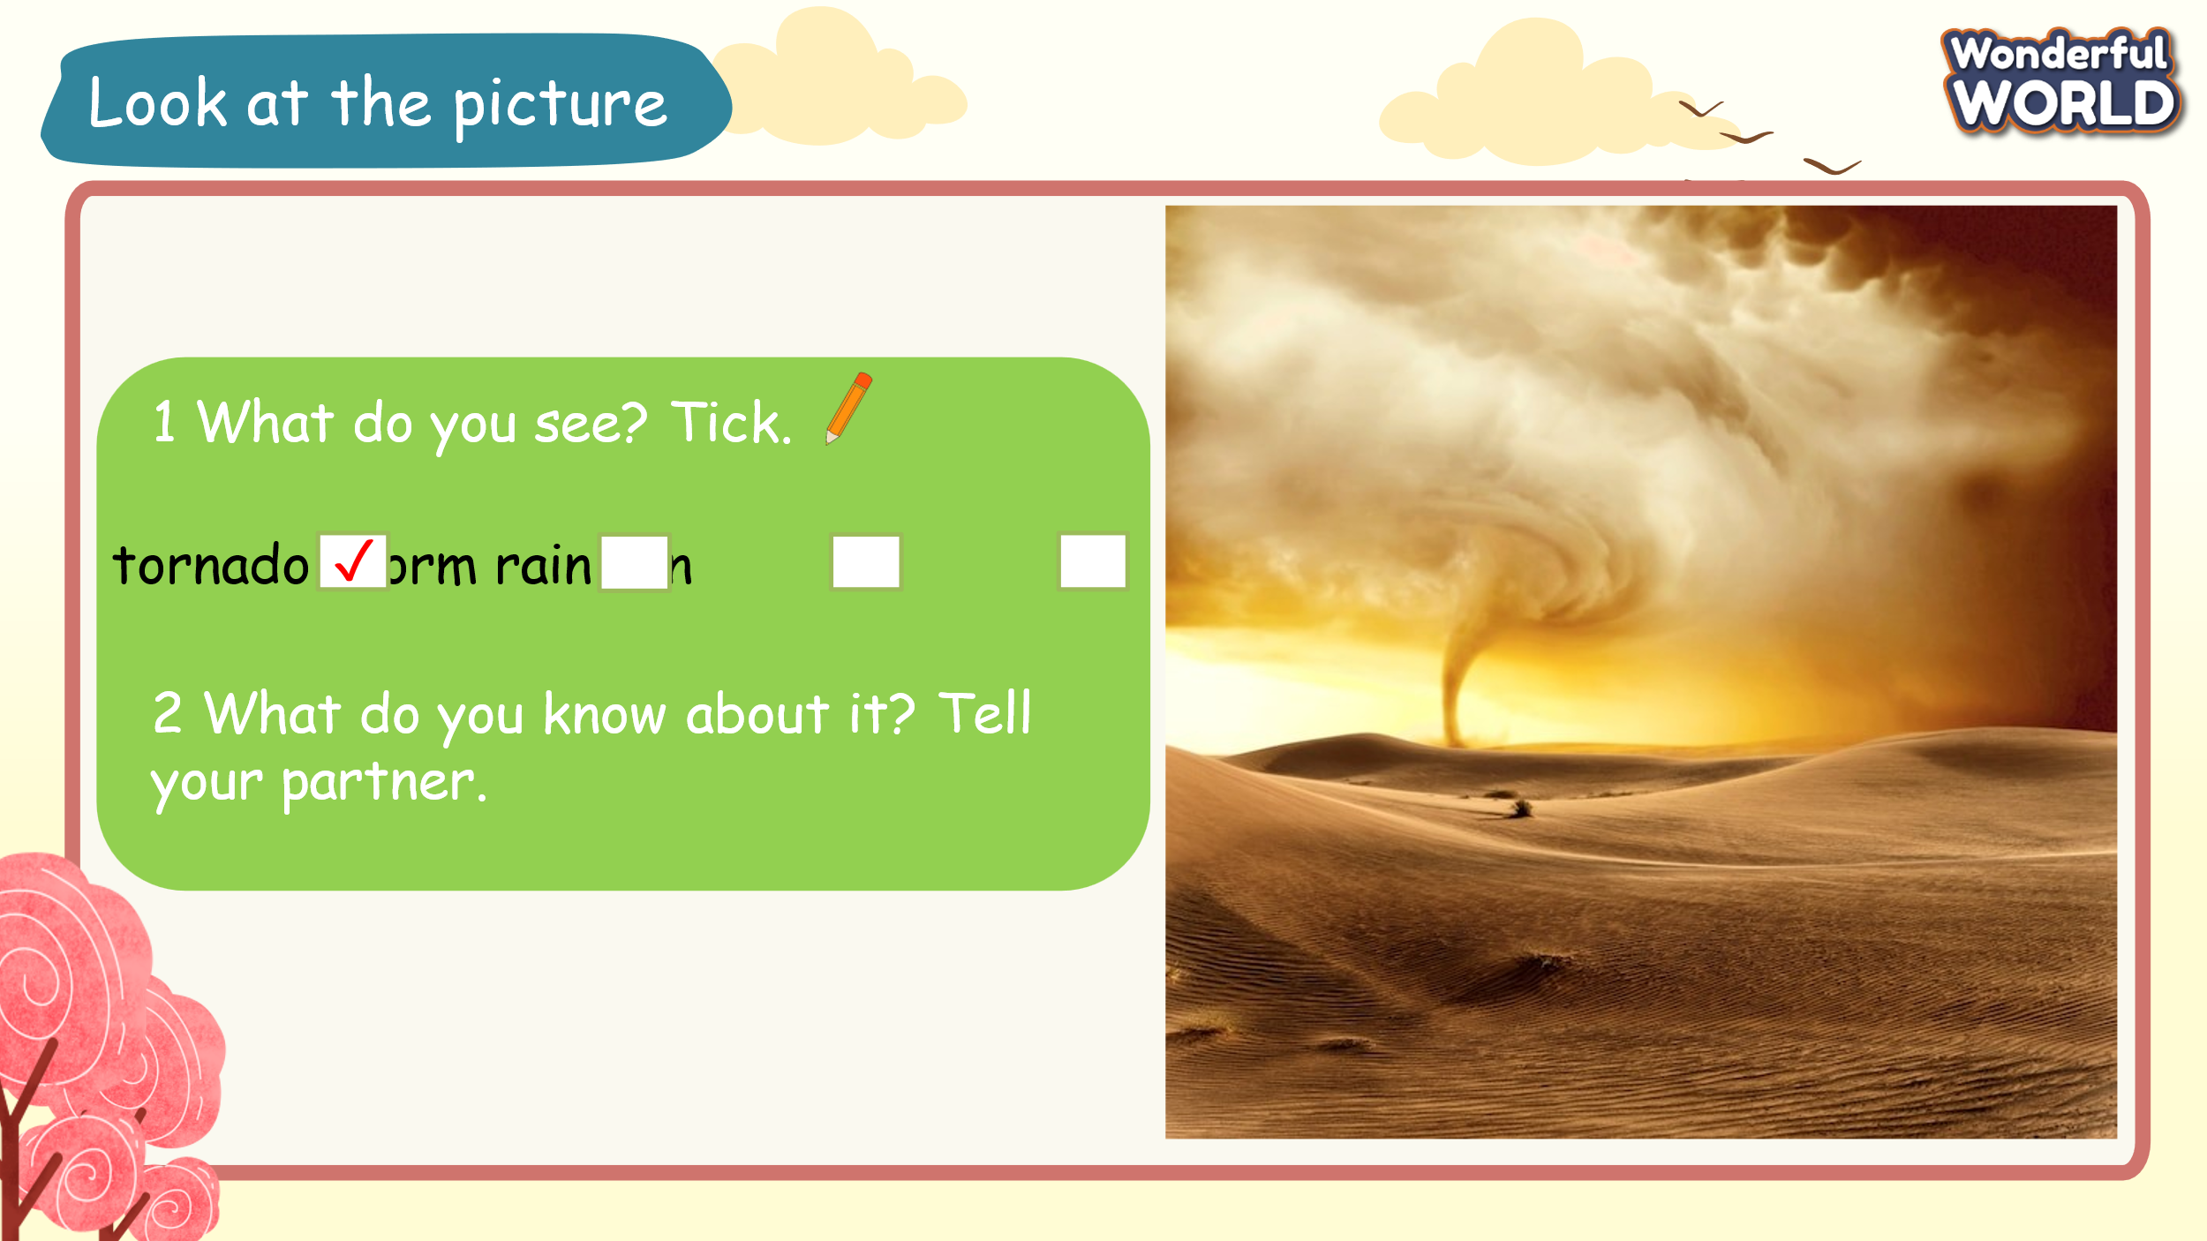  - Ask Ss to look at it and choose the correct answer for question 1 in their coursebook.  - Ask Ss to express their choice in question 1 and their thoughts in question 2.  Expected answers:  1 Tornado  2 A tornado is a strong, dangerous wind that forms itself into an upside-down spinning cone and is able to destroy buildings as it moves across the ground. | - Learn the words.  - Look and say.  - Join an activity.  - Listen and match.
Activity 3: Practice – Controlled practice (8 minutes)
Teacher’s Activities | Students’ Activities
Aim: Ss will practice listening and fill in the gaps to complete task 2.
Task 3: Listen and complete the sentences.  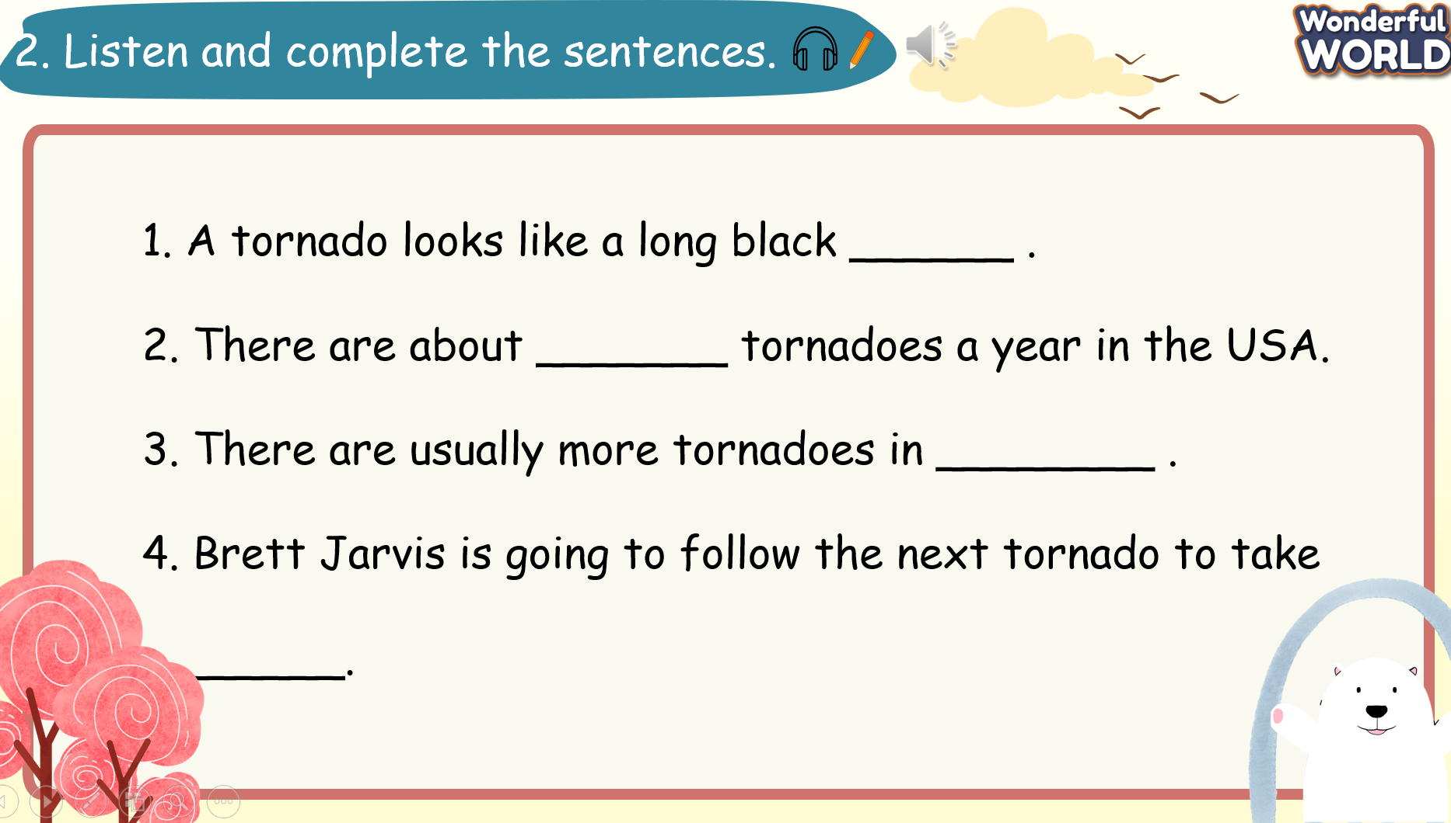  - Ask Ss to listen to the recording twice and fill in the information.  - Show them sentence 1 as an example.  - Ask Ss to work individually and do the task.  - Go around and offer help.  - Check answers as a whole class.  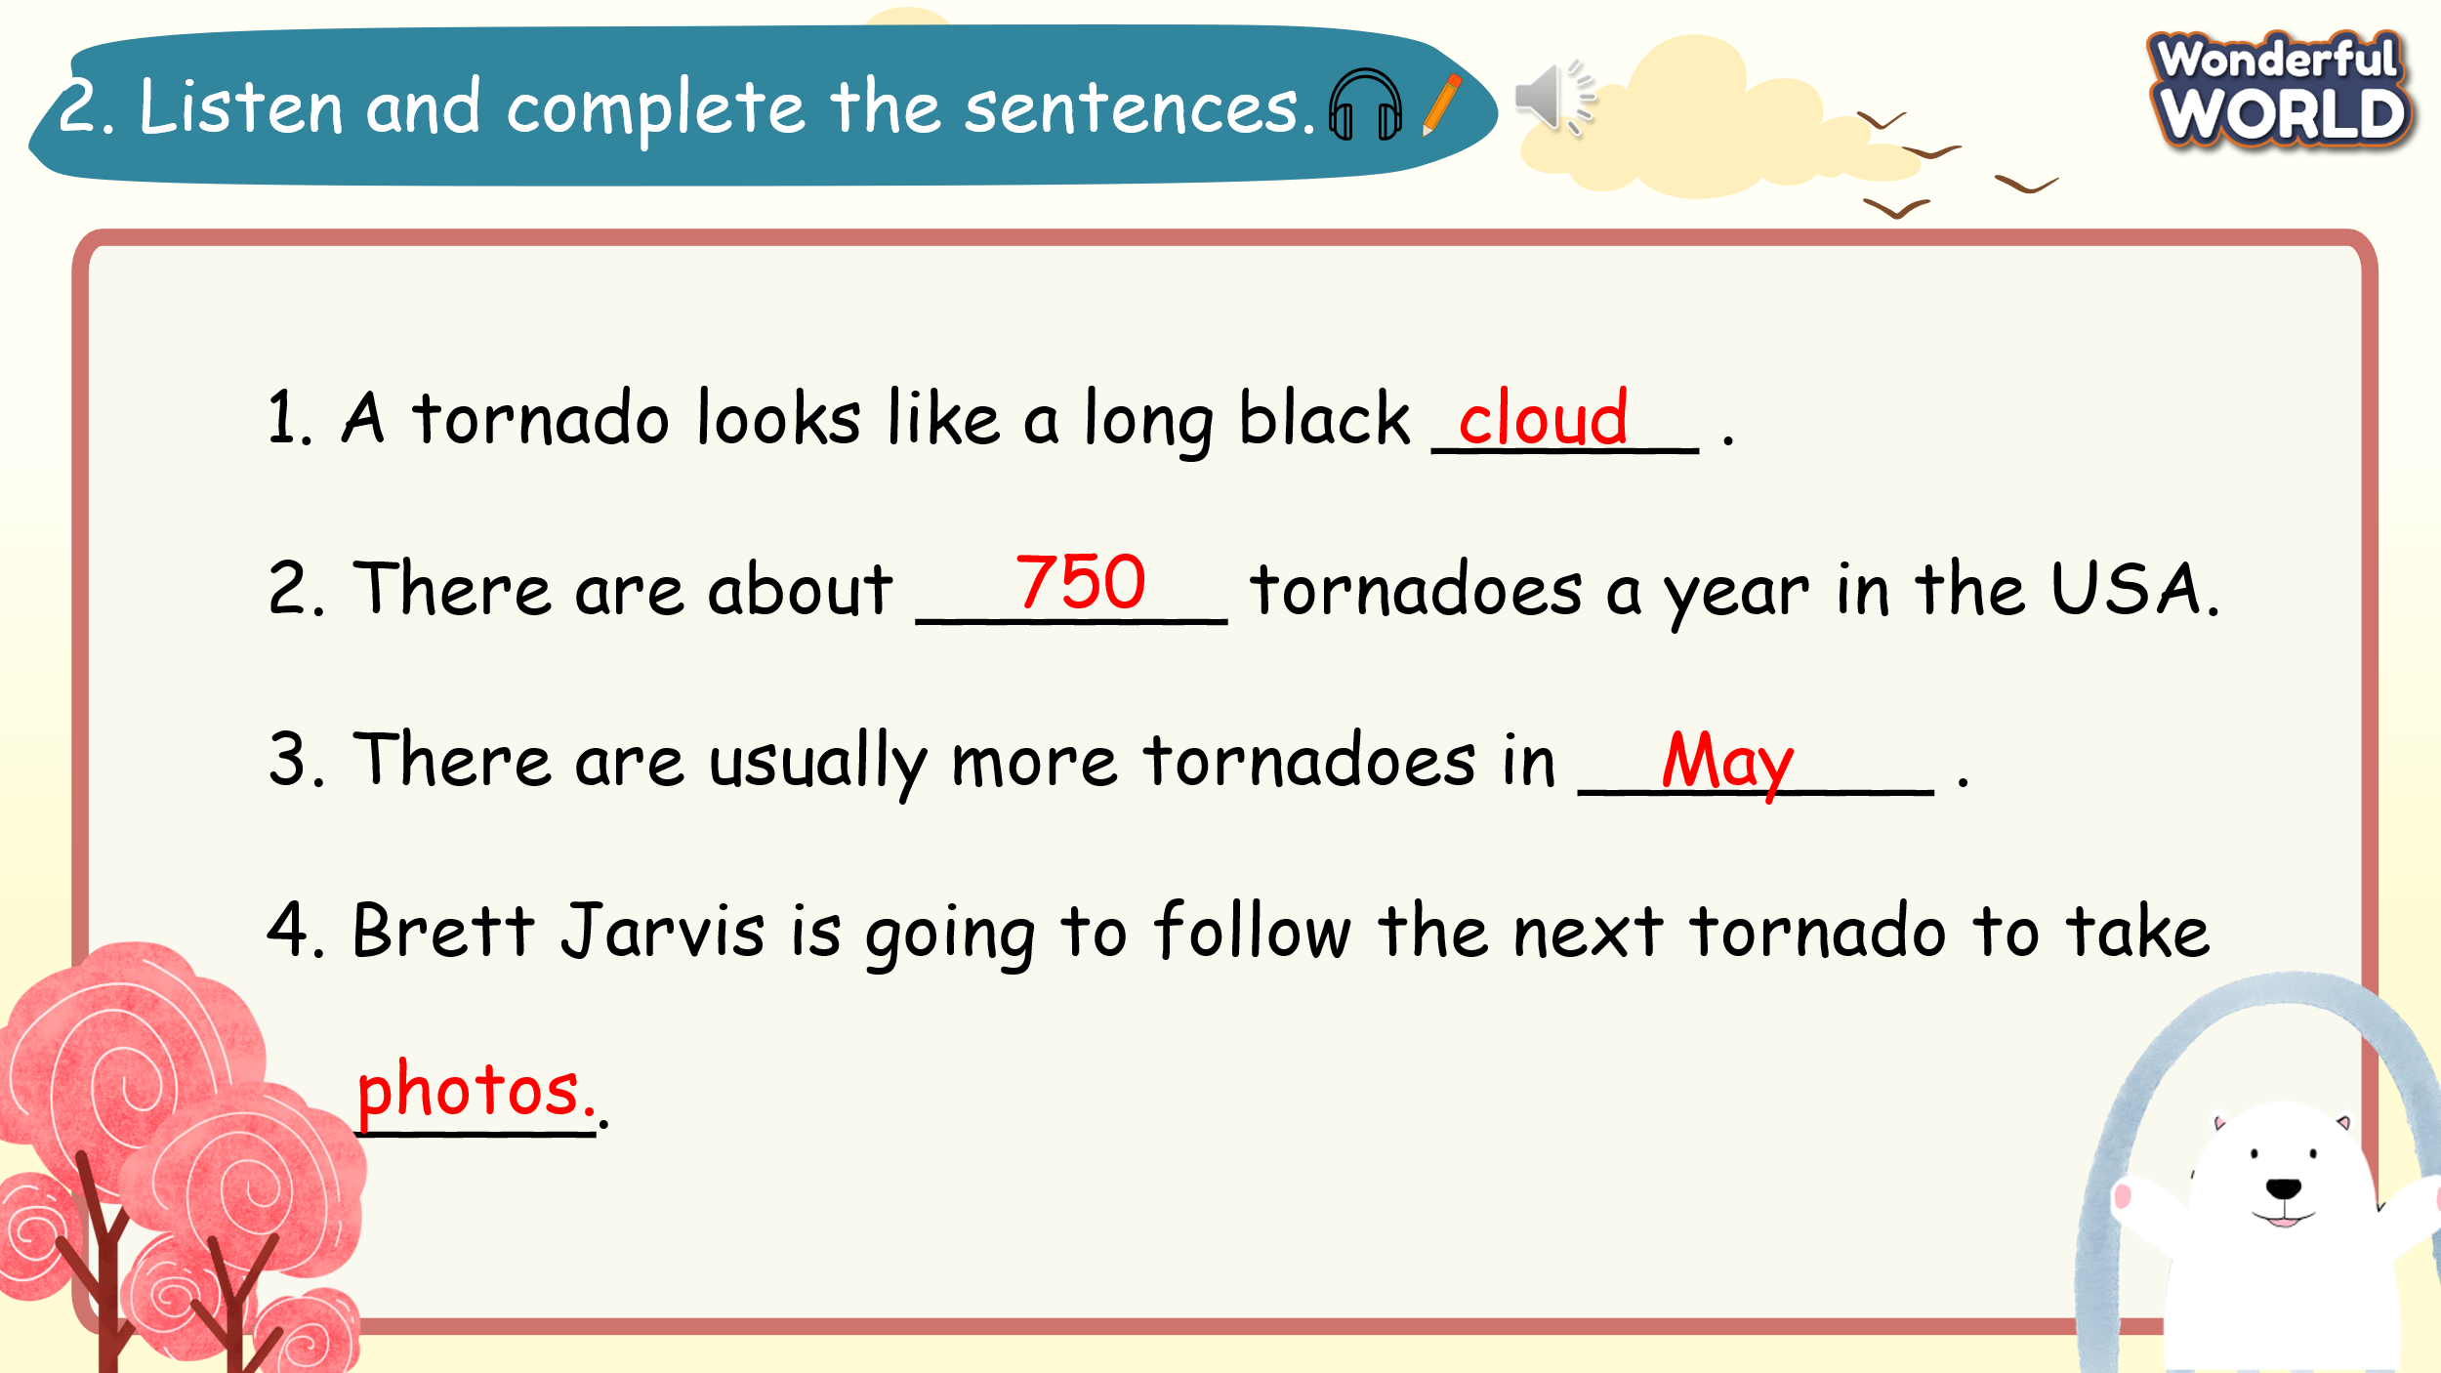 | - Listen and complete task 2.  - Listen to the T-check answers.
Activity 4: Production (5 minutes)
Teacher’s Activities | Students’ Activities
Aim: Ss complete task 3.
- Work in pairs to practice speaking about a holiday plan.
Task 3: Ask and answer about a holiday plan.  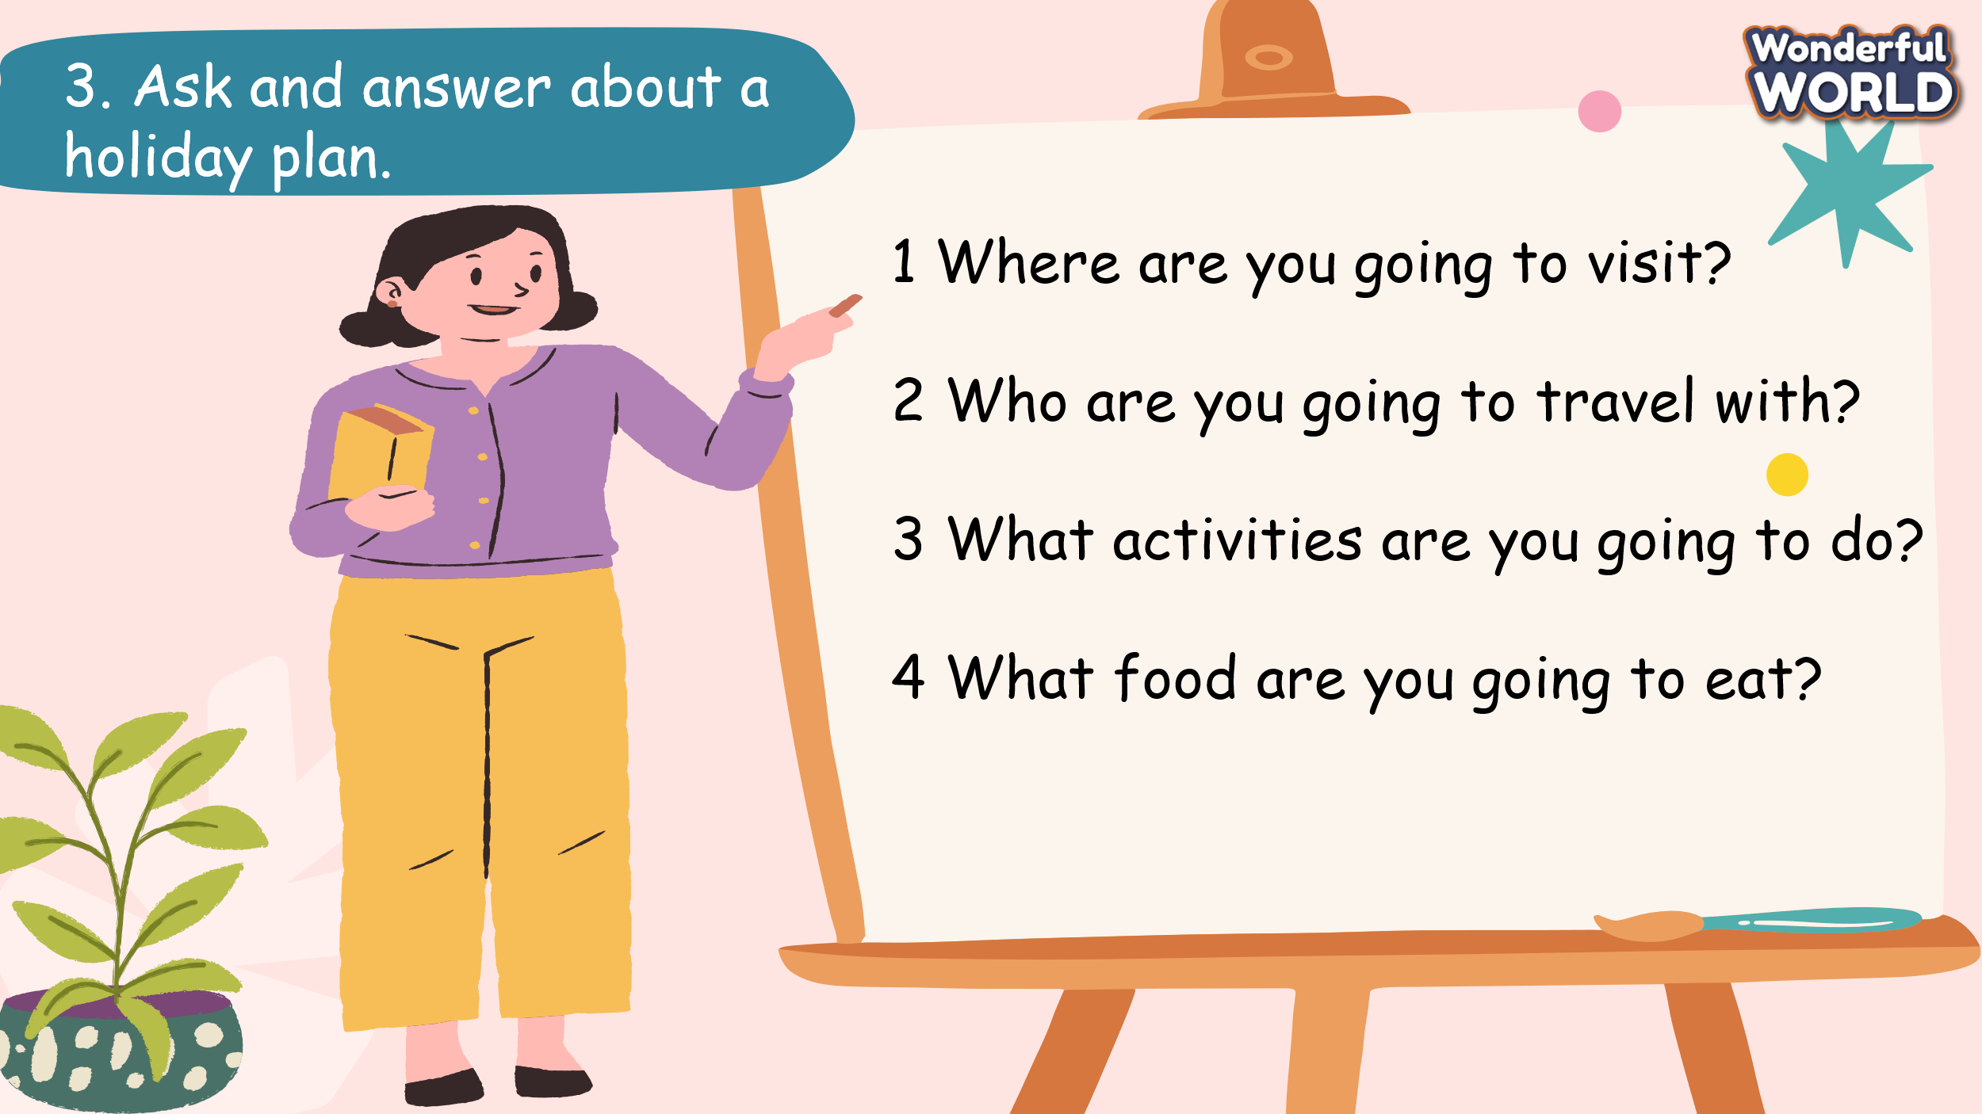  - Tell Ss that they are going to work in pairs to talk about a holiday plan.  - Tell Ss to look at the given questions and the dialogue.  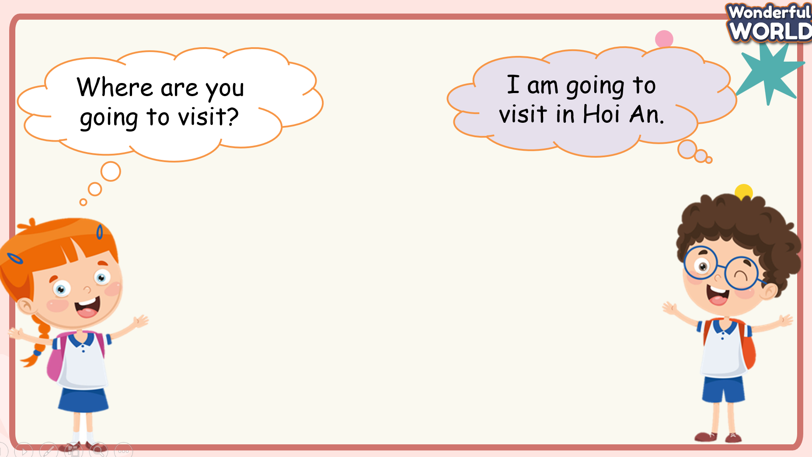  - Read out the dialogue. Read it out again, pause after each sentence, and ask Ss to repeat.  - Ask two Ss to read out the dialogue.  - Ask Ss to work in pairs and allow Ss enough time to practice speaking. Go round the class helping Ss where necessary.  - Ask some volunteers to speak in front of the class. | - Read some questions in task 3.  - Look at the dialogue and read out.  - Work in pairs and practice speaking about a holiday plan.  - Some pairs come to the board and practice speaking.
Activity 5: Wrap up & Assessment (5 minutes)
Teacher’s Activities | Students’ Activities
Aims:
- Check students’ understanding of what they have learned.
- Students rehearse what they have learned in the lesson.
Assessment:  Complete the following questions as you plan your holiday.  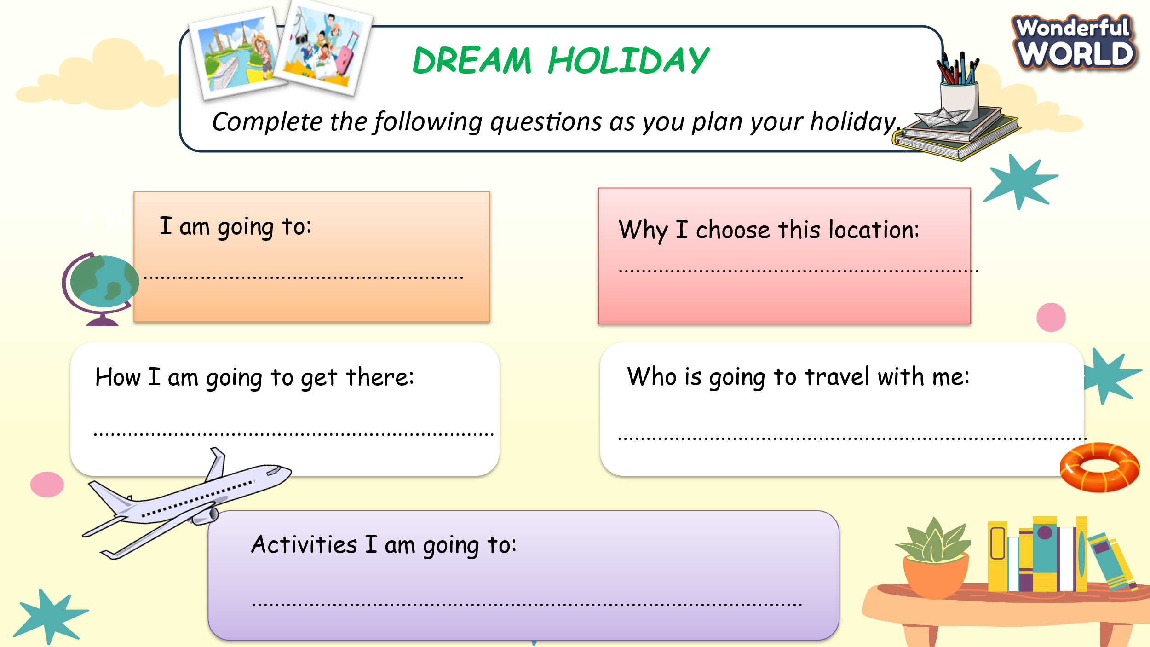  Wrap up:  * Remember  - Vocabulary:  tornado, storm.  - Practice speaking and speaking skills. | - Write answers about a holiday plan.  - Answer T’s question about what they learnt in today’s lesson.  - Stand up and say goodbye to the teacher.

