ĐỀ 1 - ĐMINH
Part 1: Listening
Question 1: Listen and number:
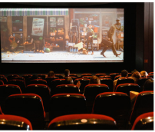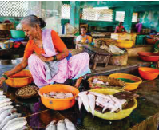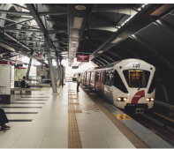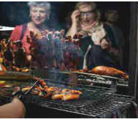
- b. c. d.
Question 2: Listen and write T for True or F for False
 |  | True/ False
1.Where do they see many people? | On the street.
2.Where is the new fountain? | Opposite the supermarket.
3.Where is the restaurant? | In front of the post office
4.How can they go home? | By bus
Question 3: Listen and circle the correct answers.
Example: 1. I was at the park/ village with my family yesterday.
2. My mother was on the train to Egypt/ England last Saturday.
3. Lan was in the library/ zoo last Sunday.
4. Mary and Ann were in a village in America/ Vietnam
5. We were on our trip to Turkey/ Egypt.
Part 3: Reading and Writing:
Question 4: Odd one out:
1. a. farmer b. farm c. nurse d. teacher
2. a. pupil b. notebook c. pencil d. rubber
3. a. factory b. farmer c. school d. hospital
4. a. strong b. play c. scary d. huge
5. a. yesterday b. last month c. Monday d. last year
Question 5: Choose the best answer:
1.Is the bookshop next to or opposite the museum?
a. It’s next to the museum b. It’s behind the museum
c. It’s between the museum d. It’s on Tran Phu Street
2.Where do we buy food?
a. At the post office B. At the supermarket C. At the school D. At the cinema
3.Where………the museum?
a. am b. are c.is d. were
4.She sometimes ……..videos on her smartphone.
a. make b. makes c.to make d. making
5.Teacher, ……we use the tablet?
a. can b. what c. would d. do
Question 6: Read and match column A with B:
1.Which place would you like to visit on holiday? | A.He likes rowing a boat on the island.
2.What can we do in Ha Long Bay? | B.I was in London last year.
3.What does he like doing? | C. I’d like to visit Ba Na Hills.
4.Where were you last year? | D. They were in museum yesterday.
5.Where were they yesterday? | E.We can eat seafood.
1. ……… 2. ……… 3. ……… 4. ……… 5. ………

Question 7: Read the text and circle the correct answer:
Marry likes fruits. She always eats fruit at home. She loves playing badminton and she sometimes plays it on Sundays. Marry sometimes talks to her grandmother on the phone. She sometimes cooks for her family and always takes care of her dog.
1.What does Marry like? A. sports b. fruits c. footballs d. books
2. She sometimes …….for her family. A. reads B. talks C. cooks D. plays
3.Marry………talks to her grandmother on the phone.
A. sometimes B. never C. often D. always
4.What does she play on Sundays? A. She plays badminton B. She plays football
C. She plays chess D. She plays volleyball
Question 8: Arrange the words to make sentences:
1.the fountain/ Is/ or/ in front of/ behind/ bookshop/ the?  a. Or the fountain in front of is behind the bookshop?  b. Is the fountain in front of or behind the bookshop?  c. The fountain is in front of or behind the bookshop? | 2. at/ shopping/ go/ We/ the supermarket.  a. We go shopping at the supermarket.  b. We gos shopping at the supermarket.  c. We goes shopping at the supermarket.
3.animals/ of/ takes care/ A vet  a. A vet take care of animals.  b. A vet takes of animals care.  c. A vet takes care of animals. | 4.lab/ computer/ Who/ can/ use/ the?  a. Who can use the lab computer?  b. Who can use the computer lab?  c. Who use can the computer lab?
5.What/ holiday/ you/do/like/ on/ doing?
a. What do you like doing on holiday?
b. What do you likes doing on holiday?
c. What doing you like do on holiday?

Question 9: Look at the picture and write one word in the blank:

………………….. ………………… . …………… . ……………….…

