Week 2 (From 15/9 to 19/9)
UNIT 1. MY FAMILY AND FRIENDS
Lesson 3 - Task 1, 2, 3
Period 5
I. OBJECTIVES:
1. Knowledge:

- Listening skills: An email to talk about your friend’s family
- Writing skills: Write about your best friend
2. Competences:
- English competences:+To review some adjectives describing people and adverbs of manners.
+To practice listening and writing skills of the topic Family or Friends.
- Common competences: Students can make Finger Puppets creatively to describe their friends or family.
3. Qualities:
- Students will
+ make their friendships deeper.
+ be confident and active in communication with friends and teachers.
II. EQUIPMENT AND MATERIALS:
- Basic things: Student’s book, flashcards, puppets...
- Advanced things: PPT, laptop, TV.
III. LESSON PROCEDURE:
Activity 1: Warm-up (5 minutes)
Teacher’s Activities | Students’ Activities
Aims: Welcome students, and engage the class with a game “PUT THE ADJECTIVES AND ADVERBS INTO SUITABLE BASKETS”.
Warm-up the atmosphere of the class.
Procedure  - Greet students.  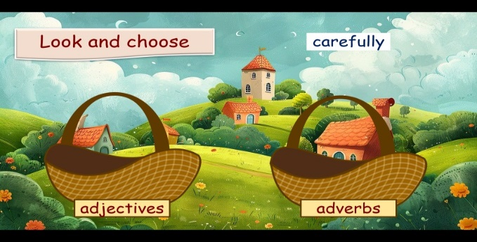  -T divides the class into 2 or 4 teams. Each team chooses their team name.  - T has students put each word into one of two baskets ( adjective basket and adverb basket)  - T prepares the wheel for students. | - Greet Teacher  - Choose a team name  - Join the activity.  - Spin the wheel to get stars.
Activity 2: Presentation (7 minutes)
Teacher’s Activities | Students’ Activities
Aims: Students know how to use adjectives to describe a person( shape, complexion, hair….)
Procedure
- T shows a few words that describe the appearance of people (long, dark, curly, short, fair, straight)
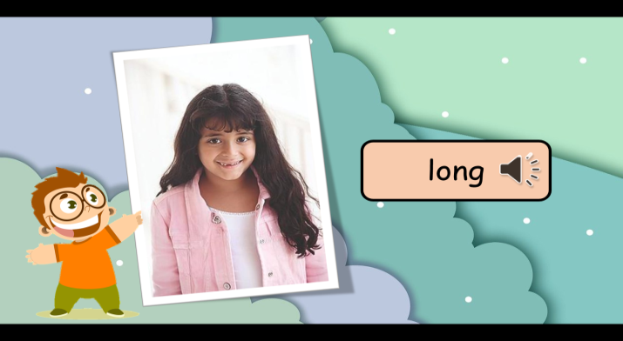
* Mini game: Look and say to review the words.
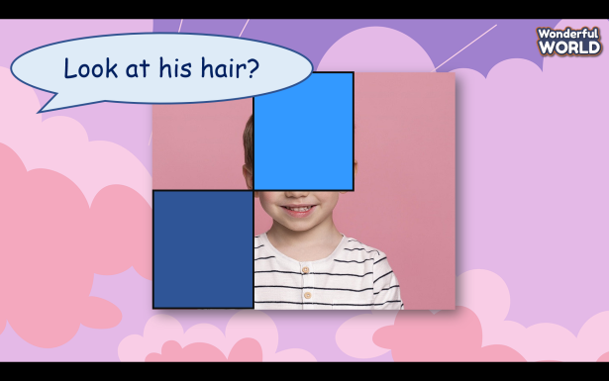
- T gives stars to the student who has a correct answer.
Activity 3: Practice (11 minutes)
Teacher’s Activities | Students’ Activities
Aims: - Practice listening and develop the question judgment ability for students.
Procedure  Task 1 Look and say. Are they friends? What do they look like?  -T tells students to look at the small photos on page 10, Task 1.  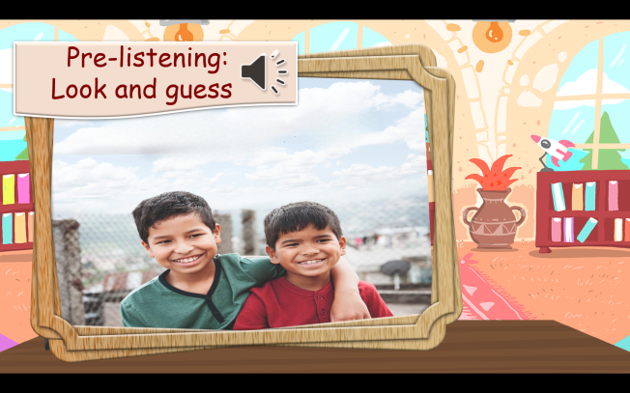  -T elicits what they can see in these photos. Read aloud again the word underneath each photo and have students repeat it.  - T asks students to observe the big photo and elicit the answers from students, encouraging them to describe what the two boys look like using the provided descriptors (dark, fair, long, short, curly, straight).  + Are they friends?  +Where are they?  + What do they look like?  + Are they happy?  (At this stage, the answers may vary)  Task 2 Listen and check. Then tick T for True or F for False. TR: 1.7  - T reads aloud the statements about Errol and his friends.  - T explains the meanings if necessary.  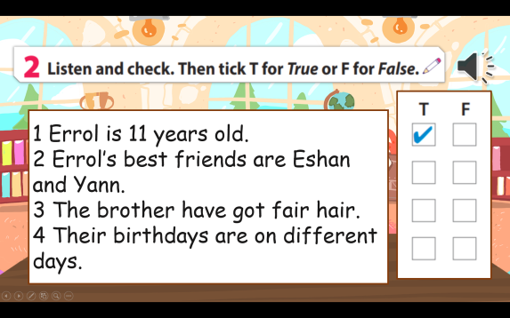  - T plays the recording. Tell students to listen carefully and decide if the sentences are true or false.  - T plays the recording again. Pause after each sentence.  - Check answers as a class. | - Look at the picture and describe the picture.  - Listen and tick true or false.  - Volunteers to read out their answers.
Activity 4: Production (7 minutes)
Teacher’s Activities | Students’ Activities
Aims: Practice writing and presentation skills in front of a crowd.
Procedure  Task 3 Write and say.  - T tells students to look at the sample. Read the example out loud and ask students to repeat.  - Discuss the key elements: name, age, place of origin, and details about their best friend’s appearance.  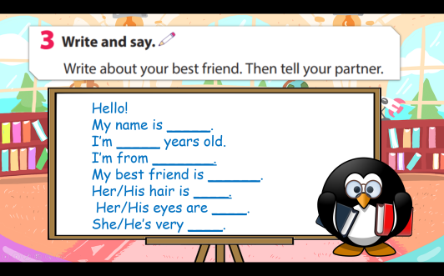  -T instructs students to write their paragraphs about their best friends, using the template provided.  - T checks that students understand the task. Allow enough time for them to complete the task.  - T encourages creativity and originality in their descriptions.  - T has students pair up and share their descriptions.  - T encourages partners to provide feedback and ask questions about each other’s best friends.  - T asks volunteers to share their descriptions with the class.  -T discusses any common themes or interesting details mentioned in the writing.  - Write any mistakes on the board and ask students to correct them. | - Read the sample and think about the best friend to write  -Have students pair up and share their descriptions  -Volunteers to share your production in front of the class.
Activity 5: Wrap up & Assessment (5 minutes)
Teacher’s Activities | Students’ Activities
Aims:
- Check students’s understanding of what they have learned.
- Students rehearse what they have learned in the lesson.
- T asks students to do the assessment ( look and choose).  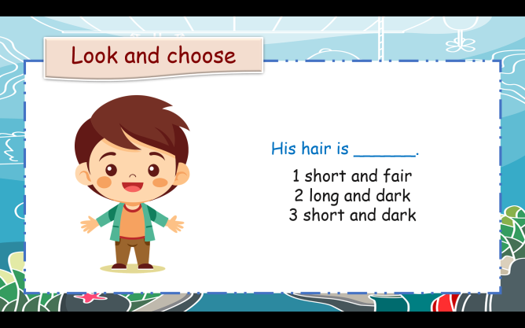  - Check with the class.  - Wrap-up  * Remember: - New words: curly, straight, long, short, fair, dark  - Writing and talking about a best friend. | -Do the assessment.  - Check with the teacher  - Sts read the wrap-up  - Stand up and say goodbye to the teacher.
__________________________________
UNIT 1. MY FAMILY AND FRIENDS
Lesson 3 - Task 4, 5, 6
Period 6
I. OBJECTIVES:
1. Knowledge:
Review Vocabulary: family members
Grammar:
Possessive‘s
- Lara’s hair is green.
- Her mother’s hair is brown.
2. Competences:
- English competences: To learn how to use possessives
- Common competences: To practice describing a family tree using possessive ‘s
3. Qualities:
- Students will
+ have a strong sense of family love.
+ understand about the blood-relationship in the family
II. EQUIPMENT AND MATERIALS:
- Basic things: Student’s book, flashcards, Family icons.
- Advanced things: PPT, laptop, TV.
III. LESSON PROCEDURE:
 | Activity 1: Warm-up (5 minutes)
 | Teacher’s Activities | Students’ Activities
Aims: Welcome students, and engage the class with a game “What letters are missing”.
Warm-up activity to review members in the family tree.
 | Procedure  -Greet students.  -Divide the class into 2 teams. Each team chooses their team name.  - Ask students to guess the title using a guessing words game.  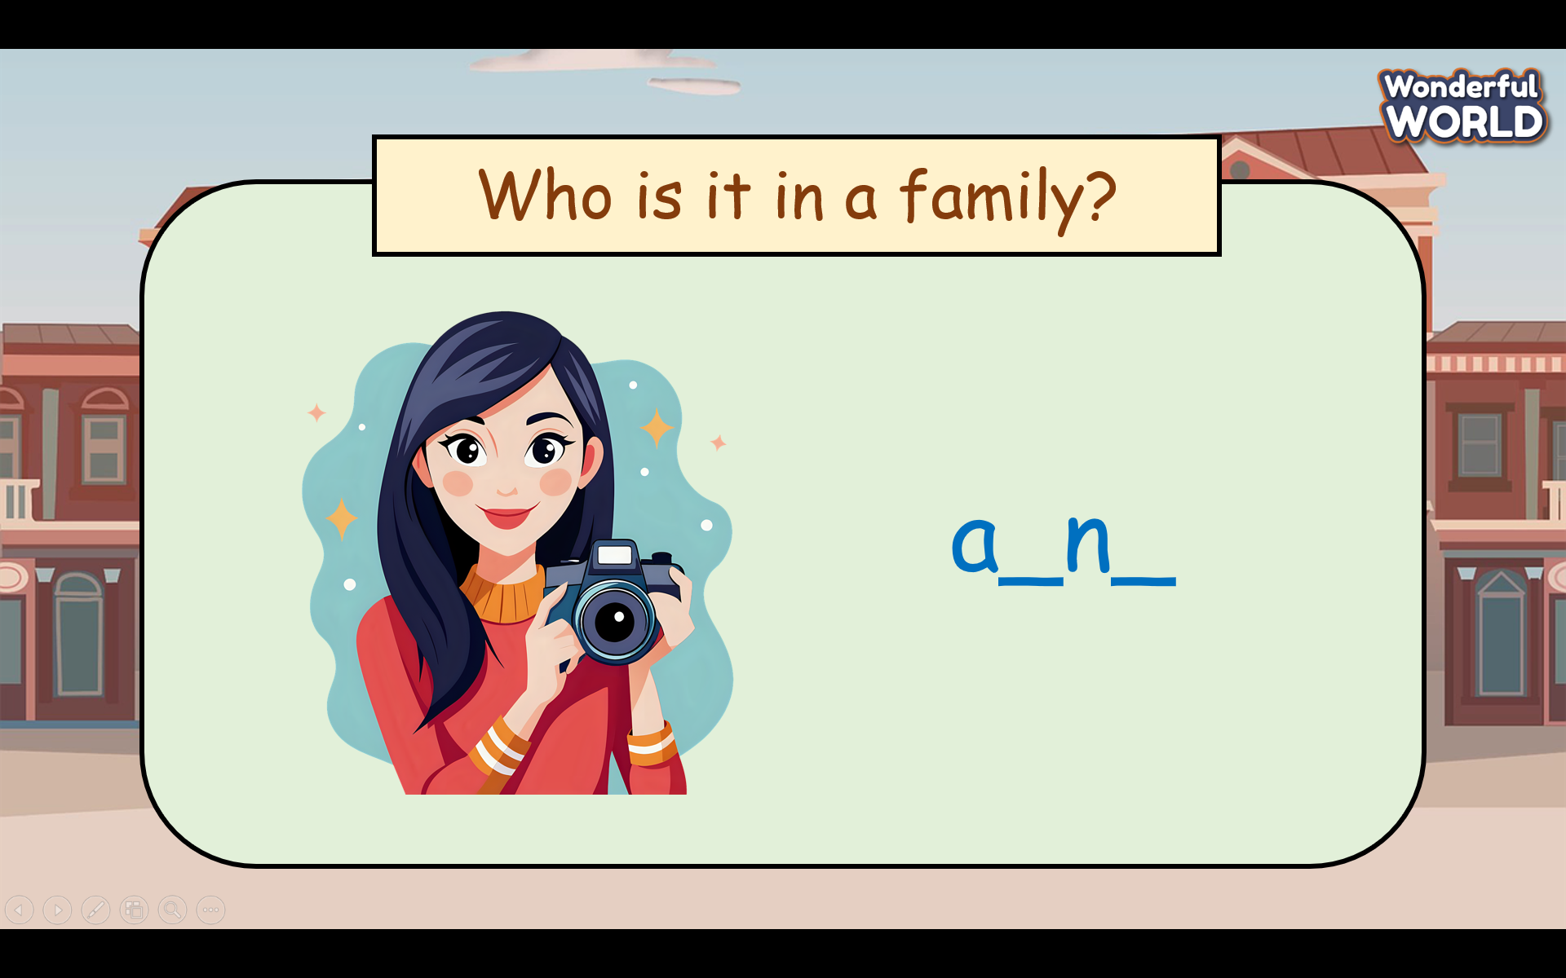  -T calls the fastest student to fill in the letters in the blanks.  -T gives stars for the correct answer. | - Greet Teacher  - Choose a team name  - Join the activity.
Activity 2: Presentation (7 minutes)
Teacher’s Activities |  | Students’ Activities
- Aims: Students know how to use possessives in a sentence.
Procedure  Task 4: Listen and read. Then color.  . 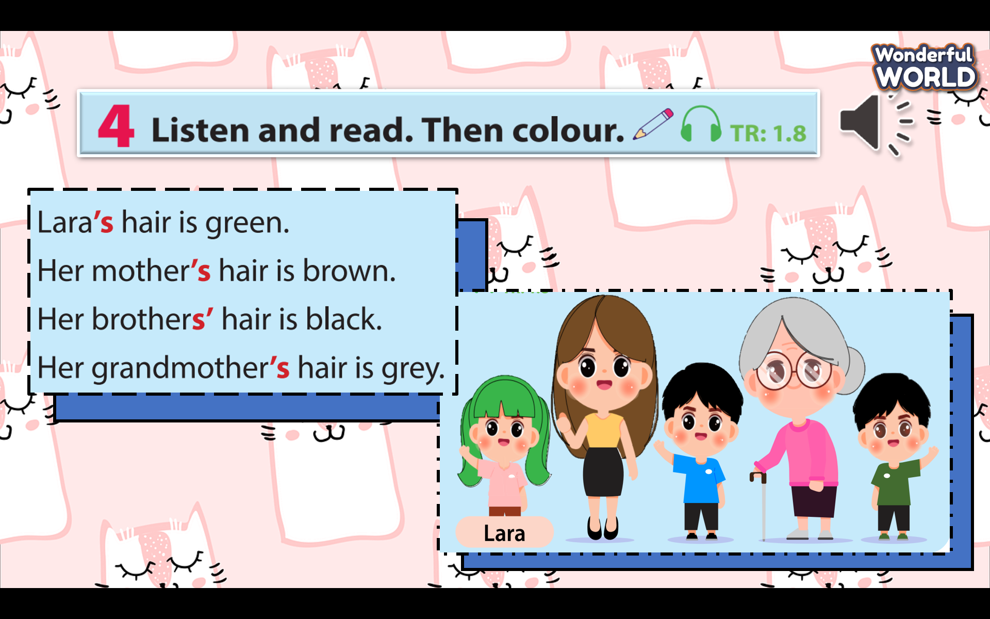  Start by playing the recording for Track 1.8.  -T instructs students to look at the sentences.  - T has students listen and follow along with the sentences using their fingers.  - T plays the recording again and asks students to repeat the sentences.  - T distributes colouring worksheets.  -T ask students to colour Lara’s hair and her family members’ hair based on the descriptions in the text. (Lara’s hair is green, her mother’s hair is brown, her brothers’ hair is black and her grandmother’s hair is grey.)  - T has students pair up and compare their coloured illustrations.  - Check the answers as class.  -T teaches how to use possessive ‘s(person (singular) or more than one person (plural).  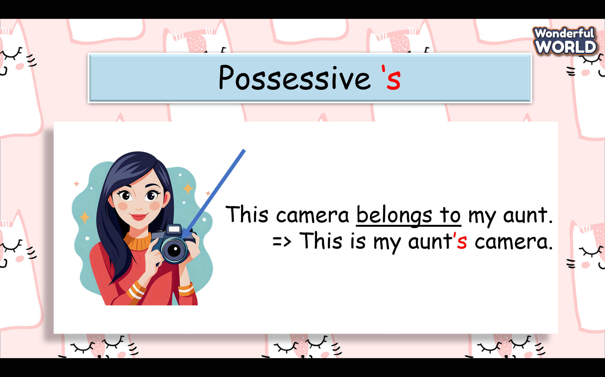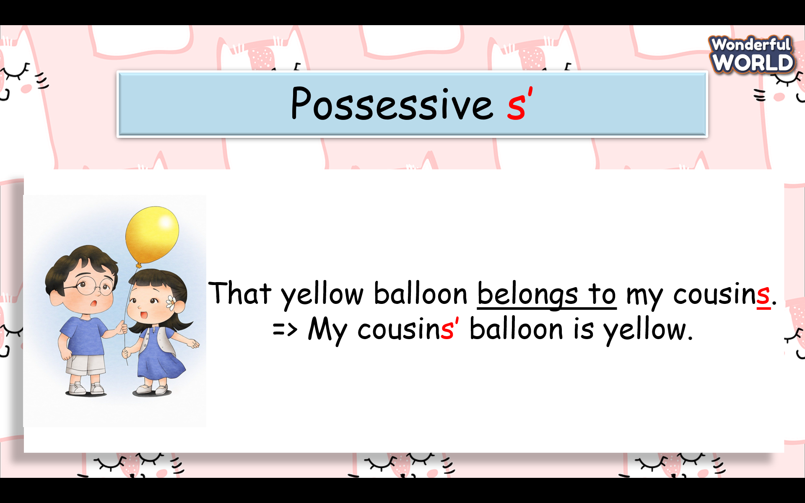  -Then T has a few examples for students to practice. |  | - Listen to teacher’s guide  -Look,listen and follow along with the sentences  - Colour Lara’s hair and her family members’ hair
Activity 3: Practice (11 minutes)
Teacher’s Activities |  | Students’ Activities
Aims: Students have a chance to practice using possessives.
Procedure  Task 5. Read and circle the correct word for each sentence.  -T tells students to look at Task 5 on page 11.  -T instructs students to read each sentence and circle the correct word for each possessive form.  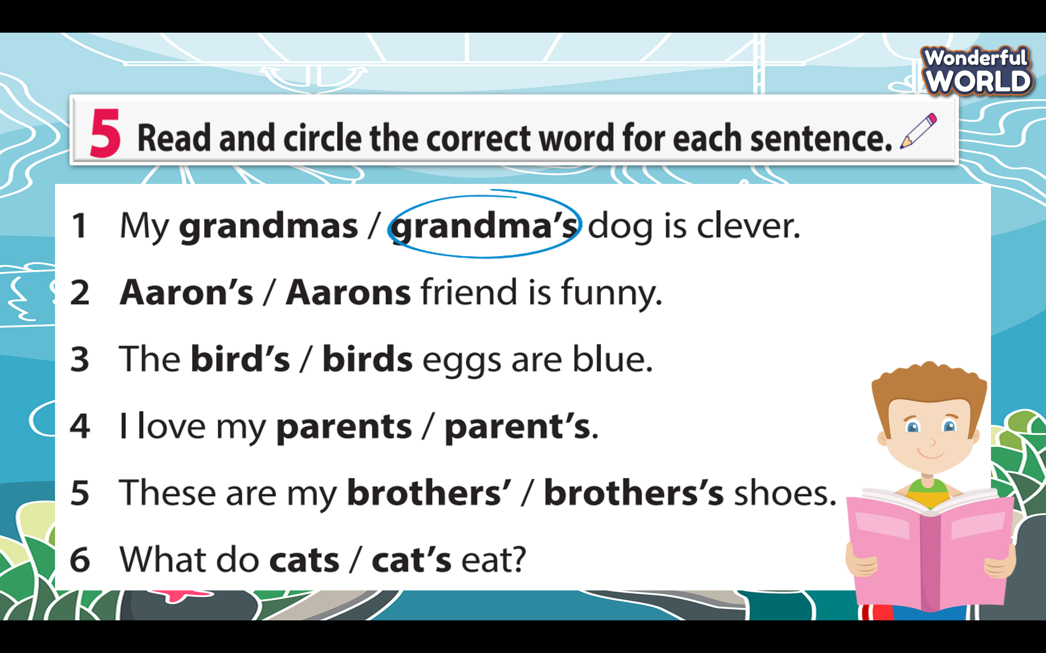  -T allows students time to independently circle the correct words in each sentence.  -T reminds them to consider whether the sentence is referring to one person (singular) or more than one person (plural).  -T has students pair up to discuss and compare their choices.  -T encourages students to explain their reasoning for choosing a particular word.  -T discusses the correct answers as a class. |  | - Read through sentences quickly and circle  - Raise the hand to answer the question  - Receive stars for his/her team.  - Discuss and compare their choices.  - Explain their reasoning for choosing
Activity 4: Production (7 minutes)
Teacher’s Activities |  | Students’ Activities
Aims: Students know how to write and speak sentences about family topics by using possessives.
Procedure  -T displays or let students look at the family tree in Task 6  Page 11 (the family relationship chart.  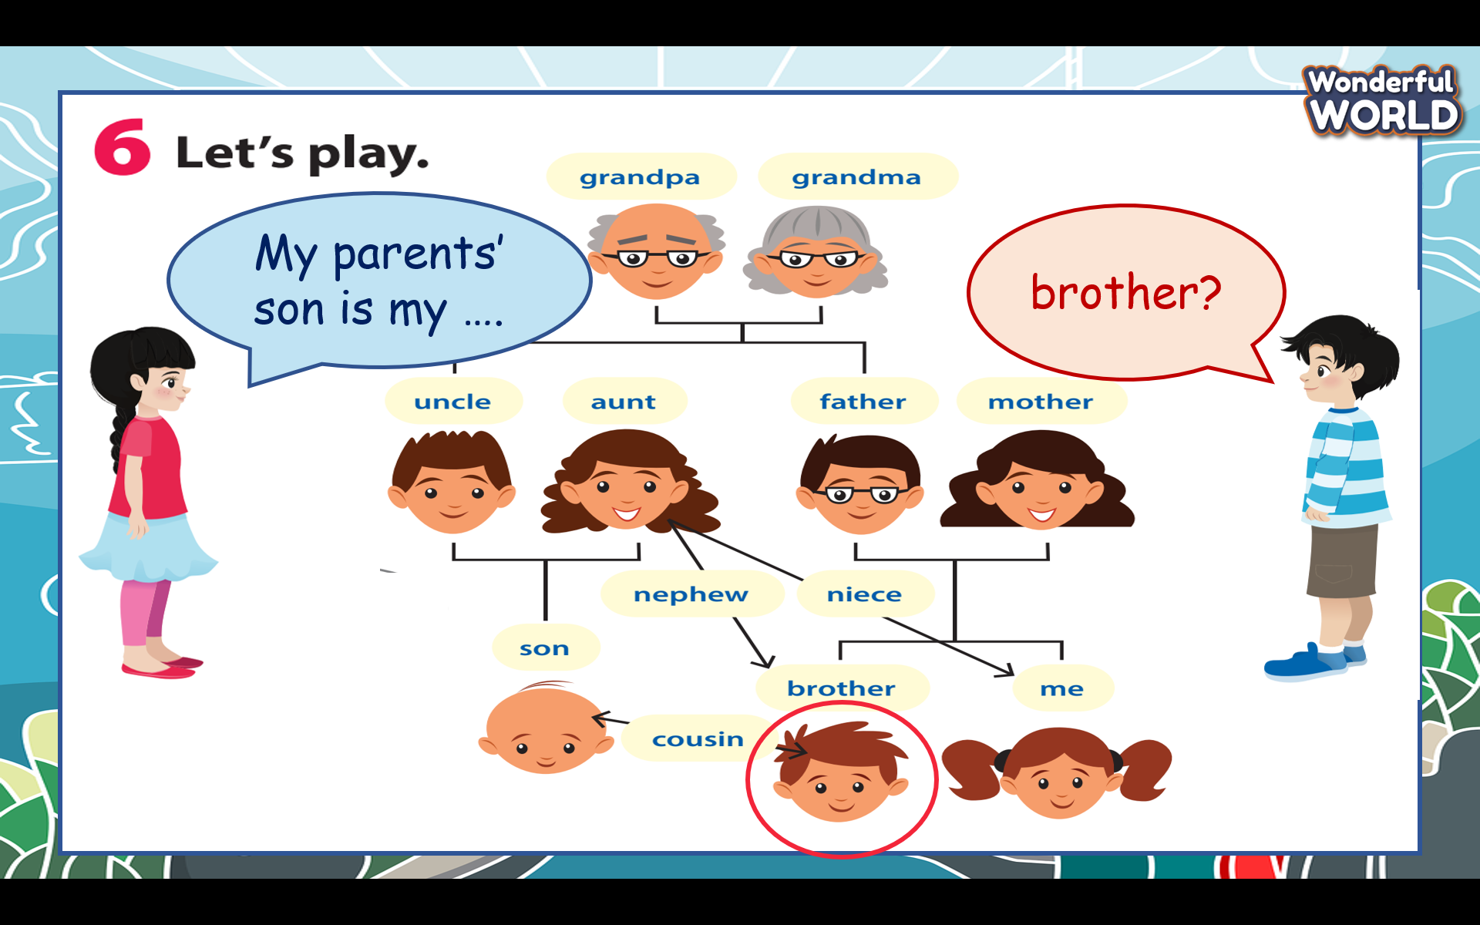  -T explains the game rules: one student describes a relationship, and the others guess the correct family member.  -T reads the example aloud and explains the answer.  -T ensures students understand the format.  - T divides the class into pairs or small groups. Each group takes turns creating relationship clues for others to guess.  -T rotates roles within the groups.  -T encourages creative and engaging clues.  -Summarise the relationships discussed during the game.  - If using game tokens or markers, acknowledge the winners or provide small gifts.  - T invites a couple of pairs to share their sentences with the class.  - Give feedback to the whole class. |  | - Guess the correct family member  - Share their sentences with the class  - Each group takes turns creating relationship clues for others to guess,
Activity 5: Wrap up & Assessment (5 minutes)
Teacher’s Activities |  | Students’ Activities
Aims:
- Check students’s understanding of what they have learned.
- Students rehearse what they have learned in the lesson.
-T asks sts to do the assessment (Find the mistake and correct it)  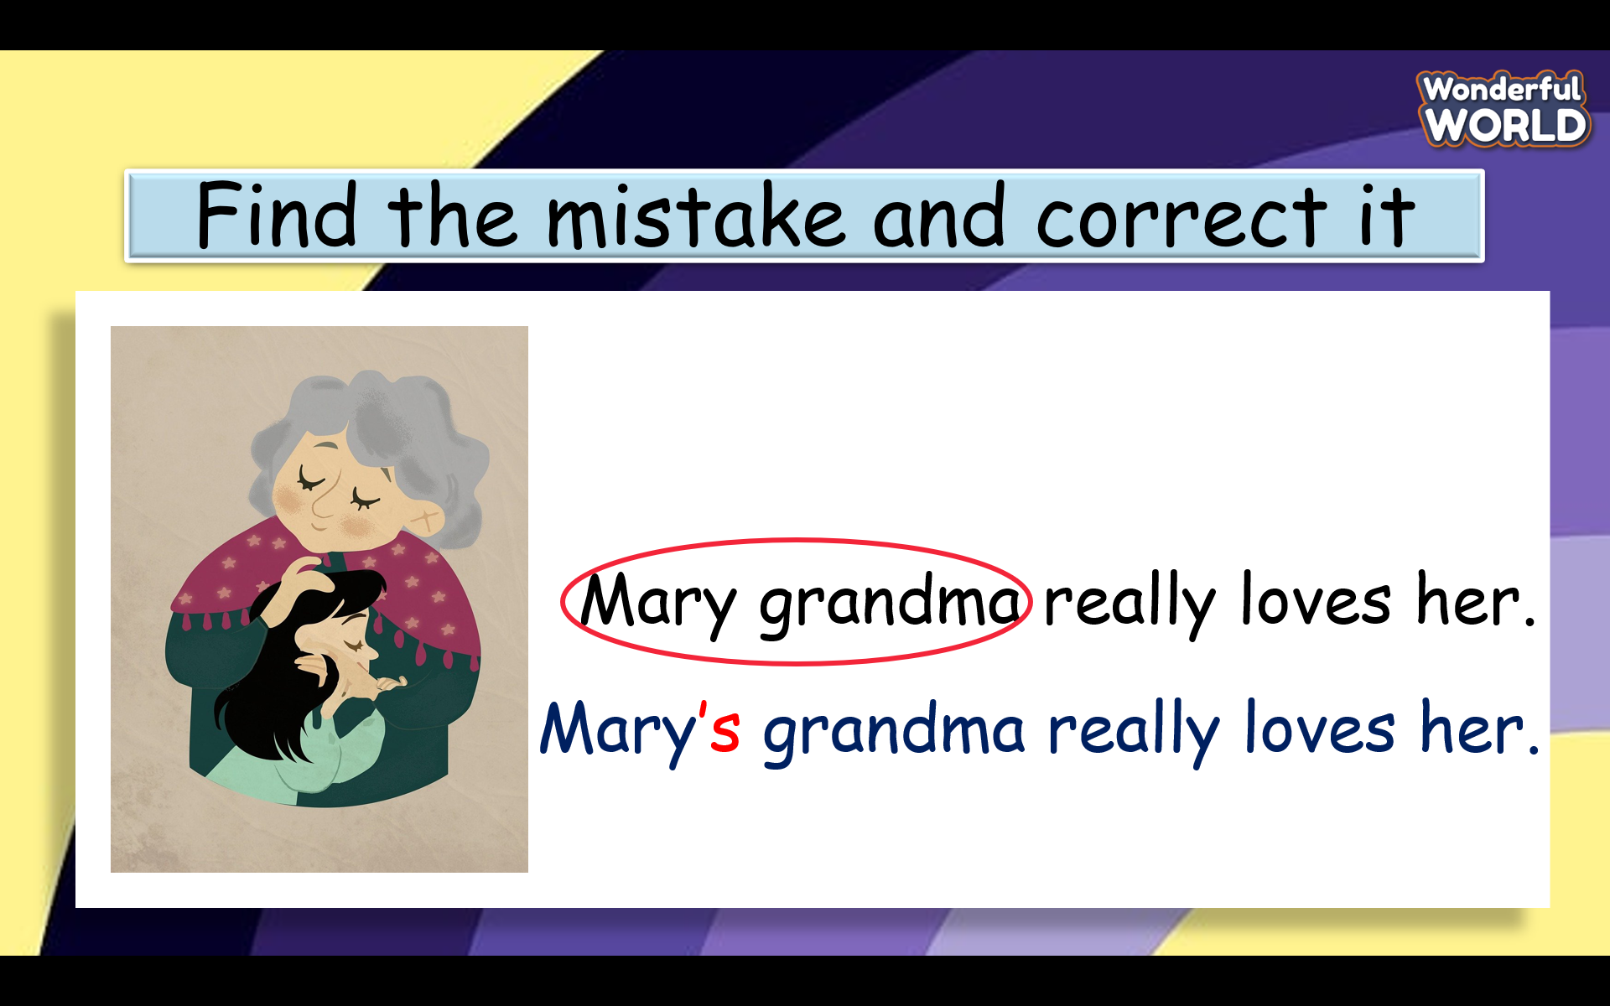  - Check with the class.  - Wrap-up  * Remember:  +members in the family  + Possessive‘s  Lara’s hair is green.  Her mother’s hair is brown. |  | - Do the assessment.  - Check with the teacher  - Sts read the wrap-up  - Stand up and say goodbye to the teacher.
___________________________________

UNIT 1. MY FAMILY AND FRIENDS
Lesson 3 - Task 7, 8, 9, 10
Period 7
I. OBJECTIVES:
1. Knowledge:
Pronunciation: Word stress (First syllable)
Friendly, noisy

- English competences:-To recognize the stressed syllable in two-syllable words

2. Competences:
- To practice pronouncing stressed syllables
- Common competences: Be confident and active in communication with friends and teachers
3. Qualities:
- Students will feel confident in their pronunciation when they speak in the crowd.
II. EQUIPMENT AND MATERIALS:
- Basic things: Student’s book, flashcards, Family icons.
- Advanced things: PPT, laptop, TV.
III. LESSON PROCEDURE:
Activity 1: Warm-up (5 minutes)
Teacher’s Activities |  | Students’ Activities
Aims: Welcome students, and engage the class with a game “ look the picture and choose ”.
Warm-up activity to review possessive.
 | Procedure  - Greet students.  -Divide the class into 2 or 4 teams. Each team chooses their team name.  - Ask students to guess the title using a guessing words game.  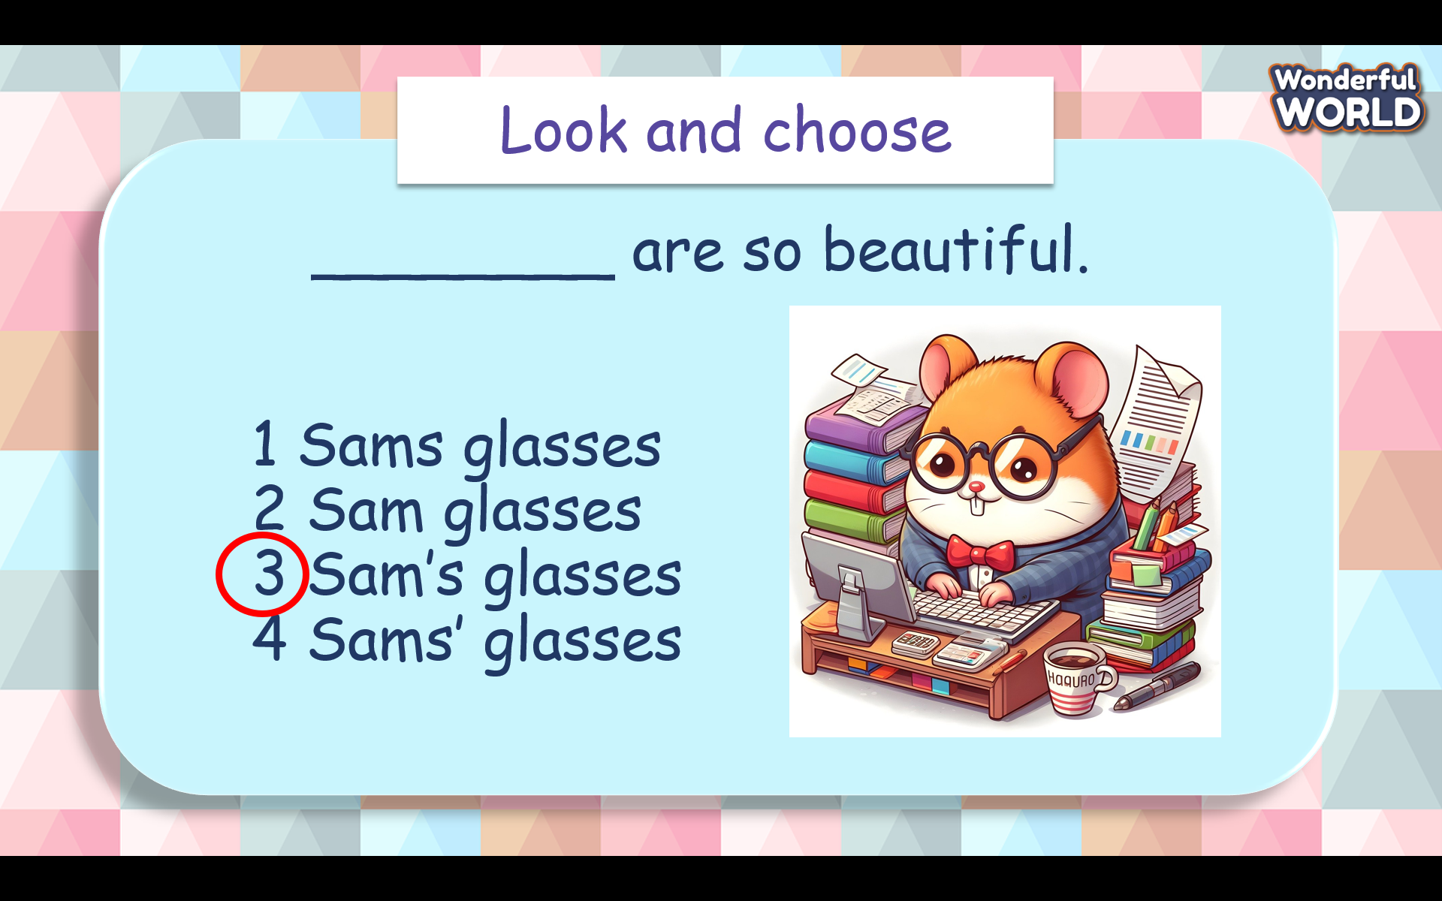  - T calls the fastest student to choose the correct answer to fill in each blank.  -T gives stars to the student who has the correct answer. | - Greet Teacher  - Choose a team name  - Join the activity.
Activity 2: Presentation (7 minutes)
Teacher’s Activities |  | Students’ Activities
Aims: Introduce the concept of word stress, explaining that it involves emphasizing certain syllables in words for clearer pronunciation
Procedure  Task 7: Listen and repeat.  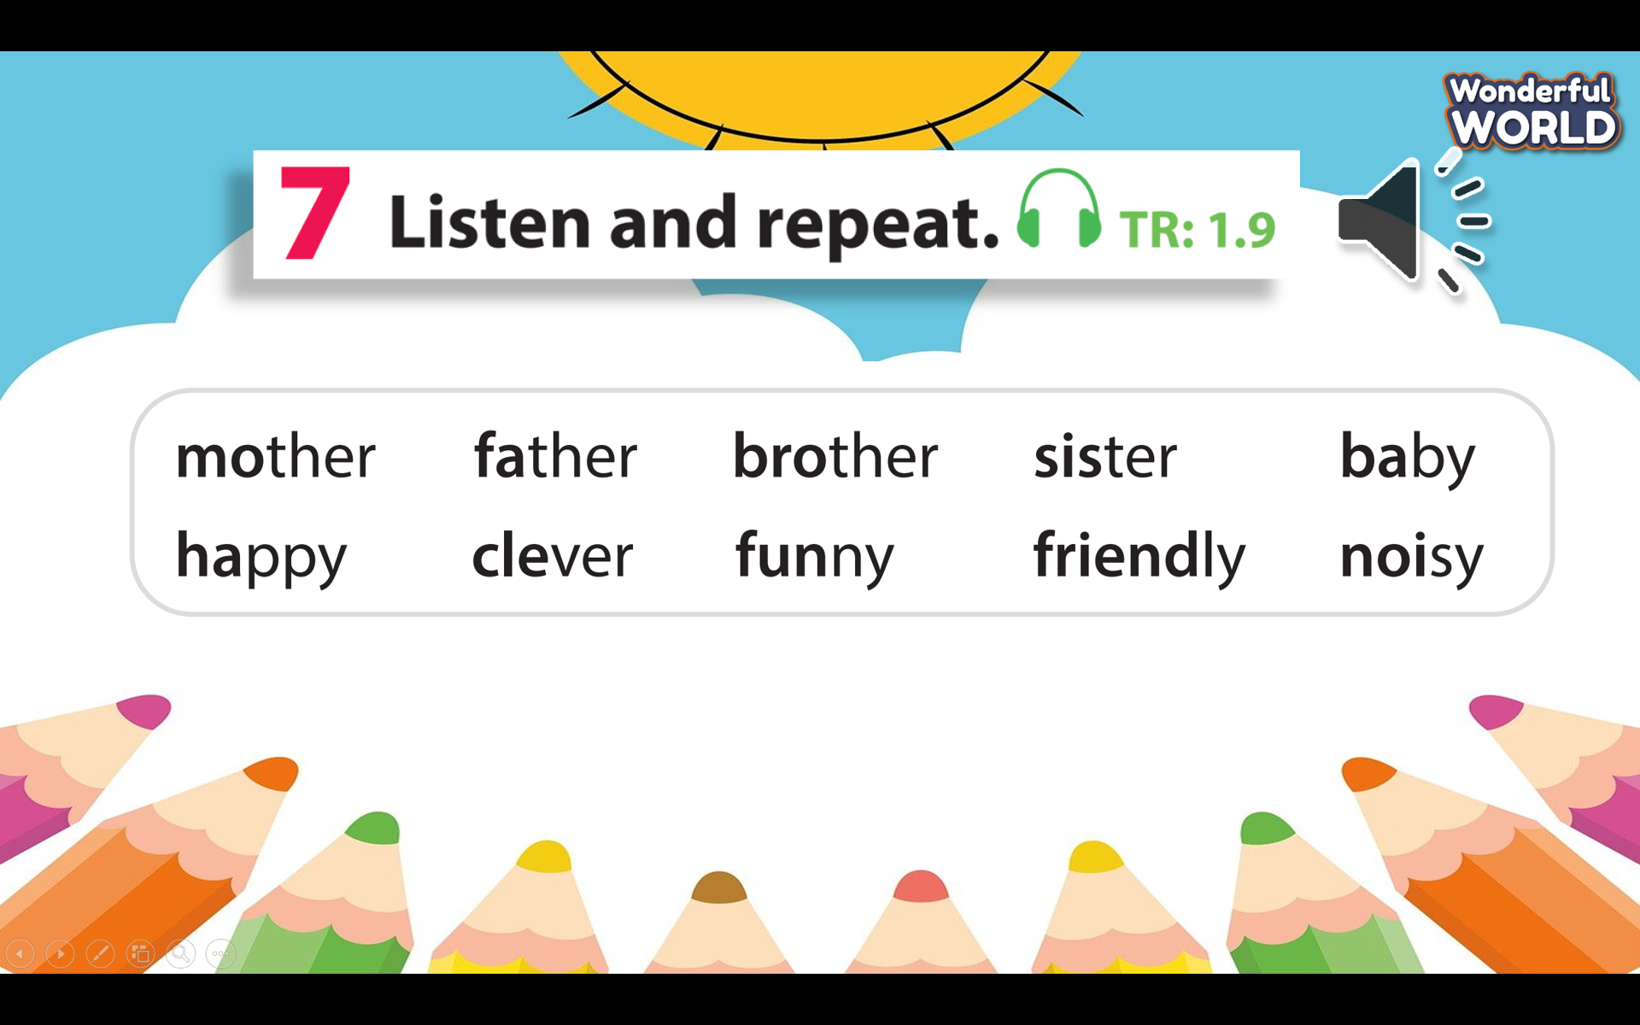  - Play the audio recording.  -T displays the words “mother, father, brother, sister, happy, clever, funny, noisy”.  -T has students repeat each word after listening, paying attention to the stressed syllables.  - T directs students to practice word stress individually.  -T encourages them to repeat the words multiple times, emphasizing the stressed syllables.  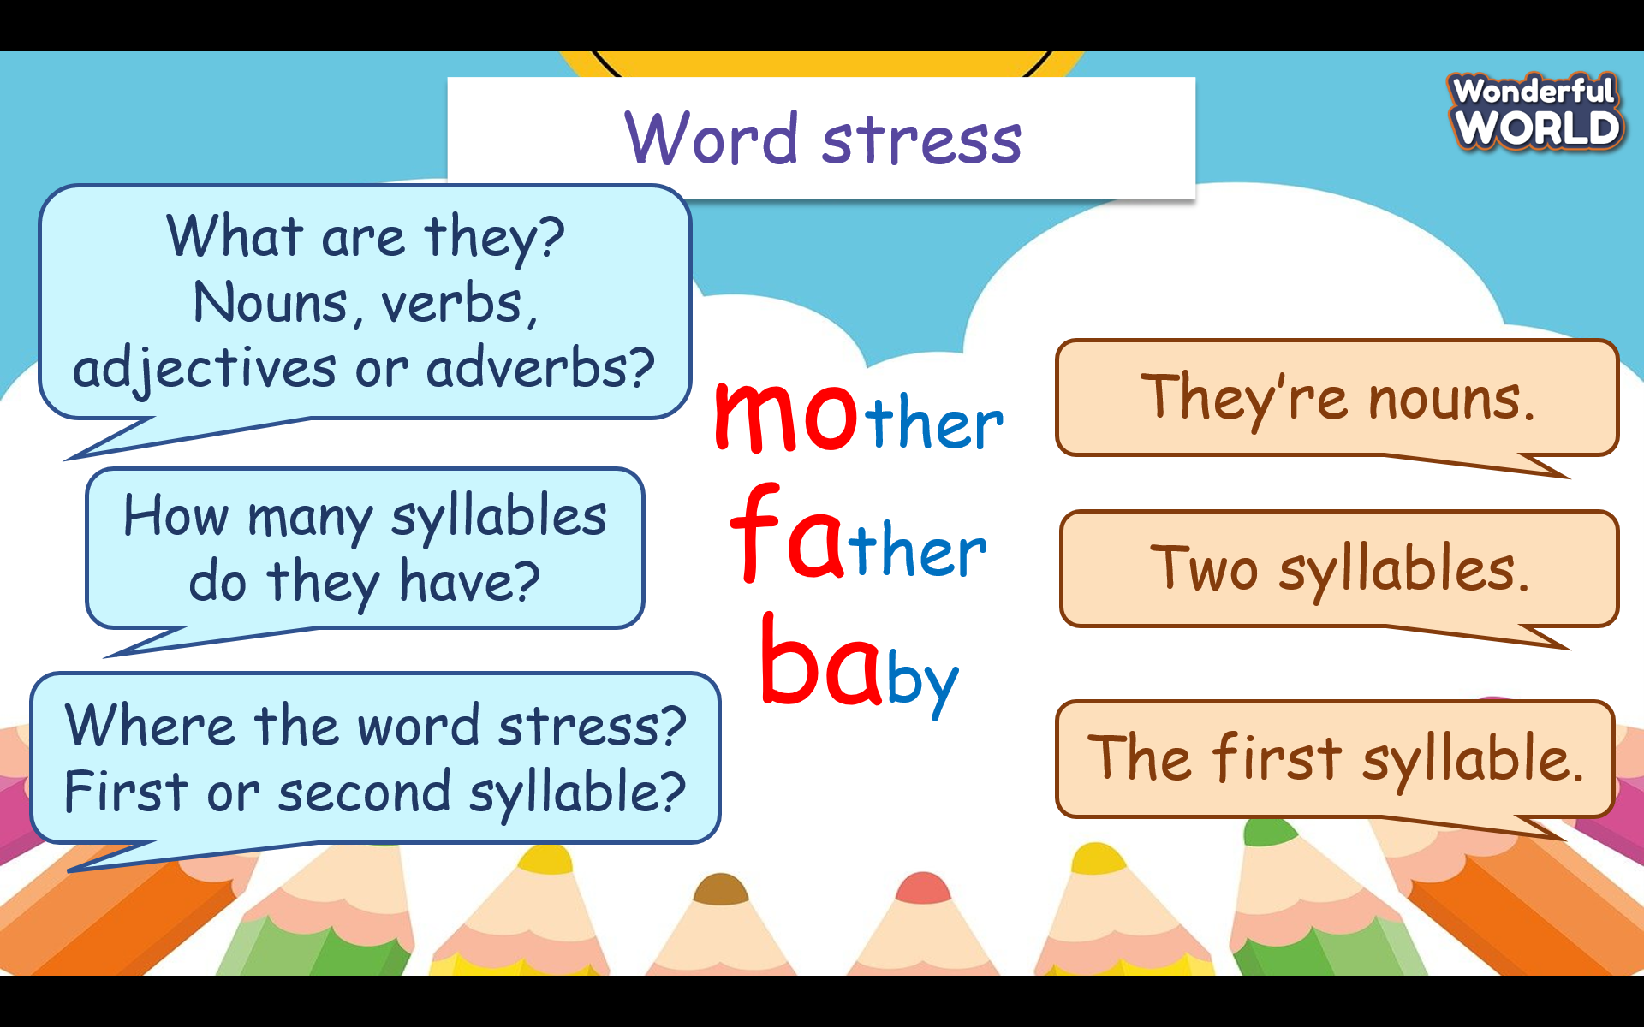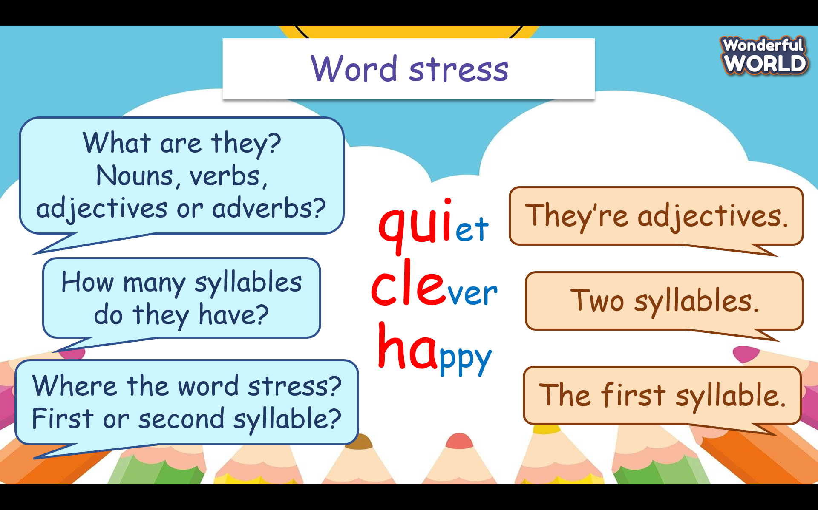  - T teaches students some tips to emphasize the stress correctly (In two-syllable nouns and adjectives, normally the stress will be on the first syllable.)  - Task 8 Listen, circle, then read aloud. TR: 1.10  -T plays the audio recording for the listening and circle activity.  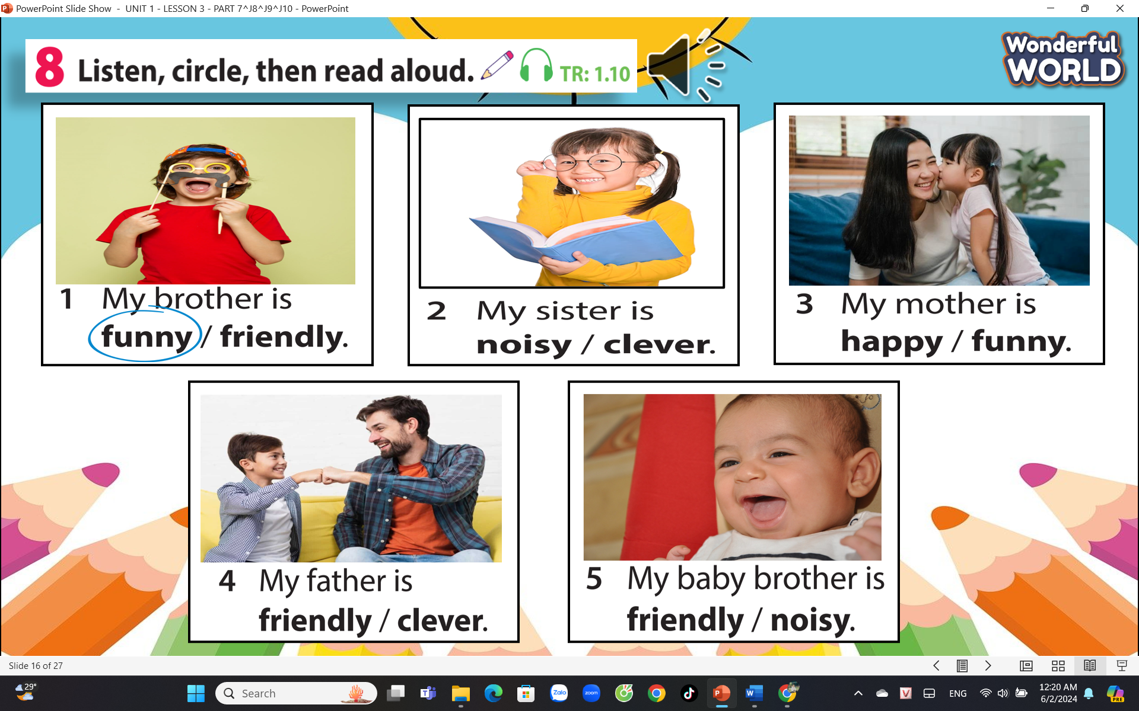  -T instructs students to circle the correct word in each sentence based on what they hear.  -T plays the recording again. Pause after each sentence. Check answers as a class.  -After that, have students take turns reading each sentence aloud.  -T emphasizes the word stress correctly while reading.  -T pairs students up and has them take turns reading the sentences to each other.  -T encourages peer feedback on word stress. |  | - Look, listen and repeat each word after listening, paying attention to the stressed syllables.  -Practise word stress individually  - Circle the correct word in each sentence  -Take turns reading each sentence aloud
Activity 3: Practice (11 minutes)
Teacher’s Activities |  | Students’ Activities
Aims:
Procedure  Task 9: Listen and chant  - Tell students they are going to learn a chant. Explain to students that the chant is about word stress.  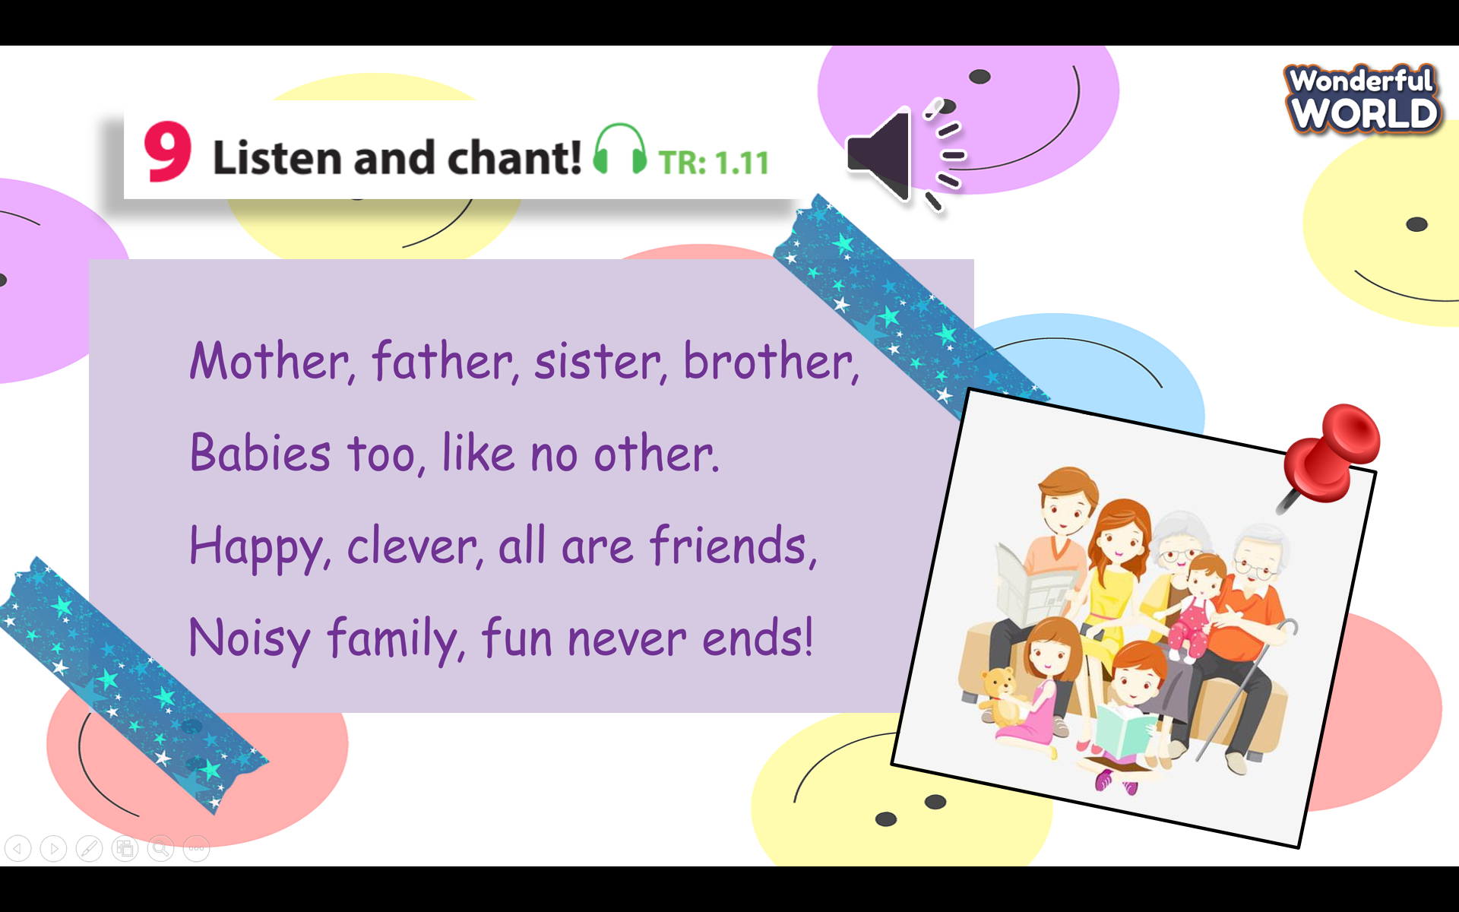  -T plays the recording and tells students to listen and follow the words with their fingers.  -T reads out the chant one line at a time and asks students to repeat after you.  -T plays the recording again. Encourage students to chant along. --Let SS practice several times until students are familiar with the words and sounds.  - T asks students to practice the chant individually, and then in pairs or groups. For example, one group chants the first verse, and the other group chants the second verse. Ask some volunteers to chant (optional).  Extention: The teacher could encourage the students to come up with their variations of the chant, using different words related to the topic of family and friends. This can be a fun way to reinforce the vocabulary and the rhythm of the chant. |  | - Underline a two-syllable word whose stress is on the first syllable.  -Listen and follow the words with their fingers.  - Practise several times until students are familiar with the words and sounds  -Practise the chant individually, and then in pairs or in groups
Activity 4: Production (7 minutes)
Teacher’s Activities |  | Students’ Activities
Aims: Reduce the pressure of the lesson and students can review word stress knowledge through this game.
Procedure  -T tells students to look at the game board in the book, on page 12.  -T explains the purpose of the game.  + They will use hand gestures for rock-paper-scissors: rock (a fist), paper (an open hand) and scissors (a fist with the index and middle fingers extended).  -T models the game with a student. Use hand gestures for rock-paper scissors, determine the number of spaces to move, and say the word on the space.  -T demonstrates how to move an extra space if landing on a “+1” space.  -T has students play the game in pairs. They use hand gestures for rock-paper-scissors to decide the number of spaces to move, then move their game piece and say the word on the space.  -T walks around to provide assistance and ensure correct pronunciation and spelling.  -T congratulates the winning pairs who reach the End space first.  -T discusses any challenging words and reinforces correct spelling and pronunciation. |  | -Guess the correct family member  -Share their sentences with the class  - Each group takes turns creating relationship clues for others to guess,
Activity 5: Wrap up & Assessment (5 minutes)
Teacher’s Activities |  | Students’ Activities
Aims:
- Check students’s understanding of what they have learned.
- Students rehearse what they have learned in the lesson.

Fun time and project
Period 8 -Task 1, 2, 3
I. OBJECTIVES:
1. Knowledge:
Students will review and practice all target words and structures related to the topic Family and Friends
2. Competences:
- English competences: Students can talk about topics Family and friends.
- Common competences: Students can develop logical thinking and develop communication among friends.
3. Qualities:
- Students will:
+ Show their love to family and friends.
+ Be confident and active in communicating with friends and teachers.
II. EQUIPMENT AND MATERIALS:
- For Teacher: PPT, flashcards, printed papers, crayons.
- For students: textbook
III. LESSON PROCEDURE:
Activity 1: Warm-up (3 minutes)
Aim: warm-up activity to greed the class, create an exciting environment and introduce the new lesson
Teacher’s Activities | Students’ Activities
Greet the Ss  Ask the Ss to join the game to create an exciting environment.  Warm-up: play the game “Hand & feet hopscotch”  T divides the class into 3 groups and each group will play in turn.  Ss in each group will stand in line in front of the templates with hands and feet.  To start, one S at a time will match their hands and feet to the first row of pictures, then continue until the last template. If the Ss make it wrong in the middle, they will go back to the bottom line and the next student will start.  Each group will have 2 minutes to play. The group that can finish the game in the shortest time will win the game.  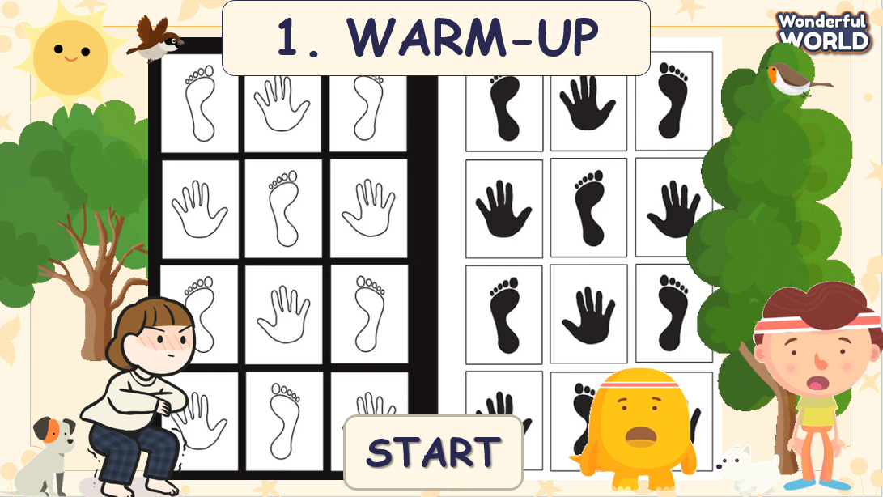  Lead in:  - T raises some pictures and asks Ss to guess the topic of the lesson  - T reviews the topic “Family and friends”.  - Write on the board “Family and friends” and review the words and structures of the learned lesson. | - Greet the T  - Listen to the game rules and join the game  - Stand in group and start the game when receiving the signal  - Each group will play in 3 minutes  - Check the result  - Look at the pictures and answer, then guess the topic  - Review the words and structure
Activity 2: Review (4 minutes)
Aim: - Do the activity to review the target words in Unit 1
Listen and practice a chant to make it easier to remember the words, and encourage Ss to use English in front of the crowd
Teacher’s Activities | Students’ Activities
Activity:  Jigsaw game:  - T divides the class into four groups  - T counts 1, 2, 3 then shows the slide and continuously clicks on the jigsaw pieces until the first answer is given out  - T stops and click the “Check” button on the screen  - If the answer is correct that team will get 1 score  - The team with the highest score will win the game    1: Find family members  - Tell students that they are going to do a crossword puzzle.  - Divide students into pairs or groups to find and circle the words.  - Ask students to look at the example in picture 1.  - Allows them enough time to do the exercise.  - Praise or award a prize to the quickest student with all correct answers.  - T shows the answers and asks SS to repeat.  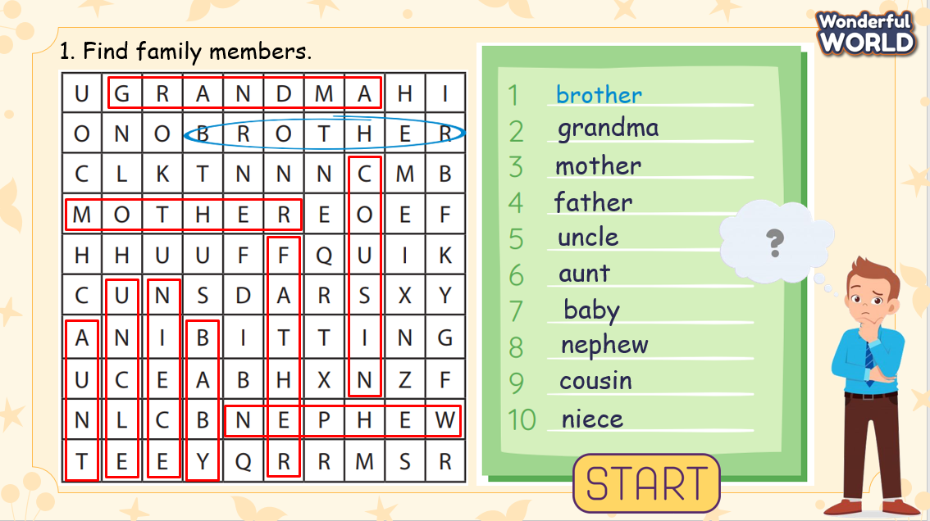  2. Listen and sing  - Tell students they are going to learn a chant about family and friends. Ask students to read the song quickly and find the words relating to family members and the adjectives that are used to describe them.  - Plays the recording and tells students to listen and follow the words with their fingers.  - Read out the chant one line at a time and ask students to repeat after T.  - Plays the recording again. Encourage students to chant along. Practice several times until students are familiar with the words and sounds.  - Optional activity: Ask students to practice the chant individually and then in pairs or groups.  For example, one group can chant the first verse, and the other group can chant the second verse.  - Ask SS to work in groups of 4 and chant, then present in front of the class.  - Gives their feedback.  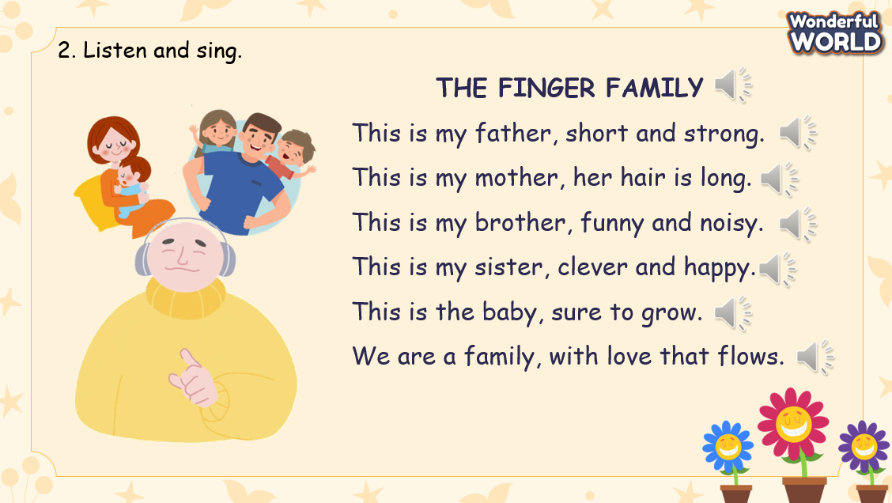 | - Look at the screen and listen to the game’s rules  - Stand in groups  - Look at the screen and guess the words, using the hints behind the jigsaw pieces  - Check the answers  - Check the result  - Look at the puzzle and listen to the T.  - Work in groups and find the words.  - Ring the bell when finishing.  - Check the answers.  - Figure out the nouns and adjectives in the chant.  - Read the chant for the first time.  - Listen to the audio.  - Listen and learn to chant each sentence.  - Practice to chant the whole paragraph.  - Present in front of the class.
Activity 3: Practice (8 minutes)
Aim: - Do a small exercise the revise the nouns and adjectives used to talk about family members
Join a small game to change the atmosphere and review the words and structure
Teacher’s Activities | Students’ Activities
Game: “Secret Garden”  T divides the class into 2 groups. Each group will choose a name and play rock, scissors, and paper to decide which group goes first.  The two groups will take turns to choose a plant and answer the corresponding questions.  If the answer is correct, the team choosing the question will get 2 scores. If not, the chance is given to the other team and they will get 1 score if the answer is correct.  When all the questions are answered, the team with higher scores will win.  When the game is finished, click on the next button on the right bottom edge to move to the next slide.  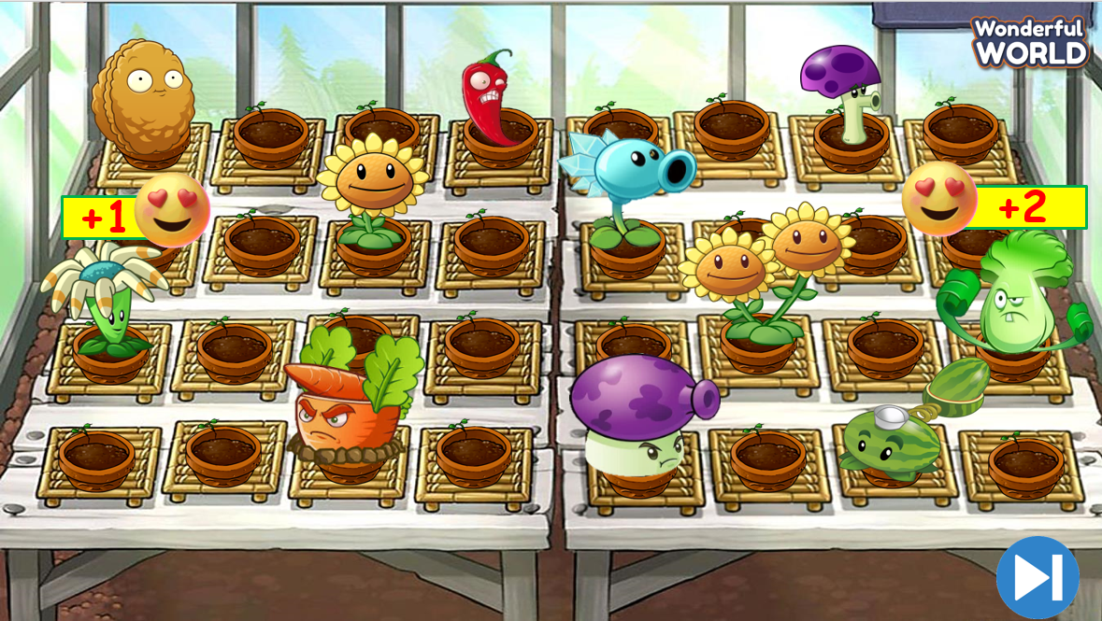 | - Listen to the game rule  - Appoint a representative to do rock, scissors, and paper to decide who goes first  - Choose the plant and answer the corresponding question  - Check the results
Activity 4: Product (15 minutes)
Aim: - Make a family portrait from clay
- Using their product to introduce their family
- Encourage Ss to speak English in front of the crowd
Teacher’s Activities | Students’ Activities
- Put Ss into groups of 4 or 6 and give each group a pack of clay  - Ask Ss to think of their family’s appearance and create models of family members, using the clay  - Give Ss some minutes to create the models. Encourage them to put the members in a specific scenario  - Instruct Ss to make a short introduction about family members  - Encourage and invite some Ss to speak in front of the class  - Give them feedback  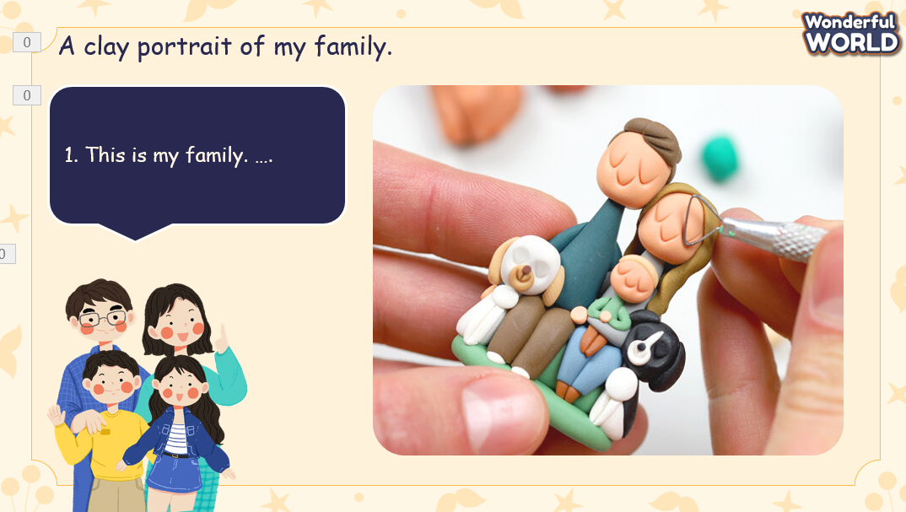 | - Stay in groups and discuss the models of a family  - Work in group  - Start making the models and create the introduction  - Introduce the family in front of the class  - Listen to the feedback
Activity 5: Assessment (5 minutes)
Aim: - Do a quick exercise to review nouns and adjectives used to describe family members
- Do the work individually to remember the target words
Teacher’s activities | Students’ activities
- Asks Ss about the words they have learned in the lesson without looking at the book.  - Asks sts to do the assessment.  - Checks with the class and asks Ss to read/sing the song aloud.  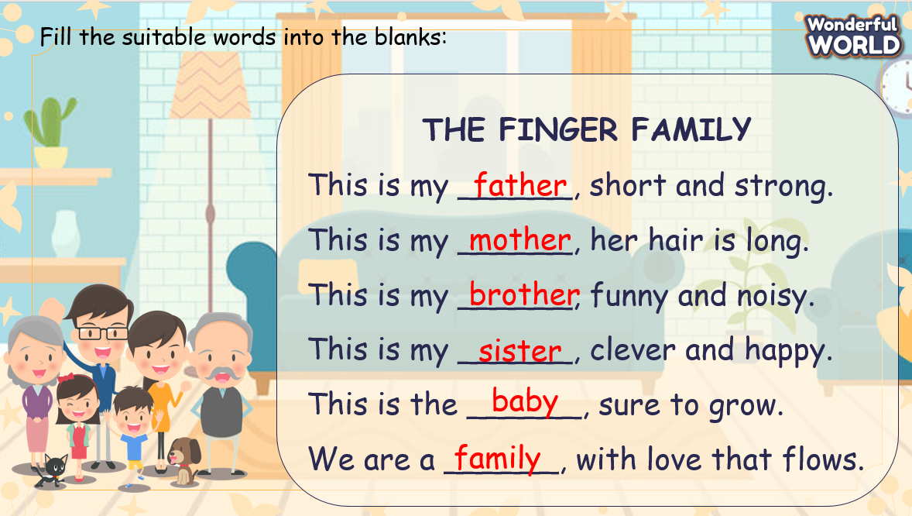 | -Do the assessment individually.  - Check with the teacher.  - Read/sing the song aloud.
Activity 6: Wrap-up (5 minutes)
Aims:
- Check student's understanding of what they have learned.
Students rehearse what they have learned in the lesson.
- Wrap-up
* Remember
Vocabulary
- father, mother, brother, sister, baby, family, clever, crazy about, different, same, funny, loud, quiet
VOCABULARY
- Went, did, had, last week, last month, last year
STRUCTURE
- Both Becky and Emma are crazy about technology.
- Becky is quiet, but Emma is loud.

