Week 3 (From 22/9 to 26/9)
UNIT 1: MY FAMILY AND FRIENDS
Fun time and project - Task 4, 5
Period 9
I. OBJECTIVES:
1. Knowledge:
To review all target vocabulary and structures of unit 1 via some fun activities.
2. Competences:
- English competences: -review vocabulary and structures of unit 1
- Common competences: -Use the simple vocabulary and structures of unit 1 to talk about topic family and other topics
3. Qualities:
- Students will
+ have a strong sense of family love.
+ have a chance to introduce the family background to friends in the class.
II. EQUIPMENT AND MATERIALS:
- Basic things: Student’s book, flashcards,
- Advanced things: PPT, laptop, TV.
III. LESSON PROCEDURE:
 | Activity 1: Warm-up (5 minutes)
 | Teacher’s Activities | Students’ Activities
Aims: Welcome students, and engage the class with a game “ Do the puzzle”.
Warm-up activity to develop logical thinking skills and review some words about family topic
.
 | - Greet students.  - Divide the class into 2 teams. Each team chooses their team name.  - Ask students to list each member of the family and give them 20 seconds to remember the picture.  - Separate the picture into many pieces.  - Give them a few minutes to reorder the picture.  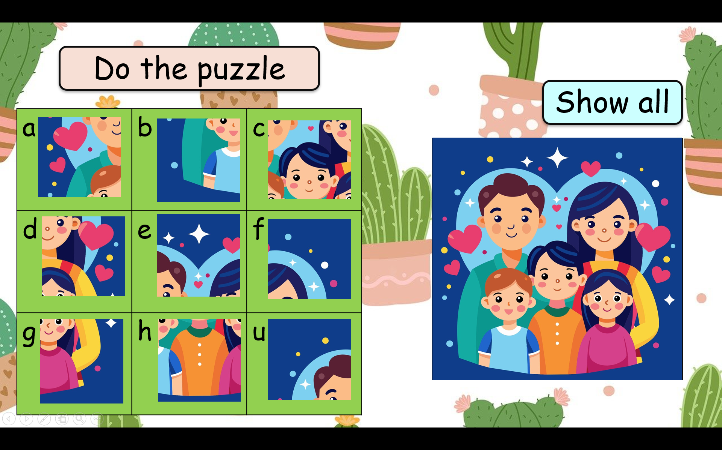  -T gives stars for the correct answer. |  | . - Greet Teacher  - Choose a team name  - Join the activity.  - Remember and reorder the picture.
Activity 2: Review & Practice (10 minutes)
Teacher’s Activities |  | Students’ Activities
- Aims: review structures and grammar knowledge.
- Listen to a song before starting the lesson.  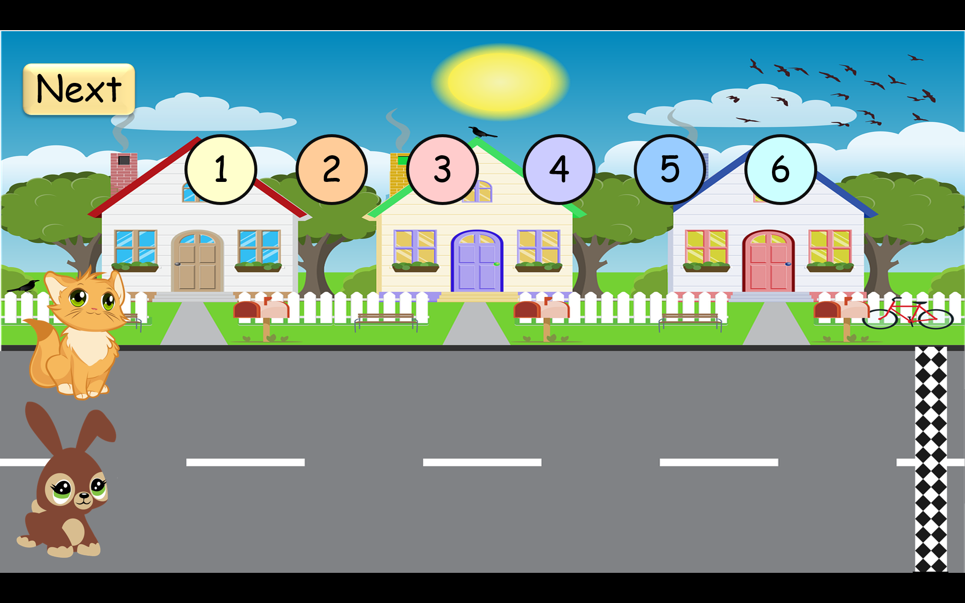  -T prepares 10 questions that relate to the grammar and structure knowledge from the previous lesson.  -T calls the fastest person.  -T gives stars to the student who has the correct answer.  ( T can explain in detail if students still don’t understand.) |  | -Listen to a song  - Look and answer the questions  -play game  -raise the hand to answer the questions
Activity 3: Production (15 minutes)
Teacher’s Activities |  | Students’ Activities
a. Aims: - Outline the ideas for the presentation (task 5)
- Project: Make a family poster.  -T tells students that they are going to make their family poster.  - List Family Members  + Instruct students to make a list of the names of their family members.  + Encourage them to include parents, siblings and other close relatives.  - Find Photos or Draw Pictures  + If possible, ask students to bring photos of their family members.  + Alternatively, they can draw pictures of each family member.  - Write About Them  -T guides students to write short descriptions for each family member, similar to the example provided on page 14 of the book.  -T reminds them to include names, physical features and a positive trait for each family member.  -T allows sufficient time for students to create their family posters.  -T circulates the classroom to provide assistance and offer guidance.  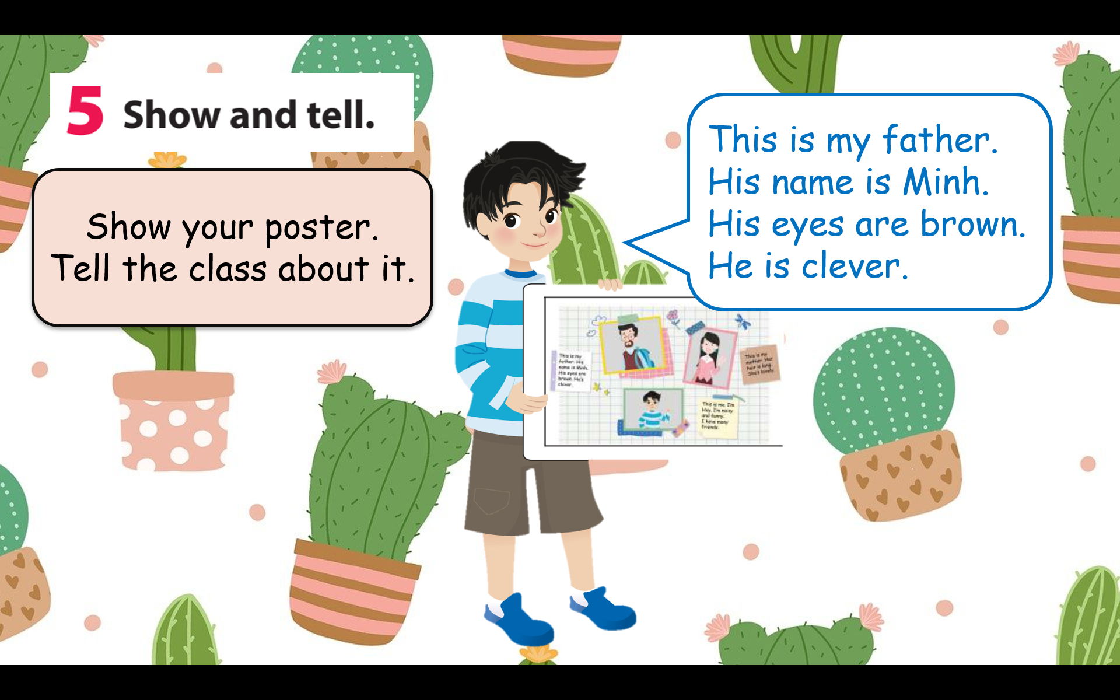  Task 5:Show and tell.  -T invites students to share their family posters with the class.  -T encourages them to use the information they wrote to tell the class about each family member.  -T promotes a positive and supportive atmosphere for sharing.  -T concludes the project by thanking students for sharing their family posters.  -Optionally, facilitate a brief discussion about the importance of family |  | - Make a list of the names of their family members  - Draw pictures of each family member  - write short descriptions for  them  - Present your production in front of the class
Activity 4: Wrap up & Assessment (5 minutes)
Teacher’s Activities |  | Students’ Activities
- Aims: - Check students’s understanding of what they have learned.
Students rehearse what they have learned in the lesson.
-T asks sts to do the assessment  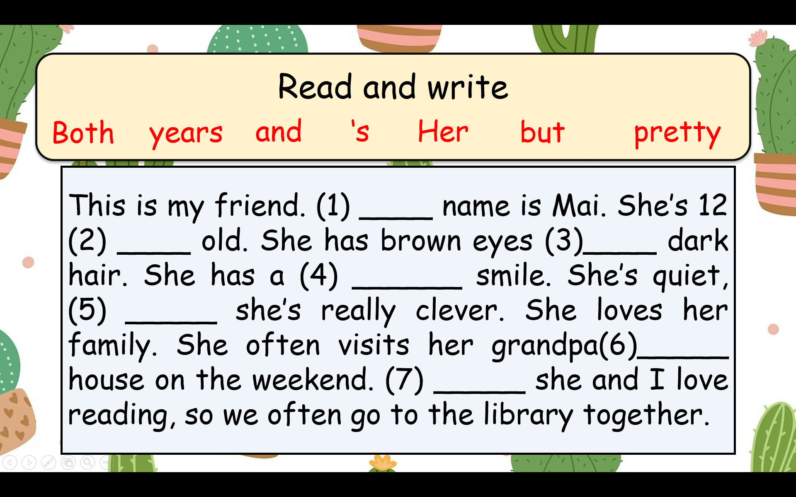 |  | -Do the assessment.  -Check with the teacher  - Sts read the wrap-up  - Stand up and say goodbye to the teacher.
UNIT 2: MY FAVOURITE THINGS
Lesson 1 - Task 1,2,3
Period 10
I. OBJECTIVES:
1. Knowledge:
- Students review words and phrases of their favourite toys and things.
- Students can draw out new words and new structure(s) through listening and reading the dialogue.
2. Competences:
- English competences: Students can use English to introduce their favourite toys.
- Common competences: Students can draw their favourite things creatively and introduce them to their friends.
3. Qualities:
- Students will
+ have a strong curiosity in exploring different types of toys and understanding their names.
+ recall and reflect on personal experiences with toys from their childhood and make it more meaningful and memorable.
II. EQUIPMENT AND MATERIALS:
- Basic things: Student’s book, flashcards, photos, papers
- Advanced things: PPT, laptop, TV.
III. LESSON PROCEDURE:
Activity 1: Warm-up (5 minutes)
A guessing game “ What’s in the box ?”
 | Aims: Welcome students. Engage the class (or warm the class up) with a guessing word game to revive the vocabulary (computer, piece, puzzle, photo, typewriter) and lead in the new lesson.
 | Teacher’s Activities | Students’ Activities
 | Procedure
 | - Greet students. Chatting…Do you like playing games?…  - Introduce the game:  - Ask students to guess the word using some clues behind the notes.  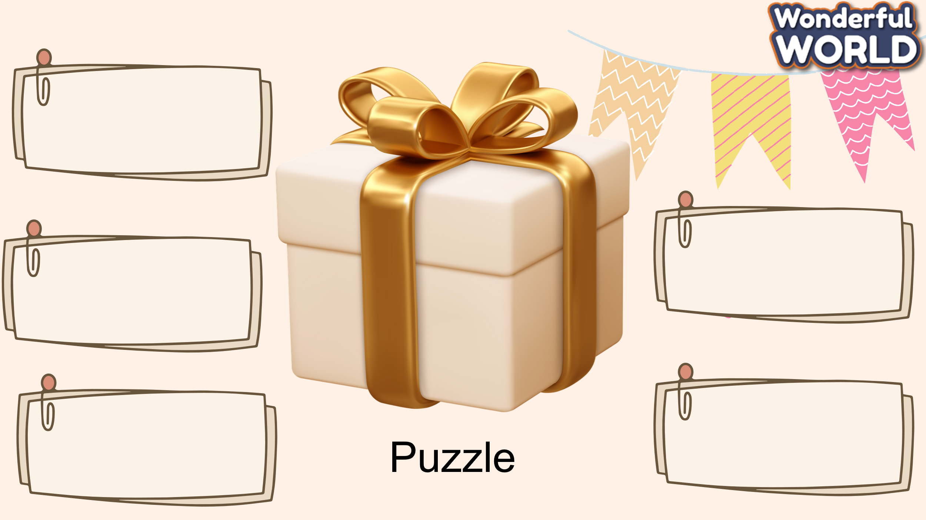  -“This is the (a) present of mine. There is a gift inside the box. I’ll open the notes and you guess what it is by giving the correct words. You can row the dice to get stars.”  - Let students guess and lead in the topic and write it down on the board.  - Play the game:  - Words: puzzle, computer, kite  - Lead in the new lesson:  Unit 2 – Lesson 1 task 1, 2, 3.  Lead in: Photo time!  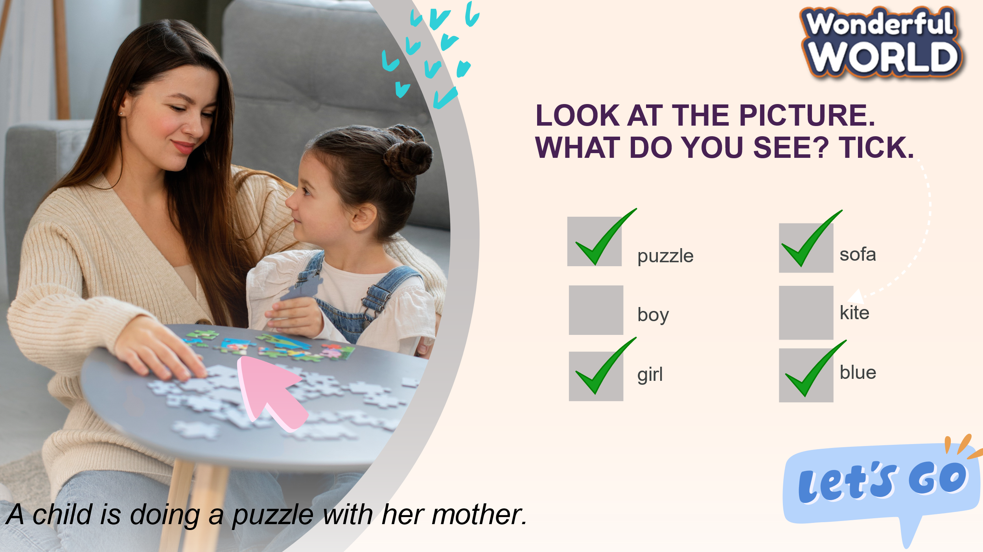  - Show the photo on the screen. Ask students to look at the photo and tell them what they can see. Elicit ideas from the class and write them on the board.  - Ask students to look at the picture and answer the questions:  - Where are they?  - What are they doing?  - Are they happy?  - Ask students to tick and say the things in the photo.  - Ask Ss to stand up and say their ideas.  - Review the words about toys and some objects in the house  - Read the title of the unit together. Check students to make sure (know) what it means.  Ask them to talk about their favourite toy or game, what colour it is, how old it is and why it is their favourite.  - Put students in groups of two or three and tell them to think of at least seven words that they can relate to belongings and favourite things. Tell them they can suggest verbs, objects, activities or adjectives. | - Greet Teacher  - Join the activity.  - Look and listen.  - Look at the picture and listen to the T  - Answer the question:  They are in the living room.  They are playing a puzzle.  - Tick and say the things in the photo.  - Review the words about toys and some objects in the house.
Activity 2: Presentation (12 minutes)
Aims: Present some new words computer, piece, puzzle, photo, typewriter
Encourage sts with the topic and vocabulary related to the topic.
+ Ss know how to pronounce the new words and can answer the question: What’s Dad got in his box? based on the dialogue
+ Finish Task 2
Teacher’s Activities |  | Students’ Activities
Task 1. Listen and read (7’)  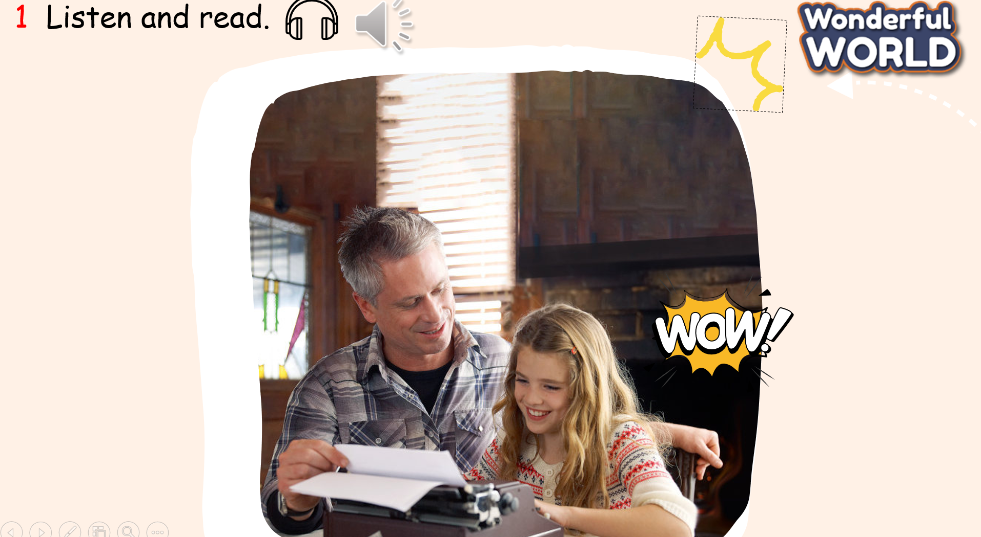  - Show the picture on the screen. Point to the children and ask Who are they? What are they doing? What can you see?  Have you seen it before?  - Tell students to look at the photo and say what they can see. – 3. Ask students to look at a conversation – listen to the tape and underline the new words and structures.  - T plays the recording twice.  - Ask ss to read the dialogue in chorus – in 2 groups (Dad and Sonja), and individually one by one in relay  - T corrects pronunciation if necessary => focus on the 5 words.  - Ask students to read a conversation again and answer the question “What’s Dad got in his box?”  => change into Task 2  Task 2. Listen, point and repeat (Track 1.2) – (5’)  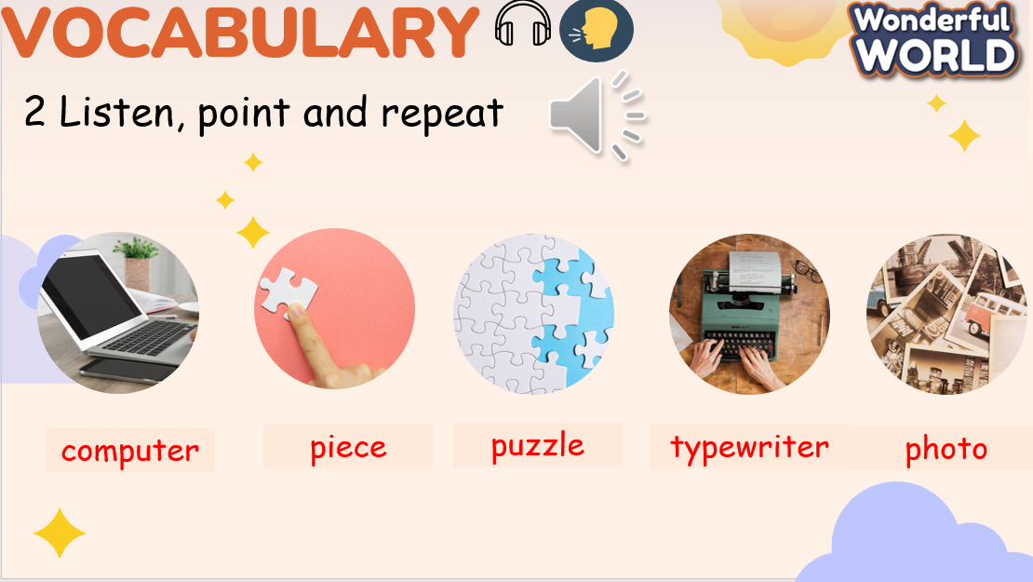  - Show all the pictures of task 2 on the screen or use the flashcards and show them on the board.  - Say the words for students to repeat in the chorus.  - Say a word for students to repeat then point.  - Play track 2.2 for the students to listen to, point to, and repeat the words in chorus, and group.  - Show pictures in random order and ask students to read out the correct words |  | - Look and answer the questions “ This is a father and his daughter. They are using a typewriter “  - Listen and underline  - Ss listen and read it chorally and individually.  - Answer the questions.  - Ss listen to the 5 words.  - Listen and repeat.  - Ss say again the answer for the Q: “What’s Dad got in his box?”  Read in front of the class.  - Learn the vocabulary.  - Join the activity.  - Look at the pictures  and read out the correct words
Activity 3: Practice – Controlled practice (8 minutes)
Aims:
Ss can say the words in task 2 in correct pronunciation.
T and Ss list out all the things the Dad got in his box
SS can say the whole complex sentence: When I was 8 years old my favorite thing was…
Teacher’s Activities |  | Students’ Activities
Task 3. Unscramble the words. Write and say.  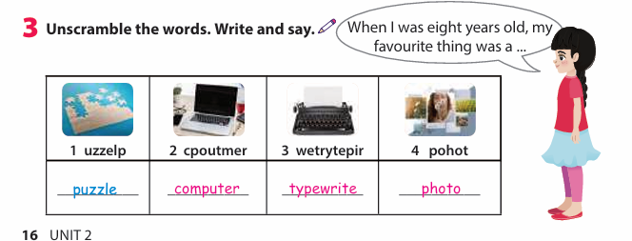  - Show the scramble words on the screen  - Ask ss to look at the pictures, arrange the letters and say out the words  - Demonstrate by explaining an example 1.  - Have students work in pairs and check answers with their partners.  - Call a student to write the unscramble words on the board.  - Ask Ss to work in groups of 4: to make sentences with the words in task 3.  - Show students an example sentence “When I was eight years old, my favourite thing was a puzzle.” to play the game.  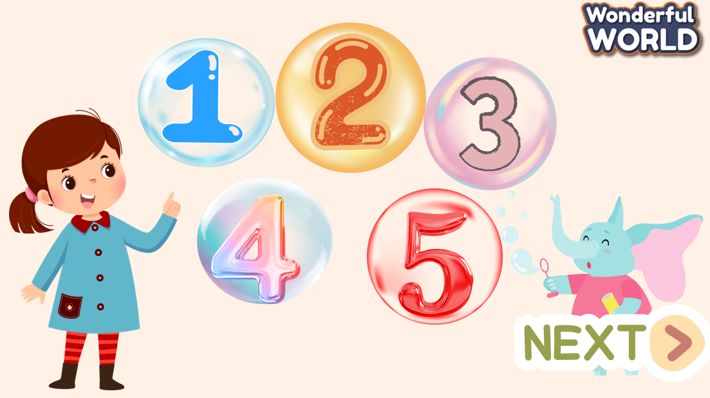 |  | - Look at the picture, listen to the example and repeat.  -Practise saying the sentences individually and in pairs.  - 4 ss write words on the board.  - Ss work in groups. Each Ss say a sentence with the model.
Activity 4: Production – Free practice (6 minutes)
Aims:
Apply the new words and structures to present in front of the class the description of the favourite toys from their childhood and make it more meaningful and memorable in using vocabulary in the lesson.
Teacher’s Activities |  | Students’ Activities
- T makes her/his own sentence like in task 3 as an example of the free talk. (He can draw a simple thing)  - Ask ss to make their own sentences by talking/ writing about their favourite things.  - Ask them to draw a picture (optional). Then say the sentences by using the structures  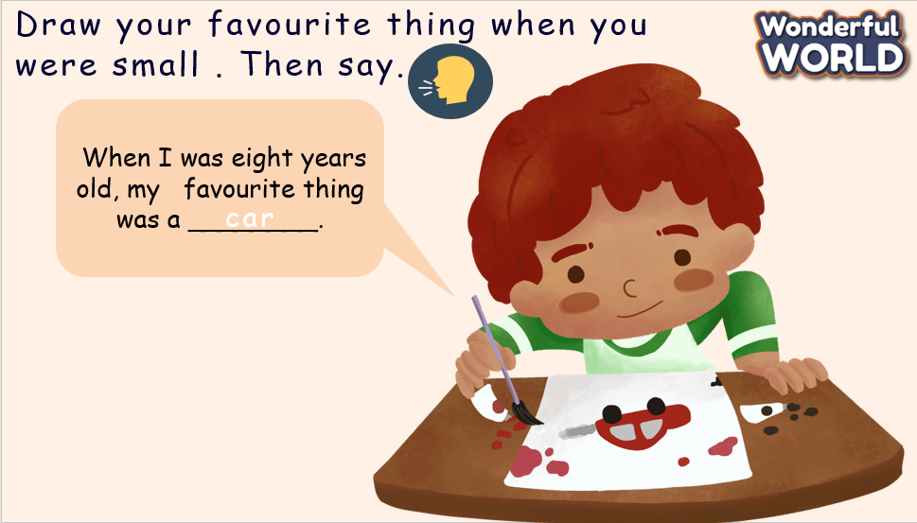 |  | - Draw and say in front of the class.
Activity 5: Wrap up & Assessment (4 minutes)
Teacher’s Activities |  | Students’ Activities
Aims:
- Check student’s understanding of what they have learned.
- Students rehearse what they have learned in the lesson.
Asks sts to do the assessment. –T gives the assessment to the class and some ss  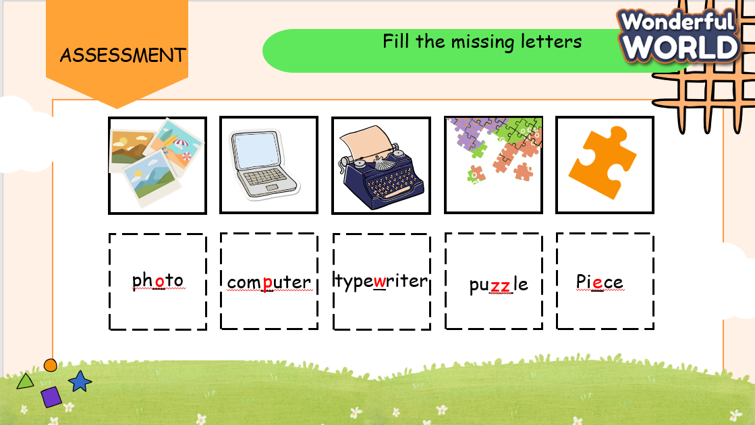  - Check with the class.  - Wrap-up  * Remember  VOCABULARY  computer, piece, puzzle, photo, typewriter  STRUCTURE  When I was……years old, my favourite thing was………… |  | - Do the assessment.  - Check with the teacher  - Sts read the wrap-up  - Stand up and say goodbye to the teacher.

UNIT 2: MY FAVOURITE THINGS
Lesson 1: Task 4,5,6
Period 11
I. OBJECTIVES:
1. Knowledge:
- Students review some objects in the house
- Students can talk about what they liked in the past, and review words and phrases of their favourite toys and things.
2. Competences:
- English competences: Students can use English to introduce their objects such as toys or school subjects in the class.
- Common competences: Students can introduce them to their friends.
3. Qualities:
- Students will
+ have a strong curiosity in exploring different types of toys. Their curiosity often drives meaningful discussions and deeper understanding of topics.
+ recall and reflect on personal experiences with toys from their childhood and make them more meaningful and memorable.
II. EQUIPMENT AND MATERIALS:
- Basic things: Student’s book, flashcards, photos, papers
- Advanced things: PPT, laptop, TV.
III. LESSON PROCEDURE:
Activity 1: Warm-up (5 minutes)
A guessing game “ What’s in the box ?”
 | Aims: Welcome students. Engage the class (or warm the class up) with a guessing word game to revive the vocabulary (computer, piece, puzzle, photo, typewrite.) and lead in the new lesson.
 | Teacher’s Activities | Students’ Activities
 | - Greet students. Chatting…Do you like playing games…  - Introduce the game:  "The teacher elicits the new lesson by showing a picture to help students recall the words, things, and structures from the previous lesson."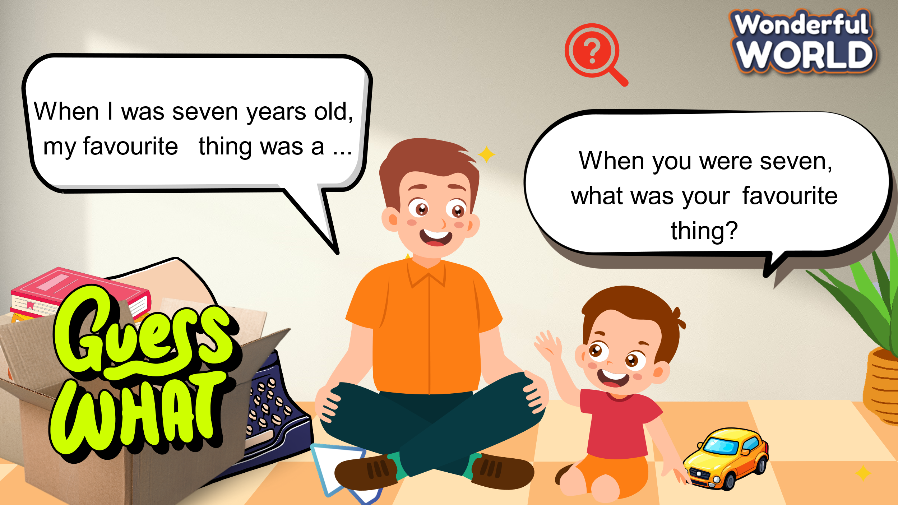  - Teacher: "This is a picture of a father and his son. Look at the son's question and answer. Can you guess what his favorite thing was? It's behind the cardboard box."  - Students: "It's a typewriter."  - Teacher: "There are also more presents at his birthday party. Let's look and find them."  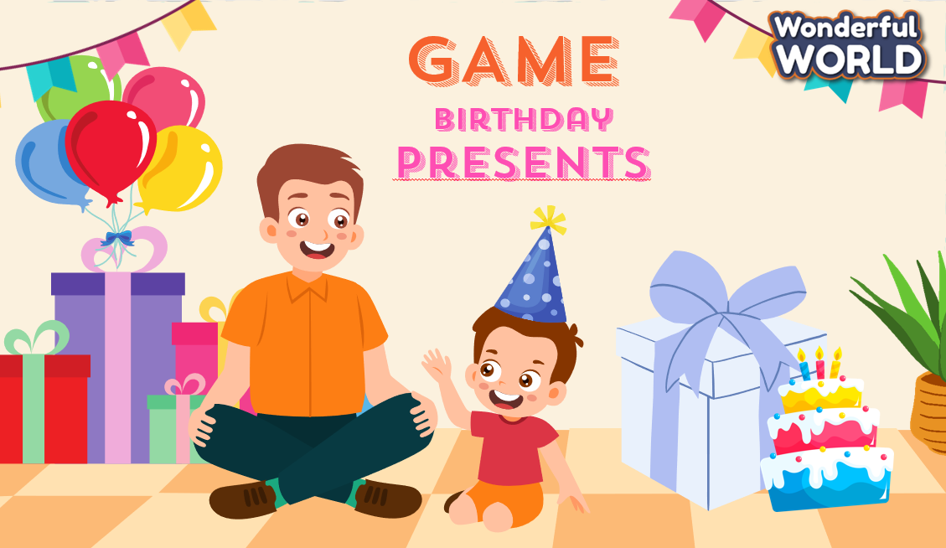  - What is this? – It’s a kite.  - What is this? – It’s a computer.  Show the screen to review :  - Words: puzzle, computer, typewriter, photo, piece  - Structure: When I was__years old, my favourite thing was_______.  Task 4. Listen and read  - Lead in the new part by listening to the dialogue.  - Ask students to look at two short conversations and play the recording twice.  - Students listen and read it chorally.  - Ask ss to read in the dialogue in chorus – in 2 groups ( Tom and Mary / Mai and Binh)  - Have students practise in pairs.  - Call on some pairs to read it out aloud and check pronunciation if necessary.  - Tell them notice the words which are red : was/were and give them some information : Past simple with tobe  - Check their understanding by having two or three students read aloud the dialogue again, ensuring they use the correct words 'was' or 'were’  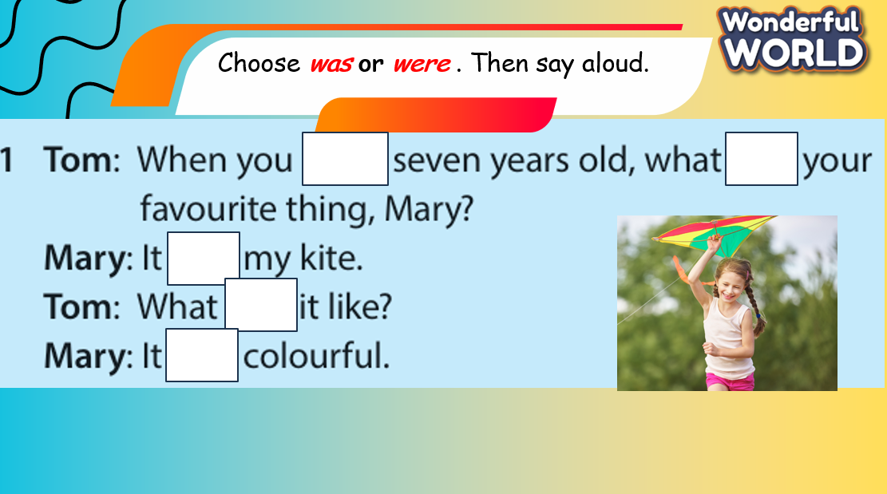  "The teacher will show the answer after the students give their answers. That ensures that students can remember and understand how to use “ was or were”. | - Greet Teacher  - Join the activity.  - Look and answer  - Listen.  - Read  - Practise  - Give the correct answers to the exercise.
Activity 2: Practice – Controlled practice (8 minutes)
Aims:
Ss can say the sentences in task 5 with correct grammar.
SS can say the whole complex sentence by using the given words and phrases.
Teacher’s Activities |  | Students’ Activities
Game: MY SURPRISED PRESENT  The teacher will provide 6 pictures along with given words and phrases, and the students will say the sentences with the correct words. After each correct answer, they can open one part of a present. This will reveal a caster board, which is interesting and useful to connect to the new lesson."  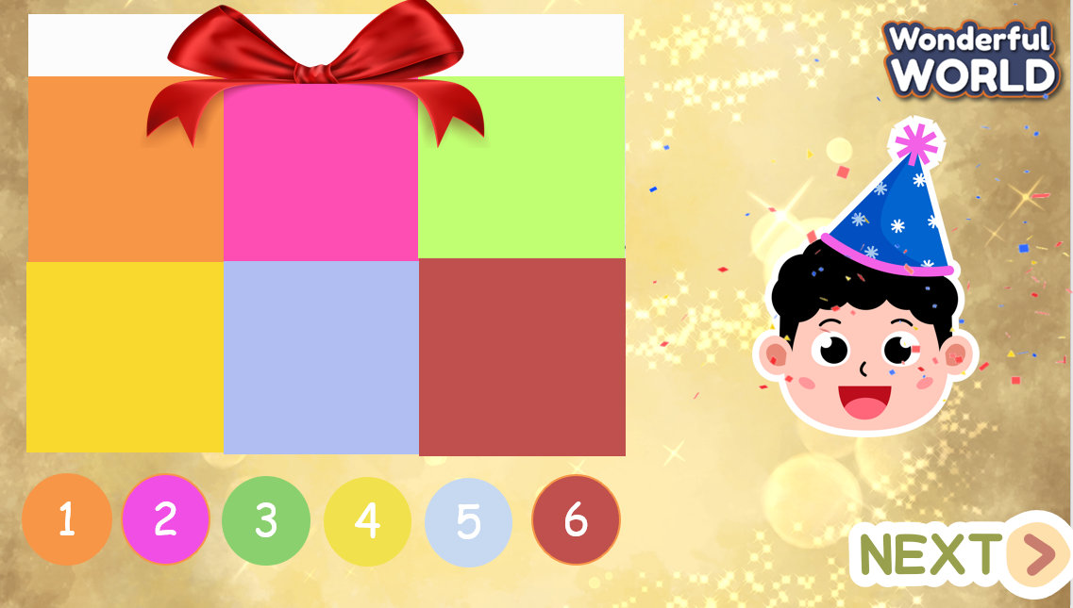.  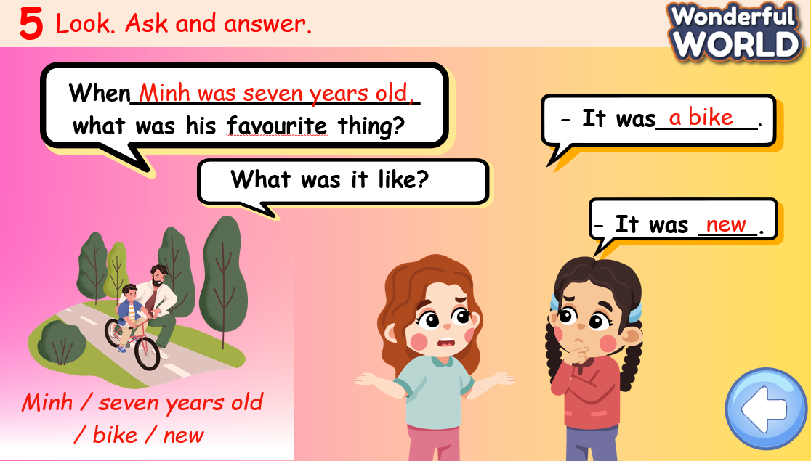  Answer key :  1. Minh / seven years old / bike / new  When Minh was seven years old what was his favourite thing?  - It was a bike. What was it like? – It was new.  2. Mary / two years old / puppets / beautiful  When Mary was two years old what were her favourite things?  - They were puppets. What were they like? – They were beautiful.  3. Hoa / four years old / doll / cute  When Hoa was four years old what was her favourite thing?  - It was a doll. What was it like? – It was cute.  4. Mike’s brothers / six years old / puzzles / interesting  When Mike’s brothers were six years old what were their favourite things?  - They were puzzles. What were they like? – They were interesting.  5. Peter / five years old / toy cars/fun  When Peter was five years old what was his favourite thing?  -– They were toy cars. What were they like? – They were fun. |  | - Join the game.
Activity 3: Production – Free practice (6 minutes)
a. Aims:
Apply the structures to present in front of the class the conservation of favourite toys from their childhood and make it more meaningful and memorable in using vocabulary in the lesson.
Teacher’s Activities |  | Students’ Activities
- Tell students that they are going to ask and answer these questions (show the two questions).  - Elicit the first example. Check students’ understanding of the task.  - Tell students to work in pairs. One will ask and one will answer. (Use the given structures and phrases).  Give feedback if necessary. |  | - Ask and answer.
Activity 4: Wrap up & Assessment (4 minutes)
Aims:
- Check student's understanding of what they have learned.
Students rehearse what they have learned in the lesson.
Teacher’s Activities |  | Students’ Activities
Asks sts to do the assessment.  T gives the assessment to the class and some Ss  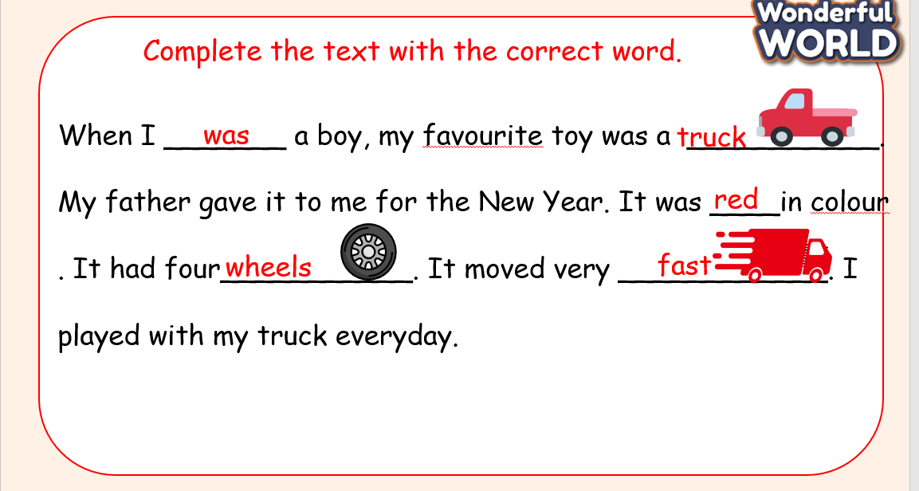  - Check with the class.  - Wrap-up  * Remember  Review Vocabulary:  computer, piece, puzzle, photo, typewriter  Review Grammar:  Past simple with To Be  When you were seven, what was your favourite thing? |  | - Do the assessment.  - Check with the teacher  - Sts read the wrap-up  - Stand up and say goodbye to the teacher.

UNIT 2: MY FAVOURITE THINGS
Lesson 2 – Task 1,2,3
Period 12
I. OBJECTIVES:
1. Knowledge:
- Students identify some more nouns and verbs describing their preferences.
- Students listen and read about the descriptions of some interesting toys
2. Competences:
- English competences: Students can use English to describe their preferences.
- Common competences: Students can draw their favourite things creatively and introduce them to their friends.
3. Qualities:
- Students will
+ have a strong curiosity in exploring the other interesting toys.
+ recall and reflect on personal experiences with toys from their childhood and make them more meaningful and memorable.
II. EQUIPMENT AND MATERIALS:
- Basic things: Student’s book, flashcards, photos, papers
- Advanced things: PPT, laptop, TV.
III. LESSON PROCEDURE:
Activity 1: Warm-up (5 minutes)
A guessing game “ What’s in the box ?”
Aims: Welcome students. Warm the class up with a game to recall the vocabulary of the previous lesson and lead in the new lesson with some new words: country, globe, map, moving, scare, spider
Teacher’s Activities | Students’ Activities
Procedure
- Greet students. Chatting…Do you like playing games ?…  - Introduce the game:  The teacher gives the students some exciting riddles which are related to the things they study in this lesson.  Part 1  Recall and Reveal:  -Teacher: "Can you remember my gift from the previous lesson?"  - Students: (Respond or guess)  - Teacher: "Let's open the pieces to reveal the picture of the caster board."  Descriptive Paragraph:  - Teacher: "Now, I'll give you a paragraph describing the caster board."  - Teacher distributes or displays the paragraph for students to read and discuss.  Video Watching:  - Teacher: "Next, let's watch a video of riding a caster board."  - Teacher plays the video for students to observe and discuss afterward  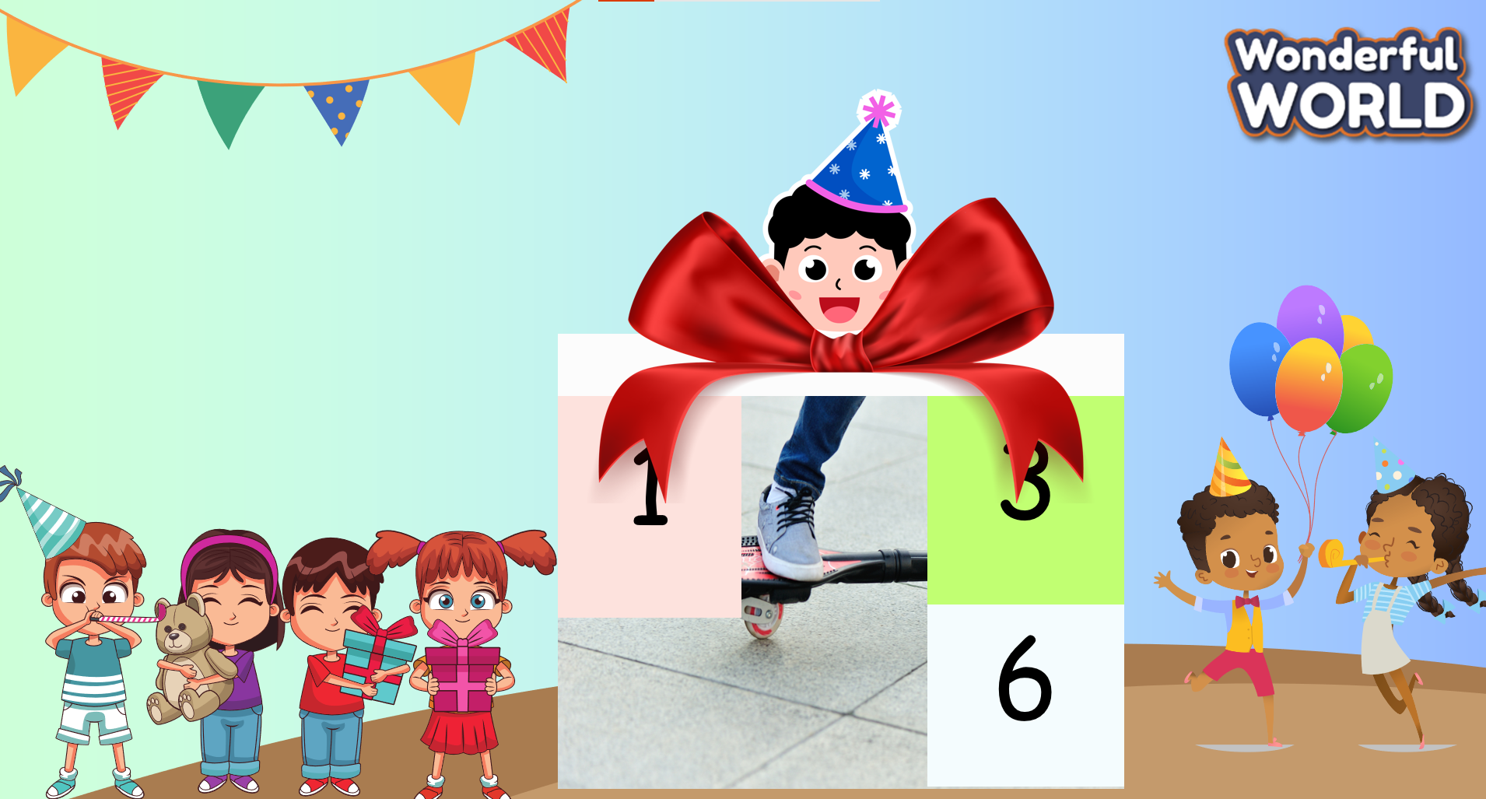  Part 2 :  Before giving the answer to the riddle about: the “ talking globe”, they will guess some words :  - Rainbow  - Basketball  - Eggplant  Talking globe  Let the students watch some photos of it to understand and imagine it. Also, the teacher asks the students to see it in real life or not. Then, show them the paragraph describing it for students to read and discuss...  Part 3. Link to New Topic  - Teacher: "Apart from the caster board and talking globe, what other toys do you play with?"  - Allow students to share their responses and discuss briefly.  - Teacher: "Now, I have another toy to show you." (Teacher brings out a toy spider.)  + Teacher: "Have you played with a toy spider before?"  + Allow students to respond and share their experiences. |  | - Greet Teacher  - Join the activity.  - Look and listen.  - Look at the picture and listen to the T  - Answer the question:  They are in the living room.  They are playing a puzzle.  - Tick and say the things in the photo.  - Review the words about toys and some objects in the house.
Activity 2: Presentation (12 minutes)
Aims: Check Students’ understanding of toys and present some new words country, globe, map, moving, scare, spider
Encourage sts with the topic and vocabulary related to the topic.
+ Ss know how to pronounce the new words and can describe some toys.
+ Finish Task 2
Teacher’s Activities |  | Students’ Activities
Listen and read. TR: 2.4  Ask students to look at three short passages and play the recording twice.  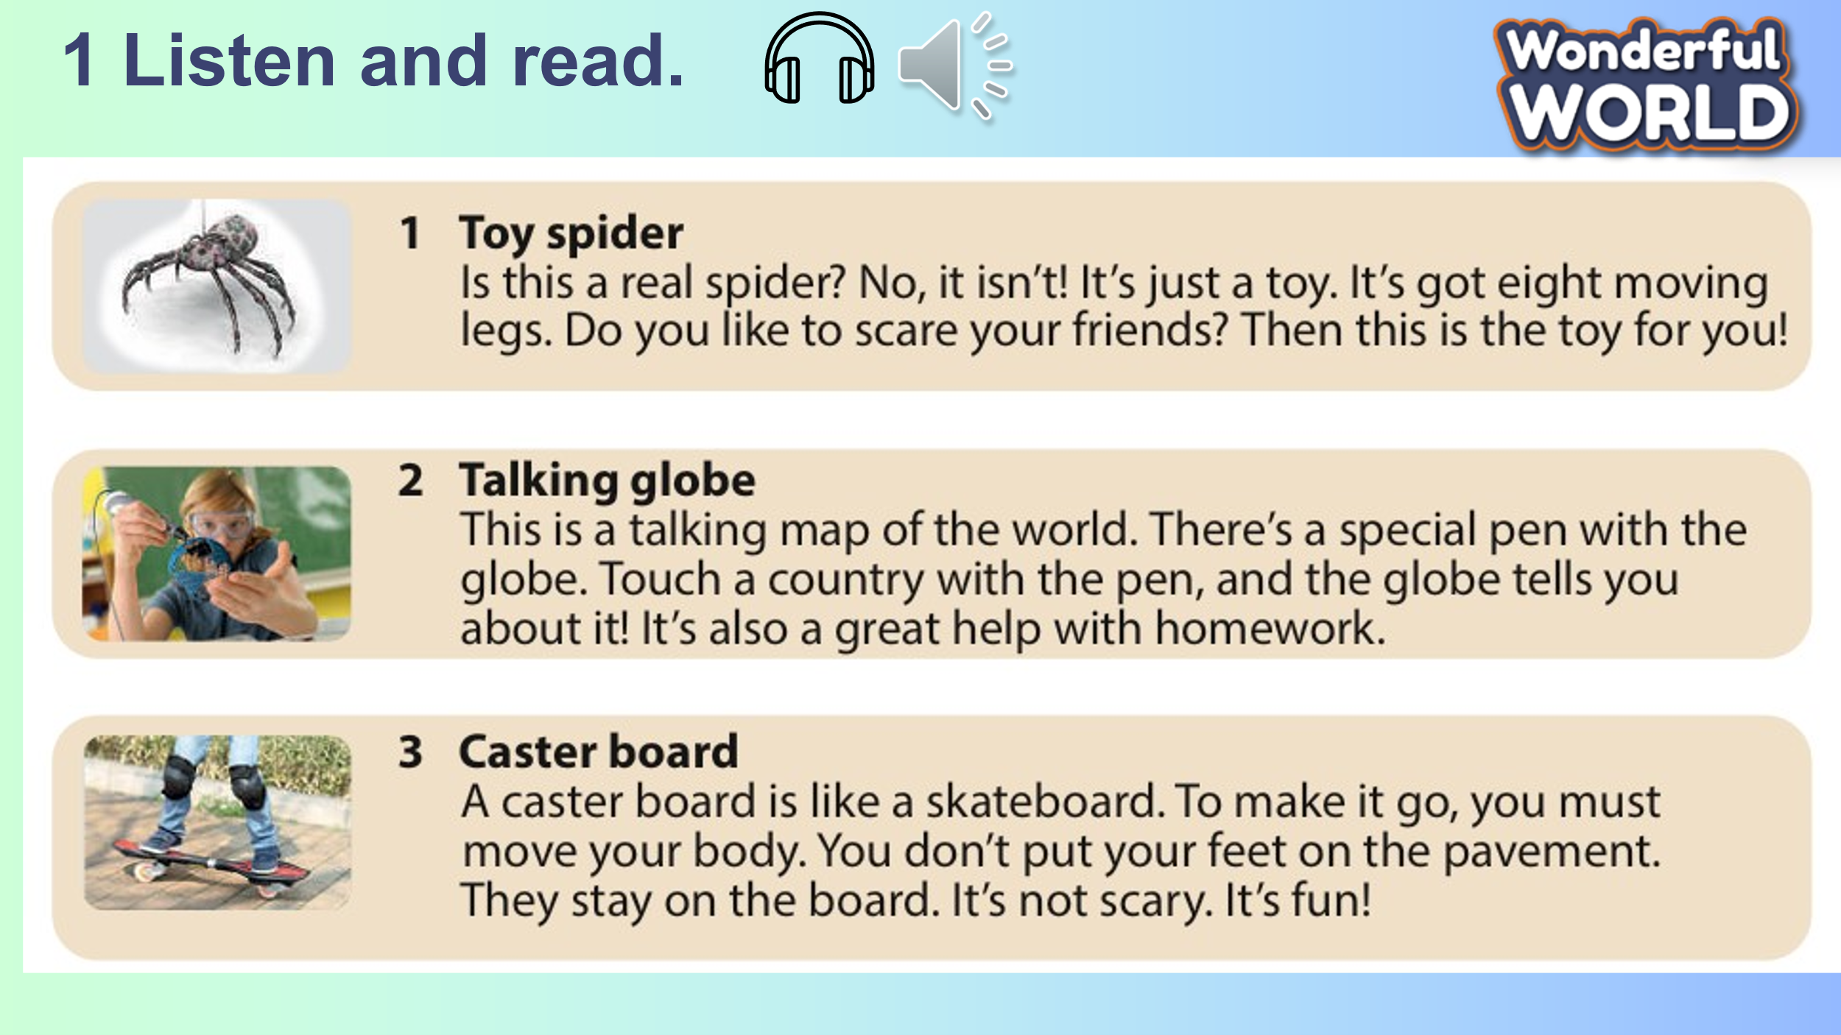  - Have students listen and read it chorally and individually.  - Call on three students to read three passages out loud and check pronunciation if necessary.  - Ask students to silently read the three short passages again and write the answer. T does an example with Sentence 1.  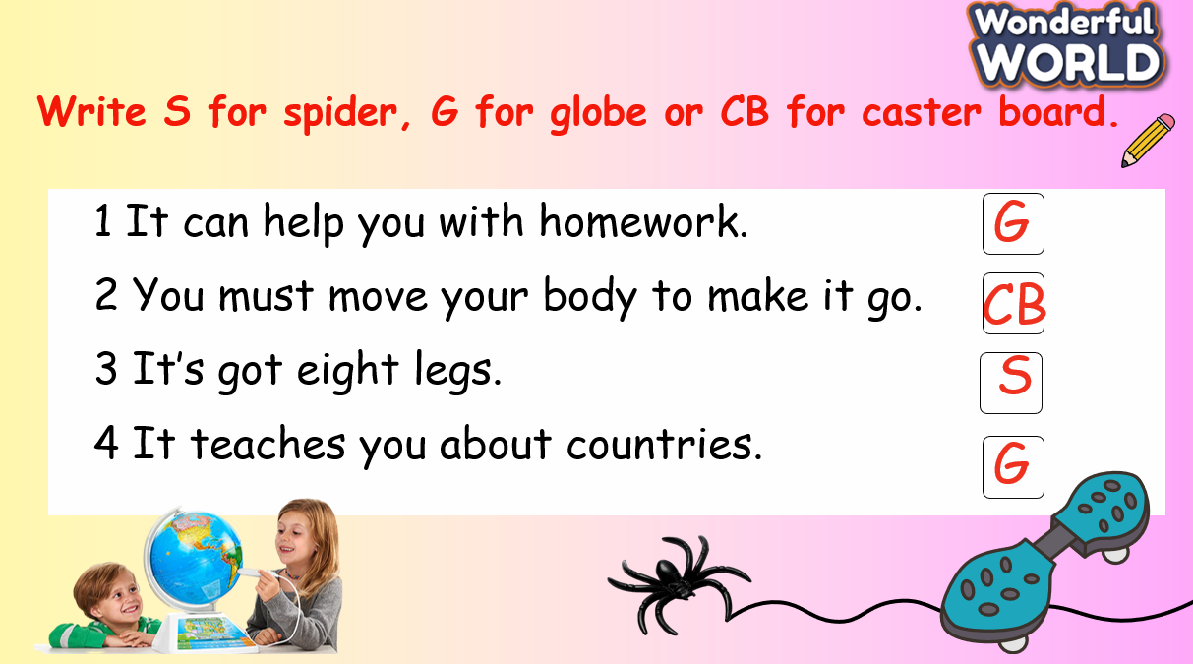  - Have students work in pairs to compare answers.  - Check answers as the whole class by asking individual Ss to read out loud the answers.  Listen, point and repeat. TR: 2.5  - Ask students to look at the five pictures, explain what they see and guess the meaning of each word.  - Check their understanding if necessary.  - Play the recording.  - Have students listen and point to each picture in the textbook along with the recording.  - Play the recording again and ask students to listen, point to each picture and repeat.  - Ask some students to read it out loud.  - Check and correct pronunciation if necessary  CHECKING VOCABULARY  - Listen and write the letter next to the word. TR: 2.6  - Ask students to look at the five words and five pictures  - Elicit what students can see in each picture.  - Play the recording twice.  - Have students listen and write the letter of the correct picture next to the word.  - Have some students call out the answers.  - Give comments and check |  | - Listen.  - Read  - Write the answers.  - Guess the words.  - Write the letters.
Activity 3: Practice – Controlled practice (8 minutes)
Aims: Ss can widen their knowledge and study more related to the things such as: map-> geography, flat map, physical map …, caster board
Teacher’s Activities |  | Students’ Activities
- T will show the students the game: “ Treasure hunters” by answering the riddles  Riddle 1: The ______ displays the Earth in its entirety, making it easier to understand the positions of countries compared to a flat map. ( globe)  Riddle 2 :  A map is essential for the study of ___________. It depicts the layout of land, cities, roads, and natural features. (geography)  Riddle 3: What do physical maps show?  all of the above : (landforms, lakes, bodies of water, mountains, oceans)  Riddle 4: What type of landform is this? - Mountain  Riddle 5: When you ride a caster board, you can place your feet directly on the pavement. 🡪 False  Riddle 6: It’s a crab 🡪 Maybe Ss can guess wrong so that Ss can make fun.  The team that can answer the questions correctly will get the most stars. |  | - Join the game
Activity 4: Production – Free practice (6 minutes)
Aims:
Apply the new words and structures to describe their preference to make it more meaningful and memorable in using vocabulary in the lesson.
Teacher’s Activities |  | Students’ Activities
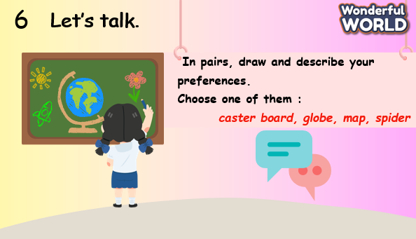 |  | - Draw and say in front of the class.
Activity 5: Wrap up & Assessment (4 minutes)
Teacher’s Activities |  |  | Students’ Activities
Aims:
- Check student's understanding of what they have learned.
- Students rehearse what they have learned in the lesson.
- Asks sts to do the assessment.  - T gives the assessment to the class and some Ss  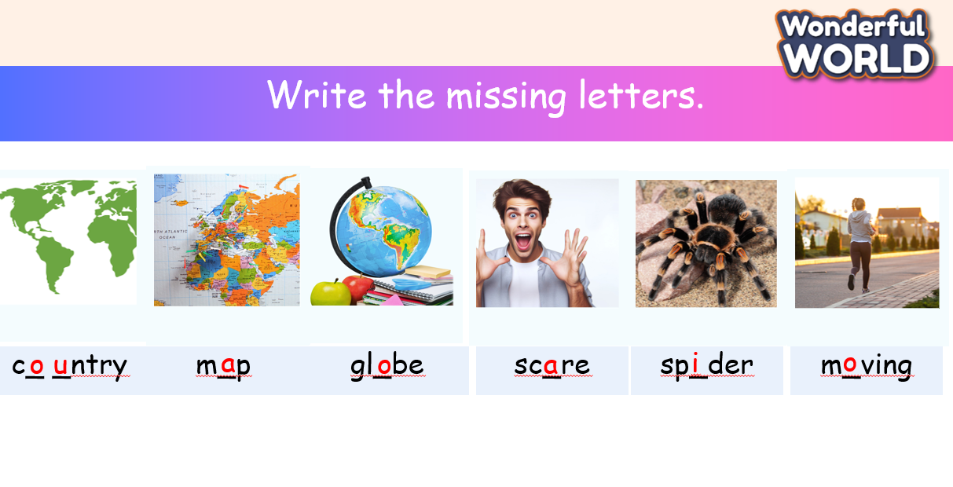  - Check with the class.  - Wrap-up  * Remember  Vocabulary:  country, globe, map, moving, scare, spider |  |  | - Do the assessment.  - Check with the teacher  - Sts read the wrap-up  - Stand up and say goodbye to the teacher.

