Week 4 (From 29/9 to 03/10)
UNIT 2: MY FAVOURITE THINGS
Lesson 2 – Task 4,5,6
Period 13
I. OBJECTIVES:
1. Knowledge:
- Students can draw out new grammar and new structures through writing and reading the sentences.
2. Competences:
- English competences: Students can use English to introduce the position of objects.
- Common competences: Students can talk about the positions of objects
3. Qualities:
- Students will revise the usage of some position prepositions.
- Students will talk about the location of objects
II. EQUIPMENT AND MATERIALS:
- Basic things: Student’s book, flashcards, photos.
- Advanced things: PPT, laptop, TV.
III. LESSON PROCEDURE:
Activity 1: Warm-up (5 minutes)
A guessing game “ What’s in the box ?”
Aims: Warm up the class with a pass-the-ball game to revive the vocabulary (globe, country, map, moving, scare, spider) and lead in the new lesson.
Teacher’s Activities | Students’ Activities
Procedure
- Greet students. Chatting…  “Do you like playing games?”  - Introduce the game:  - Ask Ss to play the “Pass the ball” game to revise the vocabulary.  - T plays the music and lets Ss pass the ball. When the music stops, Ss having the ball will answer the flashcard that T showed before.    -“Teacher will play the music, and you can pass the ball to your friends. When the music stops, whoever has the ball will answer the flashcard that I show you now. If you have the correct answer, you can roll the dice to get stars.”  - Let students join the game and lead in the topic and write it down on the board.  - Play the game:  - 4 turns to play using 4 flashcards: map, country, globe, spider.  - Lead in the new lesson:  Unit 2 – Lesson 2 Part 4,5,6 | - Greet Teacher  - Ss answers: “Yes”  - Join the activity.  - Look at the flashcard and listen to music.  - When the music stops, Ss, who has the ball,will answer the questions.  - Ss roll the dice to get stars if they have correct answers.
Activity 2: Presentation (12 minutes)
Aims: - Ss understand the meaning and pronounce correctly some prepositions: inside, outside, above, below, in the middle of.
- Finish Part 4 – colouring the ball.
Procedure
Teacher’s Activities |  | Students’ Activities
Lead in: Watch videos of prepositions and play “help the monkey” game. 5’  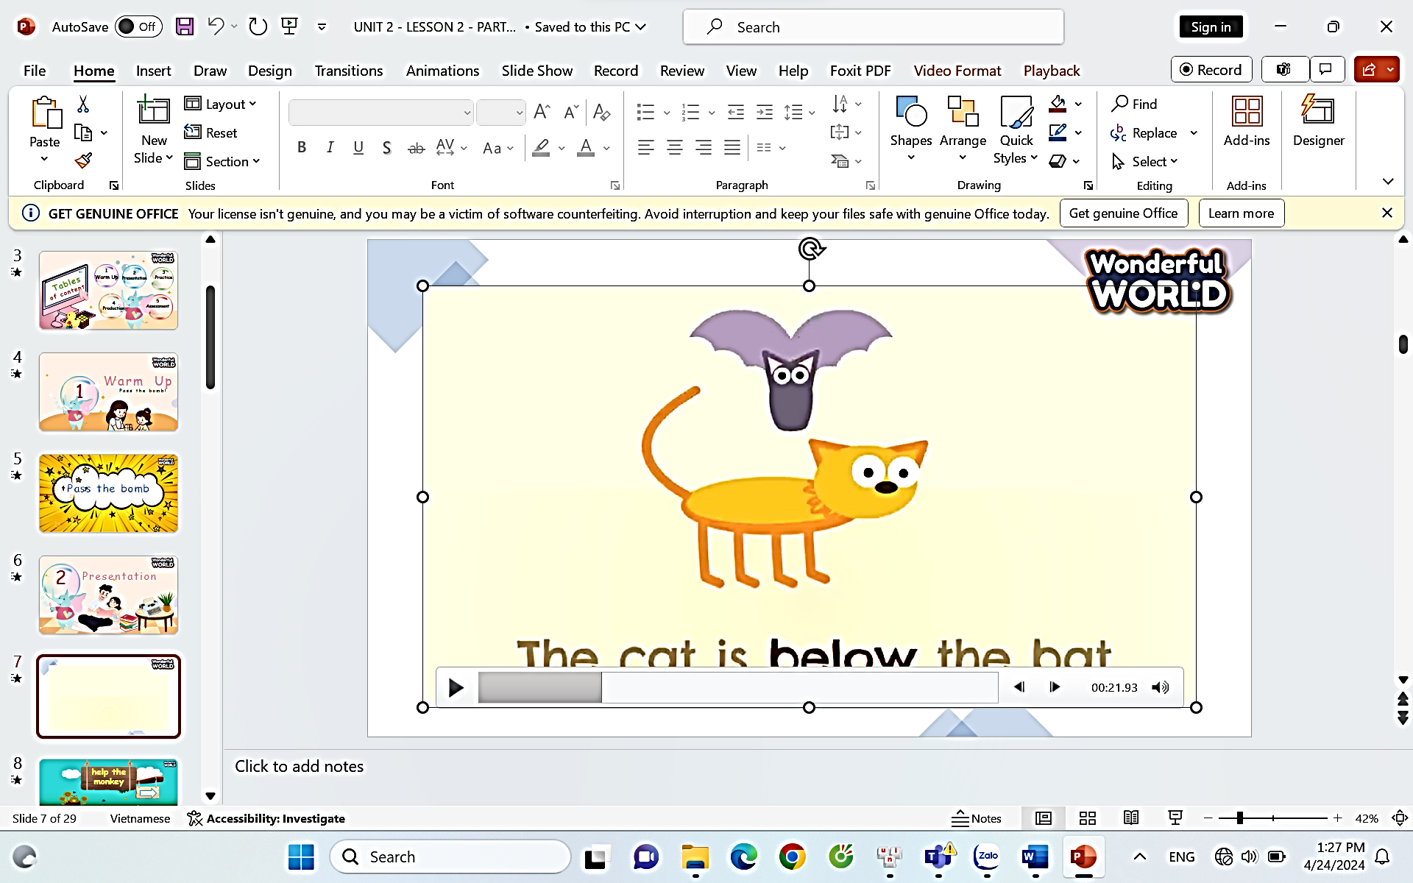  - Show the video on the screen. Tell students to listen to the video and ask them what they can see.  - Where is the cat?  - What prepositions can they see in the video?  - Let's join the “Help the monkey” game to learn about the location of prepositions.  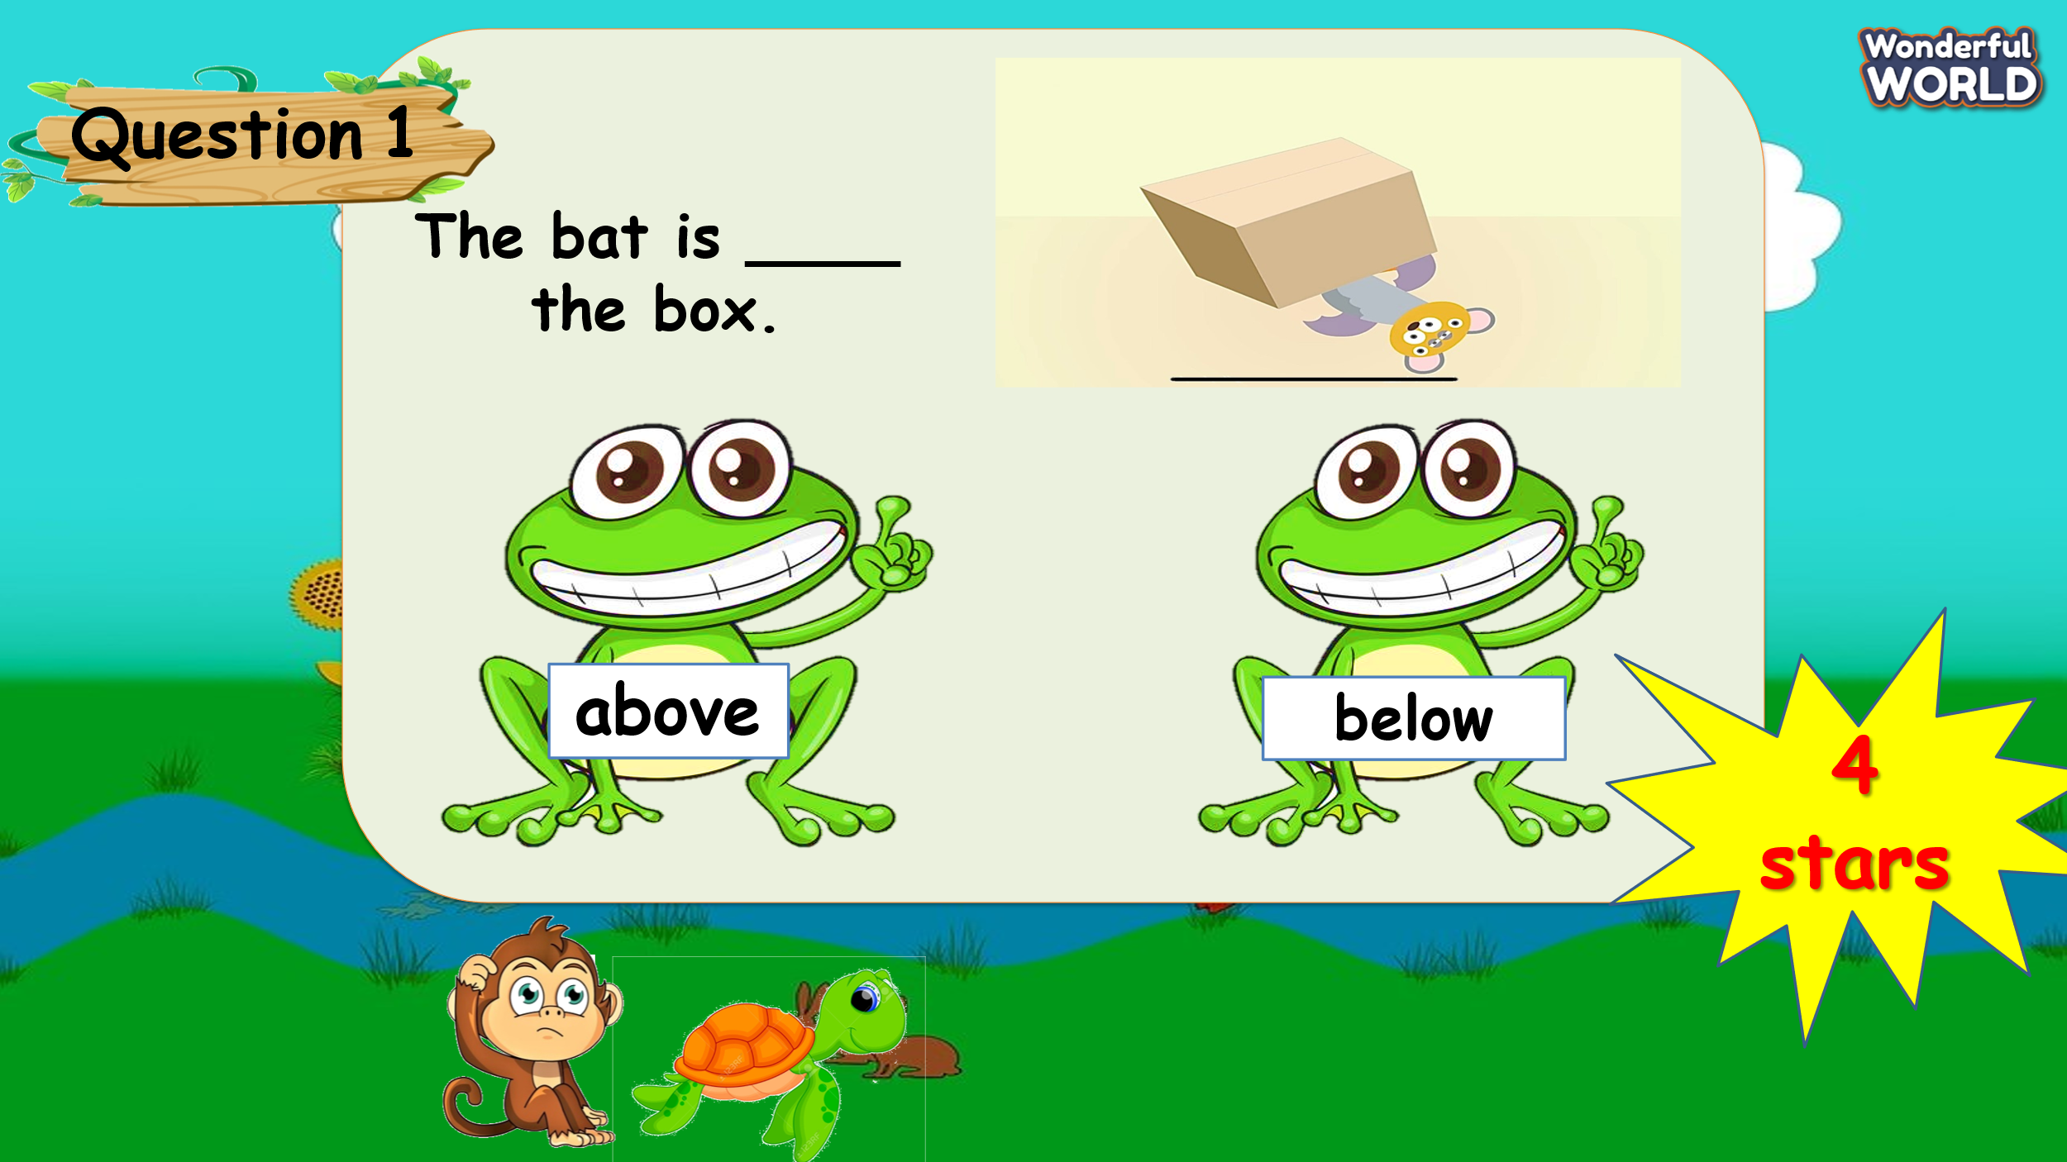  - T asks S to raise their hands and answer 4 questions about prepositions. If they have correct answers, they will get stars.  - “Now, do you want to play a game?”  - “Can you help the monkey by answering the questions? If you have correct answers, your team will get stars.”  Q1: The bat is ____ the box.  Q2: The rocks are ____ the box.  Q3: The cheese is _____ the box.  Q4: The bat is ____ the cat.  Task 4. Listen and read (7’)  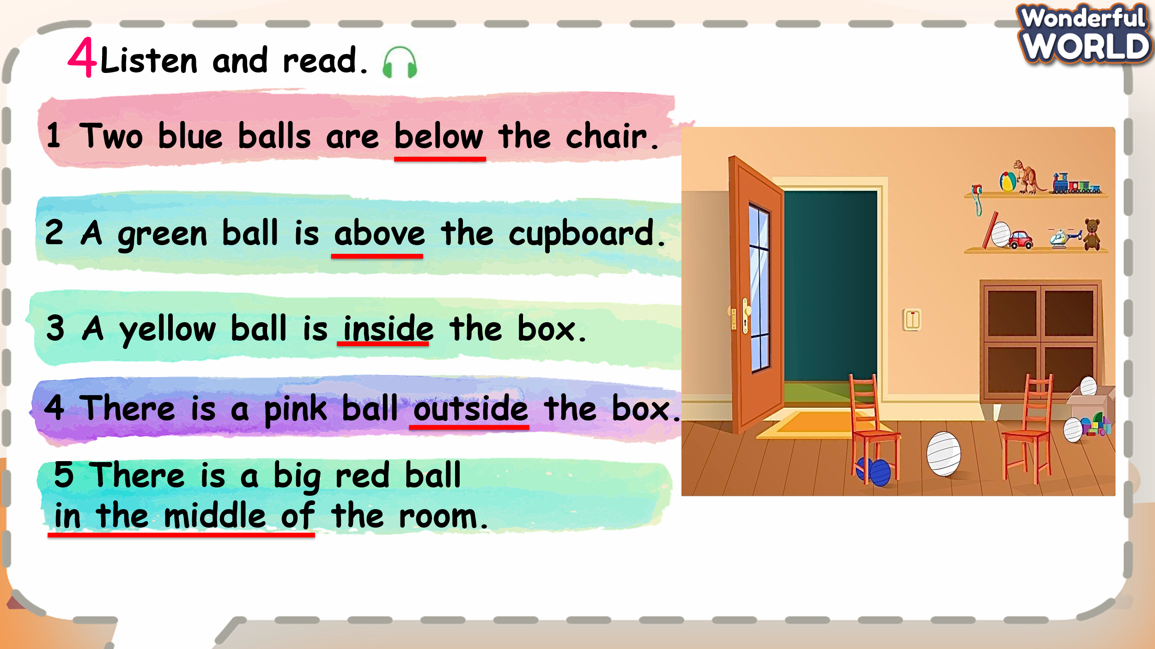  - Show the picture on the screen.  - Tell students to look at the photo and say what they can see.  What can you see? How many balls are there?  - Ask students to look at 5 sentences, listen to the tape and underline the prepositions.  - T plays the recording twice.  - Ask ss to read sentences in chorus, in groups and individually each sentence.  - Ask Ss to read each sentence again, then find the balls and colour them.  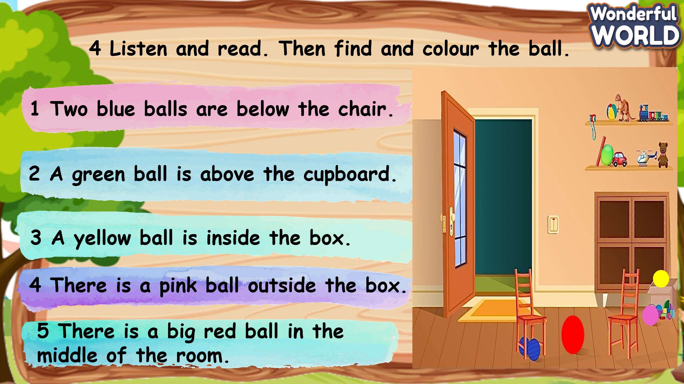  - Have Ss work in pairs and check answers with their partners. |  | - Listen to the video and answer the questions.  - Answer the question:  + The cat is below the bat.  + Prepositions are below, above, inside, outside…  - Join the game and answer the questions to get stars.  S answers “Yes”.  - S raise hands and answer questions:  Q1: The bat is below the box.  Q2: The rocks are outside the box.  Q3: The cheese is inside the box.  Q4: The bat is above the cat.  - Look at the pictures and answer the questions:  I can see balls, chairs, shelves, doors…  There are 5 balls in the picture.  - Listen and underline 5 prepositions: below, above, inside, outside, in the middle of.  - Ss listen and read it chorally and individually.  - Read sentences again, find the ball and colour.
Activity 3: Practice – Controlled practice (8 minutes)
a. Aims: - Ss can practice prepositions through writing skills such as: “below, outside, above, inside, in the middle of”
- Finish task 5 – Write correct prepositions
b. Procedure
Teacher’s Activities |  | Students’ Activities
Task 5. Look and write  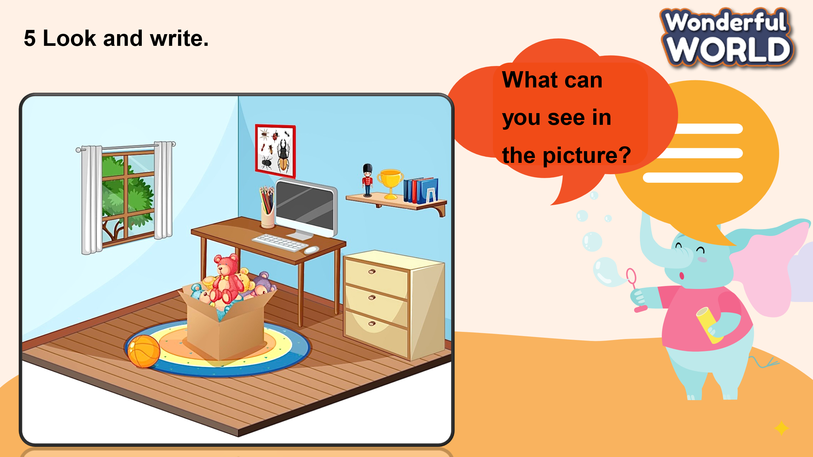  - Ask Ss to look at the picture and answer what they can see in it.  “What can you see in the picture?”  “Where are the pencils?”  - Let Ss look at five sentences and five words. They complete the sentences by using the given words in the box.  “You can fill the blank using words in the box to complete five sentences.”  - Demonstrate by explaining an example 1.  “Look at sentence 1, where are the pencils?”  -Have Ss do Task 5 individually. Then ask them to exchange their books with their partners to check out the answers.  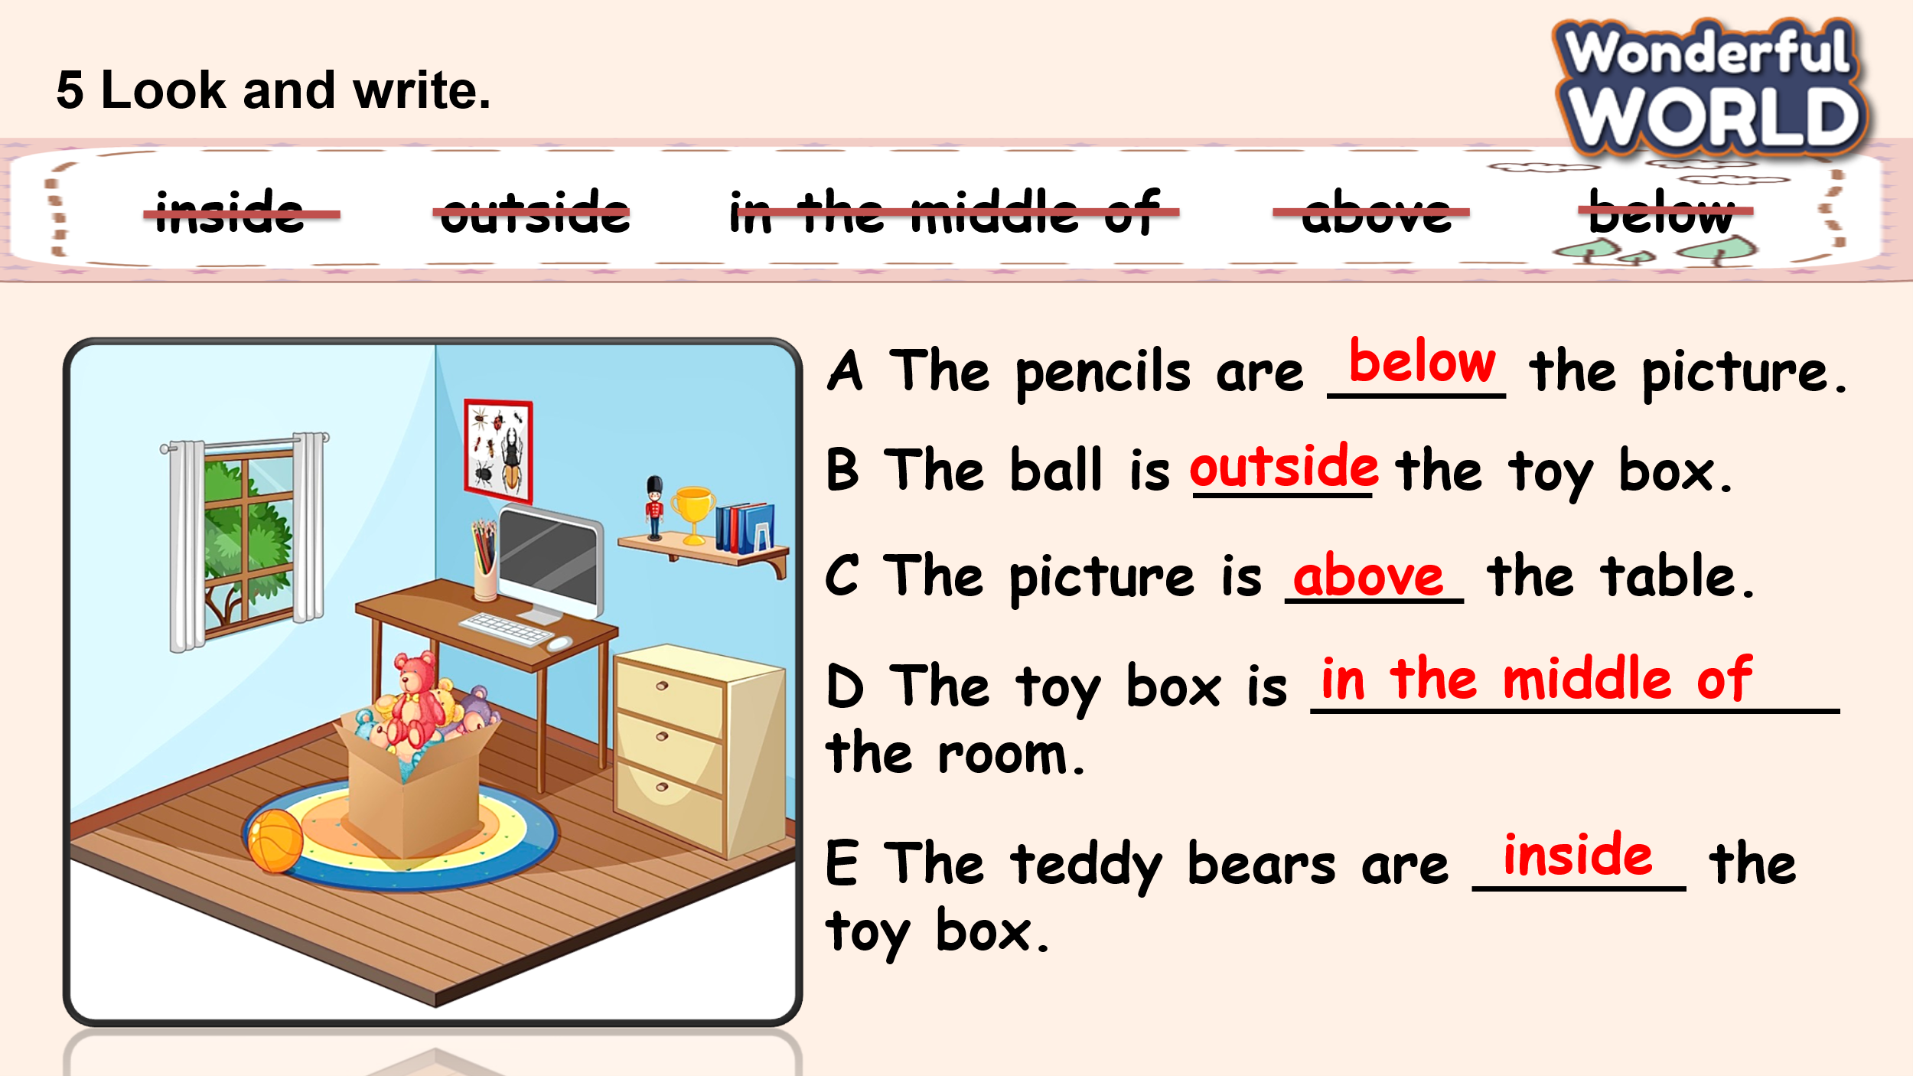  - Ask Ss to answer the sentences and check them with the whole class. |  | - Look at the picture, and answer what they can see in it.  “I can see some teddy bears, a ball, a picture, a toy box, some pencils.”  “I can see the pencils on the table.”  - Ss look at sentences and words.  - Answer sentence 1: “The pencils are above the picture.”  - Write down their answers in the textbooks.  - Check their friend’s results.  - Practise saying the sentences individually and in pairs.  - Check their answers.  “A.below  B.outside  C. above  D. in the middle of  E. inside
Activity 4: Production – Free practice (6 minutes)
a. Aims: Apply the grammar to present in front of the class to discuss and make sentences using prepositions such as: on, next to, below, above.
Encourage sts to answer and make full sentences using prepositions.
b. Procedure
Teacher’s Activities |  | Students’ Activities
Task 6: Let’s talk  - T shows the pictures and asks Ss to find out where the map is. Point to locations of maps, globes, books, pictures and toys.  “Can you point to the objects that we need to find out?”  “Where is the map?”  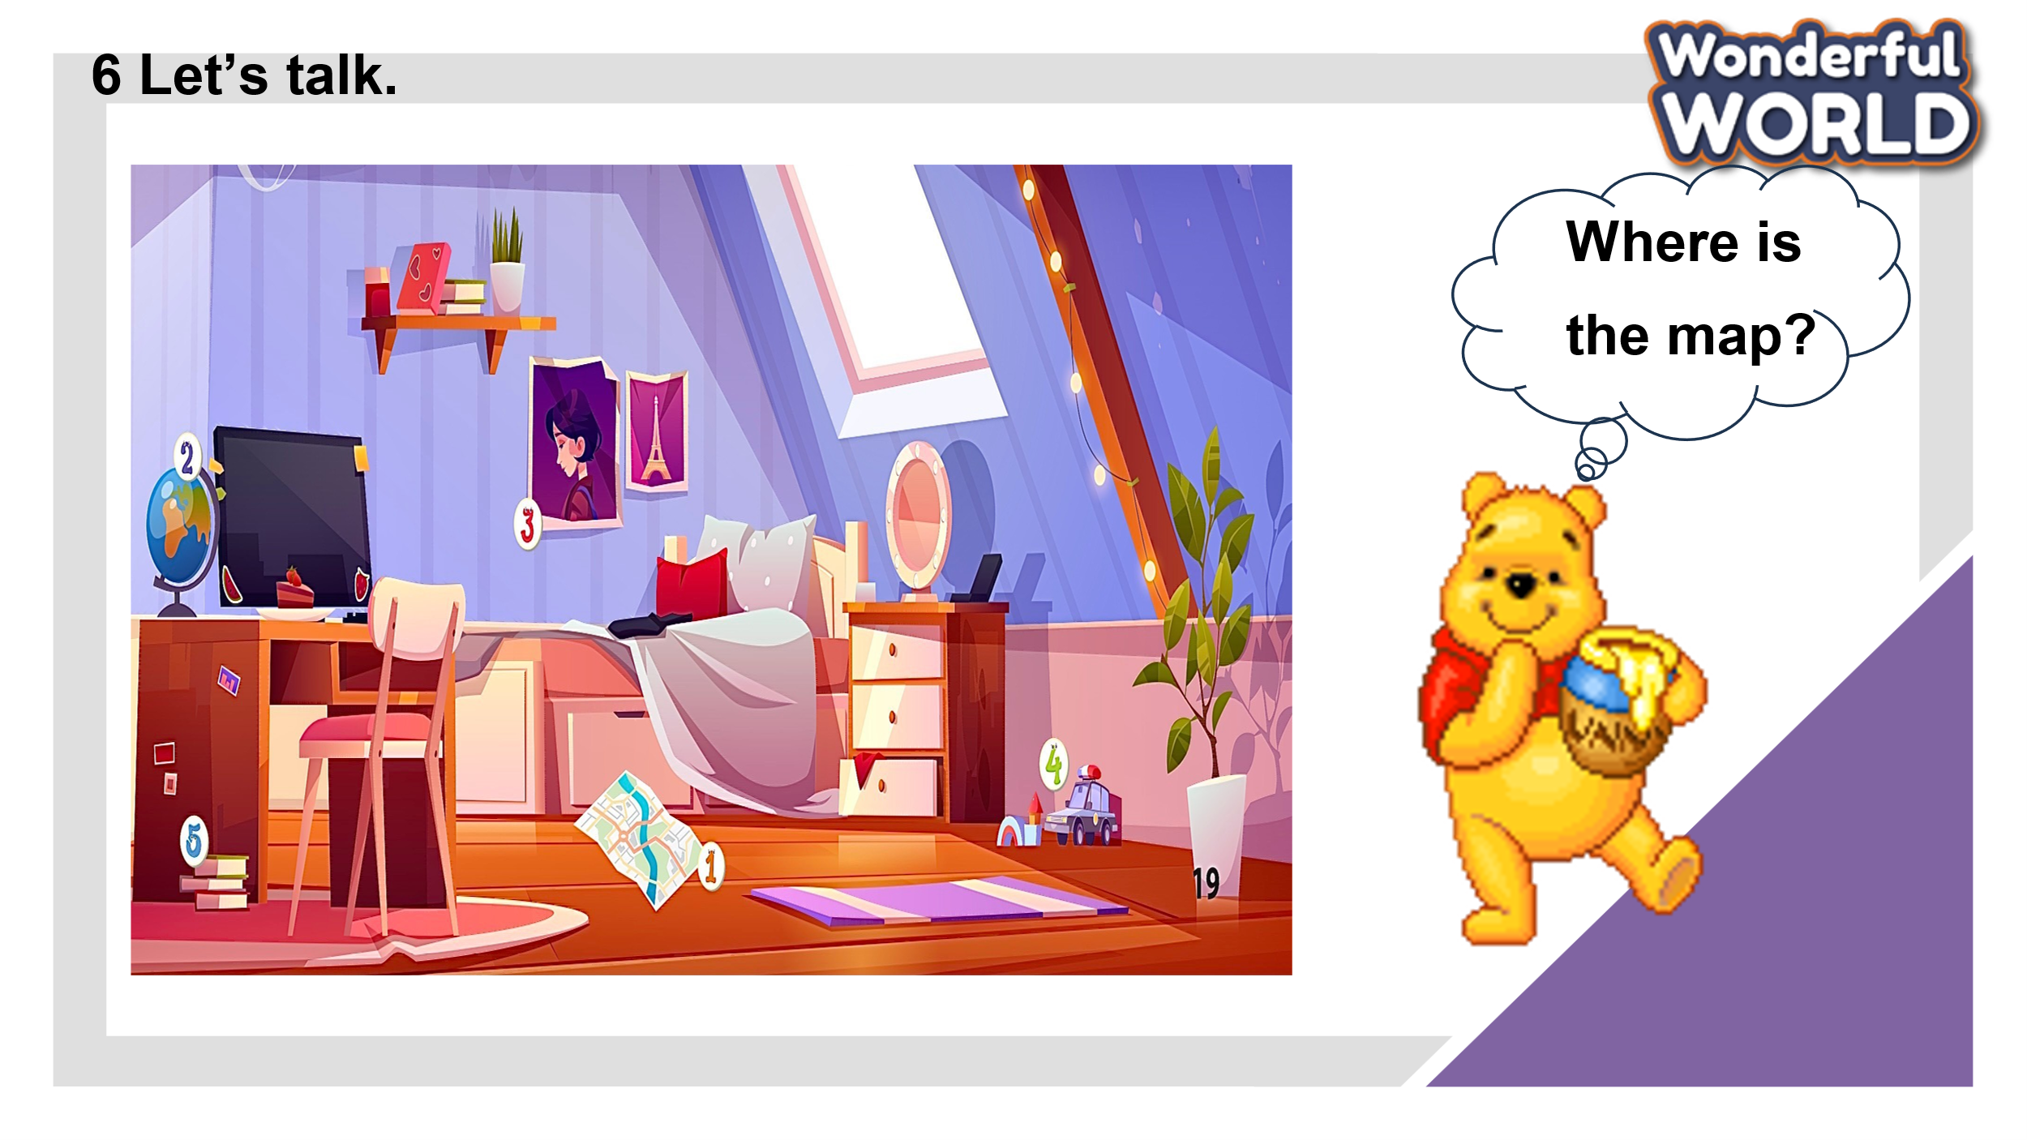  - Let sts play the game: Help the Pooh according to the picture.  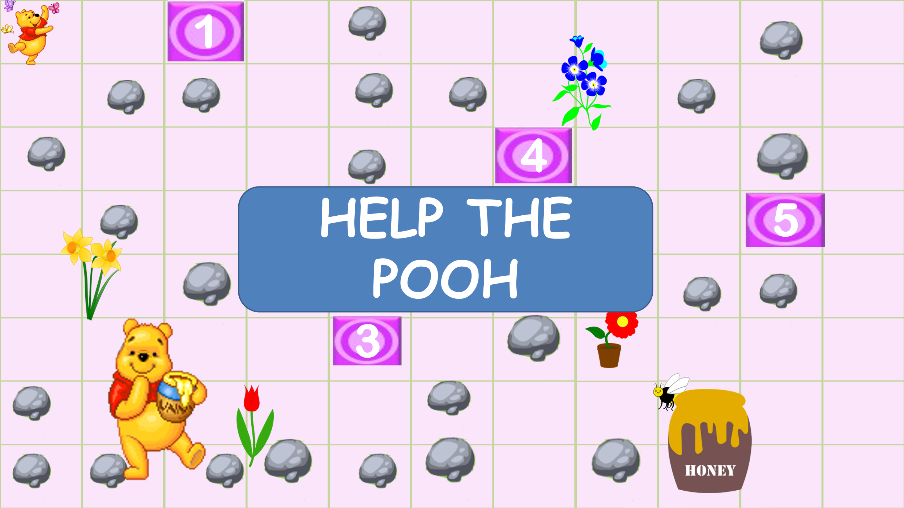  - Sts answer the questions on time to get stars and move to the next question. They are going to talk about the position of objects in the picture through the game.  - Let Sts choose the answers to help the Pooh get to the honey.  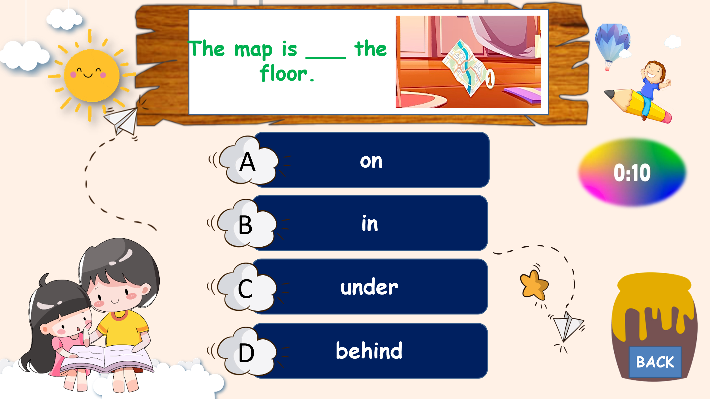  - Let’s Sts read their sentences aloud. Then, ask them to work in pairs, using the model sentence 1 as an example.  A: “Where is the map?”  B: “The map is on the floor.” |  | - Sts look at the picture and point to the different objects.  - Sts answer the question through the game.  - Take part in the games.  - Look at the pictures.  - Read the sentences. Choose the correct answers.  - If they have the correct answer they can roll the dice to get stars for their team.  - Sts work in pairs to make questions and answers using the sentences in the game.
Activity 5: Wrap up & Assessment (4 minutes)
Teacher’s Activities |  | Students’ Activities
a. Aims:
- Check student's understanding of what they have learned.
- Students rehearse what they have learned in the lesson.
Asks sts to do the assessment.  - T gives the assessment to the class and some Ss can answer them.  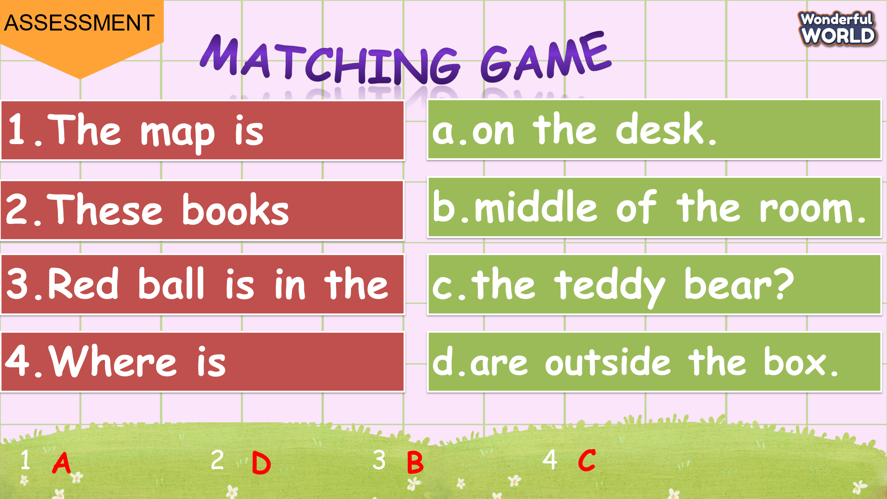  - Check with the class.  - Wrap-up  * Remember  VOCABULARY  Inside, outside, in the middle of, below, above  STRUCTURE  “Where is the map?” – “It’s in the middle of the room.” |  | - Do the assessment.  - Check with the teacher  - Sts read the wrap-up  - Stand up and say goodbye to the teacher.
____________________________________

UNIT 2: MY FAVOURITE THINGS
Lesson 3 – Task 1,2,3
Period 14
I. OBJECTIVES:
1. Knowledge:
- Students can draw out new grammar and new structures through practicing speaking dialogues and listening to the audio.
2. Competences:
- English competences: Students can use English to introduce their favourite things.
- Common competences: Students can talk about their preferences.
3. Qualities:
- Students will revise the usage of some position prepositions.
- Students will talk about their favourite things or activities.
II. EQUIPMENT AND MATERIALS:
- Basic things: Student’s book, flashcards, photos.
- Advanced things: PPT, laptop, TV.
III. LESSON PROCEDURE:
Activity 1: Warm-up (5 minutes)
A guessing game “ Racing game ?”
Aims: Warm up the class with a quick game named “Racing game’’ to revise prepositions of location (on, below, outside, inside) and lead in the new lesson.
Teacher’s Activities | Students’ Activities
Procedure
- Greet students. Chatting… Ask Ss:  “Do you like playing games?”  - Introduce the game:  - Ask Ss to play the “Racing” game to revise grammar.  - T shows each question, ss look at the picture and answer the question. If they have the correct answer, they can throw the ball to get stars.  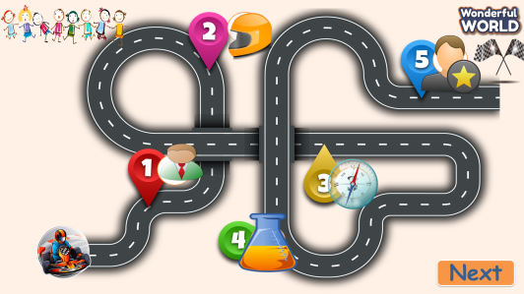  -“I will give you the questions and pictures. Look at them and give me correct answers. If you have the correct answers, you can throw the ball to get stars.”  - Let students join the game and lead in the topic and write it down on the board.  - Play the game:  - 5 turns to play using some grammar and structures.  - Lead in the new lesson:  Unit 2 – Lesson 3 Part 1,2,3 | - Greet Teacher  - Ss answers: “Yes”  - Join the activity.  - Look at the question and pictures.  - When the music stops, Ss, who has the ball, will answer the questions.  - Ss can throw the ball to get stars if they have correct answers.
Activity 2: Presentation (12 minutes)
a. Aims:- Ss revise objects and activities from the last lesson.
- Ss practice listening through the dialogues of describing someone’s preferences.
- Finish Part 1 – Write the correct name
b. Procedure
Teacher’s Activities | Students’ Activities
Lead in: Make correct words. 5’  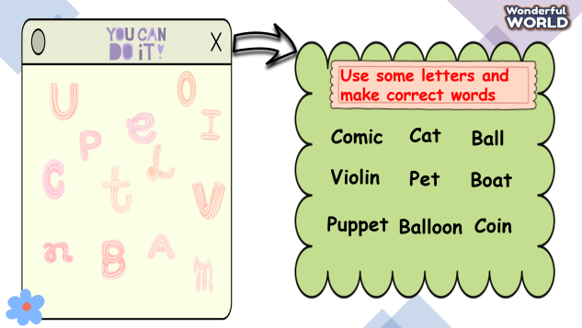  - Show some letters on the board. Ask Sts to make correct words using those letters.  “Teacher has some letters here. Use them and make your own correct words. A team can find out more words, will have a chance to get more stars.”  “Let's check the result.”  - T asks Sts to raise their hands and give T answers about words they have found out. If they have correct answers, they will get stars.  Answers: comic, ball, cat, balloon, puppet, coin, violin, pet…  Task 1. Listen and write the name under the correct pictures. (7’)  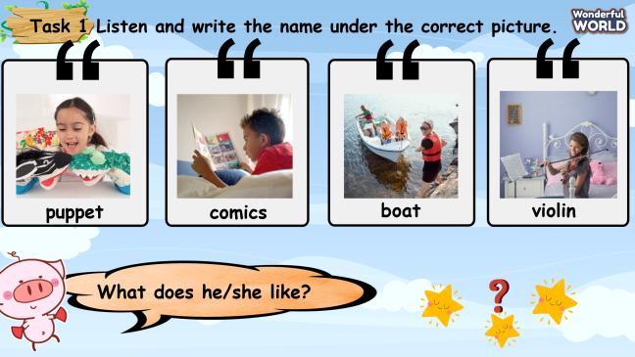  - Show the pictures on the screen.  - Tell students to look at the photo and let Sts guess what things people like in each picture.  What can you see? What does he/she like?  - Ask students to answer about people’s preferences.  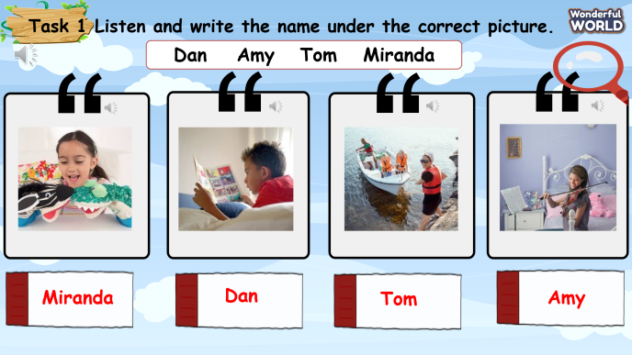  - T shows different names and lets Sts listen to the audio.  - T plays the audio again and lets Sts write down the names under the correct pictures.  - Show the correct answers.  - Have ss work in pairs and check answers with their partners. | - Look at some letters and make Ss’ own correct words.  - Join the game.  - Answer the question:  comic, cat, balloon, boat, coin, puppet, ball….  - Look at the pictures and answer the questions:  I can see the girl playing with puppets.  I can see a boy reading comics.  I can see a boat  I can see a girl playing the violin.  - Listen to the audio and find out Ss’ favourite objects and activities.  - Ss listen again and write down the correct name under each picture.  - Work in pairs to check their results.  Answers:  - Dan  - Amy  - Tom  - Miranda
Activity 3: Practice – Controlled practice (8 minutes)
a. Aims: - Ss can practice listening through the dialogues of describing someone’s preferences.
- Finish task 2- Listen again and write D, A, M, T for each question.
b. Procedure
Teacher’s Activities | Students’ Activities
Task 2. Listen again. Write D,A,M,T  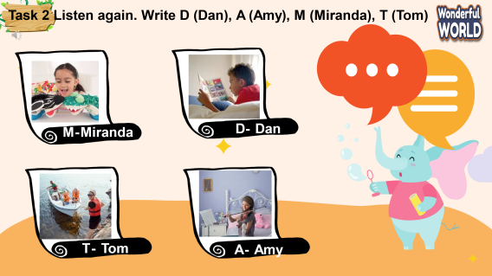  - Ask Ss to look at the picture and answer what they can see.  “What can you see in the picture?”  - Let Ss listen to the audio and participate in the game.  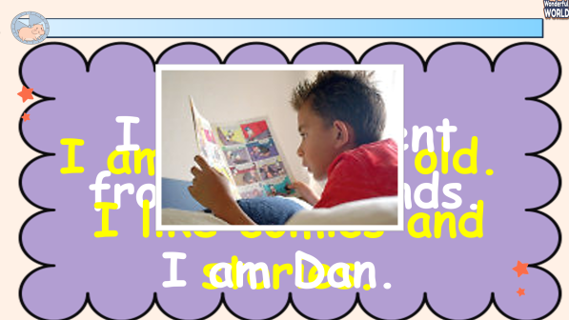  - T shows a guessing game. Show three sentences as three suggestions to find out who he/she is.  - Ask Sts to attentively listen and give answers.  - If they have correct answers, Ss can roll the dice to get stars.  *Dan: - I am 11 years old.  - I like comics and stories.  - I am different from my friends.  *Amy: - I like the violin.  - I have violin lessons.  - My mom likes it, too.  *Miranda: - My favourite thing is puppet.  - Tony and I play puppets together.  - It’s so fun.  *Tom: - I am 9 years old.  - I like my family’s boat.  - My boat is named Sea Queen.  -Tell Ss to listen to the recording in Activity 1 again and write.  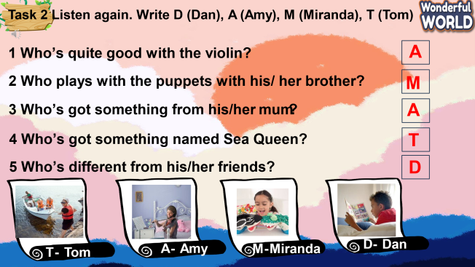  - Have Ss do Task 2 individually. Then ask them to exchange their books with their partners to check out the answers.  - Call some Ss to go to the board and write answers then check them with the whole class. | - Look at the picture, and answer what they can see in it.  “I can see Miranda playing with puppets.”  “Dan is reading a comic.”  “Amy is playing the violin.”  - Ss listen to the recording and join the game.  - Ss guess who he/she is.  If they have the correct answer, they can roll the dice to get stars.  - Ss listen to recordings again and do the task.  - Write down their answers in the textbooks.  - Check their friend’s results.  - Practise saying the sentences individually and in pairs.  - Check their answers.  “1. A  2. M  3.A  4. T  5. D”
Activity 4: Production – Free practice (6 minutes)
a. Aims: Apply the grammar to present in front of the class to discuss and make sentences to show someone’s favourite activities or objects.
Encourage sts to answer and make full sentences using the structure: “My/his/her favourite thing is ….”, “He/She likes…..”
b. Procedure
Teacher’s Activities | Students’ Activities
Task 3. Look and say  - T shows the pictures and text box.  - Ask Ss to look at Activity 1 and say it by using given words.  - T asks some questions and lets ss make the sentences using words in the box.  “What are his favourite things?”  -“Dan’s favourite things are comics and stories. He likes drawings.”  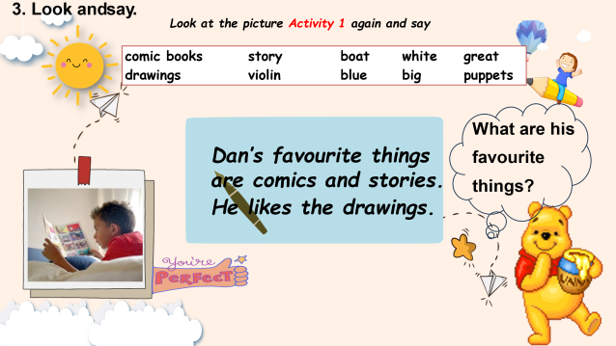  - Model 1 as an example.  - T gives Ss 3 minutes to work in pairs.  *Amy’s favourite thing is her violin. She likes playing the violin.  *Marina’s favourite things are playing puppets with her brother, Tony.  *Tom’s favourite thing is his family’s boat. The boat is white and blue. It’s so big and great.  -Call some Ss to go to the board and present in front of the class aloud.  - T gives feedback and checks pronunciation if necessary. | - Look at the pictures and the box.  - Read the questions and guess the answers.  - Ss work in pairs to make sentences using the structure.  - Some Ss raise their hands and come to the board to say their sentences aloud.  - Check their answers in class.
Activity 5: Wrap up & Assessment (4 minutes)
Teacher’s Activities | Students’ Activities
a. Aims:
- Check student's understanding of what they have learned.
- Students rehearse what they have learned in the lesson.
Asks sts to do the assessment.  - T gives the assessment to the class and some Ss can answer them.  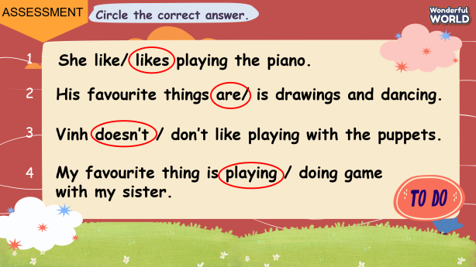  - Check with the class.  - Wrap-up  * Remember  VOCABULARY  puppet, violin, boat, comics, like, favourite thing.  STRUCTURE  “What is his/her favourite thing?  - His/ her favourite thing is…  He/She likes…..” | - Do the assessment.  - Check with the teacher  - Sts read the wrap-up  - Stand up and say goodbye to the teacher.
______________________________________

UNIT 2: MY FAVOURITE THINGS
Lesson 3 - Task 4,5,6
Period 15
I. OBJECTIVES:
1. Knowledge:
- Students review words and phrases about their favourite toys and things.
- Students learn about the conjunctions: “and” and “but”, and clarify the differences between these two.
2. Competences:
- English competences: Students can use English to introduce their favourite toys.
- Common competences: Students can draw their favourite things creatively and introduce them to their friends using “and” and “but”.
3. Qualities:
- Students will
+ have a strong curiosity in exploring different types of toys and understanding their names.
+ recall and reflect on personal experiences with toys from their childhood and make them more meaningful and memorable.
II. EQUIPMENT AND MATERIALS:
- Basic things: Student’s book, flashcards, photos, papers
- Advanced things: PPT, laptop, TV.
III. LESSON PROCEDURE:
Activity 1: Warm-up (5 minutes)
A guessing game “ What’s in the box ?”
Aims: Welcome students. Engage the class (or warm the class up) with a guessing word game to revive the vocabulary (write the words here….) and lead in the new lesson.
Teacher’s Activities | Students’ Activities
Procedure
- Greet students. Chatting…Do you like playing games…  - Introduce the game:  Ask them to think of their favourite things inside and outside of the class.  - Put students in groups of two or three.  - Show the picture and the letters. Give them 5 seconds to put the letters in the correct order.  - Click on the screen to check the word. Ask Ss to read aloud.  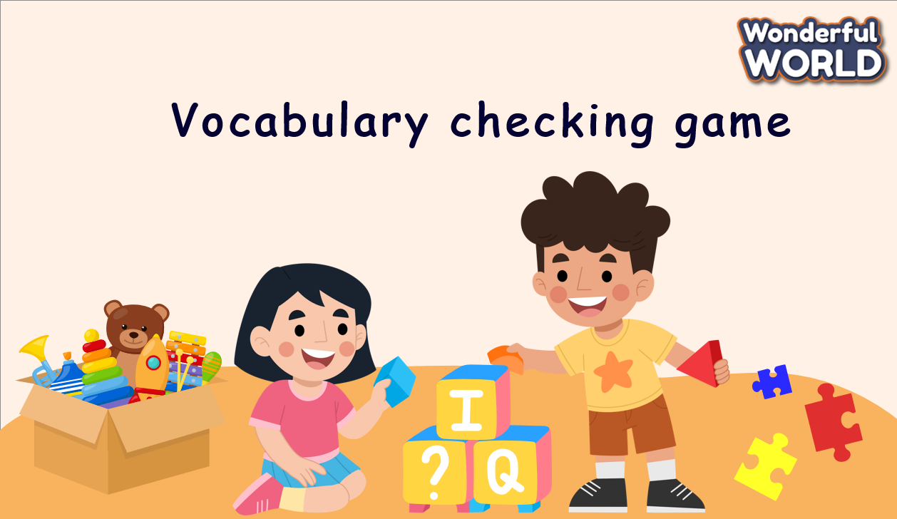  Lead in:  - Raise some pictures and ask Ss to guess the topic of the lesson  - Review the topic “My favourite things”  - Write on the board “My favourite things” and review the words and structures of the learned lesson | - Greet Teacher  - Listen to the clues  - Stand in a group and pay attention to the game, remember the key words related to the given clues  - Raise the hands to get the chance to answer the questions  - Check the result.
Activity 2: Presentation (12 minutes)
a. Aims: - Present new words: and and but
- Explain what conjunctions are and how to use them in sentences.
- Ss know how to use and and but in conversations
- Finish Task 4
b. Procedure
Teacher’s Activities | Students’ Activities
Task 4. Match, listen and check.  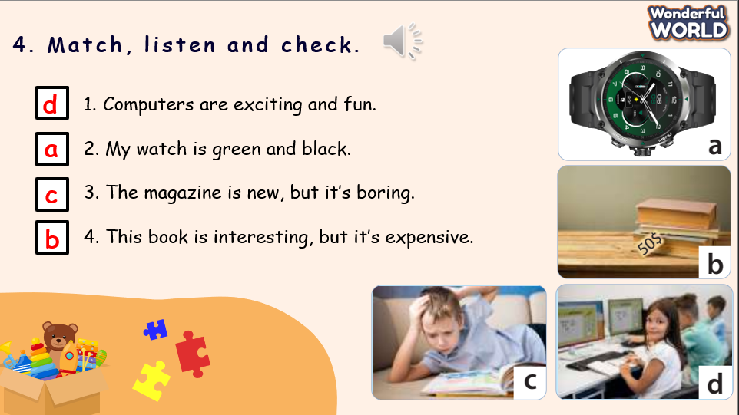  - Show the picture on the screen.  - Ask students to read the sentences on the left aloud  - Ask students to name the things they can see on the right.  - Ask students to listen to the audio and match the sentences with the pictures.  - Invite some students to write their answers on the board  - Play the audio again and check the answers | - Look at the screen and read the sentences aloud  - Look at the pictures and identify the objects  - Listen and match  - Write the answer on the board and check.
Activity 3: Practice – Controlled practice (8 minutes)
a. Aims:
- Ss can use “and”, “but” in sentences correctly.
- Ss can complete sentences using “and” and “but”.
- Ss join the game to review the use of “and” and “but”
b. Procedure
Teacher’s Activities | Students’ Activities
Task 5. Complete the sentence with “and” or “but”  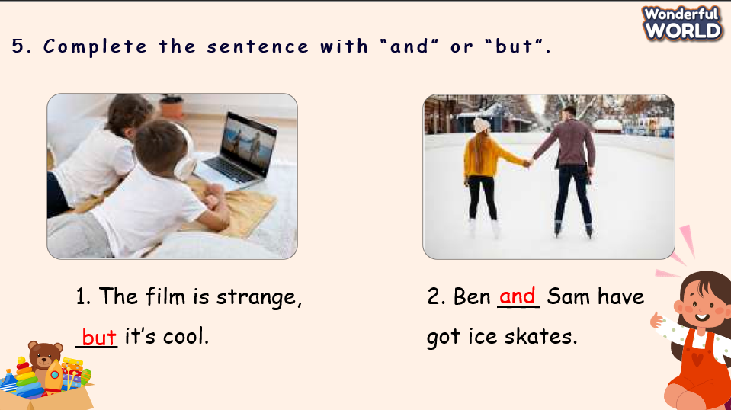  - Show the sentences on the screen,  -Ask Ss to look at the pictures, and identify the items/people/activities in the pictures.  - Ask Ss to work individually  - Call a student to write the unscrambled words on the board.  - Check the answer  Game: “Board game”  - T divides the class into 2 groups. Each group will choose a character (boy or girl) and play rock, scissors, and paper to decide which group goes first.  - The two groups will take turns to choose a number and answer the corresponding questions.  -T checks the answer. If it is correct, T clicks on the home button to go back to the choosing question screen. T clicks on the orange button to move the boy, the grey button to move the girl.  If the answer is incorrect, T asks the next team to choose the number.  - When all the questions are answered, the team that moves closer to the finish line will win.  - When the game is finished, click on the next button on the right bottom edge to move to the next slide.  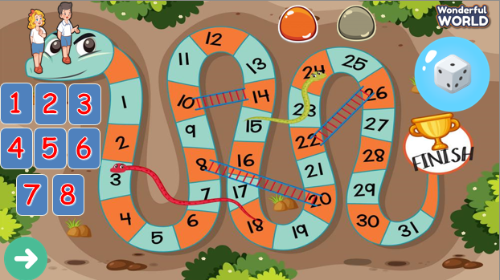 | - Look at the picture, listen to the example and repeat.  - Practice saying the sentences individually and in pairs.  - 4 Ss write the answer on the board.  - Check the answers  - Listen to the rules of the game  - Appoint a  representative to do rock, scissors, and paper to decide who goes first  - Choose the number and pay attention to the questions, and then answer  - If the answer is correct, spin the wheel to get the points  - If not, the next team will choose another number to continue the game  - Check the results
Activity 4: Production – Free practice (6 minutes)
a. Aims:
Apply the new words and structures to present in front of the class the description of favourite toys from their childhood and make it more meaningful and memorable in using vocabulary in the lesson.
b. Procedure
Teacher’s Activities | Students’ Activities
- T makes her/his own sentence like in task 5 as an example of the free talk. (He can draw a simple thing)  - Ask Ss to make their own sentences by talking/ writing about their favourite things.  - Ask them to draw a picture (optional). Then say the sentences by using the structures  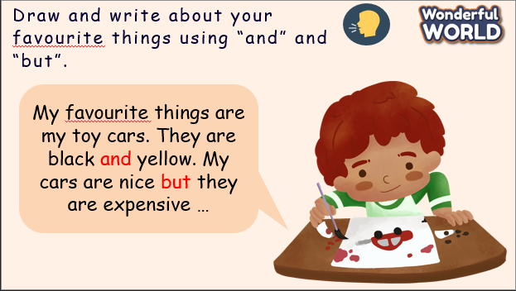 | - Draw and say in front of the class.
Activity 5: Wrap up & Assessment (4 minutes)
Teacher’s Activities | Students’ Activities
a. Aims:
- Check student's understanding of what they have learned.
- Students rehearse what they have learned in the lesson.
- Asks sts to do the assessment.  -T gives the assessment to the class and some Ss  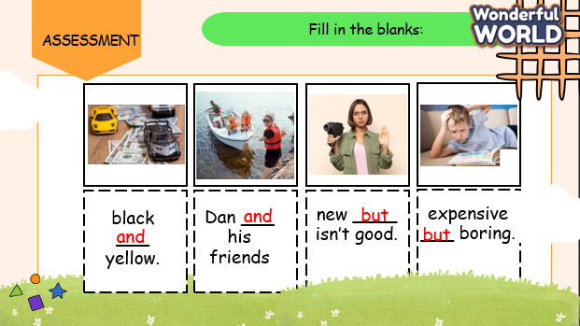  - Check with the class.  - Wrap-up  * Remember  VOCABULARY  computer, piece, puzzle, photo, typewriter  STRUCTURE  My favourite toys are … and …  My favourite toy is … but it’s … | - Do the assessment.  - Check with the teacher  - Ss read the wrap-up  - Stand up and say goodbye to the teacher.

UNIT 2: MY FAVOURITE THINGS
Lesson 3 - Task 7,8,9,10
Period 16
I. OBJECTIVES:
1. Knowledge:
- Students learn about stress in words and practice speaking the words correctly
2. Competences:
- English competences: Students can speak English with correct stress in words.
- Common competences: Students can speak English with intonation
3. Qualities:
- Students will
+ have a strong ability in defining the changes in word intonation
+ know the beauty of English while speaking with intonation
II. EQUIPMENT AND MATERIALS:
- Basic things: Student’s book, flashcards, photos, papers
- Advanced things: PPT, laptop, TV.
III. LESSON PROCEDURE:
Activity 1: Warm-up (5 minutes)
A guessing game
Aims: Welcome students. Engage the class (or warm the class up) with a guessing word game to revive the vocabulary (write the words here….) and lead in the new lesson.
Teacher’s Activities | Students’ Activities
Procedure
- Greet students. Chatting… ‘Do you like playing games?’  - Introduce the game:  Ask them to think of their favourite things inside and outside of the class.  - Put students in groups of two or three.  - Show the picture on the screen. Give them 5 seconds to guess what shown on the screen is  - Click on the  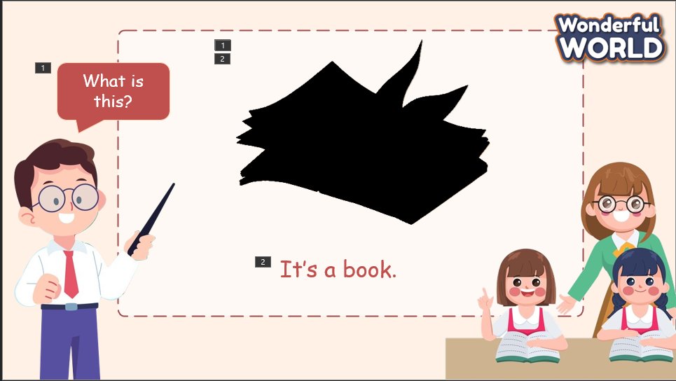  Lead in:  - Raise some pictures and ask Ss to guess the topic of the lesson  - Review the topic “My favourite things”  - Write on the board “My favourite things” and introduce the new lesson |  | - Greet Teacher  - Listen to the clues  - Stand in groups and pay attention to the game, remember the key words related to the given clues  - Raise the hands to get the chance to answer the questions  - Check the result
Activity 2: Presentation (12 minutes)
a. Aims: Present the stress in words
Explain what stress is, where we can find the stress, and how to stress in words.
+ Ss know how to put the stress in words while speaking
+ Finish Task 7
b. Procedure
Teacher’s Activities |  | Students’ Activities
Teacher explains the stress:  - The way that a word or syllable is pronounced with greater force than other words in the same sentence or other syllables in the same word  - Show the words on the screen and explain  - Play audio and ask Ss to listen and identify the stress in words  - Ask Ss to repeat after the audio.  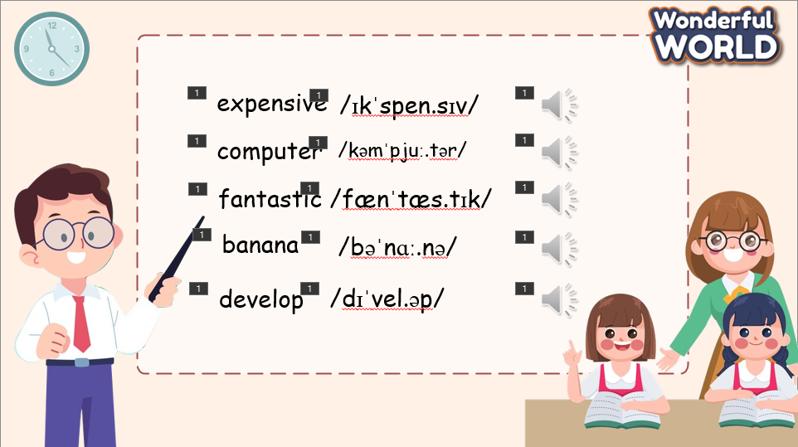  Task 4. Listen, point, and repeat.  - Ask Ss to look at the screen and guess the stress of each word.  - Ask Ss to read each word.  - Play the audio and ask Ss to listen to it.  - Check the stress  - Invite Ss to repeat.  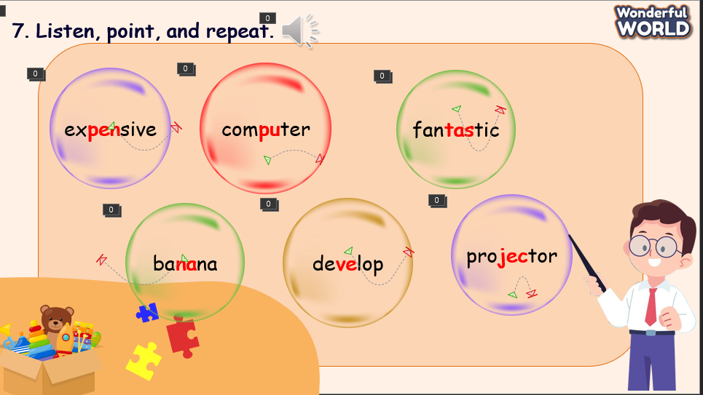 |  | - Look at the screen and listen to the explanation  - Look at the words and identify the stress on words  - Listen to the audio and repeat themselves  - Repeat after the audio  - Look at the screen and guess the stress of each word.  - Listen to the audio and identify the stress  - Listen again and check the result  - Repeat the words with the correct intonation
Activity 3: Practice – Controlled practice (8 minutes)
a. Aims:
Ss can practice speaking the words with intonation by saying words individually
Ss practice speaking with intonation while chanting
Join a game to make an encouraging environment and help Ss practice listening skills and identify the stress of words
b. Procedure
Teacher’s Activities |  | Students’ Activities
Task 8. Circle the word that is stressed differently. Then read aloud.  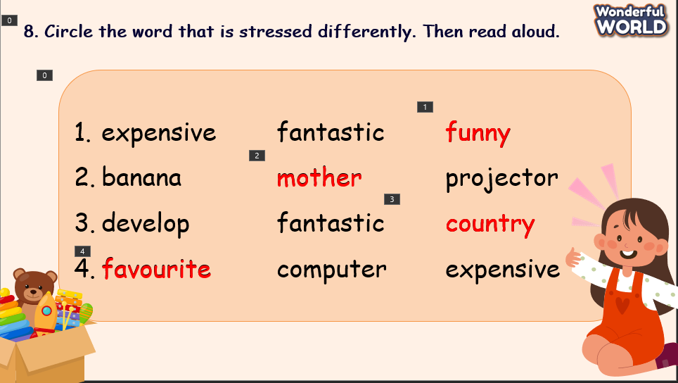  - Show the words on the screen  - Ask Ss to read the words individually to identify the word that is stressed differently  - Ask Ss to work in groups of 4 to choose the words  - Check the answer and ask the reason why Ss chose the word  - Ask Ss to read the words aloud  - Invite some Ss to speak in front of the class and give them feedback  Game: “Lucky wheel”  - T divides the class into 2 groups. Each group will choose a character (boy or girl) and play rock, scissors, and paper to decide which group goes first.  - Two groups will take turns to choose a number and answer the corresponding questions.  - T checks the answer. If it is correct, T clicks the “spin” button to rotate the wheel, then clicks on the wheel to stop and check the points. If the answer is incorrect, T asks the next team to choose the number. When all the questions are answered, the team with the higher score will win the game.When the game is finished, click on the next button on the right bottom edge to move to the next slide.  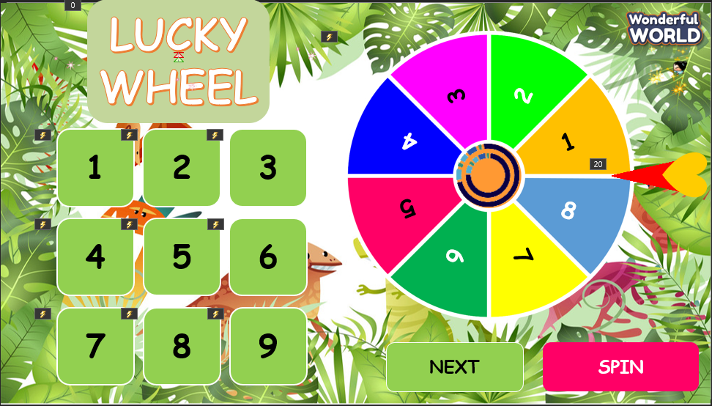 |  | - Look at the screen and read the word individually  - Work in groups to give out the result  - Write the answers on the board and explain why they choose that word  - Check the result  - Listen and repeat the words  - Listen to the rules of the game  - Appoint a representative to do rock, scissors, and paper to decide who goes first  - Choose the number and pay attention to the questions, and then answer  - If the answer is correct, spin the wheel to get the points  - If not, the next team will choose another number to continue the game  - Check the results
Activity 4: Production – Free practice (6 minutes)
a. Aims:
Apply the knowledge Ss have learnt today to say the words correctly while playing a tic-tac-toe game to encourage Ss to remember the words
b. Procedure
Teacher’s Activities |  | Students’ Activities
- Show the words and explain the rules of the game  - Divide the class into two groups. Two groups will play rock, paper, scissors to decide their symbol and who goes first(X or O)  - Each team will choose a word to say and put their symbol on the board  - The first team who can make a line with three symbols (horizontal, vertical, cross) will win the game  - T helps Ss to correct the pronunciation while speaking  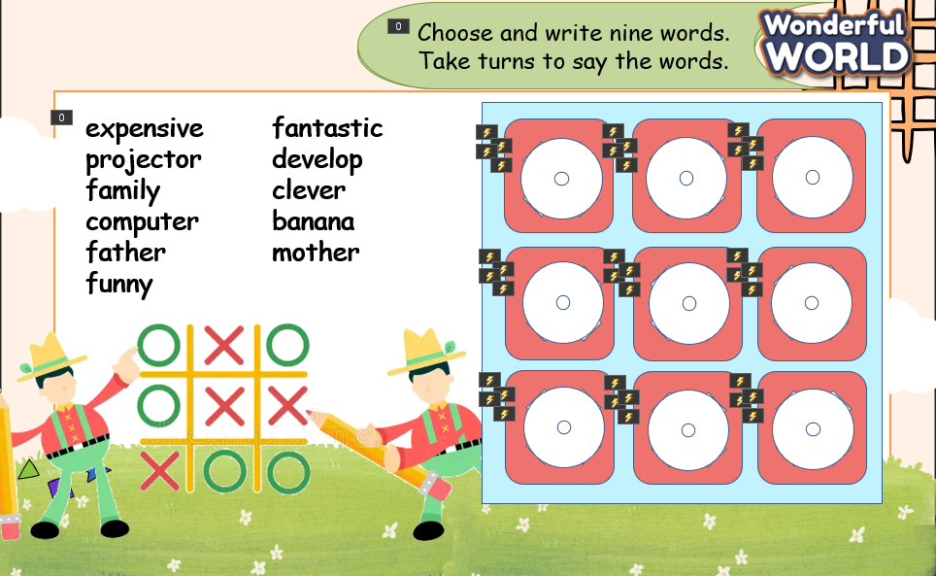 |  | - Listen to the rules of the game  - Stay in the two groups  - Each group has a representative to play rock, paper, scissors to decide their symbol and who goes first  - Choose the words to speak and put their symbol on the board  - Try to make a line with 3 symbols continuously
Activity 5: Wrap up & Assessment (4 minutes)
Teacher’s Activities |  | Students’ Activities
a, Aims:
- Check student's understanding of what they have learned.
- Students rehearse what they have learned in the lesson.
- Ask Ss to do the assessment.  - T gives the assessment to the class and some Ss  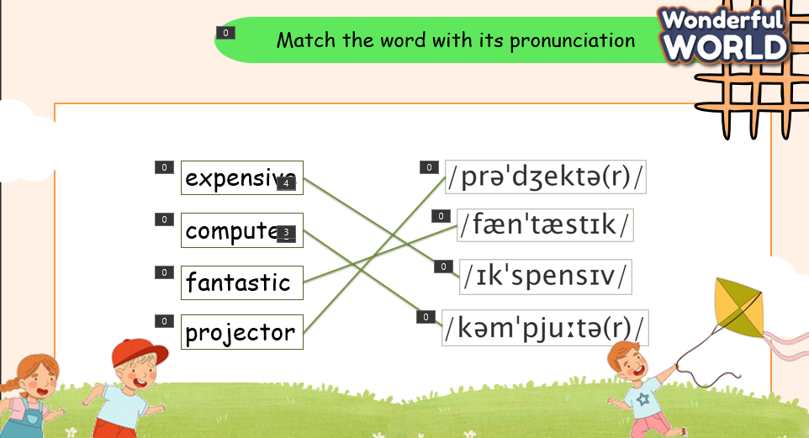  - Check with the class.  - Wrap-up  * Remember  Stress in the words:  - expensive  - computer  - fantastic  - banana  - projector  - develop |  | - Do the assessment.  - Check with the teacher  - Sts read the wrap-up  - Stand up and say goodbye to the teacher.

