Week 2 (16/9 – 20/9)
UNIT 1. FAMILY AND FRIENDS
Lesson 2. Task 7, 8, 9
Period 5
I. OBJECTIVES:
1. Knowledge:
- Students can use properly the words related to the topic Family and friends:
- English competences: Students will be able to review some adjectives to describe someone’s personalities
- Common competences: Students will have the opportunity to develop cooperation in working in groups and creativity in drawing their favourite person and describing someone’s personality.
3. Qualities:
- Students develop a love for their families and friends.
II. EQUIPMENT AND MATERIALS:
- For Teacher: PP, unscramble cards,
- For students: personal board, marker, paper,
III. LESSON PROCEDURE:

Activity 1: Warm up (5 minutes)
Aims: To make Ss get ready for the topic Family and review some words they learnt in the previous lesson.
Teacher’s Activities | Students’ Activities
- Warm up: Family song  - Asks Ss to listen and sing along to the song  Unscramble Words Game: 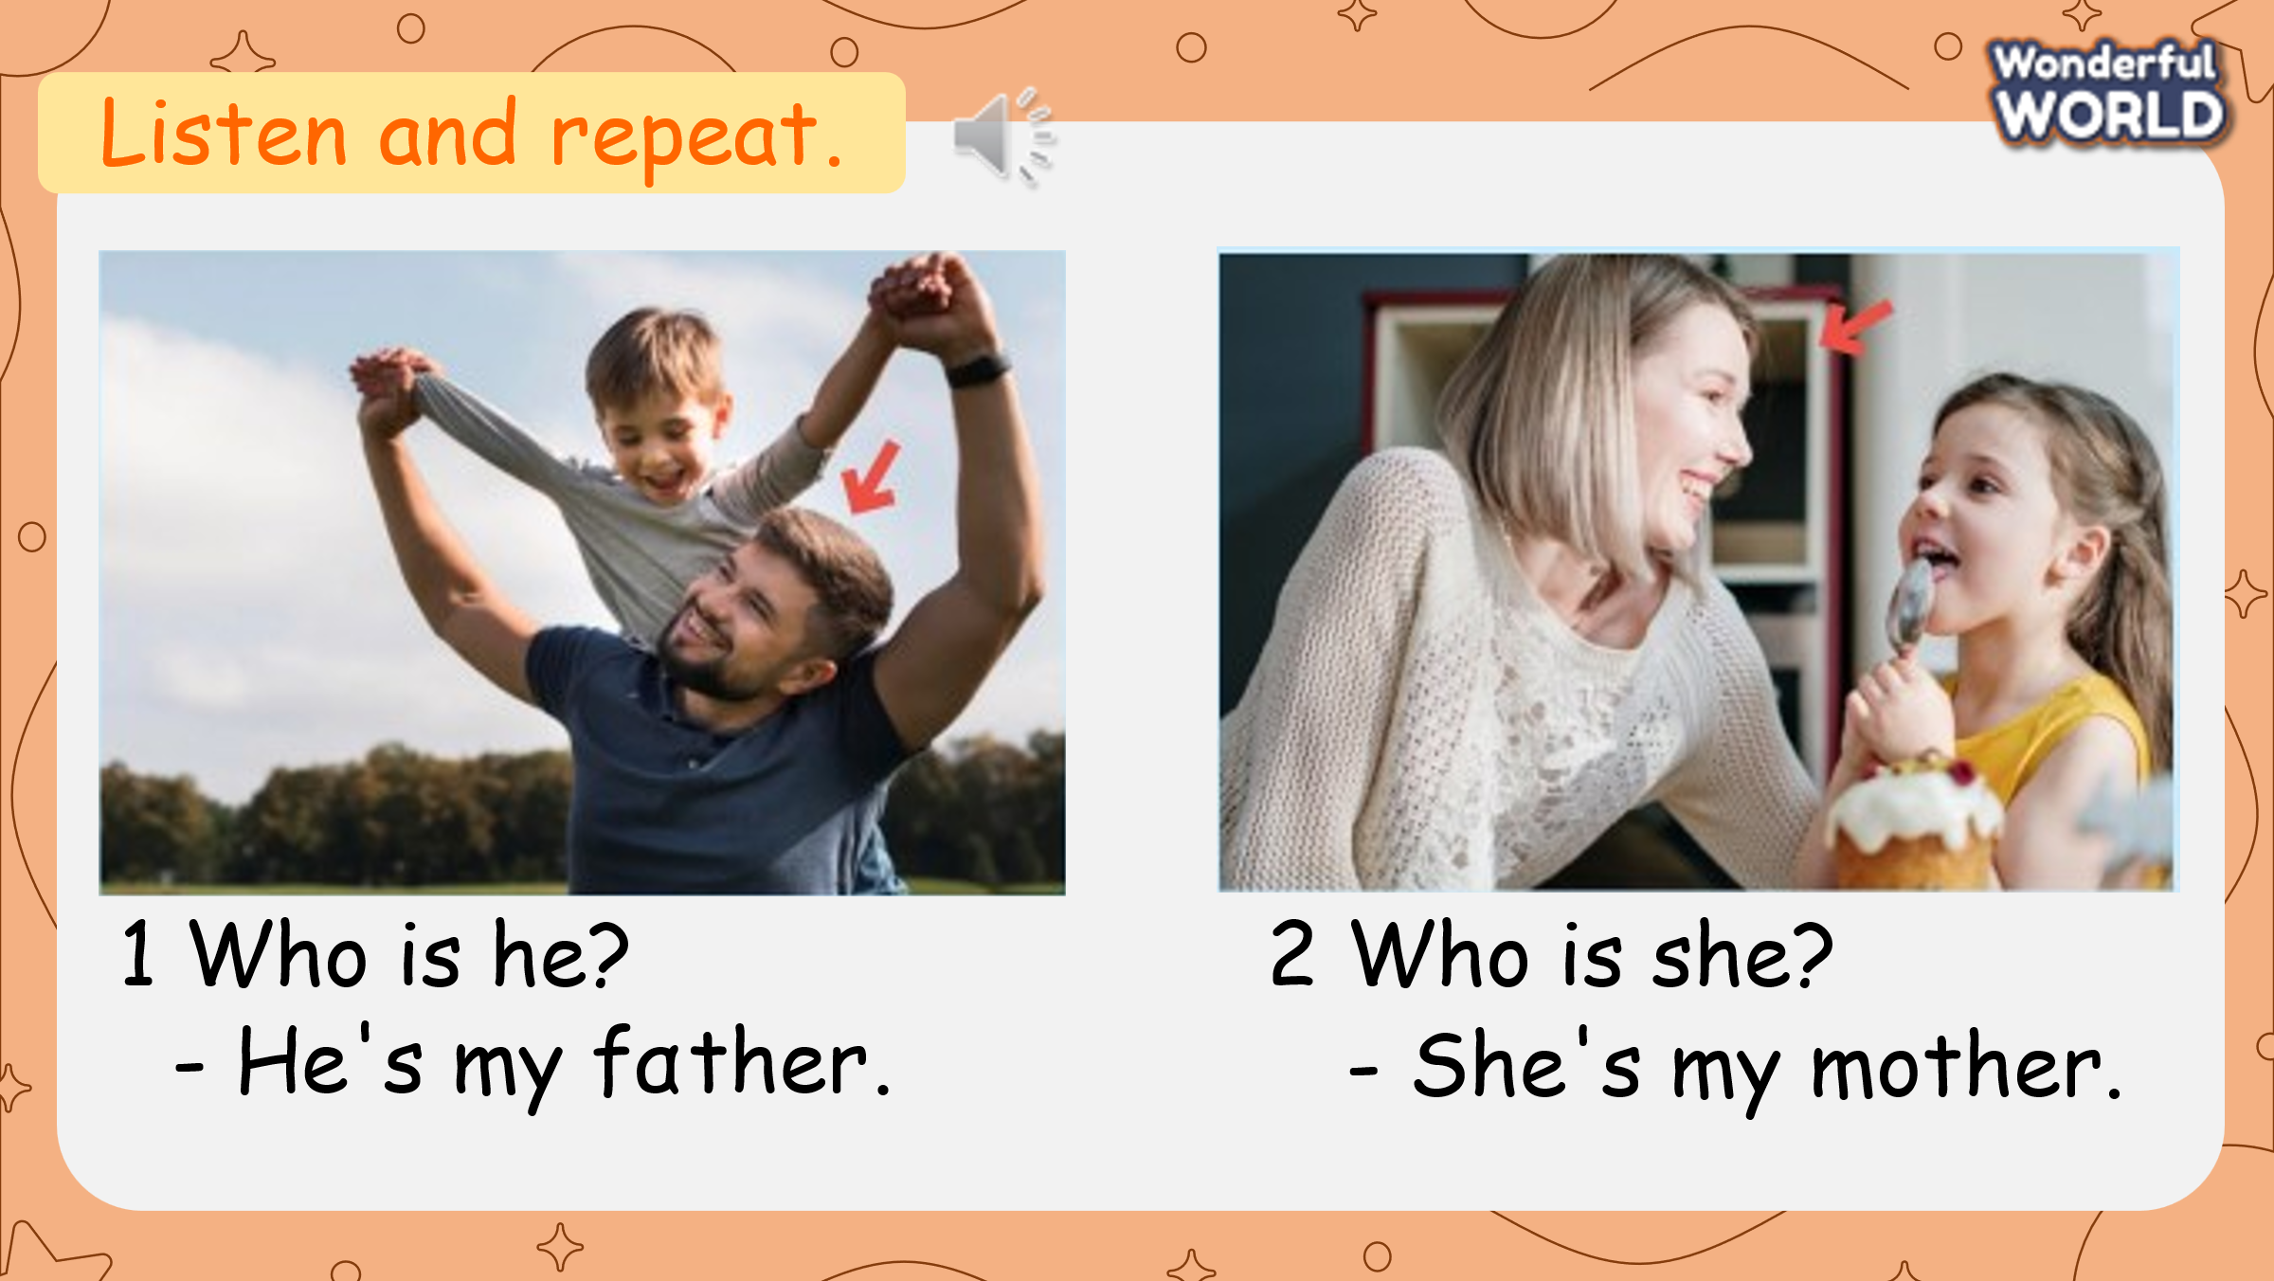  Sts can play in groups or individually. Prepare slides/pictures/ unscramble letters to review: Clever, polite, kind, young, tall, short, cute. T gradually shows the unscrambled words and pictures as their hints. Sts write the answer on their personal board/paper. Then board up and say the word. The fastest correct answer will get the point.  - Give game instruction  - Show unscrambled words one at a time  - Let sts play  - The team/person that gets the highest score is the winner | - Listen and sing along to the song.  Listen to the game instruction  - Look at the letters and the picture/sound  - Reorder the letters and write on the board/ paper.  - Board up and say the word aloud
Activity 2: Practice (8 minutes)
Aims: Practice listening and writing skills.
Teacher’s Activities | Students’ Activities
Task 7: Listen and write the names:  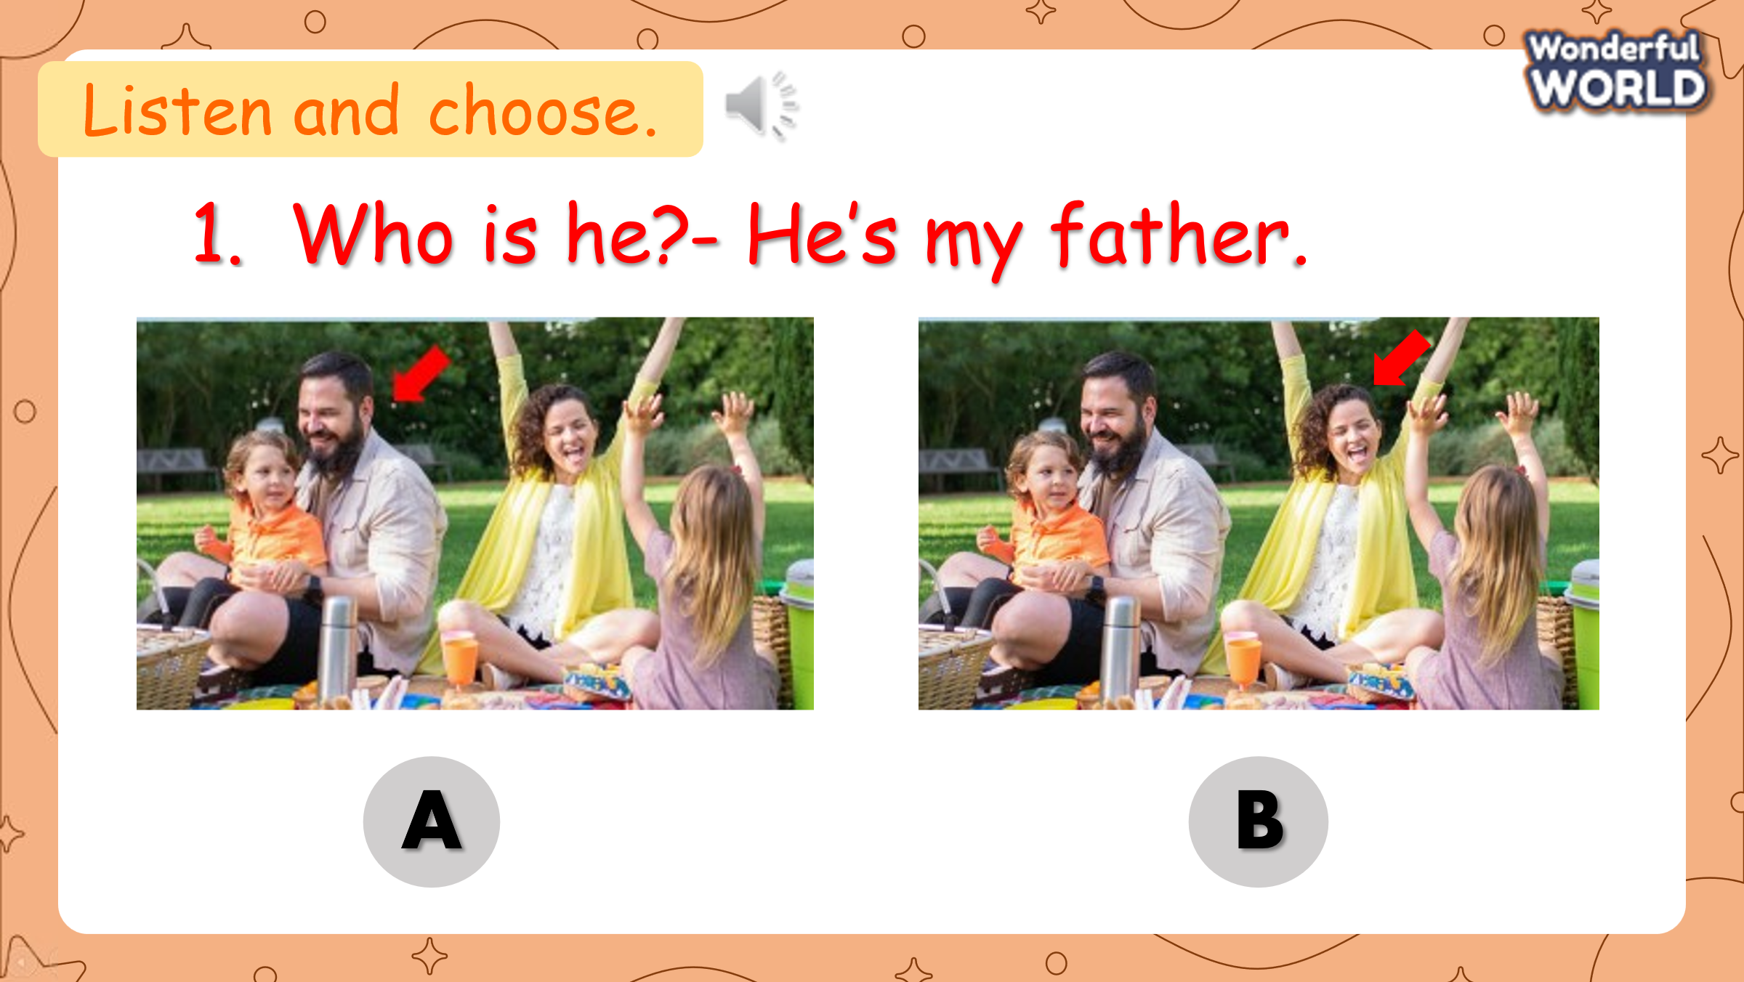  - Ask Ss to look at task 7.  - Tell them they’re going to listen to some information about Amy and Fred. They must write their names in the blank.  - Read and guess answers with students  - Give the guessing answer on the board  - Ask sts to listen and check whether their guesses are correct or not.  - Ask sts to listen and write  - Play audio twice  - Ask sts to give their answer as they listen  - Ask sts to check with a peer. Then check with the teacher  - Award the correct guessing | - Listen to the teacher carefully  - Read and give the guessing answer  - Listen and write  - Check with a peer. Then with teacher  - Receive award
Activity 3: Practice (10 minutes)
Aims: Practice speaking skills.
Teacher’s Activities | Students’ Activities
Task 8: Look and say  Spinning Game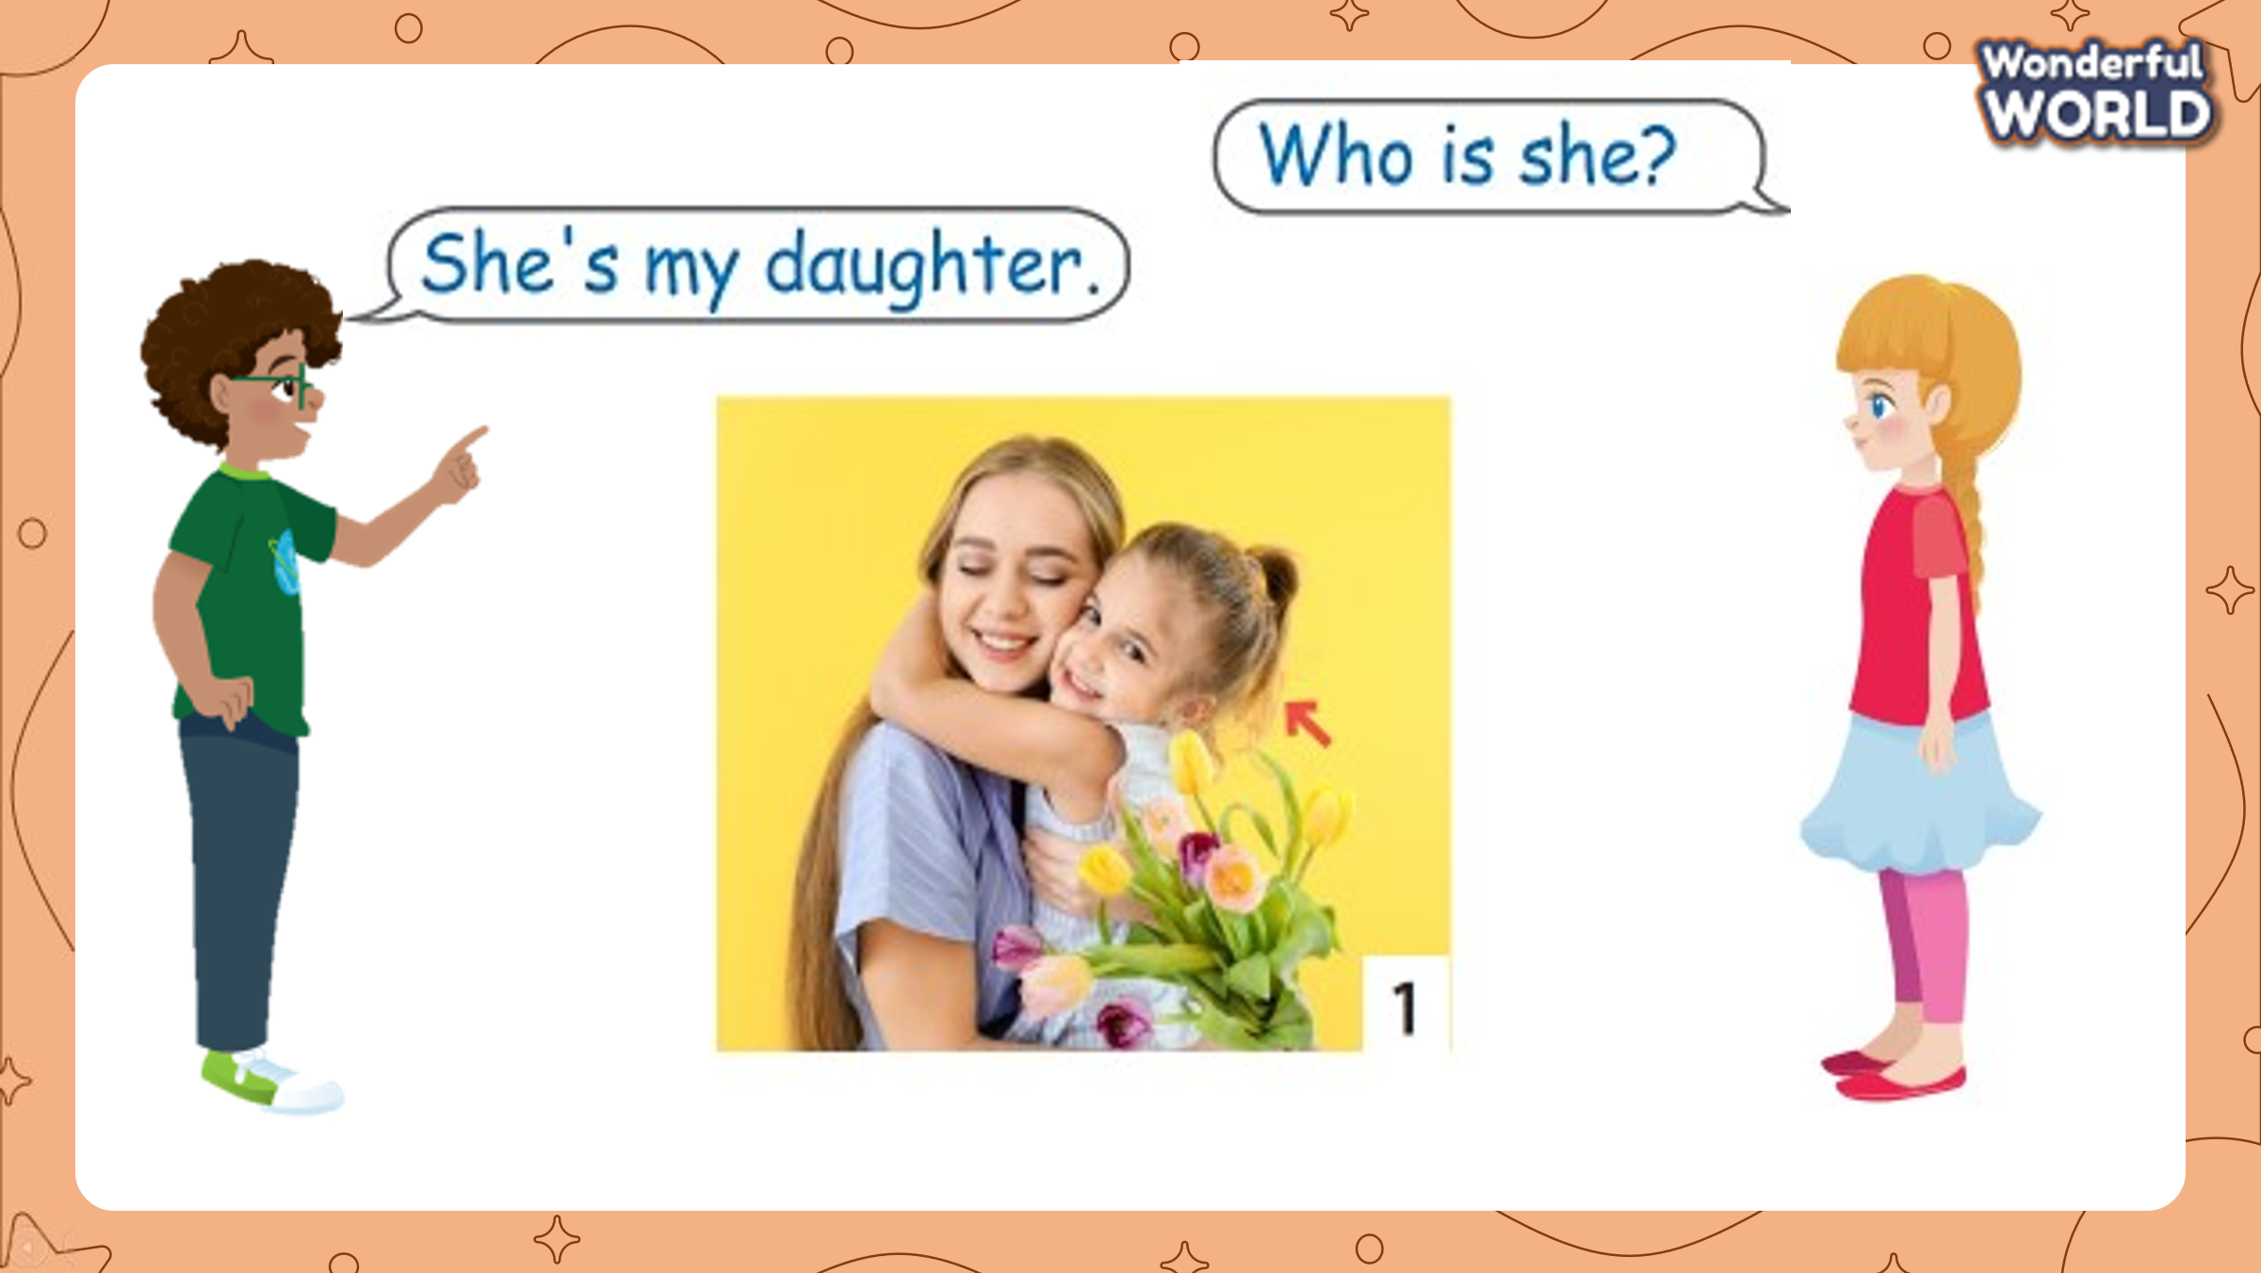  (Teacher prepares a wheel with phrases:  My friend/ ugly.(X).She/ pretty/ tall.(v). His son/ funny. (X). He/ polite/clever (v). Her grandma/ Young ( X). She /old/kind (V). His twin brother/ short.(X) . He/ tall/ cute(V)  - Sts can play in teams/whole class. The teacher shows the wheel and spins. Sts as fast as possible make the sentences on pieces of paper. The fastest team/person gets a point and a chance to spin for the next round.)  -Set game rules  - Do a model  - Give sts time to spin and play the game  - Award the winner of the game  Look and say  - Ask sts to work in 8 groups  - Vote for the group’s leader  - Ask groups to place back the 5 sentences they have just written in the Spinning game in the middle.  - Make a sample with a group (pick up a sentence at random, read and say it aloud. Then face it back)  - Give groups time to practice under the leader’s control until everyone has a chance to say  - Go around to support when needed | -Listen to the teacher carefully  - Spin the wheel  - Read and make sentences as fast as possible.  - Check with a teacher by saying the sentences aloud.  -Form groups  - Vote for the leader  - Place the sentences back  - Pick a sentence and say it aloud
Activity 4: Production (9 minutes)
Aims: Apply structure to real world , Ss can use vocabularies and structures they’ve learnt
Teacher’s Activities | Students’ Activities
Task 9: Let’s talk  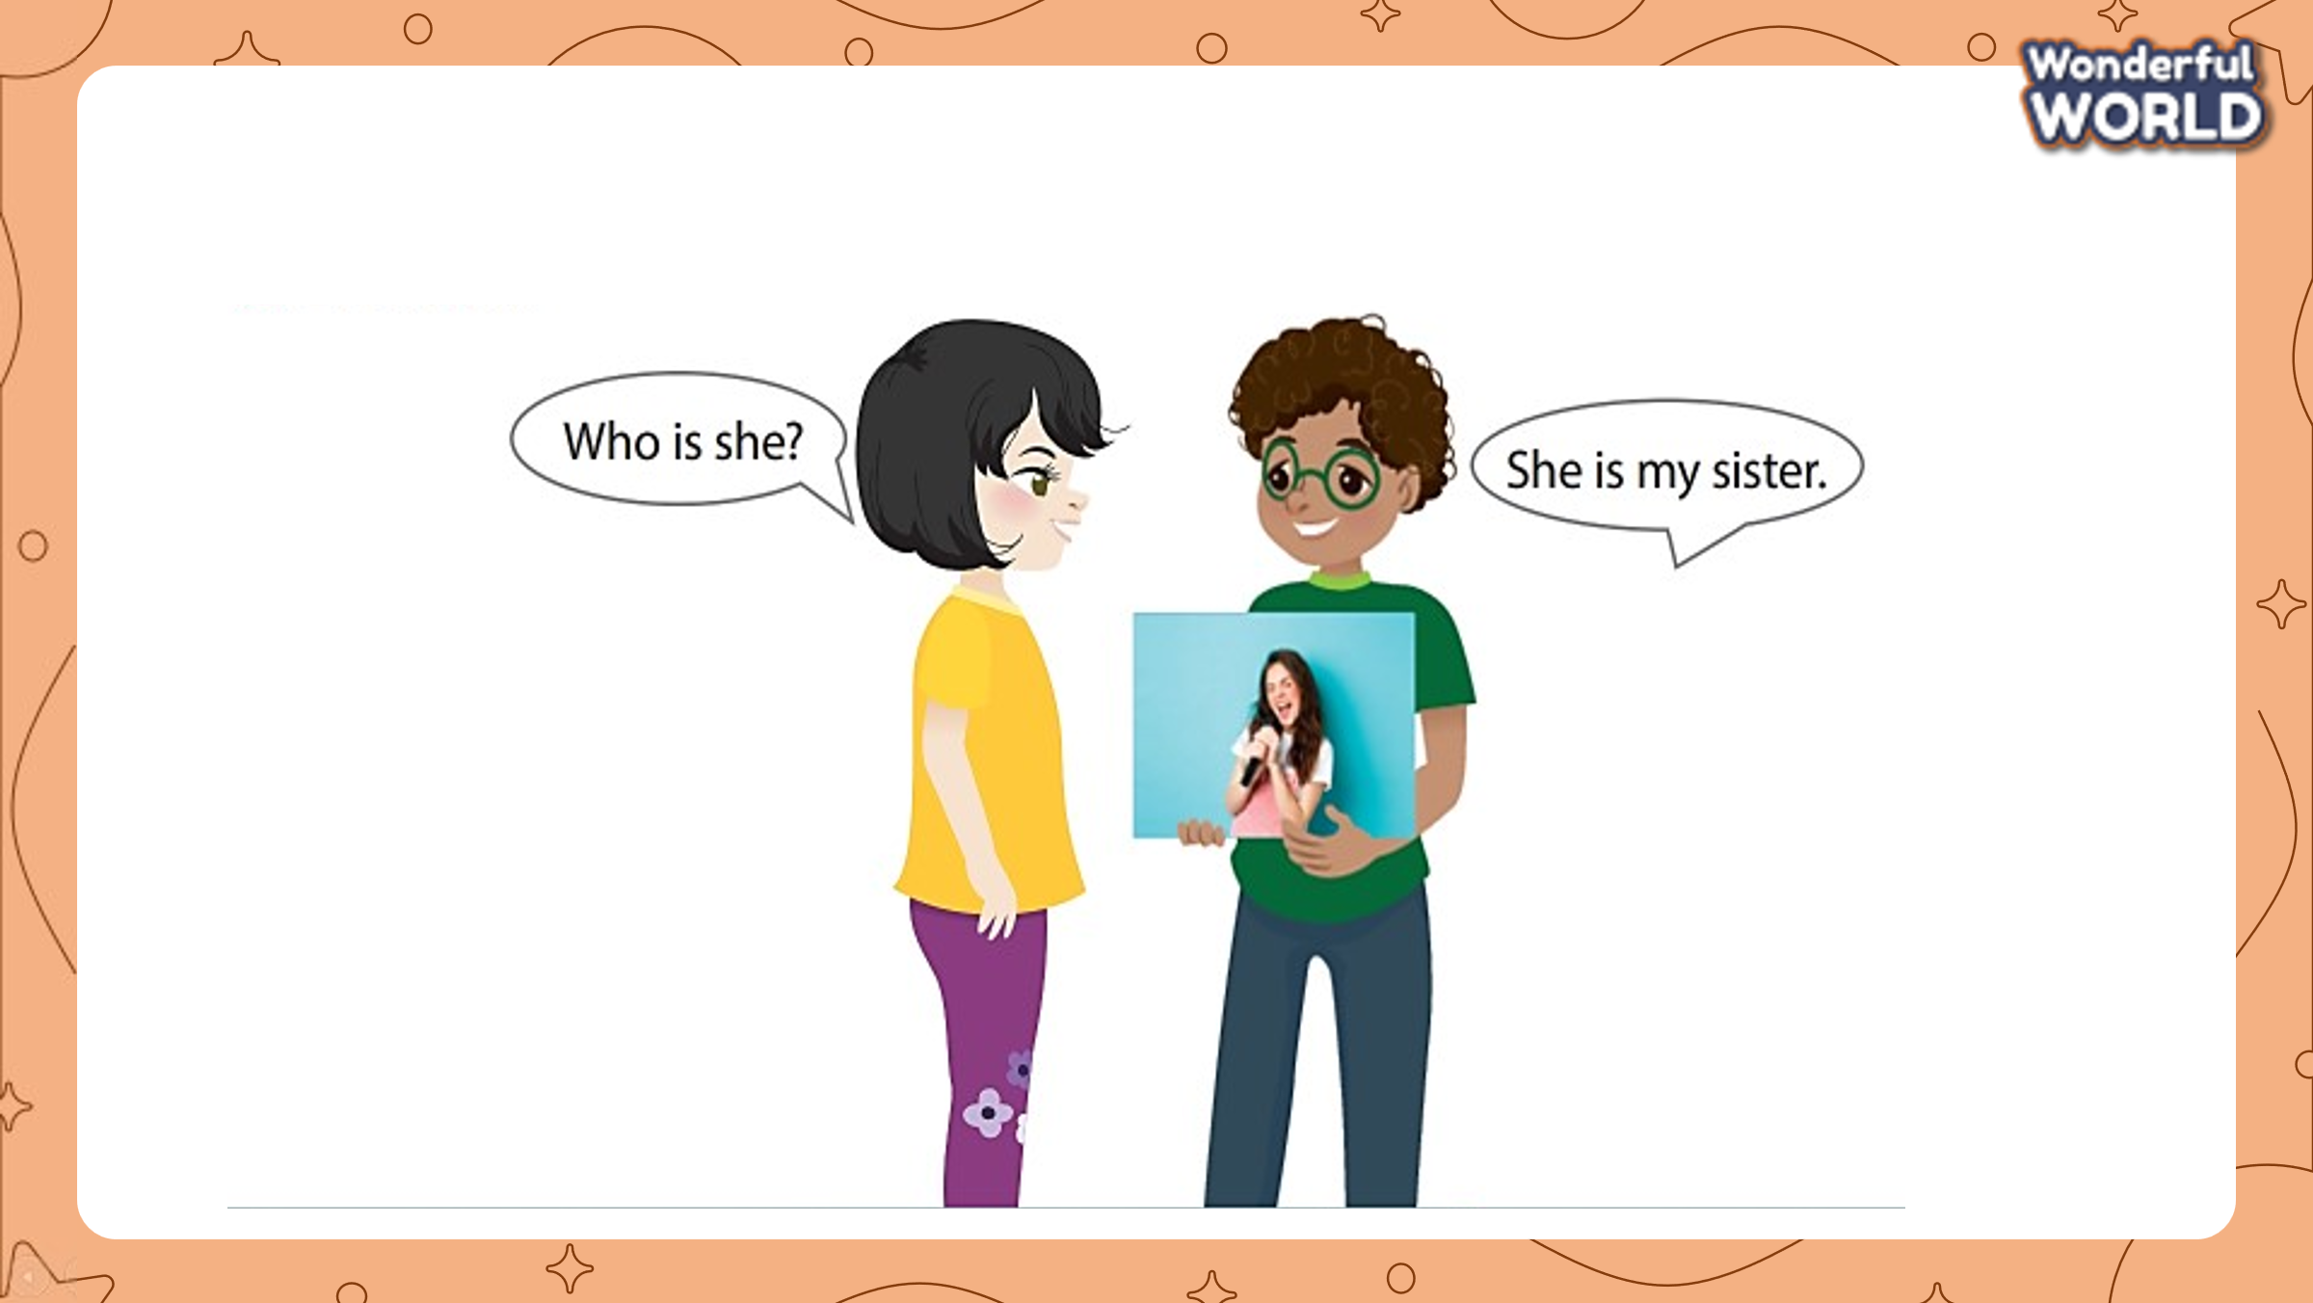  - Show the picture in the task to set the context  - Ask sts some questions: What can you see in the picture? Who is it? What is he like?  - Show sample writing: This is my friend, Alex. He is nice and cute.  - Ask sts to draw and write some sentences about their favourite people.  - Let sts time to draw their pictures  - Go around to support Sts.  - Call some Ss to go to the board and introduce their picture.  - Give some feedback | - Listen to the teacher  - Look at the picture and answer the questions  - Draw and write about your favorite person.  - Stand up and introduce their picture.
Activity 5: Assessment (3 minutes)
Aims: Consolidate the content of the lesson
Teacher’s Activities | Students’ Activities
- Ask sts to do the assessment  - Reorder the words:  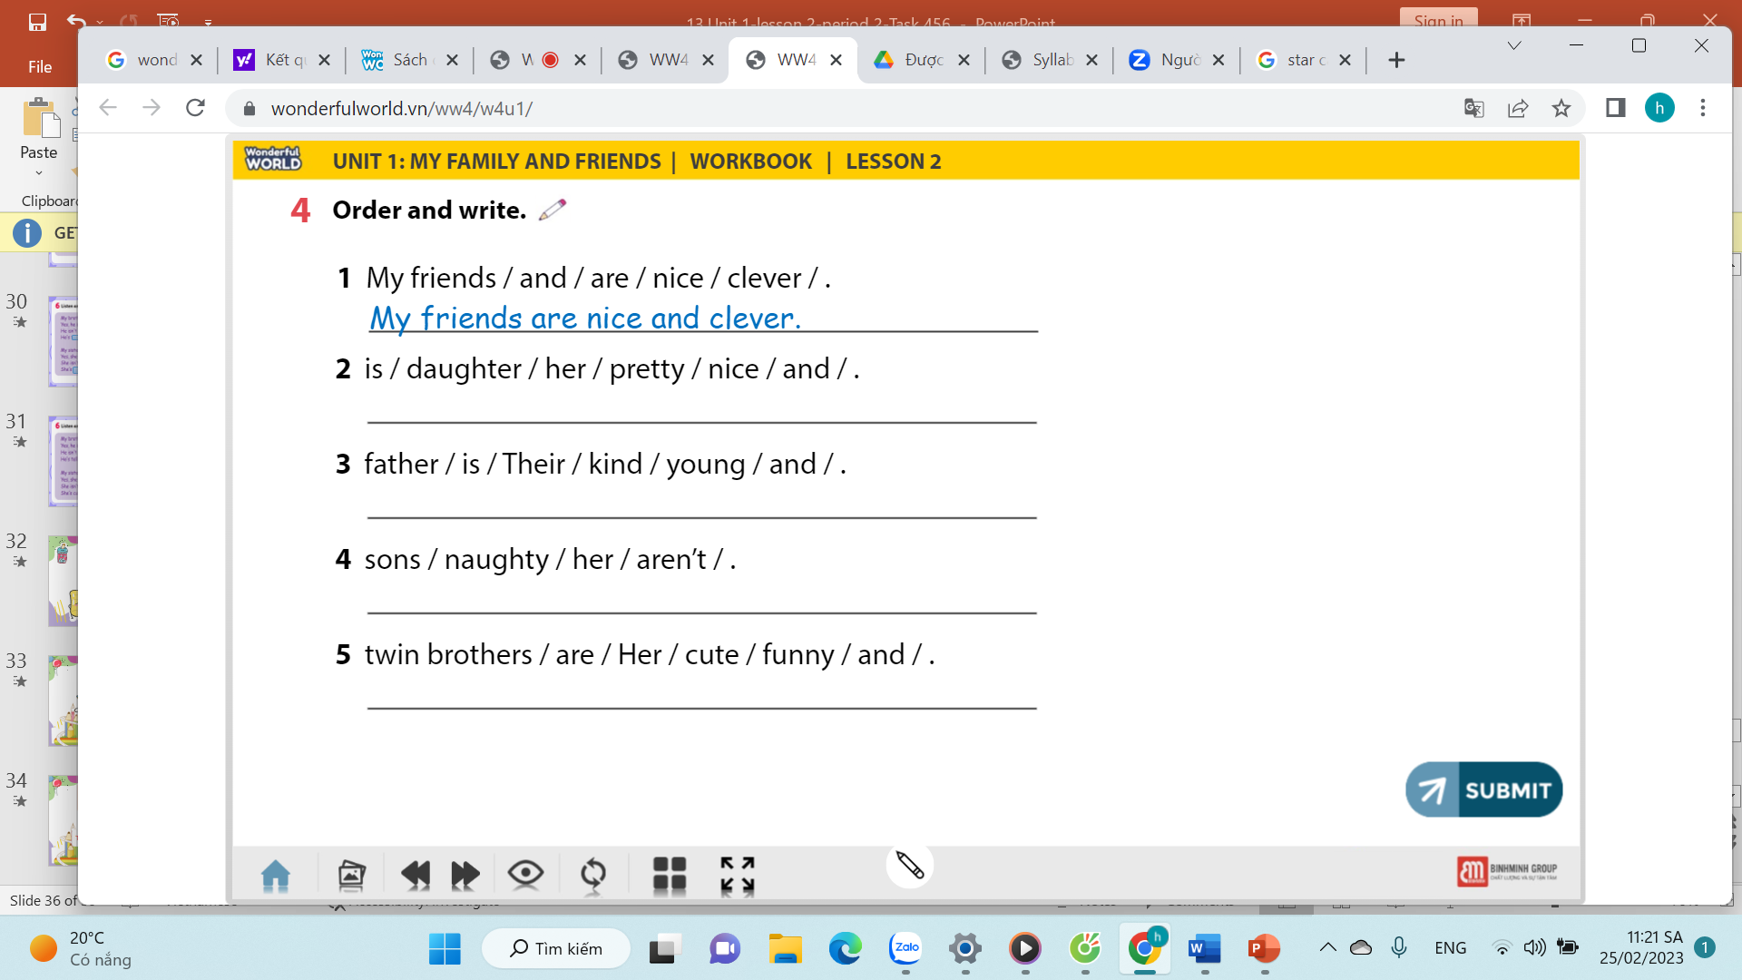Check with the whole class  Say goodbye | -Do the assessment  - Check with the whole class.  - Say goodbye
_____________________________
UNIT 1. FAMILY AND FRIENDS
Lesson 3. Task 1, 2, 3
Period 6
I. OBJECTIVES:
1. Knowledge:
Students will learn words and phrases related to the topic My family and friends: cheerful, friendly, hardworking, pleasant.
2. Competences:
- English competences: Students will be able to talk about different members of the family
- Common competences: Students will have the opportunity to develop the creativeness in drawing the family tree and develop communication among friends.
3. Qualities:
- Students develop the love toward family.
II. EQUIPMENT AND MATERIALS:
- For Teacher: PP, flashcards, handout, track 1.9, track 1.10
- For students: pens, A4 paper, crayons,
III. LESSON PROCEDURE:

Activity 1: Warm up (5 minutes)
a. Aim: Introduce more the topic My family related to adjectives.
Teacher’s Activities | Students’ Activities
b. Procedure  Dance and sing: Go bananas  - Teacher divides the class into 6 groups.  - Ask students to watch the video  Dance and sing along to the song. | - Sit in 6 circles  - Listen to the instruction carefully and watch the video.  - Watch the video again and sing along to the song.
Activity 2: Presentation (8 minutes)
a. Aim: Present the new words of adjectives: cheerful, friendly, hardworking, pleasant.
Teacher’s Activities | Students’ Activities
b. Procedure  Task 1: Listen and point. Repeat. (Track 1.9)  - Use flashcards to introduce the vocabulary and structure of the lesson.  - Say the words/sentences for students to repeat in the chorus.  - Say a word/sentence for students to repeat then point.  - Show pictures in random order and ask students to read out the correct words. | - Repeat after the teacher.
Activity 3: Practice (10 minutes)
a. Aims: Identify some leisure activities via the listening task.
- Be able to read and match to complete the sentences.
Teacher’s Activities | Students’ Activities
b. Procedure  Task 1 Listen and point. Repeat  Look at the picture and let students repeat the words  • Tell students to look at the vocabulary box  Ask if they know any of the words. Play the recording for students to listen and point to the correct pictures. Say the words in a different order for students to listen and point.  • Play the recording again, pausing after each word for  students to say the word.  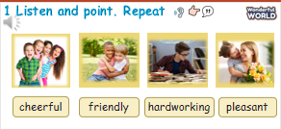  Task 2. Listen and match.  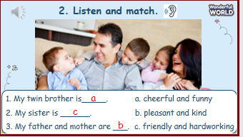  Point to the photo and ask students who they can see. Elicit father, mother, sister and twins.  • Ask students to look at the sentences below the picture. Read the sentences and the options.  • Play the recording and ask students to listen and match the sentences with the options.  • Play the recording more than once if students cannot catch all the answers.  • Play the recording again and pause after each sentence to check answers.  • Elicit the answer from students and check with the whole class.  • Ask students to act out the dialogue in pairs. Ask some volunteers to act it out in front of the whole class.  Task 3. Let’s play.  Slap the board  - Have 4 -5 students come to the board or divide the students into two teams.  For each round, ask one student from each team to come to the board.  - Teacher calls out a word (cheerful, friendly, hardworking, pleasant.). Once the word has been called, have the students turn around and touch the correct picture.  - Tell students to slap the board as  quickly as they can after hearing the teacher read out two words from the list on the board. The quicker student to slap the correct words get to make a sentence with those words (see the example) and gain 1 point for their team. The team with more points wins. | - Students look at the vocabulary box  - Listen and students repeat the words  - Students look at the sentences below the picture.  - Read the sentences and the options.  - Play the game  - Students slap the board as quickly as they can after hearing the teacher read out two words from the list on the board.  - The team with more points wins.
Activity 4: Production (9 minutes)
Aim:
- Review the words and structure via the game
- Encourage sts to apply in the right context.

Teacher’s Activities | Students’ Activities
b. Procedure  Game Horserace  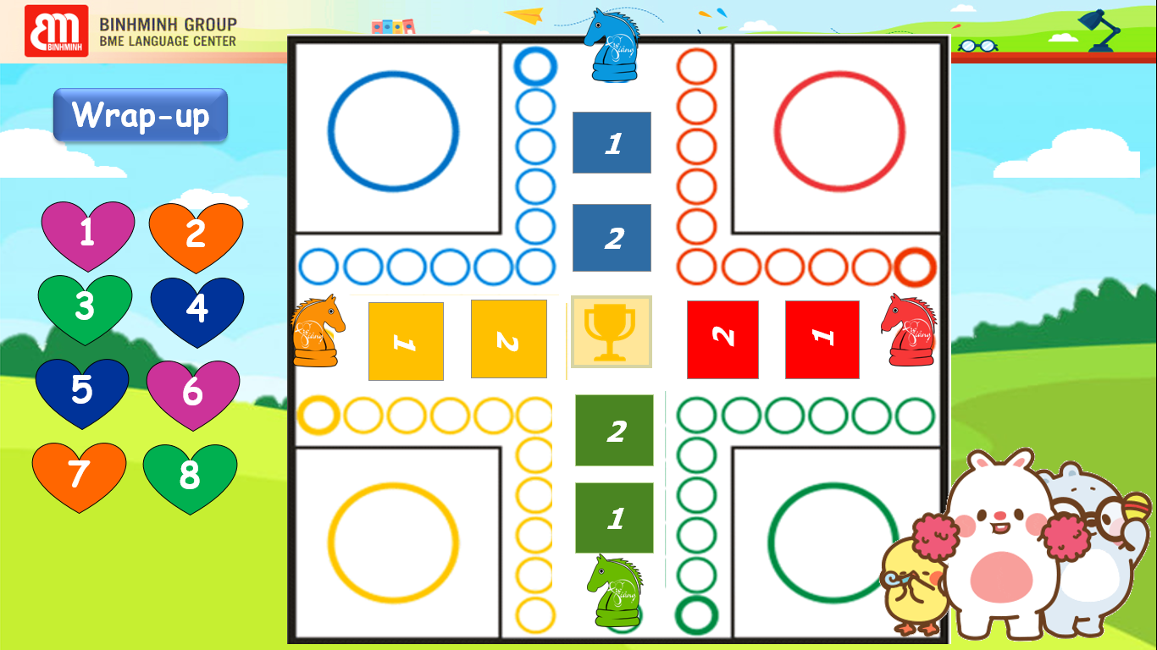  - Divide the class into 4 teams.  - Explain the game rule:  + When Ss have the right answer, the horse can step one step forward.  + Team that finishes all the steps first will be the winner. | - Listen to the rule carefully.  - Play the game.  - When the horse comes to step 2 (Ss finish all questions), it will automatically come to the final box.
Activity 5: Assessment (3 minutes)
a. Aim: Consolidate the content of the lesson.
Teacher’s Activities | Students’ Activities
b. Procedure  -Ask sts to do the assessment  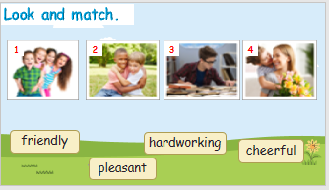  - Check with the class | -Do the assessment  - Check with the teacher
_____________________________
UNIT 1. FAMILY AND FRIENDS
Lesson 3. Task 4, 5, 6
Period 7
I. OBJECTIVES:
1. Knowledge:
Students will review words and phrases related to the topic My family and friends: cheerful, friendly, hardworking, pleasant.
2. Competences:
- English competences: Students will be able to talk about different members of the family.
The structure:
What is your sister like? - She’s hardworking and pleasant.
What is his twin brother like? - He’s naughty and cute.
- Common competences: Students will have the opportunity to develop the creativeness in drawing the family tree and develop communication among friends.
3. Qualities:
- Students develop the love toward family.
II. EQUIPMENT AND MATERIALS:
- For Teacher: PP, flashcards, handout, track 1.11
- For students: pens, A4 paper, crayons,
III. LESSON PROCEDURE:

Activity 1: Warm up (5 minutes)
a. Aims: To introduce Sts to the topic My family and friends
Review some words about family topic they have learnt from the previous lesson
Teacher’s Activities | Students’ Activities
b. Procedure  Dance and sing: Stand up, sit down  - Ask students to watch the video  - Dance and sing along to the song.  Review: Play game: The little bee.  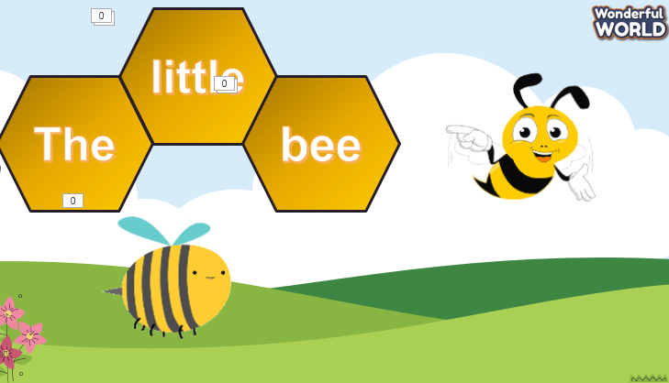  Let Ss look at the picture. Then choose the best answer.  T asks Sts to say some adjectives to describe someone’s personality and what they studied. | - Listen to the instruction carefully and watch the video.  - Watch the video again and sing along to the song.  - Play the game.
Activity 2: Presentation (8 minutes)
a. Aim: Present grammar to ask and answer about family and friends, relating to adjectives of family member.
Teacher’s Activities | Students’ Activities
b. Procedure  Set a text:  T uses some adjectives to describe someone’s personality.  Then T asks and answers questions about someone’s personalities  Focus on the structure:  - What is ………………like?  - She’s/ He’s……………….. | - Repeat after the teacher.
Activity 3: Practice (10 minutes)
Teacher’s Activities | Students’ Activities
a. Aims:
- Help sts to practise the vocab and new grammar via listening activities.
- Encourage sts to make a conversation about family and friends.
b. Procedure  Task 4 Listen and repeat. Track 1.11  Look at the picture and let sts repeat the words  Tell students to look at the pictures and the sentences.  • Play the recording. Tell students to look at the pictures and follow the sentences with their fingers.  • Play the recording again. Ask students to repeat.  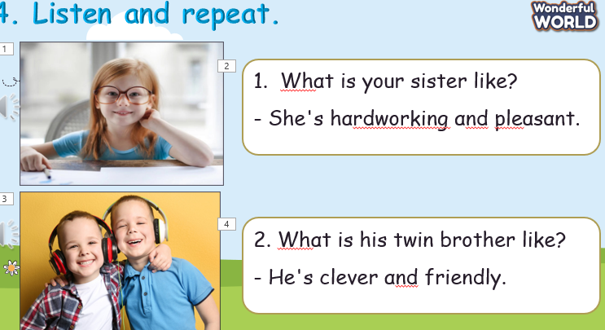  Task 5. Look. Ask and answer.  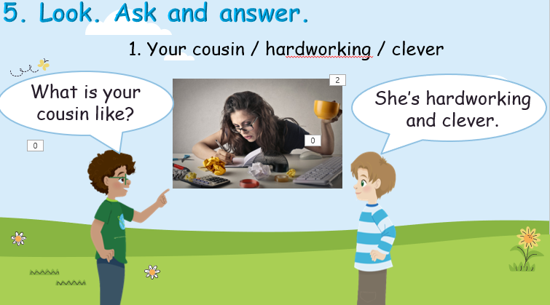  Look at the picture and let sts choose and say the sentence like the example.  • Tell students to look at the pictures and the prompts. Read out the prompts and ask students to repeat.  • Tell students to look at the picture for question 1 and the example. Read out the example and ask students to repeat.  Task 6. Draw. Αsk and answer.  - Students draw a photo of their favourite members quickly in their notebooks if no photo is available.  - Give students suggestions in case they have difficulties.  - Give students time to practise other sentences in pairs.  - Ask some volunteers to read their sentences aloud in front of the whole class | - Discuss in groups  - Listen and answer.  - Repeat after the teacher.  - Students to repeat the  sentences. Let them know that this  activity is linked to the next activity  - Students to look at the picture for question 1 and the example.  - Read out the example and repeat.  - Draw and say.  - Students draw a photo of their favourite members quickly in their notebooks if no photo is available.
Activity 4: Production (9 minutes)
a. Aim:
Join the game to review the words and structure
Teacher’s Activities | Students’ Activities
b. Procedure  Game Family Tree  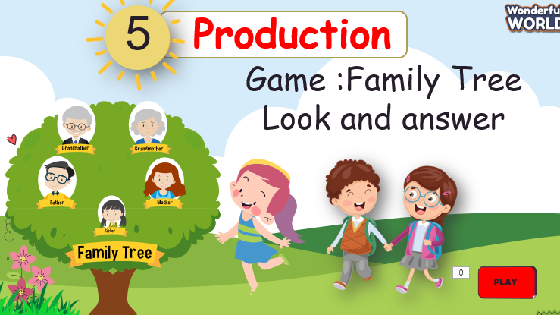  - Ask SS to choose any picture of a family member. Teacher, please click on that picture. Then have students do the work. | - Listen to the rule carefully.  - Join the game.  -Look and read.  -Read  -Identify and read.  - Check with friends and then with the teacher and the whole class.
Activity 5: Assessment (3 minutes)
a. Aim: Consolidate the content of the lesson.
Teacher’s Activities | Students’ Activities
b. Procedure  -Ask sts to do the assessment  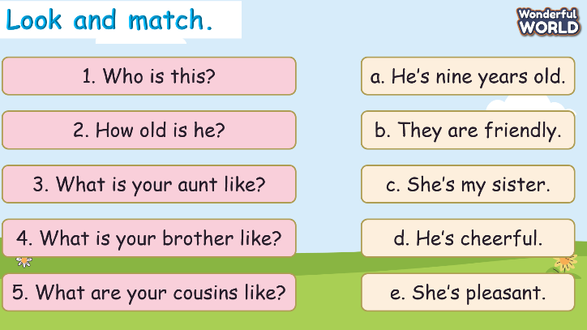  - Check with the class | - Do the assessment  - Check with the teacher
_____________________________
UNIT 1. FAMILY AND FRIENDS
Lesson 3. Task 7, 8, 9
Period 8
I. OBJECTIVES:
1. Knowledge:
Students will review words and phrases related to the My family and friends:
- identify and write th, o
- identify and pronounce words with initial sounds /n/, /ɑ/, /p/, and /kw/.
2. Competences:
- English competences: Students will be able to talk about their family.
- Common competences: Students will have the opportunity to develop the creativeness in drawing the family tree and develop communication among friends.
3. Qualities:
- Students develop the love toward family.
II. EQUIPMENT AND MATERIALS:
- For Teacher: PP, TV, music, relating audio track.
- For students: paper, colour pencils or crayons, personal boards and markers.
III. LESSON PROCEDURE:

Activity 1: Warm up (5 minutes)
a. Aim: warm-up activity to stir up the learning atmosphere My family and friends
Teacher’s Activities | Students’ Activities
b. Procedure  Dance and sing: Head, shoulders, knees, and toes.  - Ask students to watch the video  - Dance and sing along to the song. | - Listen to the instruction carefully and watch the video.  - Watch the video again and sing along to the song.
Activity 2: Presentation (8 minutes)
a. Aim: - Identify and pronounce words with phonics sounds via listening task.

Teacher’s Activities | Students’ Activities
b. Procedure  Vocabulary:  Task A: Listen and repeat. (track 3.7)  -Write “th” on the board. Ask students to say the  word. Then write “father” on the board.  Ask students to pronounce the sound for “ð” in the  word.  -Write “o” on the board. Ask students to say  the word. Then write” son” on the board.  Ask students to pronounce the sound for “ʌ” in  the word.  - Pronounce both sound again and show  students how they are different from each other.  -Point to each word on the board and ask students to  practise the sounds with you.  - Play the recordings and tell students to repeat  the words and the sentences. | - Join the game.  -Look and read.  -Read  -Identify and read.
Activity 3: Practice (10 minutes)
a. Aims: Encourage students to chant along.
-Practise saying the sentence individually and then in pairs.
Teacher’s Activities | Students’ Activities
b. Procedure  7. Listen and repeat. (Track 1.12)  - Play TR: 1.12, pointing to each photo as students hear  the corresponding word.  - Have students repeat each word.  - Show students that the sounds come from different parts of your mouth. Point to each word on the board and ask students to practice the sounds with you.  - Play the recording again and tell students to repeat the  words and the sentences, paying particular attention to  the correct pronunciation of the sounds.  - Ask students to practice pronunciation in pairs, and ask some volunteers to read out the words and sentence. Correct them if there are any mistakes  8. Listen and chant. (1.13)  • Play the recording and tell students to listen and follow the words with their fingers.  • Read out the chant one line at a time and ask students to repeat after you.  • Play the recording again. Encourage students to chant  along. Practice several times until students are familiar with the words and sounds  9. Say it  - Look at the pictures. Say the whole sentences.  - Ask students to look at the sentence. Ask them to focus on words with highlighted sounds and read them aloud.  - Ask students to practice saying the sentence individually and then in pairs. | - Learn the words through pictures.  - Listen then circle.  - Repeat the words.  - Repeat then point.  - Say aloud the sentences  - Listen carefully  - Check with friends and then with teacher and whole class  - Students look at the pictures and sentence.  - Read them aloud.  - Students practice saying the sentence individually and then in pairs.
Activity 4: Production (9 minutes)
a. Aim: Review the vocab and grammar of the previous lesson - using the fun activities in the lesson.
Teacher’s Activities | Students’ Activities
b. Procedure  - Ask SS to play a game “Board game”.  - Introduce the rule of game.  T divides the class into 2 teams. Each team will choose a figure (girl or boy).  Each team chooses a number from 1 to 8 and answer the question. If the answer is correct, the team will get the chance to roll the dice. If not, the chance is given to the other team.  Click on the dice icon to roll. The steps each team can move are corresponding to the number on the dice. If they move to the head of snake or one side of the ladder, they can move to the tail of snake or the other side of the ladder.  The first team coming to finish will win the game.  When the game is over, click on the home icon on the left bottom edge to move to the next slide.  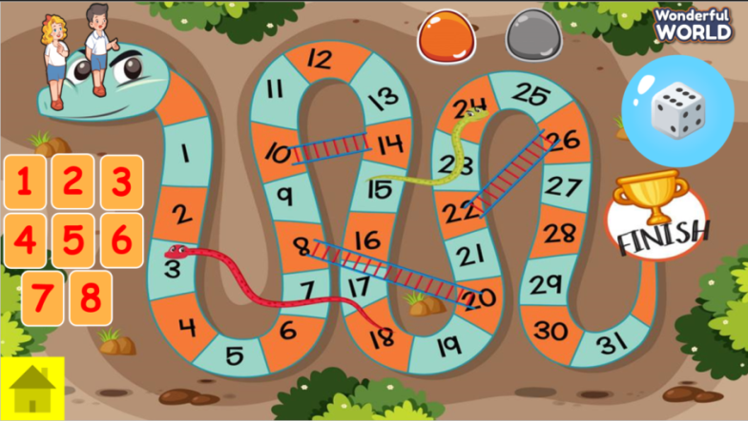 | - Listen the rule carefully.  -Look and read.  -Read  -Identify and read.  - Check with friends and then with teacher and whole class.
Activity 5: Assessment (3 minutes)
a. Aim: Do the exercise to review and practice the words
Teacher’s Activities | Students’ Activities
b. Procedure  -Ask sts to do the assessment  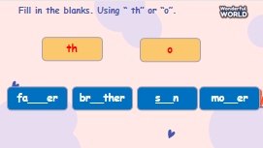  - Check with the class | - Do the assessment  - Work in pairs.

