Week 3 (23/9 – 27/9)
UNIT 1. FAMILY AND FRIENDS
Fun time and project. Task 1, 2
Period 9
I. OBJECTIVES:
1. Knowledge:
- Students will review family vocabulary and unit grammar
2. Competences:
- English competences: Students will be able to talk about their family members.
- Common competences: Students will develop their creativity in drawing pictures.
- Know how to use structure: “He’s/She’s …….” in the presentation.
3. Qualities:
- Students are fun with friends.
II. EQUIPMENT AND MATERIALS:
- For Teacher: PP, TV, boards, markers
- For students: A4 paper, books, pens, crayons
III. LESSON PROCEDURE:

Activity 1: Fun Time (10 minutes)
Teacher’s Activities | Students’ Activities
A, Aims: Review vocabulary of family members via song chant or Game.
WARM-UP : (4 MINUTES)  Clothes song  - Introduce the song  - Ask sts to review some vocabulary and do action  - Play the family song:  https://www.youtube.com/watch?v=Te2M7oYFQgA  Task 1: Unscramble (7 MINUTES)  Before unscrambling through a game  Ask sts to look at the screen and choose the characters they want. Then, answer all the questions and get stars  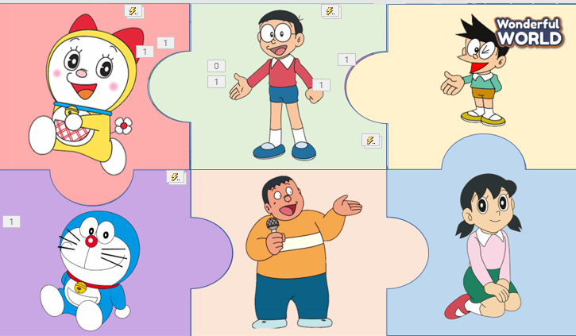  While gaming  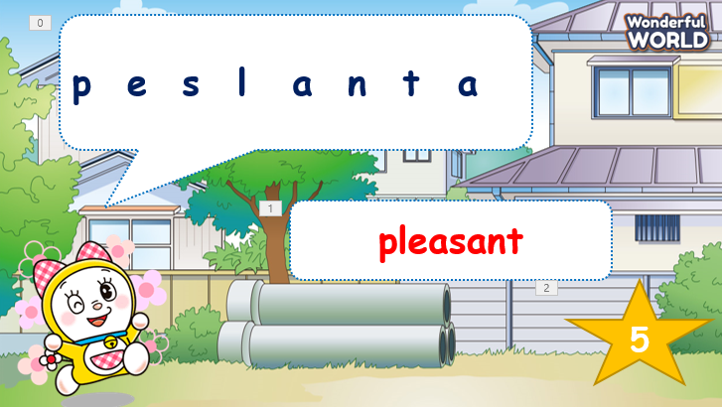  - Ask sts to work in groups  - Hand each group a print of task 1  - The sts will unscramble the words and get stars.  - The team, who gets the highest scores, will be the winner. | -Listen to the teacher  - Repeat and do the action  - Sing along and repeat the song.  Speak out correctly, paying attention to the pronunciation.  Do the game and get stars
Activity 2: Project (20 minutes)
Teacher’s Activities | Students’ Activities
A, Aims: - Review all words and structures of unit 1 via the project lesson.
- Encorage sts to apply and practice following the modelled structures
Project: My family  Family quiz  - Guides sts to play with the game and match the correct pictures with the correct words  - Anyone who can answer correctly, will be given a star.  Video for the project  https://www.youtube.com/watch?v=FHaObkHEkHQ  My family  There are 5 people in my family.  -T shows pictures of family members.  - Writes down the structure and ask them to repeat the structure, using adjectives about personality or appearance.  Implementing stage  DRAWING  Before drawing  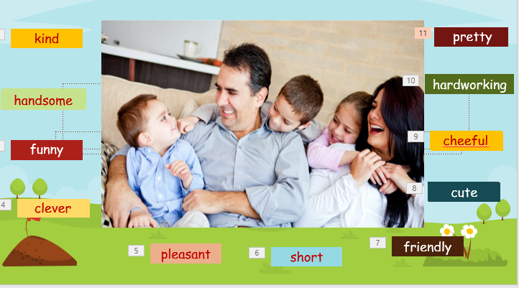  - Ask sts to work individually  - Show the picture of members and ask sts to guess some adjectives about personality or appearance.  - Ask sts to make sentences about family members.  - Show the sentences one by one  - Tell them to draw a picture of family  - Colour the picture  - Ask sts to go to the board – group by group and present.  Displaying and Reflecting on the board  - Ask sts to walk around and talk about their family members in class.  - Go around to offer help when necessary.  - Check the number of members they have talked to  - Award the best speaker  Evaluation (2 MINUTES)  Answer the multiple choice and show answers  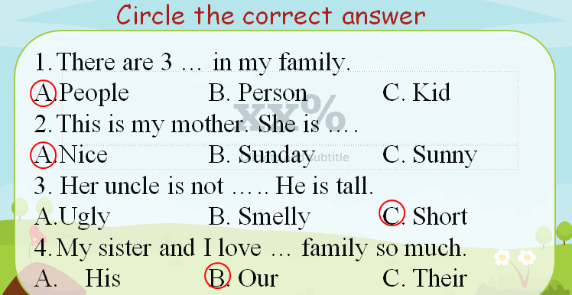  Home work (2 MINUTES)  Myschool.com.vn | - Listen to the teacher  - Listen to the game rules  - Look at the picture  - choose the correct answer  - show the board of correct answers.  -Talk to friends about the picture  Read aloud the answers about family members.  Follow sts’ instructions.  - Look at the pictures and complete some words.  - Speak out the sentences of a family member.  - Draw a picture of their families. (Family tree/ human figures)  - Present in group  - comment – cross-checking group by group.  Write down the answer on their own board/book.
____________________________________
UNIT 2. MY HOME
Lesson 1. Task 1, 2, 3
Period 10
I. OBJECTIVES:
1. Knowledge:
Students will learn words and phrases related to the topic House: bowl, plate, table, spoon, dining room.
2. Competences:
- English competences: Students will be able to talk about different members of the family
- Common competences: Students will have the opportunity to develop the creativeness in drawing the dining room and develop communication among friends.
3. Qualities:
- Students develop love toward their home.
II. EQUIPMENT AND MATERIALS:
- For Teacher: PP, flashcards, handout, track 2.1, track 2.2
- For students: pens, A4 paper, crayons,
III. LESSON PROCEDURE:
Activity 1: Warm-up (5 minutes)
Teacher’s Activities | Students’ Activities
Warm-up: Song time! “Where are you?”  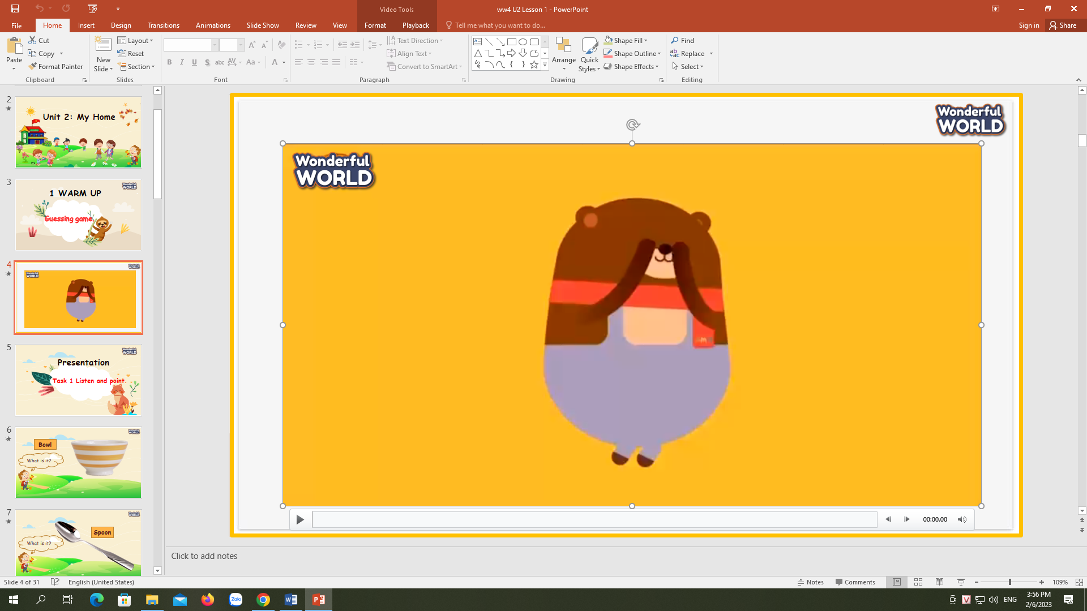  - The teacher shows the song about House  Lead in: Photo time!  - Teacher holds up a photo of house.  - Point at picture and ask sts what they can see in the picture.  - Write on the board My Home and introduce the lesson. | - Listen to the song  - Listen to the teacher.  - Tick what they can see.
Activity 2: Presentation (8 minutes)
Teacher’s Activities | Students’ Activities
Task 1: Listen and point. Repeat. (Track 2.1)  - Use flashcards to introduce the vocabulary and structure of the lesson.  - Say the words/sentences for students to repeat in the chorus.  - Say a word/sentence for students to repeat then point.  - Play track 2.1 for the students to listen to, point to, and repeat the words in chorus, and group.  - Show pictures in random order and ask students to read out the correct words.  VOCABULARY CHECKING :  Let Sts play the “Honey Bee Game”. They can look at picture and answer the questions to practice the vocabulary and get stars  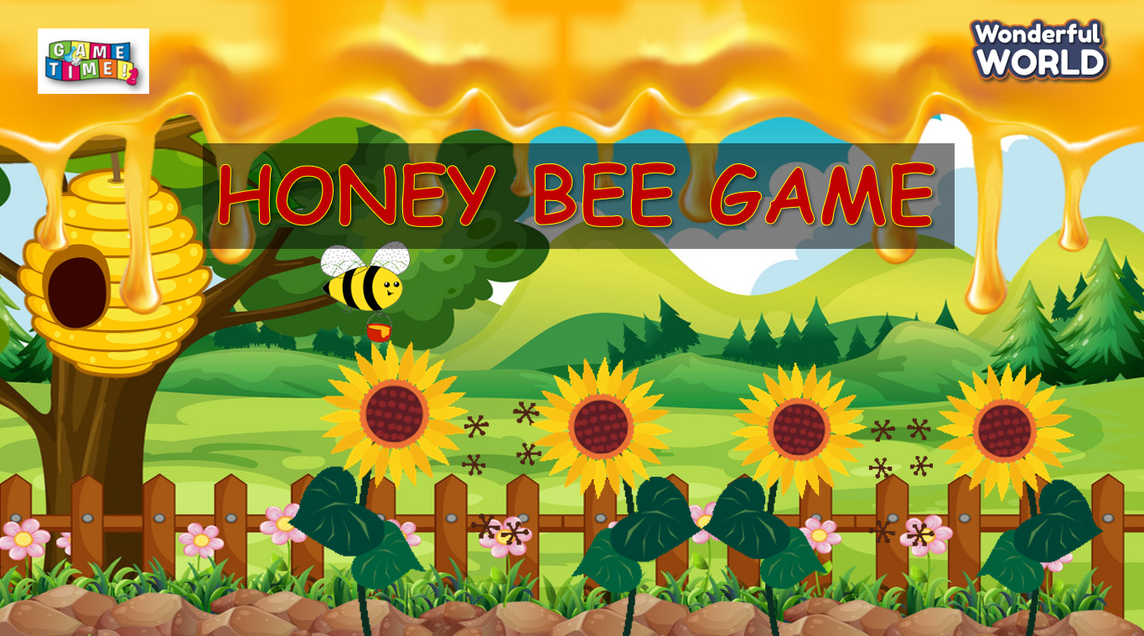 | - Repeat after the teacher.  - Join in the game and get stars.
Activity 3: Practice (14 minutes)
Teacher’s Activities | Students’ Activities
Task 2: Listen tick  -Let Sts listen and read the dialogue by Role-play “ Anna and Andy” to practice the words and the sentences.  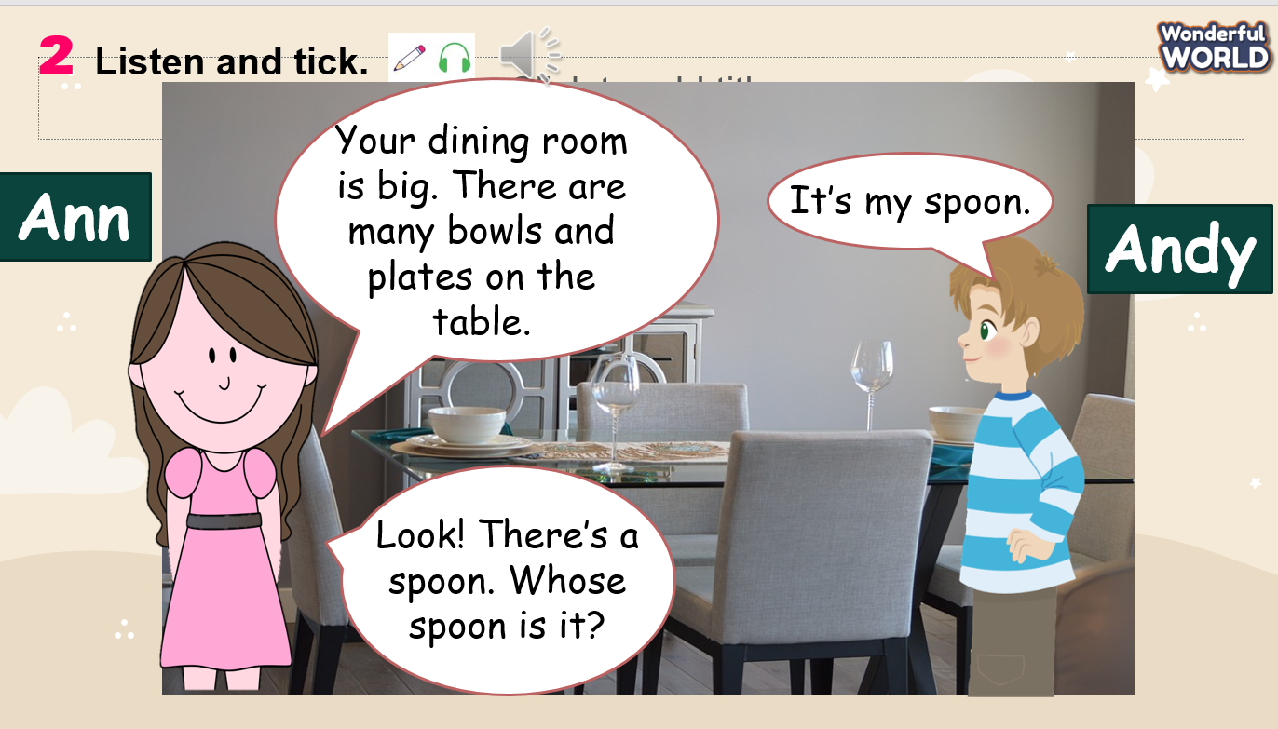  -Then play the audio again and ask sts to tick the correct answers.  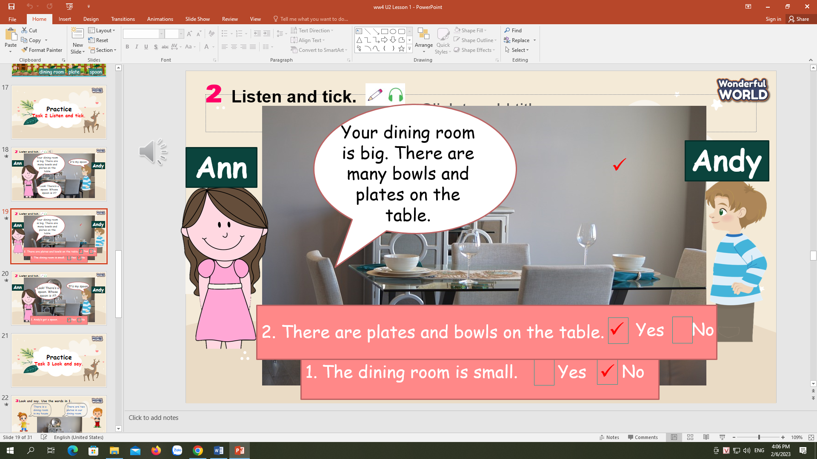  Task 3: Look and say :  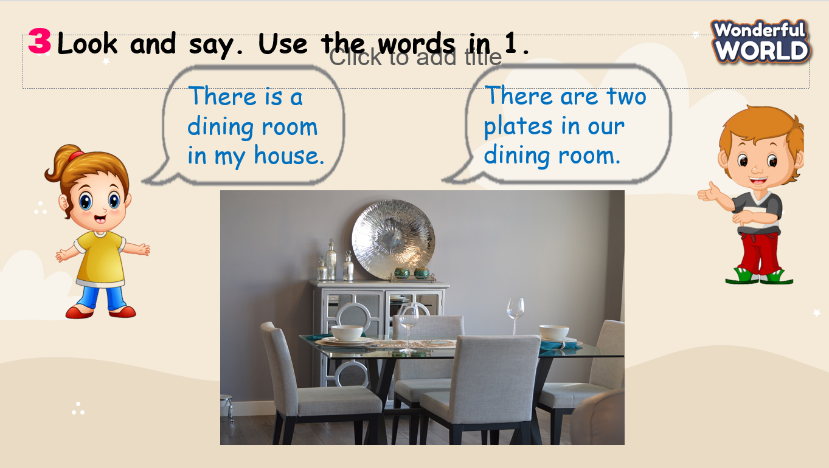  -Look at the picture and read the dialogue.  - Ask sts to practice the dialogue in pairs through some pictures.  - Then let some pairs present in front of the class.  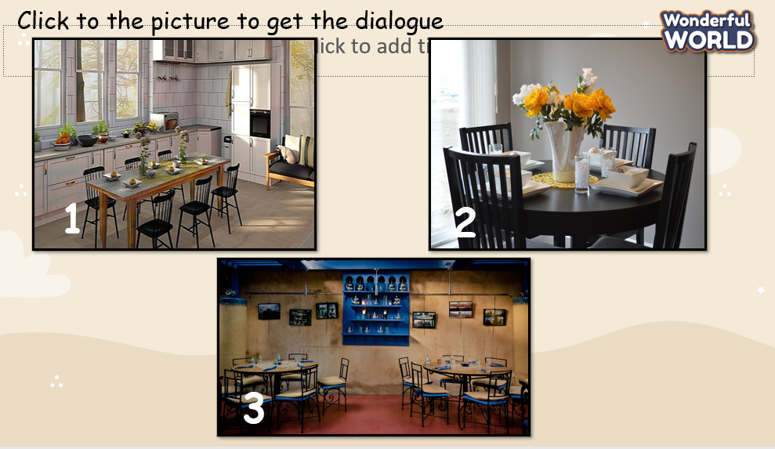 | - Listen and read.  - Sts listen again and answer the questions.  - Read the dialogue.  - Practice some dialogue in pairs and present in the class.
Activity 4: Production (9 minutes)
Teacher’s Activities | Students’ Activities
Drawing the dining room :  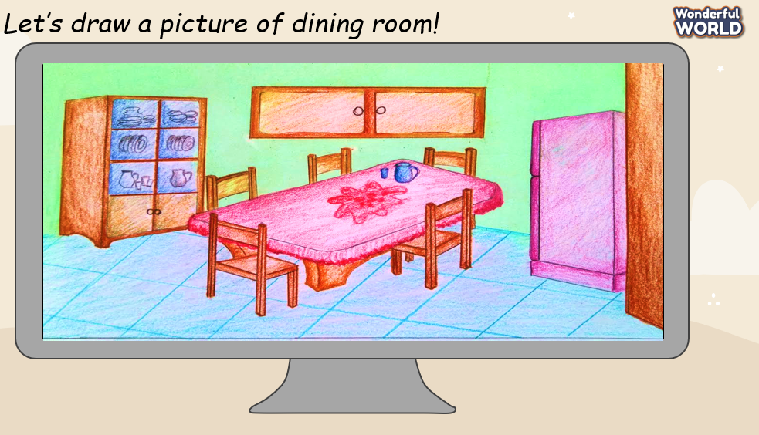  -T show picture pictures of dining room and ask sts about the numbers of chairs, table, bowls and plates.  -T ask sts to draw pictures of their dining rooms and show them to their friends and class. | Sts answer the questions.  Draw the dining room.
Activity 5: Assessment (3 minutes)
Teacher’s Activities | Students’ Activities
-Ask sts to do the assessment.  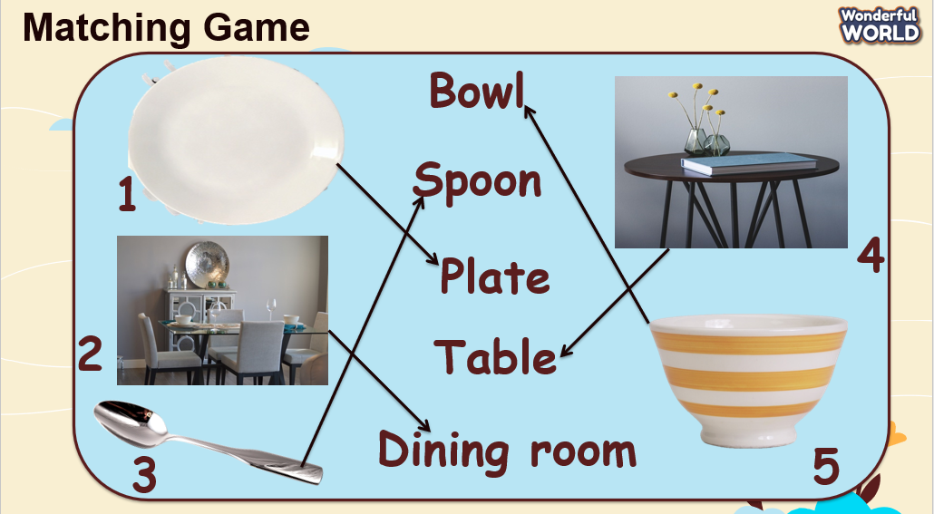  - Check with the class. | -Do the assessment.  - Check with the teacher
__________________________________
UNIT 2. MY HOME
Lesson 1. Task 4, 5, 6
Period 11
I. OBJECTIVES:
1. Knowledge:
- Students will revise words and phrases related to the topic House: bowl, plate, table, spoon, dining room.
- Students will learn about new structure:
Whose table is it?
- It’s their table.
2. Competences:
- English competences: Students will be able to talk about different objects in the house.
- Common competences: Students will have the opportunity to develop the creativeness in participating in games and develop communication among friends.
3. Qualities:
- Students develop love toward their home.
II. EQUIPMENT AND MATERIALS:
- For Teacher: PP, flashcards, handout, track 2.3.
- For students: pens, books.
III. LESSON PROCEDURE:

Activity 1: Warm-up (5 minutes)
Teacher’s Activities | Students’ Activities
Aims: Review the words of House which they have learned from previous lesson.
b, Procedure  - Greet students and divide class into 4 teams.  - Warm-up: Game time!  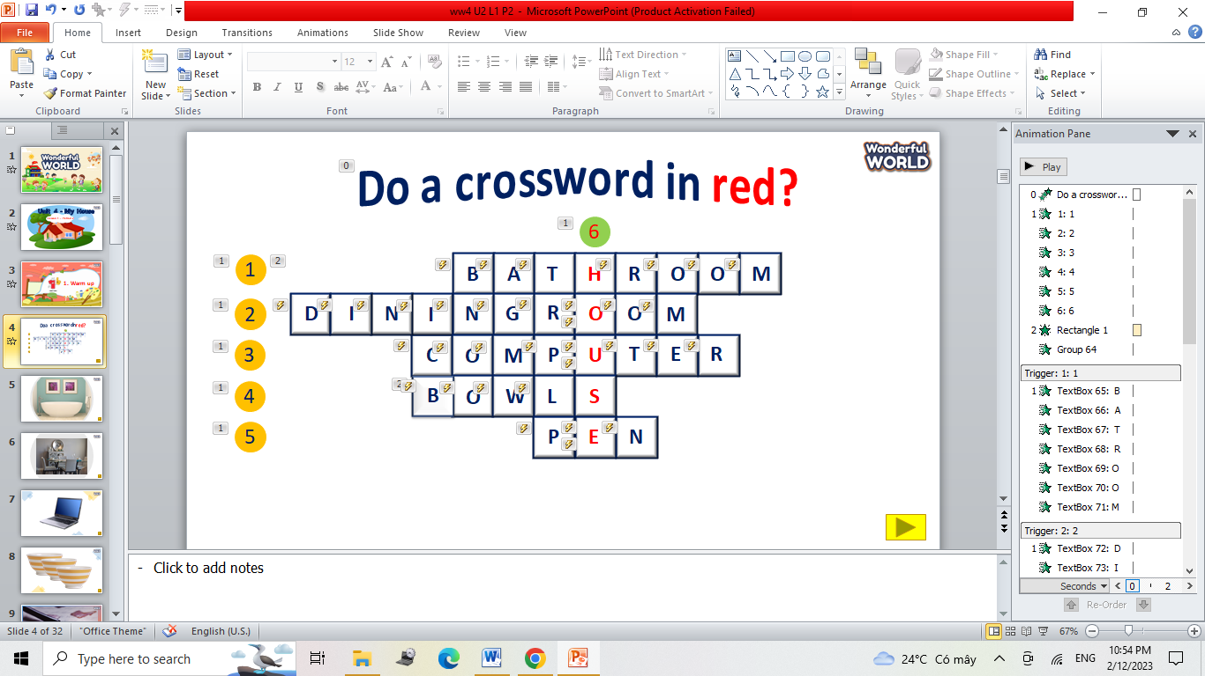  - The T shows the crossword.  - Ask Sts to choose the numbers and answer the questions, then open the words.  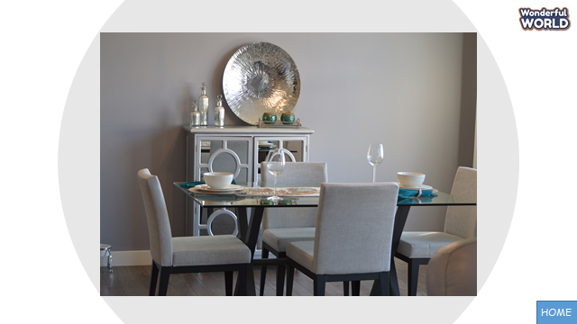  - Sts can guess the key word and get more stars | - Great teacher and choose the team’s name.  - Join in the game.
Activity 2: Presentation (8 minutes)
Teacher’s Activities | Students’ Activities
Aims: Present new grammar: possessive adjectives and possessive question
b, Procedure  Task 4: Listen and repeat.  - Use flashcards to introduce the possessive adjectives.  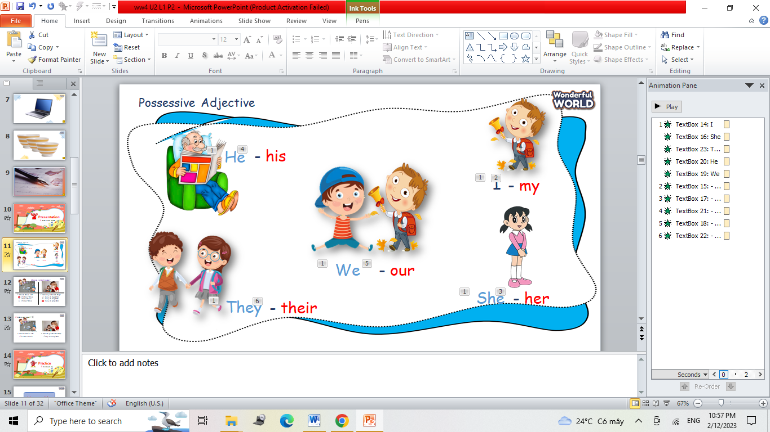  - Say the words/sentences for students to repeat in the chorus.  - Say a word/sentence for students to repeat then point.  - Ask Sts to look at pictures and choose the correct answers.  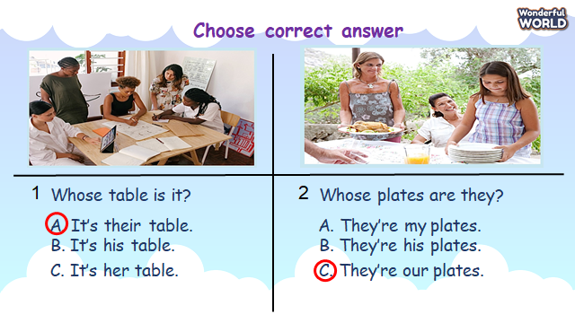  - Tell sts to open their books to page 17.  - Ask them to look at pictures and follow the sentences with fingers.  - Play track 2.3 for the students to listen to and repeat in chorus, and group.  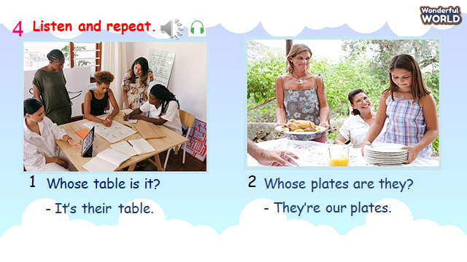  - Point to the pictures. Explain that we use demonstrative Whose…?to ask a question about possession.  - Show pictures in random order and ask students to read out the dialogues. | - Repeat after the teacher.  - Say possessive words.  - Sts look at pictures and answer the questions  Sts listen to the track.  Sts point to the sentences.  Sts repeat each sentence..  Sts practice the dialogue.  Some volunteers read out the dialogues.
Activity 3: Practice (14 minutes)
Teacher’s Activities | Students’ Activities
Aims: Practice the structures they have learned using demonstrative: Whose bowl …? It’s/ They’re….
b, Procedure  Task 5: Look and say.  -Let Sts play “Yes or No” questions to review the previous lessons.  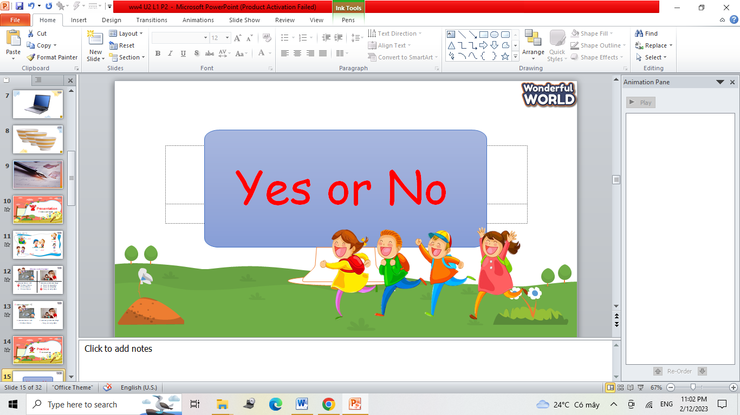  - Show sts pictures and some questions. Sts can choose Yes or No for the answers. If they have correct answers, they can roll the dice to get stars.  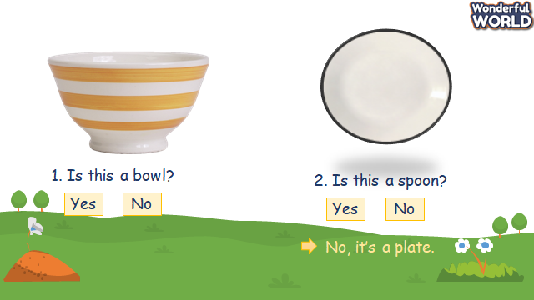  -Then show sts the picture and phrase of objects to make the conversation.  - Read out the prompts and ask sts to repeat.  - Tell sts to look at example and ask them to repeat each sentence.  - Explain the rest of task. Ask sts to make and practice the dialogue in pairs through some pictures. 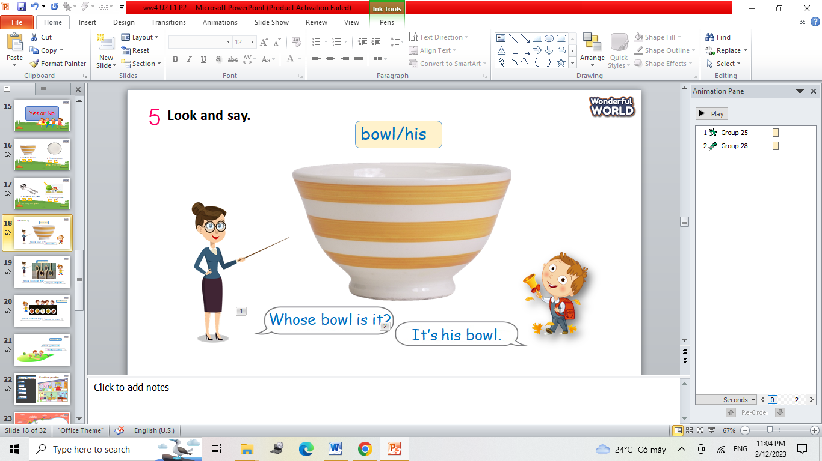  - Then let some pairs present in front of the class.  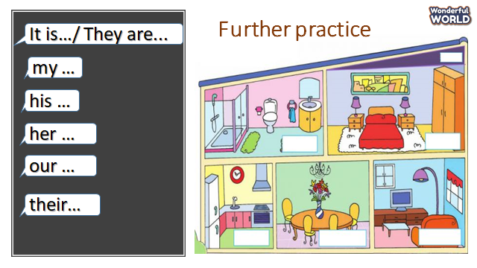 | - Take part in the games.  - Sts look at pictures and questions.  - Choose correct answers and roll the dice.  Read the prompts.  Read the sentences.  Make and practice some dialogue in pairs and present in the class.
Activity 4: Production (9 minutes)
Teacher’s Activities | Students’ Activities
Aims: - Encourage Sts to practice a dialogue using the prompts.
- Support sts where necessary to make their own dialogue.
b, Procedure  Game: Dart Board.  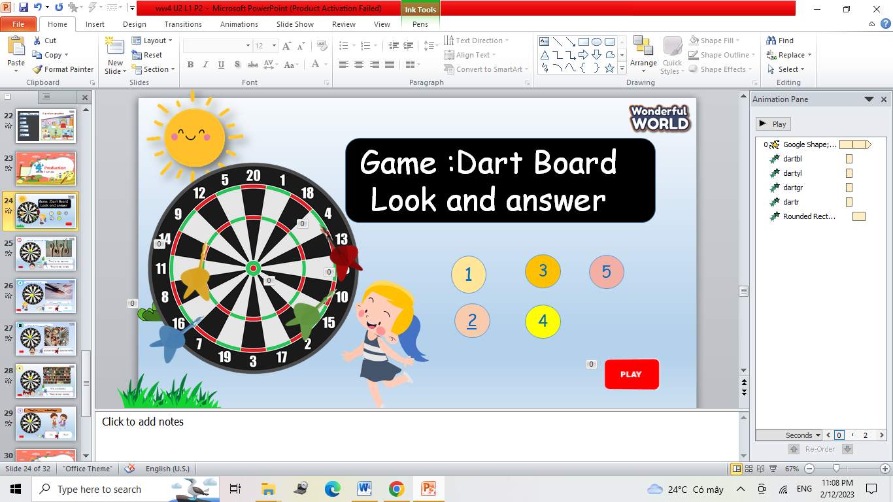  - Tell sts they are going to talk about goods at home through a game.  -T shows the game and asks sts to choose the numbers.  - Sts can look at pictures and questions, then choose the answers.  - Then, let sts read out each sentence.  - Answer some questions and get stars for their teams.  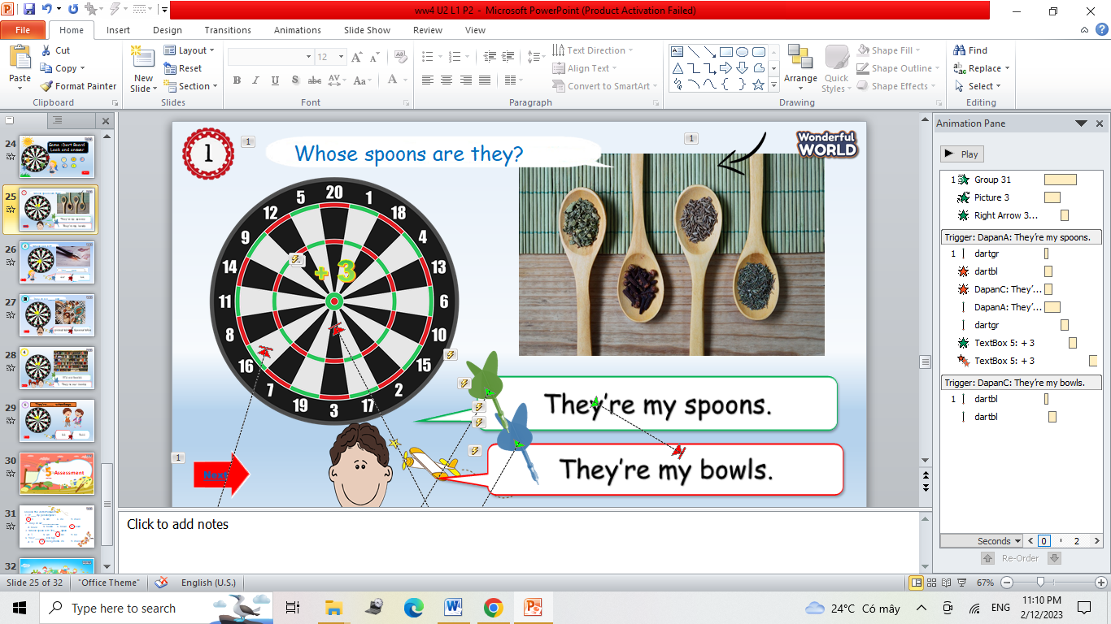  - If they have correct answer, the arrow will be let off to the board and show the stars. | -Sts look at the game.  - Sts choose numbers to answer the question.  - Repeat after each sentence.  - Read out the dialogue.
Activity 5: Assessment (3 minutes)
Teacher’s Activities | Students’ Activities
Aims: Consolidate the content of the lesson.
b, Procedure  -Ask sts to do the assessment.  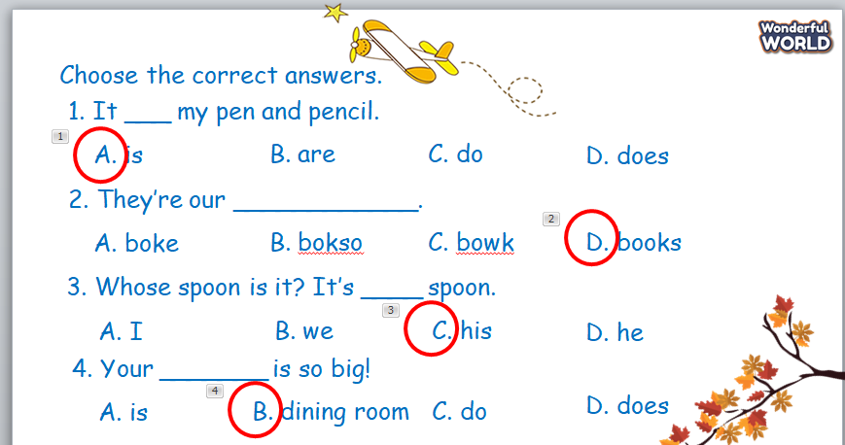  - Check with the class.  - Wrap up the vocabulary and structure  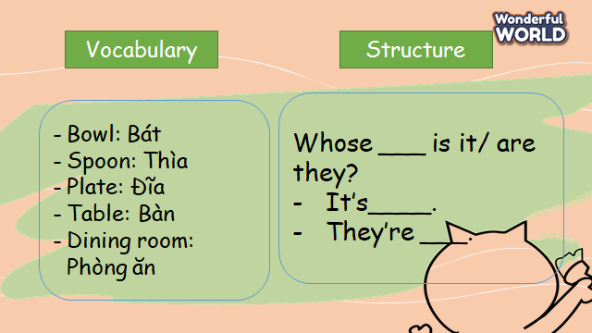 | -Do the assessment.  - Check with the teacher  - Stand up and say goodbye to the teacher.
__________________________________
UNIT 2. MY HOME
Lesson 2. Task 1, 2, 3
Period 12
I. OBJECTIVES:
1. Knowledge:
- Students will learn words and phrases related to the topic House: rug, sofa, sink, fridge, living room, kitchen.
- Students will learn about new structure:
The sofa is in the living room.
2. Competences:
- English competences: Students will be able to talk about different objects and places in the house.
- Common competences: Students will have the opportunity to develop the creativeness in participating in games and develop communication among friends.
3. Qualities:
- Students develop love toward their home.
II. EQUIPMENT AND MATERIALS:
- For Teacher: PP, flashcards, handout, track 2.4,2.5.
- For students: pens, books, crayons, paper.
III. LESSON PROCEDURE:

Activity 1: Warm-up (5 minutes)
Teacher’s Activities | Students’ Activities
Aims: Warm-up activity to revise the words of previous lesson
b, Procedure  - Greet students and divide class into 4 teams.  Warm-up: Guessing game.  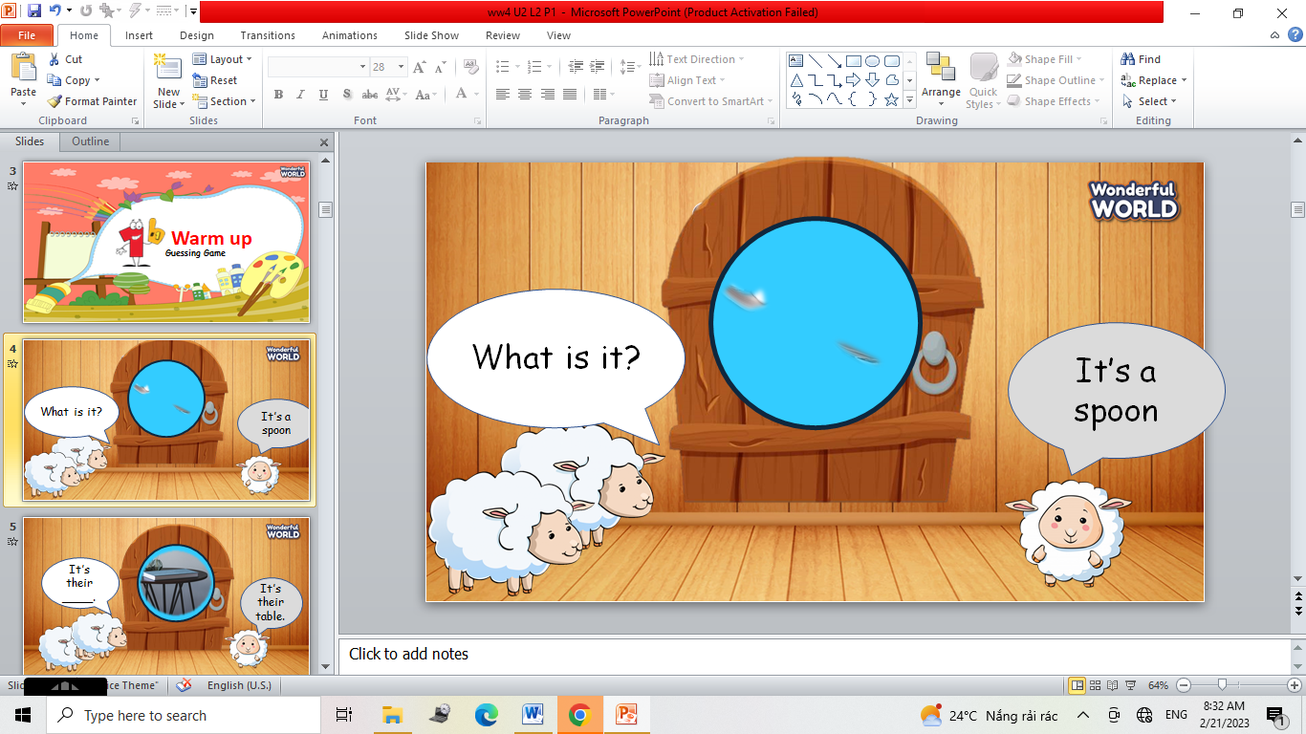  - The T shows the hint of pictures and asks sts to look at pictures.  - Ask Sts to guess the pictures and answer the questions, then get stars.  - Check sts answers and give them stars | - Sts greet the teacher and choose their team names.  - Join in the game.  - Guess the pictures.  - Answer the questions.
Activity 2: Presentation (8 minutes)
Teacher’s Activities | Students’ Activities
Aims:- Present some new words of house: rug, sofa, sink, fridge, living room, kitchen.
- Encourage sts with the topic and vocab of related topic.
b, Procedure  Task 1. Listen and point. Repeat.  - Use flashcards to introduce the vocabulary and structure of the lesson.  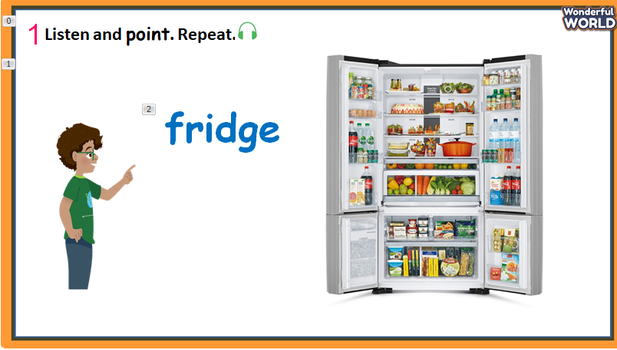  - Say the words/sentences for students to repeat in the chorus.  - Say a word/sentence for students to repeat then point.  - Play track 2.4 for the students to listen to and repeat in chorus, and group.  - Show pictures in random order and ask students to read out the dialogues.  VOCABULARY CHECKING  - Let Sts play the “Slap the board”.  - Ask some Sts come to the board and the others read out the words.  - Then Sts slap the board, the first one can get stars.  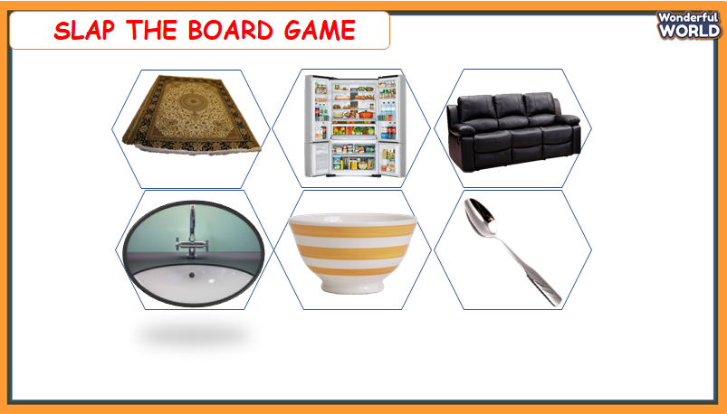 | - Look at the pictures.  - Repeat after the teacher.  - Sts listen and practice the words.  - Sts join the game and get stars.  - Sts come to the board and slap the correct ones.
Activity 3: Practice (14 minutes)
Teacher’s Activities | Students’ Activities
Aims: - Controlled-practice: Listen and tick a conversation using the vocab of task 1.
- Encourage sts to act out the dialogue in pairs in front of the class.
b, Procedure  Task 2: Listen and tick.  -Let Sts listen and read the dialogue by role play “Dad” and “Jack” to practice the words and sentences.  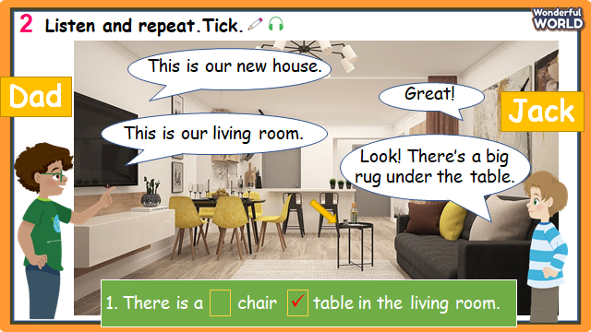  -Pause the audio after each sentence, and read out loud for sts.  - Ask sts to repeat sentences.  - Ask them to practice the dialogue in pairs.  - Then let some volunteers read out loud in front of the class.  -Then play the track 2.5 again and ask Sts to tick the answers.  Task 3: Look and say.  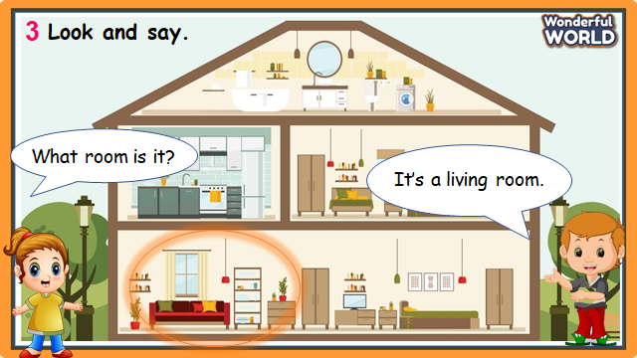  - Look at the picture and answer some questions about rooms.  - Then ask Sts to choose the objects and read the dialogue.  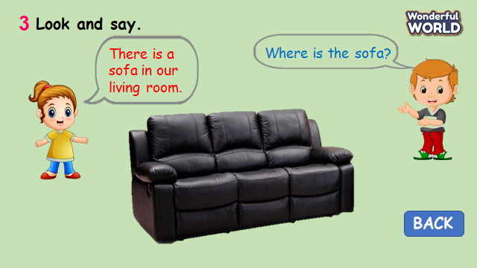  - Let Sts to make some dialogue through some pictures and practice them in pairs.  - Require some pairs present in front of class. | - Listen and read.  - Sts read aloud each sentence.  - Repeat the sentences.  - Some pairs present in front of the class.  - Sts listen again and tick the correct answers.  - Answer the question.  - Read some dialogues.  - Make and practice some dialogue in pairs and present in the class.
Activity 4: Production (9 minutes)
Teacher’s Activities | Students’ Activities
Aims: Apply the new words and structures to present their favourite room.
b, Procedure  Drawing their favourite room with some objects that have been learnt.  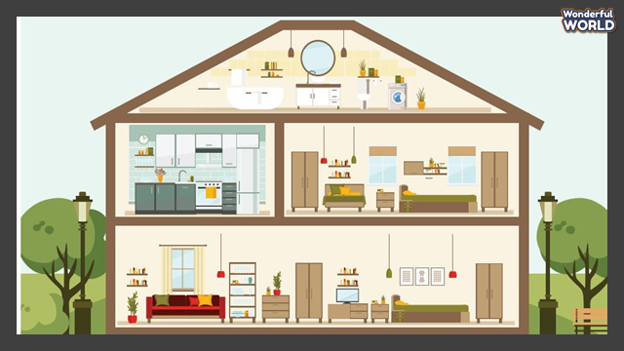  -T shows the picture of rooms and asks Sts about the places of some objects.  - T asks Sts to draw their favourite rooms and show them to their class.  -Then let sts make some sentences about their rooms/objects and present in front of class. | -Sts answer the questions.  - Sts draw the pictures.  - Sts make sentences about their favourite rooms with some objects that have been learnt.
Activity 5: Assessment (3 minutes)
Teacher’s Activities | Students’ Activities
Aims: Consolidate the content of the lesson
b, Procedure  -Ask sts to do the assessment.  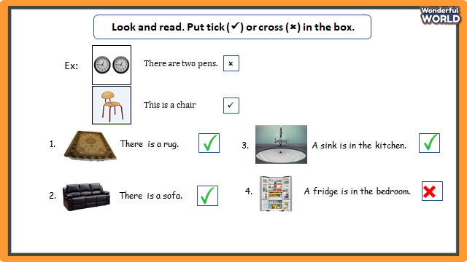  - Check with the class.  - Wrap up:  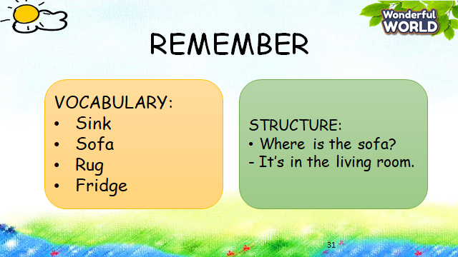 | -Do the assessment.  - Check with the teacher  - Sts read the wrap-up  - Stand up and say goodbye to the teacher.

