GRADE 4
WEEK 4 (30/9 – 04/10)
UNIT 2. MY HOME
Lesson 2. Task 4, 5, 6
Period 13

I. OBJECTIVES:
1. Knowledge:
- Students will revise words and phrases related to the topic House: rug, table, sofa, sink, fridge.
- Students will learn about the preposition: next to, between, in front of, behind
- Students will learn about new structure:
Where is the sofa?
The sofa is behind the table.
2. Competences:
- English competences: Students will be able to talk about the position of objects in the house.
- Common competences: Students will have the opportunity to develop the creativeness in participating in games and develop communication among friends.
3. Qualities:
- Students develop love toward their home.
II. EQUIPMENT AND MATERIALS:
- For Teacher: PP, flashcards, handout, track 2.6, 2.7.
- For students: pens, books.
III. LESSON PROCEDURE:

Activity 1: Warm-up (5 minutes)
Teacher’s Activities | Students’ Activities
Aims: Review the vocabulary which they have learned from previous lesson.
b, Procedure  - Greet students and divide class into 4 teams.  - Warm-up: Game time!  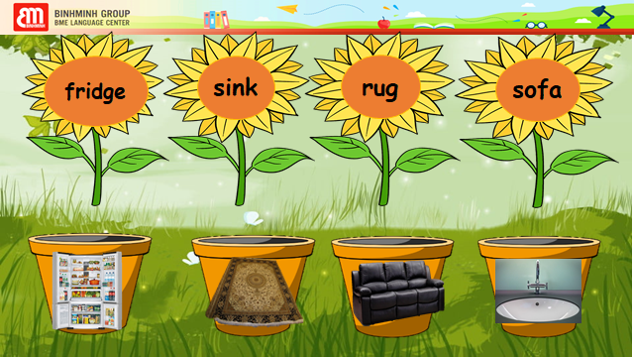  - The T shows the pictures and words.  - Ask Sts to match the pictures to the correct places.  - Sts having correct answers will get more stars. | - Sts greet the teacher and choose their team names.  - Join in the game.  - Match the picture to the correct words.
Activity 2: Presentation (8 minutes)
Teacher’s Activities | Students’ Activities
Aims: To identify the preposition by looking at the picutes relating to house’s objects.
b, Procedure  Task 4: Listen and repeat.  - Let Sts listen to the song to introduce about Preposition.  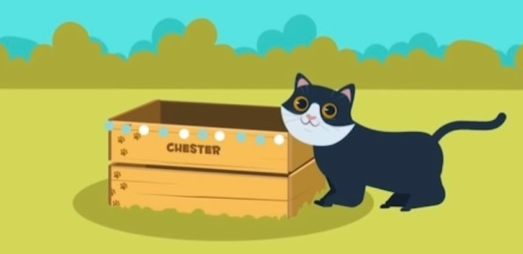  - After watching the video, sts take part in the game to revise about preposition.  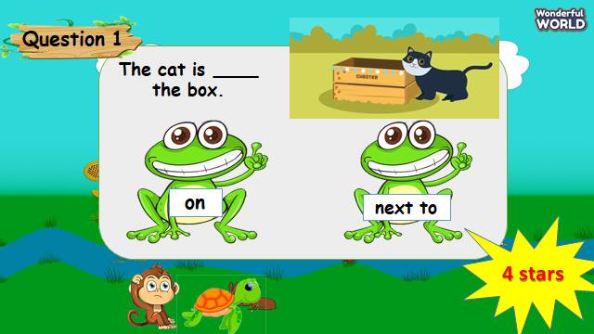  - Say the words/sentences for students to repeat in the chorus.  - T explains the meaning of preposition.  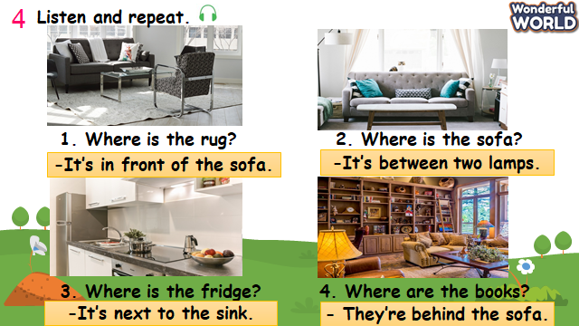  - Ask Sts to look at pictures and answer the questions.  - Say a word/sentence for students to repeat then point.  - Play track 2.6 for the students to listen to and repeat in chorus, and group.  - Ask sts to notice the preposition in each sentence. | - Listen to the song.  - Sts take part in the game.  - Listen to the teacher about preposition.  - Sts repeat the preposition.  - Look at the pictures and sentences.  - Sts answer the questions.  - Sts listen and practice the dialogues.  - Take note the preposition.
Activity 3: Practice (14 minutes)
Teacher’s Activities | Students’ Activities
Aims: To practice saying the sentences individually and then in pair using the right positions of objects
- To encourage sts to read the prompts aloud and repeat when asked.
Task 5: Look and say.  -Let Sts play “Yes or No” questions to review the previous lessons.  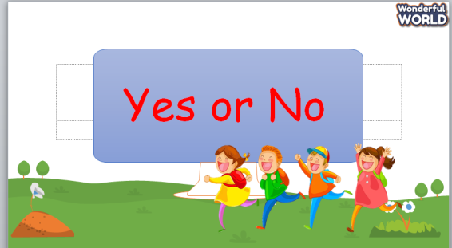  -Then show sts the pictures and some prompts.  - Read out the prompts and make the dialogue. Then asks sts to repeat.  - Explain the rest of task and ask sts to make and practice the dialogue in pairs through some pictures.  - Then let some pairs present in front of the class.  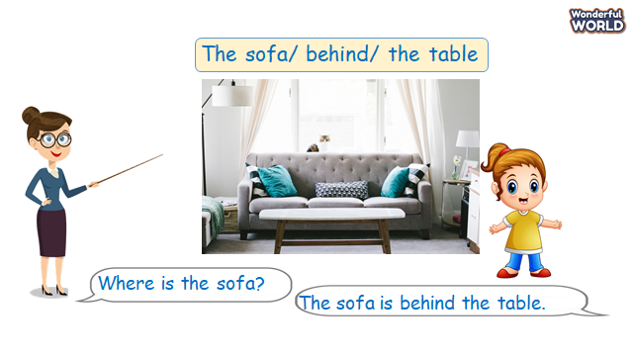 | - Take part in the games.  - Read the dialogue.  - Make and practice some dialogue in pairs and present in the class.
Activity 4: Production (9 minutes)
Teacher’s Activities | Students’ Activities
Aims: - List things they can see from the kitchen and read them aloud before the chant.
- Chant the song correctly by reading aloud words of a beautiful kitchen.

b, Procedure  Task 6: Listen and Chant.  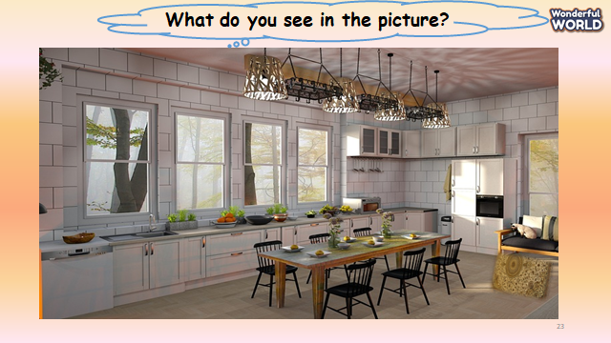  - T shows the pictures of big and modern dining room.  - Ask sts what they can see in the picture.  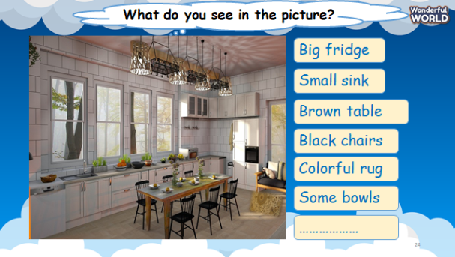  -T shows the objects with their colors.  - Then, T shows the chant and let sts listen to the whole chant.  - Then, T pauses after each sentence and asks sts to repeat.  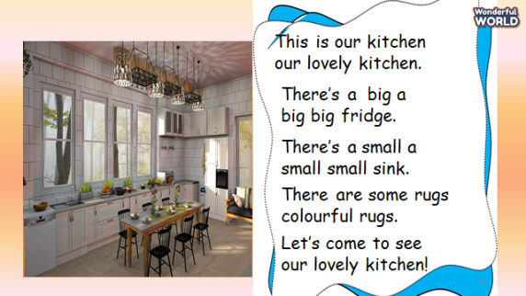  - After practicing the chant, sts can sing along. | - Sts look at picture and answer the questions.  - Sts check the answers.  - Listen to the chant.  - Repeat after each sentence.  - Practice the chant.  - Sts chant the song.
Activity 5: Assessment (3 minutes)
Teacher’s Activities | Students’ Activities
Aims: Consolidate the content of the lesson
b, Procedure  -Ask sts to do the assessment.  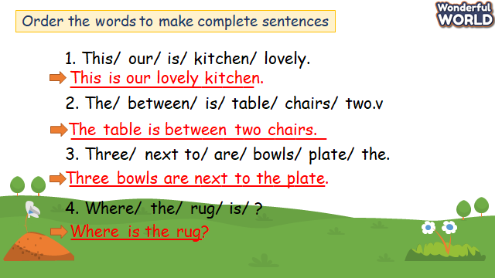  - Check with the class.  - Wrap-up  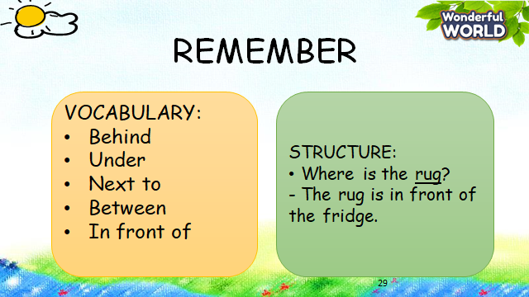 | -Do the assessment.  - Check with the teacher  - Sts read the wrap-up  - Stand up and say goodbye to the teacher.

UNIT 2. MY HOME
Lesson 2. Task 7, 8, 9
Period 14
I. OBJECTIVES:
1. Knowledge:
- Students will revise words and phrases related to the topic House: rug, table, sofa, sink, fridge, table, bowl, spoon, plate.
- Students will learn about the preposition: next to, between, in front of, behind
- Students will review about structure:
Where is the sofa?
The sofa is behind the table.
2. Competences:
- English competences: Students will be able to talk about the position of rooms and furniture in the house.
- Common competences: Students will have the opportunity to develop the creativeness in participating in games and develop communication among friends.
3. Qualities:
- Students develop love toward their home.
II. EQUIPMENT AND MATERIALS:
- For Teacher: PP, flashcards, handout, track 2.8.
- For students: pens, books, crayons, paper.
III. LESSON PROCEDURE:

Activity 1: Warm-up (5 minutes)
Teacher’s Activities | Students’ Activities
Aims: Review the words and structures which they have learned from previous lesson.
b, Procedure  - Greet students and divide class into 4 teams.  Warm-up: Game time!  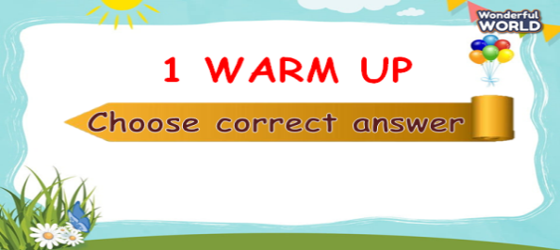  - The T shows the pictures and sentences.  - Ask Sts to choose the correct words for the blanks.  - Sts having correct answers will get more stars.  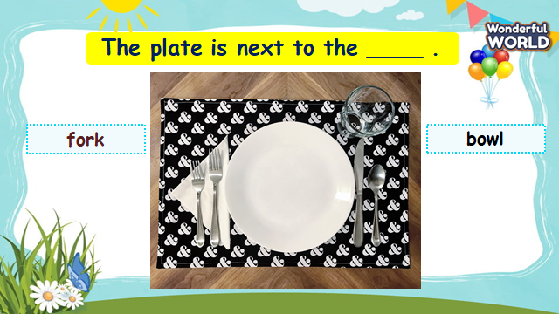 | - Sts greet the teacher and choose their team names.  - Join in the game.  - Sts choose the correct answer.
Activity 2: Practice (8 minutes)
Teacher’s Activities | Students’ Activities
Aims: Practice the vocab and structures through listening skills by doing tick exercise.
b, Procedure  Task 7: Listen and tick.  - After playing game using the content of task, Sts will do Task 7.  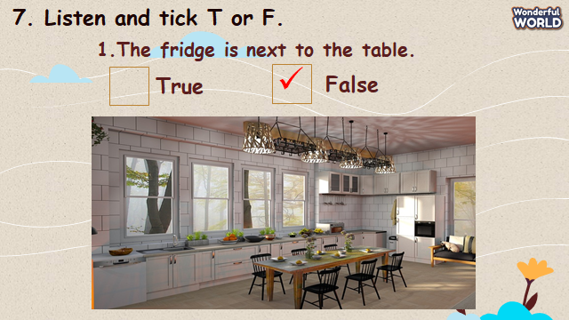  - Ask Sts to look at pictures and guess the sentences true or false.  - Say a word/sentence for students to repeat then point.  - Play track 2.8 for the students to listen to and tick the correct answers for question 1-5.  - Play the track again and pause after each sentence to check answers. | - Sts look at pictures and guess the answers.  -Sts repeat the sentences.  - Sts listen to the track and do the task.  - Sts check the answers.
Activity 3: Practice (14 minutes)
Teacher’s Activities | Students’ Activities
Aims: Controlled-practice: to discuss and make sentences using preposition.
Encourage sts to make full sentences using preposition.
b, Procedure  Task 8: Look and say.  - T shows the picture of the room and asks sts look at it.  - Ask sts to answer what they can see.  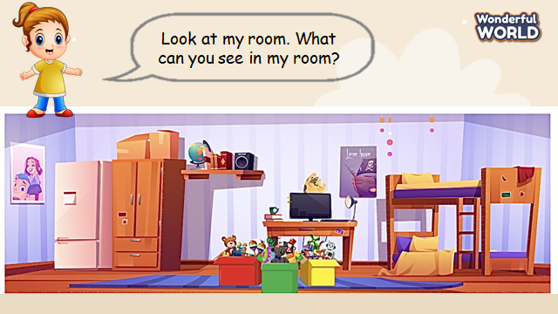  - Then, let sts play the game: Help the Pooh according to the picture.  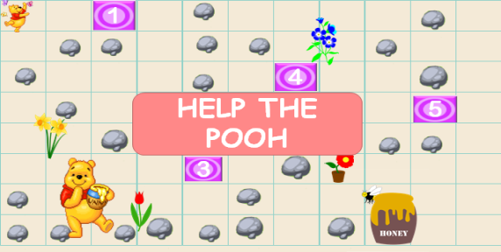  - T explains how to play the game. ( T divides class into 4 teams. There are 5 questions that sts can answer in succession. If they have corrected answers, they can roll the dice to get stars).  - Sts look at the sentences or questions, then choose the correct answers.  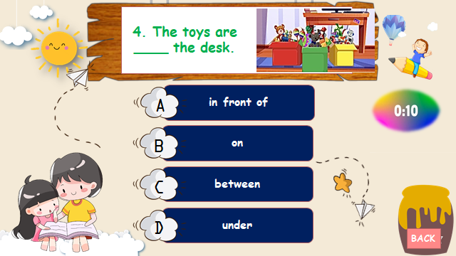  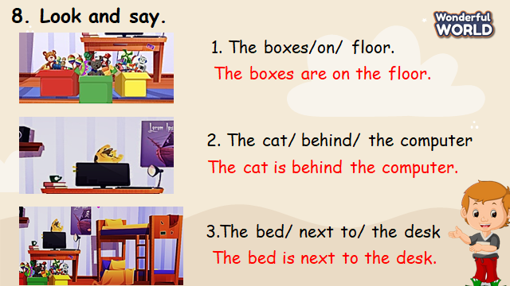  -Then show sts the pictures and some prompts.  - Read out the prompts and ask sts to repeat.  - Tell sts to look at picture for sentence 1 and make sentence.  - Read out example 1 and ask sts to repeat.  - Explain the rest of task and ask sts to make and practice the dialogue in pairs through some pictures.  - Then let some pairs present in front of the class. | - Sts look at picture and answer the question.  - Take part in the games.  - Look at the sentence and choose correct answers.  - Read the prompts.  - Read the sentence.  - Make and practice some sentences in pairs and present in the class.
Activity 4: Production (9 minutes)
Teacher’s Activities | Students’ Activities
Aims: Apply the words and structures about the position of rooms and objects.
Encourage sts to draw their own rooms and objects inside and present about them in front of the class.
b, Procedure  Task 9: Let’s talk.  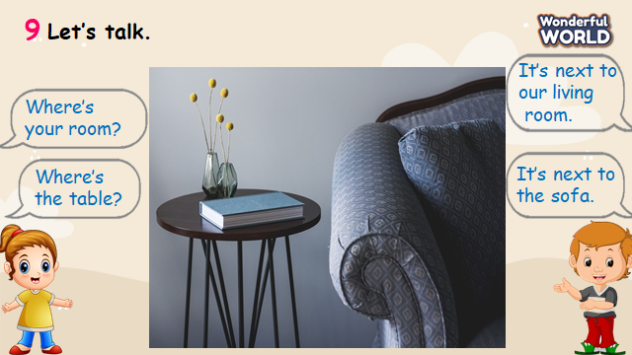  -T shows the picture and asks sts what they can see.  - Then, T shows the dialogue.  - Read out the dialogue, pause after each sentence and ask sts to repeat.  - Ask two sts to read out the dialogue.  - Let sts draw their houses/ rooms and the furniture.  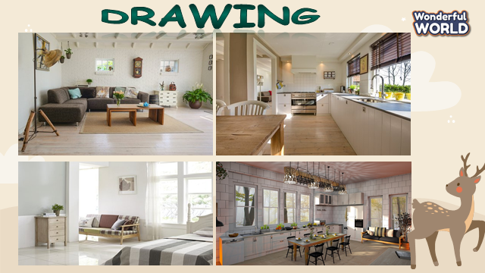  - Then ask they work in pairs to talk about their houses.  - Ask volunteers to read out their answers. | - Sts answer the questions.  - Repeat each sentence.  - Read out the dialogue.  - Draw a picture of their houses or rooms and make sentences about them.  - Sts work in pairs and practice the dialogue.  - Some volunteers present in front of the class.
Activity 5: Assessment (3 minutes)
Teacher’s Activities | Students’ Activities
Aims: Consolidate the content of the lesson
-Ask sts to do the assessment.  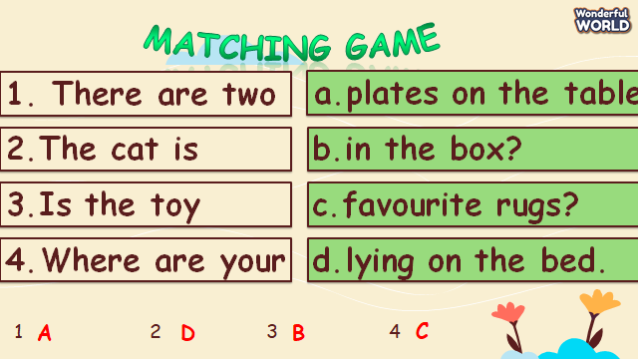  - Check with the class.  - Wrap- up  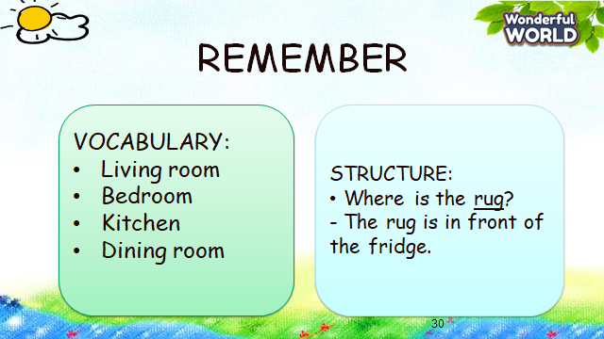 | -Do the assessment.  - Check with the teacher.  - Sts read the wrap-up  - Stand up and say goodbye to the teacher.
__________________________________
UNIT 2. MY HOME
Lesson 3. Task 1, 2, 3
Period 15
I. OBJECTIVES:
1. Knowledge:
- Students will learn words and phrases related to the topic House: bookshelf, toy box, floor, messy, tidy.
- Students will learn about the new structure:
The room is tidy/ messy.
The bookshelf is next to the television.
2. Competences:
- English competences: Students will be able to talk about different objects and places in the house.
- Common competences: Students will have the opportunity to develop the creativeness by participating in games and developing communication among friends.
3. Qualities:
- Students develop a love for their home.
II. EQUIPMENT AND MATERIALS:
- For Teacher: PP, flashcards, handout, track 2.9,2.10
- For students: pens, books, paper.
III. LESSON PROCEDURE:

Activity 1: Warm-up (5 minutes)
Teacher’s Activities | Students’ Activities
Aims: Warm-up activity to revise the words of the previous lesson.
b, Procedure  - Greet students and divide the class into 4 teams  - Warm-up: Racing game.  - The T shows the race.  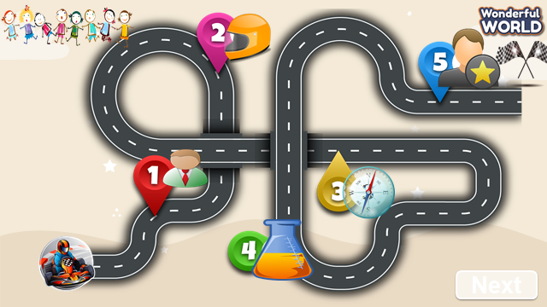  - Ask Sts to look at the pictures and answer the questions, then get stars.  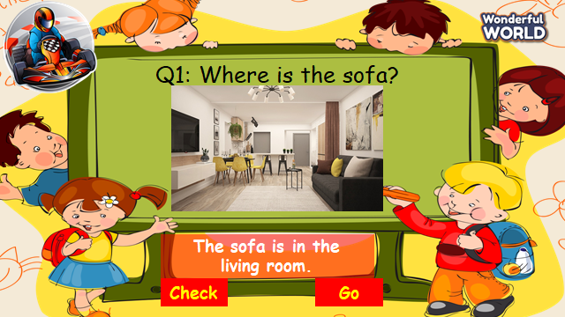  - T let sts answer the questions, then check the correct ones. | - Sts greet the teacher and choose their team names.  - Join the game.  - Look at the questions and pictures  - Sts having correct answers will have stars.
Activity 2: Presentation (8 minutes)
Teacher’s Activities | Students’ Activities
Aims: - Present some new words of the house: bookshelf, toy box, floor, messy, tidy.
- Encourage sts with the topic and vocab of related topics.
Task 1. Listen and point. Repeat.  - Use flashcards to introduce the vocabulary and structure of the lesson.  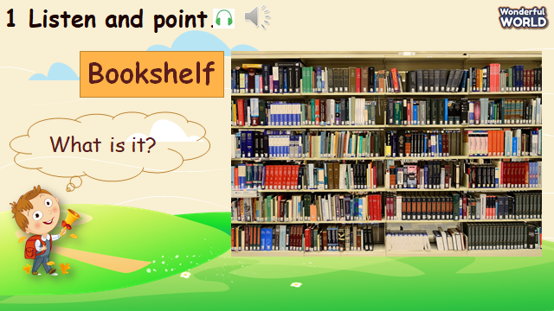  - Say the words/sentences for students to repeat in the chorus.  - Say a word/sentence for students to repeat then point.  - Play track 2.9 for the students to listen to and repeat in chorus, and groups.  - Show pictures in random order and ask students to read out the words.  VOCABULARY CHECKING  - Let Sts play the “Protect the jungle”.  - Ask some Sts to choose the numbers, look at pictures, and answer the questions.  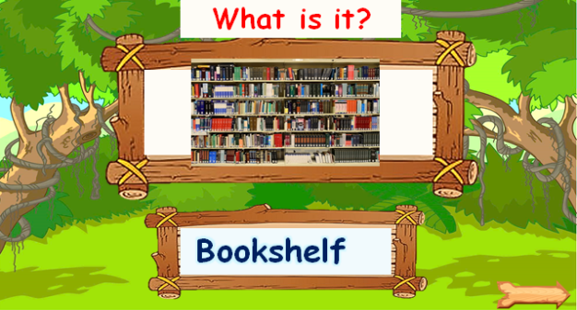  - If they have correct answers, they can hit the hunters through some monkeys and have their stars. | -Repeat after the teacher. --Listen to the track and repeat the whole class.  -Sts practice the new words individually and in groups.  -Take notes of new vocab, write down translations if needed  -Sts join the game and get stars.
Activity 3: Practice (14 minutes)
Teacher’s Activities | Students’ Activities
Aims: - Controlled-practice: Listen and tick a conversation using the vocab of task 1.
- Encourage sts to act out the dialogue in pairs in front of the class.
Task 2: Listen and tick.  -Let Sts listen and read the dialogue about her son’s bedroom by role-playing “Mom” and “Andy” to practice the words and sentences.  - Let sts listen to the track.  -Pause the audio after each sentence, and read out loud for sts.  - Ask sts to repeat sentences.  - Ask some pairs to read the dialogue.  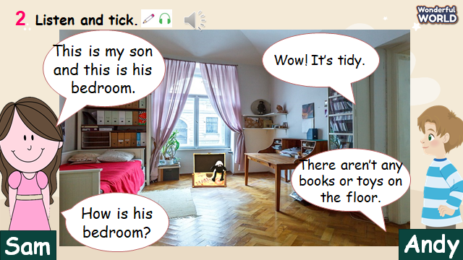  -Then play the track 2.10 again and ask Sts to tick the answers.  - Check their answers.  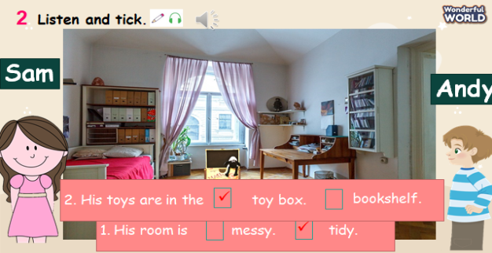  Task 3: Look and say.  - Look at the picture and answer some questions about rooms.  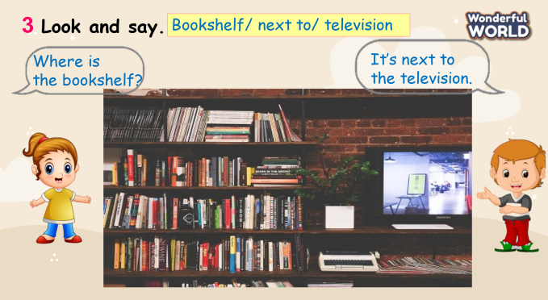  - Then ask Sts to choose the objects and read the dialogue.  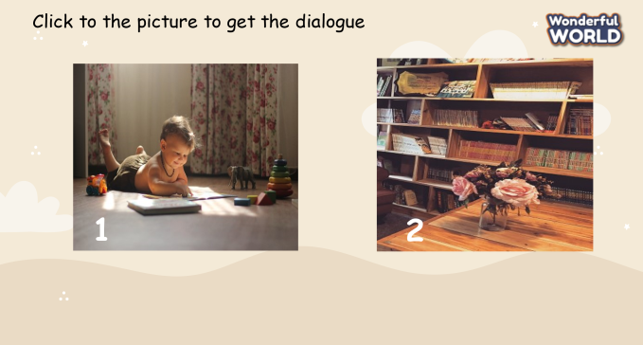  - Let Sts make some dialogue through some pictures and practice them in pairs.  - Require some pairs present in front of the class. | -Listen and read.  -Sts read aloud each sentence.  -Repeat the sentences.  -Some pairs read the dialogue.  -Sts listen again and tick the correct answers.  -Answer the questions.  -Read some dialogues.  -Make and practice some dialogue in pairs and present in the class.
Activity 4: Production (9 minutes)
Teacher’s Activities | Students’ Activities
Aims: Watch the video and write the objects that they can see.
Apply the new words and structures to describe their rooms using the vocabulary in task 1.
-Watch the video and present about their rooms.  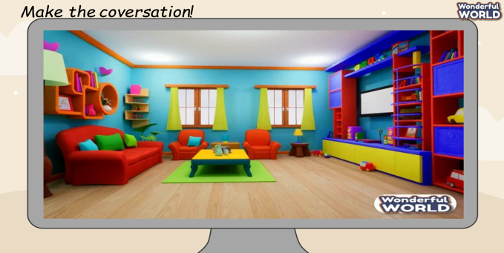  -T shows the videos of rooms and asks Sts about the places and some objects.  - Let sts write down what objects they can see in the videos.  - Ask them to read out the objects in the video.  - Then, write some sentences about their rooms using the vocabulary in task 1.  - Ask some volunteers present about their rooms in front of the class. | -Sts watch the video and answer what they can see in the rooms.  -Sts practice and talk about their rooms.  -Write down and answer about the objects in the video.  -Make sentences about their rooms.  -Some sts present about their rooms.
Activity 5: Assessment (3 minutes)
Teacher’s Activities | Students’ Activities
Aims: Consolidate the content of the lesson.
-Ask sts to do the assessment.  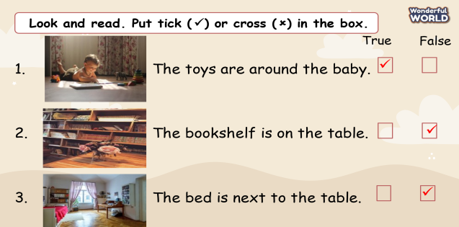  - Check with the class.  - Wrap-up  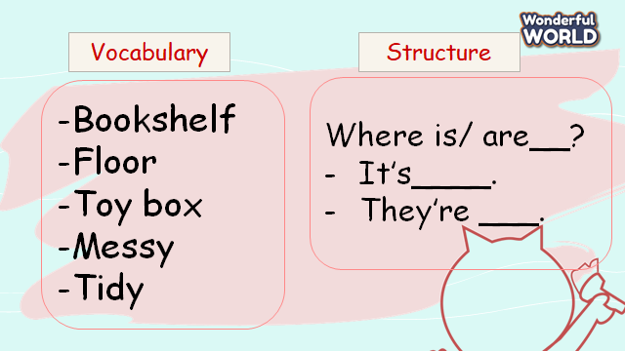 | -Do the assessment.  - Check with the teacher  - Sts read the wrap-up  - Stand up and say goodbye to the teacher.
__________________________________
UNIT 2. MY HOME
Lesson 3. Task 4, 5, 6
Period 16
I. OBJECTIVES:
1. Knowledge:
- Students will revise words and phrases related to the topic House: bookshelf, tidy, messy, toy box, floor.
- Students will learn about some adjectives: big, new, messy, tidy
- Students will learn about new structure:
How tidy is his/her room?
-It is very tidy.
2. Competences:
- English competences: Students will be able to talk about the position of objects in the house.
- Common competences: Students will have the opportunity to develop the creativeness in participating in games and develop communication among friends.
3. Qualities:
- Students develop love toward their home.
II. EQUIPMENT AND MATERIALS:
- For Teacher: PP, flashcards, handout, track 2.11
- For students: pens, books, paper, crayons.
III. LESSON PROCEDURE:
Activity 1: Warm-up (5 minutes)
Teacher’s Activities | Students’ Activities
a, Aims: Review the vocabulary which they have learned from previous lesson.
b, Procedure  - Greet students and divide class into 4 teams  - Warm-up: Unscramble Game!  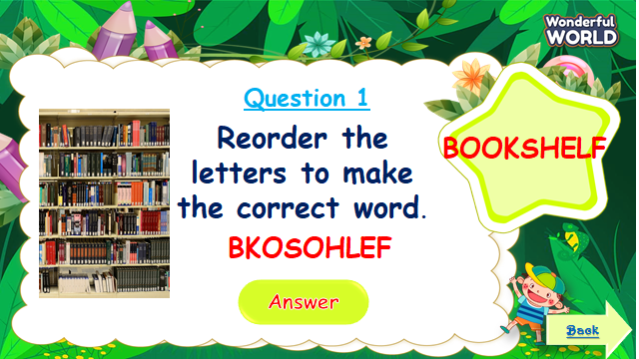  - The T shows the pictures and words.  - Ask Sts to reorder the letters to make the correct words.  - Sts answer all the questions and roll the dice to get stars. | - Sts greet the teacher and choose their team names.  - Join in the game.  - Look at the questions and pictures  - Sts having correct answers will have stars.  - Sts get stars.
Activity 2: Presentation (8 minutes)
Teacher’s Activities | Students’ Activities
Aims: Present new structure: How messy/tidy …?
Encourage sts to work in pairs using new structure.
b, Procedure  Task 4: Listen and repeat.  - Let Sts look at the words patterns and pictures.  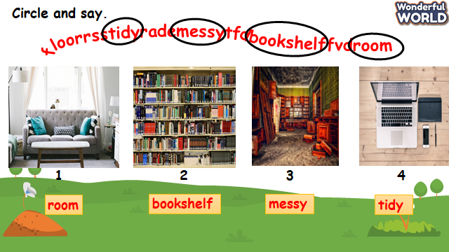  - Ask sts to figure out the words and say aloud.  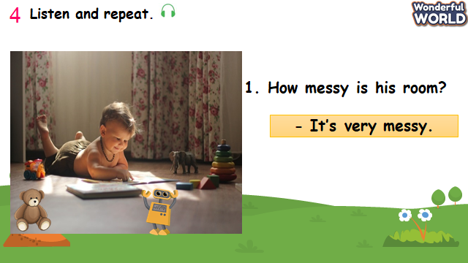  - Ask Sts to look at pictures and answer the questions.  - Say a word/sentence for students to repeat then point.  - Explain the structure “How adjective ….?”to ask about the condition or quality of an object.  - Give sts the answer that uses “It’s + adjective”.  - Play track 2.11 for the students to listen to and repeat in chorus, and group.  - Ask some pairs to read the questions and answers. | - Look at some pictures and wordpatterns.  - Sts take part in the game.  - Sts repeat the answers.  - Sts answer the questions.  - Sts listen and practice the dialogues.  - Some pairs present in front of class.
Activity 3: Practice (14 minutes)
Teacher’s Activities | Students’ Activities
Aims: Controlled-practice: to to ask and answer about the rooms and objects using new adjective that they have learned.
b, Procedure  Task 5: Look and say.  -Let Sts play “Candy Catcher” questions to review the previous lessons. Ask sts work in teams.    - T shows pictures and words, then let sts choose the correct answers.  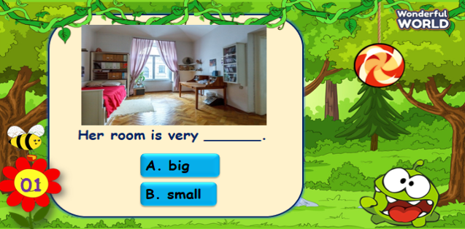  -Then show sts the pictures and some prompts.  - Read out the prompts and make the dialogue. Then asks sts to repeat.  - Explain the rest of task and ask sts to make and practice the dialogue in pairs through some pictures.  - Then let some pairs present in front of the class.  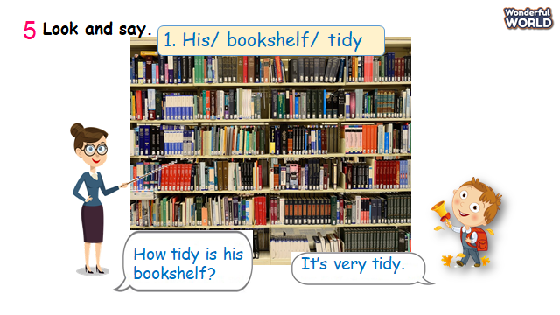 | - Look at pictures and questions.  - Take part in the games.  - Read the dialogue.  - Make and practice some dialogue in pairs and present in the class.
Activity 4: Production (9 minutes)
Teacher’s Activities | Students’ Activities
Aims: Apply the words and structures to make sentences about their rooms.
b, Procedure  Task 6: Draw and write. Say  -T shows the picture and asks sts what they can see. Let sts know that it is a picture of the room.  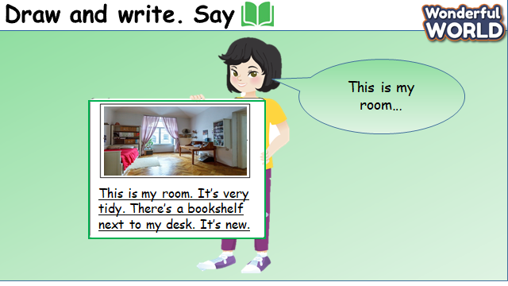  - Read out the sentences and ask them to repeat.  - Tell sts draw a picture of their room on a sheet of paper.  - Ask sts to write a description of their room using the examples.  - Ask some volunteers to show their pictures and read out their works. | - Sts answer the questions.  - Repeat sentences.  - Draw their own pictures and make sentences of their rooms.  - Some volunteers presents about their rooms.
Activity 5: Assessment (3 minutes)
Teacher’s Activities | Students’ Activities
Aims: Consolidate the content of the lesson
-Ask sts to do the assessment.  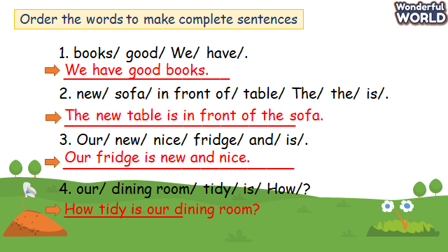  - Check with the class.  - Wrap up:  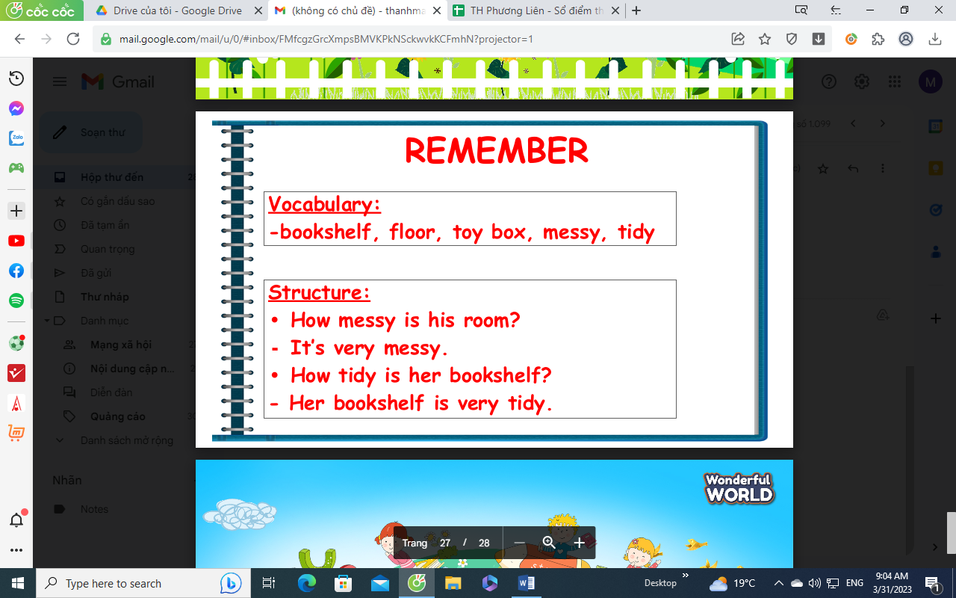 | -Do the assessment.  - Check with the teacher  - Sts read the wrap-up  - Stand up and say goodbye to the teacher.

