UBND HUYỆN VĨNH BẢO  TRƯỜNG TH HÙNG TIẾN | ĐỀ KHẢO SÁT CHẤT LƯỢNG HỌC KỲ 1  MÔN TIẾNG ANH LỚP 4  NĂM HỌC 2024 - 2025  (Thời gian làm bài: 40 phút)
Question 1 : Listen and number (1pt)
  a. |   b. |   c. |   d.
Question 2: Listen and circle . (1pt)
- I’ve got 21 / 22 cupcakes.
- We’ve got 23/ 24 apples.
- She’s got 26 biscuit / 26 biscuits
- She’s got 25 oranges / 25 orange trees
Question 3: Listen and tick . (1pt)
1 My cousin hasn’t got…….. |  | 2 I have got …………..
 |  | 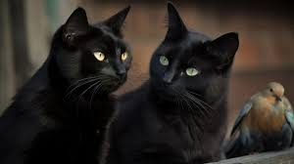 | 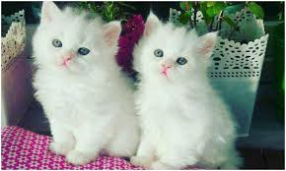
a. | b. | a. | b.
3 My parents have got……. |  | 4 I haven't got ……..
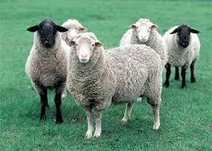 | 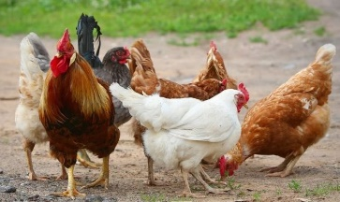 |  | 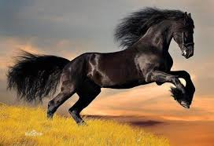
a. | b. | a. | b.

Question 4: Listen to the question and circle the correct answer. (0,5pt)
1.  A. She’s riding a horse  B. She’s playing board games.  C. She’s jumping rope. | 2.  A. They playing basketball.  B. They’re playing basketball.  C. They are play basketball

PART II . Reading and writing.
Question 5: Odd one out . (1,5pt)
1 | a. cheerful | b. friend | c. hard-working | d. cool
2 | a. bowl | b.bookshelf | c. messy | d. sofa
3 | a. chicken | b. cow | c. field | d. goat
4 | a. orange | b. vegetables | c. sandwich | d. lemonade
5 | a. windy | b. snowy | c. hot | d. weather
6 | a. sheep | b. horse | c. dog | d. cat

Question 6 . Chosse the best answer (1,5pts)
- I’ve got a ( cow / two cows / some cows / cows ) .
- She ( have got / is / has got/ haves got ) five sheep .
- The cows haven’t got ( legs / tail / fur / hands ).
- The weather is ( cold / warm / sunny / windy ) 
- They are ( riding / dancing / swimming / swim ) in the pool .
- We can’t have a picnic ( because / and / but / so ) it’s rainy.
Question 7 . Chosse the word from the box.(1,5pts)
spaghetti | kitchen | Orange |  | sandwich | next to | food

This is our________(1). There’s a fridge________(2) the sink and there is an apple and an________(3) in the fridge. I’m very hungry so I’d like a _________(4) and some _______(5) now. Sandwich is my favourite________(6).
Question 8. Ararange the words to make sentences. (1pt)
- cold/ It’s / windy / and / today /. /
_____________________________________________________
- weather / What’s / like / Sunday / the / on / ? /
_____________________________________________________
- snowy / very / It’s / week / this /. /
_____________________________________________________
- summer / in / What’s / like / weather / the / ? /
_____________________________________________________
Question 9 Look at the picture and write one word in the blank.(1pt)
1……………… | 
2 . The baby is very …………….. | 
3. My ………………. is funny. | 
4.They are …………….. They are pretty. | 

UBND HUYỆN VĨNH BẢO  TRƯỜNG TH HÙNG TIẾN | ĐỀ KHẢO SÁT CHẤT LƯỢNG HỌC KỲ 1  MÔN TIẾNG ANH LỚP 4  NĂM HỌC 2024 - 2025  (Thời gian làm bài: 40 phút)

ĐÁP ÁN
Question 1 : Listen and number (1pt)
1.c | 2.a | 3.d | 4.b
Question 2: Listen and circle . (1pt)
22 | 24 | 26 biscuits | 25 orange trees
Question 3: Listen and tick . (1pt)
1. b | 2.a | 3.b | 4.b
Question 4: Listen to the question and circle the correct answer. (0,5pt)
1.c 2.b
Question 5: Odd one out . (1,5pt)
1.b | 2.c | 3.c | 4.d | 5.d | 6.a
Question 6 . Chosse the best answer (1,5pts)

1. cow | 2. has got | 3. hands | 4. sunny | 5. swimming | 6. because

Question 7 . Chosse the word from the box.(1,5pts)
1. kitchen | 2. next to | 3. orange |  | 4. sandwich | 5. spaghetti | 6. food
Question 8. Ararange the words to make sentences.(1pt)
- It’s windy and cool today.
- What’s the weather like on Sunday?
- It’s very snowy this week.
- What’ the weather like in summer.
Question 9 Look at the picture and write one word in the blank(1pt)
1.clever | 2.cute | 3.father | 4.twins

