Đề đề xuất | ĐỀ KHẢO SÁT CHẤT LƯỢNG HỌC KỲ 1  MÔN TIẾNG ANH LỚP 3  NĂM HỌC 2024 - 2025  (Thời gian làm bài: 40 phút)

Part I. Listening
Question 1: Listen and number from 1 to 4. (1.0 pt)
C
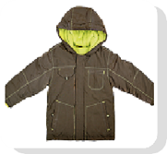
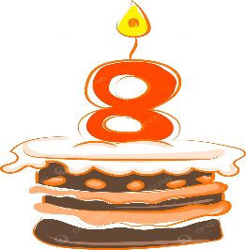
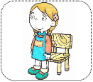
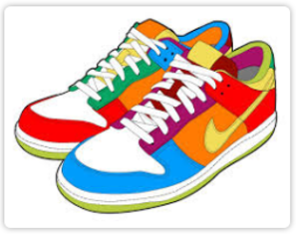



2. Listen and circle. (1pt)
1. A. It’s a classroom  B. It’s a computer room | 3. A. That’s a TV  B. That’s a book
2. A. He’s a student  B. She’s a student | 4. A. That’s a computer.  B. That’s a lamp.
3.Listen and tick the word. (1pt)
1. This is ……………………………  giraffe monkey | 2. That is ……………………………  dog lion
3. These are ………………………  monkeys elephants | 4. Those are ……………………………  giraffes rabbits
4. Listen to the question and choose the correct answer. (0.5pt)
1. A. No, I don’t B. Yes, I have. C. Yes, it is
2. A. No, there isn’t B. Yes, it is. It’s a coat. C. Yes, it isn’t

Part II. Reading and Writing.
Questions 5: Odd one out.(1.5pts)

1. a. warm | b. coat | c. dress | d. hat
2 a. brother | b. mum | c. family | d.grandpa
3. a. trousers | b. ball | c. doll | d. clock
4. a. teacher | b. board | c. student | d. pupil
5. a. sea | b. turtle | c. whale | d. shark
6. a. socks | b. shoes | c. skirt | d. trousers

Question 6: Choose the best answer.(1.5pts)

1. Is ____________ a clock in the bedroom? – Yes, there is.
A. this B. there C. that
2. There is ________ teacher. She’s nice.
A. a B. an C. the
3. She’s got a______ hat.
A. dress B. bed C. big
4. Are you a ____ student?
A. cool B. blue C. What
5. ________ a chair.
A. He’s B. It’s C. She’s
6. ________ got T- shirt.
A. They’ve B. They C. Their
Questions 7: Choose the words from the box.(1.5pts)
They young rabbits is black are

There are two (1)_____ in my garden. They (2)_____ from Australia. They are brown, white and (3)______. They are (4)______. The small rabbit is one year old. The big rabbit (5)_____ two years old. (6)______ like carrots.
Question 8: Arrange the words to make sentences.(1.0pt)
- It’s/ baby/ a/ shark/.
_________________________________________________________
- is/ That/ a / bird/.
_________________________________________________________
- turtles / are / in /the / sea / These/.
________________________________________________________
- in/ are / elephants/ Africa/ Those/.
_________________________________________________________
Question 9: Look at the picture and write One word in the blank.(1.0pt)
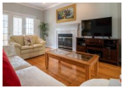
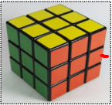

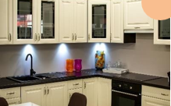

- 2. 3. 4.

Đáp Án

Question 1: Listen and number from 1 to 4. (1.0 pt)
1.B 2.C 4.A 5.D
Question 2: Listen and circle. (1.0pt)
1A. 2B 3A 4A
Question 3: Listen and tick the word. (1.0pt)
1. Giraffe 2. Lion 3. Monkeys 4. Rabbits
Question 4: Listen to the questions and circle the correct answers. (0.5pt)
1.B 2.B
Questions 5: Odd one out.(1.5pts)
1.A 2.C 3.A 4.B 5.A 6.C
Question 6: Choose the best answer A, B or C.(1.5pts)
1.B
2.A
3.C
4.A
5.B
6.A
Questions 7: Choose the words from the box.(1.5pts)
1. Rabbits
2. are
3.black
4. young
5. is
6. They
Question 8: Arrange the words to make sentences.(1.0pt)
1. It’s a baby shark.
2. That is a bird.
3. These are turtles in the sea.
4. Those are elephants in Africa.
Question 9: Look at the picture and write One word in the blank.(1.0pt)
1.living room
2.toy
3. computer
4. kitchen

