UBND HUYỆN VĨNH BẢO  TRƯỜNG TH HÒA BÌNH | ĐỀ KHẢO SÁT CHẤT LƯỢNG HỌC KỲ 1  MÔN TIẾNG ANH LỚP 3  NĂM HỌC 2024 - 2025  (Thời gian làm bài: 40 phút)
Question 1 : Listen and number (1pt)
1.a/  b/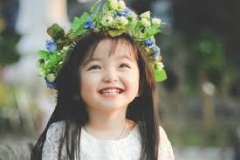 | 2.a. 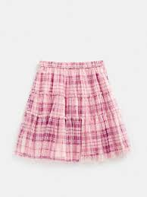 b. 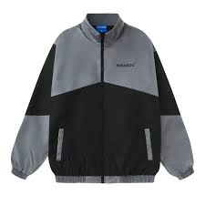
3. a. 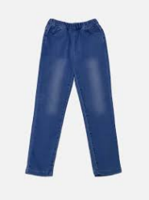 b. 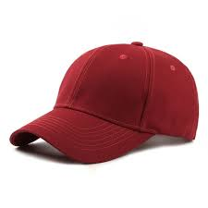 | 4. a.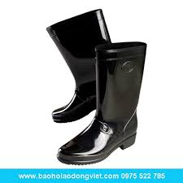 b. 

Question 2: Listen and circle the correct picture (1pt)
1.The .............. are black  a.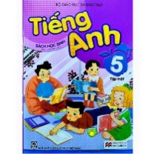 b.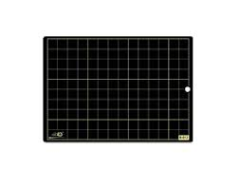 | 2.The students are at the .....................  a.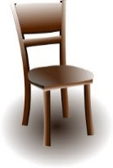 b. 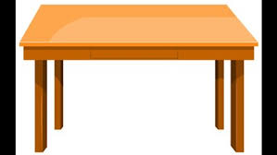
3. The ......................... are black  a. 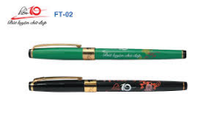 b. 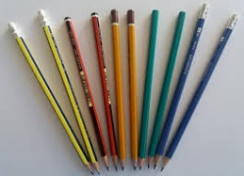 | 4. The ................... are blue.  a.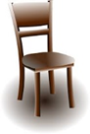 b.

Question 3. Listen and tick .(1 pt)
- Simon is my ...........................
- Dad B. Uncle c.Father
- ..................... is my aunt.
- Tom b. Laura C. Clare
- John is my ............................
A.Cousin b.mother c. brother
4. My ......................... is great.
a. school B.family c.class

Question 4. Listen to the question choose the correct anwser .(1 pt)
- These are students in ( England / Japan / Viet Nam ).
- Really ?
- Yes, They are in their ( class / school / house ) uniform. They’ve got skirts. Their skirts are blue.
-That’s right. They’ve got ( skirts / shirts / shoes ) and socks, too.
Their shoes are ( blue / black / brown ) and their socks are white.
Question 5: Odd one out (1,5 pt)
1. a. Ten | b. Eight | c. One | d.Two
2 a. Blue | b. Pen | c. Book | d.Rubber
3.a Great | b. Good | c.Mum | d. Cool
4.a. teacher | b. House | c. School | d. Class
5. Cat | b. Tiger | c. Dog | d. Parrot
6. a.Shirt | b. Shoes | c. skirt | d. Hat

Question 6. Choose the best answer (1.25pt)
1. ............. are chairs .They're brown.
a. He b. I c. They d. You
2. Are you a……………. ?
a. Pen b. Student c . school d. shirt
3. ……………… is my bedroom .It’s small.
a. They b. Those c . This d. These
4. Is Jonh a student ? – Yes, ………. is
a . they b. I c. He d. she
5. I …………… got a blue hat .
a. is b. has c. have d. are
Question 7. Choose the words from the box (1,25 pt)
student is I are baby has

This ...........(1) my family. There are four people. They .................(2) my father, my mother, my brother and ............(3). My sister is a ....................... (4). She is twelve years old. She ............................(5) got a blue pen and a black school bag.And she is a good student.
8. Arrange the words to make sentences (1 pt)
1. are/These/ sharks.
........................................................................................................................................
2. those /baby /the /whales./ are
.......................................................................................................................................
3. aren’t /the /in/ garden /tigers /the.
......................................................................................................................................
4. an /that / elephant / is / .
......................................................................................................................................
Question 9. Look and write (1 pt)

1. 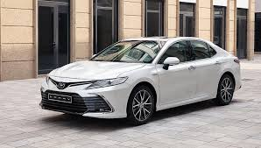 | 2. 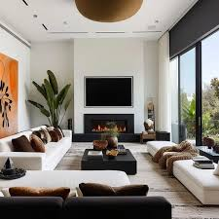 | 3. 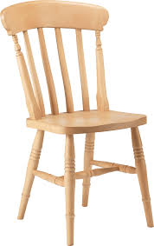 | 4. 
My …………. is white | The ………….. is very nice. | This is a …………. | It’s my ……………..

