Question 1: Listen and number

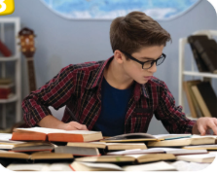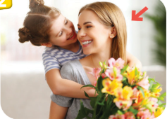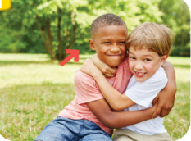

Question 2: Listen and circle

- My favourite food is vegetables / yoghurt
- His favourite food is nuts / yoghurt
- Her favourite drink is lemonade / bubble tea
- Their favourite drink is bubble tea/ soft drink
- My favourite drink is milk/ soft drink
Question 3: Listen and tick
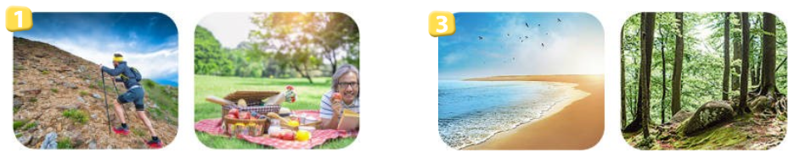

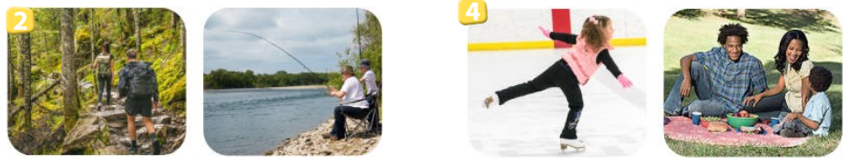
A B A B

A B A B

Question 4: Listen to the question and circle the correct answer.

- a/ She’s playing on the seesaw

b/ She’s riding a horse

c/ She’s jumping rope

d/ He’s playing football

- a/ They’re jumping rope
b/ They’re playing basketball

c/ They’re reading books

d/ They’re watching TV
Question 5: Odd one out
1. a. messy b. fridge c. plate d. sink
2.a. weather b. cloudy c. snowy d. stormy
3. a.soft drink b. sandwich c. spaghetti d. pizza
4. a. beach b. forest c. mountain d. ice-skate
5. a. animals b. hands c. legs d. wings
6. a. clever b. kind c. pleasant d. twins

Question 6: Choose the best answer A, B, C or D to complete the sentences:

1. Have you got plants on the farms?
a. No, we don’t b. Yes, we have c. No, we have d. Yes, we haven’t
2. The sheep haven’t got ………
a. legs b. fur c. wings d, tails
3. What can we do on the lake? - We can ………………….
a. pitch a tent b. walk the dog c. fly a kite d. ice- skate
4. The monkey has got two ……..
b, wings c, tails d, head a, hands
5.We can’t have a picnic in the park today because it’s so……………..
a. warm b. rainy c. sunny d. stormy
6. It’s snowy and cold. I can _______________ hiking, but I can’t walk a lot.
A. forest B. have C. go D. pitch

Question 7: Choose the words from the box
hiking sunny next are can’t wings
1.There is a fridge ……….. to the sink.
2.. It isn’t windy this afternoon. We …..………. fly a kite.
3. The boxes …………on the floor.
4. It’s ……….. We can go to the beach.
5. They can’t go………..…. on the mountain.
6. The cats haven’t got ………………..
Question 8: Reorder these words to make sentences;
1, Autumn /weather/is/what/like/in/the/?
………………………………………………………………………..
2, playing /seesaw/on /they/are/the/
…………………………………………………………………………..
3, cooking/is/My /mother/ kitchen/now/in/the/
…………………………………………………………………………..
4, where/Mary/Anna /and/playing/games/boards/are/.
…………………………………………………………………………..
Question 9: Look at the pictures and write one word only to complete sentences:



1.Her …………..….are good and pretty

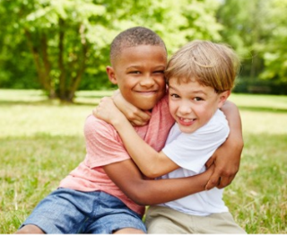
2. My friend is ………………….


3.What is her sister like?
Her sister is………………
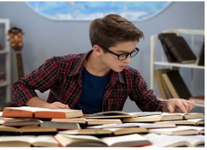

4. What ‘s your brother like ?
My brother is ……………..

KEY
Question 1: Listen and number

4 --- 3 ----- 2 ------ 1

Question 2: Listen and circle

1. yoghurt 2. Nuts 3. lemonade 4. bubble tea 5. milk
Question 3: Listen and tick

1 A 2 B 3 A 4. B

Question 4: Listen to the question and circle the correct answer.

1 C 2 B
Question 5: Odd one out
1 a 2 a 3 a 4d 5 a 6.d

Question 6: Choose the best answer A, B, C or D to complete the sentences:

1. Have you got plants on the farms?
a. No, we don’t b. Yes, we have c. No, we have d. Yes, we haven’t
2. The sheep haven’t got ………
a. legs b. fur c. wings d, tails
3. What can we do on the lake? - We can ………………….
a. pitch a tent b. walk the dog c. fly a kite d. ice- skate
4. The monkey has got two ……..
b, wings c, tails d, head a, hands
5.We can’t have a picnic in the park today because it’s so……………..
a. warm b. rainy c. sunny d. stormy
6. It’s snowy and cold. I can _______________ hiking, but I can’t walk a lot.
A. forest B. have C. go D. pitch

Question 7: Choose the words from the box
hiking sunny next are can’t wings
1.There is a fridge …next…….. to the sink.
2.. It isn’t windy this afternoon. We ….can’t.………. fly a kite.
3. The boxes ……are……on the floor.
4. It’s …sunny…….. We can go to the beach.
5. They can’t go……hiking…..…. on the mountain.
6. The cats haven’t got ……wings…………..
Question 8: Reorder these words to make sentences;
1, Autumn /weather/is/what/like/in/the/?
What’s the weather like in Autumn
2, playing /seesaw/on /they/are/the/
They are playing on the seesaw
3, cooking/is/My /mother/ kitchen/now/in/the/
My mother is cooking in the kitchen now
4, where/Mary/Anna /and/playing/games/boards/are/.
Where are Mary and Anna are playing board games

Question 9: Look at the pictures and write one word only to complete sentences:

1.Her ……twins ……..….are good and pretty

2. My friend is ……friendly…………….

3.What is her sister like?
Her sister is……kind…………

4. What ‘s your brother like ?
My brother is ……hard-working………..

