PHẦN 1: ĐỀ
UBND HUYỆN VĨNH BẢO  TRƯỜNG TH THANH LƯƠNG  (Đề đề xuất) | ĐỀ KHẢO SÁT CHẤT LƯỢNG HỌC KỲ I  MÔN TIẾNG ANH LỚP 3  NĂM HỌC 2024 - 2025  (Thời gian làm bài: 40 phút)

Question 1: Listen and number. (1pt)

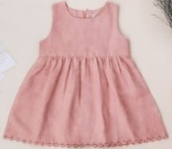 | 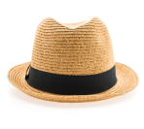 | 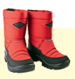 | 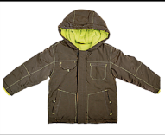
a. | b. | c. | d.

Question 2: Listen and circle. (1pt)

1. The boards are ……………… a. green b. white c. black
2. The students are at the …….. a. desks b. rooms c. board
3. The pencils are ……………. a. brown b. black c. red
4. The chair are ……………. a. black b. yellow c. blue

Question 3. Listen and tick the word. (1pt)

1. This is a……………………………  a.monkey b. giraffe c. tiger | 2. That is a…………………………  a. lion b. dog c. bird
3. These are ………………………  a. fish b. elephants c. monkeys | 4. Those are ……………………………  a. giraffes b. rabbits c. hippos

Question 4. Listen to the question and circle the correct anwser. (0,5 pt)

1. A. Yes. My hat is white and black.  B. Yes. My hat is white and red.  C. Yes. My hat is white and yellow. | 2. A. Yes, she’s got an old skirt.  B. No. He’s got a new shirt.  C. Yes. She’s got a new skirt.

Question 5: Odd one out. (1,5 pts)
1. a. five | b. orange | c. seven | d. eight
2. a. brother | b. father | c. grandma | d. short
3. a. board | b. student | c. rubber | d. book
4. a. elephant | b. shark | c. run | d. bird
5. a. bedroom | b. warm | c. great | d. new
6. a. trousers | b. coats | c. clothes | d.socks

Question 6. Choose the best answer. (1.5pts)
1. This is .............teacher, Mrs Lee.
a. she b. its c. my d. they
2. A: Are you a student? B: Yes, ……… am.
a. we b. I c. they d. she
3. There...........three bedrooms in my house.
a. is b. are c . am d. these
4. There is an elephant. The elephant is …………. .
a. small b. new c. big d. pink
5. They've got T-shirts. Their ……………… are white.
a. skirts b. shoes c. trousers d. T-shirts
6. Lan has got a ……….. dress. It is very nice.
a. new b. young c. tall d. ugly

Question 7. Choose the words from the box. (1,5 pts)
father name and years am family

Hello. My (1) ................ is Mai. I am eight (2) ................ old. I (3) ................... a student. This is my family. This is my (4) ... ................. He is tall and strong. This is my mother. She is young (5) ................. beautiful. And this is my brother. He is short and funny. I love my (6) ..................... very much.

8. Arrange the words to make sentences. (1pt)
1. is / a / rabbit / This / and/ is /an / that/ elephant/.
-> .............................................................................................................................................
2. Africa / are / These /animals / in / .
-> .............................................................................................................................................
3. are / These / turtles / the / in / baby/ sea /.
-> .............................................................................................................................................
4. those / What / are /? - giraffes / are/ they/.
-> .............................................................................................................................................

Question 9. Look at the picture and write one word in the blank. (1pt)
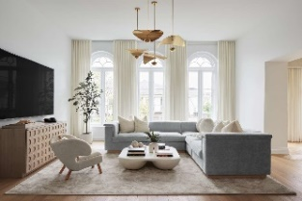  1. ........................... |   2. .............................. | 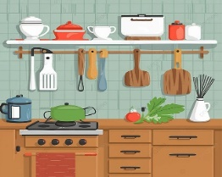  3. ............................ | 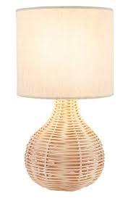  4. ..........................

PHẦN 2: ĐÁP ÁN
UBND HUYỆN VĨNH BẢO  TRƯỜNG TH THANH LƯƠNG  (Đề đề xuất) | ĐÁP ÁN ĐỀ KHẢO SÁT CHẤT LƯỢNG HỌC KỲ I  MÔN TIẾNG ANH LỚP 3  NĂM HỌC 2024 - 2025  (Thời gian làm bài: 40 phút)
Question 1: Listen and number. (1pt)
a. 4 | b. 3 | c. 2 | d. 1
Question 2: Listen and circle. (1pt)
1. c | 2. a | 3. b | 4. c
Question 3. Listen and tick the word. (1pt)
1. b | 2. a | 3. c | 4. b
Question 4. Listen to the question and circle the correct anwser .(0,5 pt)
1. b | 2. c
Question 5: Odd one out. (1,5 pts)
1. b | 2. d | 3. b | 4. c | 5. a | 6. c
Question 6. Choose the best answer. (1.5pts)
1. c | 2. b | 3. b | 4. c | 5. d | 6. a

Question 7. Choose the words from the box. (1,5 pts)
1. name | 2. years | 3. am | 4. father | 5. and | 6. family

Question 8. Arrange the words to make sentences. (1pt)
1. This is a rabbit and that is an elephant.
2. Theses are animals in Africa.
3. These are baby turtles in the sea.
4. What are those? -> They are giraffes.
Question 9. Look at the picture and write one word in the blank. (1pt)
1. living room | 2. computer | 3. kitchen | 4. lamp

