PHẦN 1: ĐỀ
UBND HUYỆN VĨNH BẢO  TRƯỜNG TH THANH LƯƠNG  (Đề đề xuất) | ĐỀ KHẢO SÁT CHẤT LƯỢNG HỌC KỲ I  MÔN TIẾNG ANH LỚP 4  NĂM HỌC 2024 - 2025  (Thời gian làm bài: 40 phút)
Question 1: Listen and number. (1pt)
 | 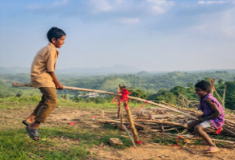 | 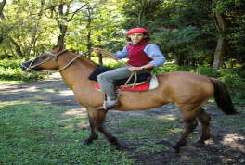 | 
a. | b. | c. | d.
Question 2: Listen and circle. (1pt)
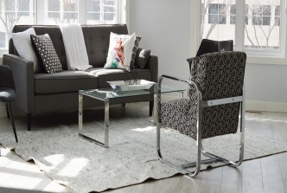  1. a | 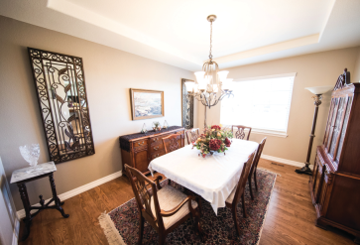  b | 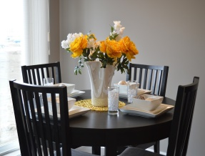  2. a |   b
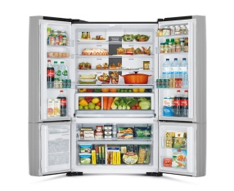  3. a | 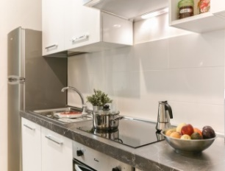  b |   4. a | 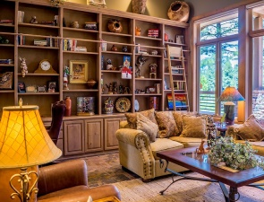  b
Question 3: Listen and tick the word or phrase. (1pt)
1. My cousin has got …….. ( a. a dog b. some fish c. many goldfish)
2. I haven't got ………… . (a. any black cats b. two white cats c. three white cats)
3. My parents have got …… ( a. one sheep b. some sheep c. some goats )
4. I have got …… ( a. a white horse b. a horse c. black and long legs)
Question 4: Listen to the question and circle the correct answer. (0,5pt)
1. a. It’s snowy. b. It’s windy. c. It’s stormy.
2. a. It’s cool and windy. b. It’s warm and rainy. c. It’s cold and snowy.
Question 5: Odd one out. (1,5 pts)
1. a. daughter b. polite c. friendly d. cheerful
2. a. spoon b. fridge c. bookshelf d. tidy
3. a. fur b. sheep c. tail d. wing
4. a. cupcake b. yoghurt c. lemonade d. vegetables
5. a. hot b. summer c. rainy d. stormy
1. a. forest b. pitch a tent c. go hiking d. have a picnic
Question 6: Choose the best answer. (1,5pts)
1. We've got many ______ and ducks on the farm.
A. tigers B. chickens C. parrots D. goldfish
2. The horses and cows haven't got________.
A. tails B. legs C. wings D. fur
3. Have you got fruit trees in the field?
A. Yes, we have. B. Yes, I do. C. No, we hasn't. D. No, we aren't.
4. What ________ you do on the mountain? - We can ski on the mountain.
A. do B. are C. can D. have
5. They can go camping on the mountain, ________ they can't go fishing there.
A. and B. but C. so D. then
6. We can't have a picnic in the park today ________ it's rainy.
A. and B. because C. so D. but
Question 7: Choose the words from the box (1.5pts)
How some It's Where favourite cookies
1. Whose garden is it? – _________ their garden.
2. _________ are the books? – They're on the bookshelf.
3. _________ tidy is her bedroom? -> It's very tidy.
4. Would you like _________ spaghetti? -> Yes, please.
5. How many _________ has she got? - She's got twenty-five.
6. What's your _________ ___ food? -> It's chicken.
Question 8: Arrange the words to make sentences. (1pt)
1. is / the / in / like / weather / What / summer/ ?
-> …………………………………………………………………………………………………
2. the / playing / playground / are / in / football / They / .
-> …………………………………………………………………………………………………
3. pool / going/ the / you / in / swimming /Are / ?
-> …………………………………………………………………………………………………
4. comic / Where / are / books / the / reading / girls / ?
-> …………………………………………………………………………………………………
Question 9: Look at the picture and write ONE word in the blank. (1pt)
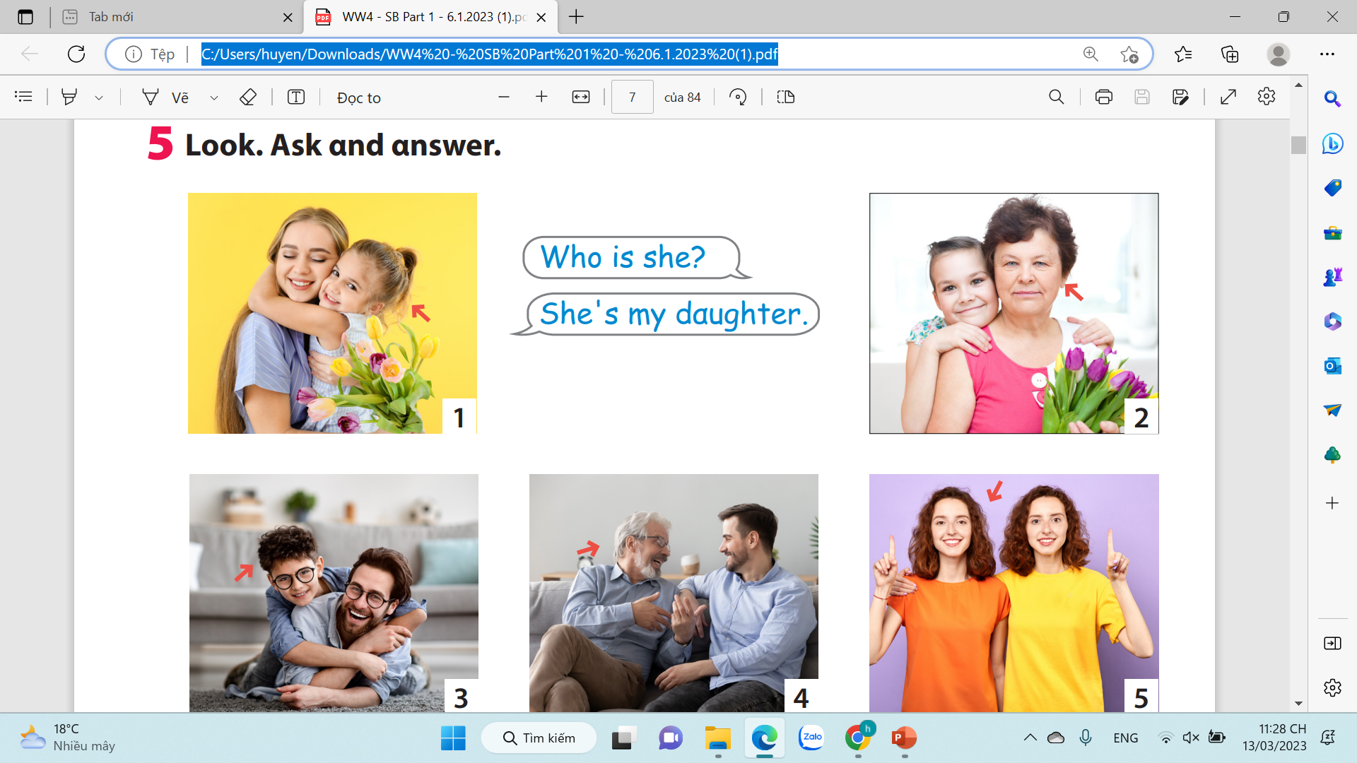  1. She is my ……………………. |   2. My brother is very ……………….
  3. She 's ………………….. |   4. They are clever and ………………..

PHẦN 2: ĐÁP ÁN
UBND HUYỆN VĨNH BẢO  TRƯỜNG TH THANH LƯƠNG  (Đề đề xuất) | ĐÁP ÁN ĐỀ KHẢO SÁT CHẤT LƯỢNG HK I  MÔN TIẾNG ANH LỚP 4  NĂM HỌC 2024 - 2025  (Thời gian làm bài: 40 phút)
Question 1: Listen and number. (1pt)
a -> 2 b -> 3 c -> 4 d -> 1
Question 2: Listen and circle. (1pt)
1 -> a 2 -> b 3 -> b 4 -> b
Question 3: Listen and tick the word or phrase. (1pt)
1. My cousin has got …….. ( a. a dog b. some fish c. many goldfish)
2. I haven't got ………… . (a. any black cats b. two white cats c. three white cats)
3. My parents have got …… ( a. one sheep b. some sheep c. some goats )
4. I have got ……… ( a. a white horse b. black and long legs c. a horse)
Question 4: Listen to the question and circle the correct answer. (0,5pt)
1. a. It’s snowy b. It’s windy c. It’s stormy
2. a. It’s cool and windy b. It’s warm and rainy c. It’s cold and snowy.
Question 5: Odd one out. (1,5 pts)
1. a. daughter b. polite c. friendly d. cheerful
2. a. spoon b. fridge c. bookshelf d. tidy
3. a. fur b. sheep c. tail d. wing
4. a. cupcake b. yoghurt c. lemonade d. vegetables
5. a. hot b. summer c. rainy d. stormy
1. a. forest b. pitch a tent c. go hiking d. have a picnic
Question 6: Choose the best answer. (1,5pts)
1. We've got many ______ and ducks on the farm.
A. tigers B. chickens C. parrots D. goldfish
2. The horses and cows haven't got________.
A. tails B. legs C. wings D. fur
3. Have you got fruit trees in the field?
A. Yes, we have. B. Yes, I do. C. No, we hasn't. D. No, we aren't.
4. What ________ you do on the mountain? - We can ski on the mountain.
A. do B. are C. can D. have
5. They can go camping on the mountain, ________ they can't go fishing there.
A. and B. but C. so D. then
6. We can't have a picnic in the park today ________ it's rainy.
A. and B. because C. so D. but
Question 7: Choose the words from the box (1.5pts)
How some It's Where favourite cookies
1. Whose garden is it? – __ It's ___ their garden.
2. _ Where _ are the books? – They're on the bookshelf.
3. _ How __ tidy is her bedroom? -> It's very tidy.
4. Would you like _ some __ spaghetti? -> Yes, please.
5. How many _ cookies _ has she got? - She's got twenty-five.
6. What's your ___ favourite ___ food? -> It's chicken.
Question 8: Arrange the words to make sentences. (1pt)
1. is / the / in / like / weather / What / summer/ ? -> What is the weather like in summer?
2. the / playing / playground / are / in / football / They / .
-> They are playing football in the playground.
3. pool / going/ the / you / in / swimming /Are / ? -> Are you going swimming in the pool?
4. comic / Where / are / books / the / reading / girls / ?
-> Where are the girls reading comic books?
Question 9: Look at the picture and write ONE word in the blank. (1pt)

1. She is my …daughter…. | 2. My brother is very ……cute….
3. She 's …hard-working.. | 4. They are clever and …friendly..

