UBND HUYỆN VĨNH BẢO  TRƯỜNG TH TAM CƯỜNG | ĐỀ KHẢO SÁT CHẤT LƯỢNG HK 1  MÔN TIẾNG ANH LỚP 3  NĂM HỌC 2024 - 2025  (Thời gian làm bài: 40 phút)
Question 1 : Listen and number (1pt)
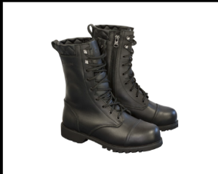
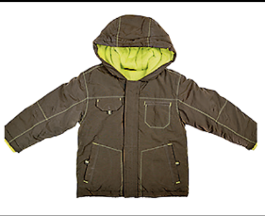
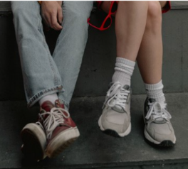
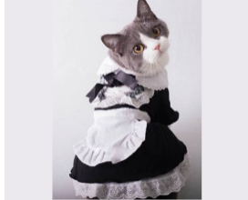

a. | b. | c. | d.
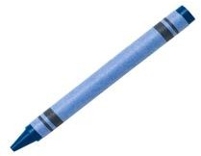

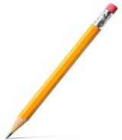
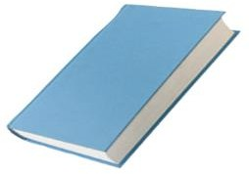
Question 2: Listen and circle the correct picture (1pt)
1. a. | b. | 2. a. | b.
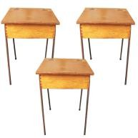
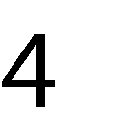

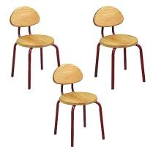
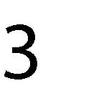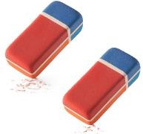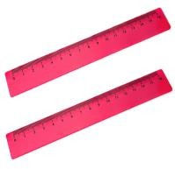
a. | b. | a. | b.

Question 3. Listen and tick .(1 pt)

1. These are the photos of the sea near Australia. Africa.

2. They're baby sharks. turtles.

3. What’s that? - It’s a shark. whale.

4. These are great. funny.
Question 4. Listen to the question choose the correct anwser .(1 pt)

1. A. My T-shirt is white.  B. My skirt is white. | 2. A. Those are shoes  B. Those are socks.

Question 5: Odd one out (1,5 pt)
1. a. boots | b. socks | c. shirt | d. shoes
2. a. lion | b. shark | c. monkey | d. giraffe
3. a. yellow | b. blue | c. red | d. sit down
4. a. lesson | b. rubber | c. ruler | d. desk
5. a. mother | b. funny | c. father | d. brother
6. a. lamp | b. bathroom | c. livingroom | d. bedroom

Question 6. Choose the best answer (1.25pt)
1. There is a chair in my ……………. 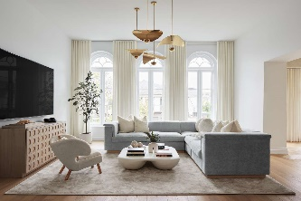
a. bedroom b. bathroom c. living room
2. My mother ………….. a pink T-shirt.
a. have got b. has got c. is got
3. ……… is a student of Tam Cuong Primary school.
a. They b. She c. We
4. Are there a chair in the classroom? – No, …………..
a. there is not b. there aren’t c. there is
5. My brother has got a T-Shirt. The T shirt ……… blue.
a. is b. am c. are
Question 7. Choose the words from the box (1,25 pt)
grandma family eight mum old is

Hello! My name's Tommy. I'm (1).................years old. Look! This is my(2)....................
This is my(3)...................... and this is my dad. My mum is Anna.She is quite young. My dad is Robert. He is very funny. My uncle (4)..................... Bob. My aunt is Tina. My grandpa is John and my (5)...................... is Lily.Both my grandma and grandpa are (6).....................
Question 8. Arrange the words to make sentences (1 pt)
1. are/Those/ elephants.
________________________________________________________________________
2.have/got/They /a/ T-shirt./new
__________________________________________________________________________
3. are/Those/in/sea/baby/sharks/the.
__________________________________________________________________________
4. is/that?/What/- rabbit./a /It’s
_________________________________________________________________________

Question 9. Look and write (1 pt)

1. 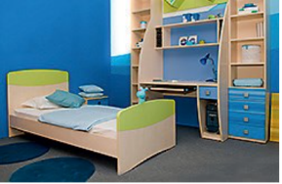 | 2. 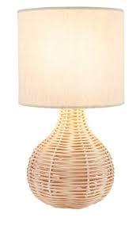 | 3. 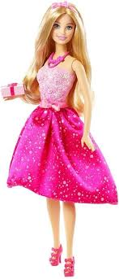 | 4. 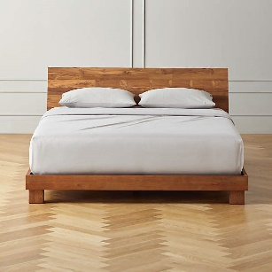

ĐÁP ÁN ĐỀ KHẢO SÁT CHẤT LƯỢNG CUỐI KÌ I MÔN TIẾNG ANH
Question 1: Listen and number (1pt)
a. 3 | b. 4 | c. 1 | d. 2
Question 2: Listen and circle the correct picture (1pt)
1. b | 2. a | 3. a | 4. b
Question 3. Listen and tick .(1 pt)
1. Australia | 2. turtles | 3. shark | 4. great
Question 4. Listen to the question choose the correct anwser .(1 pt)
1. a | 2. b
Question 5: Odd one out (1,5 pt)
1. c | 2. b | 3. d | 4. a | 5. b | 6. a
Question 6. Choose the best answer (1.25pt)
1. c | 2. b | 3. b | 4. a | 5. a
Question 7. Choose the words from the box (1,25 pt)
1. eight | 2. family | 3. mum | 4. is | 5. grandma | 6. old
Question 8. Arrange the words to make sentences (1 pt)
1. Those are elephants.
2. They have got a new T-shirt.
3. Those are baby sharks in the sea.
4. What is that? – It’s a rabbit.
Question 9. Look and write (1 pt)
1.bedroom | 2. lamp | 3. doll | 4. bed

