UBND HUYỆN VĨNH BẢO  TRƯỜNG TH LIÊN AM – LÝ HỌC | ĐỀ KHẢO SÁT CHẤT LƯỢNG HỌC KỲ 1  MÔN TIẾNG ANH LỚP 3  NĂM HỌC 2024 - 2025  (Thời gian làm bài: 40 phút)
Question 1: Listen and number (1pt)
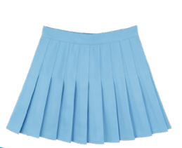 | 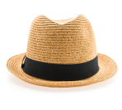 | 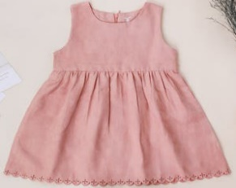 | 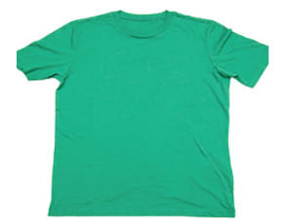
a. | b. | c. | d.
Question 2: Listen and circle the correct picture (1pt)
1. | 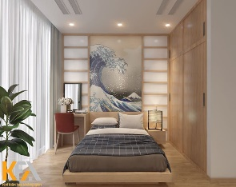 | 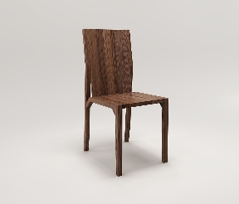 | 2. | 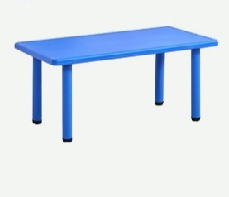 | 
1. | a. | b. |  | a. | b.
3. | 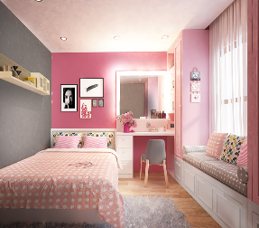 | 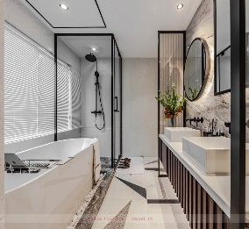 | 4. | 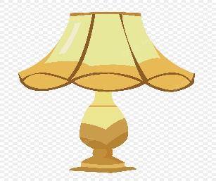 | 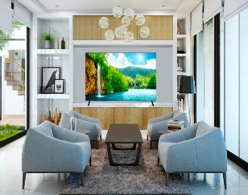
3. | a. | b. | 4. | a. | b.
Question 3: Listen and tick the word .(1 pt)
1. This these is my grandma, Maria.
2. My aunt is Anna. She's old young.
3. That is my brother sister. He is cool.
4. My brother and sister is are funny

Question 4. Listen to the question choose the correct anwser .(0,5 pt)
1. A. I’ve got a coat. It is warm.  B. They’ve got skirts | 2. A. These are socks  B. They've got black shoes.
Question 5: Odd one out (1,5 pt)
1. a. mum | b. brother | c. family | d. sister
2. a. blue | b. red | c. yellow | d. cool
3. a. uncle | b. great | c. funny | d. tall
4. a. desk | b. student | c. chair | d. clock
5. a. whale | b. turtle | c. garden | d. shark
6. a. boots | b. T-shirt | c. shoes | d. trousers
Question 6. Choose the best answer (1,5pt)
1. They're .............They're brown.
a. desks b. board c. table d. clock
2..............you students ?
a. Is b. Am c . Are d. Do
3. There...........a kitchen in my house.
a. are b. is c . that d. those
4. Is Mai a student ? – Yes, she ……………………….
a. do. b. does c. is d. isn’t
5. My mother ...........got a blue dress .
a. are b. has c. have d. are
6. Are there ............in the bedroom?
a. lamp b. book c. toy d. beds
Question 7. Choose the words from the box (1,5 pt)
Look giraffes animals are young sister
These are ...................(1) in Africa: lions, ...................(2), monkeys and elephants. (3) ........................... at the elephants. They’re a family. That is the mum. Those (4 ) ....................... the baby elephants. They’re ..................(5). They're a brother and a ...................(6) .
Question 8. Arrange the words to make sentences (1 pt)
1. are / these / lions/ big/.
____________________________________________________________________
2. a / blue / It / is / bird. / nice/ It’s/.
____________________________________________________________________
3. are / these / in / sea/ turtles / the/.
____________________________________________________________________
4. cat / is / It / in/ garden/ a / the /.
____________________________________________________________________
Question 9. Look at the picture and write one word in the blank (1 pt)
 |  | 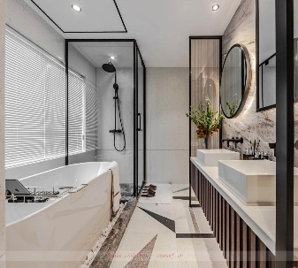 | 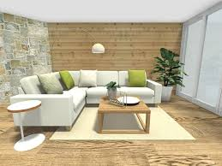
1. | 2. | 3. | 4.

ĐÁP ÁN ĐỀ KHẢO SÁT CHẤT LƯỢNG CUỐI KÌ I MÔN TIẾNG ANH
Question 1: Listen and number (1pt)
1. d | 2. c | 3. a | 4. b
Question 2: Listen and circle the correct picture (1pt)
1. a | 2. b | 3. b | 4. b
Question 3. Listen and tick .(1 pt)
1. this | 2. young | 3. brother | 4. are
Question 4. Listen to the question choose the correct anwser .(1 pt)
1. A | 2. B
Question 5: Odd one out (1,5 pt)
1. c. family | 2. d. cool | 3. a. uncle | 4. b. student | 5. c. garden | 6. b. T - shirt
Question 6. Choose the best answer (1.25pt)
1. a. desks | 2. c. Are | 3. b. is | 4. c. is | 5. b. has | 6. d. beds
Question 7. Choose the words from the box (1,25 pt)
1. animals | 2. giraffes | 3. Look | 4. are | 5. young | 6. sister
Question 8. Arrange the words to make sentences (1 pt)
1. These are big lions.
2. It is a blue bird. It’s nice.
3. These are turtles in the sea.
4. It is a cat in the garden.
Question 9. Look and write (1 pt)
1. computer | 2. lamp | 3. bathroom | 4. livingroom

