UBND HUYỆN VĨNH BẢO  TRƯỜNG TH LIÊN AM – LÝ HỌC | ĐỀ KHẢO SÁT CHẤT LƯỢNG HỌC KỲ 1  MÔN TIẾNG ANH LỚP 4  NĂM HỌC 2024 - 2025  (Thời gian làm bài: 40 phút)
Question 1: Listen and number (1pt)
  a. |   b. | 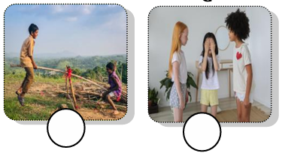  c. | d.
Question 2: Listen and circle (1pt)
1. |  |  | 2. |  | 
1. | a b |  |  | a b
3. |  |  | 4. |  | 
3. | a b |  | 4. | a b
Question 3: Listen and tick (). (1pt)
1. a. The chicken has got wings.  b. The fish haven’t got wings | 2. a. The goat has got white fur.  b. The goat has got black fur.
3. a. We have got plants on the farm.  b. We have got animals on the farm. | 4. a. The horses have long legs.  b. The horses have long tails.
Question 4. Listen to the question choose the correct anwser .(0,5 pt)
1. A. It’s cold and snowy.  B. It’s sunny and windy  C. It’s stormy and windy. | 2. A. I’m jumping rope  B. They’re playing hide-and-seek .  C. She’s riding a horse.
Question 5: Odd one out (1,5 pt)
1 | a. polite | b. clever | c. hard-working | d. daughter
2 | a. tidy | b. spoon | c. plate | d. bowl
3 | a. horse | b. cow | c. farm | d. goat
4 | a. cookie | b. lemonade | c. sandwich | d. cupcake
5 | a. cloudy | b. stormy | c. summer | d. sunny
6 | a. sheep | b. wings | c. hands | d. legs
Question 6. Choose the best answer (1,5pt)
1. | The horses haven’t got ………..
 | a. tail | b. legs | c. wings | d. fur
2. | Have you got sheep on the farm?
 | a. No, we have | b. Yes, we have | c. Yes, we haven’t | d. No, we hasn’t
3. | He can’t have a picnic in the park today because it’s …………
 | a. stormy | b. sunny | c. cloudy | d. warm
4. | The cows have got long…………
 | a. wings | b. tails | c. fur | d. hands
5. | Let’s………...to the mountain and ski
 | a. play | b. run | c. swim | d. go
6. | We……….. go camping today because it’s sunny.
 | a. can | b. is | c. can’t | d. are
Question 7. Choose the words from the box (1,5 pt)
can rainy many rug hiking in
1. The sofa is ……………. front of the fridge.
2. We can’t go camping today because it’s …………..
3. There is a big ………..under the table.
4. They can’t go………..…. on the mountain.
5. It is windy this afternoon. We …..………. fly a kite.
6. How ……….sandwiches has she got? She’s got 21.
Question 8. Arrange the words to make sentences (1 pt)
1. is / What / in / like / weather / the / summer/ ?
…………………………………………………………………………………………
2. are / playing / playground / the / in / hide- and- seek / They /.
…………………………………………………………………………………………
3. kitchen / cooking/ the / She / in / is / with her mother/. …………………………………………………………………………………………
4. watching/ Where / are / a / the / film / girls /?
…………………………………………………………………………………………
Question 9. Look at the picture and write one word in the blank (1 pt)
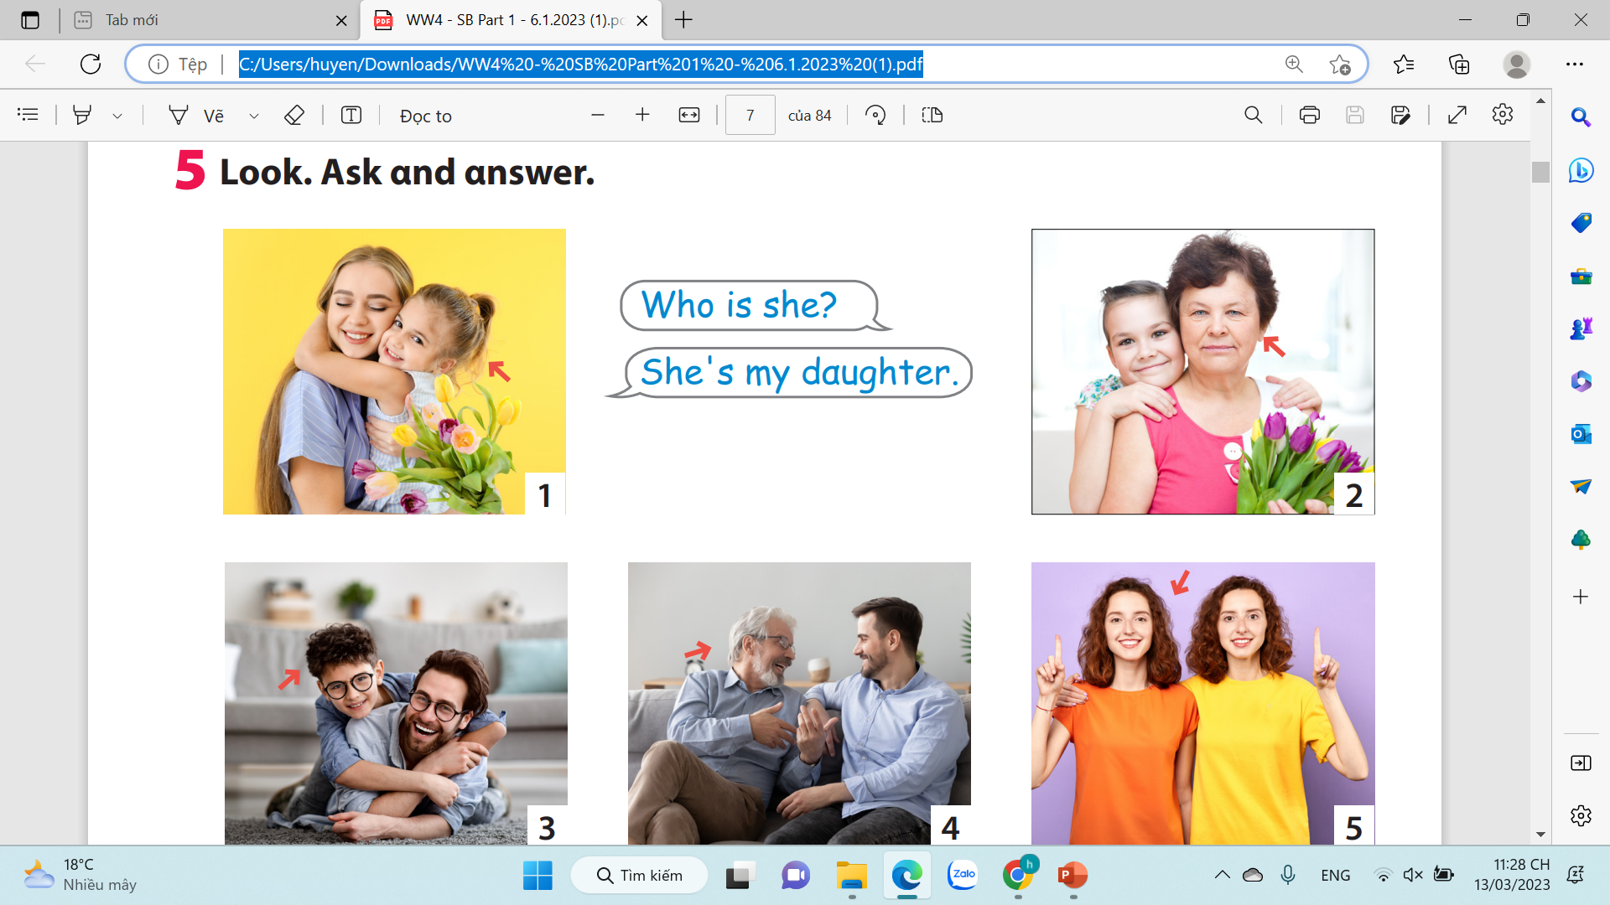 | 
1. She is my ……………………. | 2. They are clever and ……………..
 | 
3. What’s your brother like ?  He is …………………. | 4. What is her sister like?  Her sister is………………
ĐÁP ÁN ĐỀ KHẢO SÁT CHẤT LƯỢNG CUỐI KÌ I MÔN TIẾNG ANH
Question 1: Listen and number (1pt)
1. d | 2. c | 3. a | 4. b
Question 2: Listen and circle (1pt)
1. b | 2. a | 3. b | 4. a
Question 3. Listen and tick .(1 pt)
1. b | 2. a | 3. a | 4. b
Question 4. Listen to the question choose the correct anwser .(1 pt)
1. A | 2. B
Question 5: Odd one out (1,5 pt)
1.d. daughter | 2. a. tidy | 3. c. farm | 4.b.lemonade | 5. c. summer | 6. a. sheep
Question 6. Choose the best answer (1.25pt)
1. c. wings | 2. b. Yes, we have | 3. a. stormy | 4.b. tails | 5. d. go | 6. a. can
Question 7. Choose the words from the box (1,25 pt)
1. in | 2. rainy | 3. rug | 4. hiking | 5. can 6. many
Question 8. Arrange the words to make sentences (1 pt)
1. What is the weather like in summer?
2. They are playing hide- and- seek in the playground.
3. She is cooking with her mother in the kitchen.
4. Where are the girls watching a film?
Question 9. Look and write (1 pt)
1. daughter | 2. friendly | 3. hardworking | 4. kind

