UBND HUYỆN VĨNH BẢO  TRƯỜNG TH LIÊN AM – LÝ HỌC | ĐỀ KHẢO SÁT CHẤT LƯỢNG HỌC KỲ 1  MÔN TIẾNG ANH LỚP 5  NĂM HỌC 2024 - 2025  (Thời gian làm bài: 40 phút)
Question 1. Listen and circle the sentences you hear (1pt)
1. a. My brother is funny  b. My father is friendly  c. My mother is happy | 2. a. My sister is noisy  b. My sister is friendly  c. My sister is clever
3. a. My sister is a careful runner  b. My sister is a slow runner  c. My sister is a quick runner | 4. a. They play well together  b. They play happily together  c. They play happy together
Question 2. Listen and fill in the blanks (1pt)
1. There is a big red ball ………………… of the room.
a. below b. inside c. above d. in the middle
2. Excuse me, can I ___________________ here? Sure, go ahead.
a. sit b. put c. move d. do
3. A yellow ball is ___________________ the box.
a. below b. inside c. above d. outside
4. There is a pink ball ___________________ the box.
a. below b. inside c. above d. outside
Question 3. Listen to the questions and circle the correct answers (1pt)
1. _________________________________?  a.Yes, she does. She has English on Mondays.  b. She has English on Mondays  c.No, she doesn’t. She has English on Mondays. | 2. ______________________________?  a. She has Geography at 3.50 on Tuesdays  a. Yes, she does  a. No, she doesn’t. She has Music at 3.50
3._________________________________?  a. She starts her lessons with her classmates.  b. She starts her lessons at school  c. She starts her lessons at 8 a.m | 4. ______________________________?  a. She has maths in the morning.  b. She has maths every Wednesday.  c. She has maths on Wednesdays.
Question 4. Listen and Match. (1pt)
1. My father often............... | a.  | 1 -
2. I’ve got a box of .............. | b.  | 2 -
3. There are ......................... on the wall of my living room. | c.  | 3 -
4. I need to buy a lot of .................... for the family party on Christmas Eve. | d. 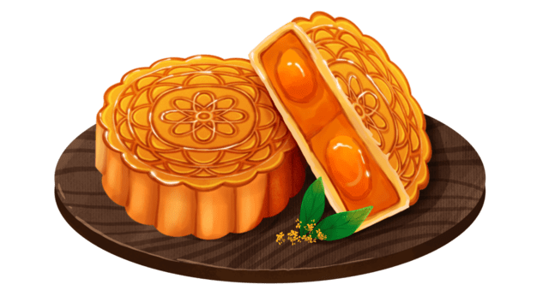 | 4 -
Question 5: Odd one out (1,5 pt)
1 | a. cupcakes | b. butter | c. bread | d. chocolate
2 | a. salty | b. food | c. sour | d. spicy
3 | a. a lot of | b. many | c. much | d. how
4 | a. map | b. above | c. globe | d. ball
5 | a. puzzle | b. typewriter | c. like | d. computer
6 | a. was | b. were | c. but | d. are
Question 6. Choose the best answer (1,5pt)
1. | 1. She ……………..to school five days a week.
 | a. go | b. going | c. went | d. goes
2. | Let’s ……………..New Year’s Eve together.
 | a. celebration | b. celebrating | c. celebrate | d. to celebrate
3. | We …………….football at the weekend.
 | a. played | b. play | c. playes | d. plays
4. | I ………….a nice time with my family last Christmas.
 | a. had | b. has | c. haves | d. have
5. | Don’t ……….out at night.
 | a. to go | b. go | c. going | d. goes
6. | Jenny brushes …………… teeth everyday.
 | a. her | b. his | c. my | d. hers
Question 7: Find and circle the mistakes. (1pt)
1. She’s good at play football. She loves playing outside everyday.
A B C D
2. Mai is got many friends
A B C D
3. Penguins are carefully parents. They take care of their eggs carefully.
A B C D
4. Do you good at making cakes in your free time?
A B C D
Question 8. Read the passage and circle the best answer(1pt)
I love reading. When I have free time, I always read my favouirte books. I love to read comic books at the (1) _______. That is a great way to pass the time. I also love (2) _________ to music and dancing. I’m good (3) _______going ice-skating. I practise it in my free time. I also enjoy going fishing with my dad when we visit our grandparents. Of course, I also (4) ________ the piano.
1. a. cinema b. zoo c. restaurant d. bookshop
2. a. read b. collecting c. listening d. watch
3. a. at b. for c. with d. from
4. a. do b. play c. make d. sing
Question 9. Arrange the words to make sentences (1pt)
1. on/ practice/ Sundays/ I/ usually /sports/.
__________________________________________________________________________
2. often / he / How / piano / play / does / the ?
__________________________________________________________________________
3. brother / maths / My / the/ studies / afternoon / in / always.
_________________________________________________________________________
4. she / English / Does / usually / have / Thursdays/ Monday / on / and ?
__________________________________________________________________________

ĐÁP ÁN ĐỀ KHẢO SÁT CHẤT LƯỢNG CUỐI KÌ I MÔN TIẾNG ANH
Question 1: Listen and number (1pt)
1.a 2. c 3. b 4. b
Question 2. Listen and fill in the blanks (1pt)
1. d. in the middle 2. a. sit 3. b. inside 4. d. outside
Question 3. Listen to the questions and circle the correct answers (1pt)
1. c 2. a 3. c 4. b
Question 4. Listen to the question choose the correct anwser .(1 pt)
1.c 2. d 3. b 4. a
Question 5: Odd one out (1,5 pt)
1.a. cupcakes 2.b. food 3.d. how 4.b. above 5.c. like 6.c. but
Question 6. Choose the best answer (1.5pt)
1. d. goes | 2. c. celebrate | 3. b. play | 4.a. had | 5. b. go | 6. a. her
Question 7: Find and circle the mistakes. (1pt)
1. C 2. B 3. B 4. A
Question 8. Read the passage and circle the best answer(1pt)
1 d 2. c 3. a 4. b
Question 9: Arrange the words to make sentenmces (1pt)
- I usually practice sports on Sundays.
- How often does he play the piano?
- My brother always studies maths in the afternoon.
- Does she usually have English on Mondays and Thursdays?

