UBND HUYỆN VĨNH BẢO  TRƯỜNG TIỂU HỌC HOÀ BÌNH | ĐỀ KHẢO SÁT CHẤT LƯỢNG HỌC KÌ I  MÔN TIẾNG ANH LỚP 4  NĂM HỌC 2024- 2025  ( Thời gian làm bài: 40 phút)
NAME:………………………………………….
CLASS:………………………………………
PART I: Listening
Question 1: Listen and number
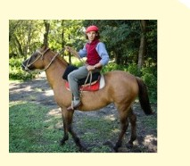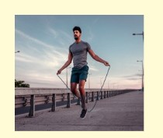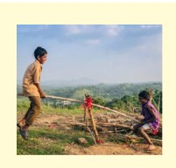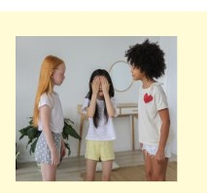

Question 2: Listen and circle
1. How many cupcakes are there? | 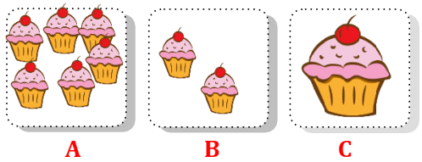
2. What is your favourite drink? | 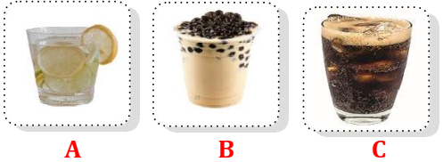
3. What is his favourite food? | 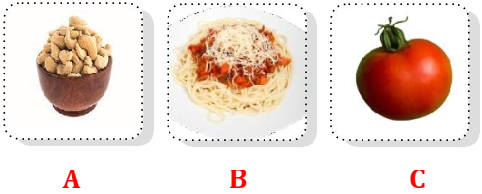
4. What has she got? | 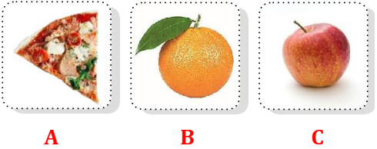
Question 3: Listen and circle
1. My cousin hasn't got _______.
A. a fish B. some fish C. a dog D. some dogs
2. The cats have got _______.
A. short tails B. long tails C. short fur D. long fur
3. My parents have got _______.
A. some sheep B. some sheeps C. some cows D. some fish
4. The _______ has got long legs.
A. goat B. goats C. horse D. horses
Question 4: Listen the questions and choose the correct answer
1.A. It’s cold and snowy B. It’s sunny and windy C. It’s stormy and windy.
2. A. She’s riding a horse B. They’re playing hide-and-seek. C. I’m jumping rope
Question 5: Odd one out
1. a. ride a bike b. forest c. mountain d. beach
2. a. sunny b. cloudy c. weather d. stormy
3. a. clever b. daughter c. pleasant d. pretty
4. a. tidy b. bookshelf c. floor d. toy box
5. a. plants b. tails c. legs d. wings
6. a. sandwich b. bubble tea c. spaghetti d. pizza
Question 6: Choose the best answer A, B, C or D to complete the sentences
1. The cats haven't got ________.
A. eyes B. wings C. legs D. tails
2. They have got fruit trees ________ the field.
A. on B. at C. of D. in
3. What's your brother doing?
A. He goes fishing with his friends. C. He is playing table tennis.
B. He is in the playground. D. He is a Maths teacher.
4. My father ________ got a cow.
A. is B. are C. has D. have
5. ________ they climbing the trees? – Yes, they are.
A. What B. Have C. Do D. Are
6. ________ are they watching a film? – In the cinema.
A. When B. What C. Where D. Why
Question 7: Choose the words from the box
can’t sunny rug hiking is
1. The rug……… in front of the fridge.
2. It’s ……….. We can go to the beach.
3. There is a big ………..under the table.
4. They can’t go………..…. on the mountain.
5. It isn’t windy this afternoon. We …..………. fly a kite.
Question 8: Reorder these words to make sentences
1. summer / weather / What’s / like / in / the/?
………………………………………………………………………….
2. cold / It’s / and / today / windy/.
…………………………………………………………………………..
3. playing / are / They / living room /game /in / board / the /.
…………………………………………………………………………..
4. they / Are / the / climbing / tree /? – are / Yes, / they /.
…………………………………………………………………………..
Question 9: Look at the pictures and write one word only to complete sentences
  1.Her daughter is …………………….. | 2. My ………………. is pleasant.
  3.His father is ………………….. | 4.They are…………………..

