UBND HUYỆN VĨNH BẢO  TRƯỜNG TH TRẤN DƯƠNG | ĐỀ KHẢO SÁT CHẤT LƯỢNG HỌC KỲ 1  MÔN TIẾNG ANH LỚP 3  NĂM HỌC 2024 - 2025  (Thời gian làm bài: 40 phút)
Question 1 : Listen and number (1pt)
1.a/  b/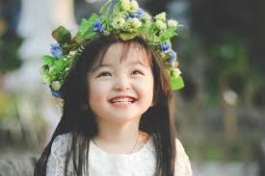 | 2.a. 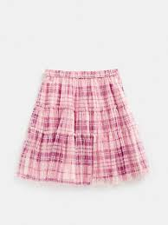 b. 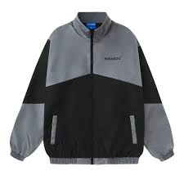
3. a. 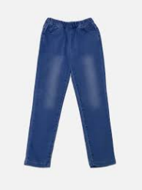 b.  | 4. a.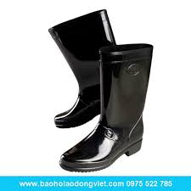 b. 
Question 2: Listen and circle the correct picture (1pt)
1.The .............. are black  a.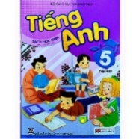 b.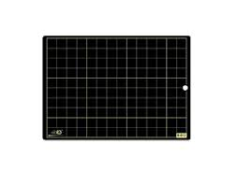 | 2.The students are at the .....................  a.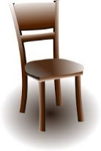 b. 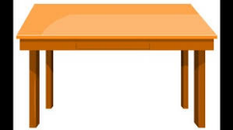
3. The ......................... are black  a. 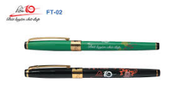 b. 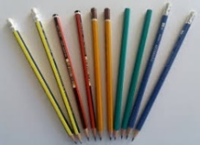 | 4. The ................... are blue.  a.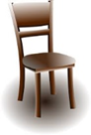 b.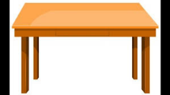
Question 3. Listen and circle .(1 pt)
- Simon is my ...........................
- Dad B. Uncle c.Father
- ..................... is my aunt.
- Tom b. Laura C. Clare
- John is my ............................
A.Cousin b.mother c. brother
4. My ......................... is great.
a. school B.family c.class
Question 4. Listen and circle .(1 pt)
- These are students in ( England / Japan / Viet Nam ).
- Really ?
- Yes, They are in their ( class / school / house ) uniform. They’ve got skirts. Their skirts are blue.
-That’s right. They’ve got ( skirts / shirts / shoes ) and socks, too.
Their shoes are ( blue / black / brown ) and their socks are white.
Question 5: Odd one out (1,5 pt)
1. a. father | b. brother | c. aunt | d.family
2 a. desks | b. students | c. rulers | d.chairs
3. a . car | b. toy | c.ball | d. doll
4. a. T-shirt | b. shoes | c. socks | d. boots
5. a. pretty | b. urgly | c. small | d. coat
6. a. black | b. green | c. colour | d. red
Question 6. Choose the best answer (1,5pt)
1. They're .............They're brown.
a. desks b. board c. table d. clock
2..............you students ?
a. Is b. Am c . Are d. Do
3. There...........a kitchen in my house.
a. are b. is c . that d. those
4. Is Nam a student ? – Yes, he ……………………….
a is. b. does c. do d. isn’t
5. My mother ...........got a blue dress .
a. are b. has c. have d. are
6. Are there ............in the bedroom?
a. beds b. book c. toy d. lam
Question 7. Choose the words from the box (1,25 pt)
student is I are baby has

This ...........(1) my family. There are four people. They .................(2) my father, my mother, my brother and ............(3). My sister is a ....................... (4). She is twelve years old. She ............................(5) got a blue pen and a black school bag.And she is a good student.
Question 8. Arrange the words to make sentences (1 pt)
1. are / these / lions/ big/.
____________________________________________________________________
2. a / blue / It / is / bird. / nice/ It’s/.
____________________________________________________________________
3. are / these / in / sea/ turtles / the/.
____________________________________________________________________
4. cat / is / It / in/ garden/ a / the /.
____________________________________________________________________
Question 9. Look and write (1 pt)
1. 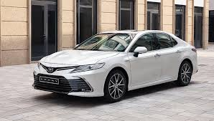 | 2.  | 3. 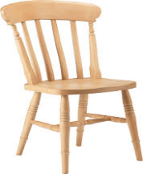 | 4. 
My …………. is white | The ………….. is very nice. | This is a …………. | It’s my ……………..

ĐÁP ÁN

Question 1 : Listen and number (1pt)
Mỗi câu 0.25 điểm x 4 câu = 1 điểm
1-b 2-b 3-a 4-a

Question 2: Listen and circle the correct picture (1pt)
Mỗi câu 0.25 điểm x 4 câu = 1 điểm
1- b 2- b 3- b 4 - a

Question 3. Listen and tick .(1 pt)
Mỗi câu 0.25 điểm x 4 câu = 1 điểm
- B 2- c 3- a 4- b

Question 4. Listen and circle .(1 pt)
Mỗi câu 0.25 điểm x 4 câu = 1 điểm
1- Japan 2- school 3 – skirts 4- black

Question 5: Odd one out (1,5 pt)
Mỗi câu 0.25 điểm x 6 câu = 1.5 điểm
1-d 2- b 3- b 4- a 5- d 6- c
Question 6. Choose the best answer (1,5pt)
Mỗi câu 0.25 điểm x 6 câu = 1.5 điểm
1.a 2- c 3- b 4- a 5- b 6- a

Question 7. Choose the words from the box (1,25 pt)
Mỗi câu 0.25 điểm x 5 câu = 1.25 điểm
- Is 2- are 3- baby 4- student 5- has

Question 8. Arrange the words to make sentences (1 pt)
Mỗi câu 0.25 điểm x 4 câu = 1 điểm
- these are big lions.
- It is a blue bird. It’s nice.
- These are turtles in the sea.
- It is a cat in the garden.

Question 9. Look and write (1 pt)
Mỗi câu 0.25 điểm x 4 câu = 1 điểm
1-car 2- living room 3- chair 4- house

