UBND HUYỆN VĨNH BẢO  TRƯỜNG TH HÙNG TIẾN | ĐỀ KHẢO SÁT CHẤT LƯỢNG CK1  MÔN TIẾNG ANH LỚP 3  NĂM HỌC 2024 - 2025  (Thời gian làm bài: 40 phút)
Question 1 : Listen and number (1 pt)
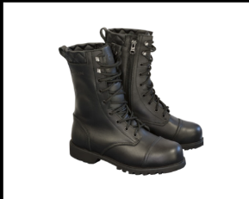
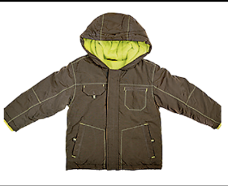
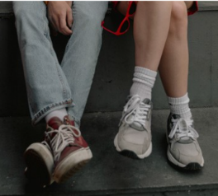
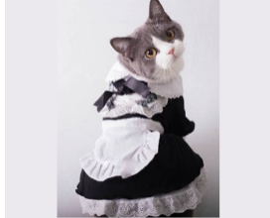

a. | b. | c. | d.
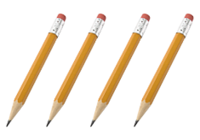
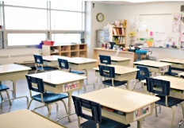


Question 2: Listen and circle the correct picture (1 pt)
1. a. | b. | 2. a. | b.
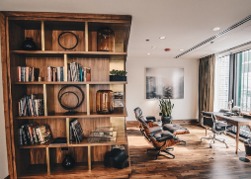
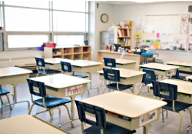
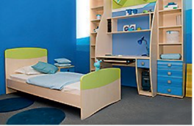
3. a. | b. | 4. a. | b.

Question 3. Listen and tick (1 pt)
gi
1. These are the photos of the sea near Australia. Africa.

2. They're baby sharks. turtles.

3. What’s that? - It’s a shark. whale.

4. These are great. funny.
Question 4. Listen to the question choose the correct anwser (1 pt)

1. A. My hat is white and red.  B. My hat is white and black. | 2. A. She’s got a shirt.  B. She’s got a skirt.
Question 5: Odd one out (1,5 pt)
1. a. boots | b. socks | c. hat | d. shoes
2. a. lion | b. whale | c. monkey | d. giraffe
3. a. green | b. blue | c. orange | d. stand
4. a. homework | b. board | c. desk | d. chair
5. a. uncle | b. funny | c. short | d. young
6. a. lamp | b. TV | c. computer | d. kitchen

Question 6. Choose the best answer (1,25 pt)
1. There is a ……………. 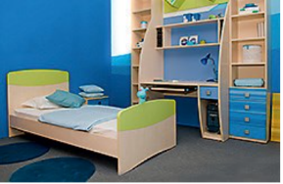
a. bedroom b. living room c. kitchen
2. My sister ………….. a yellow dress.
a. have got b. has got c. is got
3. ……… is a student.
a. They b. He c. You
4. Is there a computer in the classroom? – No, …………..
a. there is not b. there aren’t c. there is
5. My cousins have got coats. Their coats ……… white.
a. is b. am c. are
Question 7. Choose the words from the box (1,25 pt)
grandmas family nine mum old are

Hi! My name's Karen. I'm (1).................. years old. Look! This is my (2)...................... My brother is Jake. He's seven years old. My (3)...................... is Angela. My dad is Robert. My uncles (4)..................... Steve and Dean. My aunt is Mary. My grandpas are John and Bill and my (5)...................... are Sarah and Lily. They're (6)........................
Question 8. Arrange the words to make sentences (1 pt)
1. is / a / rabbit / This / .
________________________________________________________________________
2. baby / are / Those / elephants / the / .
__________________________________________________________________________
3. are / These / turtles / the / in / sea /.
________________________________________________________________________
4. that / What / is /? - It’s / bird / a /.
_________________________________________________________________________

Question 9. Look and write (1 pt)

1. 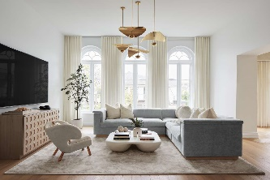 | 2. 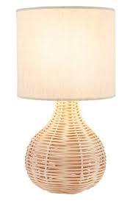 | 3. 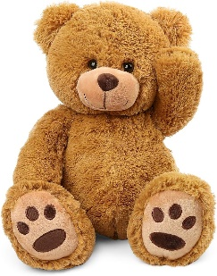 | 4. 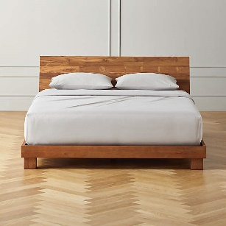

ĐÁP ÁN
Question 1: Listen and number (1 pt)
a. 3 | b. 4 | c. 1 | d. 2
Question 2: Listen and circle the correct picture (1pt)
1. a | 2. b | 3. a | 4. b
Question 3. Listen and tick (1 pt)
1. Australia | 2. turtles | 3. shark | 4. great
Question 4. Listen to the question choose the correct anwser (1 pt)
1. a | 2. b
Question 5: Odd one out (1,5 pt)
1. c | 2. d | 3. b | 4. a | 5. a | 6. d
Question 6. Choose the best answer (1,25 pt)
1. a | 2. b | 3. b | 4. a | 5. c
Question 7. Choose the words from the box (1,25 pt)
1. nine | 2. family | 3. mum | 4. are | 5. grandmas | 6. old
Question 8. Arrange the words to make sentences (1 pt)
1. This is a rabbit.
2. Those are the baby elephants.
3. These are turtles in the sea.
4. What is that? – It’s a bird.
Question 9. Look and write (1 pt)
1. living room | 2. lamp | 3. teddy bear | 4. bed

