Đề đề xuất | ĐỀ KHẢO SÁT CHẤT LƯỢNG HỌC KỲ I  TIẾNG ANH LỚP 4  NĂM HỌC 2024 - 2025  (Thời gian làm bài: 40 phút)
I. LISTENING
Question 1. Listen and number (1pt)
a. b.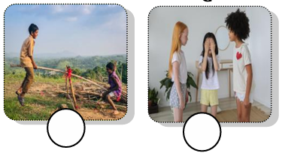 c.  d.
Question 2. Listen and circle (1pt)
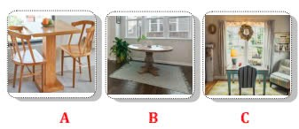  - Where is the table? | 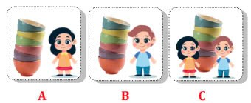  2. Whose bowls are they?
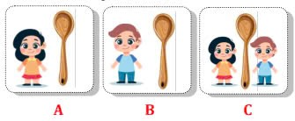  3. Whose spoon is it? | 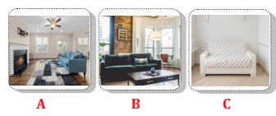  4. Where is the sofa?
Question 3. Listen and tick (1pt)
1. The fish haven’t got __________. wings hands legs
2. The goat has got ________. black fur white fur brown fur
3. We have got ________ on the farm. animals plants goats
4. The ___________ have long tails. cows sheep horses
Question 4. Listen to the question and circle the correct answer. (0,5pt)
1. A. We play on the seesaw. 2. A. It’s cold and snowy.
B. In the park. B. It’s hot and sunny.
II. READING
Question 5. Odd the one out (1.5pt)
1. A. daughter B. son C. family D. mother
2. A. tidy B. fridge C. table D. sofa
3. A. hands B. fur C. legs D. tails
4. A. vegetables B. yogurt C. twenty D. pizza
5. A. messy B. cloudy C. snowy D. rainy
6. A. making B. dining C. pitching D. going
Question 6. Choose the correct answer (1.5pt)
- I’ve got a _____________ .
- cat B. ats C. cates
- She ____________ five sheep .
- have got B. is got C. has got
- The horses haven’t got ______________ .
- legs B. tails C. hands
- What’s the weather like in summer? – It’s ___________ .
- cold B. warm C. sunny
- They are _____________ in the pool .
- riding B. swimming C. dancing
- We can’t have a picnic ___________ it’s rainy.
- because B. and C. but
Question 7 . Chosse the words from the box.
next | food | like | three | spaghetti | kitchen

This is our (1)__________.There’s a fridge (2)________ to the sink. There is an apple and (3) __________oranges in the fridge. I’m very hungry so I’d (4) _________ a sandwich and some (5)__________ now. Sandwich is my favourite (6)_________.
Question 8. Arrange the words to make sentences. (1pt)
1. camping/ on/ go/ I/ can/ mountain/ the/.
=>...............................................................................................................................................
2. are / My grandma / and / reading / grandpa /comic / books / .
=> ..............................................................................................................................................
3. in / What’s / like / summer /weather / the / ?
=> ..............................................................................................................................................
4. is / jumping / she / in / rope/ garden / the
=> ..............................................................................................................................................
Questions 9: Look at the pictures and write one word in the blank (1pt)
 |  |  | 
1. They are  ________________. | 2. My sister is  ________________. | 3. My mother is ________________. | 4. My friends are very ____________________.

ANSWER KEYS
I. LISTENING
Question 1. Listen and number (1pt)
a – 4 b – 1 c – 3 d – 2
Question 2. Listen and circle (1pt)
1 – A 2 – B 3 – A 4 – B
Question 3. Listen and tick (1pt)
1 – wings 2 – white fur 3 – plants 4 – horses
Question 4. Listen to the question and circle the correct answer. (0,5pt)
1 – B 2 – B
II. READING
Question 5. Odd the one out (1.5pt)
1 – C 2 – A 3 – B 4 – C 5 – A 6 – B
Question 6. Read and choose the correct answer (1.5pt)
1 – A 2 – C 3 – C 4 – C 5 – B 6 – A
Question 7. Fill in the blank with the given words (1,5pt)
1 – kitchen 2 – next 3 – three 4 – like 5 – spaghetti 6 – food
Question 8. Reorder the words to make the correct sentence. (1pt)
1. I can go camping on the mountain.
2. My gradma and grandpa are reading comic books.
3. What’s the weather like in Summer?
4. She is jumping rope in the garden.
Question 9.Look at the pictures and write one word in the blank (1pt)
1. twins 2. clever 3. pleasant 4. cheerful

