MA TRẬN ĐỀ KSCL HỌC KỲ 1 MÔN TIẾNG ANH LỚP 3 - 2024
Thứ tự | Nội dung | Cấp độ |  |  |  | Số câu-Số điểm
Thứ tự | Nội dung | 1 | 2 | 3
 |  |  |  | thấp | cao
Part I | Listening |  |  |  |  | 14 câu = 3,5 điểm 35%
Question 1 | Listen and number  Unit 0: Greeting.  Unit 5: My clothes | 2 câu | 1 câu | 1 câu |  | 4 câu=1.0 điểm
Question 2 | Listen and circle  Unit 2: My school  Unit 4: My house | 1 câu | 1 câu | 2 câu |  | 4 câu =1.0 điểm
Question 3 | Listen and tick the word.  Unit 3: Animals  Unit 1: My family | 2 câu | 1 câu | 1 câu |  | 4 câu=1.0 điểm
Question 4 | Listen to the question and circle the correct answer.  Unit 5: My clothes |  |  | 1 câu | 1 câu | 2 câu= 0,5 điểm
Part II | Reading and Writing |  |  |  |  | 26 câu= 6.5 điểm  65%
Question 5 | Odd one out  From Unit 0 to Unit 5 | 2 câu | 2 câu | 2 câu |  | 6 câu=1.5điểm
Question 6 | Choose the best answer  Unit 2: My school  Unit 4: My house  Unit 5: My clothes | 2 câu | 2 câu | 2 câu |  | 6 câu=1.5điểm
Question 7 | Choose the words from the box  Unit 0: Greeting.  Unit 1: My family  Unit 3: Animals | 2 câu | 2 câu | 1 câu | 1 câu | 6 câu=1,5 điểm
Question 8 | Arrange the words to make sentences  Unit 3: Animals | 1 câu | 2 câu | 1 câu |  | 4 câu=1,0 điểm
Question 9 | Look at the picture and write one word in the blank  Unit 4: My house | 1 câu | 1 câu | 1 câu | 1 câu | 4 câu=1.0 điểm
 |  | 13 câu  = 3,25đ  32,5 % | 12 câu  = 3đ  30 % | 12 câu  = 3 đ  30 % | 3 câu  = 0,75đ  7,5% | 40 câu = 10điểm 100%

UBND HUYỆN VĨNH BẢO  TRƯỜNG TH VĨNH AN | ĐỀ KHẢO SÁT CHẤT LƯỢNG CUỐI HỌC KỲ I  MÔN TIẾNG ANH LỚP 3  NĂM HỌC 2024 – 2025  (Thời gian làm bài: 40 phút)
Name: …………………………. Class: ……………………….
Question 1 : Listen and number (1pt)
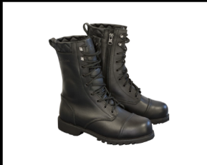
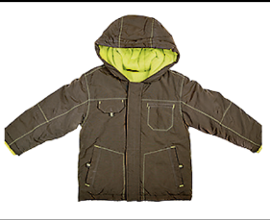

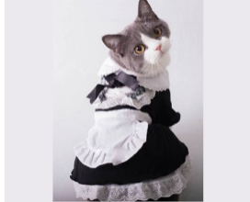

a. | b. | c. | d.
Question 2: Listen and circle the correct picture. (1pt)



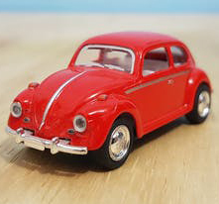


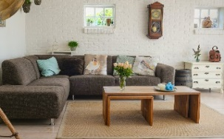
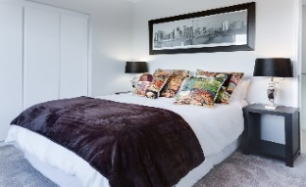
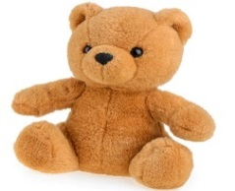
1. 2.
A
B
A
B
A
B
A
B

3. 4.

Question 3. Listen and tick the word. (1pt)
1. This is ……………………………  giraffe monkey | 2. That is ……………………………  dog lion
3. These are ………………………  monkeys elephants | 4. Those are ……………………………  giraffes rabbits
Question 4. Listen to the question and choose the correct answer. (0.5pt)
1. A. No, I don’t B. Yes, I have. C. Yes, it is
2. A. No, there isn’t B. Yes, it is. It’s a coat. C. Yes, it isn’t
Question 5: Odd one out (1.5 pts)
1. a. skirt | b. dress | c. hat | d. trousers
2. a. turtle | b. whale | c. monkey | d. shark
3. a. green | b. blue | c. orange | d. come
4. a. homework | b. board | c. desk | d. chair
5. a. funny | b. cousin | c. short | d. young
6. a. lamp | b. TV | c. computer | d. kitchen

Question 6. Choose the best answer. (1.5pts)
1..............they pencils ?
a. Is b. Am c . Are d. Do
2.They're ............. They're green
a.door b. chair c. table d. desks
3. There..........two bedrooms in my house.
a. is b. are c . this d. these
4. Is Hoa a teacher ? – No, she ……………………….
a is. b. does c. do d. isn’t
5. My sister ...........got a red skirt .
a. is b. has c. have d. are
6. Laura has got a brother……………..name is Brandon.
a. her b. my c. his d. he
Question 7. Choose the words from the box (1.5pts)
parrot - family - orange - old - mum - is
Hello, My name (1) …………………. Tung. I’m eight years (2) …………... This is a picture of my (3) …………………. This is my dad. His name is Hai. This is my (4) ………………. Her name is Mai. We live in a big house. I have a (5) ……………………………….in my house. Its colour is blue and (6) ……. I love my pet very much.
Question 8. Arrange the words to make sentences (1 pt)
1. are / those / cats.
____________________________________________________________________
2.she / got / Has / blue / a / dress/ ?
____________________________________________________________________
3. are / the / The / in / birds / garden / .
____________________________________________________________________
4. aren’t / The / garden / in / giraffes / the /
____________________________________________________________________

Question 9. Look and write (1 pt)
1.  | 2.  | 3.  | 4.  

Answer Keys
Question 1: Listen and number (1pt)
1 – c 2 – d 3 – a 4 - b
Question 2: Listen and circle the correct pictures (1pt)
1 – b 2 – b 3 – a 4 – a
Question 3: Listen and tick the word. (1pt)
1. giraffe 2. lion 3. monkeys 4. rabbits
Question 4: Listen to the question and choose the correct answer. (0.5pt)
1. b 2. b
Question 5: Odd one out (1.5 pts)
1. d 2. c 3. d 4. a 5. c 6. d
Question 6: Choose the best answer. (1.5pts)
1. c 2. d 3. b 4. d 5. a 6. c
Question 7: Choose the words from the box (1.5pts)
1. is 2. old 3. family 4. mum 5. parrot 6. orange
Question 8: Arrange the words to make sentences (1 pt)
1. Those are cats.
2. Has she got a blue dress?
3. The bird is in the garden.
4. The giraffes aren’t in the garden
Question 9: Look and write (1 pt)
1. living room 2. bathroom 3. computer 4. lamp

