MA TRẬN ĐỀ KSCL HỌC KỲ 1 MÔN TIẾNG ANH LỚP 4 - 2024
Thứ tự | Nội dung | Cấp độ |  |  |  | Số câu –  Số điểm
Thứ tự | Nội dung | 1 | 2 | 3
 |  |  |  | thấp | cao
Part I | Listening |  |  |  |  | 14 câu = 3,5 điểm 35%
Question 1 | Listen and number  Unit 1: My family and friends  Unit 5: Leisure time | 2 câu | 1 câu | 1 câu |  | 4 câu=  1.0 điểm
Question 2 | Listen and circle  Unit 2: My home  Unit 4: Food and drink | 1 câu | 1 câu | 2 câu |  | 4 câu =  1.0 điểm
Question 3 | Listen and tick the word.  Unit 3: On the farm  Unit 6: Outdoor Activities. | 2 câu | 1 câu | 1 câu |  | 4 câu=  1.0 điểm
Question 4 | Listen to the question and circle the correct answer.  Unit 5: Leisure time. |  |  | 1 câu | 1 câu | 2 câu=  0,5 điểm
Part II | Reading and Writing |  |  |  |  | 26 câu=  6.5 điểm  65%
Question 5 | Odd one out  From Unit 1 to Unit 6 | 2 câu | 2 câu | 2 câu |  | 6 câu=1.5điểm
Question 6 | Choose the best answer  Unit 3: On the farm  Unit 6: Outdoor Activities. | 2 câu | 2 câu | 2 câu |  | 6 câu=1.5điểm
Question 7 | Choose the words from the box  Unit 2: My home  Unit 4: Food and drink. | 2 câu | 2 câu | 1 câu | 1 câu | 6 câu=  1,5 điểm
Question 8 | Arrange the words to make sentences  Unit 5: Leisure time. | 1 câu | 2 câu | 1 câu |  | 4 câu=  1,0 điểm
Question 9 | Look at the picture and write one word in the blank  Unit 1: My family and friends | 1 câu | 1 câu | 1 câu | 1 câu | 4 câu=  1.0 điểm
 |  | 13 câu  = 3,25đ  32,5 % | 12 câu  = 3đ  30 % | 12 câu  = 3 đ  30 % | 3 câu  = 0,75đ  7,5% | 40 câu = 10điểm 100%

UBND HUYỆN VĨNH BẢO  TRƯỜNG TH VĨNH AN | ĐỀ KHẢO SÁT CHẤT LƯỢNG CUỐI HỌC KỲ I  MÔN TIẾNG ANH LỚP 4  NĂM HỌC 2024 – 2025  (Thời gian làm bài: 40 phút)
Name: ………………………….. Class: ………………………..
I. LISTENING
Question 1. Listen and number (1pt)
a.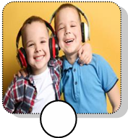 b.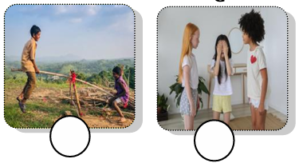 c. 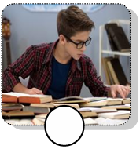 d.
Question 2. Listen and circle the correct picture (1pt)
1. Where is the table? 2. Whose bowls are they?
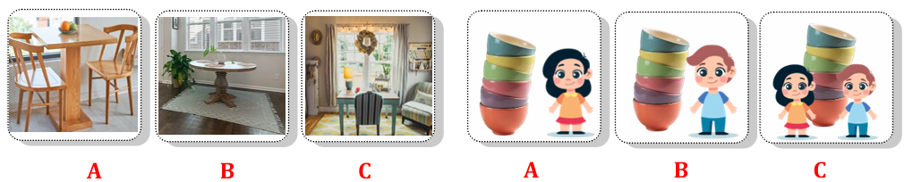
3. How many cupcakes are there? 4. What is your favourite drink?
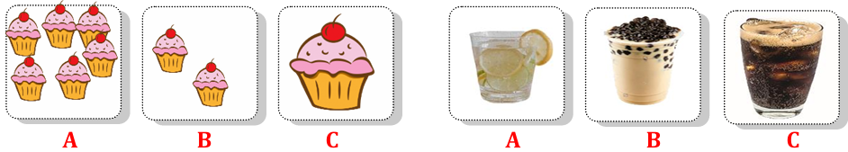
Question 3. Listen and tick (1pt)
1. They can go __________today. ice – skating ice hockey fishing
2. They can go swimming in the _____. sea river pool
3. We have got ________ on the farm. animals plants goats
4. The goat have got ___________. white tails white fur white hands
Question 4. Listen to the questions and circle the correct answers. (0,5pt)
1. A. He’s jumping rope. 2. A. They’re playing basketball.
B. She’s jumping rope. B. We’re playing on the seesaw.
II. READING
Question 5. Odd the one out (1.5pt)
1. A. daughter B. son C. father D. polite
2. A. messy B. plate C. table D. sofa
3. A. hands B. fur C. legs D. tails
4. A. vegetables B. yogurt C. twenty D. pizza
5. A. tidy B. cloudy C. snowy D. rainy
6. A. making B. dining C. pitching D. going
Question 6. Read and choose the correct answer (1.5pt)
1. The cows haven’t got _____________________.
A. tails B. tail C. hand D. hands
2. Have ____________________ got wings? – Yes, they have.
A. fish B. birds C. horses D. goats
3. We’ve got some chickens ________ the farm.
A. in B. on C. at D. of
4. We can’t make a campfire today __________________ it’s rainy.
A. but B. can C. because D. Let’s
5. ______________________ can we do on the mountain?
A. Where B. Why C. What D. How many
6. It’s snowy and cold. I can _______________ hiking, but I can’t walk a lot.
A. forest B. have C. go D. pitch
Question 7. Fill in the blank with the given words (1,5pt)
egg and food cupcakes pieces sandwich
Today, Tim has lunch at school. His mom made a lot of (1) _______________ for him. Tim has got two(2) _______________ of pizza, some spaghetti (3) _______________ yoghurt for his lunch. His friends are having lunch with him. Jake has got a (4) _______________, some nuts and an orange for his lunch. Jane has got an (5) ______________ and some vegetables. Surprisingly, today is Tammy’s birthday! She brought twenty-four (6) ______________ and some bubble tea for her classmates. They eat together and have lots of fun!
Question 8. Reorder the words to make the correct sentence. (1pt)
1. is / weather/ today / The / sunny / .
_______________________________________________________
2. Are / tree / they / the / climbing / ?
_______________________________________________________
3. are / Grandma / and / reading / grandpa / books / .
_______________________________________________________
4. video / your friends / Where / playing / are / games / ?
_______________________________________________________

Question 9. Look and write (1pt)
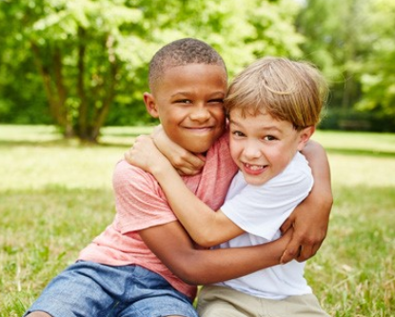
1. ________________ 2. ____________ 3. ______________ 4. ________________

ANSWER KEYS
I. LISTENING
Question 1. Listen and number (1pt)
a – 4 b – 1 c – 3 d – 2
Question 2. Listen and circle the correct picture (1pt)
1 – A 2 – B 3 – A 4 – B
Question 3. Listen and tick (1pt)
1 – ice-skating 2 – pool 3 – plants 4 – white fur
Question 4. Listen to the question and circle the correct answer. (0,5pt)
1 – B 2 – A
II. READING
Question 5. Odd the one out (1.5pt)
1 – D 2 – A 3 – B 4 – C 5 – A 6 – B
Question 6. Read and choose the correct answer (1.5pt)
1 – D 2 – B 3 – B 4 – C 5 – C 6 – C
Question 7. Fill in the blank with the given words (1,5pt)
1 – food 2 – pieces 3 – and 4 – sandwich 5 – egg 6 – cupcakes
Question 8. Reorder the words to make the correct sentence. (1pt)
1. The weather is sunny today.
2. Are they climbing the tree?
3. Grandma and grandpa are reading books.
4. Where are your friends playing games?
Question 9. Look and write (1pt)
1. pleasant 2. clever 3. cheerful 4. friendly

