PHẦN 1: ĐỀ
UBND HUYỆN VĨNH BẢO  TRƯỜNG TH ĐỒNG MINH  (Đề đề xuất) | ĐỀ KHẢO SÁT CHẤT LƯỢNG HỌC KỲ I  MÔN TIẾNG ANH LỚP 3  NĂM HỌC 2023 - 2024  (Thời gian làm bài: 40 phút)
PART I: LISTENING
Question 1: Listen and tick (1pt)
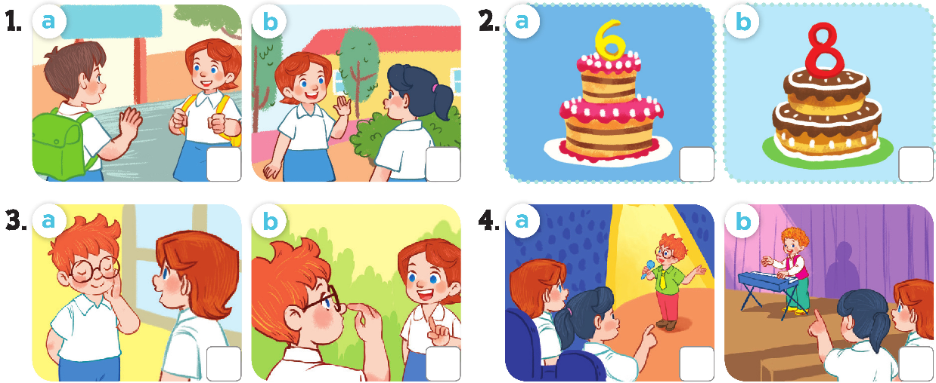

Question 2: Listen and number (1pt)
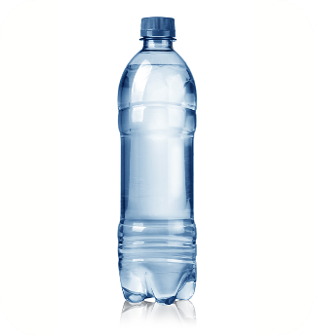 | 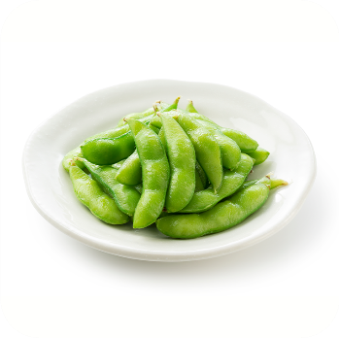 | 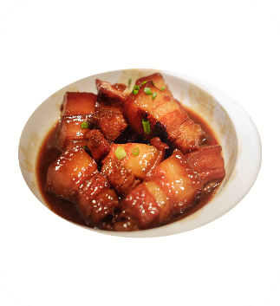 | 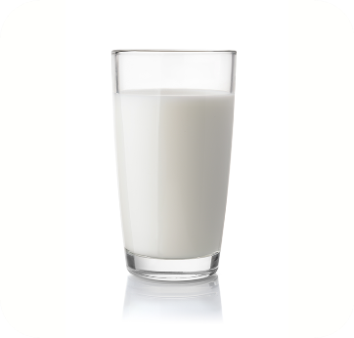
Question 3: Listen and complete (1pt)
- What’s your hobby? .....................................
- What’s your hobby? It’s.................................
- What’s your hobby?.....................................
- What’s your hobby? It’s ....................................
PART II: READING
Question 4: Odd one out (1.5pt)
1. A. hello B. hi C. bye D. Good morning
2. A. hand B. nose C. body D. mouth
3. A. red B. yellow C. white D. colour
4. A. ten B. nine C. fine D. eight
5. A. badminton B. football C. basketball D. play
6. A. my B. do C. play D. chat
Question 5: Choose the best answer (1.5pt
1. What’s _______ hobby? – I like cooking.
A. his B. her C. your D. my
2. I have an _______.
A. eraser B. pen C. notebook D. book
3. Is that Mary? - _______.
A. Yes, I do B. No, I don’t C. Yes, they are D. No, it isn’t
4. Do you have a book? – Yes, _______.
A. it is B. I don’t C. I do D. It isn’t
5. I like _______.
A. sing B. singing C. sings D. sang
6. That is my _______,Mary.
A. pen B. friend C. pencil D. class
Question 6: Read and tick True or False (1.5pt)
Look at my school things. I have a pencilcase. It is green. My books and notebooks are yellow. My pen and pencil are orange. My school bag is white. I love my school things very much.
 | True | False
1. My school bag is white.
2. My notebooks and pens are blue.
3. I have a red pencil.
4. I have a green pencilcase.
5. My pencil case is orange.
6. I love my school things.
PART III: WRITING
Question 7: Look at the pictures and write the words (1pt)

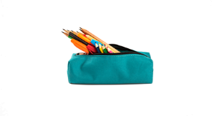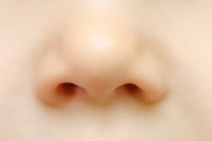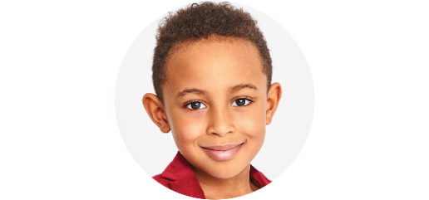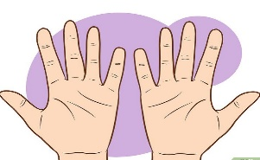

1.It is a............. 2. It is a........... 3. It is a............ 4.They are ............................
Question 8: Arrange the words to make sentences (1.5pt)
1. have/an/ eraser/I .
_________________________________________________________________________________
2. my / pencil / like / I .
_________________________________________________________________________________
3. is / hobby / What / your / ?
_________________________________________________________________________________
4.a/Do/you/have/backpack ?
._________________________________________________________________________________
5. cooking / like / I / drawing / and /
_________________________________________________________________________________
6. things/Look/at/my /school .
_________________________________________________________________________________

PHẦN 2: ĐÁP ÁN
UBND HUYỆN VĨNH BẢO  TRƯỜNG TH ĐỒNG MINH  (Đề đề xuất) | ĐỀ KHẢO SÁT CHẤT LƯỢNG HỌC KỲ I  MÔN TIẾNG ANH LỚP 3  NĂM HỌC 2023 - 2024  (Thời gian làm bài: 40 phút)
PART I: LISTENING
Question 1: Listen and tick (1pt)
√
√
√
√
Question 2: Listen and number (1pt)

1b 2c 3d 4a

Question 3: Listen and complete (1pt)
- What’s your hobby? Dancing
- What’s your hobby? It’s drawing
- What’s your hobby? Swimming
- What’s your hobby? It’s Singing
PART II: READING
Question 4: Odd one out (1.5pt)
1. A. hello B. hi C. bye D. Good morning
2. A. hand B. nose C. body D. mouth
3. A. red B. yellow C. white D. colour
4. A. ten B. nine C. fine D. eight
5. A. badminton B. football C. basketball D. play
6. A. my B. do C. play D. chat
Question 5: Choose the best answer (1.5pt
1. What’s _______ hobby? – I like cooking.
A. his B. her C. your D. my
2. I have an _______.
A. eraser B. pen C. notebook D. book
3. Is that Mary? - _______.
A. Yes, I do B. No, I don’t C. Yes, they are D. No, it isn’t
4. Do you have a book? – Yes, _______.
A. it is B. I don’t C. I do D. It isn’t
5. I like _______.
A. sing B. singing C. sings D. sang
6. That is my _______,Mary.
A. pen B. friend C. pencil D. class
Question 6: Read and tick True or False (1.5pt)
Look at my school things. I have a pencilcase. It is green. My books and notebooks are yellow. My pen and pencil are orange. My school bag is white. I love my school things very much.
 | True | False
1. My school bag is white. | v
2. My notebooks and pens are blue. |  | v
3. I have a red pencil. |  | v
4. I have a green pencilcase. | v
5. My pencil case is orange. |  | v
6. I love my school things. | v
PART III: WRITING
Question 7: Look at the pictures and write the words (1pt)

1.Pencil case. 2 nose 3 .face 4 .hands

Question 8: Arrange the words to make sentences (1.5pt)
- I have an eraser.
- I like my pencil.
- What is your hobby?
- Do you have a backpack?
- I like cooking and drawing.
- Look at my school things.

. 2

