PHẦN 1: ĐỀ
UBND HUYỆN VĨNH BẢO  TRƯỜNG TH ĐỒNG MINH  (Đề đề xuất) | ĐỀ KHẢO SÁT CHẤT LƯỢNG HỌC KỲ I  MÔN TIẾNG ANH LỚP 5  NĂM HỌC 2023 - 2024  (Thời gian làm bài: 40 phút)
PART I: Listening
Question 1 1: Listen and circle .
- 2
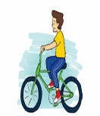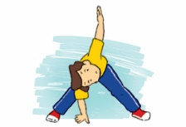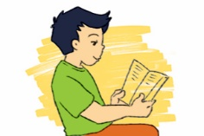
a. b c a b c

3 4.
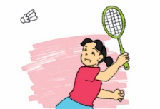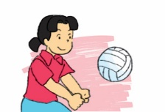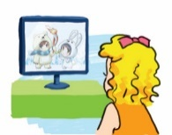
a b c a b c
Question 2 2:Listen and number.
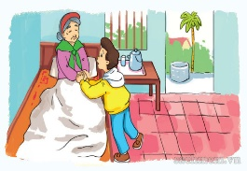
a b c d
Question 3 3:Listen and complete.
1. Linda: ….. , High Street
2. Tony: ….. , Green Lane
3. Peter: 765, ……. Street
4. Tom: the second ……. of City Tower
PART II: Pronunciation.
Question 4 .Circle the word which has the stressed syllable different from the rest ones.
1 a. city b. village c. mountains d. enjoyed
2 a. tower b. always c .usually d. invite
3 a. often b. sometimes c. holiday d. repeat
4 a. motorbike b. underground c. family d. invite
5 a. party b. invite c. complete d. enjoy
6 a. Sunday b. enjoy c. picnic d. birthday
PART III: Reading.
Question 5. Look and read: Choose the best answer.
1.Did you ……to the party ?
a. go b. going c. went d. goes
2…….did you do at the party?
a. what b. when c. where d .who
3.How …… you learn English?
a. do b. doing c. does d. did
4.What did you………….at the party?
a. see b. saw c. seeing d. sees
5.How do you practice………English?
a. writing b. wrote c. write d. writes
6. Where………..you yesterday?
a. was b. were c. is d. are
Question 6. Fill in the blank
1. Where did you go ……………… holiday?
2. How many ……………..do you have today?
3. What …………the trip like?
4. ………..do you have English?
5. I have it four …… a week.
Question 7. Read and write (T/F)
Hello, I'm Mai. I'll go to Ha Long Bay with my family next Sunday. It'll be a lot of fun. In the morning, I think my parents will swim in the sea. They love swimming! My brother and I will build sandcastles on the beach. In the afternoon, my mum and dad will sunbathe. My brother and I will play badminton. Then we'll have dinner on Tuan Chau Island. Seafood, I hope!
1. I'll go to Ha Long Bay with my family next Sunday.
2. I think my parents will not swim in the sea.
3. In the afternoon, my mum and dad will sunbathe.
4. My brother and I will play badminton.
5. We'll have dinner on Cat Ba Island
PART IV: Writing
Question 8. Arrange the words to make sentences.
- is / your/What/address?……………………………………………………………
- on /where/did/you/go/holiday?...............................................................................
- many /How/lessons/do/you/have/today?...............................................................
- are /What/you/doing?..............................................................................................
- Day/ Sports/ be/ When/ will ?....................................................................................
- did / How/you/get/there?..........................................................................................

PHẦN 2: ĐÁP ÁN

UBND HUYỆN VĨNH BẢO  TRƯỜNG TH ĐỒNG MINH  (Đề đề xuất) | ĐÁP ÁN ĐỀ KHẢO SÁT CHẤT LƯỢNG HK I  MÔN TIẾNG ANH LỚP 5  NĂM HỌC 2023 - 2024  (Thời gian làm bài: 40 phút)
PART I: Listening
Question 1 1: Listen and tick pictures.
- 2
a. b c a b c

3 4.
a b c a b c
Question 2 2:Listen and number.
3. a 4. b 2. c 1. d
Question 3 3:Listen and complete.
1. Linda: 208. , High Street
2. Tony: 321 , Green Lane
3. Peter: 765, White Street
4. Tom: the second floor of City Tower
PART II: Pronunciation.
Question 4 .Circle the word which has the stressed syllable different from the rest ones.
1 a. city b. village c. mountains d. enjoyed
2 a. tower b. always c .usually d. invite
3 a. often b. sometimes c. holiday d. repeat
4 a. motorbike b. underground c. family d. invite
5 a. party b. invite c. complete d. enjoy
6 a. Sunday b. enjoy c. picnic d. birthday
PART III: Reading.
Question 5. Look and read: Choose the best answer.
1.Did you ……to the party ?
a. go b. going c. went d. goes
2…….did you do at the party?
a. what b. when c. where d .who
3.How …… you learn English?
a. do b. doing c. does d. did
4.What did you………….at the party?
a. see b. saw c. seeing d. sees
5.How do you practice………English?
a. writing b. wrote c. write d. writes
6. Where………..you yesterday?
a. was b. were c. is d. are
Question 6. Fill in the blank
1. Where did you go on holiday?
2. How many lessons do you have today?
3. What was the trip like?
4. When do you have English?
5. I have it four times a week.
Question 7. Read and write (T/F)
Hello, I'm Mai. I'll go to Ha Long Bay with my family next Sunday. It'll be a lot of fun. In the morning, I think my parents will swim in the sea. They love swimming! My brother and I will build sandcastles on the beach. In the afternoon, my mum and dad will sunbathe. My brother and I will play badminton. Then we'll have dinner on Tuan Chau Island. Seafood, I hope!
1. I'll go to Ha Long Bay with my family next Sunday. T
2. I think my parents will not swim in the sea. F
3. In the afternoon, my mum and dad will sunbathe. T
4. My brother and I will play badminton.T
5. We'll have dinner on Cat Ba Island. F
PART IV: Writing
Question 8. Arrange the words to make sentences.
- What is your address ?
- Where did you go on holiday?
- How many lessons do you have today?
- What are you doing?
- When will Sports Day be?
- How did you get there?

