UBND HUYỆN VĨNH BẢO  TRƯỜNG TH HIỆP HOÀ  (Đề đề xuất) | ĐỀ KHẢO SÁT CHẤT LƯỢNG HỌC KỲ I  MÔN TIẾNG ANH LỚP 3  NĂM HỌC 2023 – 2024  (Thời gian làm bài: 40 phút)
PART I: Listening
Question1 1:Listen and tick (1pt)

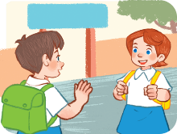  1.  a. | 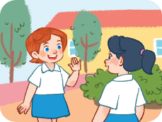  b. |   2.  a. | 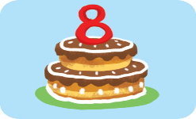  b.
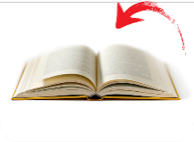  3. | 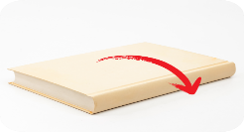  b. |   4.  a. |   b.
Question 2: Listen and Number (1p)
  a. | 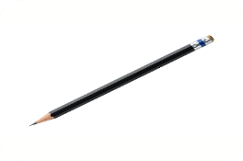  b. | 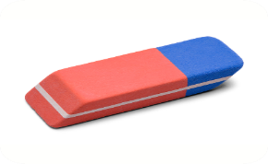  c. | 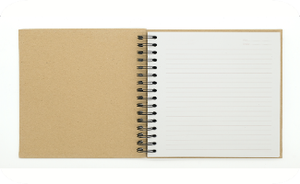  d.
Question 3: Listen and complete (1p)
- We play _____________________ at school.
- There are five _____________________.
- ___________ go home!
- ________________, please!
PART II: Reading
Question 4: Odd one out (1.5p)
1. A. black | B. pen | C. pink | D. blue
2. A. ruler | B. yard | C. pencil | D. book
3. A. football | B. baseball | C. basketball | D. chess
4. A. face | B. eye | C. hand | D. eraser
5. A. bye | B. fine | C. hello | D. goodbye
6. A. have | B. school bag | C. pencil | D. eraser
Question 5: Choose the best answer (1.5p)
1. Is this Lucy? – No, __________.
a. is it b. it is c. it isn’t

2. I have two pencils and ________eraser.
a. a b. an. c. two
3. Do you have a school bag? - Yes, I ___________.
a. am b. do c. do
4. I like_______________.
a. cook b. sing c. swimming
5. What’s ____________ hobby? – He likes dancing.
a. his b. her c. your
6. Is that Ms Hoa? - ________, it is.
a. Yes b. No c. It
Question 6:Read and complete (1.5p)
years eight thanks are Hello you
Lan: (1) _________, Hoa. How (2) ____________ you?
Hoa: Hi, Lan. I’m great, (3) __________. And (4)_____?
Lan: Fine, thank you. How old are you?
Hoa: I’m eight (5) ____________old. And you?
Lan: I’m (6) ____________ years old, too.
Phần III: Writing
Question 7: Look at the pictures and write the words
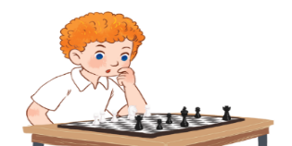 |  | 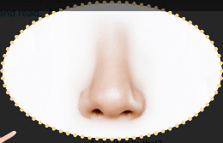 | 
1. I play__________  at breaktime. | 2. He is __________  years old. | 3. It’s a_______ | 4. ___________your mouth!
Question 8: Arrange the words to make sentences (1.5p)
1. this / music / Is / room / your /
_________________________________________?
2. your / Close / please / book, /
_________________________________________.
3. She / bag / has / school / a /
_________________________________________.
4. are / colour / notebooks / What / your /
_________________________________________?
5. some / have / school / I / things /.
__________________________________________
6. Vietnamese / I / speak / May /?
______________________________________________

PHẦN 2: ĐẤP ÁN

UBND HUYỆN VĨNH BẢO  TRƯỜNG TH HIỆP HOÀ  (Đề đề xuất) | ĐÁP ÁN ĐỀ KHẢO SÁT CHẤT LƯỢNG HK I  MÔN TIẾNG ANH LỚP 3  NĂM HỌC 2023 – 2024  (Thời gian làm bài: 40 phút)
PART I: Listening
Question1 1:Listen and tick (1pt)

- B
- B
- B
- A

Question 2: Listen and Number (1p)
- A
- B
- D
- C

Question 3: Listen and complete (1p)
- badminton
- pencils
- let’s
- stand up

PART II: Reading
Question 4: Odd one out (1.5p)
- B. Pen 5. B. fine
- B. Yard 6. A. have
- D. Chess
- D. Eraser
Question 5: Choose the best answer (1.5p)
- c. it isn’t. 5. a. his
- b. an 6. a. Yes
- b. do
- c. singing

Question 6:Read and complete (1.5p)
- hello
- are
- thanks
- you
- years
- eight
Phần III: Writting
Question 7: Look at the pictures and write the words( 1.0p)
- chess 3. nose
- seven 4. Open

Question 8: Arrange the words to make sentences (1.5p)

1. Is this your music room?
2. Close your book, please.
3. She has a school bag.
4. What colour are your notebooks?
5. I have some school things.
6. May I speak English?

