UBND HUYỆN VĨNH BẢO  TRƯỜNG TH HIỆP HOÀ | ĐỀ KHẢO SÁT CHẤT LƯỢNG HỌC KỲ I  MÔN TIẾNG ANH LỚP 4  NĂM HỌC 2023 - 2024  (Thời gian làm bài: 40 phút)
PART I: Listening
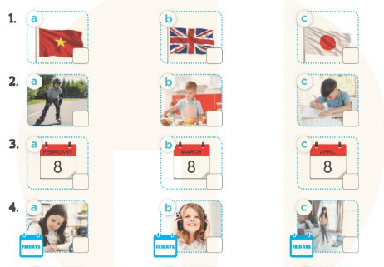
Question 1: Listen and tick (1pt)
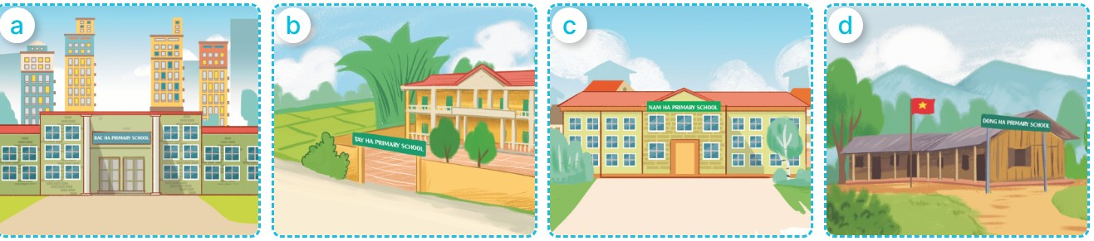
Question 2: Listen and number (1pt)



Question 3: Listen and complete (1pt)
1. What subjects do you have today? - I have _________________________.
2.What subjects do you have today? - I have _________________________.
3.What subjects do you have today? - I have__________________________.
4. What subjects do you have today? - I have _________________________.
PART II: READING
Question 4. Odd one out (1,25pt)
1. A. January B. English C. February D. April
2. A. chips B. grapes C. lemonade D. jam
3. A. Malaysia B. Thailand C. Viet Nam D. Tokyo
4. A. have B. go C. breakfast D. watch
5. A. Japan B. London C. Bangkok D. Sydney
Question 5. Circle the words which have underlined parts pronuced differently from the rest. (1.0 pt)
1. A. Sunday B. subject C. study D. Music
2. A. chips B. school C. watch D. chicken
3. A. music B. city C. village D. bike
4. A. Art B. May C. play D. April
Question 6. Choose best answer (1.25pt)
1. Can you ride a horse? No, I______
A. can’t B. can C. am D. don’t
2. What do you do ___________Sundays?
A. at B. on C. in D. by
3. Can you __________ a kite? Yes, I can.
A. love B. ride C. fly D. play
4. What is your _______________subject? It’s English.
A. like B. love C. favorite D. hobby
5. He likes Music because she wants to be a ____________
A. painter B. teacher C. dancer D. singer
Question 7. Read and tick True or False (1,0 pt)
Our sports day is in December. It’s in the school playground. There are many students and teachers. We play different sports and games. The girls play badminton. The boys play football. Our teachers play basketball. It is a lot of fun!
 | TRUE | FALSE
1. The sports day is in November.
2. The sports day is in the school playground.
3. The boys play badminton.
4. The teachers play basketball.
PART III: Writing
Question 8. Look at the picture and complete the sentnces. (1.0 pt)
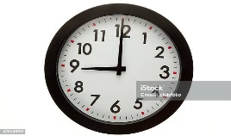 | 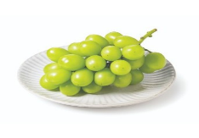 | 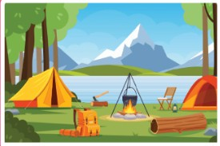 | 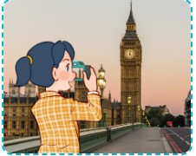
1. It’s _____________ | 2. I want some ____________ | 3. Were you at the ________________  last weekend. | 4. Last summer I was in ___________________.
Question 9. Reorder the words to make sentences (1.5 pt)
1. is / She / America / from /. /
_________________________________________________________________________
2. you/ Can/ a /ride/ bike/?
__________________________________________________________________________
3. are/ from / you /Where / ? /
__________________________________________________________________________
4. is /English / My / subject /favourite / . /
__________________________________________________________________________
5. Ben / swim / ride/ but / can / a / horse /can’t / he /./
__________________________________________________________________________
6. like / art / I / want / a painter. / because / I / to be
_______________________________________________________________________

