UBND HUYỆN VĨNH BẢO  TRƯỜNG TH HIỆP HOÀ | ĐỀ KHẢO SÁT CHẤT LƯỢNG HỌC KỲ I  MÔN TIẾNG ANH LỚP 5  NĂM HỌC 2023 - 2024  (Thời gian làm bài: 40 phút)
PART I: Listening
Question 1: Listen and tick (1pt)
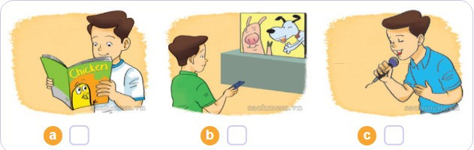

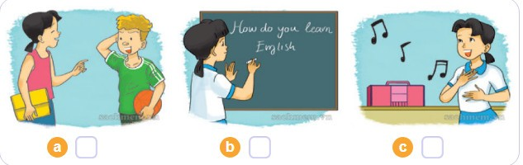

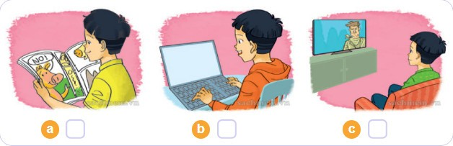

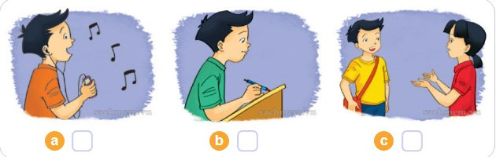

Question 2: Listen and number (1pt)
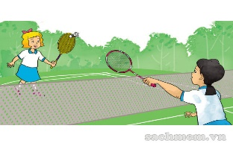

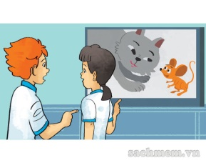
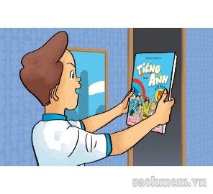

a  b c. d.
Question 3: Listen and complete (1pt)
1. Tom lives in a pretty and ______________ village.
2. Tony lives in a________________ and busy city.
3. Peter lives in a small and busy _______________.
4. Linda’s city is ____________ and busy.

PART II: Pronunciation
Question 4: Circle the word which has the stressed syllable different from the rest ones (1,5pt)
1. a. city | b. village | c. repeat | d. tower
2. a. mountain | b. cartoon | c. party | d. birthday
3. a. repeat | b. enjoy | c. invite | d. water
4. a. seaside | b. picnic | c. complete | d. water
5. a. enjoy | b. comics | c. Sunday | d. island
6. a. holiday | b. invite | c. countryside | d. motorbike
III. READING
Question 5: Choose the best answer (1,5pts)
1. Did they enjoy the birthday party? – No, I ________
A. did B. didn’t C. isn’t D. can’t
2. What _______ you do at the zoo yesterday?
A. do B. does C. did D. doing
3. How do you practice speaking English?
I practice speaking English________ speaking it every day.
- on B. from C. by D. at
4._________do you learn English? – Because I want to sing English songs.
- What B. Who C. Why D. How
5. What did the lions do when you were at the zoo? They ____________ loudly.
- moved B. ate C.roared D. sang
6. The pandas usually do things ___________
A. slowly B. loudly C. quickly D. noisily
Question 6: Read and complete with the words given (1,25pts)
Art four lessons Wednesday Tuesday
My name is Trung. I'm a new pupil in Class 5B. Today is (1) ________________. I have five (2) ______________: Maths, Vietnamese, Science, IT and PE. Tomorrow is (3) _____________________. I'll have (4) _________________ lessons: Maths, Vietnamese, Music and (5)________________ .
Question 7: Read and tick True or False (1,25pts)
Tom likes reading. On Sundays, he often stays at home and reads comic books. He likes Case Closed very much. It is a Japanese story. The main character is a schoolboy called Jimmy Kudo. He often helps the police. He is good at his job. Jimmy Kudo is Tom's favorite character because he is clever and brave.
 | TRUE | FALSE
1.Tom likes reading books in his free time.
2.Case Closed is a Malaysian story.
3.The main character is Jimmy Kudo.
4.Jimmy Kudo is a policeman.
5.Jimmy Kudo is clever and brave.
IV. WRITING
Question 8: Arrange the words to make sentences (1,25pt)
1. hometown / like? /What/ your/ is
............................................................................................................................................
2. on/ you/go /Where/ holiday? /did/
..............................................................................................................................................
3. We /plane. / to / Phu Quoc /went/Island /by /
...........................................................................................................................................
4.do/Maths?/have/often/you/How
............................................................................................................................................
5. reading/ Aladdin / He / is / and/ the Magic Lamp.
..............................................................................................................................................
6. Teacher’s Day / will / When / be ?
..............................................................................................................................................

