* Ma trận đề kiểm tra học kỳ 1 môn tiếng Anh lớp 4
Thứ tự | Nội dung | Cấp độ |  |  |  | Số câu-Số điểm
Thứ tự | Nội dung | 1 | 2 | 3
 |  |  |  | thấp | cao
Phần I | Listening |  |  |  |  | 12 câu = 3điểm 30%
Bài 1 | Listen and tick  Review 1 and Review 2 | 2 câu | 1 câu | 1 câu |  | 4 câu=1.0 điểm
Bài 2 | Listen and number  Unit 3: My week  Unit 6: Our school facilities  Unit 8: My favourite subjects | 1 câu | 1 câu | 2 câu |  | 4 câu =1.0 điểm
Bài 3 | Listen and complete  Unit 5: Things we can do  Unit 7: Our timetables | 2 câu | 1 câu | 1 câu |  | 4 câu=1.0 điểm
Phần II | Reading |  |  |  |  | 18 câu= 4,5 điểm  45%
Bài 4 | Odd one out  Unit 1: My friends  Unit 2: Time and daily routines  Unit 4: My birthday party.  Unit 9: Our sports day.  Unit 10: Our summer holidays. | 1 câu | 2 câu | 1 câu | 1 câu | 5 câu=1.25điểm
Bài 5 | Circle an underlined word that has a different pronunciation  Sounds: /a/ /u/ /i/ /ch/ | 1 câu | 1 câu | 1 câu | 1 câu | 4 câu=1.0điểm
Bài 6 | Look and read: Choose the best answer  Unit 3: My week  Unit 5: Things we can do  Unit 8: My favourite subjects | 1 câu | 1 câu | 2 câu | 1 câu | 5 câu=1.25điểm
Bài 7 | Read and complete/ Read and tick (T/ F)  Unit 4: My birthday party  Unit 7: Our timetables  Unit 9: Our sports day | 1 câu | 1 câu | 1 câu | 1 câu | 4 câu=1,0 điểm
Phần III | Writing |  |  |  |  | 10 câu = 2.5điểm 25%
Bài 8 | Look at the pictures and write the words  Unit 2: Time and daily routines  Unit 4: My birthday party  Unit 10: Our summer holidays | 1 câu | 1 câu | 1 câu | 1 câu | 4 câu=1.0 điểm
Bài 9 | Arrange the words to make sentences  Unit 1: My friends  Unit 5: Things we can do  Unit 8: My favourite subjects | 2 câu | 1 câu | 2 câu | 1 câu | 6 câu= 1,5 điểm
 |  | 12 câu  = 3,0đ  30% | 10 câu  =2,5đ  25% | 12 câu  = 3,0 đ  30% | 6 câu  =1,5đ  15% | 40 câu = 10điểm 100%

UBND HUYỆN VĨNH BẢO  TRƯỜNG TIỂU HỌC VĨNH AN  (Đề đề xuất) | ĐỀ KHẢO SÁT CHẤT LƯỢNG HỌC KỲ I  MÔN TIẾNG ANH LỚP 4  NĂM HỌC 2023 - 2024  (Thời gian làm bài: 40 phút)
PART I: Listening
Question 1: Listen and tick (1pt)
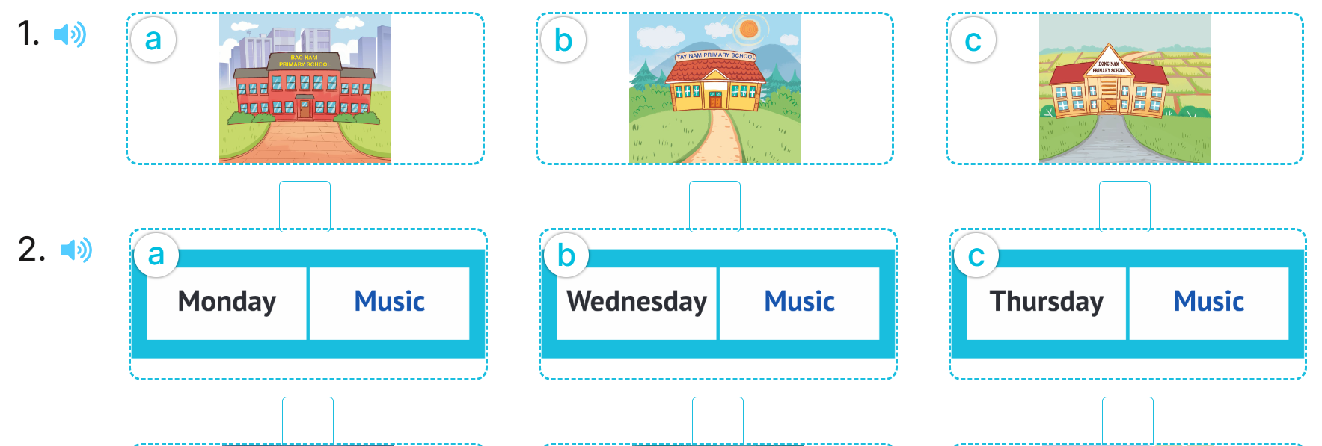
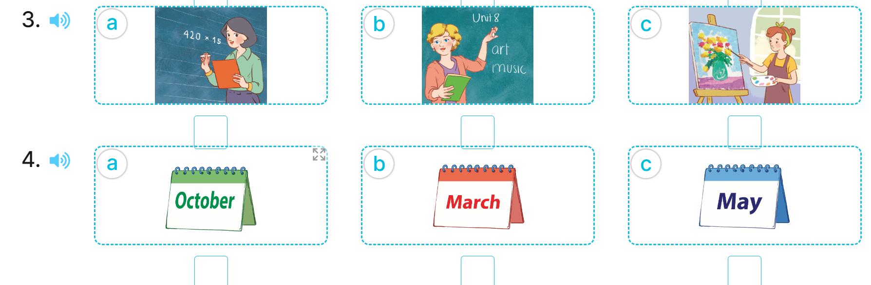
Question 2: Listen and number (1pt)
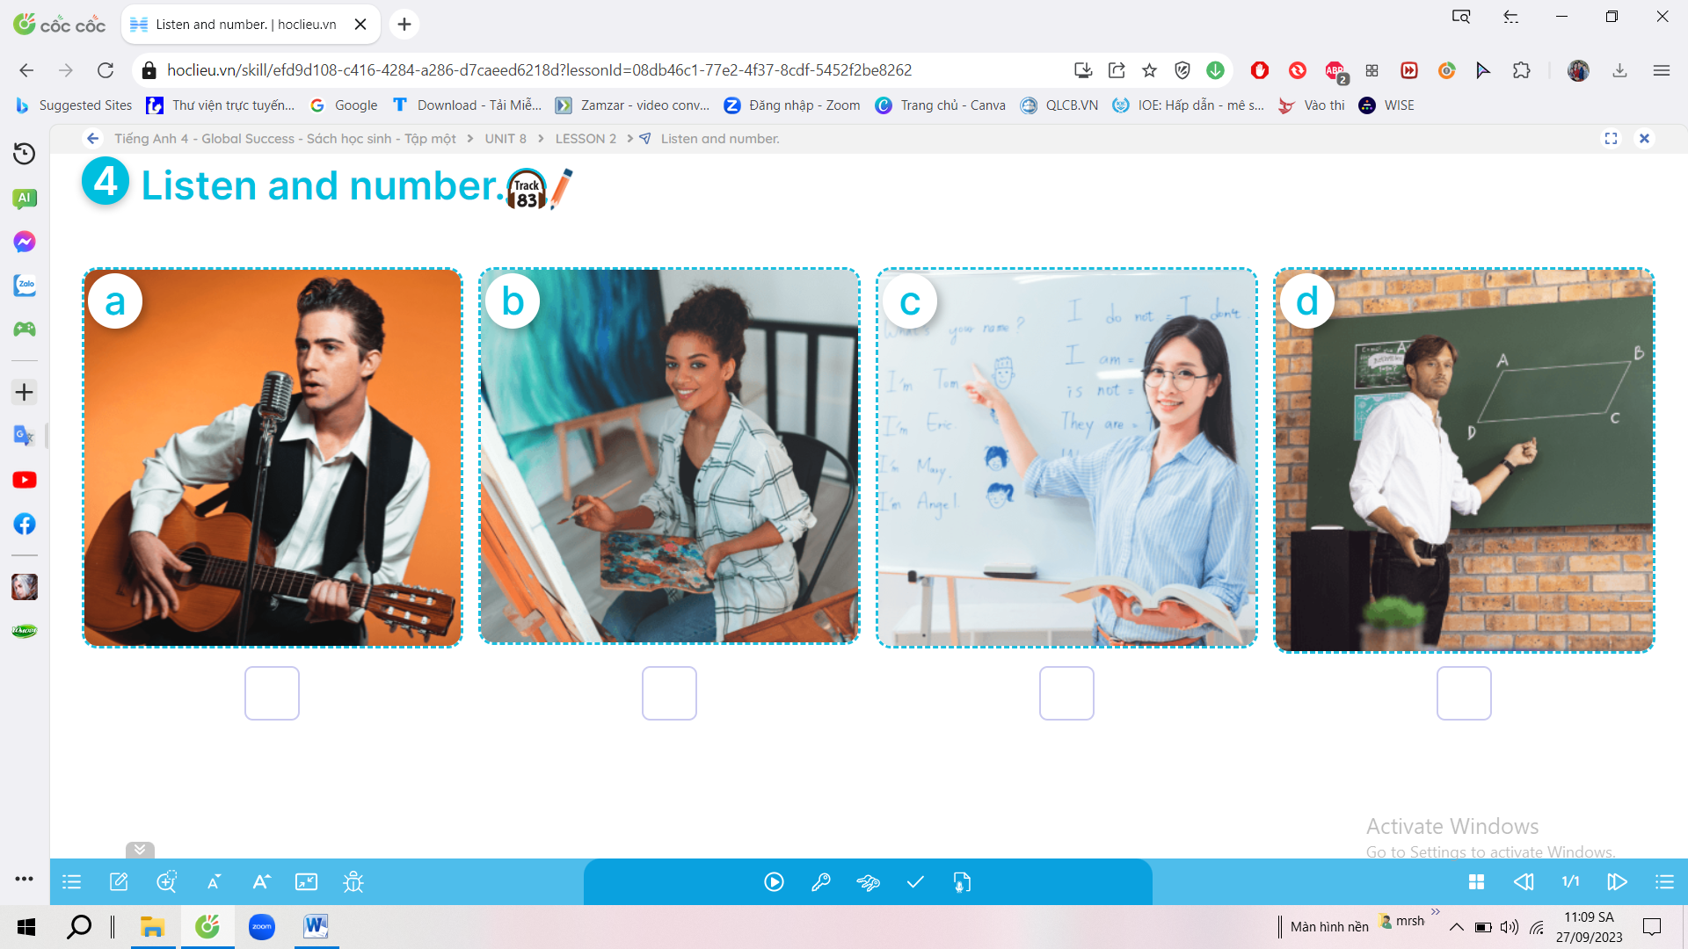
Question 3: Listen and complete (1pt)
1. My brother can ………………..................……
2. My sister can ...................................................
3. She can ……………………….................……
4. My brother can’t …………….........……………
Question 4: Odd one out (1,25pts)
1. a. America | b. Britain | c. Vietnamese | d. Malaysia
2. a. clean | b. chat | c. watch | d. housework
3. lemonade | b. grapes | c. water | d.juice
4. a. January | b. March | c. October | d. Monday
5. a. have | b. lunch | c. dinner | d. breakfast

Question 5: Circle an underlined word that has a different pronunciation (1pt)
1. a. school | b. beach | c. watch | d.chips
2. a. music | b. student | c. computer | d. sunday
3. a bike | b. kite | c. sing | d. like
4. a. America | b. may | c. table | d. today

Question 6. Choose the best answer (1,25pt)
1. What time is it?
a. at four fifteen b. on four fifteen
c. it’s four fifteen d. It’s four fifteen o’clock
2. Can you ride a bike?
a. No, I can’t b. I can sing c. Yes, I can’t d. No, I cann’t
3. I like drawing because I want to be ….............................................
a. a singer b. a painter
c. a doctor d. an English teacher
4. A: …………..do you like Math?
B: Because I want to be a Maths teacher.
a. What b. Why c. Where d. When
5. He ….............................at school every day.
a. study b. studies c. studys d. studyes

Question 7. Read and True (T) or False (F) (1pt)
My name is Minh. I go to school from Mondays to Fridays. I have Vietnamese and Maths every school day. I have English on Mondays, Thursdays and Fridays. I have Science on Wednesdays and Thursdays. I have Music on Tuesdays. I like Music very much.
1. Minh goes to school five days a week.
2. He has Maths from Mondays to Fridays
3. He has Science on Tuesdays and Thursdays.
4. His favourite subject is Music.

Question 8: Look at the pictures and write the words (1pt)

1. I was in ............................................... | 
2. A: Were you at the......................................?  B: Yes, I was | 
3. A: What time is it?  B: It’s ....................................................... | 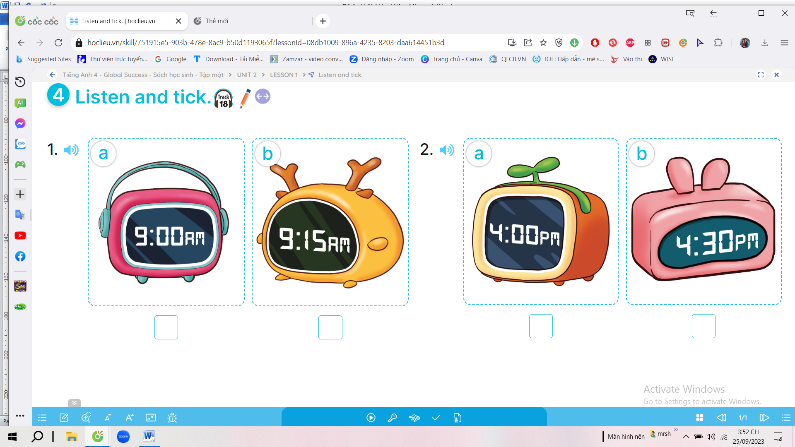
4. A: What do you want to eat?  B: I want some ....................................... | 

Question 9. Reoder to make the sentences (1,25pts)

1. America / Mary / is / from.
....................................................................................................................................................
2. from, / Where / you / Mai / are?
...................................................................................................................................................
3. can / skate / all / We / roller.
....................................................................................................................................................
4. ride / brother / a / your / horse / can?
....................................................................................................................................................5. favourite / What’s / subject / your?
....................................................................................................................................................
6. likes / he / English / wants / Quan / tobe / English / an / teacher / because.
....................................................................................................................................................

UBND HUYỆN VĨNH BẢO  TRƯỜNG TIỂU HỌC VĨNH AN  (Đề đề xuất) | ĐÁP ÁN ĐỀ KHẢO SÁT CHẤT LƯỢNG HK I  MÔN TIẾNG ANH LỚP 4  NĂM HỌC 2023 - 2024  (Thời gian làm bài: 40 phút)
PART I: Listening
Question 1: Listen and tick the correct pictures.(1pt)
4 câu x 0,25 = 1đ
1 b 2 c 3 b 4 c
Question 2: Listen and number (1pt)
4 câu x 0,25 = 1đ
1. b 2.d 3.a 4.c
Question 3: Listen and write (1pt)
4 câu x 0,25 = 1đ
1. cook 2. Roller skate 3. swim 4. Play badminton
PART II: Pronunciation
Questions 4: Question 4: Odd one out (1,25pts)

5 câu x 0,25 = 1,25đ
1.c 2.d 3.a 4. d 5.a
III. READING
Question 5: Circle an underlined word that has a different pronunciation (1pt)
4 câu x 0,25 = 1đ
1. a 2.d 3.c 4.a
Question 6: Choose the best answer (1,25pt)
5 câu x 0,25 = 1,25đ
1.c 2.a 3.b 4.b 5.b
Question 7: Read and Tick True (T) or False (F) (1,25pt)

4 câu x 0,25 = 1,0đ
1. T 2. T 3. F 4. T

Question 8: Look at the pictures and write the words (1pt)
4 câu x 0,25 = 1,0đ
1. Sydney 2. campsite 3. Nine fifteen 4. grapes
IV. WRITING
Question 8: Arrange the words to make sentences (1,25pt)
5 câu x 0,25 = 1,25đ
1. Mary is from America.
2. Where are you from, Mai?
3. We can all roller skate.
4. Can your brother ride a horse?
5. What is your favourite subject?
6. Quan likes English because he wants to be an English teacher.

KÝ DUYỆT CỦA BGH | NGƯỜI RA ĐỀ  (Ký, ghi rõ họ, tên)

